Create table facebook (

userid INT,age INT,dob_day INT ,dob_year INT ,dob_month INT ,gender STRING ,tenure INT ,friend_count INT ,

friendships_initiated INT ,likes INT ,likes_received INT ,mobile_likes INT ,mobile_likes_received INT ,www_likes INT ,www_likes_received INT)

ROW FORMAT DELIMITED FIELDS TERMINATED BY ','

LINES TERMINATED BY '\n'

STORED As TextFile

tblproperties(

"skip.header.line.count"="1"

);

LOAD DATA LOCAL INPATH '/home/mavricbdhnov0121/pseudo_facebook.csv' INTO TABLE facebook;

1. Find out the total no of users in the dataset

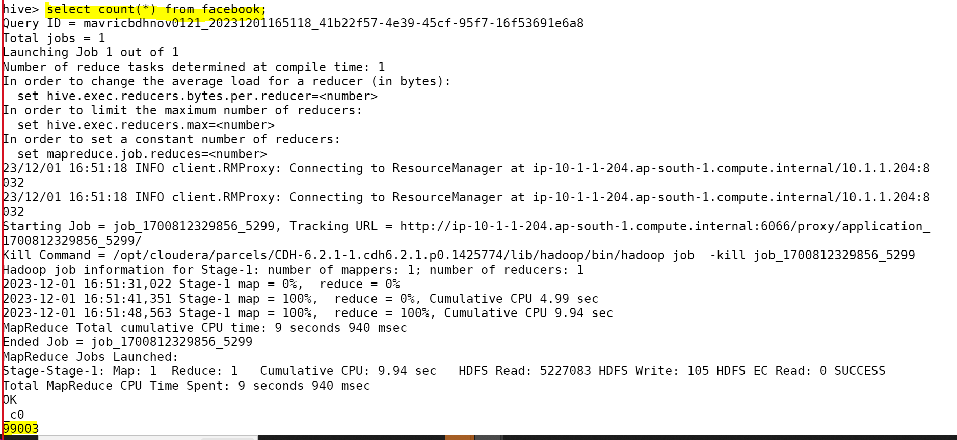

1. Find out the no of users above the age of 25

1. Do male face book users tend to have more friends or female users

4.How many likes do young people receive on facebook as opposed to old people

select a.people , a.total_likes from( select 'Young' as people ,sum(likes_received) as tot_likes from facebook where age <= 20 union select 'OLD' as people ,sum(likes_received) as tot_likes from facebook where age > 20)a;

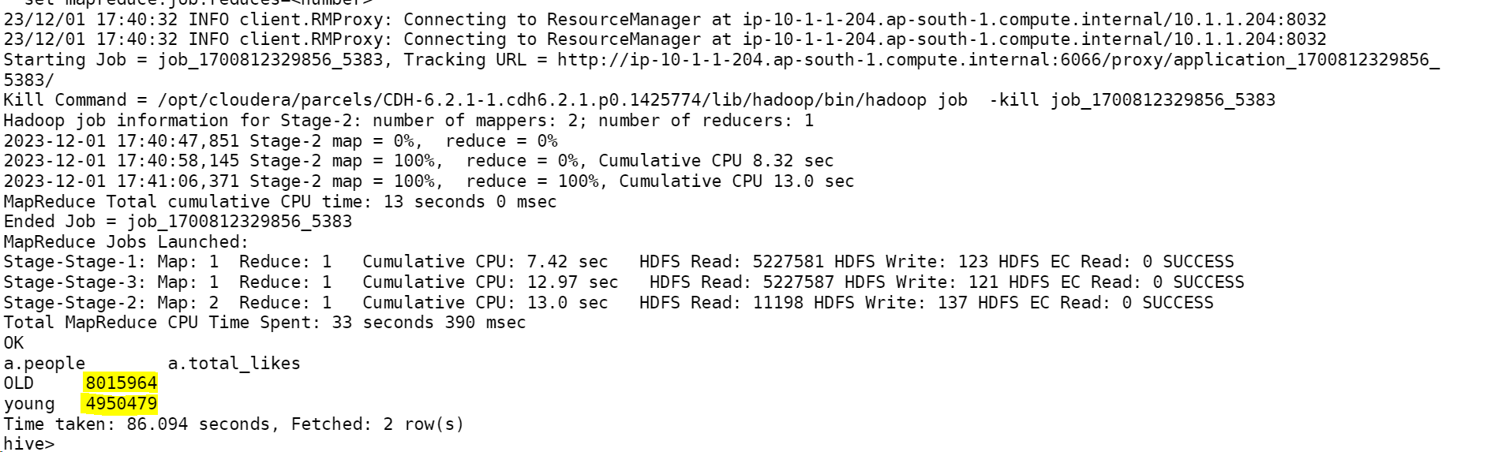

5.Find out the count of facebook users for each birthday month

Select count(userid),dob_month from facebook group by dob_month;

6.Do young members use mobile phones or computers for facebook browsing

select 'Young' as people ,sum(mobile_likes) as Mobile_users, sum(www_likes) as Computers_Users from facebook where age <= 18;

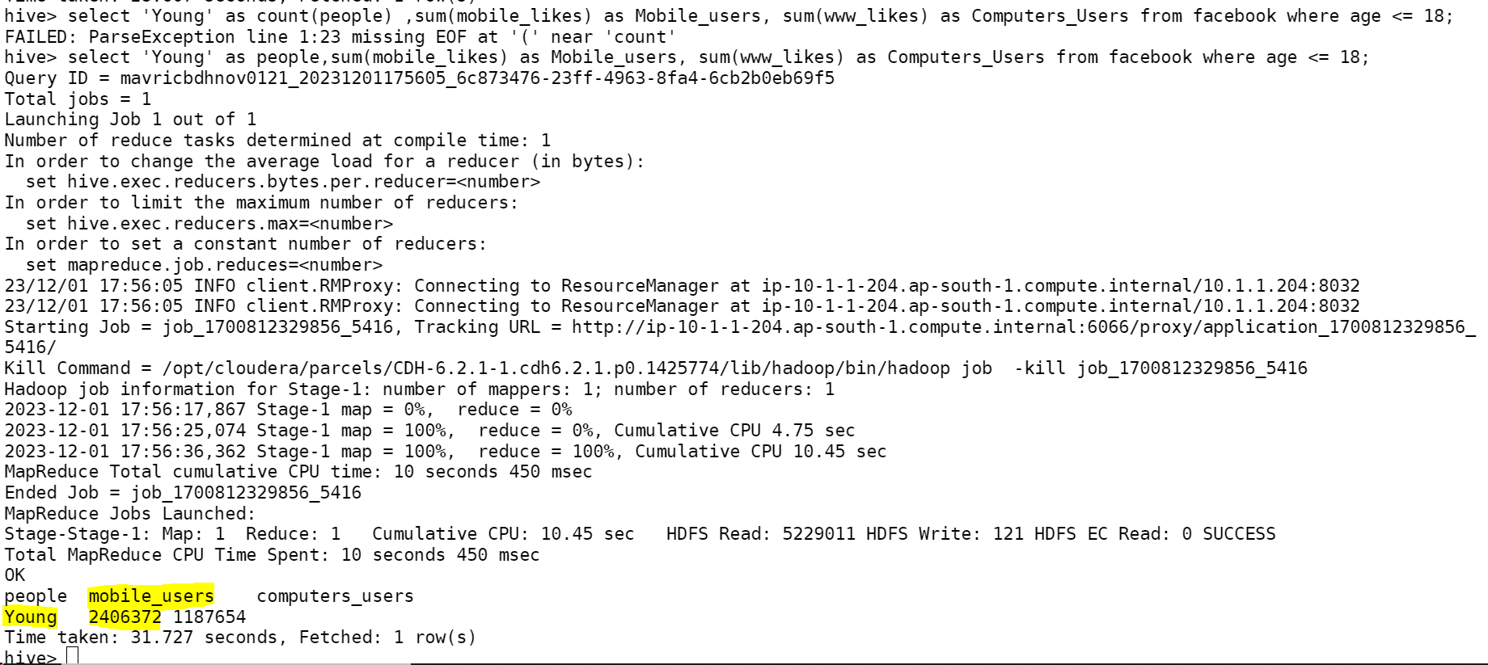

7. Do adult members use mobile phones or computers for facebook browsing

