Step 1: Copy the provided csv files in a directory named AirlinesOntimeAnalysis

Step 2: Unzip the contents for the bz2 files



Step 3: Create the directories in hdfs where your data will reside

Hdfs dfs -mkdir -p rawdata/airline/flights

Hdfs dfs -mkdir -p rawdata/airline/planeinfo

Hdfs dfs -mkdir -p rawdata/airline/airport

Hdfs dfs -mkdir -p rawdata/airline/carriers

Step 4: copy the respective files to the above created hdfs structure

**2. Create tables using Hive**

**Create all the tables in a different database in Hive(airline_db)**

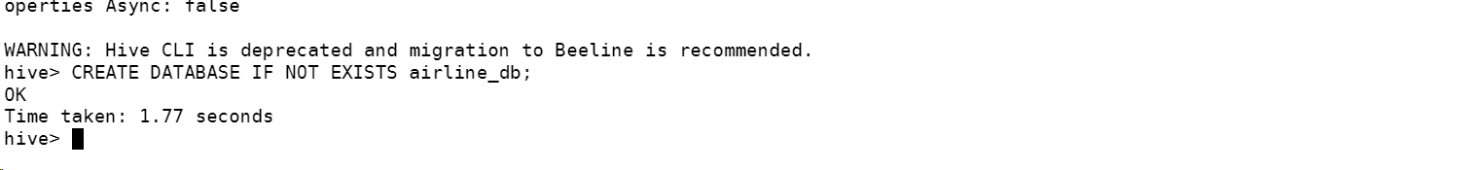

**3.Create tables using Hive**

Create the required tables as External (flights, airports, carriers, plane_info) in the staging area. The schema of each of the tables is provided above. Also point these tables to the hdfs locations already created above Note: Name every table name at the end with _stg. Create all the tables in a different database in Hive(airline_db)

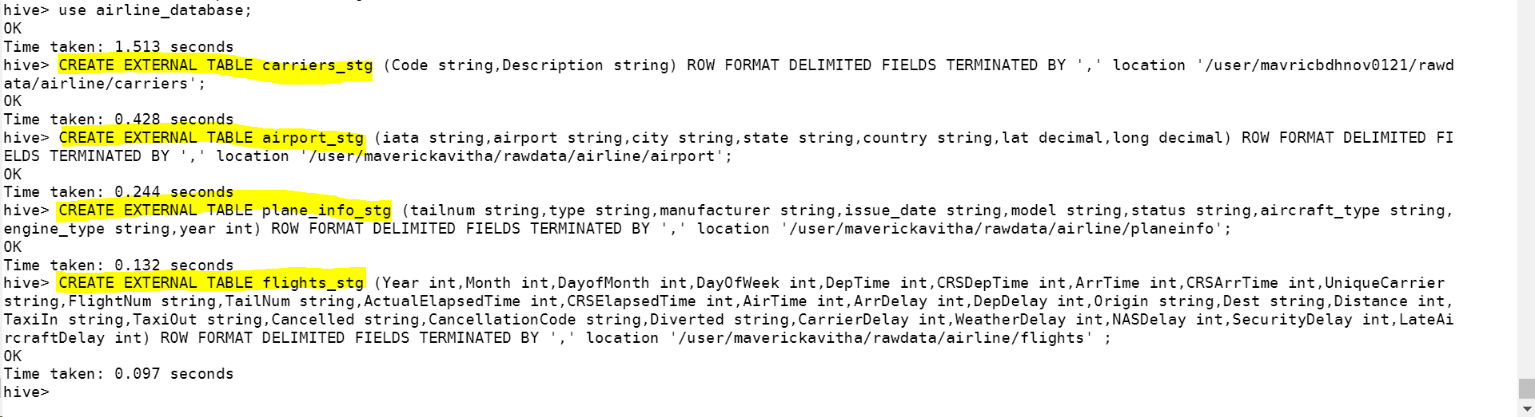

Skipping headers

Checking data:

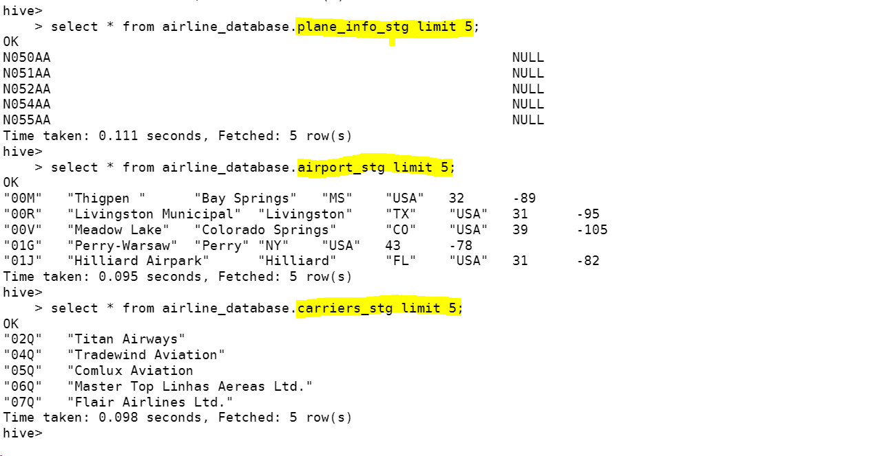

**What is the average arrival delay and average departure delay in each month of the year 2004?**

**3. Improving the performance of Hive tables - Parquet format**

Create the parquet table as external tables for flights from the above staging table. Name the new table with _pq as a suffix: Ex : flights_pq Point all the table location output/airline/pq_flights





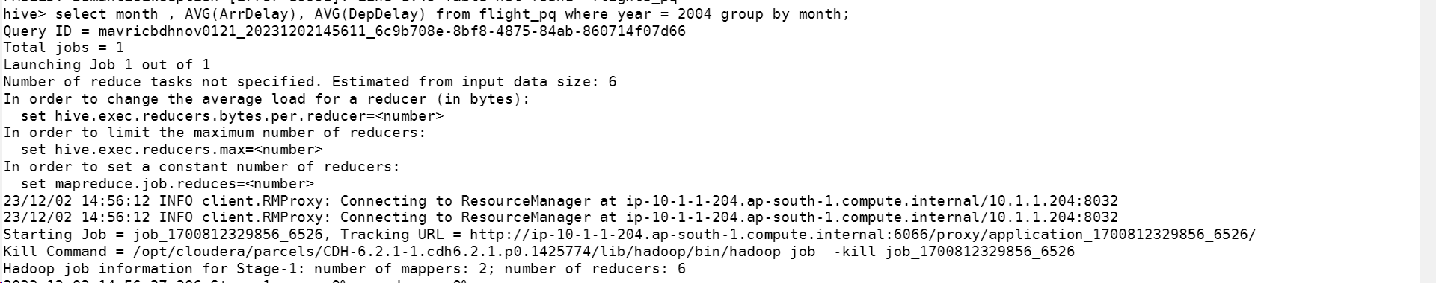

**The time is reduced from 4+ min to 1min 21 seconds.**

