1.

Descriptive statistics:

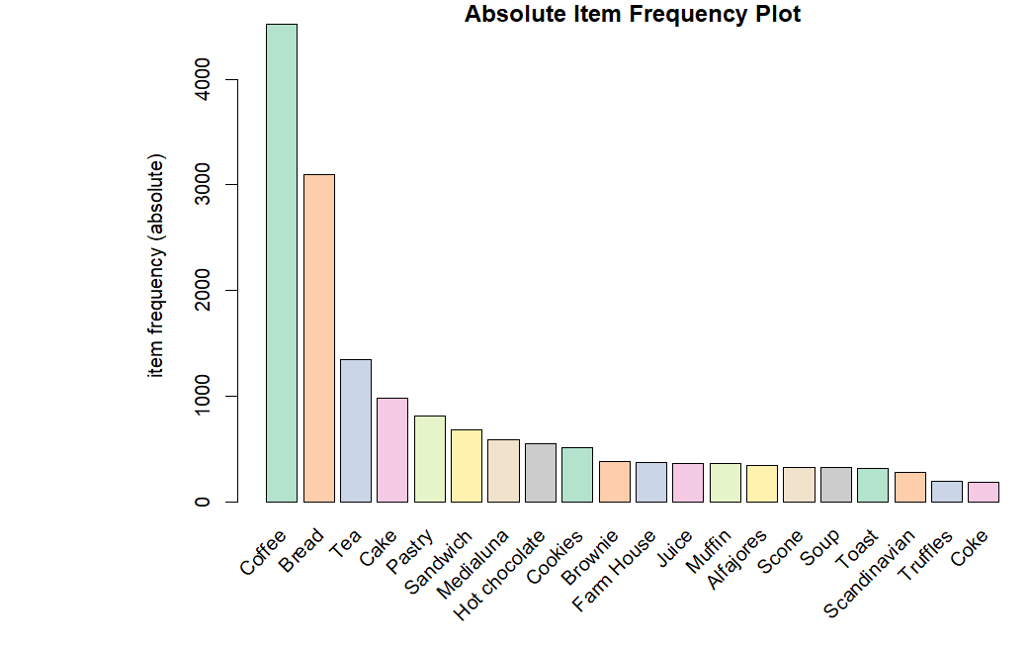

2.

Association Rules

Coffee filter

Support:

Support is the percentage of transactions in a dataset that contain a particular itemset. It tells you how often a particular combination of items appears in your dataset.

Confidence:

Confidence is the percentage of transactions that contain item A also contain item B. It tells you how often customers who buy item A also buy item B.

Lift:

Lift is a measure of how much more often item A and item B are bought together than would be expected by chance. A lift value of 1 means that the items are independent of each other, a value greater than 1 indicates that they are positively correlated, and a value less than 1 indicates that they are negatively correlated.