What is a Histogram?
A histogram is a graph used to show the distribution of numerical data. It divides numerical values into intervals called bins and shows how many values fall into each bin.
Simple example
Suppose the marks of students are:
45, 52, 55, 61, 63, 67, 72, 75, 78, 82, 85, 91
We can divide them into intervals:
Marks interval | Number of students
40–50 | 1
50–60 | 2
60–70 | 3
70–80 | 3
80–90 | 2
90–100 | 1
The histogram displays these intervals as bars.
Basic hist() Syntax
The basic syntax is:
plt.hist(x, bins=10, ...)
Here:
- x → numerical data
- bins → number of intervals/groups
- ... → other optional parameters
EX1:
import matplotlib.pyplot as plt
marks = [45, 52, 55, 61, 63, 67, 72, 75, 78, 82, 85, 91]
plt.hist(marks, bins=5)
plt.xlabel('Marks')
plt.ylabel('Number of Students')
plt.title('Distribution of Student Marks')
plt.show()
Output:
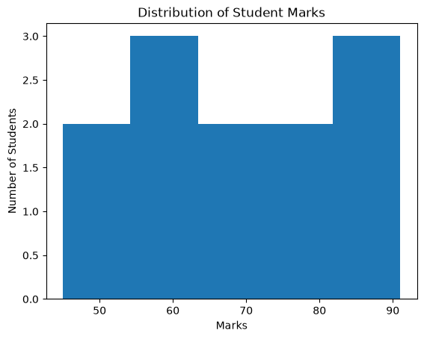
What are Bins?
Bins are intervals used to group numerical data.
Suppose: marks = [45, 52, 55, 61, 63, 67, 72, 75, 78, 82, 85, 91]
If we use: bins=5, Matplotlib divides the range of marks into 5 groups.
Conceptually:
45 ───── 54 ───── 63 ───── 72 ───── 81 ───── 91
Bin 1 Bin 2 Bin 3 Bin 4 Bin 5
The height of each bar represents the frequency—the number of observations in that interval.
Parameters of hist() Function:
Parameter | Description | Example / Notes
x | The numerical data to be plotted | plt.hist(marks)
bins | Specifies the number of intervals (bins) into which the data is divided | bins=5
range | Specifies the lower and upper limits of the data range | range=(40,100)
density | If True, the histogram shows probability density instead of frequency | density=True
color | Specifies the fill color of the histogram bars | color='skyblue'
edgecolor | Specifies the color of the border/outline of each bar | edgecolor='black'
linewidth | Controls the thickness of the bar borders | linewidth=2
alpha | Controls the transparency of the bars. 0 = transparent, 1 = opaque | alpha=0.5
histtype | Specifies the type/style of histogram | 'bar', 'step', 'stepfilled'
label | Gives a name to the histogram, displayed using a legend | label='Class A'
orientation | Specifies the direction of the histogram | 'vertical' or 'horizontal'
rwidth | Controls the relative width of the histogram bars | rwidth=0.8
cumulative | If True, creates a cumulative histogram showing running totals | cumulative=True
weights | Assigns a weight to each data value when calculating the histogram | weights=w
range:
range specifies the minimum and maximum values considered for the histogram.
Ex: plt.hist(marks, bins=5, range=(40, 100))
Here: 40 → minimum and 100 → maximum. So the histogram considers the range: 40 to 100
color:
color changes the fill color of the histogram bars.
EX: plt.hist(marks, bins=5, color='skyblue')
edgecolor:
edgecolor specifies the color of the boundary/outline of each bar.
Ex: plt.hist( marks, bins=5, edgecolor='black' )

linewidth:
linewidth controls the thickness of the bar boundaries.
plt.hist(marks, bins=5, edgecolor='black', linewidth=2)
alpha:
alpha controls transparency.
Its value ranges from: 0 → completely transparent
1 → completely opaque
Ex: plt.hist(marks, bins=5, alpha=0.5)
alpha=0.5 means the histogram is partially transparent.

Ex2:
import matplotlib.pyplot as plt
marks = [45, 52, 55, 61, 63, 67, 72, 75, 78, 82, 85,91]
plt.hist(marks, bins=5, color='red', edgecolor='black', linewidth=5, alpha=0.3)
plt.xlabel('Marks')
plt.ylabel('Number of Students')
plt.title('Distribution of Student Marks')
plt.show()
Output:
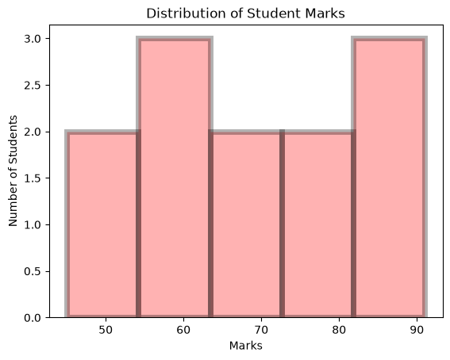
histtype:
histtype controls the type of histogram. Common types include:
histtype='bar' Normal histogram.
histtype='step' Displays an outline.
histtype='stepfilled' Displays a filled outline.
histtype='barstacked' This is useful when you have more than one dataset and want their frequencies to be stacked on top of each other.

Example:
import matplotlib.pyplot as plt
marks = [45, 50, 52, 65, 69, 70, 72, 78, 82, 85, 90, 96]
plt.hist(marks, bins=8, histtype='step')
plt.xlabel('Marks')
plt.ylabel('Number of Students')
plt.title('Distribution of Student Marks')
plt.show()

Output:
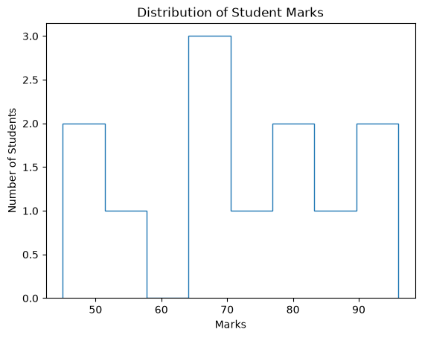
rwidth:
rwidth controls the relative width of the histogram bars.
Ex: plt.hist(marks, bins=5, rwidth=0.8)
Here, 0.8 means the bars occupy about 80% of the available bin width.

Cumulative:
cumulative=True creates a cumulative histogram.
Ex: plt.hist(marks, bins=5, cumulative=True)
Instead of showing only the frequency in each bin, it shows the running total.
For example: Bin 1 → 2 students
Bin 2 → 5 students total
Bin 3 → 8 students total
Bin 4 → 10 students total

Ex3:
import matplotlib.pyplot as plt
data= [1, 2, 3, 4, 5, 6, 7, 8, 9, 20, 21, 22, 23, 44, 55, 66, 77, 88, 99, 20, 21, 22, 23, 24, 25, 26, 27, 28, 29, 30, 31, 32, 33, 34, 35, 36, 37, 38, 39, 40, 41, 42, 43, 44, 45, 46, 47, 48, 49, 50, 51, 52, 53, 54, 55, 56, 57, 58, 59, 60, 61, 62, 63, 64, 65, 66, 67, 68, 69, 70, 71, 72, 73, 74, 75, 76, 77, 78, 79, 80, 81, 82, 83, 84, 85, 86, 87, 88, 89, 90, 91, 92, 93, 94, 95, 96, 97, 98, 99, 100]
plt.hist(data,20, ec='g', rwidth=0.5, color='blue', alpha=0.5, histtype="step")
plt.xlabel('X-axis Label')
plt.ylabel('Frequency')
plt.title('Histogram of the Distribution')
plt.show()
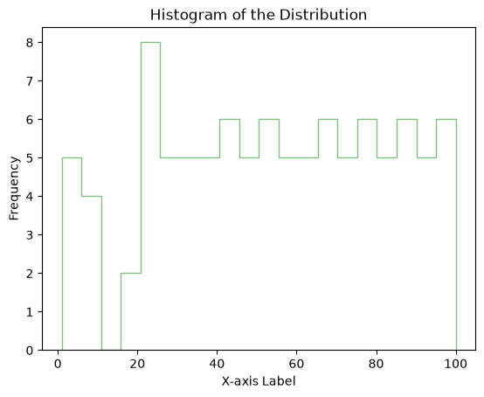
Ex4:
import matplotlib.pyplot as plt
import seaborn as sns
x= [1, 2, 3, 4, 5, 6, 7, 8, 9, 20, 21, 22, 23, 44, 55, 66, 77, 88, 99, 20, 21, 22, 23, 24, 25, 26, 27, 28, 29, 30, 31, 32, 33, 34, 35, 36, 37, 38, 39, 40, 41, 42, 43, 44, 45, 46, 47, 48, 49, 50, 51, 52, 53, 54, 55, 56, 57, 58, 59, 60, 61, 62, 63, 64, 65, 66, 67, 68, 69, 70, 71, 72, 73, 74, 75, 76, 77, 78, 79, 80, 81, 82, 83, 84, 85, 86, 87, 88, 89, 90, 91, 92, 93, 94, 95, 96, 97, 98, 99, 100]
fig, axs = plt.subplots(nrows=2, ncols=2)
axs[0, 0].hist(x, 20, density=True, histtype='stepfilled', facecolor='g', alpha=0.75)
axs[0, 0].set_title('stepfilled')
axs[0, 1].hist(x, 20, density=True, histtype='step', facecolor='g', alpha=0.75)
axs[0, 1].set_title('step')
w= [1, 2, 3, 4, 5, 6, 7, 8, 9, 20, 21, 22, 23, 44, 55, 66, 77, 88, 99, 20, 21, 22, 23, 24, 25, 26, 27, 28, 29, 30, 31, 32, 33, 34, 35, 36, 37, 38, 39, 40, 41, 42, 43, 44, 45, 46, 47, 48, 49, 50, 51, 52, 53, 54, 55, 56, 57, 58, 59, 60, 61, 62, 63, 64, 65, 66, 67, 68, 69, 70, 71, 72, 73, 74, 75, 76, 77, 78, 79, 66, 69, 42, 53, 74, 85, 96, 27, 58, 19, 10, 11, 72, 99, 84, 75, 86, 27, 98, 29, 12]
axs[1, 0].hist(x, density=True, histtype='barstacked', rwidth=0.8)
axs[1, 0].hist(w, density=True, histtype='barstacked', rwidth=0.8)
axs[1, 0].set_title('barstacked')

# Create a histogram by providing the bin edges (unequally spaced).
bins = [100, 150, 180, 195, 205, 220, 250, 300]
axs[1, 1].hist(x, bins, density=True, histtype='bar', rwidth=0.8)
axs[1, 1].set_title('bar, unequal bins')
fig.tight_layout()
plt.show()

Output:
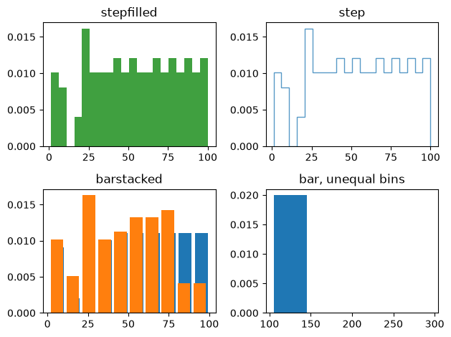
Ex4: Using Titanic dataset
import seaborn as sns
import matplotlib.pyplot as plt
data = sns.load_dataset('titanic')
plt.hist( data['age'].dropna(), bins=10, edgecolor='black')
plt.xlabel('Age')
plt.ylabel('Number of Passengers')
plt.title('Distribution of Titanic Passenger Ages')
plt.show()
Output:
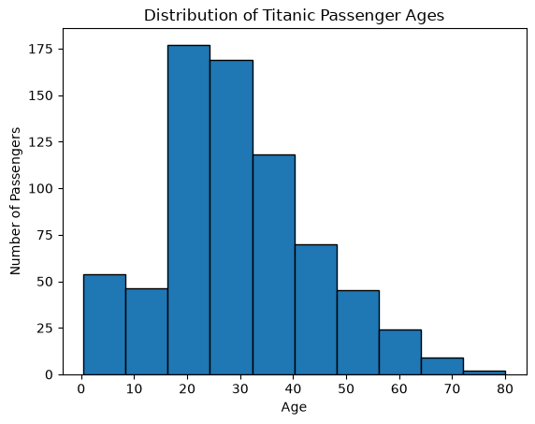

- What is a Density Plot?
A density plot is a smooth curve that shows the distribution of numerical data.
It is similar to a histogram, but instead of using rectangular bars, it uses a smooth curve.
For example, suppose we have students' ages:
ages = [18, 19, 19, 20, 20, 20, 21, 21, 22, 23, 23, 24]
A histogram divides the ages into bins and counts how many observations fall in each bin.
A density plot produces a smooth curve representing the same distribution.

Important point: The total area under a density curve is approximately 1.
So the y-axis of a density plot usually represents probability density, not the actual number of observations.
- Functions Used to Plot Density Plots
There are two commonly used approaches in the material:
Using Seaborn:
sns.kdeplot()
sns.histplot(..., kde=True)
Using Pandas:
DataFrame.plot.density()
The most important function for a pure density plot is: sns.kdeplot()
- sns.kdeplot()
kde stands for: Kernel Density Estimation. It estimates the underlying distribution of the data and produces a smooth curve.
Basic syntax: sns.kdeplot(data)
Example:
import seaborn as sns
import matplotlib.pyplot as plt
ages = [18, 19, 19, 20, 20, 20, 21, 21, 22, 23, 23, 24]
sns.kdeplot(ages)
plt.show()
Output:
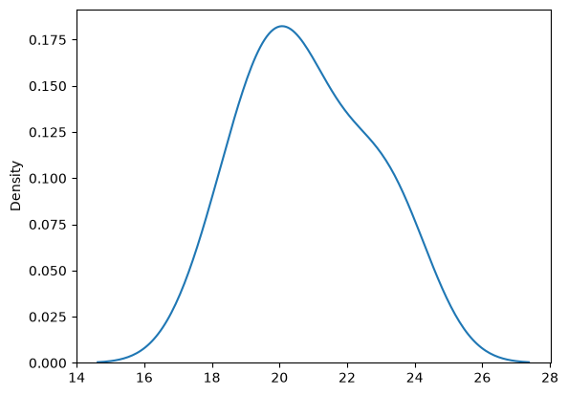

- Important Parameters of sns.kdeplot()
Parameter | Meaning | Example
data | Numerical data used to create the density plot | sns.kdeplot(ages)
bw_adjust | Controls the smoothness of the curve | bw_adjust=0.5
fill | Fills the area under the density curve | fill=True
color | Sets the curve color | color='green'
alpha | Controls transparency | alpha=0.5
linewidth | Controls thickness of the curve | linewidth=2
label | Gives a name to the curve | label='Age'
clip | Restricts the curve to a specified range | clip=(0,100)
cumulative | Creates a cumulative density curve | cumulative=True

Ex1:
import seaborn as sns
import matplotlib.pyplot as plt
marks = [
45, 50, 52, 55, 58, 60,
62, 64, 65, 68, 70, 72,
75, 78, 80, 82, 85
]

sns.kdeplot(
marks,
fill=True,
color='green',
bw_adjust=1,
linewidth=5,
alpha=0.3
)
plt.title("Density Plot of Student Marks")
plt.xlabel("Marks")
plt.ylabel("Density")
plt.show()

Output:
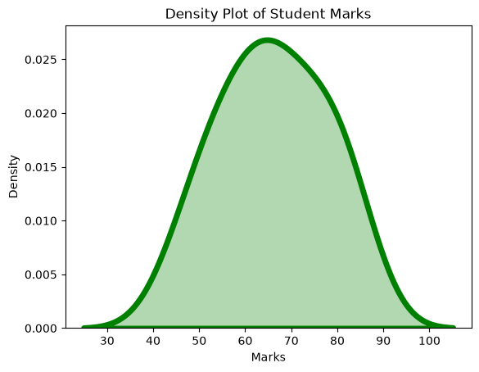

Visualizing multiple distributions with histograms and density plots is a way to compare and analyze data. We can create these plots using various data visualization libraries in Python, such as Matplotlib and Seaborn.
import matplotlib.pyplot as plt
import seaborn as sns
import numpy as np

# Generate some example data
data1 = np.random.normal(0, 1, 1000)
data2 = np.random.normal(2, 1, 1000)
data3 = np.random.normal(-2, 1, 1000)

# Create a figure with subplots
fig, axes = plt.subplots(nrows=1, ncols=2, figsize=(12, 6))

# Plot histograms on the first subplot
sns.histplot(data=data1, kde=True, ax=axes[0], label='Data 1', color='blue')
sns.histplot(data=data2, kde=True, ax=axes[0], label='Data 2', color='red')
sns.histplot(data=data3, kde=True, ax=axes[0], label='Data 3', color='green')
axes[0].set_title('Histograms with Density Plots')
axes[0].legend()

# Plot density plots on the second subplot
sns.kdeplot(data=data1, ax=axes[1], label='Data 1', color='blue')
sns.kdeplot(data=data2, ax=axes[1], label='Data 2', color='red')
sns.kdeplot(data=data3, ax=axes[1], label='Data 3', color='green')
axes[1].set_title('Density Plots')
axes[1].legend()
plt.show()

Output:
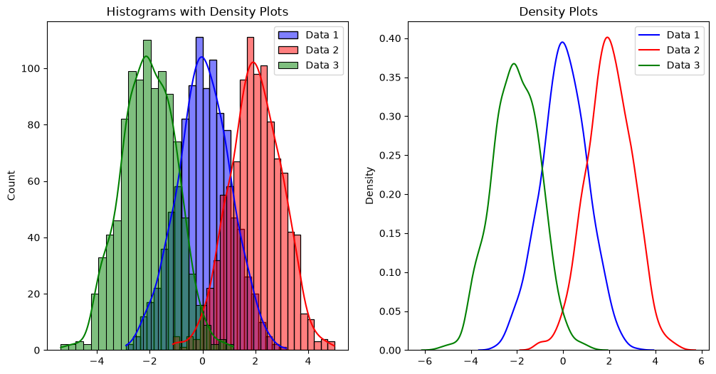
A figure created with two subplots. The first subplot shows histograms with density plots for three different datasets (Data 1, Data 2, Data 3), while the second subplot displays only the density plots.

Visualizing a single distribution is a common task in statistics and data analysis. The choice of visualization method depends on the nature of the data and what you want to convey. Here are some common ways to visualize a single distribution:
Histogram: A histogram is a common way to visualize the distribution of a continuous variable. It divides the data into intervals or "bins" and displays the frequency or density of data points within each bin. Histograms give you an idea of the data's shape and central tendency.

import matplotlib.pyplot as plt
import numpy as np
data = np.random.normal(0, 1, 1000) # Example data
plt.hist(data, bins=20, density=True, alpha=0.6, color='b')
plt.title('Histogram of a Distribution')
plt.xlabel('Value')
plt.ylabel('Frequency')
plt.show()

Kernel Density Estimation (KDE) Plot: A KDE plot provides a smooth estimate of the probability density function of the data. It can help you see the underlying distribution more clearly.
import seaborn as sns
import numpy as np
data = np.random.normal(0, 1, 1000) # Example data
sns.kdeplot(data, shade=True)
plt.title('KDE Plot of a Distribution')
plt.xlabel('Value')
plt.ylabel('Density')
plt.show()

Cumulative Distribution Function (CDF) Plot: A CDF plot shows the probability that a random variable takes on a value less than or equal to a specific value. It's useful for understanding the cumulative distribution of the data.

import numpy as np
import matplotlib.pyplot as plt
data = np.random.normal(0, 1, 1000) # Example data
plt.hist(data, bins=20, cumulative=True, density=True, alpha=0.6, color='b')
plt.title('CDF Plot of a Distribution')
plt.xlabel('Value')
plt.ylabel('Cumulative Probability')
plt.show()

