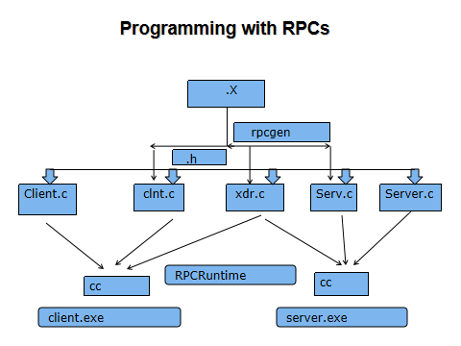

USE rpcgen on square.x
This will generate 4 files.
The client stub,server stub,the .h header file and the xdr file.
Client end :-
- Compile the client code
cc -c r_client.c
- Compile the Client stub
cc -c square_clnt.c
- Compile the XDR file
cc -c square_xdr.c
cc -o client r_client.o square_clnt.o square_xdr.c

Server end :-
- Compile the server code
cc -c r_server.c
- Compile the server stub
cc -c square_svc.c
- Compile the XDR file
cc -c square_xdr.c
cc -o server r_server.o square_svc.o square_xdr.c

./server&

Client 127.0.0.1 4

