Pune Institute of Computer Technology

Department of Computer Engineering
(2022- 2023)
“Predict survival of people in the Titanic Shipwreck using Machine Learning”

Submitted to the
Savitribai Phule Pune University
In partial fulfilment for the award of the Degree of
Bachelor of Engineering
in
Computer Engineering
By
- Medha Badamikar 41108
- Udayan Chavan 41117
- Tejas Deshpande 41122

Under the guidance of
Prof. Vaishali Kandekar

Problem Statement
Build a machine learning model that predicts the type of people who survived the Titanic shipwreck using passenger data (Age, Gender, Socio-Economic class).

Objective
To implement classification using Logistic Regression and test accuracy of the trained model.

Theory

Machine Learning:

Machine learning (ML) is a field of inquiry devoted to understanding and building methods that 'learn', that is, methods that leverage data to improve performance on some set of tasks. It is seen as a part of artificial intelligence.
Machine learning algorithms build a model based on sample data, known as training data, in order to make predictions or decisions without being explicitly programmed to do so.
Machine learning algorithms are used in a wide variety of applications, such as in medicine, email filtering, speech recognition, and computer vision, where it is difficult or unfeasible to develop conventional algorithms to perform the needed tasks.

Logistic Regression:

This type of statistical model (also known as logit model) is often used for classification and predictive analytics. Logistic regression estimates the probability of an event occurring, such as voted or didn’t vote, based on a given dataset of independent variables. Since the outcome is a probability, the dependent variable is bounded between 0 and 1. In logistic regression, a logit transformation is applied on the odds—that is, the probability of success divided by the probability of failure. This is also commonly known as the log odds, or the natural logarithm of odds.

Libraries used:

- Numpy: It is a library for the Python programming language, adding support for large, multi-dimensional arrays and matrices, along with a large collection of high-level mathematical functions to operate on these arrays.
- Pandas: It is a software library written for the Python programming language for data manipulation and analysis. In particular, it offers data structures and operations for manipulating numerical tables and time series.
- Seaborn: It is a Python data visualization library based on matplotlib. It provides a high-level interface for drawing attractive and informative statistical graphics.
- Sklearn: (Scikit-learn) is a free software machine learning library for the Python programming language. It features various classification, regression and clustering algorithms including support-vector machines, random forests, gradient boosting, k-means and DBSCAN, and is designed to interoperate with the Python numerical and scientific libraries NumPy and SciPy.

Titanic Dataset:
The dataset contains detailed information about passengers from the famous Titanic ship and the statistics of their survival. It has a total of 891 values that have been reduced to 400 for this particular application. It contains several columns such as survival, pclass, sex, age, sibsp, ticket, parch, fare, cabin and embarked that contain details about the passengers.
This detailed nature of the dataset makes it easier for analysing and drawing relations between various attributes of the passengers.

CODE:
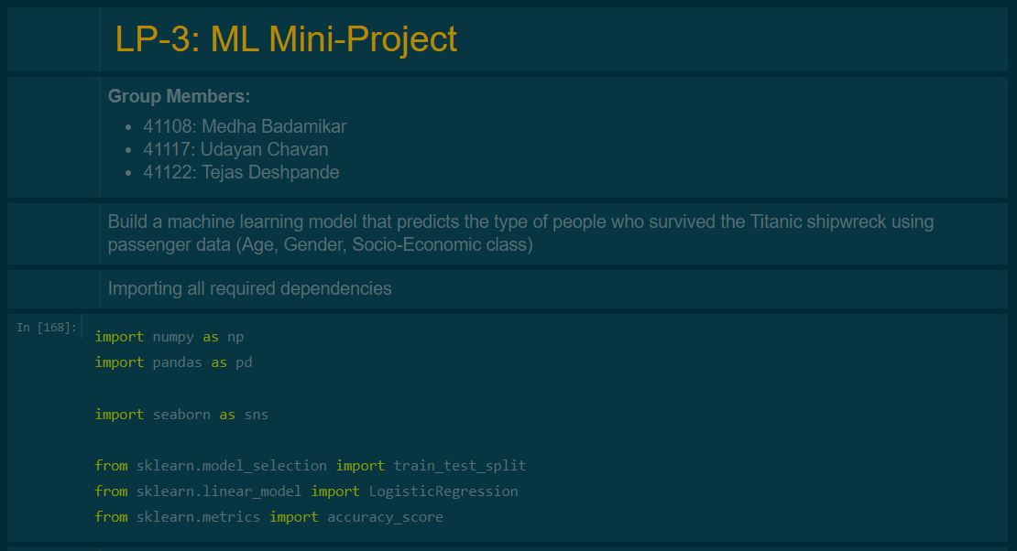

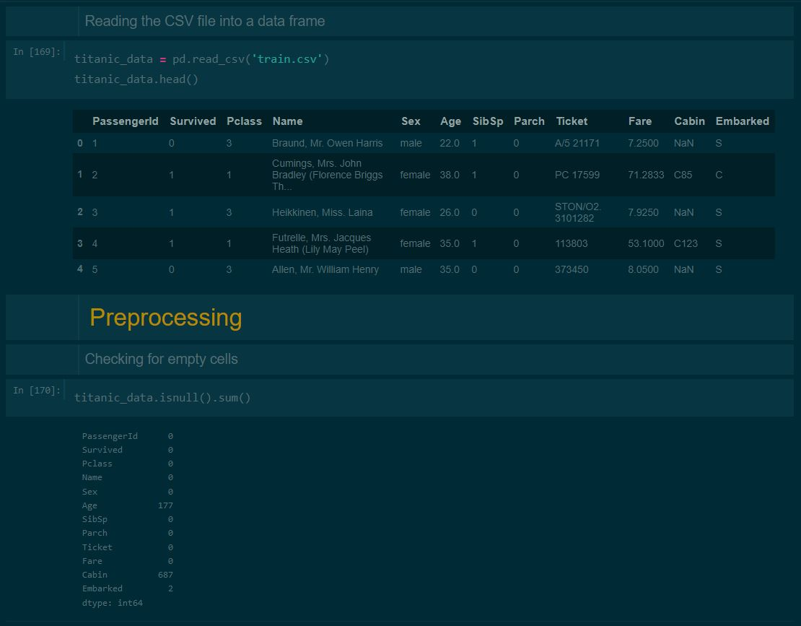
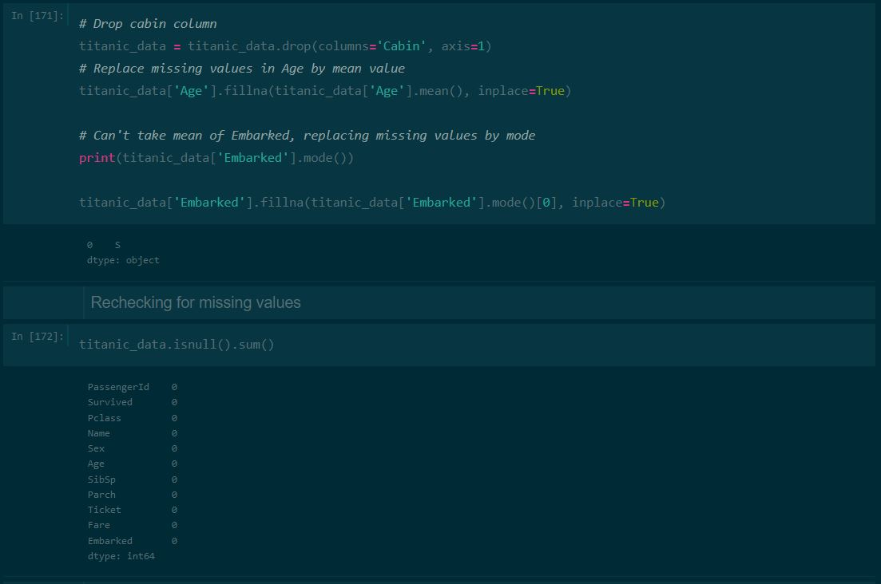
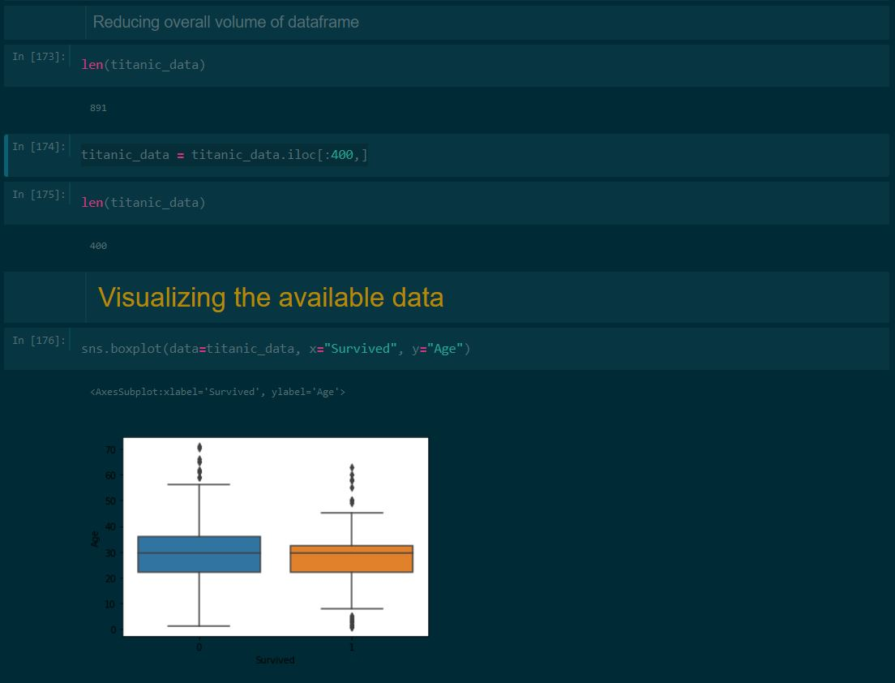
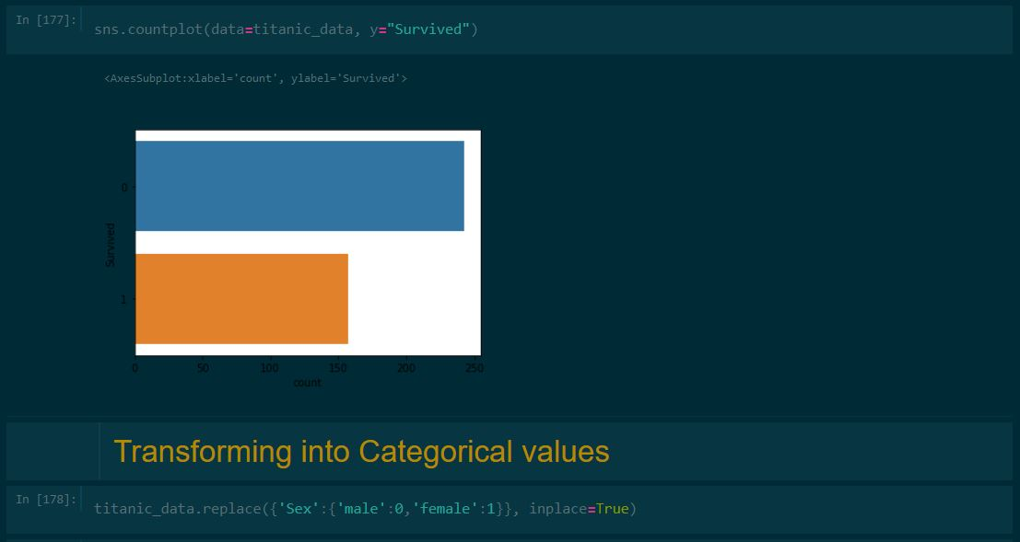
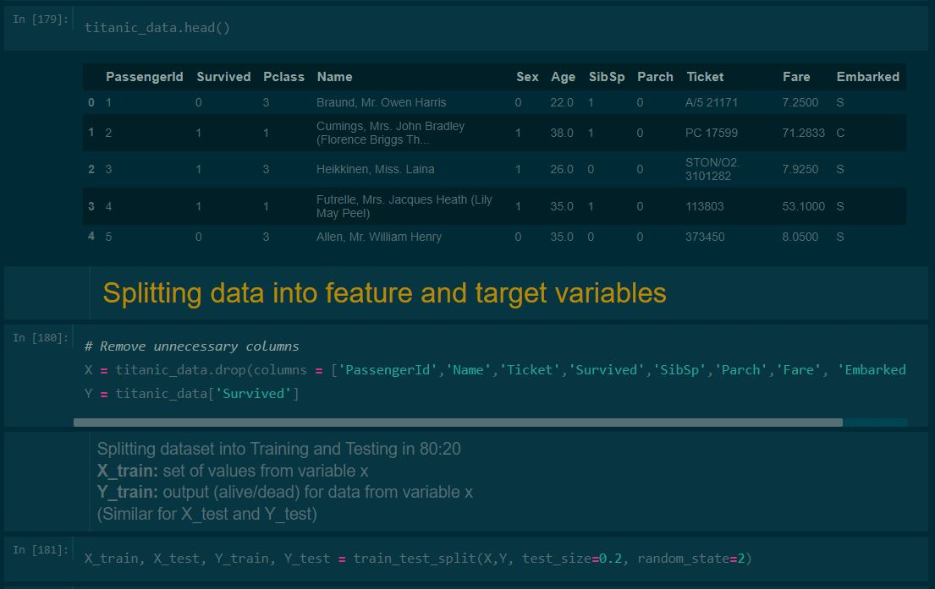

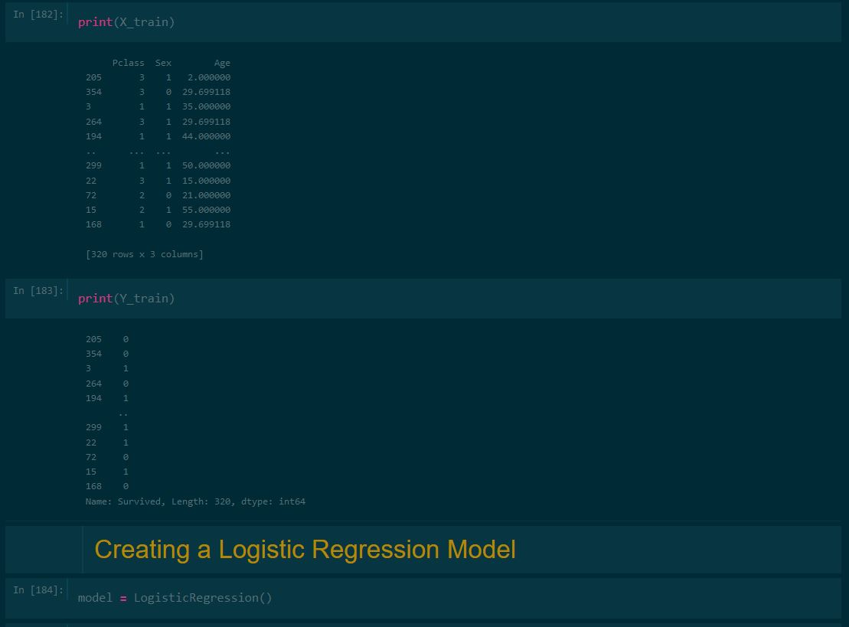
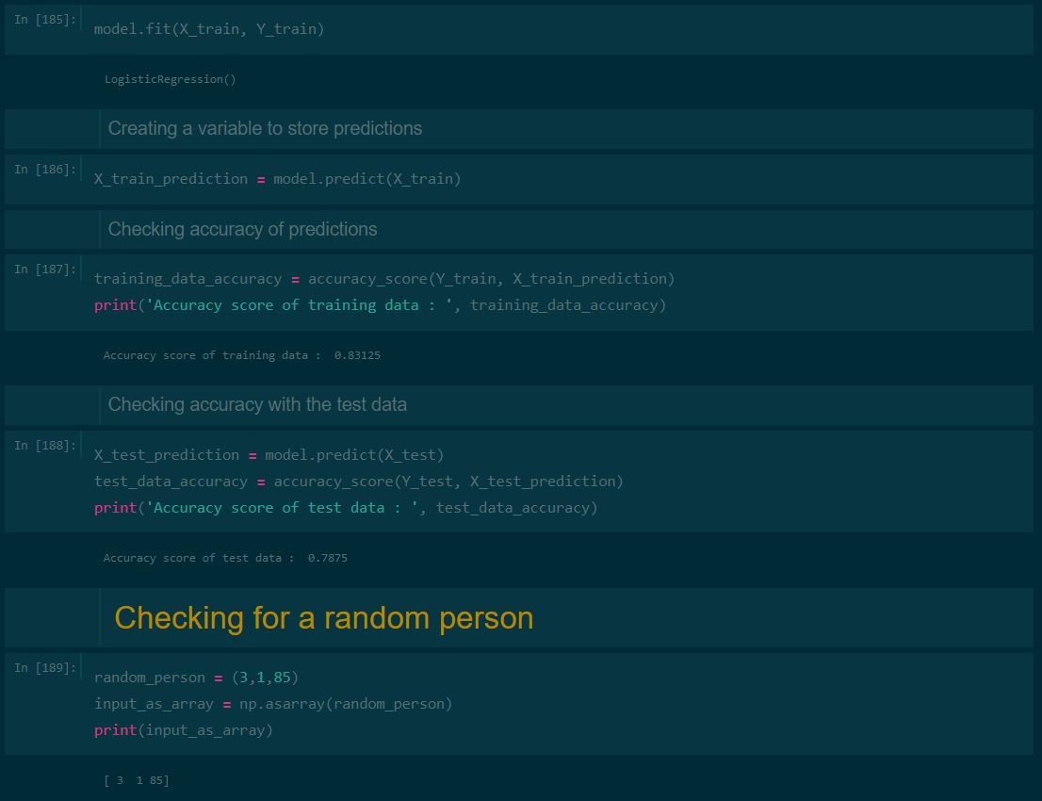
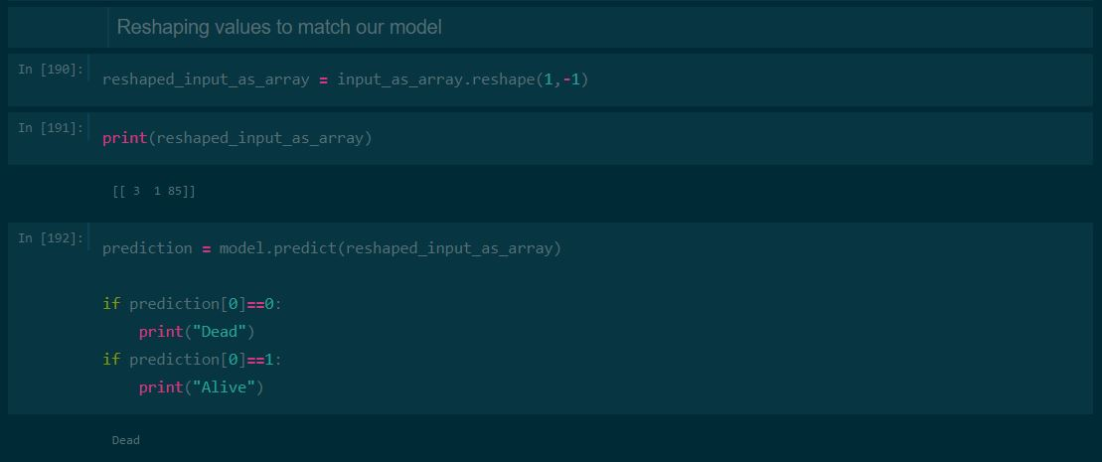

Conclusion

Hence we successfully implemented Logistic Regression on the Titanic Dataset to create a model to calculate probability of a person surviving the Titanic shipwreck and tested it for accuracy.

