1. Create a window 2019 VM with Ds1-V2 standard

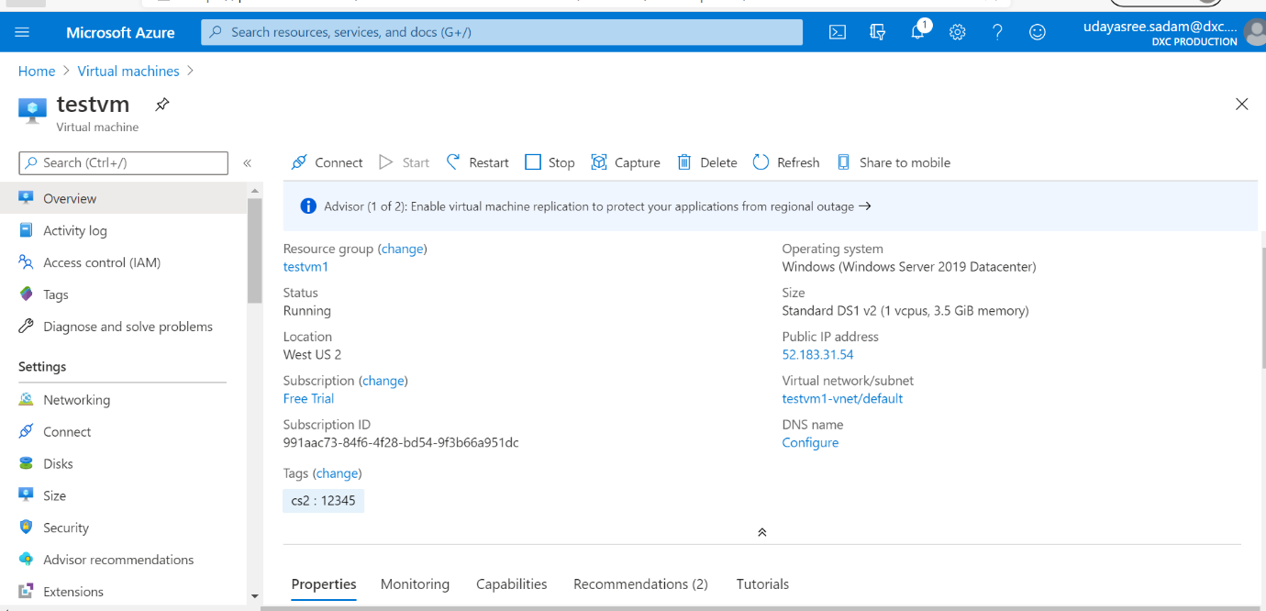

1. Attach one data disk of size 50GB and split into 3 inside the VM

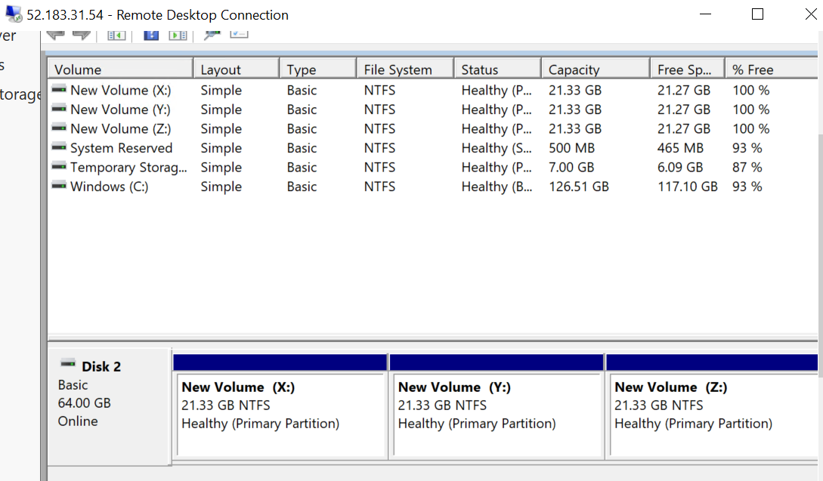

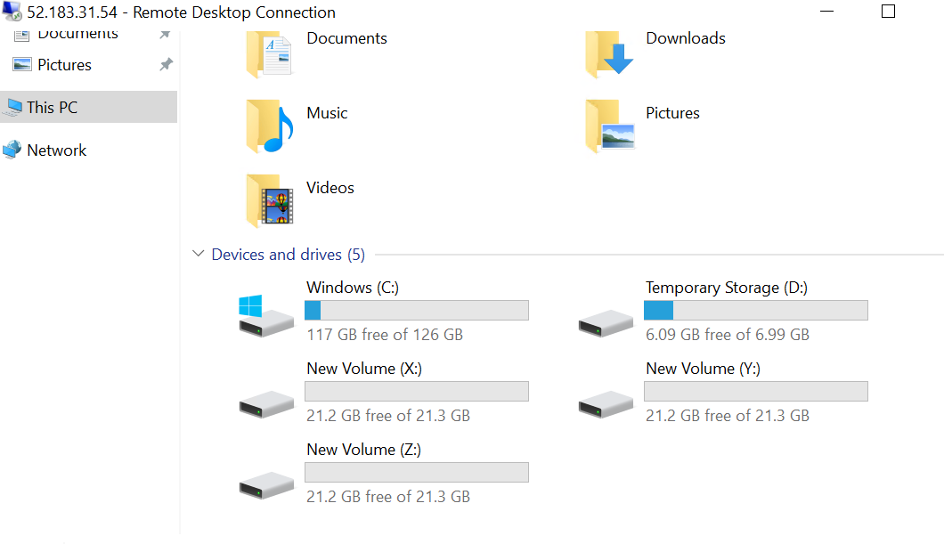

1. It should have enabled auto shutdown by 5.00 PM IST before that it has to trigger a notification to mail id

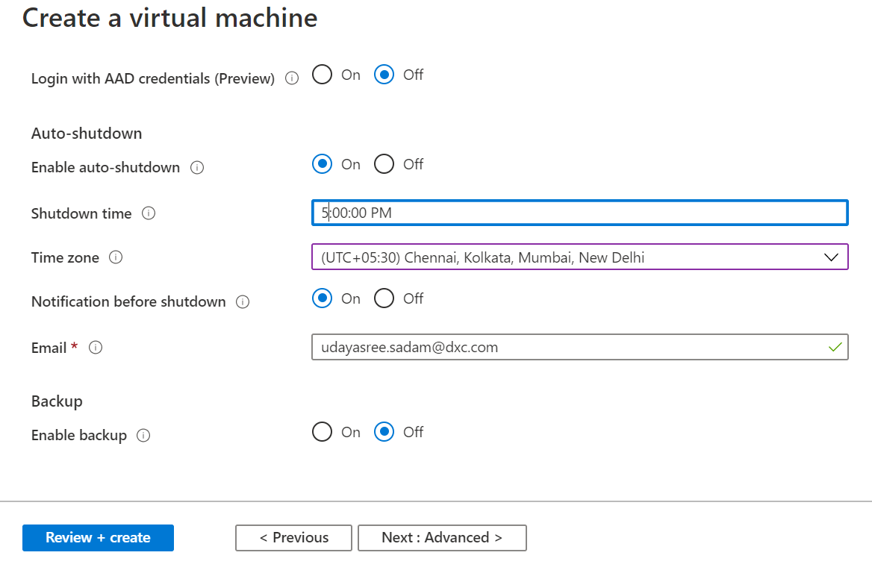

1. You should be able to login to the servers with two usernames

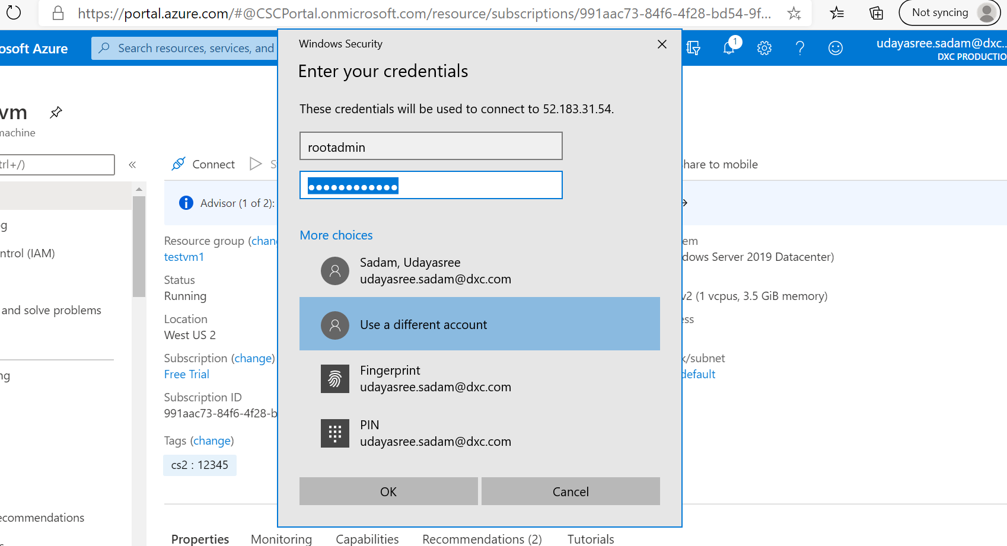

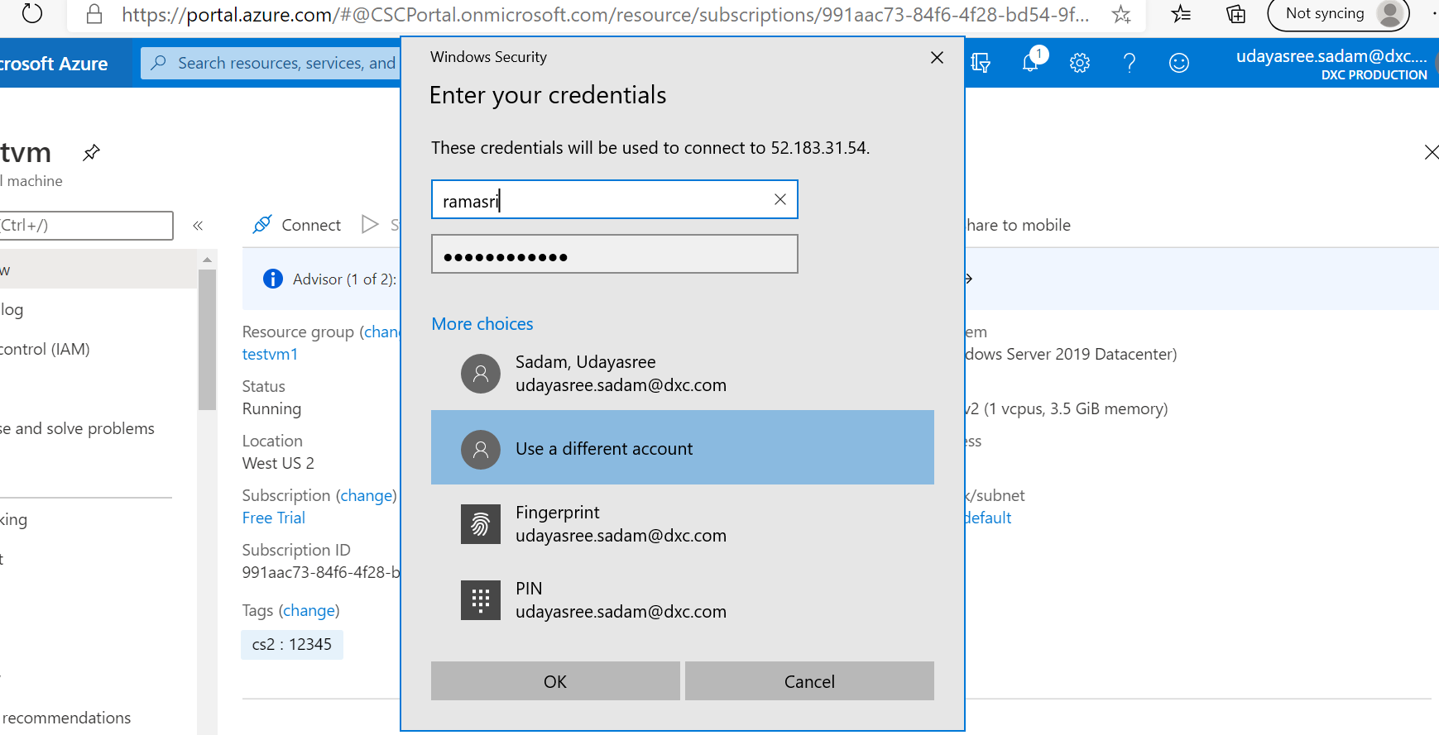

1. Install Microsoft antimalware extension in the VM

