Create a scale set with windows OS

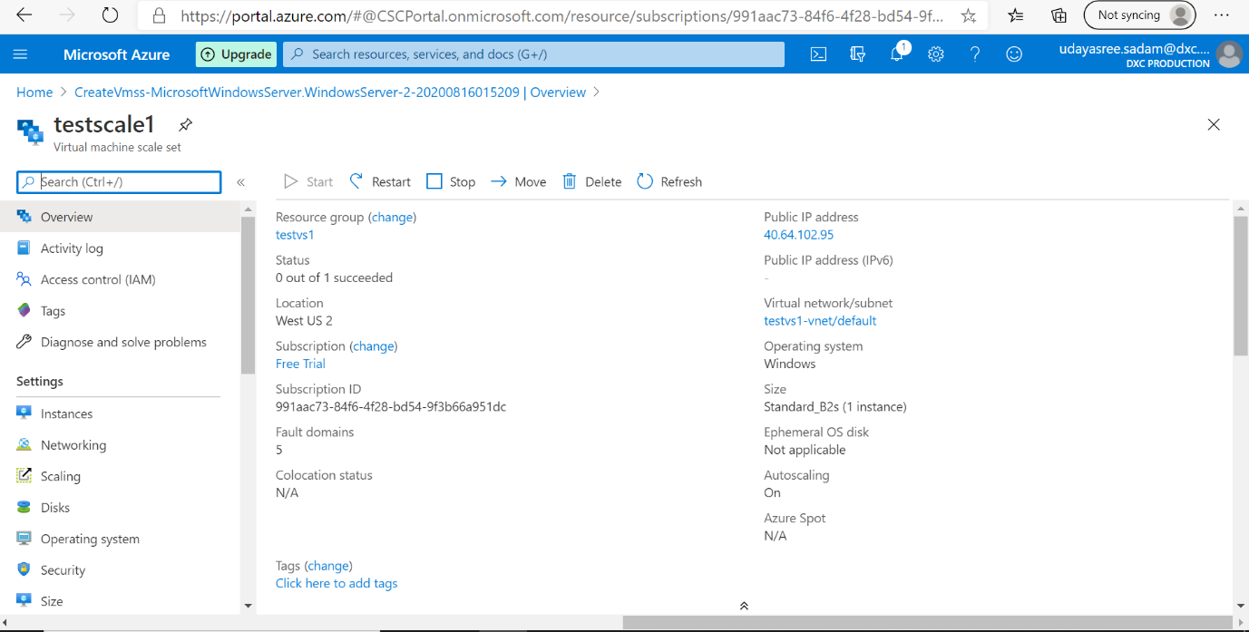

Write a scale out rule using CPU percentage of 70% threshold and a scale in rule using CPU percentage of 40% threshold

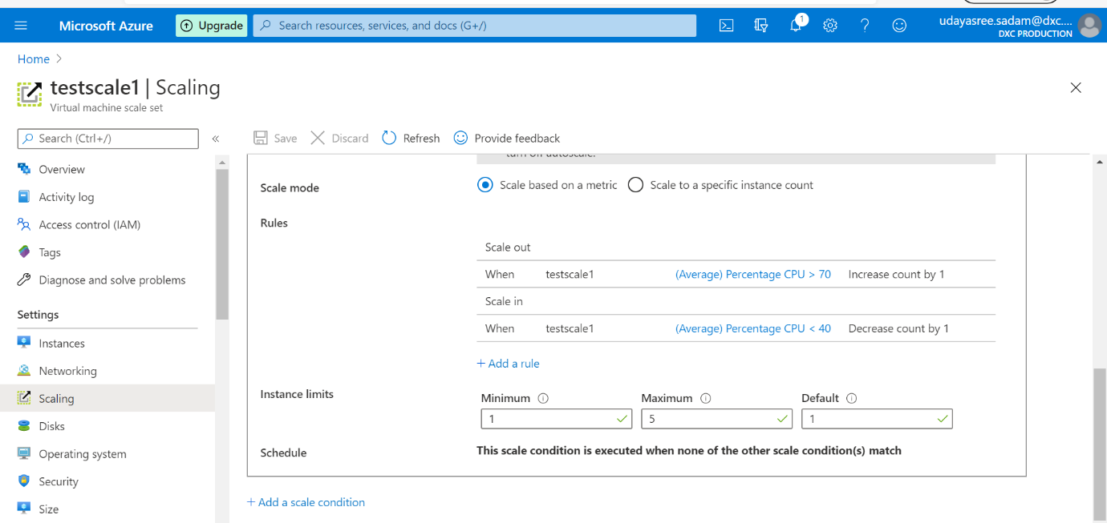

Create an storage account and containers with anonyms access, create a static website in the storage account

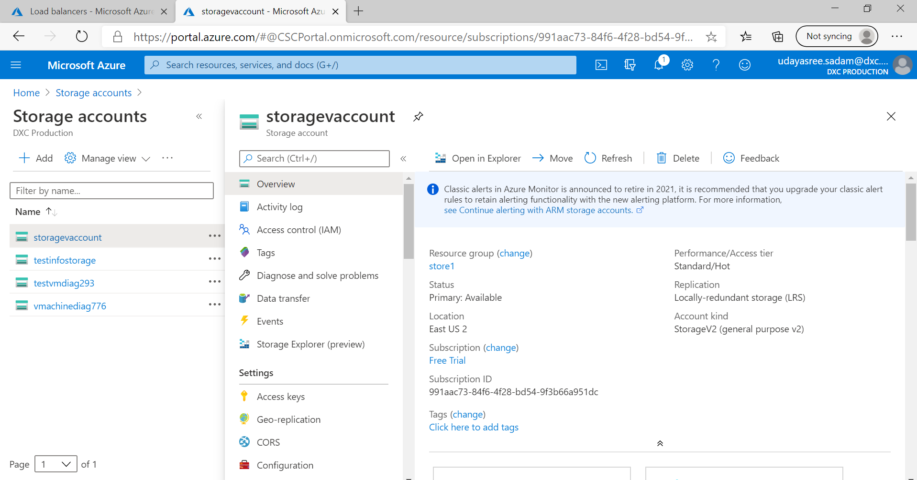

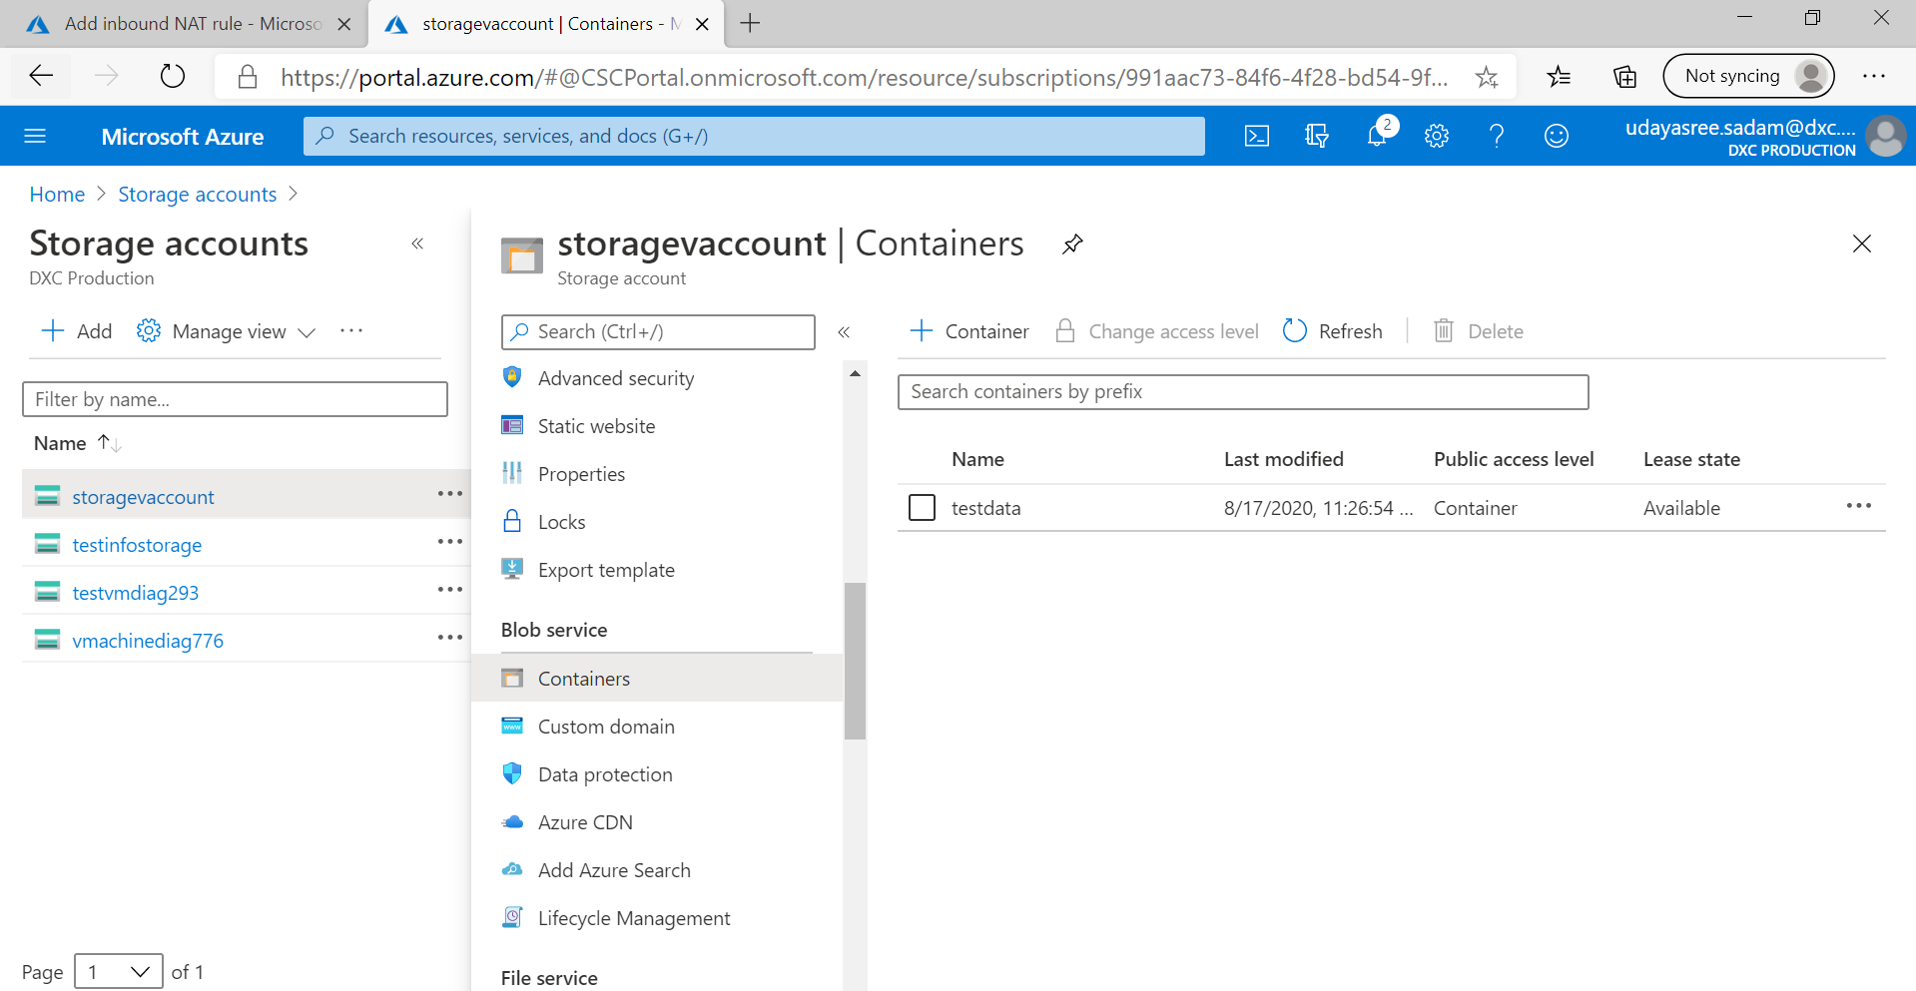

Create an two virtual machines with no public ip’s

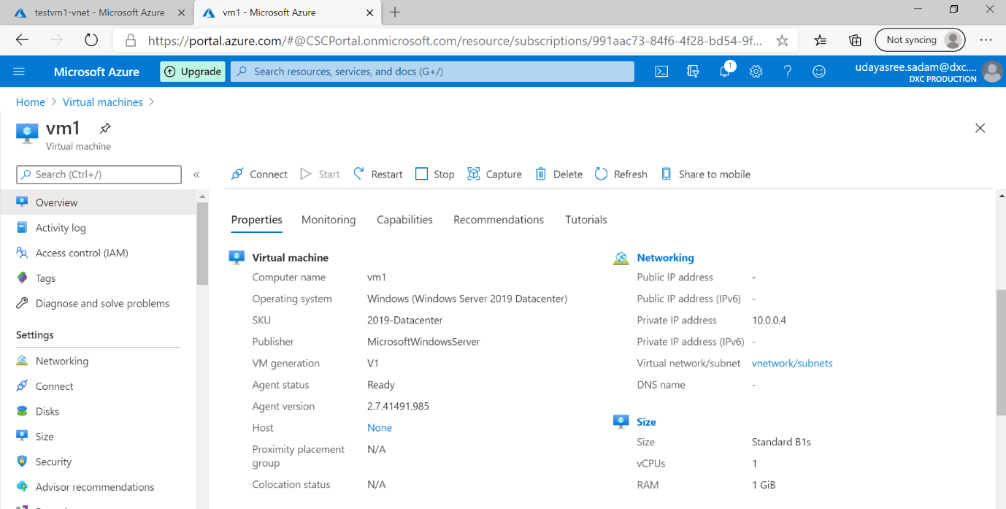

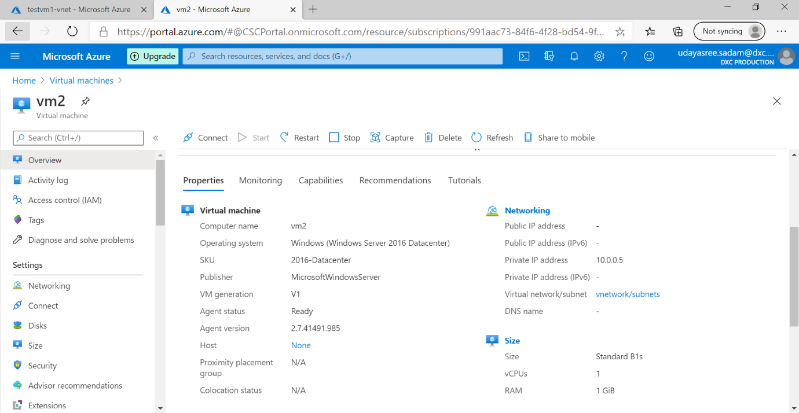

Attach the machines to the load balancer and block the 3389 port use 50010

