ASSIGNMENT – 13.1
Name :P.Akshith
ROLL: 2303A54015
Batch : 47 A
Task 1– Removing Code Duplication
🔹 Prompt Used
Identify duplicate logic in the following Python script and refactor it using reusable functions. Remove all repetition, maintain the same output, and add proper docstrings to each function following Python best practices.
print("Area of Rectangle:", 5 * 10)
print("Perimeter of Rectangle:", 2 * (5 + 10))
print("Area of Rectangle:", 7 * 12)
print("Perimeter of Rectangle:", 2 * (7 + 12))
print("Area of Rectangle:", 10 * 15)
print("Perimeter of Rectangle:", 2 * (10 + 15))
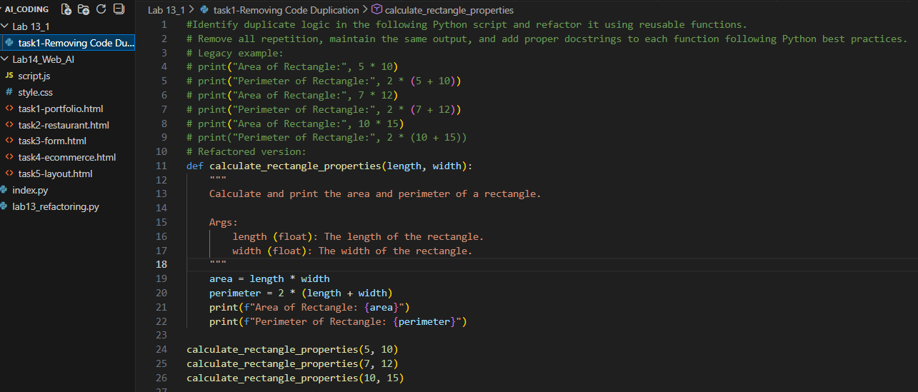
OUT PUT :
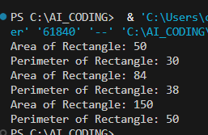
Task 2 – Optimizing Loops and Conditionals
🔹 Prompt Used
Analyze the following Python code and improve its efficiency. Replace nested loops with optimized structures such as sets. Keep the logic unchanged. Add execution time comparison using the time module and display a small performance comparison table.
names = ["Alice", "Bob", "Charlie", "David"]
search_names = ["Charlie", "Eve", "Bob"]
for s in search_names:
found = False
for n in names:
if s == n:
found = True
if found:
print(f"{s} is in the list")
else:
print(f"{s} is not in the list")
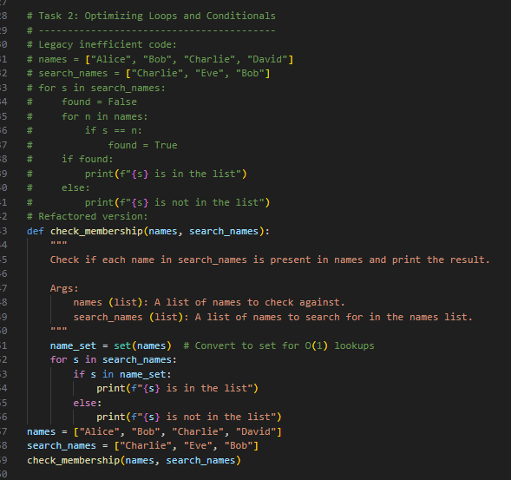
OUT PUT :
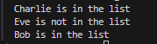

Task 3– Extracting Reusable Functions
🔹 Prompt Used
Refactor the following Python script by extracting the repeated tax calculation logic into a reusable function named calculate_total(price). Add proper docstrings, keep logic unchanged, and improve readability.
price = 250
tax = price * 0.18
total = price + tax
print("Total Price:", total)
price = 500
tax = price * 0.18
total = price + tax
print("Total Price:", total)
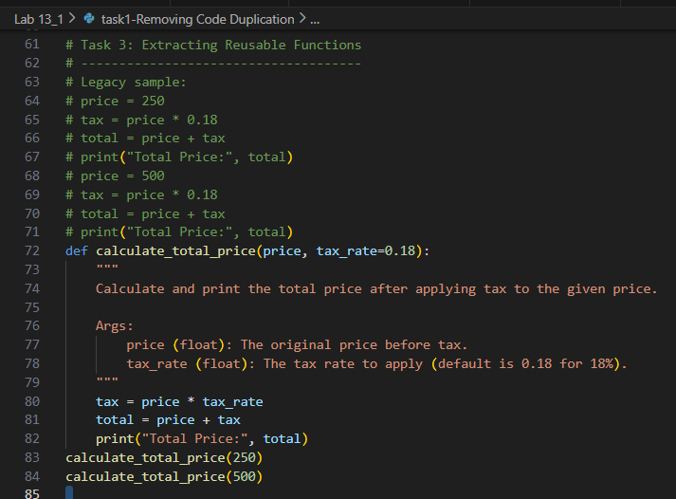
OUT PUT :
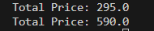

Task 4 – Replacing Hardcoded Values with Constants
🔹 Prompt Used
Improve the following Python script by replacing all hardcoded magic numbers with named constants defined at the top of the file. Follow Python constant naming conventions and keep the output unchanged.
print("Area of Circle:", 3.14159 * (7 ** 2))
print("Circumference of Circle:", 2 * 3.14159 * 7)
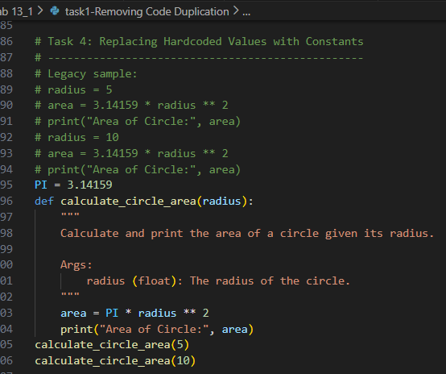
OUT PUT :
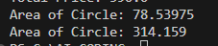

Task 5– Improving Variable Naming and Readability
🔹 Prompt Used
Refactor the following Python script to improve readability. Rename unclear variables with meaningful names, add inline comments where needed, and keep the functionality exactly the same.
a = 10
b = 20
c = a * b / 2
print(c)
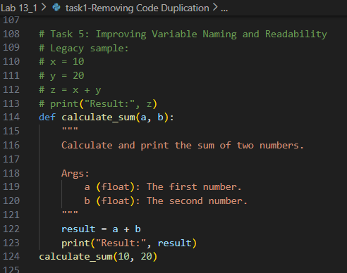
OUT PUT :

Task 6 – Removing Redundant Conditional Logic
🔹 Prompt Used
Refactor the following Python script by extracting the repeated grading logic into a reusable function named calculate_grade(marks). Add a clear docstring and keep the grading logic unchanged.
marks = 85
if marks >= 90:
print("Grade A")
elif marks >= 75:
print("Grade B")
else:
print("Grade C")
marks = 72
if marks >= 90:
print("Grade A")
elif marks >= 75:
print("Grade B")
else:
print("Grade C")
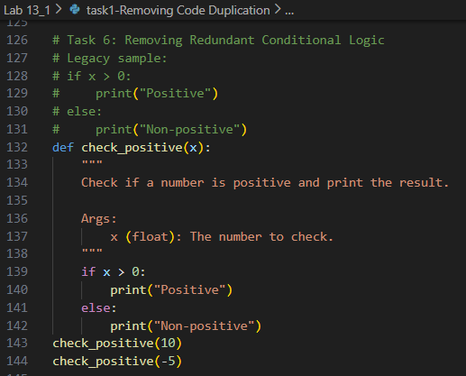
OUT PUT :
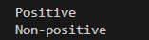

Task 7 – Converting Procedural Code to Functions
🔹 Prompt Used
Refactor the following procedural Python code into modular functions. Separate input, processing, and output into three functions named get_input(), calculate_square(num), and display_result(result). Add docstrings and keep behavior unchanged.
num = int(input("Enter number: "))
square = num * num
print("Square:", square)
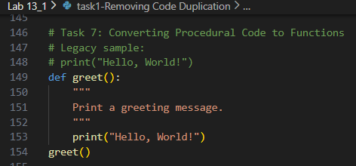
OUT PUT :

Task 8 – Optimizing List Processing
🔹 Prompt Used
Refactor the following Python code by replacing the manual loop with a list comprehension. Improve readability while keeping the output identical.
nums = [1, 2, 3, 4, 5]
squares = []
for n in nums:
squares.append(n * n)
print(squares)
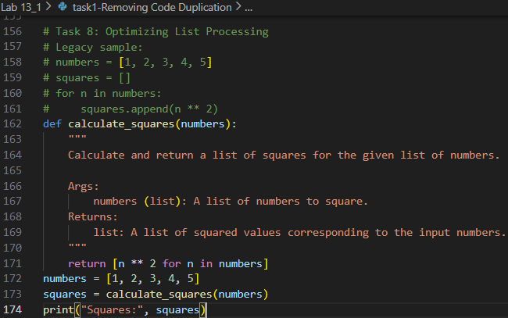
OUT PUT :

