Generate synthetic satellite images using GANs

Ultimate goals :

• Build a base model from an off-the-shelf implementation

• Train it with the chosen dataset, finding a good set of parameters

• Discuss possible model predictions

• Extract conclusions about the different improvements attempted.

The Datasets :

The data has been taken from the **SAS planet satellite** image dataset. We are working on the satellite images and maps of Mumbai city and its outside area. We have created a dataset by merging satellite images and their corresponding map images. The whole training set consists of a training set (863 images ) and a test set (174 images ).

All the images and maps have a resolution of 7424*7424 pixels.

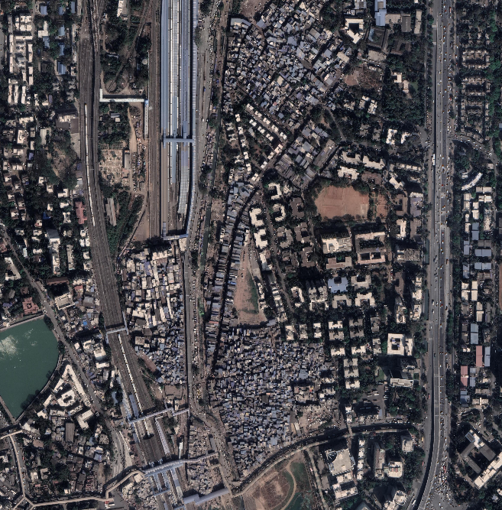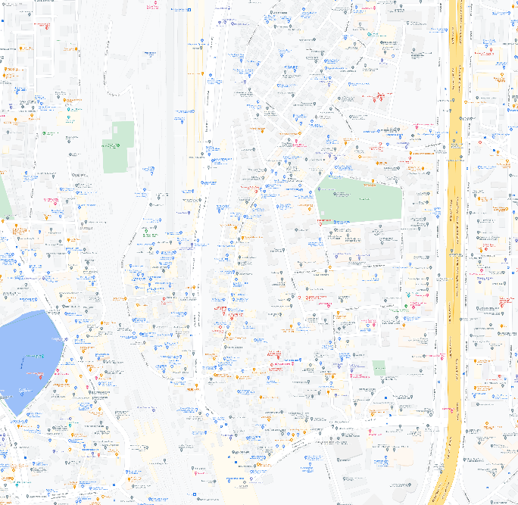

Related Work :

First steps :

Our first steps with the chosen implementation were to understand it, compare it with the original pix2pix implementation and prepare a [Jupyter notebook](https://github.com/diegotascon/ldd-pix2pix/blob/main/colab_notebooks/01_TrainOriginalImages.ipynb) to test the code.

Required Library :

1. Tensorflow
2. Os
3. Time
4. Datetime
5. Matplotlib
6. Ipython

## Accessing the dataset :

## First we read the all data file with help of tensorflow and decode it into jpeg file and we visualize one of the image from the data. we get 256*512 size images

## The images are then resized to 286x286, transformed into a tensor

## Their values get normalized,

## A random 256x256 crop is performed and in half of the times they're flipped .

Features Steps :

1. Now built a input pipeline with tf.data
2. **Build the generator :**

Define the generator loss

1. **Build the discriminat:**

Define the discriminator loss

1. Define the optimizers and a checkpoint-saver
2. Generate images
3. Training
4. Restore the latest checkpoint and test the network
5. Generate some images using the test set.

Role of Each Team Member :

1. Udaybhan Rathore 19328 :

**Role** : Find and load the dataset & build an input pipeline for training and test dataset.

1. Manoj kumar 19188 :

**Role** : Build the generator and discriminator and find the loss of the generator and discriminator

1. Tanuj singh shekhawat 19323 :

**Role** : Build the model & train it . Generate predicted images.