Figma
Figma is a collaborative design platform for teams creating products collectively. Originating on the Web, Figma enables teams to create, share, test, and deliver improved designs from beginning to end. Whether it involves integrating tools, streamlining workflows, or working together across teams and time zones, Figma accelerates this design process, enhancing efficiency and enjoyment while ensuring everyone stays aligned.

- Usability
A Interface Design:Figma has a simple, modern and easily comprehensible interface. It is designed to make the tools and panels accessible. This aspect is both user- and developer-friendly.
B. Onboarding and Tutorials:Figma has a number of time-proven onboarding tutorials, a variety of interactive guides, and a help center that is especially directed in dealing with the new users' issues. In addition to video tutorials, newcomers can also rely on community-contributed contents.
C. Comprehensive Feature Set:
Wireframing and Prototyping:Figma tool is an efficient and all-encompassing design framework product that allows you to create both high- and low-fidelity wireframes. This flexibility not only gives you the ability to experiment with your design but also allows you to convert interactive prototypes that can emulate the user flows and transitions thus, let you have a realistic idea about the usability of the product.
Design Tools:Figma is an online user interface and vector-based design tool. It stands out as one of the most reliable vector-editors with its unique vector networks. Designers can quickly create their own shapes and UI elements due to robust vector editing tools. Having a component library and design systems that can be imported make the design procedure smooth and linear.Layer styles and color styles can be applied when editing a component that helps designers have a consistent style.To save time, you can create a library of reusable components such as buttons and forms. With design systems, you can have versions of your works and can access them across different devices and platforms. So the designers have the liberty of focusing on one place and feel secure of the same consistency across applications.
System Integration for Design: With Figma, it becomes really easy to design, share, and keep design systems updated so that teams can keep a consistent design language across their projects.
- Learning Curve:
Being simple to understand and use Figma, an app with quite a friendly interface, shapes initial learning to the point where non-tech intermediates can grasp basic functionalities in a few hours. On the contrary, following a certain group of additional tutorials and the community the new user will be able to familiarize with creating complex component systems or utilizing auto-layout not also the video tutorials and other resources will be needed for the all-encompassing learning process.

- Features and Capabilities:
Responsive layout: Multiple frames and art boards come unbuilt so that they may be fitted to different device sizes; this allows the design adjusts to maintain its consistency across a variety of form factors.
Real Time Collaboration: The hallmark of Figma is that it allows for real-time collaboration where multiple team members are able to work on a given project concurrently. This type of live collaboration allows immediate feedback and therefore quick iterations.
Cloud Storage and Version Control:The Figma files live completely in the cloud, which guarantees version history as well as simple recovery. It allows tracking all changes made along with restoring the necessary previous versions.
Vector editing tool:Figma includes a vector editing tool that allows users to create and edit vector shapes using features like the Pen tool and vector networks. This tool enables detailed customization of shapes and paths for design projects.

- Collaboration Efficiency:
i. Real-time Collaboration:
Figma is built so that everything is collaborative from the ground up. So, basically, multiple designers can edit, comment, and review designs simultaneously to ensure feedback gets integrated on-the-go, cutting down the project timeframe.
ii. Version Control:
It offers a complete version history, allowing the team to inspect changes, compare iterations, and rewind to the previous versions if need be, which definitely helps with iterative processes in design.
iii. Integrations:
In addition, a rich variety of plugins and integrations (project management, communication, developer handoff, etc.) enhance the collaboration side of Figma and provide a flexible tool for different team workflows.
- Costing:
Figma provides flexible pricing suitable for individuals and large teams:
Starter Plan: Free version will be given to individuals for very basic design and collaboration features that are great for personal use or tiny projects.
Professional Plan: Approximately $12 per editor per month, per year (for billing), suitable for professional design work and collaborative projects.
Organization Plan: Designed for larger teams and enterprises. Around $45 per editor per month offers greater administrative, security features, and support.
Pricing goes in steps that make Figma accessible to freelancers, startups, and large organizations alike. Quite often, educational institutions and nonprofits can get better discounts or even free access, promoting cost-effective design solutions.

- Platform Compatibility
i. Desktop: It opens on any modern browser, be it Windows or macOS, and it also contains desktop applications that make them native-like.
ii. Mobile: The Figma Mirror application for iOS and Android allows designers to see real-time previews on mobile.
iii. Web: In practice, though, since Figma is really a web application, designs and prototypes can be viewed and shared through modern web browsers across the operating systems. Some features work best in newer browser versions, though.
- Community and Support:
The Figma Community portal has a large and expanding base of designers and developers that offer contributions in the form of tutorials, plugins, templates, and even best practices. Online documentation in the form of guides, step-by-step articles, videos, and FAQs is also available to help users sort out their problems and improve their skills.
Users can open support tickets and receive direct assistance from Figma’s customer representatives, but response times depend on the issue’s complexity and the user's subscription plan. Fortunately, community activity means that a lot of standard queries get rapid solutions in forums and social media.
- Offline Availability
Figma works mainly as a cloud-based tool, but its desktop version lets you do some things offline. You can keep working on your files when you're not connected to the internet. Once you're back online, any changes you made will update . This means designers can stay productive even when their internet goes down for a bit.

Below is a small online shopping made as an example using Figma
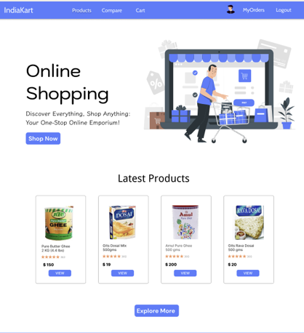
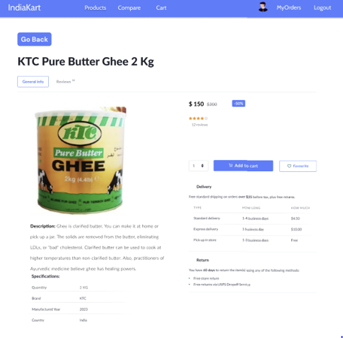

References:
https://research.contrary.com/company/figma
https://www.figma.com/resource-library/design-research/
https://www.newtonx.com/case-study/figma-designer-report/

