ASSIGNMENT - 1

1. What is SDLC?

> SDLC is stand for software devlopment life cycle.there are 6 phases available in SDLC:

1) requirement gathering 2) analysis 3) design 4) implementation 5) testing 6) maintenance.

2. What is software testing?

> software testing is process used to identify correctness,completeness and quality of devloped computer sodtware.

3. What is agile methodology?

> agile model is combination of iterative and incremental process models.agile model is suitable for fixed and changing requirements.

4. What is SRS?

> SRS is stand for software requirements specification.

5.What is oops?

> object oriented programming is a concepts of object , class , abstaction , encapsulation , inheritance and polymorphism.

6. Write basic concepts of oops

> 1) object

2) class

3) abstaction

4) encapsulation

5) inheritance

6) polymorphism

7. What is object?

> object is any entity which has own state and behaviour is called object.

8. What is class?

> class is a collection of objects.

9. What is encapsulation?

> encapsulation is wrapping of data or binding a data.

10. What is inheritance?

> when one objects acquire all the properties and behaviour of parent class is called inheritance.

11. What is polymorphism?

> polymorphism is allows different objects to respond to the same message in different ways.

12. Draw usecase on online book shopping

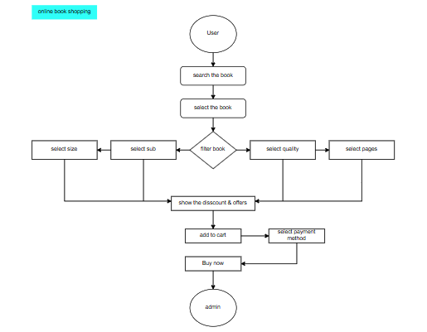

13. Draw usecase on online bill payment system

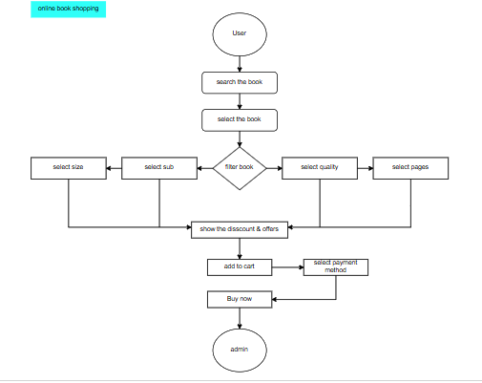

14. Write SDLC phases with basic introduction

> Requirement gathring -customer needs

Analysis -model data anlysis

Design -model specification and designed

Implementation -data implement and model solution

Testing -software testing and solution

Maintenance -defect repair and requirement solution

15. Explain phases of the waterfall model

> Waterfall model phases is classical software model on various software development.

16. Write phases of spiral model

> spiral model phases is planning,risk and analysis,engineering and etc.

17. Write agile manifesto principls

> - Customer satisfaction and delivery

- Avoid of requirement features

- Working software deliver

- Collobration the business developers

- Successful comunication

18. Explain working methodology of agile model and also

write pros and cons.

> - High ability project frequently

- Development process is high

- Project result is batter

- project quality and detail is batter provide

19. Draw usecase on online shopping product using COD.

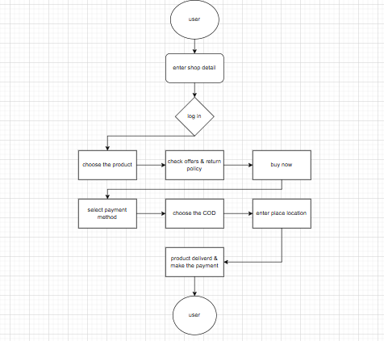

20. Draw usecase on online shopping product using payment gateway.

