**Cake Company Portal**

This document contains high level overview of the Cake Portal.

**Software Specs**

**Software:** MVC Framework, C#, Entity Framework, SQL Server Object

**Design Patterns:** Repository, Unit of Work

**Design Principle:** SOLID

**Unit Test cases:** Microsoft Unit Test cases with TypeMock Framework

**DB transactions:** In this development, the data set is pushed and retrieved to/from DB using entity framework.

**ER Diagram**

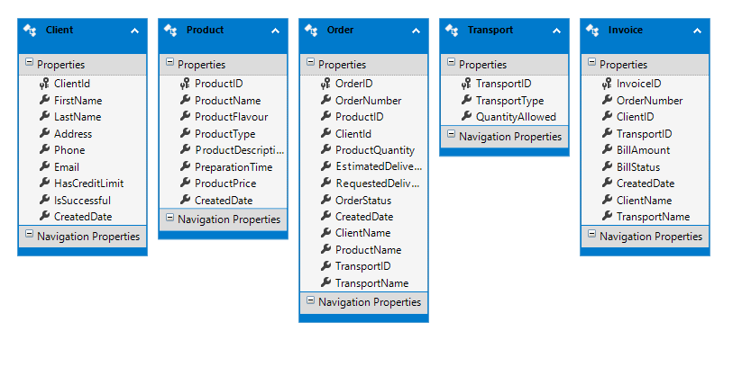

**Class Diagram** 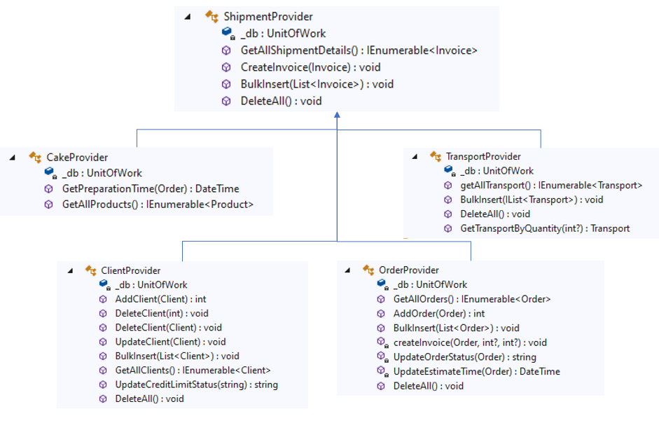

**User Interface**

**Menus & Reports**



Cake Company Portal has the following menus/links

Invoice

Orders

Products

Transport

Customers

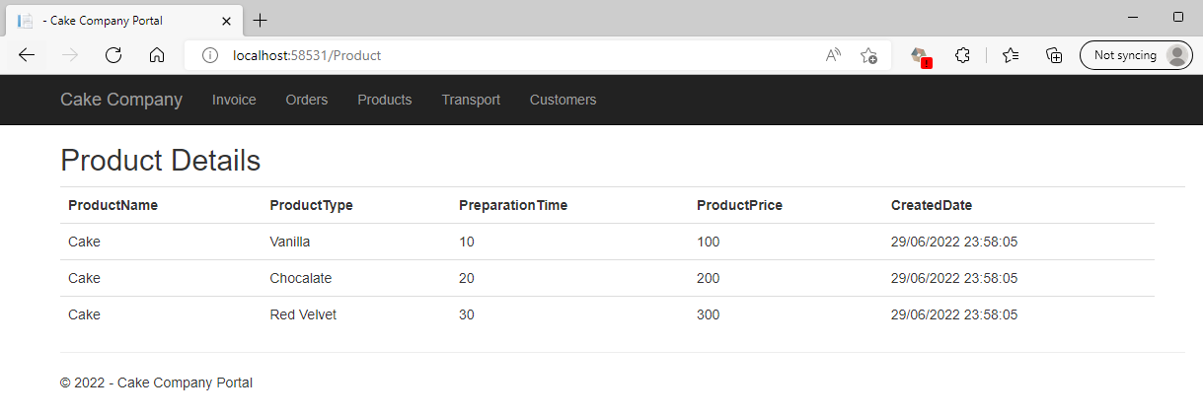

The Product details displays all the available products in the portal, the preparation time for each product and its respective price.

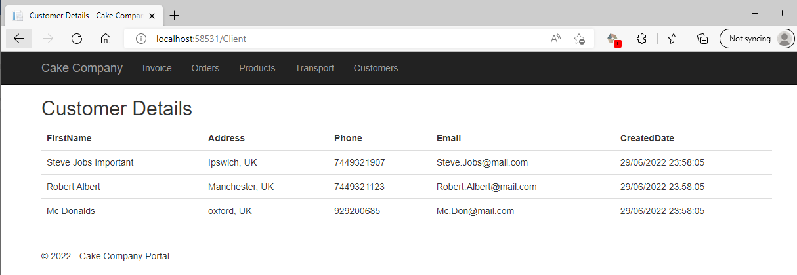

The Customer details displays all the current customers and their contact information in the portal.

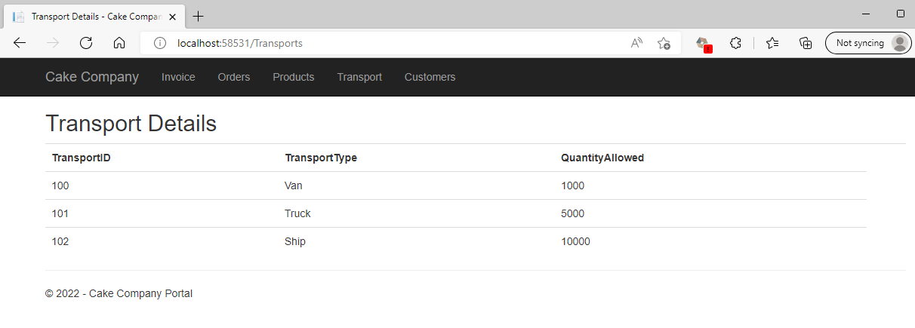

The Transport details displays all the current available transport and their ability to transport quantity in the portal.

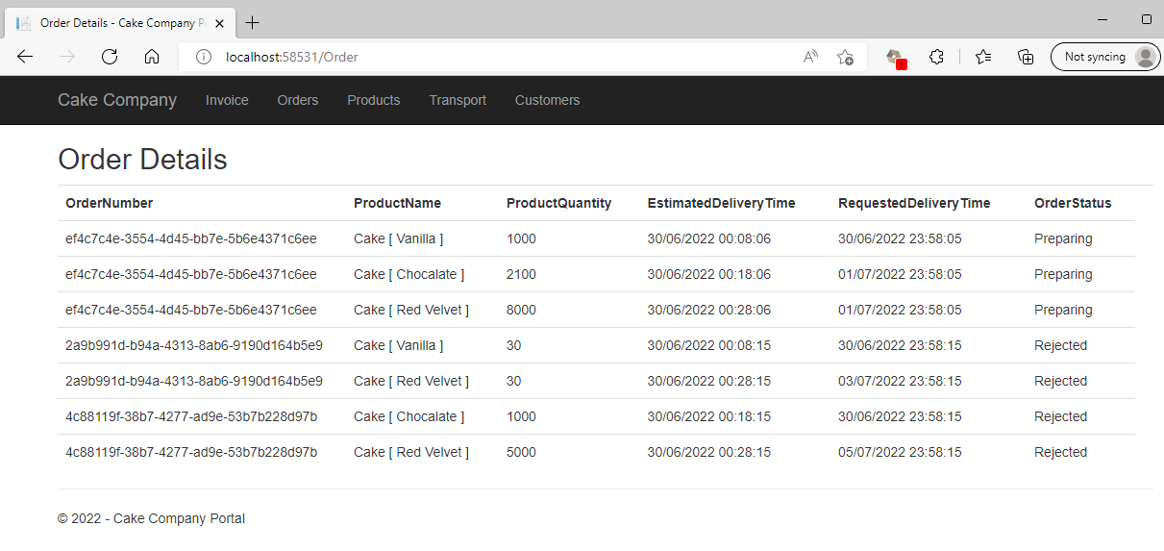

The Order details displays all the orders and their status in the portal.

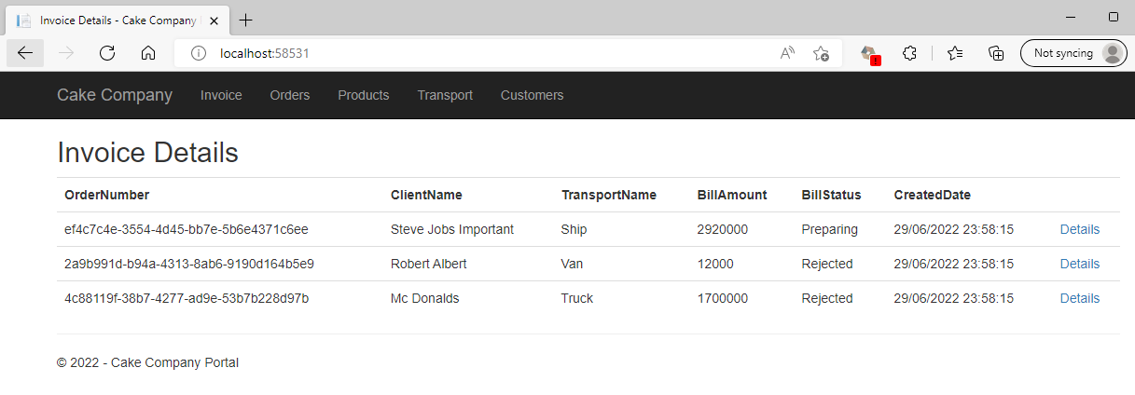

The Invoice details displays all the orders and their billing status in the portal. It has link for the order line (screen shot below) details further routed to the order details of the specific order.

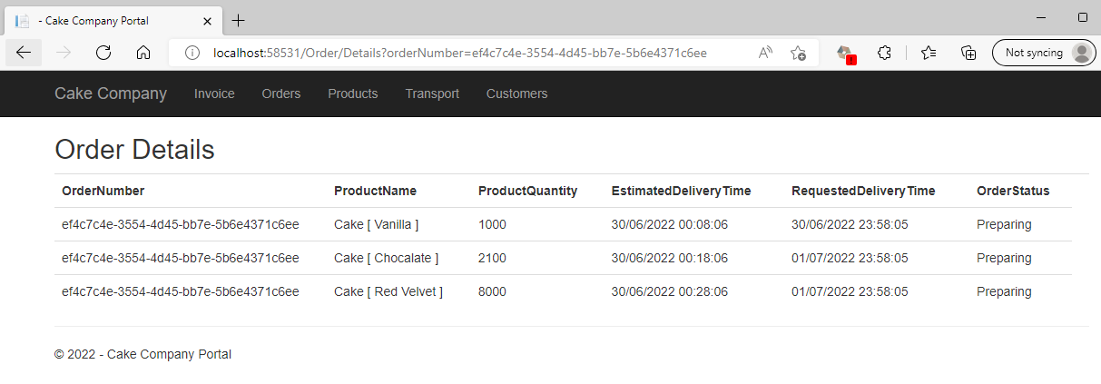

**Unit Testing Code Coverage**

ShipmentProvider.cs

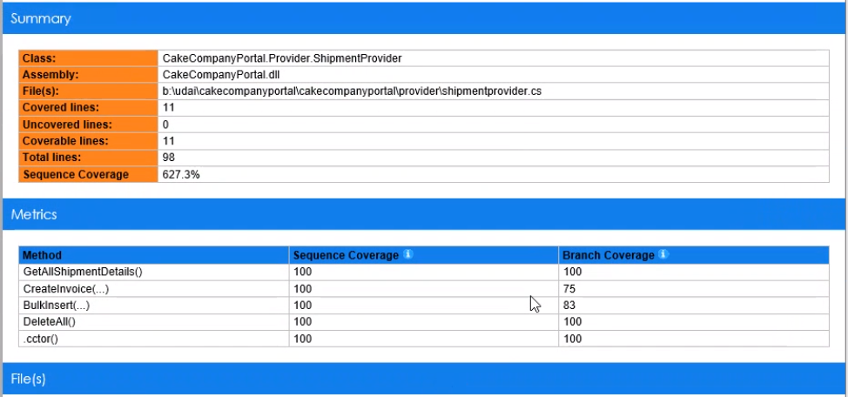

CakeProvider.cs

