# Java Program: questions and answers

**1. How to convert Integer to String in Java?**

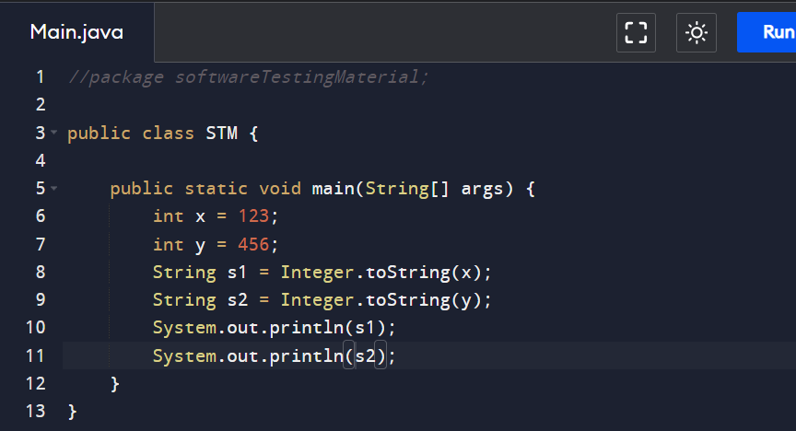

**2. How to convert String to Integer in Java?**

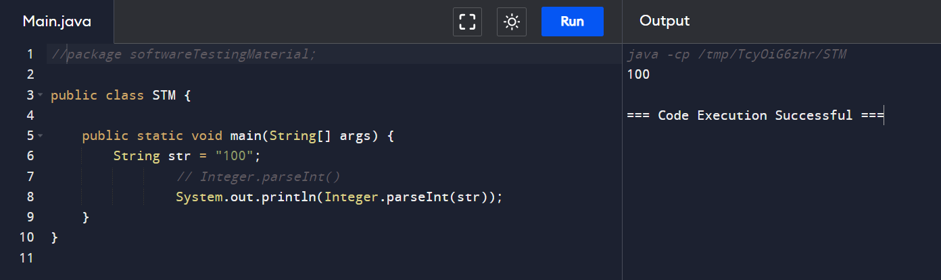

**3. How to convert Char to Integer in Java?**

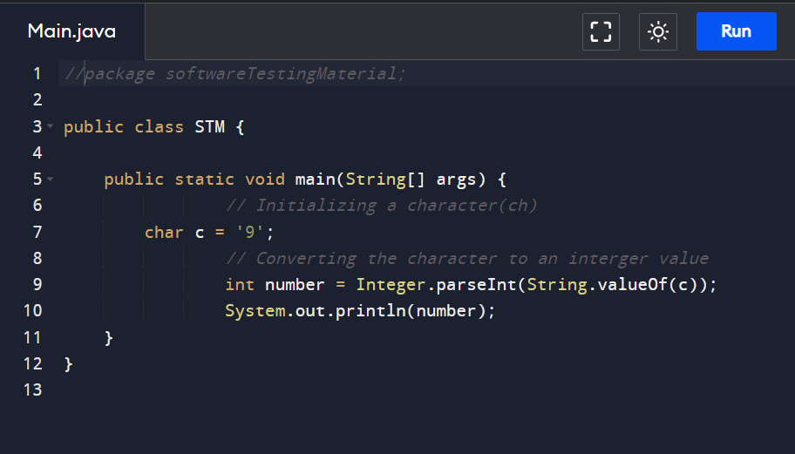

**4. Write a program to print the pattern given below**

1

1 2

1 2 3

1 2 3 4

1 2 3 4 5

Here is the program to print the pattern mentioned above

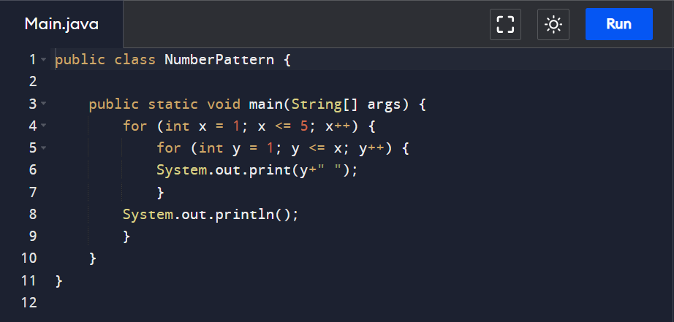

**5. Write a program to print the pattern given below (Left Triangle Star Pattern)**

*

* *

* * *

* * * *

* * * * *

Here is the program to print the pattern mentioned above

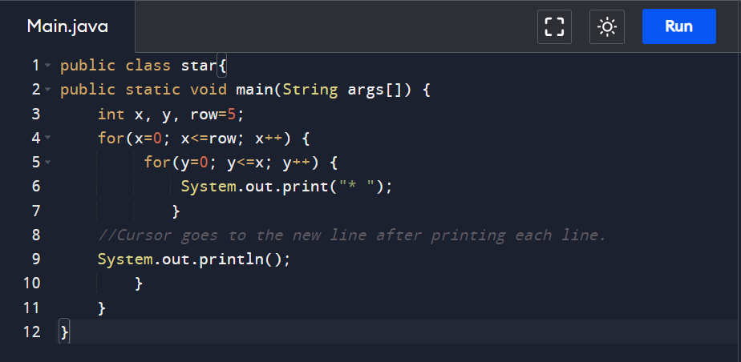

**6. Write a program to print the pattern given below (Right Triangle Star Pattern)**

*

* *

* * *

* * * *

* * * * *

Here is the program to print the pattern mentioned above

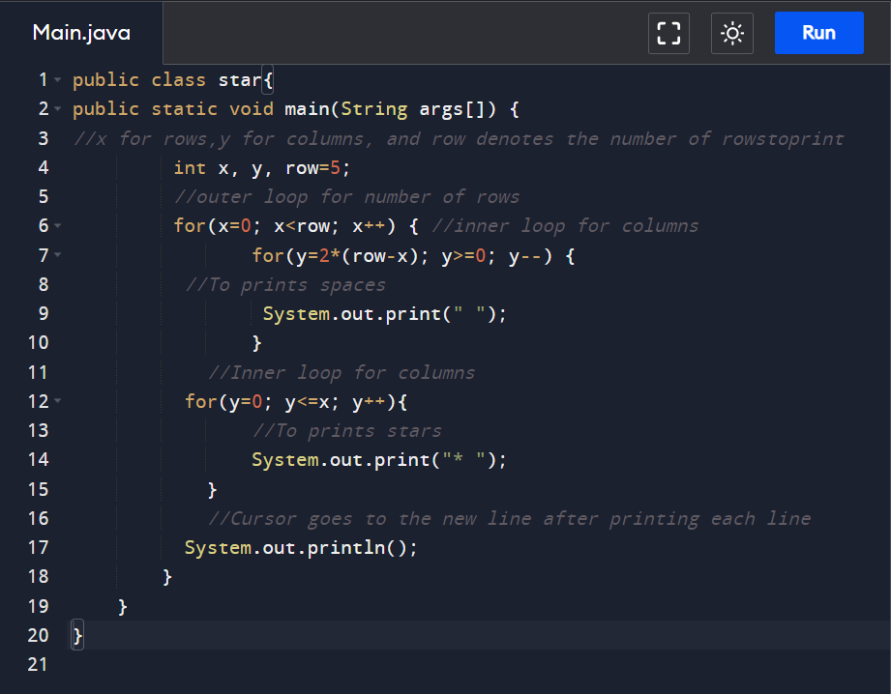

**7. Write a program to print the pattern given below (Pyramid Star Pattern)**

*

* *

* * *

* * * *

* * * * *

Here is the program to print the pattern mentioned above

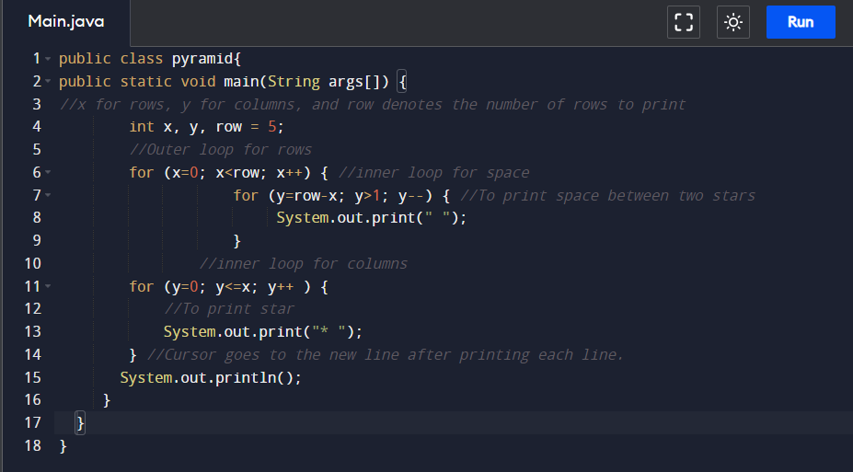

**8. How to reverse a String in Java?**

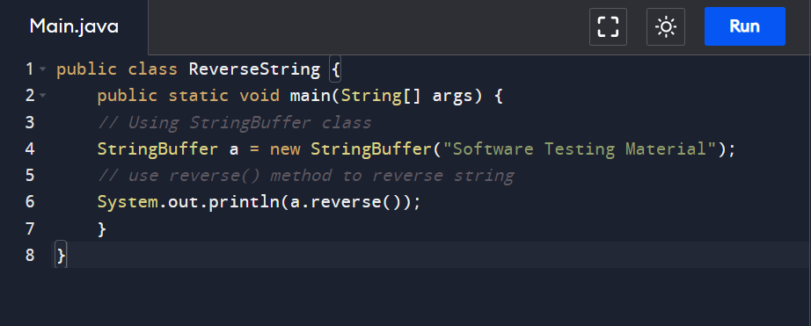

**Another method:**

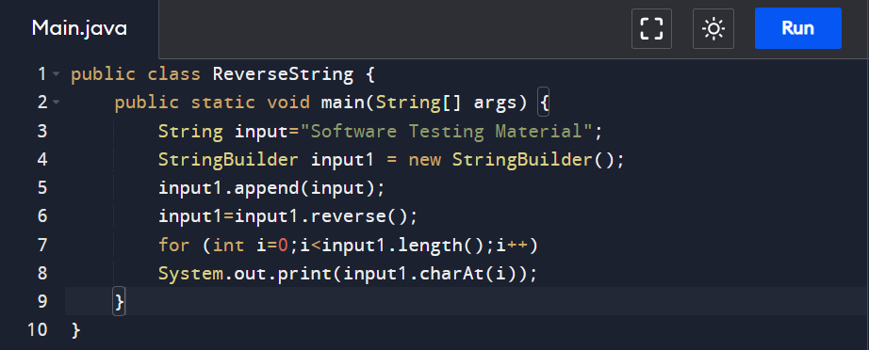

**9. How To Find The Largest Value From The Given Array.**

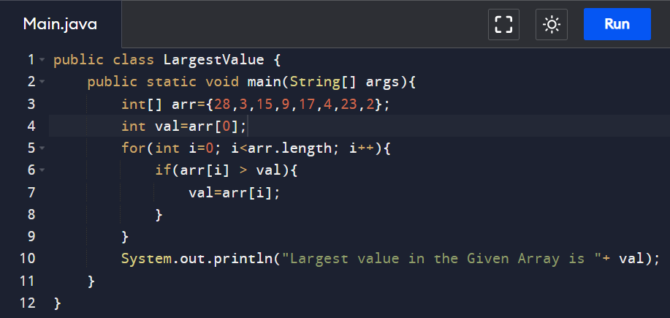

**10. How to display all the prime numbers between 1 and 100**

The number which is only divisible by 1 and itself is known as a prime number. For example 2, 3, 5, 7, 11… are prime numbers.

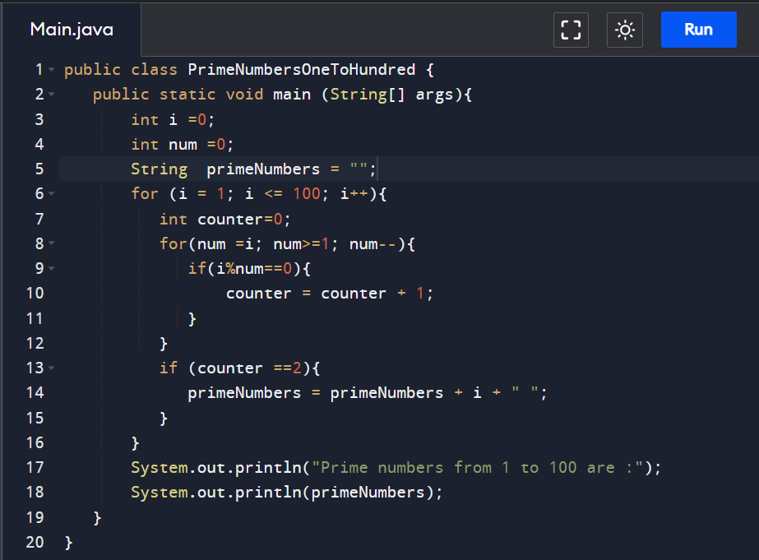

**11. How to display all the prime numbers between 1 and n (n is the number, get the input from user)**

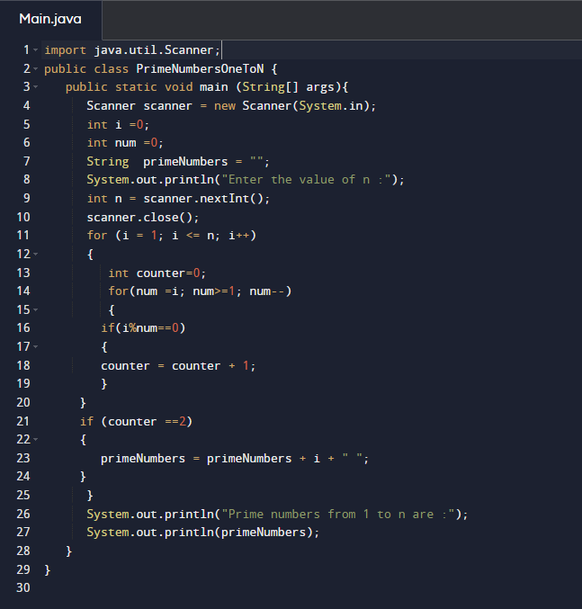

**12. How to find the given number is a prime number or not by getting input from the user**

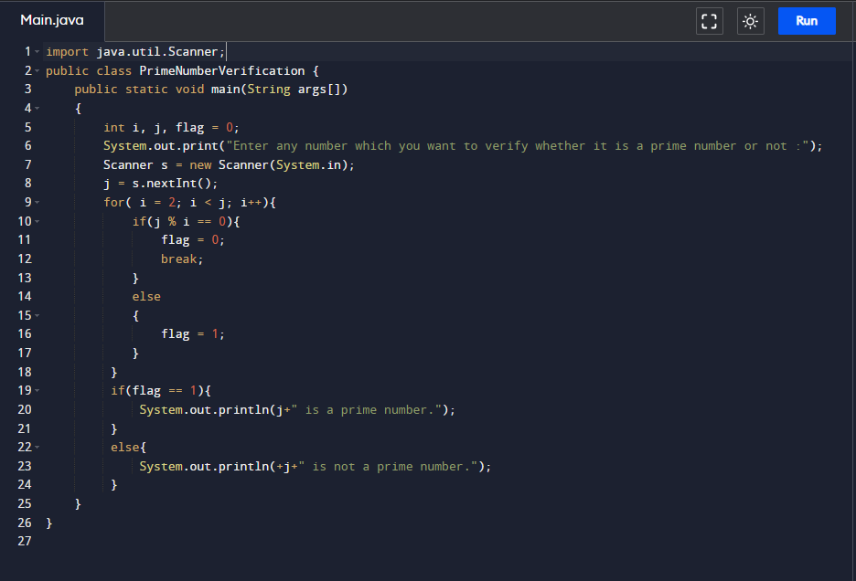

**13. Write a program to print Fibonacci Series**

**Method 1:**

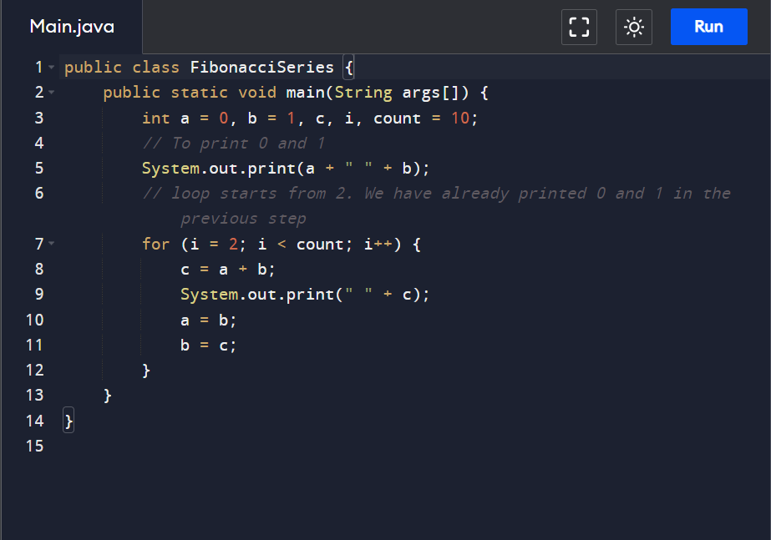

**Method 2:**

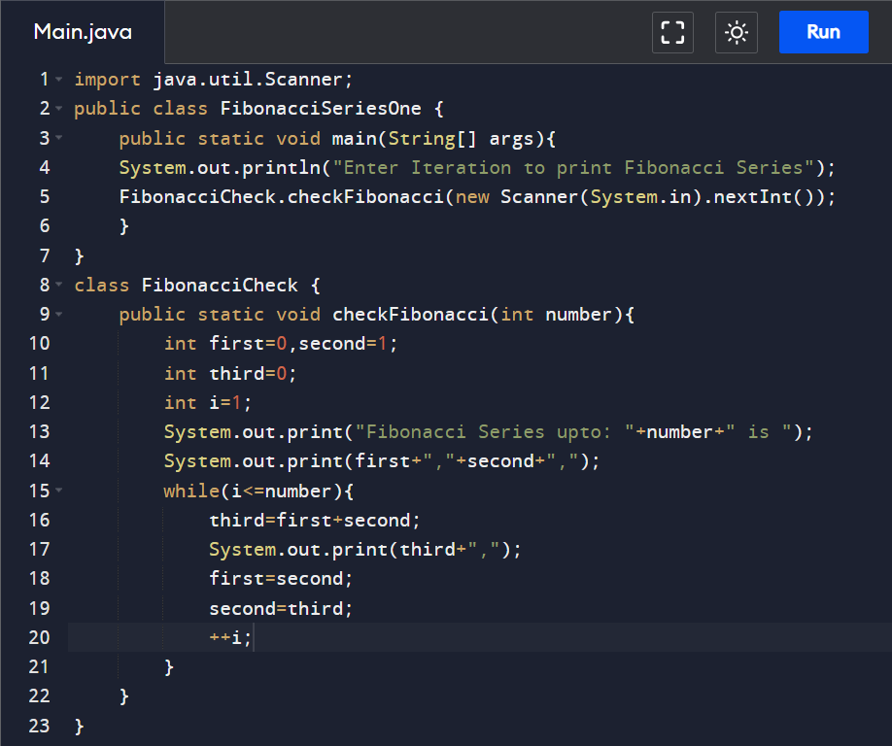

**14. How to read a file line by line in Java?**

We can read a file line by line in Java in two ways.

1.BufferedReaderClass  
2. Scanner Class

**Using BufferedReader Class:**

BufferedReader Class belongs to java.io package and it provides readLine() method to read a file line by line in Java.

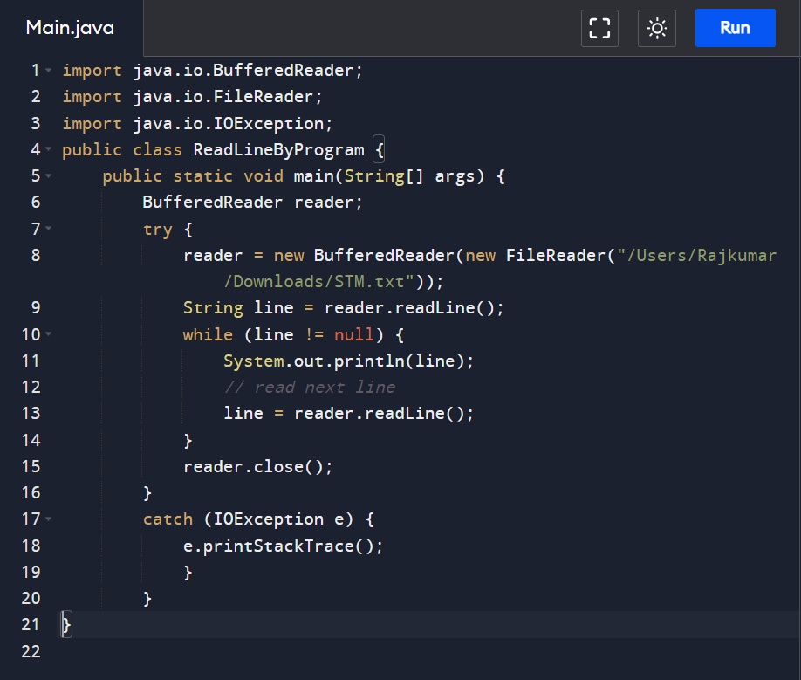

**Using Scanner Class:**

Java Scanner class provides the nextLine() method to facilitates line by line of file’s content.

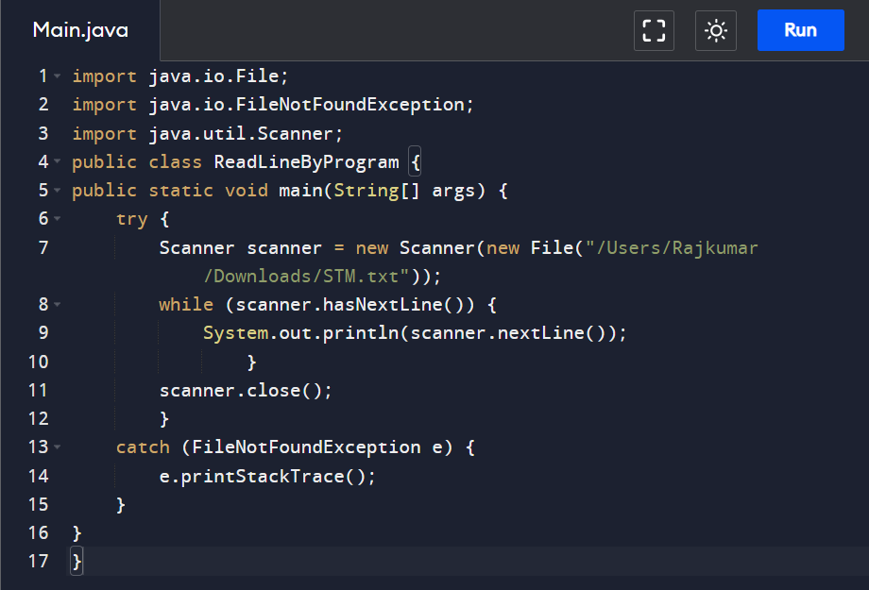

**15. Swap string without 3rd variable?**

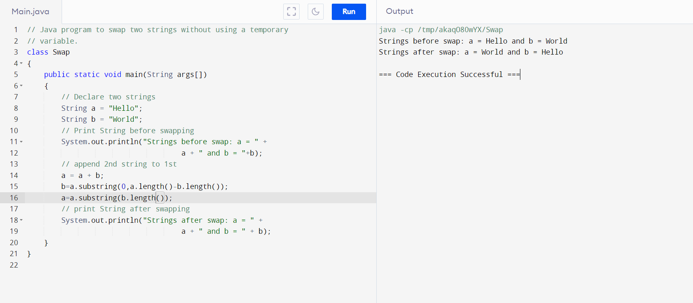

### 16.Duplicates in a String?

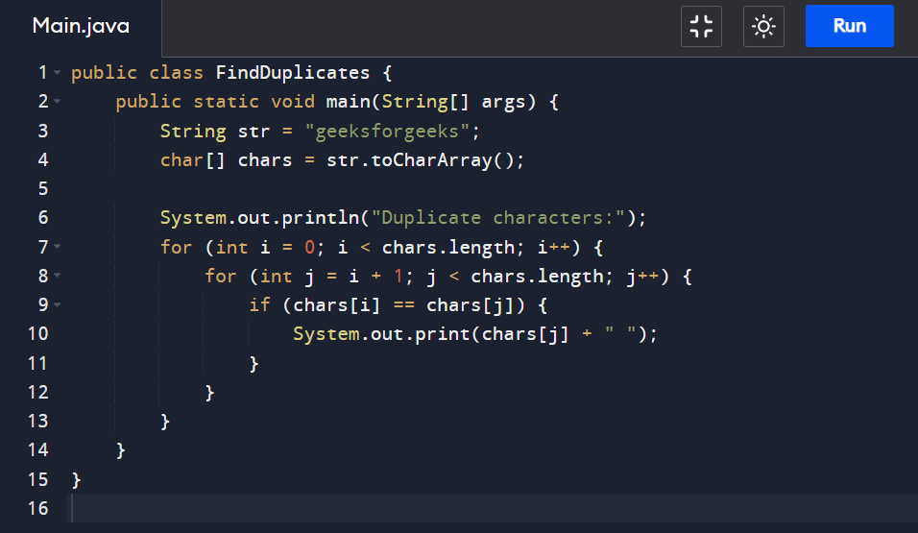

### 17. How to find the length of the string without using length?

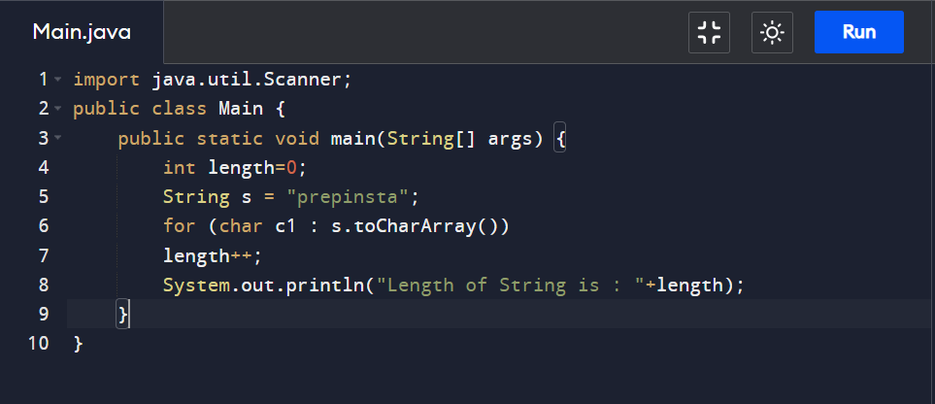

### 18.Largest number in an Array

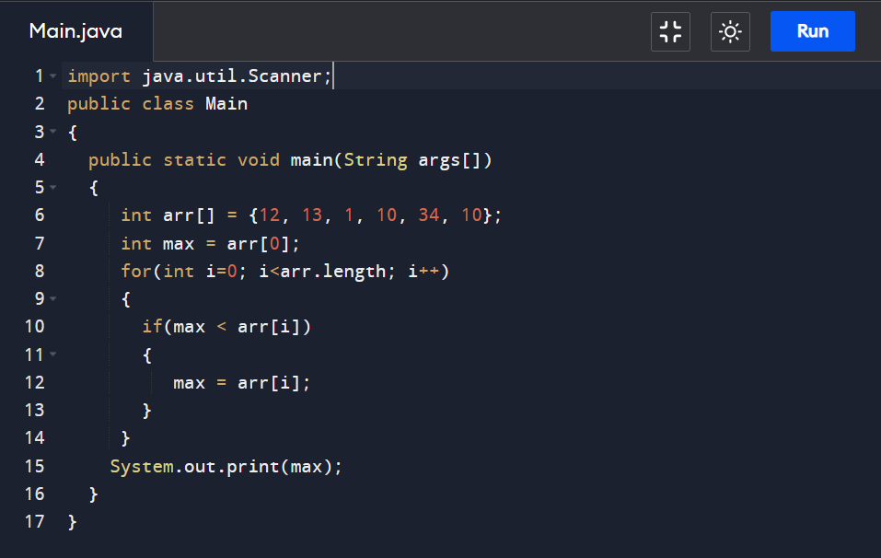

### 19.Reverse a string without using reverse function

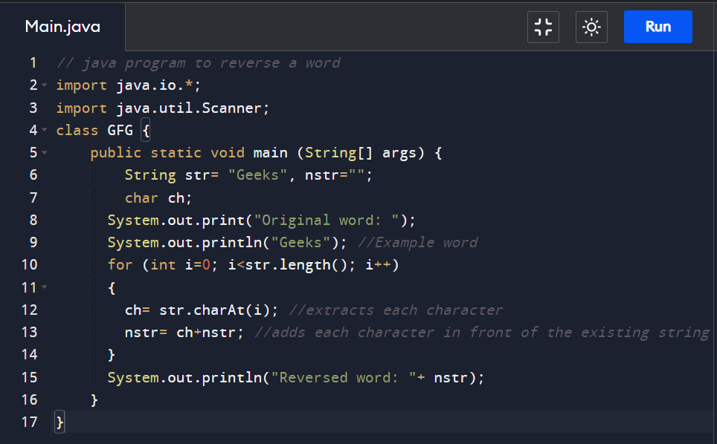

### 20. Write code to print only the even numbers from an array.

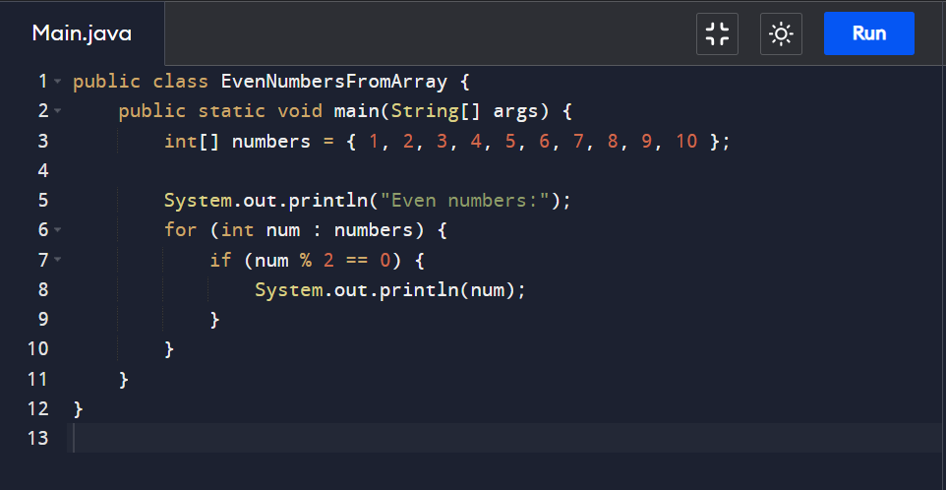

### 21. Write code to find special character, number, capital and small letter in a given string.

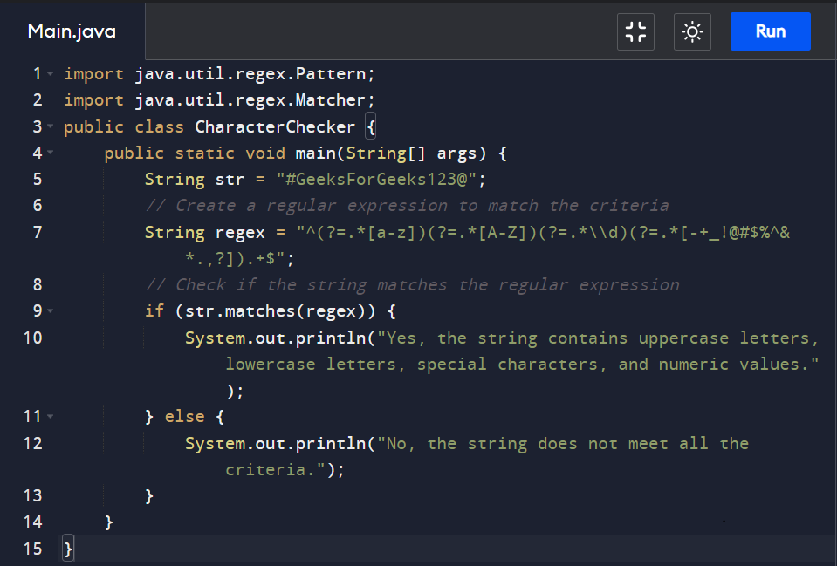

### 21. Write code to check if a number is palindrome?

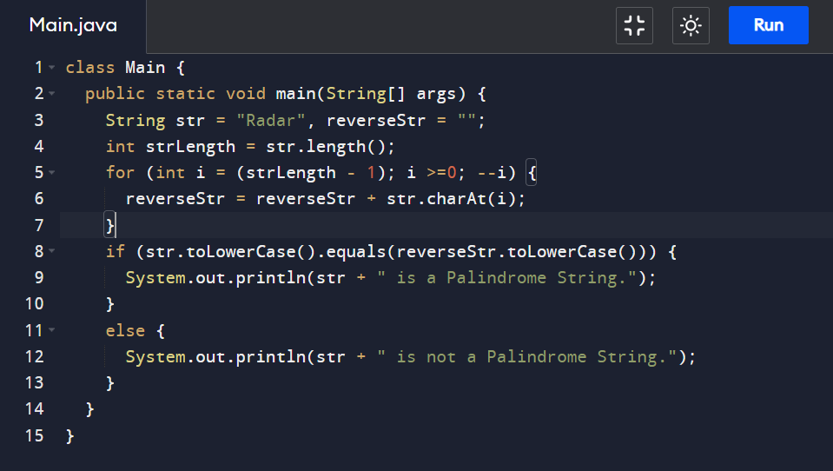

### 22. Write a Java code to identify, if the pair of strings are an Anagram or not

### 

23. Write a java code for factorial of a Number using recursive method ?

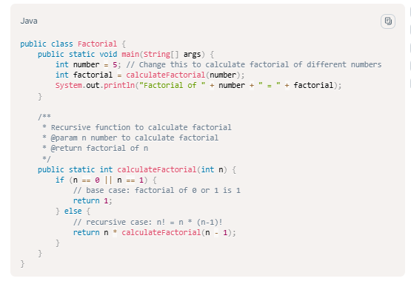

24. Write Java code to print all the array elements that appear at least 2 times (meaning 2 or greater than two).

