How to Use - Project Review Application

# 1. Login Page

On the login page, users are required to enter their STAFF NUMBER and PASSWORD to access the system. If the user does not have an account, they should click on 'Signup' to create a new account.

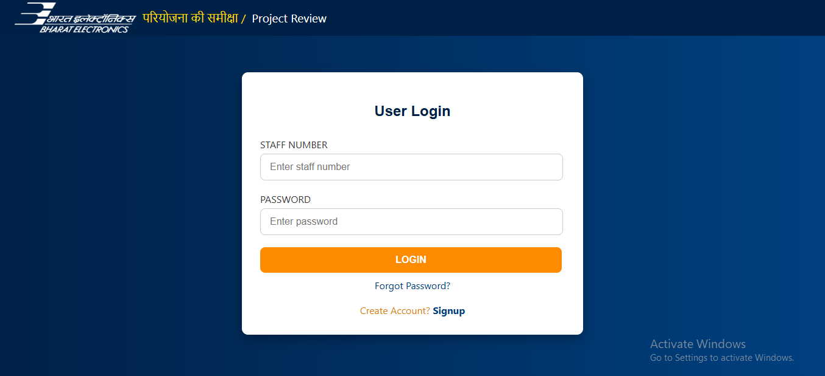

📌 Highlighted:

→ 'STAFF NUMBER' and 'PASSWORD' fields to log in.  
→ 'Signup' link to register a new account.  
→ 'Forgot Password?' for help resetting password.

# 2. Signup Page

Users can register by providing their USERNAME, STAFF NUMBER, EMAIL, PASSWORD, and CONFIRM PASSWORD. Click 'SUBMIT' to complete the registration.

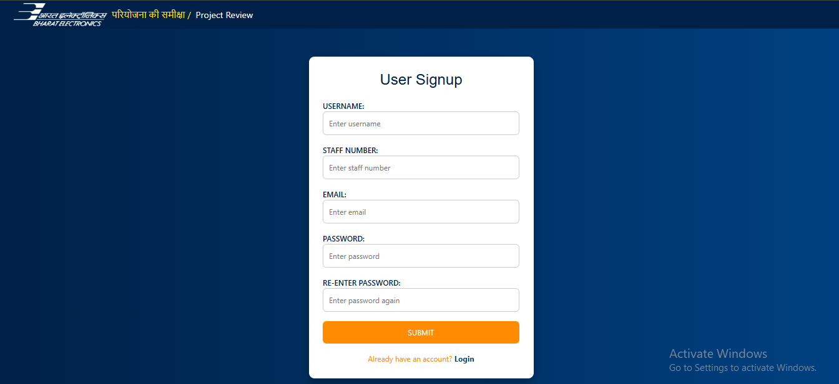

📌 Highlighted:

* → All input fields must be filled.  
  → The passwords must match.  
  → Once registered, users can log in from the login page.

# 3. Main Dashboard

Once logged in, users can view their project entries in tabular format. From here, they can ADD NEW data, UPDATE, DELETE, or VIEW detailed project info.

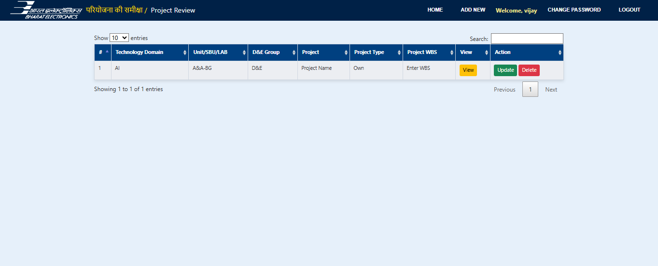

📌 Highlighted:

* → 'ADD NEW' for entering a new project.  
  → 'Update' to modify existing data.  
  → 'Delete' to remove a project.  
  → 'View' to see full details of the project.

# 4. Project Details View

Clicking the 'View' button on a project entry opens the full project details. This includes domains, WBS, budget and expenditure breakdowns, and date tracking.

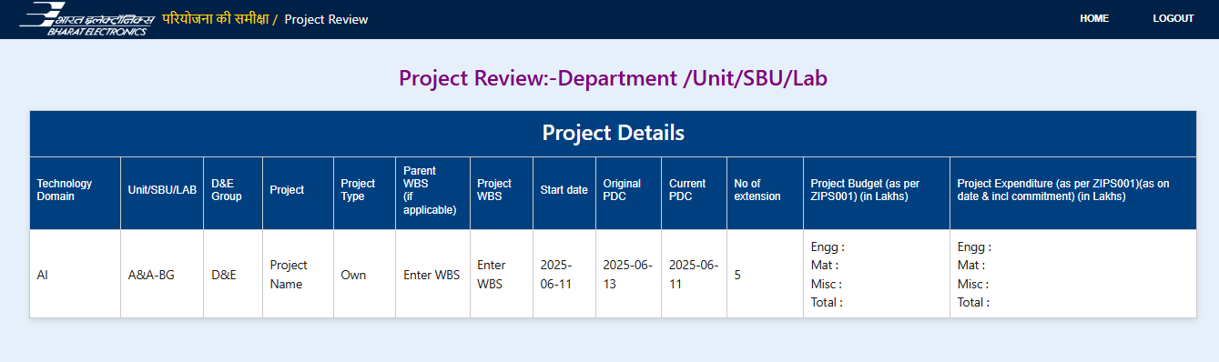

📌 Highlighted:

* → Summary of complete project data.  
  → Engineering, Material, Miscellaneous budget and expenditure shown.  
  → Useful for monitoring project progress and cost tracking.

# 5. Account Management

Users can update their password by clicking on 'CHANGE PASSWORD' on the top navigation bar. To exit the application securely, click on 'LOGOUT'.

* → 'CHANGE PASSWORD': Updates current account password.  
  → 'LOGOUT': Ends session and returns user to login screen.