COLLABRIX
A Team-First Freelance Collaboration Platform
A Project Report
Submitted by
Jaghatha Uday Prakash
2303031240447
Boddu Venkata Sai Kowshik
2303031241591
Katreddi Hima Nagendra
2303031240520
Immadi Venkata Rama Chaitanya Vardhan
2303031240436
In Partial Fulfilment for the
Award of the Degree of
BACHELOR OF TECHNOLOGY
COMPUTER SCIENCE AND ENGINEERING (Spl. In Artificial Intelligence)
Under the Guidance of
Assistant Prof. Barkha Makwana

PARUL UNIVERSITY, VADODARA
October – 2026

PARUL UNIVERSITY
CERTIFICATE
This is to certify that Project-2, Subject Code 303105423 of the 7th Semester, entitled “CollabriX: A Team-First Freelance Collaboration Platform” of Group No. PIET CSE NON ASMP - 8 has been completed by
• JAGHATHA UDAY PRAKASH – 2303031240447
• BODDU VENKATA SAI KOWSHIK – 2303031241591
• KATREDDI HIMA NAGENDRA – 2303031240520
• IMMADI VENKATA RAMA CHAITANYA VARDHAN – 2303031240436
under my guidance, in partial fulfilment of the Bachelor of Technology (B. Tech) in Computer Science and Engineering at Parul University in the Academic Year 2026–2027.
Date of Submission: ____________________
Project Guide Head of Department,
Assistant Prof. Barkha Makwana Dr. Sanjay Agal
Department of Artificial Intelligence
and Data Science, PIET
Parul University, Vadodara

Project Coordinator
Dr. Mohammad Arif External Examiner

Acknowledgements
“Alone we can do so little; together we can do so much.”
– Helen Keller
It gives us great pleasure to present this report on CollabriX, a platform that is itself about people working better together. Building it taught us as much about collaboration as about software, and we owe that lesson to many people.
First and foremost, we express our sincere gratitude to our project guide, Assistant Prof. Barkha Makwana, for her constant encouragement, patient reviews and valuable suggestions at every stage of this work. Her questions about scope, security and evaluation shaped the direction of the project and of this report.
We thank Dr. Sanjay Agal, Head of the Department of Artificial Intelligence and Data Science, PIET, and Dr. Mohammad Arif, Project Coordinator, for providing the facilities, guidelines and timely reviews that made this project possible.
We are grateful to our parents and families for their unwavering support and belief in us, and to our friends and classmates for their constant encouragement.
Finally, we thank all the faculty and staff of Parul Institute of Engineering and Technology who helped us directly or indirectly during the course of this project.

Jaghatha Uday Prakash
Boddu Venkata Sai Kowshik
Katreddi Hima Nagendra
Immadi Venkata Rama Chaitanya Vardhan
B.Tech. – CSE (AI)
Parul University, Vadodara

Abstract
Freelance marketplaces such as Upwork, Fiverr and Freelancer have made it easy for an individual to sell a skill to a client anywhere in the world. They are, however, designed around a single seller competing against other single sellers through bids. Larger projects need a front-end developer, a back-end developer and a designer who already trust each other, and today such teams are assembled informally, outside the platform, through personal messages and spreadsheets. Reputation is also fragile: ratings are often inflated, and they are frequently disconnected from the actual work that was delivered.
CollabriX is a web-based, team-first freelance collaboration platform built to address these gaps. It provides two role-based workspaces. Developers browse open projects, discover peers by skill, region and rating, exchange connection requests that the receiver accepts or rejects, chat in real time, assemble team batches from accepted connections with an automatically computed synergy score, answer project invitations and climb a leaderboard computed only from verified work. Clients post projects, search for talent with faceted filters, invite developers, assign one who accepted, mark the work complete and rate it. Both roles receive real-time notifications.
The system is a single-page application in React 18, TypeScript and Vite, styled with Tailwind CSS and shadcn/ui components, with TanStack Query for server-state caching. The back end is Supabase: PostgreSQL with twelve application tables, Row-Level Security (RLS) on every table, and triggers and security-definer functions that enforce each workflow rule inside the database. A developer is never assigned merely because an invitation was sent, a rating requires a completed project shared by both parties, and notifications can only be produced by the database itself. Realtime subscriptions push messages, requests and notifications without polling.
The prototype was built in five agile sprints. The final build passes the TypeScript compiler with no errors and ESLint with no errors (down from 14), all 18 automated browser test cases, and a database test suite of 104 behaviour and security checks run against all eleven migrations, including a rehearsal of the upgrade on a copy of the live schema with legacy data. A Lighthouse audit of the production build gives Performance 76, Accessibility 84, Best Practices 100 and SEO 100. Remaining limitations are documented with future work.

Table of Contents
Acknowledgements iii
Abstract iv
Table of Contents v
List of Tables vii
List of Figures ix
List of Algorithms xi
1 Introduction 1
1.1 Drawbacks of the Existing Solution 2
1.2 Scope 2
1.2.1 Key Features and Expected Outcomes 3
1.3 Aim and Objectives 3
1.4 Organisation of the Report 4
2 Literature Survey 5
2.1 Critical Evaluation of Available Literature 5
2.2 Other Platforms Reviewed 7
2.3 Summary of the Literature 8
2.4 Research Gap and Proposed Solution 8
3 Project Flow and Methodology 9
3.1 Software Dependencies 9
3.1.1 Technology Stack 9
3.1.2 Hardware and Software Requirements 10
3.2 Requirement Analysis 10
3.2.1 Intended Users 10
3.2.2 Functional Requirements 11
3.2.3 Non-Functional Requirements 12
3.2.4 User Interface Requirements 13
3.2.5 Assumptions and Constraints 13
3.3 Development Methodology 13
3.3.1 Design Thinking and User-Centric Principles 14
3.3.2 Quality Assurance Strategy 15
3.3.3 Tools for Collaboration 15
3.3.4 Project Timeline (Gantt Chart) 15
3.4 System Architecture 16
3.5 Database Design 17
3.6 UML Design Diagrams 20
3.6.1 Use Case Diagram 20
3.6.2 Sequence Diagram — Registration and Onboarding 20
3.6.3 Sequence Diagram — Connection and Real-time Messaging 21
3.6.4 Navigation Design 22
3.6.5 State Diagram — Connection Requests 22
3.6.6 State Diagram — Project and Invitation Lifecycle 23
3.6.7 Sequence Diagram — From Invitation to Rating 23
3.7 User Interface Design 24
3.8 Communication Profile 24
3.9 Security Design 25
3.9.1 Workflow Rules Enforced by Triggers 27
3.9.2 Trusted Operations and Security-Definer Functions 28
3.9.3 Threat Model Review 29
3.10 Module Implementation 30
3.10.1 Project Structure 30
3.10.2 Authentication and Role Routing 30
3.10.3 Onboarding and Profiles 31
3.10.4 Developer Discovery, Connections and Requests 32
3.10.5 Real-time Messaging 32
3.10.6 Team Formation Engine 33
3.10.7 Projects, Ratings and Leaderboard 34
3.10.8 Project Posting and Management 35
3.10.9 Invitations and Assignment 36
3.10.10 Notification System 36
3.10.11 Settings and Account Management 37
3.10.12 Contact Support 37
3.10.13 Error Handling and User Feedback 38
3.11 Configuration and Deployment 38
4 Results and Analysis 39
4.1 Tools and Technologies 39
4.2 Results 39
4.2.1 Quantitative Results 42
5 Conclusion and Future Works 51
5.1 Conclusion 51
5.1.1 Lessons Learned 52
5.2 Limitations 52
5.3 Future Prospectus 53
5.3.1 Possible Integration with Other Tools 53
Bibliography 54

List of Tables
1.1 Scope of the CollabriX prototype 2
1.2 Key features of CollabriX and their expected outcomes 3
2.1 Comparison of existing freelance platforms with CollabriX 7
2.2 Summary of reviewed literature 8
3.1 Technology stack and justification 9
3.2 Hardware requirements 10
3.3 Software requirements 10
3.4 Illustrative user personas 10
3.5 Functional requirements 11
3.6 Non-functional requirements 12
3.7 Sprint plan and deliverables (dates from the Git history) 14
3.8 Collaboration and development tools 15
3.9 Architectural layers and responsibilities 16
3.10 Description of database tables 17
3.11 Data dictionary of the profiles table 18
3.12 Data dictionary of the notifications table 19
3.13 Communication channels used by CollabriX 25
3.14 Row-Level Security policies implemented 25
3.15 Database functions exposed to or used by the application 28
3.16 Threats considered and their mitigations 29
3.17 Source code organisation 30
3.18 Relationship states and the actions offered 32
3.19 Worked example of the leaderboard formula 35
3.20 Validation rules of the Post Project form 36
3.21 Notification types, their triggers and the preference that controls them 37
3.22 Mapping of technical errors to user-facing messages 38
4.1 Tools and technologies used 39
4.2 Comparative analysis of conventional freelance platforms vs. CollabriX 39
4.3 Static analysis results 43
4.4 Automated UI test cases and results 43
4.5 Manual test cases for authenticated features 45
4.6 RLS validation with an anonymous client 46
4.7 Lighthouse metrics and bundle sizes 47
4.8 Database test suite: areas and results 48
4.9 Upgrade rehearsal with legacy data 49
4.10 Defects, root causes and fixes 50
5.1 Project goals versus accomplishments 51
5.2 Known limitations of the current prototype 52

List of Figures
1.1 Overview of the CollabriX collaboration ecosystem 1
3.1 Iterative sprint cycle followed in the project 14
3.2 Gantt chart of the project timeline 15
3.3 Layered system architecture of CollabriX 16
3.4 Entity–relationship diagram 17
3.5 Entity–relationship diagram of the collaboration extension 19
3.6 Use case diagram 20
3.7 Sequence diagram for registration and onboarding 21
3.8 Sequence diagram for connection request and messaging 21
3.9 Role-based navigation map 22
3.10 State diagram of a connection request 23
3.11 State diagrams of the project and invitation lifecycles 23
3.12 Sequence diagram from invitation to two-way rating 24
3.13 Flowchart of authentication and role-based routing 31
3.14 Flowchart of the synergy score algorithm 34
3.15 Flowchart of rating submission and validation 34
3.16 Notification pipeline from database event to the user interface 37
4.1 Splash screen shown while the session is restored 40
4.2 Login screen with e-mail/password and Google sign-in 40
4.3 Sign-up screen with Developer / Client role selection 41
4.4 Developer workspace: (a) profile with ratings and badges, (b) real-time chat with a connection 41
4.5 (a) Team Formation Engine with synergy score and skill gaps, (b) client dashboard 42
4.6 (a) Notifications page, (b) project details with invitations and the Assign action 42
4.7 ESLint findings before and after the fixes 43
4.8 Sign-up screen rendered at mobile width (TC-09) 45
4.9 Lighthouse category scores before and after the extension 47
4.10 Database test suite results by area 49

List of Algorithms
1 Synergy Score Calculation for a Team Batch 33
2 Leaderboard Ranking (database function get_leaderboard) 35
3 Invitation-gated assignment of a developer 36

Chapter 1

Introduction
The way software is built has changed. A modern product is rarely written by one person; it is assembled by small cross-functional teams in which a front-end engineer, a back-end engineer, a designer and someone responsible for deployment work together for a few weeks or months. At the same time, an increasing share of this work is performed by independent professionals who are hired online. The freelance or gig economy has therefore become an important channel through which companies, especially start-ups and small businesses, access technical talent.
This project, CollabriX, is a web platform that connects clients who need software built with developers who build it, and, crucially, lets developers find each other and form teams on the platform itself. The name combines collaboration with X, indicating that collaboration is the core of the product rather than an afterthought.
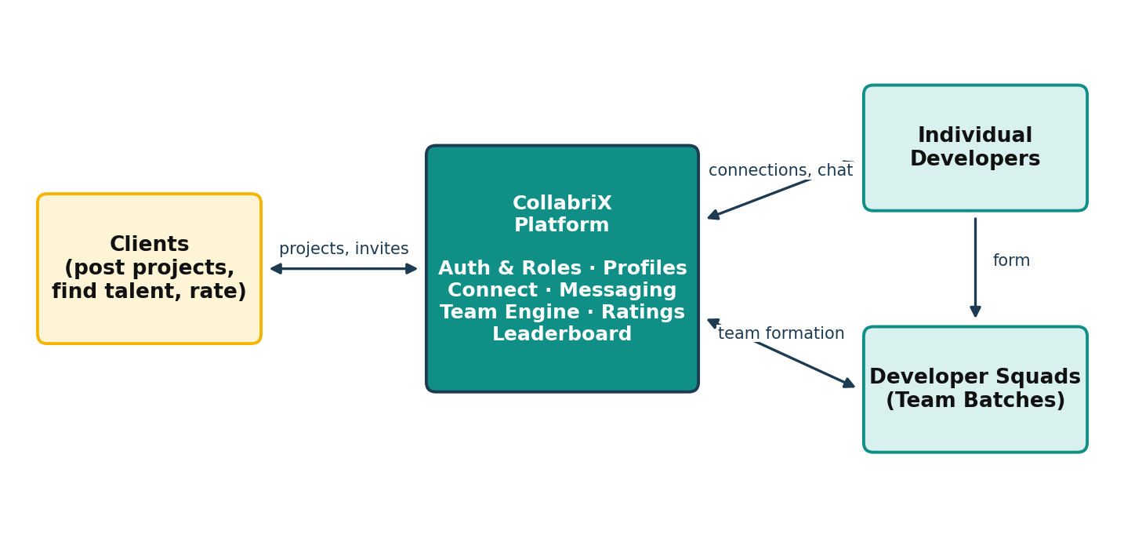
Figure 1.1: Overview of the CollabriX collaboration ecosystem
Online labour markets are two-sided platforms: one side (clients) posts work and the other side (freelancers) offers skills. The platform earns trust by verifying identities, providing communication tools, and maintaining reputation systems such as star ratings and job success scores. Research on online labour markets shows that reputation is the primary signal clients use when choosing whom to hire, and that new entrants without a track record find it hard to win their first contracts [1], [2].
Technically, platforms in this domain are data-intensive, multi-tenant web applications. Every user must only see and modify the data that belongs to them; conversations must be delivered instantly; profile, project and rating data must be consistent. These requirements map naturally onto a relational database with strong access control and a realtime messaging layer, which is the architecture CollabriX adopts.
Student and early-career developers commonly face the same situation: a client asks for a complete application, but no single person can deliver every part alone. Finding a reliable partner usually means asking around in college or social groups, and once a team is formed there is no shared place to talk to the client, track the project or build a joint reputation. Research on flash teams and flash organisations [6], [7] shows that experts recruited online can deliver complex work when the platform gives them structure. CollabriX applies that idea to everyday freelance development.
The project is relevant to the Indian context in particular, where a large population of young developers is entering the global freelance market and where team-based delivery can help them compete for larger, better-paid contracts.

1.1 Drawbacks of the Existing Solution
- Individual-only model: mainstream marketplaces are optimised for one freelancer bidding on one job. There is no first-class way for developers to discover complementary peers and apply to a project as a team.
- Bidding fatigue: clients receive many generic proposals and must filter them manually, while freelancers spend unpaid time writing bids.
- Weak link between ratings and work: reviews tend to be inflated over time [8] and are not always tied in a verifiable way to a completed engagement, which reduces their value as a quality signal.
- Fragmented communication: conversations, team coordination and project status often move to external tools such as e-mail or chat apps, so the platform loses context.
- Cold-start problem: newcomers without reviews are almost invisible in search results, regardless of their actual skills [2].

1.2 Scope
The scope of the project is a working web prototype of the platform, including both user roles, the developer networking features and the supporting database and security layer. Table 1.1 summarises what is included and what is deliberately excluded.
Table 1.1: Scope of the CollabriX prototype
In scope | Out of scope (for this phase)
Role-based sign-up and login (e-mail/password and Google OAuth) | Payments, escrow and invoicing
Developer and client onboarding wizards and profile editing | Native Android / iOS applications
Developer search with type, skill and region filters | Automated résumé or LinkedIn parsing
Connection requests and real-time one-to-one messaging | Video calls and file sharing in chat
Team batch formation with synergy scoring | Activity tracking / screenshot monitoring
Completion-gated project and user ratings, leaderboard, badges | Dispute resolution and moderation tools
Row-Level Security for every application table | Multi-language (i18n) support
Project posting, invitations, assignment and completion | Proposals, bidding and contracts
Real-time notifications, settings and support tickets | Staff console for support and moderation

1.2.1 Key Features and Expected Outcomes
Table 1.2: Key features of CollabriX and their expected outcomes
Feature | Description | Expected outcome
Role-based workspaces | Separate bottom-navigation and screens for developers (5 tabs) and clients (4 tabs) | Each user sees only relevant tools
Guided onboarding | Three-step developer and company setup wizards with live preview | Complete profiles from day one
Developer discovery | Search by name, skill, type; continent → country region filter; rating badge | Faster peer and talent discovery
Connections & messaging | Request/accept workflow, unread badges, realtime chat threads | In-platform communication
Team Formation Engine | Batches built from accepted connections with role assignment and synergy % | Balanced, complementary teams
Ratings & leaderboard | 1–5 star ratings tied to completed projects; ranking and badges | Trustworthy reputation signal
Security by design | RLS policies, JWT sessions, per-user storage folders | Zero-trust data access
Project lifecycle | Post, edit, invite, assign a developer who accepted, mark complete | Ratings flow from real, finished work
Notifications | Generated by database triggers, delivered in real time, per-type preferences | No missed requests or invitations
Settings and support | Profile, privacy, account security and ticketed help | Self-service account management

1.3 Aim and Objectives
- To design and implement a responsive single-page web application with separate, role-specific workspaces for developers and clients.
- To enable developers to discover peers by skill, developer type and region, and to connect with them through a request–accept workflow.
- To provide real-time messaging between connected users without polling.
- To let developers assemble team batches from their verified connections and see an objective skill-coverage score for the team.
- To build a reputation system in which ratings can only be submitted for completed projects by the people who took part in them.
- To provide a complete project lifecycle (posting, invitation, assignment and completion) whose rules are enforced by the database, so that ratings come only from real engagements.
- To keep every user informed through real-time notifications that respect individual preferences.
- To enforce all authorisation rules at the database level using PostgreSQL Row-Level Security, so that the browser never has to be trusted.
- To evaluate the system through functional, security and performance testing and to document its limitations.

1.4 Organisation of the Report
Chapter 2 evaluates related research and existing platforms. Chapter 3 covers the project flow and methodology, from requirements and design to the implementation of each module, including the collaboration extension (notifications, invitations and the project lifecycle) added in the final sprint. Chapter 4 presents the tools used, screenshots and the results of static, browser, database and performance tests. Chapter 5 concludes the report and outlines future work.

Chapter 2

Literature Survey
This chapter reviews research on online labour markets, reputation systems and team formation, followed by an analysis of popular freelance platforms. The goal is to identify what is already known, what existing systems do well, and where a team-first platform can contribute.

2.1 Critical Evaluation of Available Literature

2.1.1 Paper 1: “Online Labor Markets” by J. J. Horton [1]
Horton describes online labour markets as markets in which workers and buyers are matched over the internet and work is delivered electronically. He discusses their economic properties: low search costs, global participation, and the strong role that the platform plays as a market designer. A key observation is that the platform's rules — how jobs are posted, how workers are ranked and how feedback is collected — directly shape outcomes for both sides.
Relevance: CollabriX treats these design choices (who may message whom, who may rate whom) as explicit, enforced rules rather than conventions.

2.1.2 Paper 2: “The Future of Crowd Work” by A. Kittur, J. V. Nickerson, M. Bernstein et al. [2]
Kittur and colleagues analyse paid crowd work and propose a research agenda for making it a career that people would want for their children. They identify the need for better task decomposition, worker collaboration, reputation and credentialing, and support for complex, interdependent work rather than isolated micro-tasks.
Relevance: the paper motivates CollabriX's focus on collaboration between workers and on reputation that reflects real outcomes.

2.1.3 Paper 3: “Reputation Systems” by P. Resnick, K. Kuwabara, R. Zeckhauser and E. Friedman [3]
This influential article explains how reputation systems build trust between strangers by collecting, distributing and aggregating feedback about past behaviour. The authors note three challenges: people may not leave feedback, negative feedback is hard to elicit, and it is hard to ensure that feedback is honest. They argue that the system must make feedback both available and credible.
Relevance: CollabriX addresses credibility by making it impossible, at the database level, to rate a user or project unless a completed engagement exists.

2.1.4 Paper 4: “A Survey of Trust and Reputation Systems for Online Service Provision” by A. Jøsang, R. Ismail and C. Boyd [4]
Jøsang, Ismail and Boyd survey trust and reputation models used in online services, from simple summation and averaging (as on eBay) to Bayesian and flow-based models. They also catalogue attacks such as ballot stuffing, bad-mouthing and identity changes, and discuss how system design can mitigate them.
Relevance: averaging is used in the prototype for simplicity; unique constraints prevent the same rater from rating the same project twice, which mitigates ballot stuffing.

2.1.5 Paper 5: “Finding a Team of Experts in Social Networks” by T. Lappas, K. Liu and E. Terzi [5]
Lappas, Liu and Terzi formalise the team formation problem: given a task requiring a set of skills and a social network of experts, find a team that covers all required skills while minimising the communication cost between members. They prove the problem is NP-hard and propose approximation algorithms based on the diameter and minimum spanning tree of the team in the network.
Relevance: CollabriX restricts team members to a developer's accepted connections (existing social ties) and measures skill coverage against domain requirements — a practical, explainable version of this formulation.

2.1.6 Paper 6: “Online Team Formation in Social Networks” by A. Anagnostopoulos, L. Becchetti, C. Castillo, A. Gionis and S. Leonardi [11]
This work extends team formation to an online setting in which tasks arrive over time and the system must assign teams while balancing the workload of experts. The authors show that good solutions must consider both skill coverage and fairness of load across people.
Relevance: the profiles table already stores a current_projects count, which can be used in future to balance workload during team suggestions.

2.1.7 Paper 7: “Expert Crowdsourcing with Flash Teams” by D. Retelny, S. Robaszkiewicz, A. To et al. [6]
Flash teams are computationally guided teams of crowd experts assembled on demand. Using a framework called Foundry, the authors modelled workflows as linked modular tasks and recruited experts from an online marketplace; flash teams completed complex tasks such as app design considerably faster than traditional self-managed teams.
Relevance: demonstrates that structured, on-platform team assembly can outperform ad hoc coordination, which is the core hypothesis of CollabriX.

2.1.8 Paper 8: “Flash Organizations: Crowdsourcing Complex Work by Structuring Crowds as Organizations” by M. A. Valentine, D. Retelny, A. To et al. [7]
Flash organisations extend flash teams with organisational structures — roles, hierarchies and the ability to change the structure while work is in progress. Crowd workers in these organisations built complex products such as a mobile application. The work highlights the importance of explicit roles.
Relevance: CollabriX lets the batch creator assign explicit roles (Team Lead, Frontend Engineer, Backend Engineer, etc.) to each member.

2.1.9 Paper 9: “Reputation Inflation” by A. Filippas, J. J. Horton and J. Golden [8]
Using data from a large online labour market, the authors show that average feedback scores rose substantially over time while underlying quality did not, because giving negative feedback is costly to the rater. As a result, ratings lose their ability to distinguish good from average workers.
Relevance: motivates multi-dimensional and completion-tied ratings, and future work on private (double-blind) feedback in CollabriX.

2.1.10 Paper 10: “Reputation Transferability in Online Labor Markets” by M. Kokkodis and P. G. Ipeirotis [9]
Kokkodis and Ipeirotis study how a worker's reputation in one category of work predicts performance in another, and propose models that transfer reputation across task categories. They find that naive aggregation can mislead employers when workers switch domains.
Relevance: supports showing skill-specific information (skills, developer type) alongside a single average rating.

2.1.11 Paper 11: “The Digitization of Word of Mouth” by C. Dellarocas [12]
Dellarocas reviews online feedback mechanisms and contrasts them with traditional word of mouth. Online systems operate at a very large scale, and, crucially, their designers control what is collected, who may contribute and how it is aggregated and displayed. The paper discusses strategic manipulation, the cost of leaving feedback and the effect of anonymous or easily changed identities, and argues that these design parameters determine whether a feedback system is informative.
Relevance: CollabriX uses this control deliberately. Only the two parties of a completed project may rate each other, the direction of every rating is recorded, ratings cannot be edited afterwards, and client and developer ratings are kept separate on profiles.

2.1.12 Paper 12: “Good Gig, Bad Gig” by A. J. Wood, M. Graham, V. Lehdonvirta and I. Hjorth [10]
Based on interviews and a survey of remote gig workers in South-East Asia and Sub-Saharan Africa, the authors show that platform work offers flexibility and autonomy but also brings algorithmic control through ratings and rankings, together with overwork, social isolation and insecurity. Workers experience opaque reputation scores as a powerful form of control.
Relevance: the leaderboard formula is public and explained on screen (“How scores work”), developers can hide themselves from the leaderboard, and notification preferences let users limit interruptions. Team batches also address isolation by making collaboration a first-class feature.

2.2 Other Platforms Reviewed
Four widely used platforms were studied from the perspective of both a client and a developer. Table 2.1 summarises the comparison against the features that matter for team-based delivery.
Table 2.1: Comparison of existing freelance platforms with CollabriX
Aspect | Upwork | Fiverr | Freelancer | Toptal | CollabriX
Hiring model | Job post + proposals | Fixed gigs / packages | Bidding + contests | Curated matching | Profiles + teams
Peer discovery between freelancers | Limited | No | Limited | No | Yes (search + connect)
Form a team on-platform | Agencies only | No | No | Matched by staff | Yes (team batches)
Skill-coverage analysis | No | No | No | Manual | Synergy score
In-platform chat | Yes | Yes | Yes | Yes | Yes (realtime)
Ratings tied to completed work | Yes | Yes | Yes | N/A | Enforced by RLS
Open leaderboard | No | Seller levels | Rankings | No | Yes + badges

2.3 Summary of the Literature
Table 2.2: Summary of reviewed literature
Ref. | Focus | Key finding | Gap addressed by CollabriX
[1] | Online labour markets | Platform rules shape market outcomes | Rules enforced in the database
[2] | Crowd work agenda | Need collaboration & reputation | Team-first design
[3], [4] | Reputation systems | Feedback must be credible; attacks exist | Completion-gated, unique ratings
[5], [11] | Team formation | Cover skills, low communication cost | Teams from existing connections + coverage score
[6], [7] | Flash teams / organisations | Structured expert teams deliver complex work | Explicit roles in batches
[8] | Reputation inflation | Average scores drift upward | Basis for future double-blind ratings
[9] | Reputation transfer | Category matters | Skills shown with ratings
[10] | Gig work and control | Ratings act as algorithmic control | Transparent formula, opt-out
[12] | Online feedback design | Designers control what is collected | Participant-only, directional ratings

2.4 Research Gap and Proposed Solution
The literature establishes that (i) structured teams of online experts can deliver complex work, (ii) team formation should consider both skills and social ties, and (iii) reputation must be credible to be useful. Existing commercial platforms, however, remain largely individual-centric and do not let freelancers discover peers, form teams and evaluate their skill coverage within the platform. CollabriX fills this gap with a connection-based team formation engine, completion-tied ratings enforced in the database, and integrated real-time communication.

Chapter 3

Project Flow and Methodology
This project aims to design and implement a team-first freelance collaboration platform. To accomplish this goal, we followed a systematic approach consisting of requirement analysis, design, iterative development, testing and evaluation. This chapter describes the software dependencies, the requirements, the development methodology, the architecture and database design, the communication and security model, and the implementation of each module.

3.1 Software Dependencies
CollabriX is a pure software project: it needs no special hardware beyond a development computer, and end users only need a modern web browser. The software stack was chosen to minimise the amount of custom server code while keeping strong typing and security.

3.1.1 Technology Stack
Table 3.1: Technology stack and justification
Layer | Technology | Reason for selection
Language | TypeScript 5.8 | Static typing catches errors early; generated database types give end-to-end type safety
UI library | React 18.3 | Component model, huge ecosystem, team familiarity
Build tool | Vite 5.4 + SWC | Instant dev server start and fast production builds (≈ 2 s)
Styling | Tailwind CSS 3.4 + shadcn/ui | Design tokens, dark mode, accessible Radix primitives
Server state | TanStack Query 5 | Caching, background refetch, mutation invalidation
Routing | React Router 6 | Declarative routes and redirects
Validation | Zod 3 | Schema-based validation of forms
Back-end | Supabase (PostgreSQL) | Auth, REST, realtime and storage without writing a server; RLS for security
Icons / charts | Lucide, Recharts | Consistent icon set; charting for dashboards
Database testing | PostgreSQL 16 + Python (psycopg) | Runs every migration and 104 security checks locally, without touching the live project
Browser testing | Puppeteer + headless Chrome | Repeatable route, sign-in and layout checks

Alternatives considered were the MERN stack (MongoDB, Express, React, Node) and Firebase. MERN would have required writing and hosting a custom API and authorisation layer; Firebase uses a document database whose security rules are less expressive for relational data such as connections and ratings. Supabase offered a relational model, SQL-based security policies and realtime in one managed service.

3.1.2 Hardware and Software Requirements
Table 3.2: Hardware requirements
Component | Development | End user
Processor | Intel Core i5 / Apple M1 or better | Any modern dual-core CPU or smartphone
Memory | 8 GB RAM (16 GB recommended) | 2 GB RAM
Storage | 2 GB free (Node modules, tooling) | No installation required
Network | Broadband internet | Internet connection (3G or better)

Table 3.3: Software requirements
Category | Software / version
Operating system | macOS, Windows 10+ or Linux (development); any OS with a modern browser (users)
Runtime & package manager | Node.js 18+ and npm 9+
Front-end | React 18.3, TypeScript 5.8, Vite 5.4, Tailwind CSS 3.4, shadcn/ui (Radix UI), TanStack Query 5, React Router 6, Zod 3
Back-end | Supabase (PostgreSQL, Auth, Realtime, Storage), supabase-js 2.88
Browser | Chrome, Edge, Firefox or Safari (latest two versions)
Tools | VS Code, Git and GitHub, Lovable, Supabase Studio, ESLint, Chrome DevTools, Lighthouse, PostgreSQL 16 (local test database), Python 3 + psycopg, Puppeteer

3.2 Requirement Analysis
The purpose of this specification is to describe the functional and non-functional requirements of the CollabriX web application in sufficient detail for design, implementation and testing. It is intended for the project team, the project guide and the evaluators.

3.2.1 Intended Users
CollabriX has two primary user classes and one supporting actor:
- Developer — an individual freelance developer, designer or engineer who wants to find projects, connect with peers, form teams and build a reputation.
- Client — a company representative, start-up founder or individual who needs software built and wants to find and communicate with talent.
- Supabase platform — the managed backend that authenticates users, stores data, enforces security policies and pushes realtime events.
The illustrative personas in the following table were used to keep design decisions focused on real needs.
Table 3.4: Illustrative user personas
Persona | Goals | Pain points today
Riya, final-year student developer | Win first paid projects; work with peers | No reviews yet; can't find a back-end partner
Arjun, freelance full-stack engineer | Take larger contracts with a reliable team | Coordinates teams over personal chat apps
Meera, start-up founder (client) | Hire a small team for an MVP quickly | Too many generic proposals; hard to judge
Rahul, SME IT manager (client) | Find specialists by region and skill | Little trust in inflated ratings

The product scope is a responsive web application usable on desktop and mobile browsers. It covers account management, profiles, discovery, connections, messaging, team formation, ratings and leaderboard, as listed in Table 1.1.

3.2.2 Functional Requirements
Table 3.5: Functional requirements
ID | Requirement | Priority
FR-1 | The system shall allow a user to register with full name, e-mail, password and a role (developer or client). | High
FR-2 | The system shall allow login with e-mail/password and with Google OAuth. | High
FR-3 | The system shall automatically create a profile and role record when a user registers. | High
FR-4 | The system shall guide new developers and clients through a three-step onboarding wizard. | Medium
FR-5 | The system shall route a logged-in user to the developer or client workspace based on the stored role. | High
FR-6 | Developers shall be able to edit profile details, avatar, skills, region and a cover image. | Medium
FR-7 | Users shall be able to search developers by name, skill and type, and filter by continent and country. | High
FR-8 | A developer shall be able to send a connection request; the receiver shall accept or reject it. | High
FR-9 | Connected users shall exchange messages delivered in real time. | High
FR-10 | The system shall show unread request and message counts as badges. | Medium
FR-11 | Developers shall create team batches from accepted connections, assign roles and view a synergy score. | High
FR-12 | Developers shall browse open projects and view projects assigned to them. | Medium
FR-13 | Clients shall view a dashboard of their projects, budget totals and hired developers. | Medium
FR-14 | Participants of a completed project shall rate the project and the other party (1–5 stars, optional review). | High
FR-15 | The system shall rank developers on a leaderboard and award badges based on ratings and activity. | Low
FR-16 | Users shall be able to sign out from any screen. | High
FR-17 | Clients shall post a project with title, description, category, required skills, budget, deadline and complexity; invalid input shall be rejected before saving. | High
FR-18 | Project owners shall edit, cancel or delete their own projects, but only while the project is open. | High
FR-19 | Clients shall invite a developer to an open project; the developer shall accept or decline the invitation. | High
FR-20 | A client shall assign only a developer who accepted the invitation; sending an invitation shall never assign anyone. | High
FR-21 | The client shall mark an in-progress project complete, which unlocks ratings in both directions. | High
FR-22 | The system shall notify users of requests, responses, batch membership, invitations, assignment, completion and ratings in real time, with read/unread state. | High
FR-23 | Users shall choose which notification types they receive and whether they appear on the leaderboard. | Medium
FR-24 | Users shall change their password and e-mail address and sign out of all devices. | Medium
FR-25 | Users shall open support tickets and follow their status. | Medium
FR-26 | Users shall open a developer's public profile from search, connections, requests and the leaderboard. | Medium

3.2.3 Non-Functional Requirements
Table 3.6: Non-functional requirements
ID | Category | Requirement
NFR-1 | Security | Every application table shall have Row-Level Security enabled; unauthenticated clients shall not read private data.
NFR-2 | Security | Sessions shall use signed JWTs; secrets other than the public anon/publishable key shall never reach the browser.
NFR-3 | Performance | The login page should reach Lighthouse Performance ≥ 75 and Best Practices ≥ 90 on the production build.
NFR-4 | Real-time | Messages and requests shall be pushed over WebSockets; no periodic polling.
NFR-5 | Usability | The interface shall be mobile-first, usable at 375 px width without horizontal scrolling.
NFR-6 | Accessibility | Text and controls should meet WCAG 2.1 AA contrast where possible; forms have labels.
NFR-7 | Maintainability | Code shall be written in TypeScript and pass the TypeScript compiler without errors.
NFR-8 | Portability | The front end shall be a static build deployable to any CDN; configuration via environment variables.
NFR-9 | Reliability | Network failures shall be reported to the user with clear messages instead of silent failures.
NFR-10 | Honesty | The interface shall never report success for an operation that failed; errors shall be translated into clear messages.
NFR-11 | Integrity | Workflow rules (state transitions and who may act) shall be enforced by database triggers and functions, not only by the user interface.

3.2.4 User Interface Requirements
- A consistent teal colour theme with light and dark modes, Inter font and rounded card components.
- A fixed bottom navigation bar with icons and labels; the active tab is highlighted.
- A sticky header with logo, theme toggle, notification bell with unread count, and account menu.
- Feedback for every action through toast notifications (success and error).
- Empty states with an icon and explanatory text whenever a list has no data.

3.2.5 Assumptions and Constraints
- Users have a valid e-mail address; Google login requires the Google provider to be enabled in Supabase.
- The free tier of Supabase limits database size and realtime connections, which is sufficient for a prototype.
- Payments are out of scope; budgets are informational only.
- Database migrations are applied by a project administrator through the Supabase SQL editor; the browser never holds a service-role key.

3.3 Development Methodology
The project followed an Agile, iterative approach inspired by Scrum [24]. After an initial phase of requirement study, literature survey and design, development proceeded in four one-week sprints. Each sprint started with selecting items from a prioritised backlog, continued with design and implementation, and ended with a demo, testing and a commit to the shared Git repository. Agile was preferred over the Waterfall model because requirements — especially around onboarding and team formation — evolved as each sprint build was reviewed.
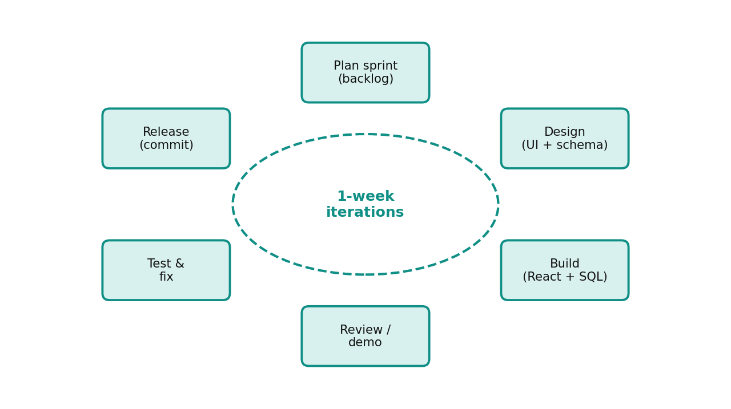
Figure 3.1: Iterative sprint cycle followed in the project
Table 3.7: Sprint plan and deliverables (dates from the Git history)
Sprint | Period | Main deliverables
Sprint 1 | 16 – 23 Aug 2026 | Supabase configuration and fallbacks, .env setup, authentication fixes, role selection
Sprint 2 | 24 – 31 Aug 2026 | Connected messaging and ratings, role-specific profile titles and talent filters, role in sign-up metadata
Sprint 3 | 1 – 5 Sep 2026 | Login page redesign, Google sign-in fix, developer and client onboarding, removal of mock data, cover images
Sprint 4 | 4 – 17 Sep 2026 | Team batch formation engine, CollabriX vs Upwork comparison, configuration restore
Stabilisation | 17 – 22 Sep 2026 | Bug fixes and build verification
Sprint 5 | 6 – 12 Oct 2026 | Collaboration core migration (notifications, invitations, project lifecycle, settings, support), rework of 20+ screens, database test suite, report update

3.3.1 Design Thinking and User-Centric Principles
We applied the five stages of design thinking:
- Empathise — studying how freelancers and clients use existing platforms (Chapter 2) and listing the frustrations of both sides, such as bidding fatigue and finding trustworthy partners.
- Define — the core problem statement: “Freelance developers cannot easily find trusted partners and deliver as a team on the same platform where clients hire them.”
- Ideate — brainstorming produced ideas such as squads, synergy scores, completion-gated ratings and a public leaderboard.
- Prototype — the first clickable prototype was generated with Lovable and then refined by hand in code.
- Test — each sprint build was exercised by the team in both roles; the findings led to changes such as separating client and developer profile titles (commit of 30 Aug 2026) and removing mock data (2 Sep 2026).

3.3.2 Quality Assurance Strategy
- Static analysis: the TypeScript compiler (tsc --noEmit) and ESLint with React Hooks rules on every significant change.
- Automated UI tests: headless Chrome driven by Puppeteer to exercise authentication flows and responsive layout.
- Security verification: direct queries with an anonymous Supabase client to confirm that RLS denies private reads and unauthenticated writes.
- Performance audit: Google Lighthouse on the production build.
- Manual acceptance testing: two-account scenarios for connections, messaging, team batches and ratings (Section 4.2.1).
- Database test suite: a Python script runs 104 behaviour and security checks as different users against a local PostgreSQL 16 instance with every migration applied (Chapter 4, Section G).

3.3.3 Tools for Collaboration
Table 3.8: Collaboration and development tools
Tool | Usage
Git and GitHub | Version control; 102 commits; history used to reconstruct sprint dates
Lovable | AI-assisted generation of the initial UI scaffold and quick iterations
Visual Studio Code | Primary code editor with ESLint and Tailwind extensions
Supabase Studio | Database tables, SQL migrations, auth provider and storage configuration
Puppeteer + headless Chrome | Automated UI test cases and screenshots (Chapter 4)
Chrome DevTools / Lighthouse | Debugging, network inspection and performance audits

3.3.4 Project Timeline (Gantt Chart)
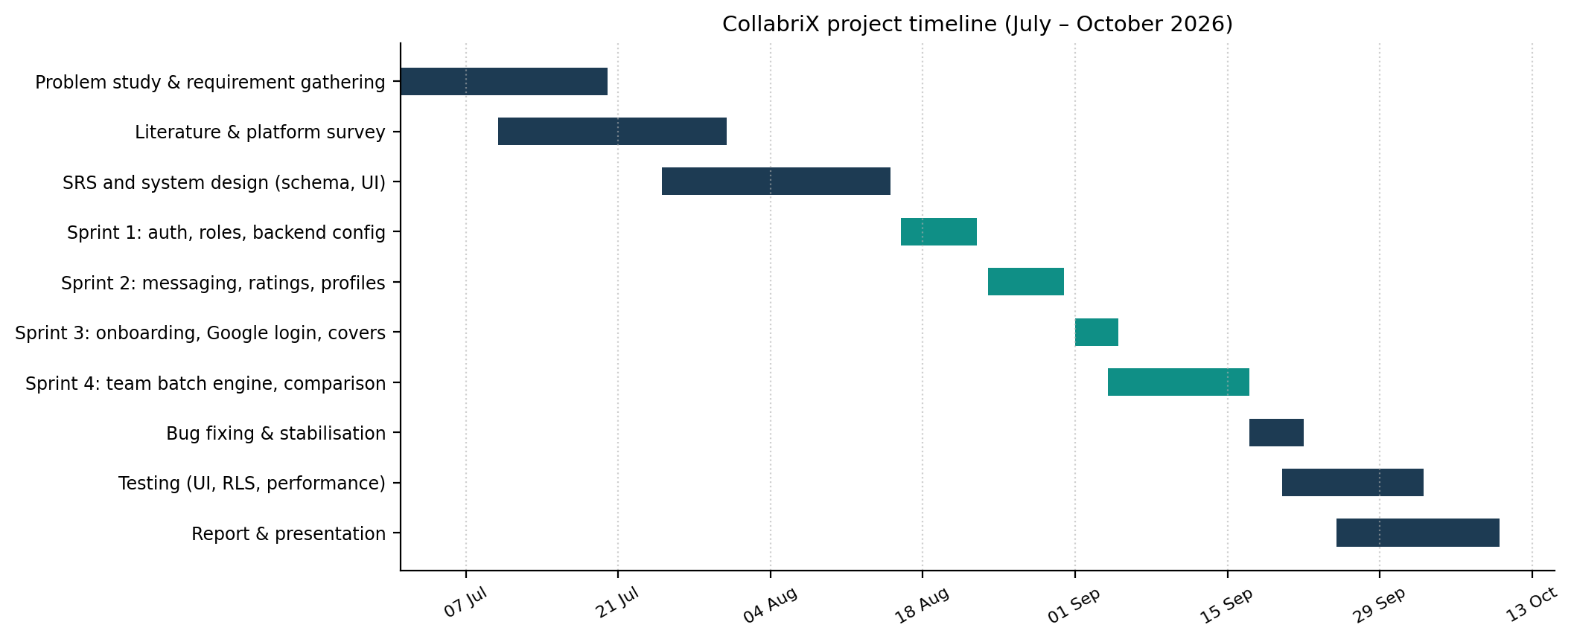
Figure 3.2: Gantt chart of the project timeline

3.4 System Architecture
CollabriX follows a client–server architecture with a backend-as-a-service (BaaS). The client is a single-page application that runs entirely in the browser. Instead of a custom application server, it talks directly to Supabase, which exposes the PostgreSQL database through an auto-generated REST API (PostgREST), authenticates users with JWTs, and broadcasts database changes over WebSockets. Business rules about who may do what are implemented as Row-Level Security policies and triggers inside PostgreSQL, so they apply no matter which client sends the request.
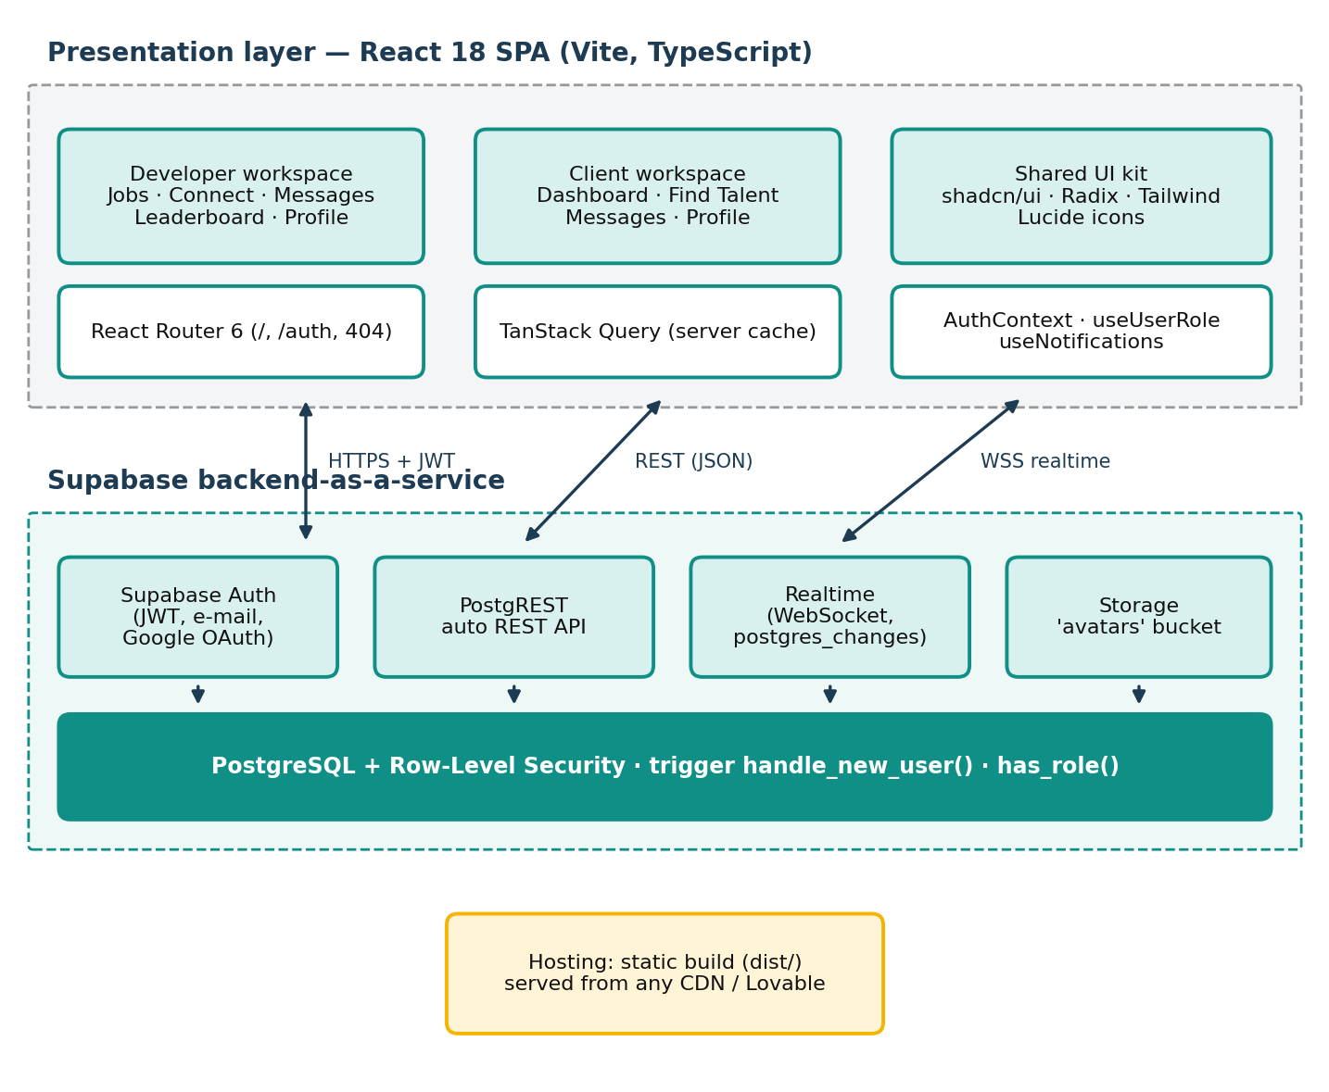
Figure 3.3: Layered system architecture of CollabriX
Table 3.9: Architectural layers and responsibilities
Layer | Components | Responsibility
Presentation | Pages (Index, Auth, Notifications, Settings, Support, Profile view, Project details, NotFound), 10 screens, 21 UI primitives | Rendering, navigation, form validation
State | AuthContext, AppShell, useUserRole, useConnections, useNotificationFeed, useUserSettings, TanStack Query | Session, role, unread counts, cached server data
API | supabase-js → PostgREST, Auth, Realtime, Storage | HTTP and WebSocket communication
Data & security | 12 tables, RLS on every table, validation and notification triggers, security-definer functions | Persistence, integrity, authorisation
The extension keeps this layering but moves more responsibility into the data layer. Every workflow that changes the state of a shared object (accepting a request, assigning a developer, completing a project) is either guarded by a trigger or performed by a database function, so a modified client cannot skip a step. The front end calls these functions through PostgREST's remote procedure call (RPC) endpoint, and renders loading, error and empty states based on the real response.

3.5 Database Design
The database consists of twelve application tables in the public schema plus the auth.users table managed by Supabase. Every profile row shares its primary key with the corresponding auth.users row, which makes auth.uid() directly comparable with profile identifiers inside RLS policies. The seven original tables are shown in the entity–relationship diagram below; the five tables and the columns added by the collaboration extension are shown in Figure 3.5.
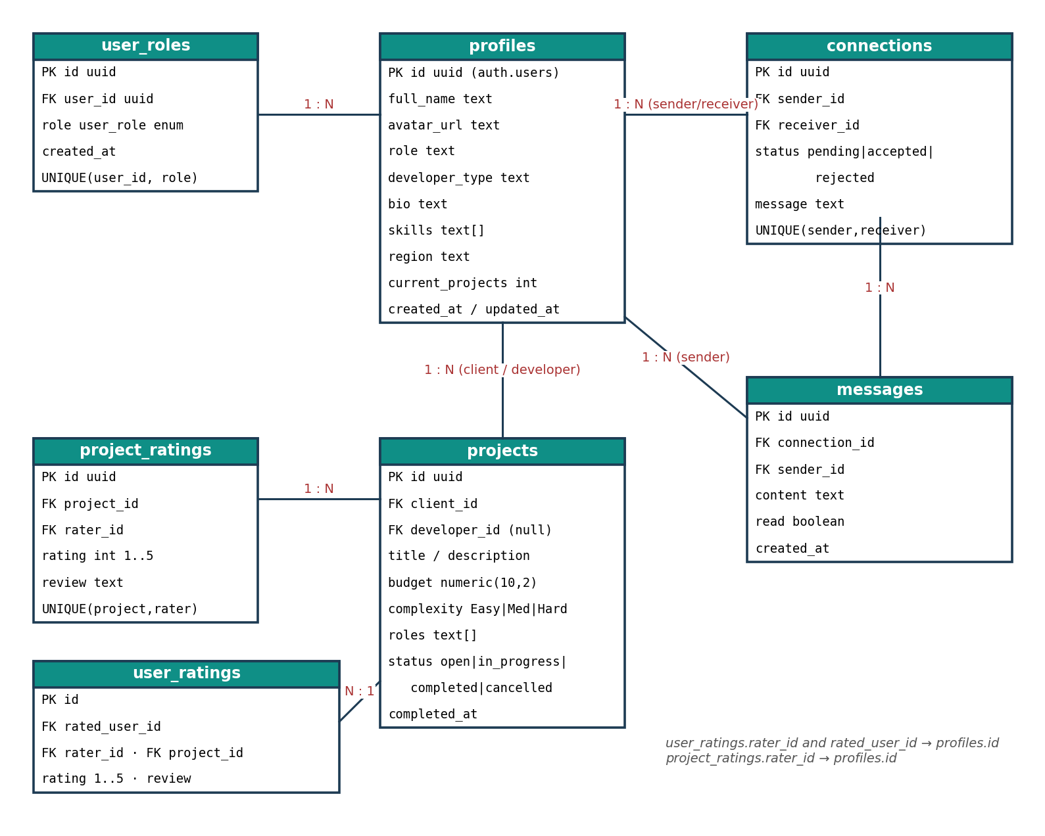
Figure 3.4: Entity–relationship diagram
Table 3.10: Description of database tables
Table | Purpose | Key constraints
profiles | Public identity: name, avatar, bio, role title, developer type, skills, region | PK = auth.users.id (ON DELETE CASCADE)
user_roles | Authorisation role: developer or client (enum user_role) | UNIQUE(user_id, role); one role per user via RLS
connections | Connection requests between two profiles | status ∈ {pending, accepted, rejected}; UNIQUE(sender, receiver)
messages | Chat messages inside a connection | FK connection_id; read flag; realtime enabled
projects | Work posted by a client, optionally assigned to a developer | complexity ∈ {Easy, Medium, Hard}; status ∈ {open, in_progress, completed, cancelled}
project_ratings | Rating of a project by a participant | rating 1–5; UNIQUE(project_id, rater_id)
user_ratings | Rating of one participant by another | rating 1–5; UNIQUE(rated_user, rater, project)
team_batches | Saved team batches with members, roles and synergy score | 1–10 members, accepted connections only, no duplicates (trigger)
notifications | In-app notifications for one recipient | type ∈ 10 values; rows created only by triggers
project_invitations | A client's invitation of a developer to a project | status ∈ {pending, accepted, declined, cancelled}; UNIQUE(project, developer)
user_settings | Notification preferences, leaderboard visibility, theme | PK = user_id; own row only
support_tickets | Help requests with a public ticket number | category and status CHECKs; subject 5–150, description 20–5000 characters

The following table gives the data dictionary of the central profiles table, which is read by almost every screen.
Table 3.11: Data dictionary of the profiles table
Column | Type | Default / constraint | Description
id | uuid | PK, FK → auth.users(id) ON DELETE CASCADE | Same identifier as the authentication account
full_name | text | from sign-up metadata, else 'New User' | Person's name, or company name for clients
avatar_url | text | nullable | Public URL of the image in the avatars bucket
role | text | 'Full Stack Developer' or 'Client' | Headline shown on cards; used to hide clients from talent search
developer_type | text | 'Full Stack Developer'; NULL for clients | Specialisation used by type filters
bio | text | nullable | Free-text professional summary
skills | text[] | '{}' | Skill tags used for search and synergy scoring
region | text | nullable | Continent or country used by the region filter
current_projects | integer | NOT NULL DEFAULT 0 | Workload counter reserved for team suggestions
created_at / updated_at | timestamptz | now(); trigger updates updated_at | Audit timestamps
Figure 3.5 shows how the collaboration extension connects to the existing schema. All new tables reference profiles (and therefore auth.users) with ON DELETE CASCADE, so deleting an account removes its notifications, settings, invitations and tickets automatically.
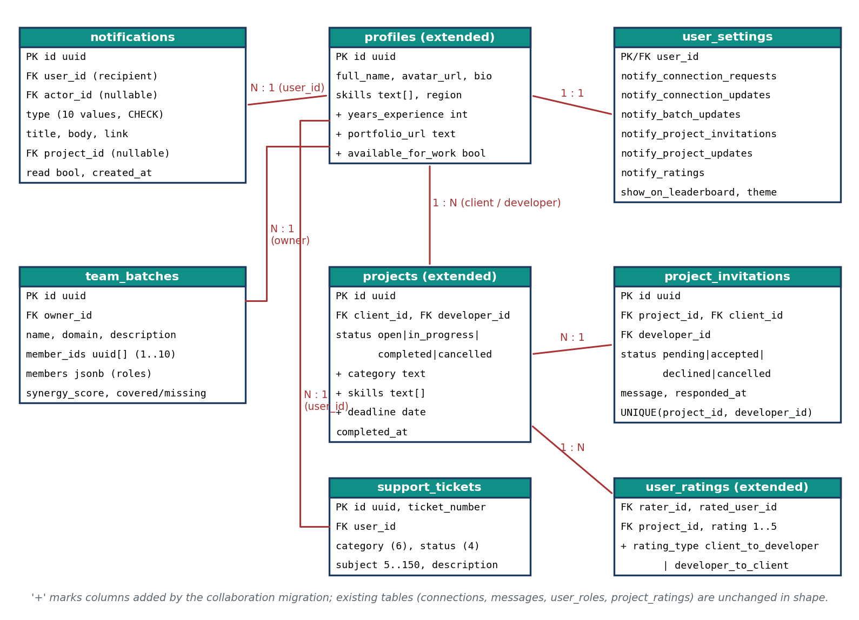
Figure 3.5: Entity–relationship diagram of the collaboration extension
The notifications table, which every screen reads through the header bell, is described column by column below.
Table 3.12: Data dictionary of the notifications table
Column | Type | Default / constraint | Description
id | uuid | PK, gen_random_uuid() | Identifier
user_id | uuid | FK → profiles, NOT NULL | Recipient; the only user who can read the row
actor_id | uuid | FK → profiles, nullable | User who caused the event (shown as avatar)
type | text | CHECK: 10 allowed values | Event kind, e.g. connection_request, project_assigned
title / body | text | title NOT NULL | Human-readable message composed by the trigger
link | text | nullable | In-app route opened on click, e.g. /projects/<id>
entity_id | uuid | nullable | Related connection, batch or project
read | boolean | DEFAULT false | Changed only through mark_notification_read functions
created_at | timestamptz | DEFAULT now() | Ordering of the feed

3.6 UML Design Diagrams

3.6.1 Use Case Diagram
The use case diagram below shows the main use cases. Developers and clients share messaging, profile editing and rating; developer-only use cases cover networking and team formation, while client-only use cases cover company onboarding, talent search and the dashboard.
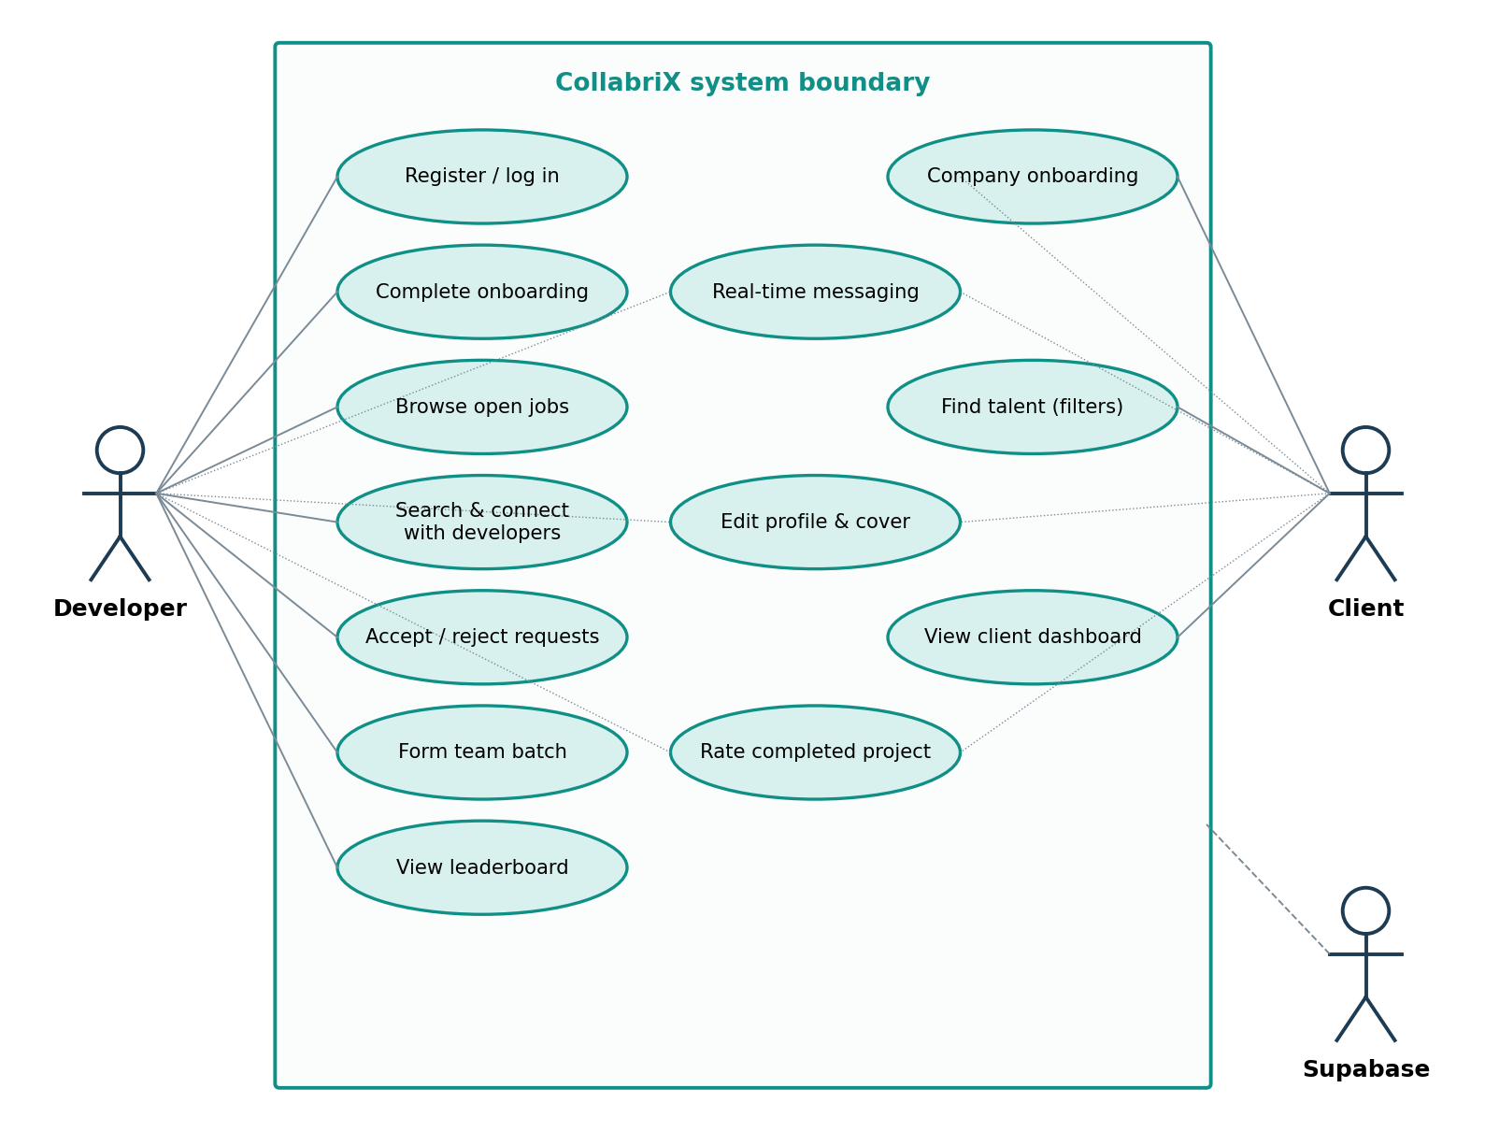
Figure 3.6: Use case diagram

3.6.2 Sequence Diagram — Registration and Onboarding
The sequence diagram below shows the sign-up flow. The role is passed as user metadata so that the database trigger handle_new_user() can create both the profile and the role record atomically, before the client even receives the session.
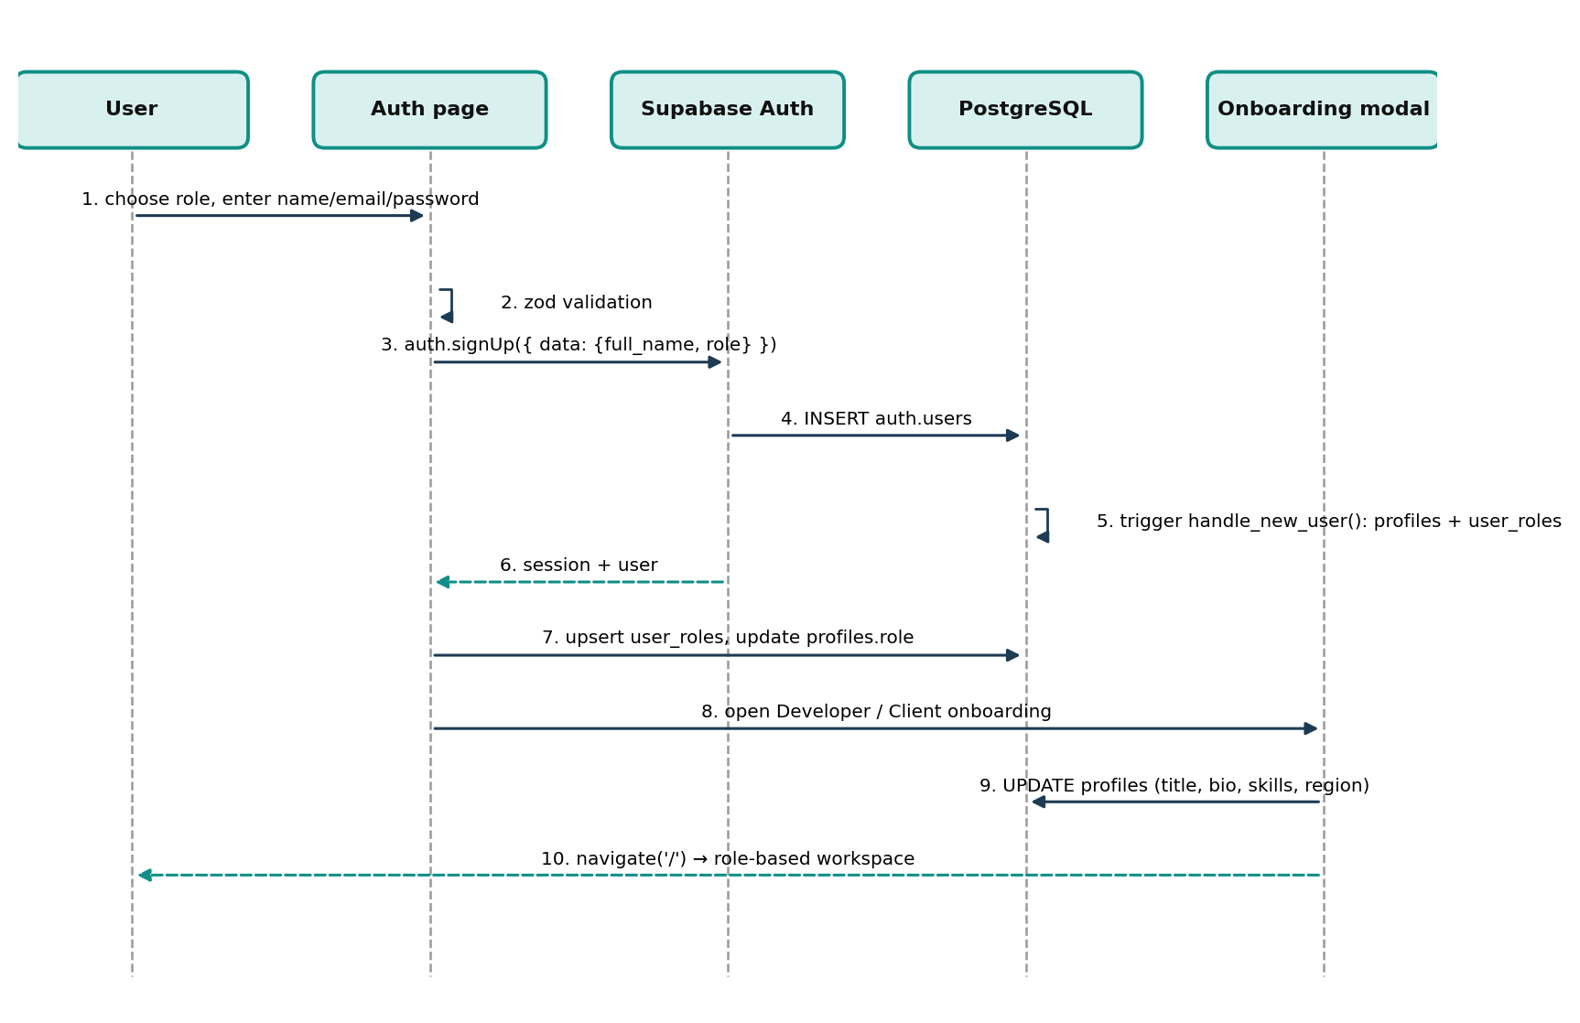
Figure 3.7: Sequence diagram for registration and onboarding

3.6.3 Sequence Diagram — Connection and Real-time Messaging
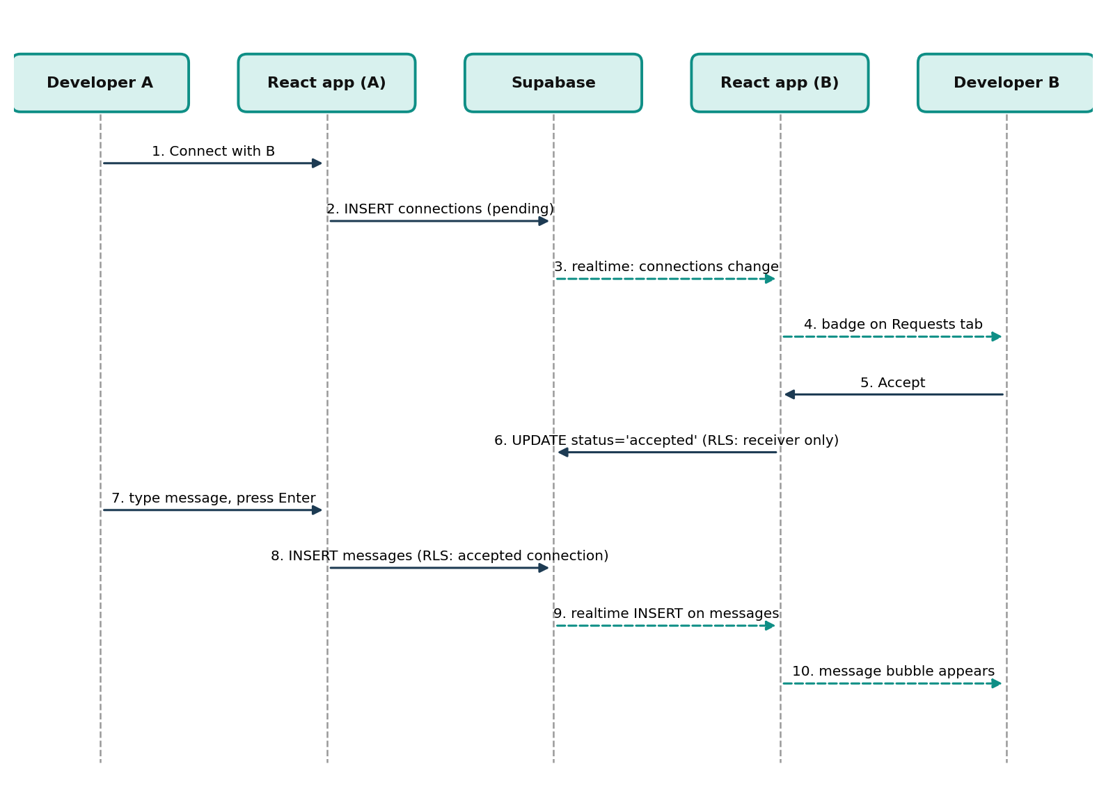
Figure 3.8: Sequence diagram for connection request and messaging

3.6.4 Navigation Design
Navigation is driven by a single route (/) whose content depends on the active tab and the user's role. This keeps transitions instant (no page reloads) and makes the application feel like a native mobile app.
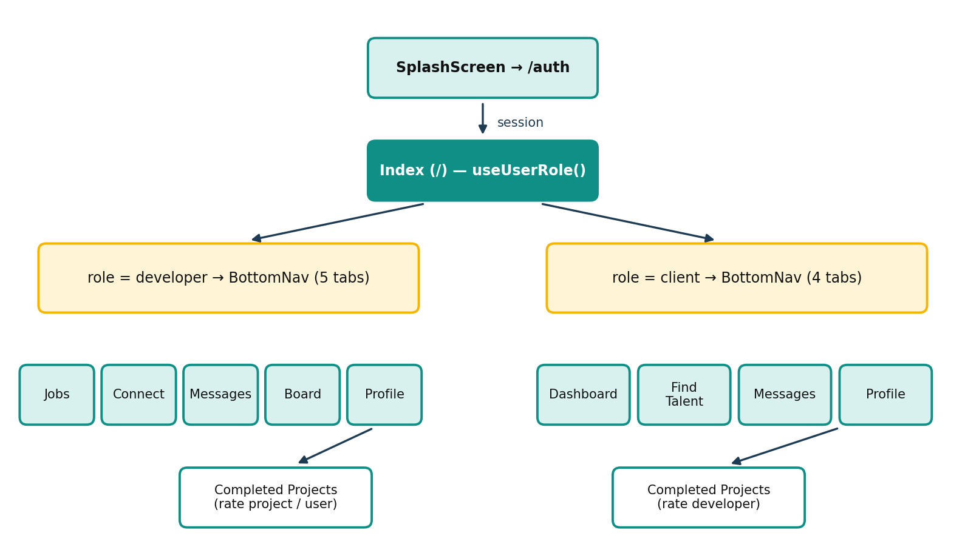
Figure 3.9: Role-based navigation map
The extended version keeps tab-based navigation for the two workspaces but stores the active tab in the URL (/?tab=connect&view=requests), so refresh, back/forward and links from notifications work. Five pages that are shared by both roles were added as real routes. All of them are wrapped by the same AppShell component, which redirects signed-out visitors to /auth and returns them to the requested page after login.

3.6.5 State Diagram — Connection Requests
A connection request is a small state machine. The rules are enforced by two triggers on the connections table: validate_connection_insert forces every new row to pending and blocks requests to oneself and duplicates in the reverse direction, and validate_connection_update allows only the receiver to move a pending request to accepted or rejected and freezes the participants (Listing 3.3).
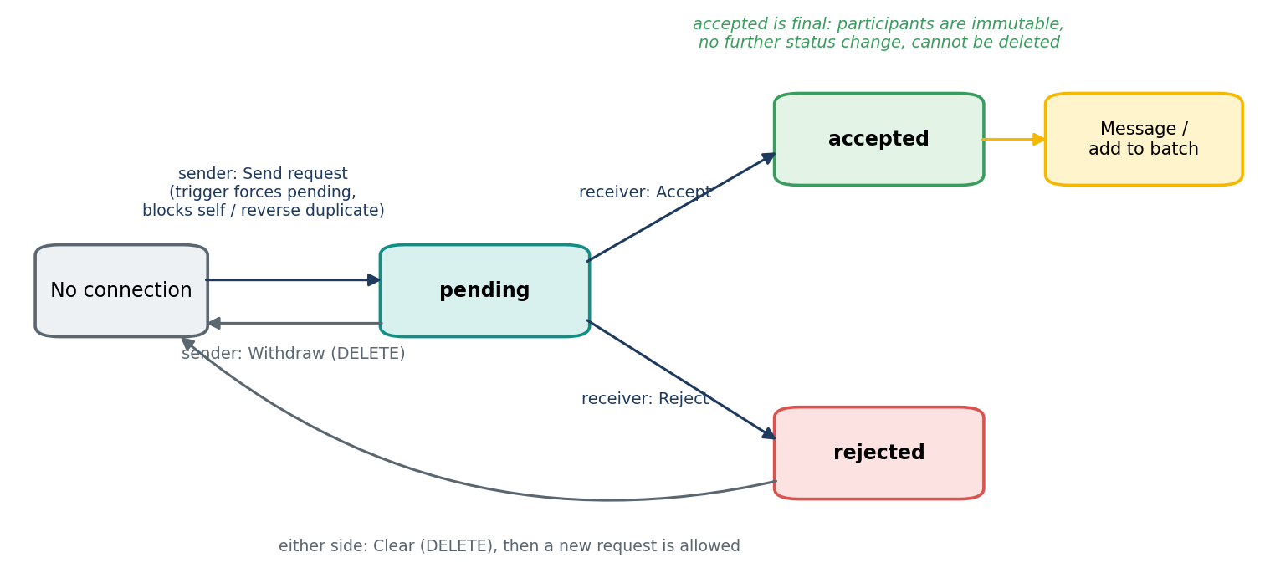
Figure 3.10: State diagram of a connection request

3.6.6 State Diagram — Project and Invitation Lifecycle
Projects and invitations have coupled lifecycles. A project starts open; it becomes in_progress only when the client assigns a developer who has accepted an invitation, and completed only when the client marks it complete, which is the event that unlocks ratings. Invitations move from pending to accepted or declined by the developer's answer, and the remaining pending invitations are cancelled automatically when another developer is assigned.
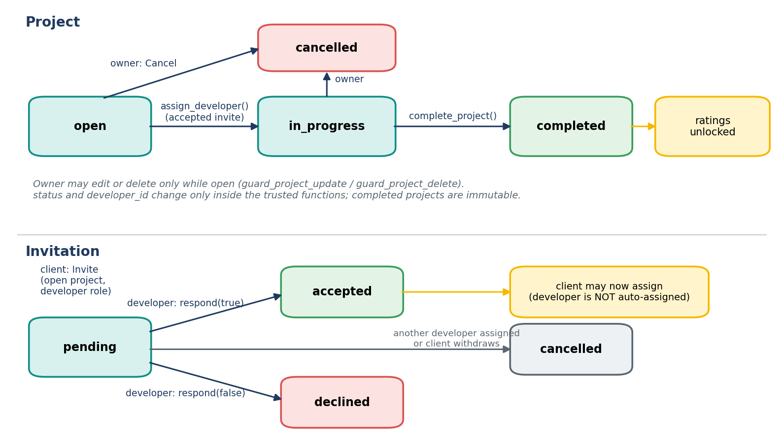
Figure 3.11: State diagrams of the project and invitation lifecycles

3.6.7 Sequence Diagram — From Invitation to Rating
Figure 3.12 follows one engagement from end to end. Dashed arrows are notifications produced by database triggers and delivered over Realtime; every solid arrow towards Supabase is checked by RLS or by a security-definer function before it changes any data.
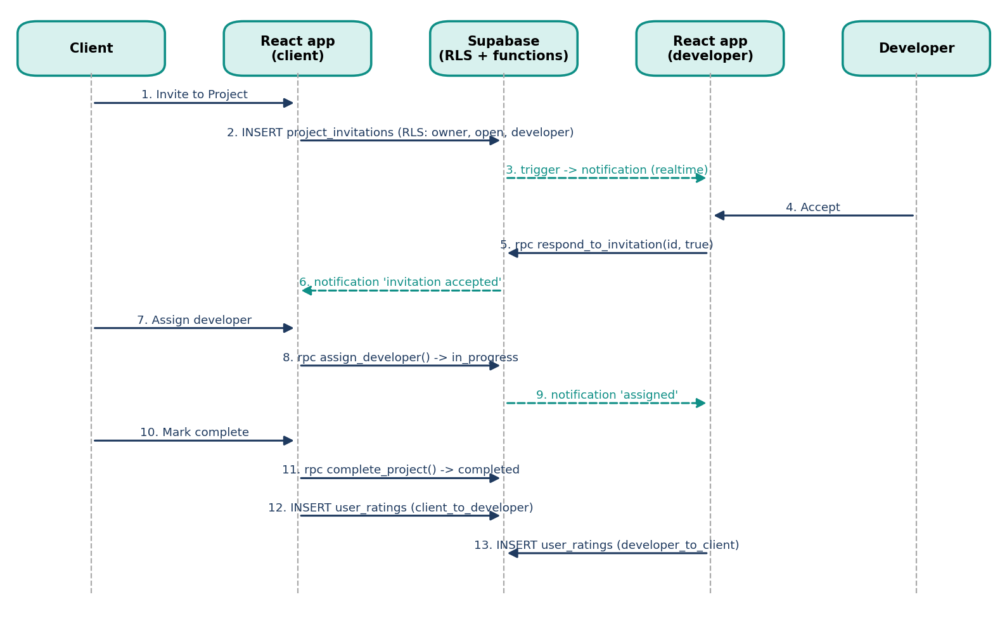
Figure 3.12: Sequence diagram from invitation to two-way rating

3.7 User Interface Design
The interface follows a mobile-first, component-driven approach. Design tokens (colours, radii, shadows, gradients) are defined once as CSS custom properties in index.css and consumed through Tailwind utility classes, so the whole application can switch between light and dark themes by toggling a single class. The primary colour is teal (HSL 175° 80% 35%), chosen to convey trust and calm. Components such as buttons, dialogs, tabs and selects come from shadcn/ui, which wraps accessible Radix UI primitives — keyboard navigation and ARIA attributes are therefore built in.
- Consistency: every screen uses the same card, badge and empty-state patterns.
- Feedback: loading spinners for every fetch, and toast messages for every mutation.
- Progressive disclosure: filters are hidden behind a filter button; onboarding is split into three short steps.
- Honest states: every list has loading, error-with-retry and empty states; destructive actions use an in-app confirmation dialog, and a success message appears only after the database confirms the change.
- URL-driven navigation: tabs and sub-views live in the query string, so every screen can be linked to, refreshed and reached from a notification.
- Accessibility: icon-only buttons have labels, rows that open a profile are keyboard-focusable, and colour is never the only signal of state.

3.8 Communication Profile
CollabriX uses two communication channels between the browser and the backend. Request–response operations (reading profiles, inserting a message, updating a connection) travel over HTTPS to PostgREST with the user’s JWT in the Authorization header [14]. Change notifications travel the other way over a single multiplexed WebSocket connection to Supabase Realtime [13], on which the client opens one channel per subscription. The following table summarises the channels used.
Table 3.13: Communication channels used by CollabriX
Channel | Protocol | Direction | Used for
PostgREST API | HTTPS + JSON, JWT | Client → server | All reads and writes on application tables
Supabase Auth | HTTPS + JSON | Client ↔ server | Sign-up, login, OAuth redirect, token refresh
Realtime: messages-<id> | WebSocket | Server → client | New messages in an open chat thread
Realtime: connection-requests | WebSocket | Server → client | New or updated requests for the receiver
Realtime: notifications-* | WebSocket | Server → client | Unread badge counts in header and navigation
Storage API | HTTPS (multipart) | Client → server | Avatar upload; public URL for display
RPC functions | HTTPS + JSON, JWT | Client → server | respond_to_invitation, assign_developer, complete_project, get_leaderboard, mark_*_read
Realtime: notifications-feed | WebSocket | Server → client | New notifications for the signed-in user
Realtime: my-connections | WebSocket | Server → client | Requests accepted, rejected or withdrawn on either side

- Caching: TanStack Query caches project and rating queries and invalidates them after mutations, avoiding repeated network calls.
- Realtime instead of polling: Supabase channels subscribe to postgres_changes filtered by connection or receiver, so only relevant events reach each client.
- Embedded joins: a single PostgREST request fetches a project together with its client, developer and ratings using foreign-key embedding.
- Integration: Google OAuth via Supabase Auth; Supabase Storage for avatars; environment variables (VITE_SUPABASE_URL, VITE_SUPABASE_PUBLISHABLE_KEY) for configuration.

3.9 Security Design
Security is designed on a zero-trust principle: the browser holds only a public (publishable) key, and the database decides on every row. The following table lists the policies implemented in the migrations.
Table 3.14: Row-Level Security policies implemented
Table | Operation | Policy (who is allowed)
profiles | SELECT / INSERT / UPDATE | Everyone may read; a user may insert and update only the row where id = auth.uid()
user_roles | SELECT / INSERT | Read own role; insert only developer/client and only if the user has no role yet
connections | SELECT / INSERT / UPDATE / DELETE | Parties may read; sender inserts (always pending); only the receiver answers a pending request; sender may withdraw a pending request; accepted connections are permanent
messages | SELECT / INSERT / UPDATE | Only members of an accepted connection may read or send; sender may update own messages
projects | SELECT / INSERT / UPDATE / DELETE | Anyone may read; only users with the client role create (status open); owner edits or deletes while open; status and assignment change only through functions
project_ratings | SELECT / INSERT | Anyone may read; insert only by a participant of a completed project
user_ratings | SELECT / INSERT | Only the counterpart of a completed project; direction recorded by trigger; ratings cannot be edited
team_batches | SELECT / INSERT / UPDATE / DELETE | Owner and members may read; owner writes; trigger accepts only 1–10 accepted connections
notifications | SELECT / DELETE | Recipient only; no INSERT or UPDATE policy, so rows come only from triggers
project_invitations | SELECT / INSERT / DELETE | Client and developer read; owner of an open project invites a developer; client withdraws a pending invitation
user_settings | SELECT / INSERT / UPDATE | Own row only
support_tickets | SELECT / INSERT | Own tickets only; new tickets must be open; status changed by administrators
storage: avatars | INSERT / UPDATE / DELETE | Only inside the folder named after the user's own id

Additional measures include input validation with Zod on the client, parameterised queries through PostgREST (eliminating SQL injection), React's automatic output escaping (mitigating XSS), and SECURITY DEFINER functions with a fixed search_path to prevent search-path hijacking.
The back end is defined entirely in SQL migrations, which makes it reproducible on any Supabase project. The most important piece is the trigger that runs when a new user is inserted into auth.users. It reads the role from the sign-up metadata and provisions both the profile and the role record:
Listing 3.1: Sign-up trigger (abridged)
CREATE OR REPLACE FUNCTION public.handle_new_user()
RETURNS TRIGGER LANGUAGE plpgsql SECURITY DEFINER SET search_path = public AS $$
DECLARE user_role_val public.user_role; raw_role text;
BEGIN
raw_role := NEW.raw_user_meta_data ->> 'role';
IF raw_role = 'client' THEN user_role_val := 'client';
ELSE user_role_val := 'developer'; END IF;
INSERT INTO public.profiles (id, full_name, avatar_url, role, developer_type)
VALUES (NEW.id, COALESCE(NEW.raw_user_meta_data ->> 'full_name', 'New User'), ...)
ON CONFLICT (id) DO UPDATE SET full_name = EXCLUDED.full_name, ...;
INSERT INTO public.user_roles (user_id, role) VALUES (NEW.id, user_role_val)
ON CONFLICT (user_id, role) DO NOTHING;
RETURN NEW;
END; $$;

Ratings are protected by a policy that checks project participation and completion status in the same statement:
Listing 3.2: Completion-gated rating policy
CREATE POLICY "Users can rate others from completed projects"
ON public.user_ratings FOR INSERT WITH CHECK (
auth.uid() = rater_id AND auth.uid() != rated_user_id AND
EXISTS (SELECT 1 FROM public.projects p
WHERE p.id = project_id
AND (p.client_id = auth.uid() OR p.developer_id = auth.uid())
AND p.status = 'completed'));

The messages and connections tables are added to the supabase_realtime publication so that inserts and updates are broadcast to subscribed clients, and an updated_at trigger keeps modification timestamps accurate on profiles, connections and projects.

3.9.1 Workflow Rules Enforced by Triggers
RLS answers the question who may touch this row, but not which change is allowed. For example, the receiver of a connection request is allowed to update the row, yet must not be able to rewrite the sender or turn an accepted connection back into a rejected one. CollabriX therefore pairs RLS with BEFORE triggers that validate the change itself. Listing 3.3 shows the trigger for connection updates.
Listing 3.3: Validation trigger for connection updates (abridged)
CREATE FUNCTION public.validate_connection_update() RETURNS TRIGGER AS $$
BEGIN
IF NEW.sender_id <> OLD.sender_id OR NEW.receiver_id <> OLD.receiver_id THEN
RAISE EXCEPTION 'Connection participants cannot be changed'
USING ERRCODE = 'insufficient_privilege';
END IF;
IF NEW.status <> OLD.status THEN
IF OLD.status <> 'pending' OR NEW.status NOT IN ('accepted','rejected') THEN
RAISE EXCEPTION 'Invalid connection status change from % to %',
OLD.status, NEW.status USING ERRCODE = 'check_violation';
END IF;
IF auth.uid() IS NOT NULL AND auth.uid() <> OLD.receiver_id THEN
RAISE EXCEPTION 'Only the receiver can respond to a connection request';
END IF;
END IF;
RETURN NEW;
END; $$ LANGUAGE plpgsql;

The same pattern protects the other tables: validate_team_batch checks the size and membership of a batch, guard_project_update and guard_project_delete stop owners from changing assignment, completion or finished projects, and prepare_user_rating derives the rating direction from the project instead of trusting the client.

3.9.2 Trusted Operations and Security-Definer Functions
Some changes are legitimate only as part of a larger operation. A client may not set developer_id on a project directly, but assigning a developer who accepted an invitation must do exactly that. These operations are implemented as SECURITY DEFINER functions that first check the caller with auth.uid(), then set a transaction-local flag (collabrix.trusted) that the guard trigger recognises, and finally make the change. Because the flag is set with set_config(..., true), it disappears at the end of the transaction and cannot be set by a normal API request. Table 3.15 lists the functions and Listing 3.4 shows the most important one.
Table 3.15: Database functions exposed to or used by the application
Function | Caller | What it checks / does
respond_to_invitation(id, accept) | Invited developer | Invitation is theirs and still pending; records the answer; notifies the client
assign_developer(project, developer) | Project owner | Project is open and unassigned; developer accepted an invitation; starts the project; cancels other pending invitations
complete_project(project) | Project owner | Project is in progress; sets completed and completed_at; notifies the developer
get_leaderboard(since) | Signed-in users | Computes scores from verified completed projects and client ratings (Algorithm 2)
mark_notification_read(id) | Recipient | Marks one of the caller's own notifications as read
mark_all_notifications_read() | Recipient | Marks all of the caller's notifications as read; returns the count
mark_messages_read(connection) | Connection party | Marks the other party's messages in that conversation as read
create_notification(...) | Triggers only | Respects the recipient's preferences; never notifies users about their own actions; EXECUTE revoked from clients
Listing 3.4: Assigning a developer only after an accepted invitation (abridged)
CREATE FUNCTION public.assign_developer(_project_id UUID, _developer_id UUID)
RETURNS void LANGUAGE plpgsql SECURITY DEFINER SET search_path = public AS $$
DECLARE proj public.projects%ROWTYPE;
BEGIN
SELECT * INTO proj FROM projects WHERE id = _project_id FOR UPDATE;
IF NOT FOUND OR proj.client_id <> auth.uid() THEN
RAISE EXCEPTION 'Project not found'; END IF;
IF proj.status <> 'open' OR proj.developer_id IS NOT NULL THEN
RAISE EXCEPTION 'Only open, unassigned projects can be assigned'; END IF;
IF NOT EXISTS (SELECT 1 FROM project_invitations i WHERE i.project_id = _project_id
AND i.developer_id = _developer_id AND i.status = 'accepted') THEN
RAISE EXCEPTION 'You can only assign a developer who accepted your invitation';
END IF;
PERFORM set_config('collabrix.trusted', 'on', true);
UPDATE projects SET developer_id = _developer_id, status = 'in_progress'
WHERE id = _project_id;
UPDATE project_invitations SET status = 'cancelled'
WHERE project_id = _project_id AND developer_id <> _developer_id AND status = 'pending';
PERFORM set_config('collabrix.trusted', 'off', true);
PERFORM create_notification(_developer_id, proj.client_id, 'project_assigned', ...);
END; $$;

The row is locked with SELECT ... FOR UPDATE, so two concurrent assignments cannot both succeed, and the whole function runs in one transaction: either the project starts, the other invitations are cancelled and the developer is notified, or nothing changes.

3.9.3 Threat Model Review
Table 3.16 reviews the main abuse cases of the extended platform and where each one is stopped. Each row marked tested is covered by the database test suite in Chapter 4.
Table 3.16: Threats considered and their mitigations
Threat | Example | Mitigation
Forged notifications | User inserts a fake “rating received” notification for someone else | No INSERT policy on notifications; create_notification revoked from clients (tested)
Self-assignment | Developer sets developer_id on a project | guard_project_update rejects direct changes; only assign_developer may assign (tested)
Assignment without consent | Client assigns a developer who never accepted | assign_developer requires an accepted invitation (tested)
Rating abuse | Rating without working together, rating twice, rating oneself | Insert policy requires the counterpart of a completed project; UNIQUE constraint (tested)
Request spoofing | Sending a request on someone else's behalf, accepting one's own request | RLS on sender_id; trigger allows only the receiver to answer (tested)
Data exposure | Reading other users' tickets, invitations or notifications | Row-owner SELECT policies; anonymous reads return no rows (tested)
Privilege escalation | Inserting an admin role for oneself | user_roles insert limited to developer/client and only if no role exists
Secret leakage | Service-role key shipped to the browser | Only the publishable key is bundled; build scanned for service_role
Cross-site scripting | Script in a project description or message | React escapes output; no dangerouslySetInnerHTML for user content

3.10 Module Implementation

3.10.1 Project Structure
The source code contains approximately 14,200 lines of TypeScript/TSX in 86 files in the src folder (up from about 9,700 before the extension) and eleven SQL migration files. The following table summarises the main folders.
Table 3.17: Source code organisation
Folder | Contents
src/pages | Index (role-based shell), Auth, NotificationsPage, SettingsPage, SupportPage, ProfileViewPage, ProjectDetailsPage, NotFound
src/screens | JobsScreen, ConnectScreen, MessagesScreen, LeaderboardScreen, ProfileScreen, ClientDashboard, ClientFindTalentScreen, ClientMessagesScreen, ClientProfileScreen, CompletedProjectsScreen
src/components | auth (onboarding), connect (ConnectionAction, search, requests, connections, message thread, team engine), layout (AppShell, Header, BottomNav), projects (PostProjectDialog, InviteToProjectDialog), gamification, cards, ratings, profile, filters, ConfirmDialog, ui (21 primitives)
src/hooks | useAuth, useUserRole, useProjects, useConnections, useNotificationFeed, useNotifications, useUserSettings, use-mobile, use-toast
src/lib | utils (class names) and errors (friendlyError: maps database errors to clear messages)
src/integrations/supabase | Typed Supabase client and generated database types
supabase/migrations | 11 SQL migrations: tables, enums, RLS policies, storage bucket, sign-up trigger, team batches, read receipts and the collaboration core (5 tables, 13 triggers, 19 functions)

3.10.2 Authentication and Role Routing
AuthProvider subscribes to onAuthStateChange before reading the existing session, so no auth event is missed during start-up. Network failures are translated into a clear message that points to the VITE_SUPABASE_URL setting. The Index page waits for both the session and the role to load, redirects anonymous users to /auth, and renders either the developer or the client screen set. The flowchart below shows the logic.
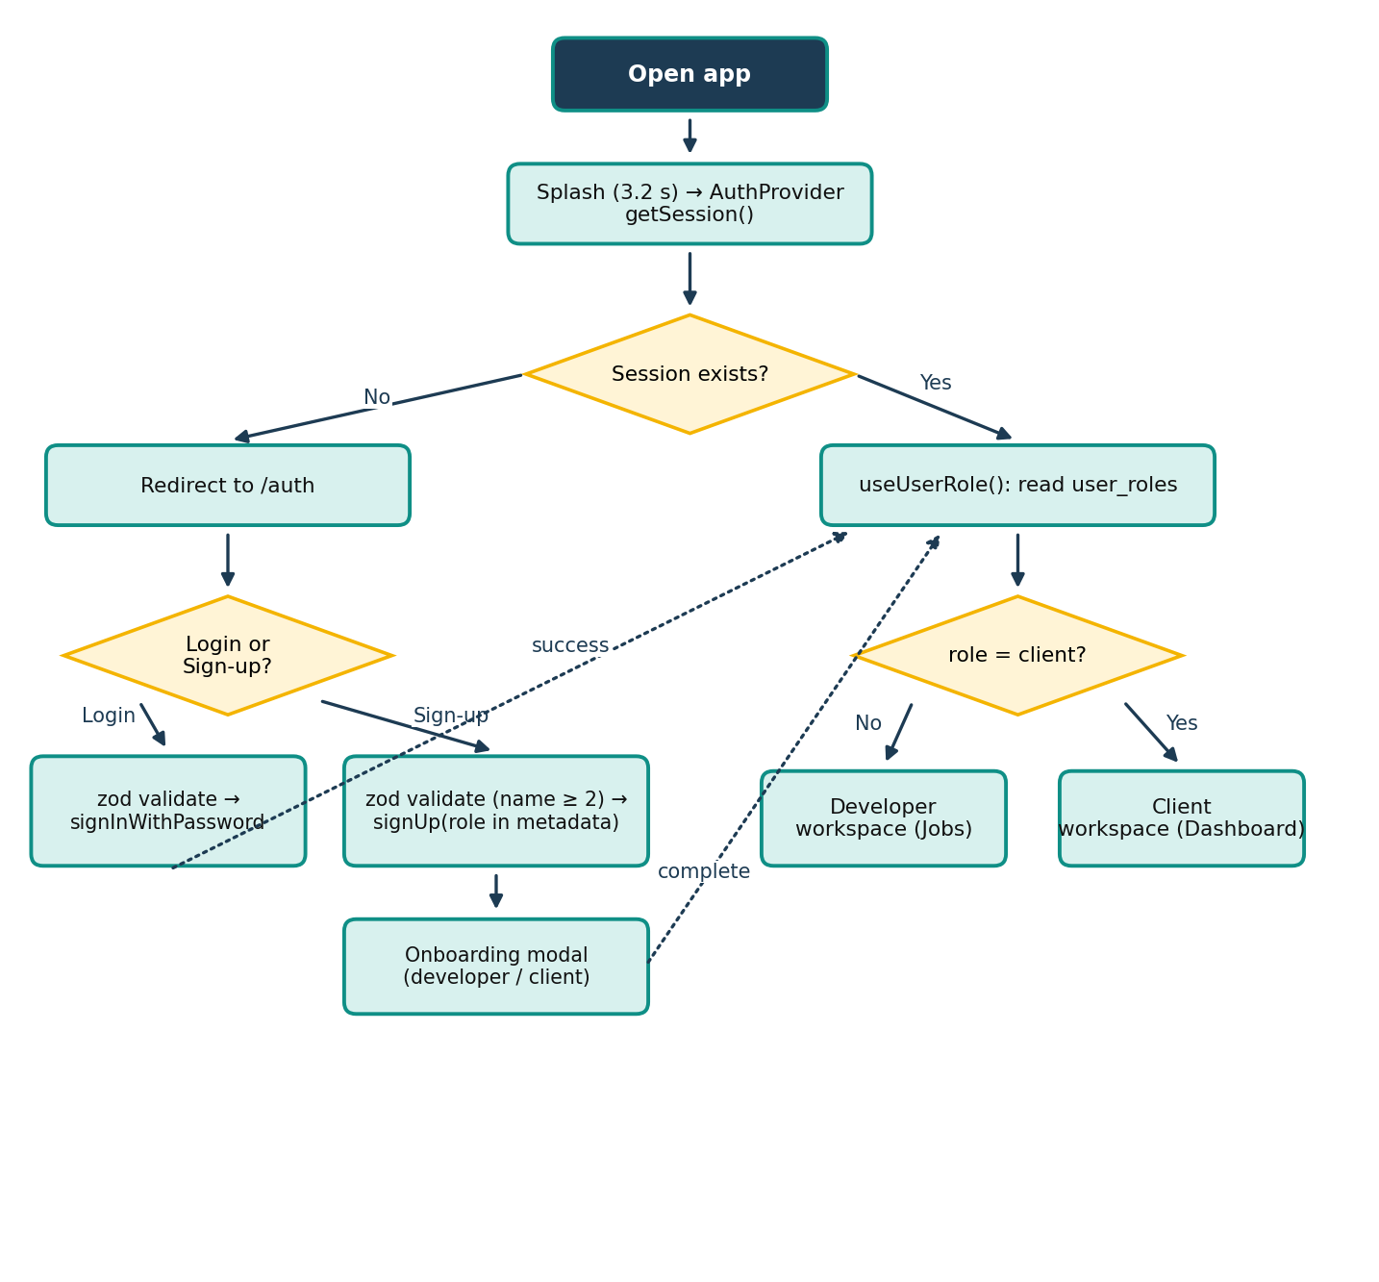
Figure 3.13: Flowchart of authentication and role-based routing
Form inputs are validated with Zod schemas before any network call: e-mail must be well-formed, the password must be non-empty and the full name must have at least two characters.
In the extended version, routing for every signed-in page is centralised in an AppShell component. It waits for the session and the role, redirects signed-out visitors to /auth while remembering the requested address, and renders the header and bottom navigation. useUserRole no longer guesses a role when the network fails; it shows an error with a retry button instead, and inserts the default developer role only when no role row exists. When a Google OAuth 2.0 sign-in [26] fails, Supabase returns the reason in the redirect URL; the application captures it before the redirect to /auth and shows it to the user instead of silently returning to the sign-in form.

3.10.3 Onboarding and Profiles
After registration, a three-step modal opens. The developer wizard offers three paths (LinkedIn link, résumé upload or manual entry) and finally shows a live preview of the profile card before saving title, bio and skills. The client wizard captures company name, website, location, industry, company size, hiring goal and mission statement. The developer profile screen shows avatar, skills, connection count, completed projects, rating summary and six dynamically earned badges; avatars are uploaded to the avatars storage bucket under the user's own folder.
The onboarding was also made honest. The LinkedIn and résumé paths previously displayed a success message without extracting any data; they now open the manual form with an explanation. The developer form validates the title and years of experience and stores years_experience in the profile, and both wizards report a real error if saving fails.

3.10.4 Developer Discovery, Connections and Requests
The Connect screen has four tabs: Find Developers, My Connections, Team Engine and Requests. Search combines free-text matching on name, type and skills with select-based filters for developer type, skill and a two-level region filter (continent → country). Each developer card shows the current connection state — Connect, Request Sent or Message — derived from the connections table. Incoming requests are loaded for the receiver and refreshed through a realtime subscription.
All buttons that relate to another person are rendered by one shared ConnectionAction component backed by the useConnections hook, which loads the user's connections once and keeps them current through a Realtime subscription. Table 3.18 lists the seven relationship states it distinguishes. The Requests tab now shows Received requests with Accept and Reject and Sent requests with Withdraw, and every name opens the person's public profile.
Table 3.18: Relationship states and the actions offered
State | Meaning | Buttons shown
self | The profile is the current user | None
none | No connection row exists | Send Connection Request
pending_sent | Current user sent a request | Request sent (disabled), Withdraw
pending_received | The other user sent a request | Accept, Reject
accepted | Both are connected | Message, Form Batch (or Connected)
rejected_sent | The other user declined | Request declined (disabled), Clear
rejected_received | Current user declined earlier | Send Connection Request (old row is cleared first)

3.10.5 Real-time Messaging
Each conversation is a MessageThread bound to one accepted connection. It loads history ordered by time and subscribes to inserts for that connection only:
Listing 3.5: Realtime subscription in MessageThread
const channel = supabase
.channel(`messages-${connectionId}`)
.on('postgres_changes',
{ event: 'INSERT', schema: 'public', table: 'messages',
filter: `connection_id=eq.${connectionId}` },
(payload) => setMessages(prev => [...prev, payload.new as Message]))
.subscribe();
return () => { supabase.removeChannel(channel); };

The inbox (MessagesScreen) lists all accepted connections with the latest message, time and unread count, sorted by recency, and is shared by both roles.
In the original version the read flag of a message was never set, because RLS allowed only the sender to update a message, so unread counts never decreased. The function mark_messages_read(connection) now marks the other party's messages as read when a conversation is opened, and the badges in the navigation update in real time.

3.10.6 Team Formation Engine
Developers create a team batch by giving it a name, a project domain and an objective, and by adding members only from accepted connections. Each member can be assigned a project role. Batches are stored in the team_batches table rather than in the browser, so members see the batches they belong to on any device and are notified when they are added. A validation trigger accepts between one and ten members, rejects the owner, duplicates and anyone who is not an accepted connection, and batches saved in the browser by older versions are imported once automatically. In the Add People dialog, other developers can be found by name and sent a connection request directly, but they can only be selected after accepting. As members are added, the engine compares the union of their skills with a recommended skill set for the selected domain and computes a synergy score using Algorithm 1.
Algorithm 1 Synergy Score Calculation for a Team Batch
1: Input: selected members M, project domain d
2: R ← DOMAIN_RECOMMENDED_SKILLS[d] ▷ default: Fullstack Web App
3: S ← ∪ { skills(m) : m ∈ M } ▷ combined stack
4: covered ← ∅; missing ← ∅
5: for each skill r ∈ R do
6: if ∃ s ∈ S : lower(s) = lower(r) or lower(s) contains lower(r) then covered ← covered ∪ {r}
7: else missing ← missing ∪ {r}
8: ratio ← |covered| / |R|
9: bonus ← min(10 × |M|, 30) ▷ team-size bonus
10: score ← min(round(70 × ratio + bonus), 100); if |M| = 0 then score ← 0
11: return score, S, missing

For example, for the Fullstack Web App domain (React, TypeScript, Node.js, PostgreSQL, UI/UX Design, AWS), a two-member team covering four of the six skills scores round(70 × 4/6 + 20) = 67 %. Missing skills are shown as skill gaps to consider, guiding the developer to invite a complementary connection.
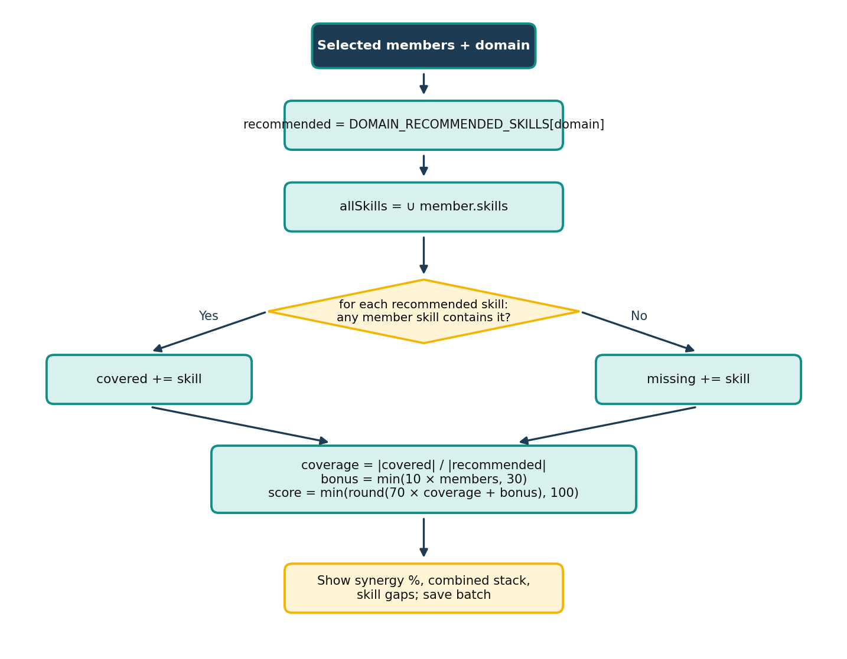
Figure 3.14: Flowchart of the synergy score algorithm

3.10.7 Projects, Ratings and Leaderboard
The useProjects hook fetches all projects, the user's own projects and completed projects using embedded joins to profiles and ratings. On the Completed Projects screen each participant sees Rate Project and a rating button for the other party (Rate Developer for the client, Rate Client for the developer). The screen checks which ratings the current user has already given (useMyGivenRatings), so each button disappears once used and shows the stars given instead. The rating dialog stays open with the review intact if saving fails. The completion-gated rating policy shown in the Security Design section makes the final decision, as the following flowchart shows.
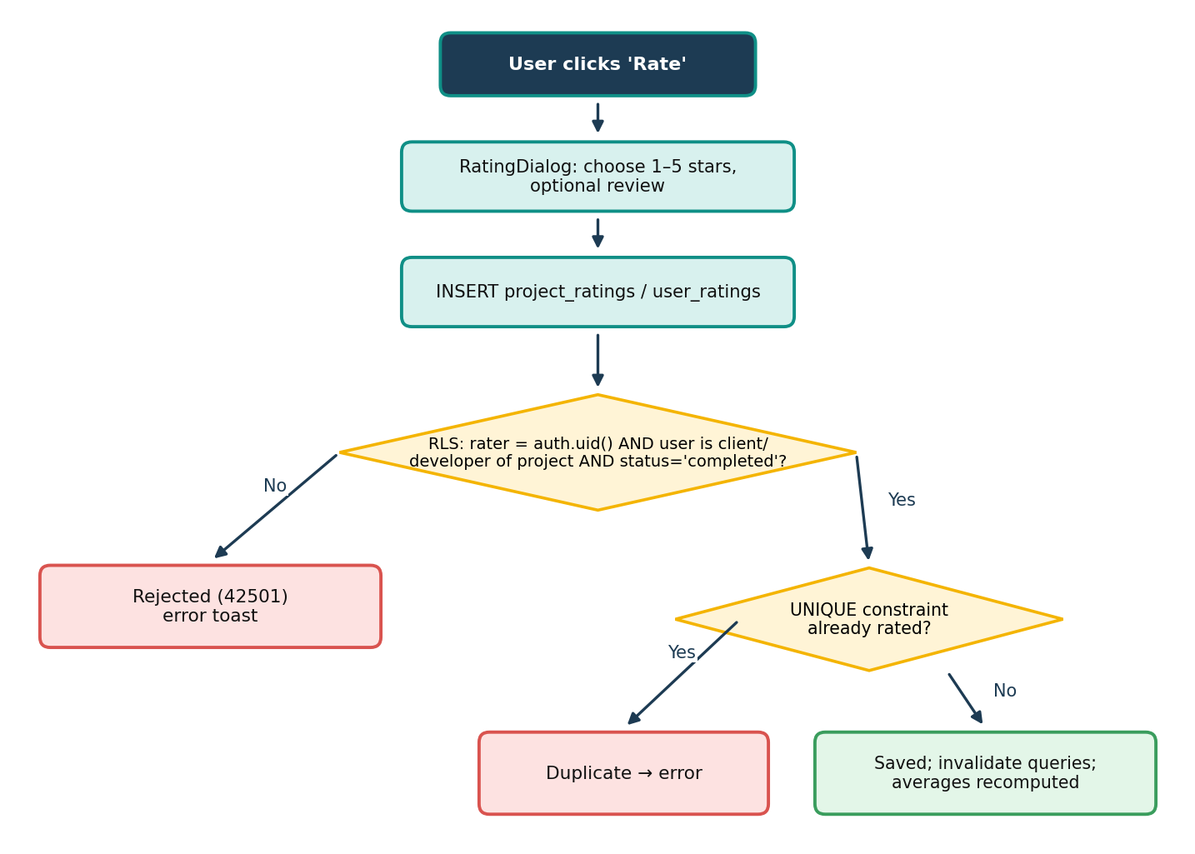
Figure 3.15: Flowchart of rating submission and validation
The leaderboard (Algorithm 2) is computed by the database function get_leaderboard, so every viewer sees the same verified numbers. A developer earns 100 points for each project a client marked complete and 20 points per star of each client rating on such a project; a completed five-star project is therefore worth 200 points. Developers without verified work are not listed (the earlier baseline average of 4.5 for unrated profiles was removed) and anyone can hide themselves in Settings. This Week and This Month pass a period start to the same function. Level tiers and six achievement badges are derived from the score, the average rating, completed projects and connections, and a How scores work panel explains the formula on screen.
Algorithm 2 Leaderboard Ranking (database function get_leaderboard)
1: Input: optional period start t₀ (NULL means all time)
2: D ← profiles with role developer whose settings allow show_on_leaderboard
3: for each developer d ∈ D do
4: C(d) ← |{ p : p.developer = d, p.status = completed, p.completed_at ≥ t₀ }|
5: R(d) ← client ratings of d on completed projects, created after t₀
6: score(d) ← 100 × C(d) + 20 × Σ rating over R(d)
7: avg(d) ← mean rating over R(d), 0 if empty; n(d) ← |R(d)|
8: end for
9: L ← { d ∈ D : C(d) > 0 or n(d) > 0 } ▷ no invented baseline
10: sort L by score ↓, avg ↓, n ↓, full_name ↑, id ↑ ▷ deterministic tie-breaks
11: rank(L[i]) ← i for i = 1 … |L|
12: return L

Table 3.19 works through the formula for six developers. It also shows a deliberate trade-off: volume of verified work counts, so Chen, with three completed projects and modest ratings, ranks above Asha, who has two excellent ones. Dina and Eli are tied on every numeric criterion and are ordered by name, and Farah, who has no verified work yet, is not listed.
Table 3.19: Worked example of the leaderboard formula
Developer | Completed | Client ratings | Score | Average | Rank
Chen | 3 | 2, 2, 2 | 300 + 120 = 420 | 2.0 | 1
Asha | 2 | 5, 5 | 200 + 200 = 400 | 5.0 | 2
Ben | 2 | 5, 3 | 200 + 160 = 360 | 4.0 | 3
Dina | 1 | 4 | 100 + 80 = 180 | 4.0 | 4 (name)
Eli | 1 | 4 | 100 + 80 = 180 | 4.0 | 5 (name)
Farah | 0 | — | 0 | — | not listed

3.10.8 Project Posting and Management
Clients post projects through a validated dialog whose rules mirror the database constraints (Table 3.20). The submit button is disabled while the request is in flight, which prevents double submission, and the dialog stays open with the entered data if the server rejects the project. The same dialog is reused for editing. On the project details page (/projects/:id) the owner can edit, cancel or delete an open project, invite developers, assign one who accepted, withdraw pending invitations and mark an in-progress project complete; every destructive step asks for confirmation first.
Table 3.20: Validation rules of the Post Project form
Field | Rule | Enforced by
Title | 5–120 characters | Form (zod) and CHECK constraint
Description | 20–4000 characters | Form and CHECK constraint
Category | One of 9 categories | Form
Required skills | 1–15 comma-separated skills, duplicates removed | Form
Budget | Optional; greater than 0 and at most 99,999,999 | Form and DECIMAL(10,2) column
Deadline | Optional; not in the past (an unchanged past deadline is allowed when editing) | Form
Complexity | Easy, Medium or Hard | Form and CHECK constraint
Status | Always open on creation | RLS insert policy
Owner | client_id = auth.uid() and the user has the client role | RLS insert policy

3.10.9 Invitations and Assignment
The Find Talent screen and every public profile offer Invite to Project. The invitation dialog lists only the client's open, unassigned projects and marks those to which the developer is already invited. The developer sees the invitation in the Jobs screen (Invitations tab) and in the notification feed and answers it there or on the project page. Accepting does not assign the developer: the client receives a notification and decides whom to assign, as summarised in Algorithm 3.
Algorithm 3 Invitation-gated assignment of a developer
1: Input: project p, developer d, caller u
2: require u = p.client and p.status = open and p.developer = NULL
3: require ∃ invitation i : i.project = p ∧ i.developer = d ∧ i.status = accepted
4: lock p (SELECT … FOR UPDATE)
5: p.developer ← d; p.status ← in_progress ▷ inside a trusted transaction
6: for each invitation j of p with j.developer ≠ d and j.status = pending do j.status ← cancelled
7: notify d: “You were assigned to p”
8: return

3.10.10 Notification System
Notifications are produced exclusively by the database. Each relevant table has an AFTER trigger that calls create_notification, which checks the recipient's preference in user_settings, skips events caused by the recipient themselves, and inserts the row (Figure 3.16). Because clients cannot insert into the table or call the function, a notification is always evidence of a real event. On the client, useNotificationFeed loads the feed with the actor's name and avatar, subscribes to inserts for the current user, and exposes mark read, mark all read and delete. The header bell shows the unread count, and clicking a notification marks it read and opens its link.
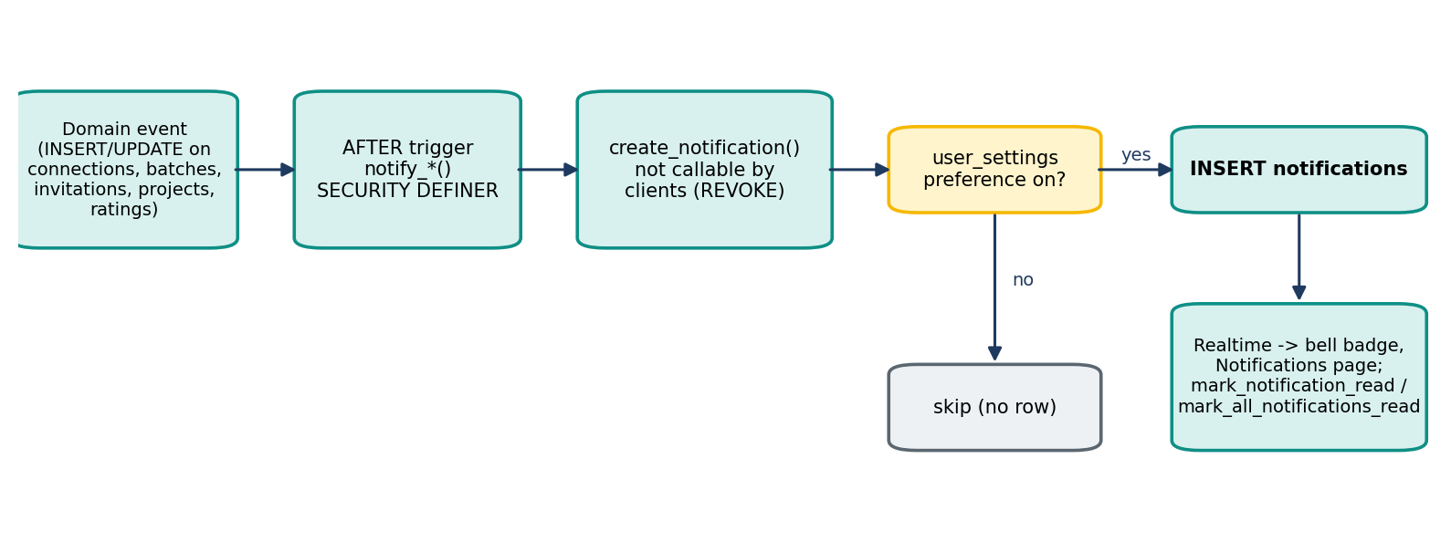
Figure 3.16: Notification pipeline from database event to the user interface
Table 3.21: Notification types, their triggers and the preference that controls them
Type | Created when | Recipient | Preference
connection_request | A request is sent | Receiver | Connection requests
connection_accepted | The receiver accepts | Sender | Connection updates
connection_rejected | The receiver rejects | Sender | Connection updates
batch_added | A user is added to a team batch | Each new member | Batch updates
project_invitation | A client invites a developer | Developer | Project invitations
invitation_accepted | The developer accepts | Client | Project invitations
invitation_declined | The developer declines | Client | Project invitations
project_assigned | The client assigns the developer | Developer | Project updates
project_completed | The client marks the project complete | Developer | Project updates
rating_received | A rating is submitted | Rated user | Ratings

3.10.11 Settings and Account Management
The Settings page (/settings) has four tabs that can be linked to directly. Profile edits the public profile, including years of experience, portfolio URL and availability for work, which the client's talent filters use. Notifications switches each of the six notification groups on or off. Privacy controls whether the user appears on the leaderboard. Account changes the password (with confirmation), changes the e-mail address through Supabase's confirmation e-mail, signs out, or signs out of every device. Settings are saved with an upsert on the user's own row, and the theme choice follows the user across devices.

3.10.12 Contact Support
Users open support tickets from the account menu or the client profile. A ticket has a subject, one of six categories (account, technical, project, safety, feedback, other) and a description; the form applies the same length limits as the table constraints. Each ticket receives a sequential number from an identity column, starts in status open and is listed with its current status (open, in progress, resolved or closed). Only the author can read a ticket; status changes are reserved for administrators.

3.10.13 Error Handling and User Feedback
A common defect of the earlier version was optimistic feedback: some actions displayed success before, or regardless of, the server's answer. All mutations now wait for the result and translate failures through a single helper, friendlyError, shown in Table 3.22. Messages raised by the project's own triggers and functions are already written for users and are passed through unchanged.
Table 3.22: Mapping of technical errors to user-facing messages
Technical cause | Detected by | Message shown
RLS or privilege violation (42501) | Error code or “row-level security” text | You don't have permission to do that.
Unique violation (23505) | Error code or “duplicate key” text | This already exists. (specific text for duplicate ratings and requests)
Network failure | “Failed to fetch” / “network” | Network error. Check your connection and try again.
Missing migration | “function … does not exist”, “relation … does not exist” | This feature needs the latest database migration.
Workflow rule | Exception raised by a trigger or function | The function's own message, e.g. “You can only assign a developer who accepted your invitation”

3.11 Configuration and Deployment
The application reads its backend location from two Vite environment variables. To make a fresh clone runnable even without a local .env file, vite.config.ts injects public fallback values through Vite's define option only when a variable is missing:
Listing 3.6: Environment fallback in vite.config.ts
const env = loadEnv(mode, process.cwd(), 'VITE_');
const define = Object.fromEntries(
Object.entries(FALLBACK_ENV)
.filter(([key]) => !env[key])
.map(([key, value]) => [`import.meta.env.${key}`, JSON.stringify(value)]));

Only the publishable (anonymous) key is ever shipped to the browser; this is safe because every table is protected by RLS. Deployment consists of three steps:
- Apply the SQL files in supabase/migrations to the Supabase project in order (tables, policies, triggers, functions and storage bucket) and enable the Google provider if required. For an existing project the three newest migrations are also combined into supabase/APPLY_PENDING_MIGRATIONS.sql, which runs inside a single transaction and records itself in the migration history.
- Run npm install followed by npm run build; Vite produces a static dist/ folder (index.html, one CSS and one JS bundle, and the logo).
- Upload dist/ to any static host or CDN and configure it to serve index.html for unknown paths so that client-side routes such as /auth work on refresh.

Chapter 4

Results and Analysis

4.1 Tools and Technologies
Table 4.1: Tools and technologies used
Category | Tools & technologies
Front-end | React 18.3 · TypeScript 5.8 · Vite 5.4 · Tailwind CSS 3.4 · shadcn/ui (Radix UI) · Lucide icons · React Router 6 · TanStack Query 5 · Zod 3
Back-end (BaaS) | Supabase: PostgreSQL, Row-Level Security, Auth (e-mail, Google OAuth), Realtime, Storage · supabase-js 2.88
Algorithms | Synergy score for team batches (Algorithm 1) · rating-based leaderboard ranking (Algorithm 2)
Development tools | Visual Studio Code · Git & GitHub · Lovable · Supabase Studio · npm
Testing tools | TypeScript compiler · ESLint · Puppeteer + headless Chrome · Lighthouse 12 · PostgreSQL 16 + psycopg (database test suite)
Communication protocols | HTTPS / REST (PostgREST) · WebSocket (Supabase Realtime) · JWT · OAuth 2.0

4.2 Results
The CollabriX prototype is functional for authentication, onboarding, profiles, developer discovery, connections, real-time messaging, team batch formation, ratings and the leaderboard, and, after the collaboration extension, for project posting, invitations, assignment, completion, notifications, settings and support tickets. The following table contrasts the approach of conventional freelance marketplaces with that of CollabriX, and the screenshots after it show the implemented system.
Table 4.2: Comparative analysis of conventional freelance platforms vs. CollabriX
Criteria | Conventional platforms | CollabriX
Unit of hiring | Individual freelancer | Individual or team batch
Peer discovery | Limited or absent | Search + connect with filters
Team composition insight | Manual judgement | Synergy score and skill gaps
Rating integrity | Platform policy | Enforced by database RLS
Communication | Built-in chat | Realtime chat gated by accepted connection
Access control | Application server code | Row-Level Security in PostgreSQL
Hiring workflow | Proposals and contracts | Invitation → developer accepts → client assigns (never automatic)
Notifications | E-mail and in-app | In-app and real-time, generated by database triggers, per-type preferences
Ranking transparency | Opaque ranking or none | Public formula computed from verified work

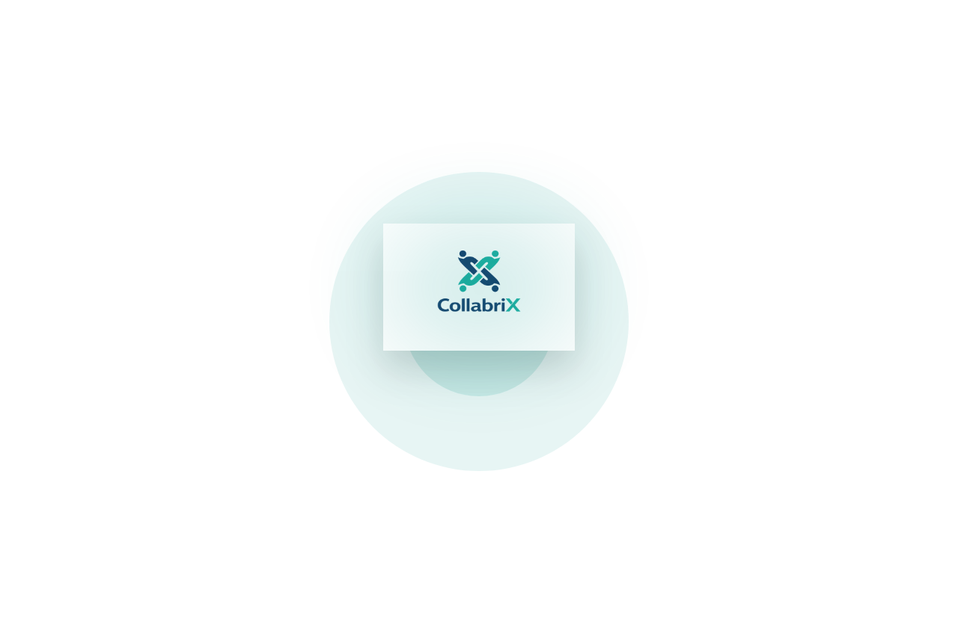
Figure 4.1: Splash screen shown while the session is restored
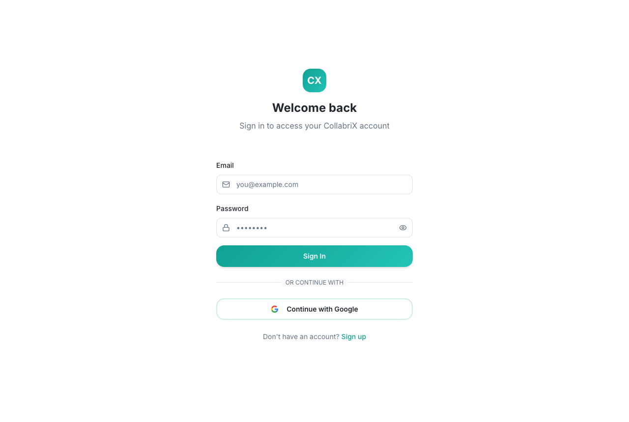
Figure 4.2: Login screen with e-mail/password and Google sign-in
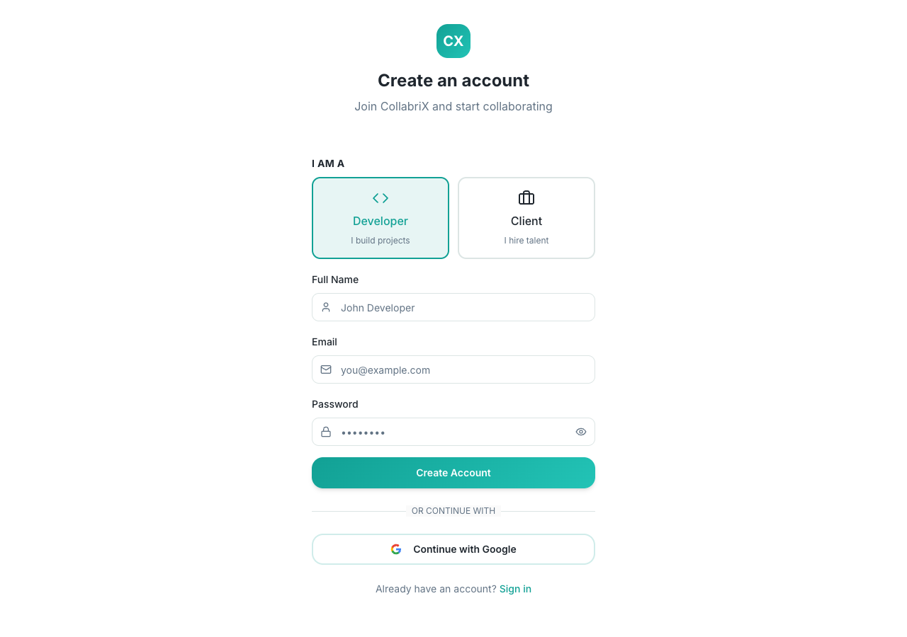
Figure 4.3: Sign-up screen with Developer / Client role selection
The signed-in screens below were captured from the production build at phone width. To avoid writing test data into the live project, the browser's requests to Supabase were answered by a scripted test backend serving a small set of sample users and projects; everything shown is rendered by the real application code.
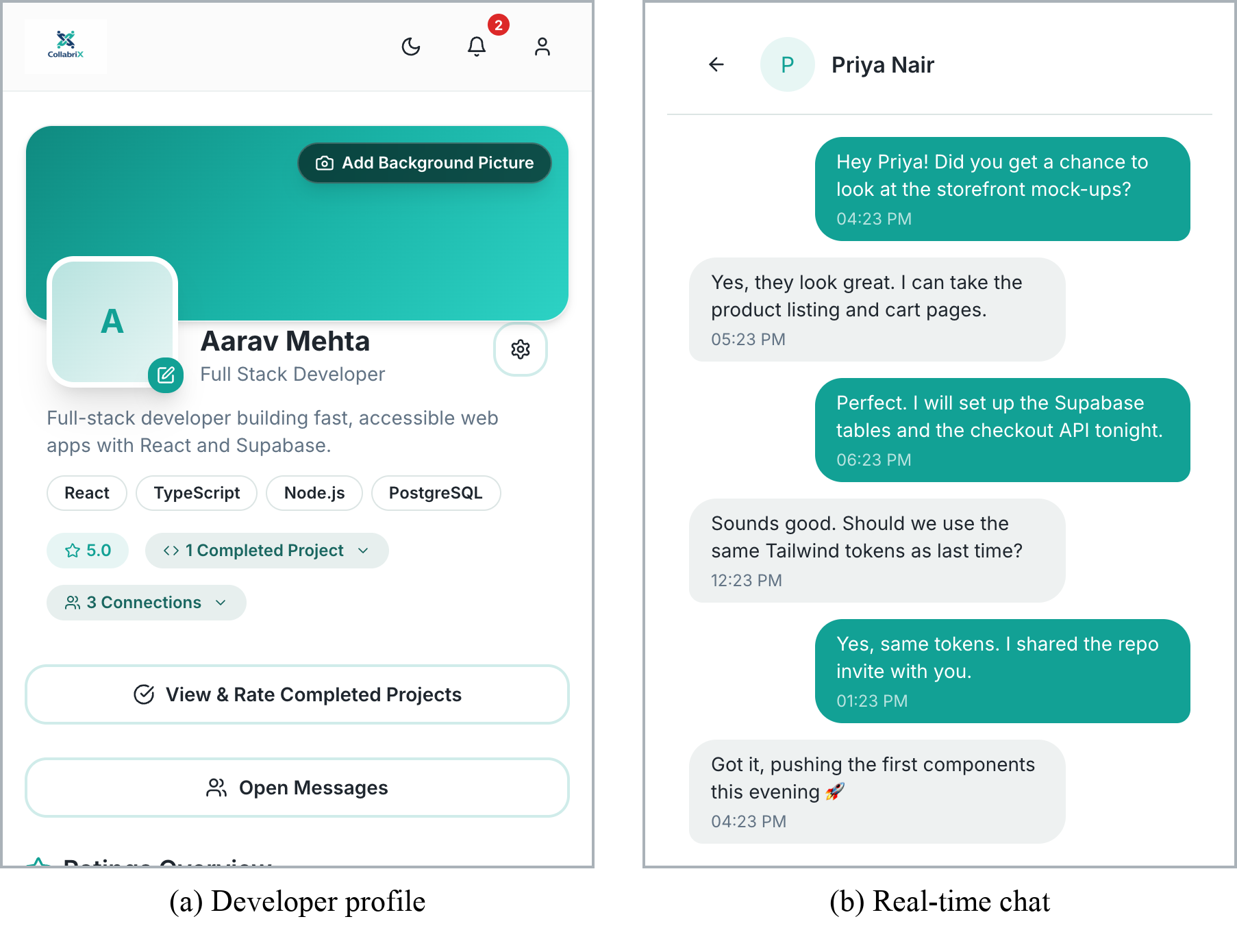
Figure 4.4: Developer workspace: (a) profile with ratings and badges, (b) real-time chat with a connection
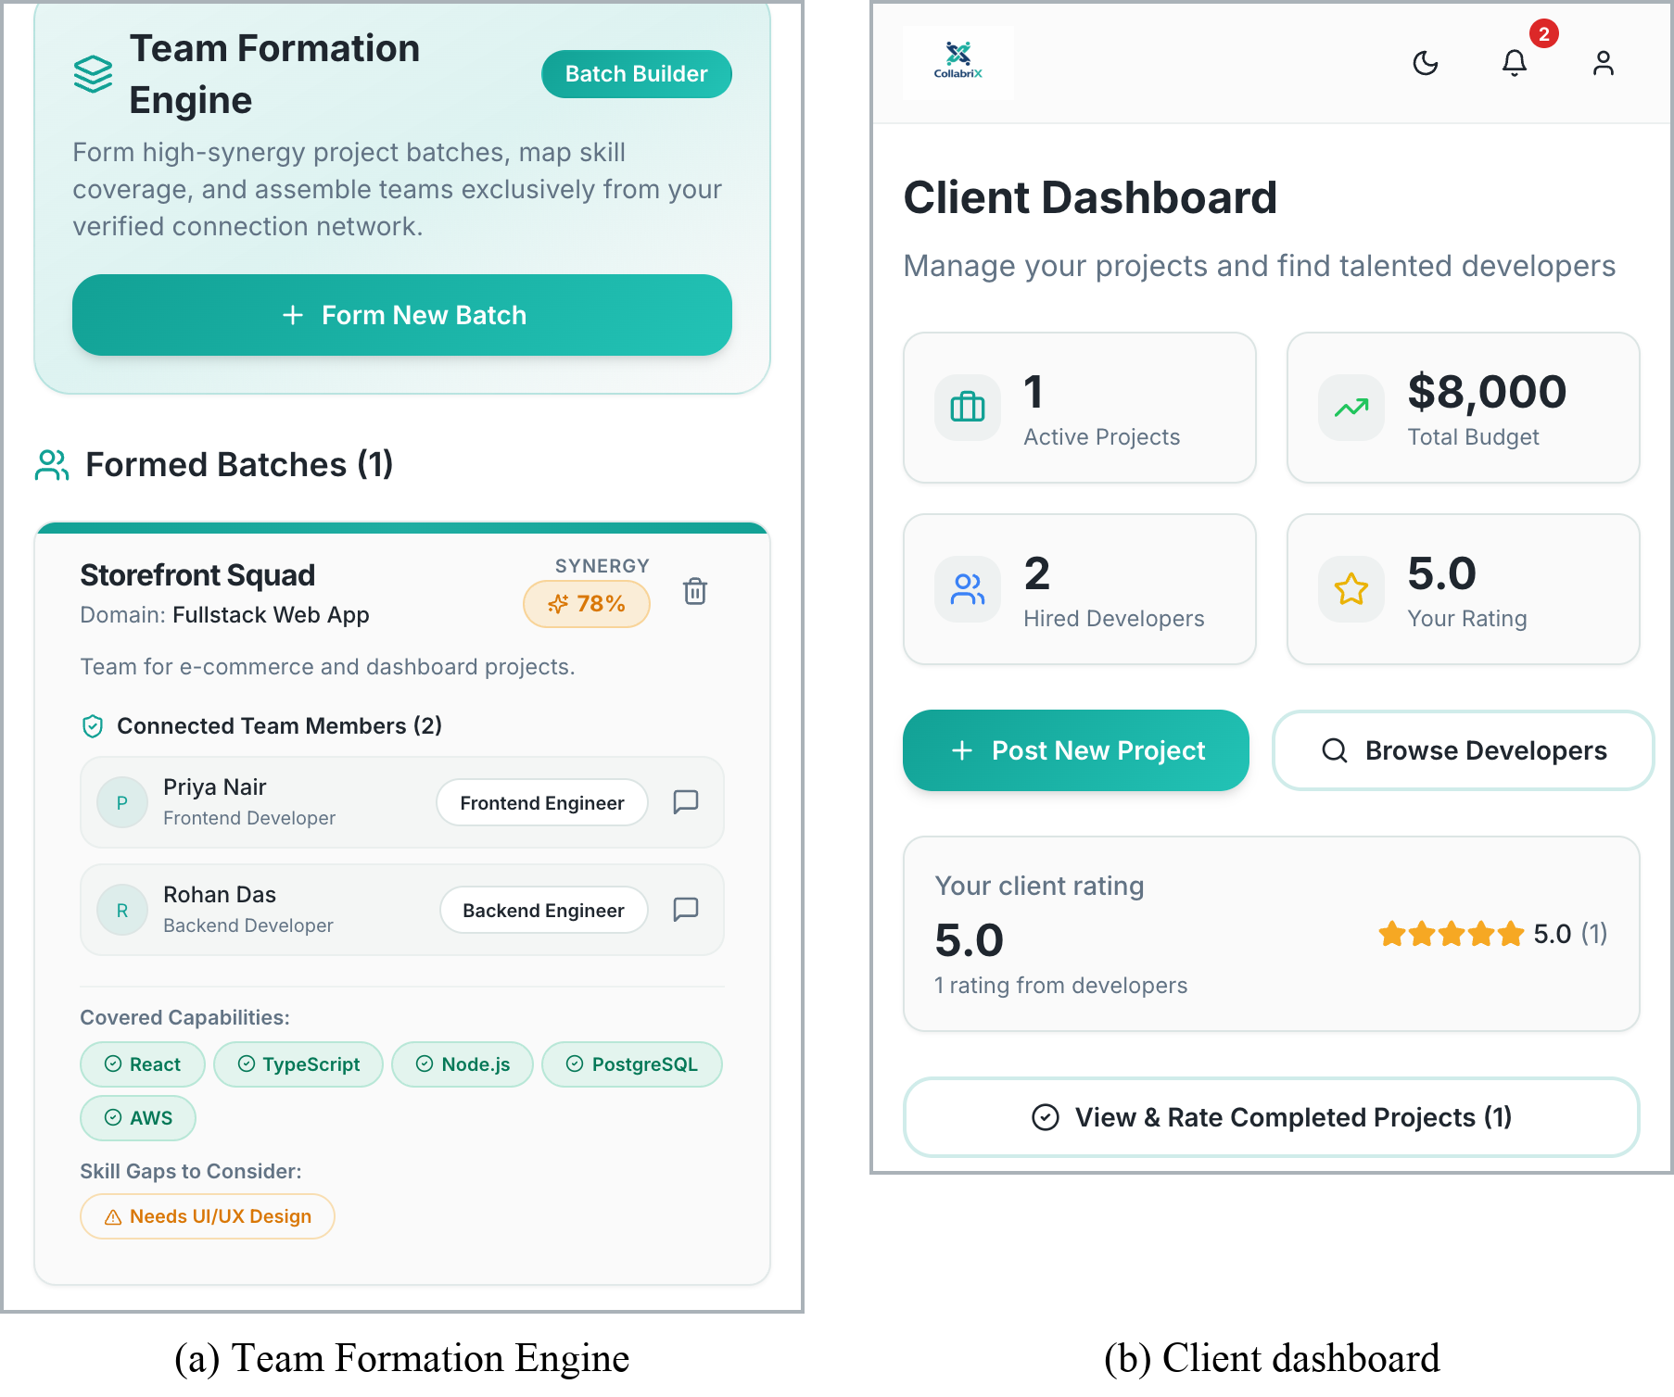
Figure 4.5: (a) Team Formation Engine with synergy score and skill gaps, (b) client dashboard
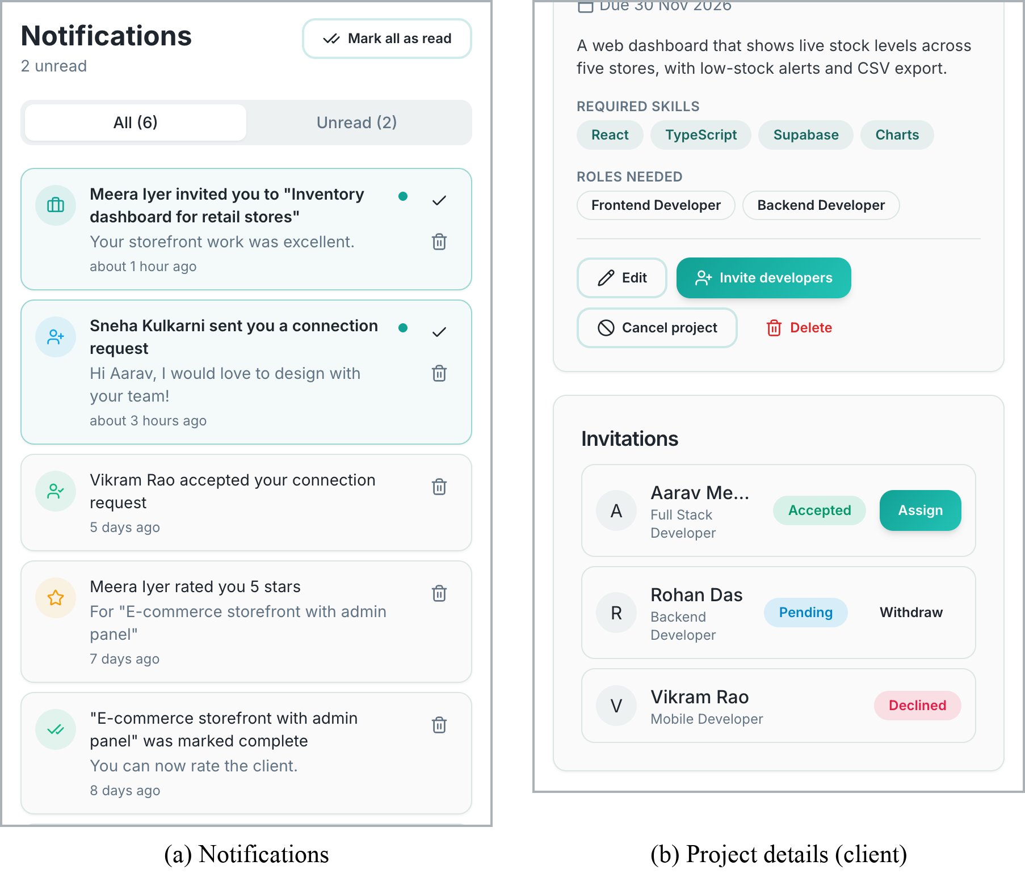
Figure 4.6: (a) Notifications page, (b) project details with invitations and the Assign action

4.2.1 Quantitative Results
Testing was carried out at five levels: static analysis, automated user-interface tests, security (RLS) verification with an anonymous client, a database behaviour and security test suite, and performance auditing. All results in this chapter were obtained by actually running the tools against the project: the original measurements on 6 October 2026 and the re-run after the collaboration extension on 12 October 2026.
A. Static analysis and unit-level checks
The project does not yet include a unit test framework such as Vitest; unit-level correctness was therefore checked through the TypeScript compiler, which type-checks every module against the generated database types, and through ESLint.
Table 4.3: Static analysis results
Check | Command | Result
Type checking | npx tsc --noEmit -p tsconfig.app.json | Passed — 0 errors (before and after)
Linting | npx eslint . | 2 warnings, 0 errors (was 49 findings: 14 errors, 35 warnings)
Production build | npx vite build | Succeeded in 1.98 s (was 1.83 s)

On 6 October the lint findings were dominated by missing dependencies in useEffect hooks (20 warnings), component files that also export constants (15 warnings) and 10 no-explicit-any errors in error-handling code. The rework replaced any with typed errors, moved data loading into TanStack Query hooks with explicit dependencies and fixed the remaining rule violations. Two only-export-components warnings remain; they affect only hot reloading during development, not the build.
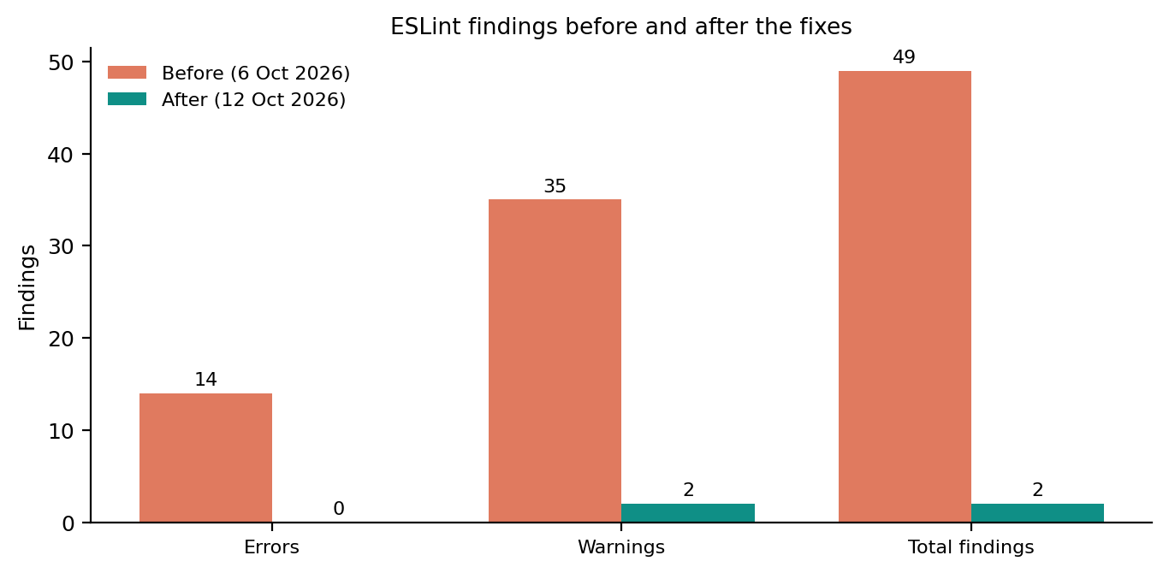
Figure 4.7: ESLint findings before and after the fixes
B. Functional test cases (automated UI tests)
A Puppeteer script drove a headless Chrome browser against the development server to validate the authentication and navigation flows. These tests exercise only client-side logic, so they did not create any accounts on the live backend.
Table 4.4: Automated UI test cases and results
ID | Test case | Expected result | Actual result | Status
TC-01 | Open “/” without a session | Redirect to /auth | Redirected to /auth | Pass
TC-02 | Log in with malformed e-mail | Submission blocked | Browser validation: “Please include an '@'…” | Pass
TC-03 | Log in with empty password | Toast “Please enter a password” | Toast shown | Pass
TC-04 | Toggle password visibility | Type password → text | password → text | Pass
TC-05 | Switch to sign-up mode | Heading and Full Name field | “Create an account”, field shown | Pass
TC-06 | Select Client role card | Card highlighted | Highlighted | Pass
TC-07 | Sign up with 1-letter name | Toast “Name must be at least 2 characters” | Toast shown | Pass
TC-08 | Open an unknown route | 404 page | “Oops! Page not found” | Pass
TC-09 | Login page at 375 px width | No horizontal overflow | scrollWidth 375 = viewport 375 | Pass
TC-10 | Open /notifications without a session | Redirect to /auth | Redirected to /auth | Pass
TC-11 | Open /settings?tab=account without a session | Redirect to /auth | Redirected to /auth | Pass
TC-12 | Open /support without a session | Redirect to /auth | Redirected to /auth | Pass
TC-13 | Open /developers/:id without a session | Redirect to /auth | Redirected to /auth | Pass
TC-14 | Open /projects/:id without a session | Redirect to /auth | Redirected to /auth | Pass
TC-15 | Open a notification deep link (/?tab=connect&view=requests) | Redirect to /auth, no errors | Redirected; no page errors | Pass
TC-16 | Google sign-in on login and sign-up | “Continue with Google” on both | Shown on both | Pass
TC-17 | Return from Google with an error | Reason shown; URL cleaned | Toast with reason; query removed | Pass
TC-18 | Sign-up page at 390 px width | No horizontal overflow | Overflow 0 px | Pass

All eighteen automated test cases passed. TC-01 to TC-09 were run against the development server on 6 October; TC-10 to TC-18, added for the new routes and sign-in behaviour, were run against the production build on 12 October. In TC-02 the request was stopped by the browser's built-in HTML5 e-mail validation before the application's own Zod check, which is the desired outcome.
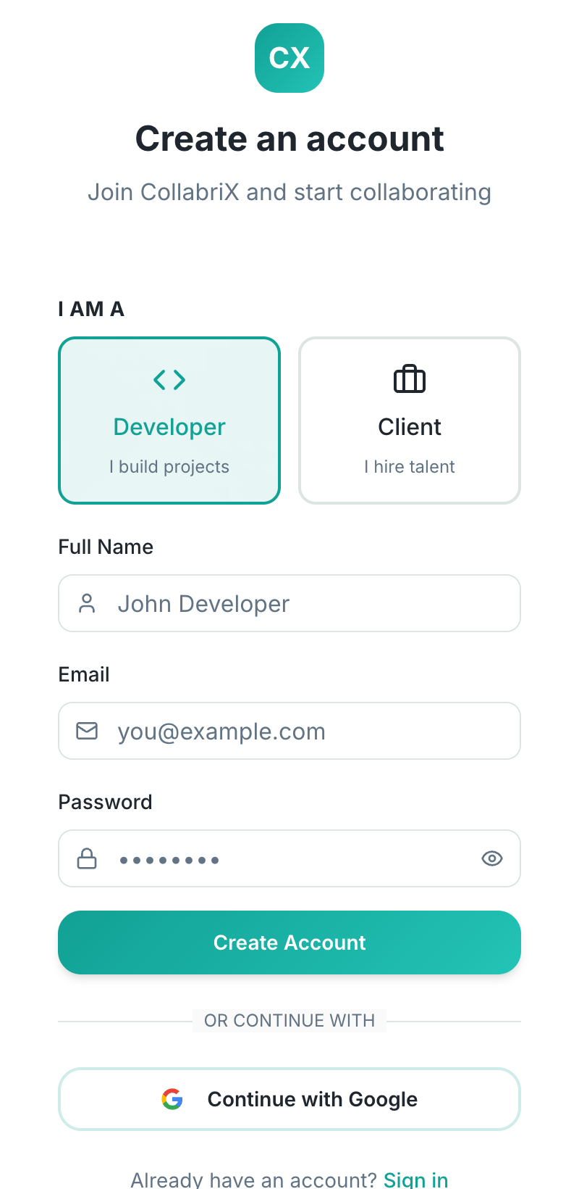
Figure 4.8: Sign-up screen rendered at mobile width (TC-09)
C. Manual test cases for authenticated features
Table 4.5: Manual test cases for authenticated features
ID | Scenario | Expected result
MT-01 | Developer A sends a connection request to B | B sees the request with a badge; A sees “Request Sent”
MT-02 | B accepts the request | Both see each other under My Connections; Message enabled
MT-03 | A sends a message | Message appears in B's open thread without refresh
MT-04 | Create a batch with two connections | Synergy score and skill gaps displayed; batch listed
MT-05 | Client opens Find Talent with region filter | Only developers from the selected country/continent listed
MT-06 | Participant rates a completed project twice | Second attempt rejected by the unique constraint
MT-07 | Client posts a project with a past deadline | Form rejects it with a clear message; nothing saved
MT-08 | Client invites developer A; A opens Jobs → Invitations | A sees the invitation and a notification
MT-09 | A accepts; client opens the project | Client is notified; A is listed as accepted but not assigned
MT-10 | Client assigns A | Status in progress; other pending invitations cancelled; A notified
MT-11 | Client marks the project complete; both rate | Both rating buttons appear once; leaderboard score of A increases
MT-12 | Developer disables “Connection requests” notifications | No notification for the next request; the request still appears
MT-13 | User opens a support ticket | Ticket number shown; ticket listed with status open
MT-14 | User changes the password, then signs out of all devices | Old password rejected; other sessions signed out

These scenarios require two real user accounts on the live backend, so they were not automated in the browser; they serve as the acceptance checklist to be run with two test accounts before the final demonstration. The database rules behind every step are, however, verified automatically by the test suite in Section G.
D. Security testing (Row-Level Security validation)
To validate NFR-1, an anonymous Supabase client (using only the public key that ships in the browser) queried each table and attempted unauthenticated inserts against the live project. Only row counts were recorded.
Table 4.6: RLS validation with an anonymous client
Table / operation | Expected | Observed | Status
SELECT profiles | Readable (public directory) | 9 rows visible | Pass
SELECT projects | Readable (public listings) | 0 rows (none posted yet) | Pass
SELECT connections | Not readable | 0 rows | Pass
SELECT messages | Not readable | 0 rows | Pass
SELECT user_roles | Not readable | 0 rows | Pass
SELECT ratings tables | Readable but empty | 0 rows | Pass
INSERT projects (anon) | Rejected | 42501: violates row-level security policy | Pass
INSERT messages (anon) | Rejected | 42501: violates row-level security policy | Pass

E. Performance testing
The production build was served locally with vite preview and audited with Lighthouse 12 using its default mobile emulation (simulated slow 4G and CPU throttling), on 6 October and again on 12 October 2026 after the extension.
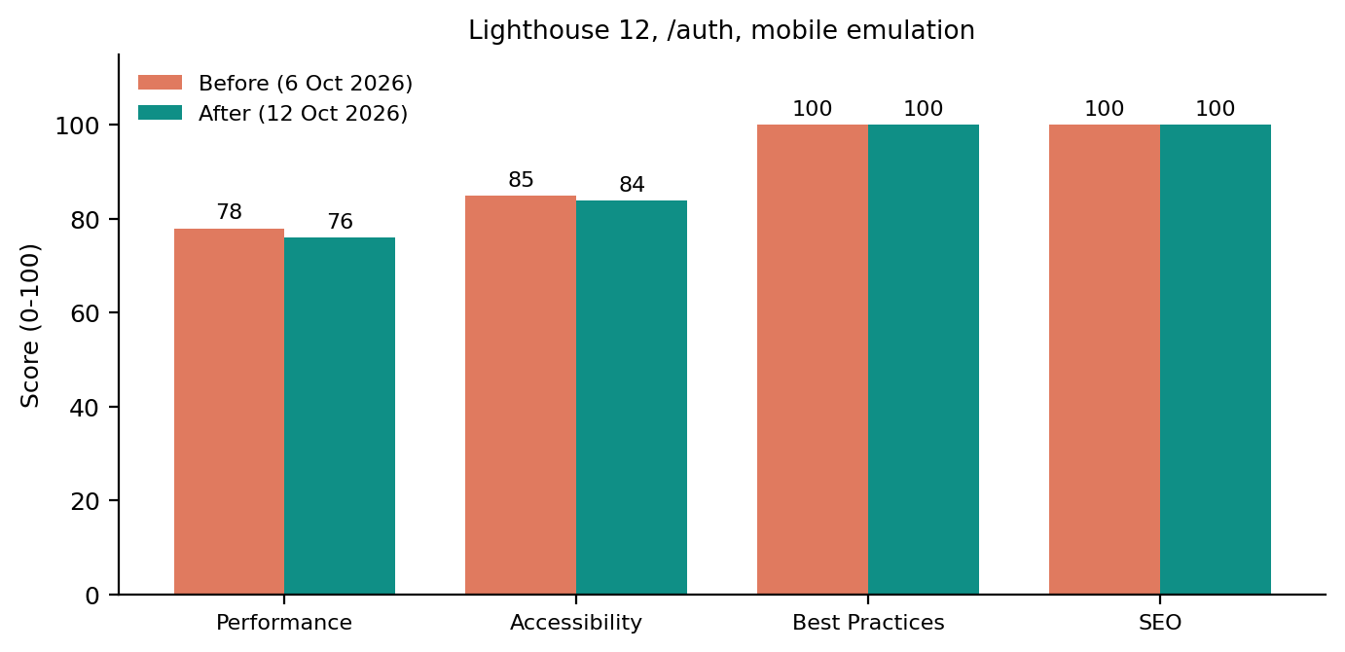
Figure 4.9: Lighthouse category scores before and after the extension
Table 4.7: Lighthouse metrics and bundle sizes
Metric | Value | Remark
First Contentful Paint | 3.2 s (was 3.3 s) | Throttled mobile profile
Largest Contentful Paint | 4.2 s (unchanged) | Dominated by the JS bundle
Total Blocking Time | 30 ms (was 10 ms) | Main thread stays responsive
Cumulative Layout Shift | 0 | No layout shifts
Speed Index | 5.3 s (was 4.0 s) | Varies between runs
JavaScript bundle | 931.1 kB (258.1 kB gzip); was 826.8 kB | Single chunk; code-splitting recommended
CSS bundle | 78.9 kB (12.9 kB gzip); was 62.5 kB | Tailwind purged output
Logo image | 163.8 kB | Candidate for compression / WebP

The main performance bottleneck remains the single JavaScript chunk, which grew from 827 kB to 931 kB with the five new pages and the extended screens; Vite flags it with a size warning. Scores moved by one or two points, which is within the run-to-run variation of a throttled audit. Splitting the client and developer workspaces and the new pages into lazily loaded chunks and compressing the logo are expected to raise the Performance score above 90.
F. Outcome discussion
The security model was compared against an external reference, the OWASP Top 10 [16]: broken access control (A01) is mitigated by RLS together with validation triggers, injection (A03) by parameterised PostgREST queries, insecure design (A04) by enforcing every state transition in the database, and identification failures (A07) by Supabase Auth. Defects found in the first round of testing, such as the Jobs complexity filter that offered Beginner/Intermediate/Advanced while the database stored Easy/Medium/Hard, were fixed in the final sprint (Section I).
G. Database behaviour and security test suite
Most of the rules added in the final sprint live in the database, so they were tested there directly. A local PostgreSQL 16 server was prepared with a small stub of the Supabase environment: the anon and authenticated roles, an auth.users table, and an auth.uid() function that reads the user id from the same JWT setting that PostgREST uses. All eleven migrations were then applied in order to an empty database, and a Python script (psycopg) created six users through the real sign-up trigger: four developers and two clients.
Every check executes its SQL statement as one of these users, by switching to the authenticated role and setting the JWT subject, exactly as Supabase evaluates a request from the browser. A check passes when an allowed action succeeds, when a forbidden insert raises an error, or when a forbidden update or delete affects no rows (RLS filters such statements silently). The live project was never modified.
Table 4.8: Database test suite: areas and results
Area | Checks | Examples of what is verified | Result
Sign-up trigger | 1 | Profile and role created for every new user | 1/1
Connections | 21 | Self, duplicate and reverse requests refused; only the receiver answers; notifications | 21/21
Team batches | 10 | Only accepted connections; no self or duplicates; members can read, others cannot | 10/10
Projects | 7 | Developers cannot post; no direct completion or assignment; other clients cannot edit | 7/7
Invitations | 19 | Owner-only, developer-only, no duplicates; assignment needs acceptance | 19/19
Ratings | 19 | Only after completion, only the counterpart, once, 1–5, immutable, direction recorded | 19/19
Notifications | 9 | Own rows only; no forging or editing; mark read; internal function not callable | 9/9
Settings | 4 | Own row only; a disabled preference suppresses the notification | 4/4
Support tickets | 6 | Own tickets only; must start open; length checks; status not editable | 6/6
Leaderboard | 4 | Only verified work listed; score formula; not callable anonymously | 4/4
Anonymous access | 4 | No notifications or invitations visible without a session | 4/4
Total | 104 |  | 104/104
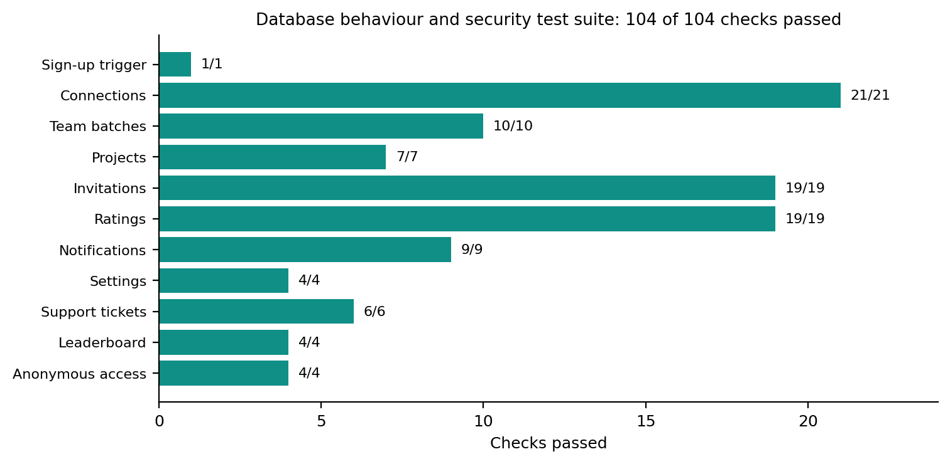
Figure 4.10: Database test suite results by area
H. Migration rehearsal on legacy data
A read-only probe of the live project through its public API showed that the five new tables, the new columns and the new functions did not yet exist, while every earlier migration had been applied. The three pending migrations were therefore combined into one transactional script and rehearsed on a local copy of the live schema seeded with rows that older versions of the application could have written (Table 4.9).
Table 4.9: Upgrade rehearsal with legacy data
Legacy row | Risk | Outcome after the upgrade
Connection from a user to themselves | New CHECK constraint could fail the upgrade | Constraint added as NOT VALID: old row kept, new ones refused
Requests in both directions between the same pair | Duplicate rule | Rule enforced by an insert trigger, so existing rows are untouched
Completed project without completed_at | Leaderboard periods | Counted in “All Time”; excluded from week/month
Ratings in both directions | Direction unknown before the upgrade | Back-filled: 2 client_to_developer, 1 developer_to_client
Rating on a project that was never completed | Score inflation | Kept for history but excluded from the leaderboard
Review longer than 2000 characters | New length CHECK | Constraint added as NOT VALID; new reviews limited
Running the script twice | Partial re-application | Second run fails on the first statement; transaction rolls back; no change
After the upgrade, the leaderboard of the rehearsal database listed exactly one developer with 200 points: 100 for the completed project and 100 for its five-star client rating, while the rating on the unfinished project was correctly ignored. The full test suite also ran on this database; the only failing check was the one that expects the leaderboard to contain a single developer, because the seeded legacy developer was a second, legitimate entry.
I. Defects fixed in the final sprint
Table 4.10 lists the most important defects found by testing and code review of the 6 October version, their root cause and how each was resolved.
Table 4.10: Defects, root causes and fixes
Defect | Root cause | Fix | Verified by
Clients could not post projects | No form or insert flow in the client UI | Validated Post Project dialog; insert policy for clients | MT-07, DB suite
No way to assign or complete projects | Lifecycle existed only in the schema | Invitations, assign_developer, complete_project | DB suite, MT-08–MT-11
Unread message counts never decreased | Only the sender could update messages | mark_messages_read function | Manual check
Team batches only in one browser | Stored in localStorage | team_batches table with trigger validation | DB suite
Demo connections and a default 4.8★ rating | Mock data shown when lists were empty | Removed; honest empty states | Code review
Leaderboard ranked unrated users at 4.5 | Baseline average in client code | Server-side get_leaderboard on verified work | DB suite
Jobs complexity filter returned nothing | UI values differed from database values | Shared Easy/Medium/Hard values | Manual check
Ratings could be mixed up by direction | No direction stored; wrong “already rated” check | rating_type column and per-direction checks | DB suite
Fake success messages | Toasts shown before or regardless of results | Await results; friendlyError | Code review
Duplicate Messages entry for clients | Quick action duplicated the tab | Removed the duplicate | Manual check
Settings, Support and bell did nothing | Buttons without handlers | Real pages and routes | TC-10–TC-12
Sign-in tokens logged to the console | Debug logging | Removed | Code review
Google sign-in failures were silent | Redirect error dropped by routing | Reason captured and shown | TC-17
Name and avatar hidden on profile headers | Positioned cover image painted over the profile row | Profile row raised above the cover | Screenshot (Figure 4.4)
Unreadable “Batch Builder” badge | Teal text on a teal background | Contrasting text colour, no wrapping | Screenshot (Figure 4.5)

Chapter 5

Conclusion and Future Works

5.1 Conclusion
CollabriX demonstrates that a freelance platform can be designed around teams rather than individuals. The prototype delivers two complete role-based workspaces, guided onboarding, developer discovery with faceted filters, a request-and-accept connection workflow, real-time messaging, a team formation engine with an explainable synergy score, and, after the final sprint, a complete project lifecycle from posting through invitation, assignment and completion to two-way ratings, with real-time notifications, settings and support. The entire authorisation model lives in PostgreSQL: RLS decides who may touch a row, triggers decide which changes are valid, and security-definer functions perform the multi-step operations. 104 automated database checks confirm that these rules hold.
From an engineering perspective, the project gave the team practical experience with a modern TypeScript front-end stack, relational schema design, SQL-based security, realtime systems, agile delivery in short sprints and systematic testing.
Table 5.1: Project goals versus accomplishments
Objective | Accomplishment | Status
Role-based responsive SPA | Developer (5 tabs) and client (4 tabs) workspaces; works at 375 px | Achieved
Peer discovery and connections | Search, type/skill/region filters, request–accept workflow | Achieved
Real-time messaging | WebSocket subscriptions per connection; shared inbox | Achieved
Team batches with synergy score | Built from accepted connections with roles and gaps; stored in the database with trigger validation; members notified | Achieved
Completion-gated reputation | RLS-enforced ratings, leaderboard and badges; rating UI on completed projects | Achieved
Database-level security | RLS on all 12 tables and storage; triggers and functions for every transition; 104 automated checks | Achieved
Evaluation and documentation | UI (18 cases), RLS, database, static and performance tests; limitations documented | Achieved
Complete project lifecycle | Post, invite, assign after acceptance, complete, rate in both directions | Achieved
Real-time notifications | 10 event types, per-type preferences, read state, deep links | Achieved
Settings and support | Profile, notifications, privacy, account security; ticketed support | Achieved

5.1.1 Lessons Learned
- Put the rules in the database first. Writing RLS policies before the screens forced us to decide early who may read and write each table, and it made the front end simpler because it never has to re-check permissions.
- Realtime needs clean-up. Every Supabase channel opened in a React effect must be removed when the component unmounts; otherwise duplicate subscriptions and repeated notifications appear.
- Demo data hides gaps. Sample connections and default ratings made early demos look complete, but they also concealed missing workflows. We now prefer honest empty states.
- Keep the data model aligned with the UI. The complexity-filter mismatch showed that enumerated values should be defined once and shared between SQL and TypeScript.
- Generated code still needs review. AI-assisted scaffolding (Lovable) sped up UI work, but generated files need the same review as hand-written code; for example, one onboarding modal was rendered twice on the client profile screen.
- Make state transitions explicit. Drawing the state diagrams for connections, projects and invitations exposed several transitions the first version allowed by accident, such as reopening a completed project.
- Never show success you have not confirmed. Waiting for the database's answer is slightly slower to implement but removes a whole class of confusing bugs.
- Test the database like code. Running the migrations against a disposable PostgreSQL instance made it possible to test security rules as different users without risking live data.

5.2 Limitations
Table 5.2: Known limitations of the current prototype
Area | Limitation
Deployment | New migrations must be applied by an administrator in the Supabase SQL editor; a combined, transactional script is provided.
Live verification | Realtime delivery and the two-account flows (MT-01–MT-14) are verified at database level but not yet end to end in the browser on the live project.
Google sign-in | Creation of new accounts through Google is still being diagnosed; the failure reason is now shown to the user.
Onboarding | LinkedIn and résumé options do not extract data; they open the manual form.
Support | There is no staff console; ticket status is changed by administrators in SQL.
Leaderboard | The score rewards volume of verified work, so many modest ratings can outrank a few excellent ones.
Code quality | No unit-test framework for React components yet (the database suite covers the rules); 2 lint warnings.
Performance | Single 931 kB JavaScript bundle; Lighthouse Performance 76.

5.3 Future Prospectus
- Team proposals: let a team batch apply to a project as one unit, with roles and a revenue split per member.
- Staff console: role-protected screens for support tickets, user reports and moderation.
- End-to-end tests: Playwright scenarios with two accounts against a disposable Supabase project in continuous integration, covering MT-01 to MT-14.
- Smarter team suggestions: recommend connections that fill skill gaps, weighting ratings and current workload, following [5] and [11].
- Multi-dimensional, double-blind ratings: separate scores for quality, communication and timeliness, revealed only after both parties submit, to counter reputation inflation [8], and a Bayesian average so that a few ratings do not dominate the leaderboard.
- Payments and escrow: milestone-based payments through a payment gateway such as Razorpay or Stripe.
- Quality and performance: code-split the workspaces and pages with React.lazy, compress the logo to WebP, and add Vitest unit tests for the hooks.

5.3.1 Possible Integration with Other Tools
- GitHub — link repositories to profiles and show contribution activity as verifiable evidence of skills.
- Google Calendar / Meet — schedule and join client meetings directly from a conversation.
- Slack or Discord webhooks — mirror team notifications for users who prefer those tools.
- LinkedIn — official OAuth-based profile import in place of the current link field.
- E-mail and push delivery — send the same notification rows by e-mail or web push through Supabase Edge Functions, respecting the existing preferences.

Bibliography
[1] J. J. Horton, “Online labor markets,” in Proc. 6th Int. Workshop on Internet and Network Economics (WINE), LNCS, vol. 6484, Springer, 2010, pp. 515–522.
[2] A. Kittur, J. V. Nickerson, M. Bernstein, E. Gerber, A. Shaw, J. Zimmerman, M. Lease, and J. Horton, “The future of crowd work,” in Proc. ACM Conf. Computer Supported Cooperative Work (CSCW), 2013, pp. 1301–1318.
[3] P. Resnick, K. Kuwabara, R. Zeckhauser, and E. Friedman, “Reputation systems,” Communications of the ACM, vol. 43, no. 12, pp. 45–48, 2000.
[4] A. Jøsang, R. Ismail, and C. Boyd, “A survey of trust and reputation systems for online service provision,” Decision Support Systems, vol. 43, no. 2, pp. 618–644, 2007.
[5] T. Lappas, K. Liu, and E. Terzi, “Finding a team of experts in social networks,” in Proc. 15th ACM SIGKDD Int. Conf. Knowledge Discovery and Data Mining, 2009, pp. 467–476.
[6] D. Retelny, S. Robaszkiewicz, A. To, W. S. Lasecki, J. Patel, N. Rahmati, T. Doshi, M. Valentine, and M. S. Bernstein, “Expert crowdsourcing with flash teams,” in Proc. 27th ACM Symp. User Interface Software and Technology (UIST), 2014, pp. 75–85.
[7] M. A. Valentine, D. Retelny, A. To, N. Rahmati, T. Doshi, and M. S. Bernstein, “Flash organizations: Crowdsourcing complex work by structuring crowds as organizations,” in Proc. CHI Conf. Human Factors in Computing Systems, 2017, pp. 3523–3537.
[8] A. Filippas, J. J. Horton, and J. Golden, “Reputation inflation,” Marketing Science, vol. 41, no. 4, pp. 733–745, 2022.
[9] M. Kokkodis and P. G. Ipeirotis, “Reputation transferability in online labor markets,” Management Science, vol. 62, no. 6, pp. 1687–1706, 2016.
[10] A. J. Wood, M. Graham, V. Lehdonvirta, and I. Hjorth, “Good gig, bad gig: Autonomy and algorithmic control in the global gig economy,” Work, Employment and Society, vol. 33, no. 1, pp. 56–75, 2019.
[11] A. Anagnostopoulos, L. Becchetti, C. Castillo, A. Gionis, and S. Leonardi, “Online team formation in social networks,” in Proc. 21st Int. Conf. World Wide Web (WWW), 2012, pp. 839–848.
[12] C. Dellarocas, “The digitization of word of mouth: Promise and challenges of online feedback mechanisms,” Management Science, vol. 49, no. 10, pp. 1407–1424, 2003.
[13] I. Fette and A. Melnikov, “The WebSocket Protocol,” RFC 6455, IETF, Dec. 2011.
[14] M. Jones, J. Bradley, and N. Sakimura, “JSON Web Token (JWT),” RFC 7519, IETF, May 2015.
[15] R. T. Fielding, “Architectural styles and the design of network-based software architectures,” Ph.D. dissertation, Univ. of California, Irvine, 2000.
[16] OWASP Foundation, “OWASP Top 10:2021.” [Online]. Available: https://owasp.org/Top10/
[17] Supabase, “Row Level Security,” Supabase Documentation. [Online]. Available: https://supabase.com/docs/guides/database/postgres/row-level-security
[18] Meta Open Source, “React — The library for web and native user interfaces.” [Online]. Available: https://react.dev
[19] Vite, “Vite — Next generation frontend tooling.” [Online]. Available: https://vitejs.dev
[20] TanStack, “TanStack Query documentation.” [Online]. Available: https://tanstack.com/query
[21] Tailwind Labs, “Tailwind CSS documentation.” [Online]. Available: https://tailwindcss.com/docs
[22] The PostgreSQL Global Development Group, “Row Security Policies,” PostgreSQL Documentation. [Online]. Available: https://www.postgresql.org/docs/current/ddl-rowsecurity.html
[23] Google, “Lighthouse overview,” Chrome for Developers. [Online]. Available: https://developer.chrome.com/docs/lighthouse/overview
[24] K. Beck et al., “Manifesto for Agile Software Development,” 2001. [Online]. Available: https://agilemanifesto.org
[25] IEEE Recommended Practice for Software Requirements Specifications, IEEE Std 830-1998, 1998.
[26] D. Hardt, “The OAuth 2.0 Authorization Framework,” RFC 6749, IETF, Oct. 2012.

