Mobile Application Development
Practical File
Name – Uday Pratap Singh
Class – BSC.IT
Roll no. – 23/SCA/BSC>IT/008
Q1. Create a Calculator with Explaining steps.

- README.md

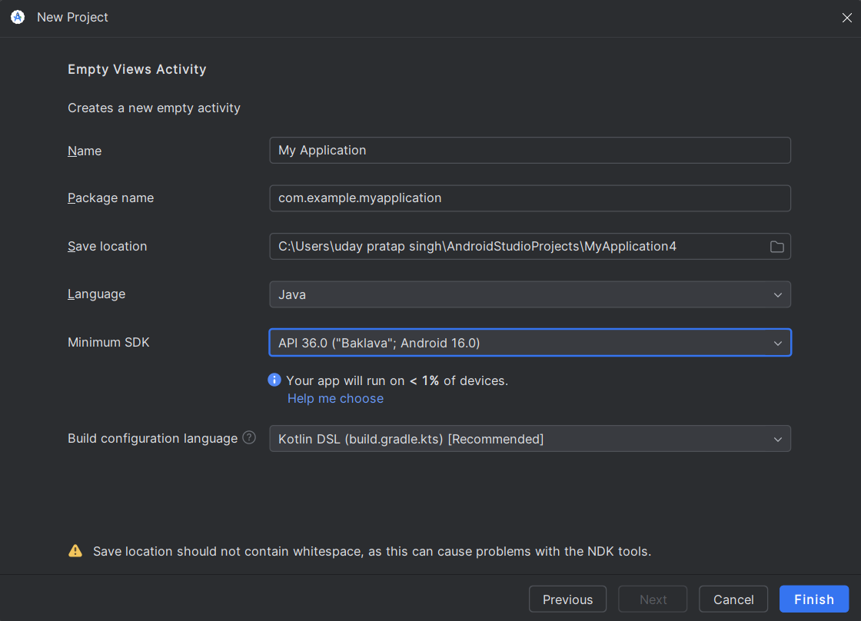

2) Activity_Main.xml
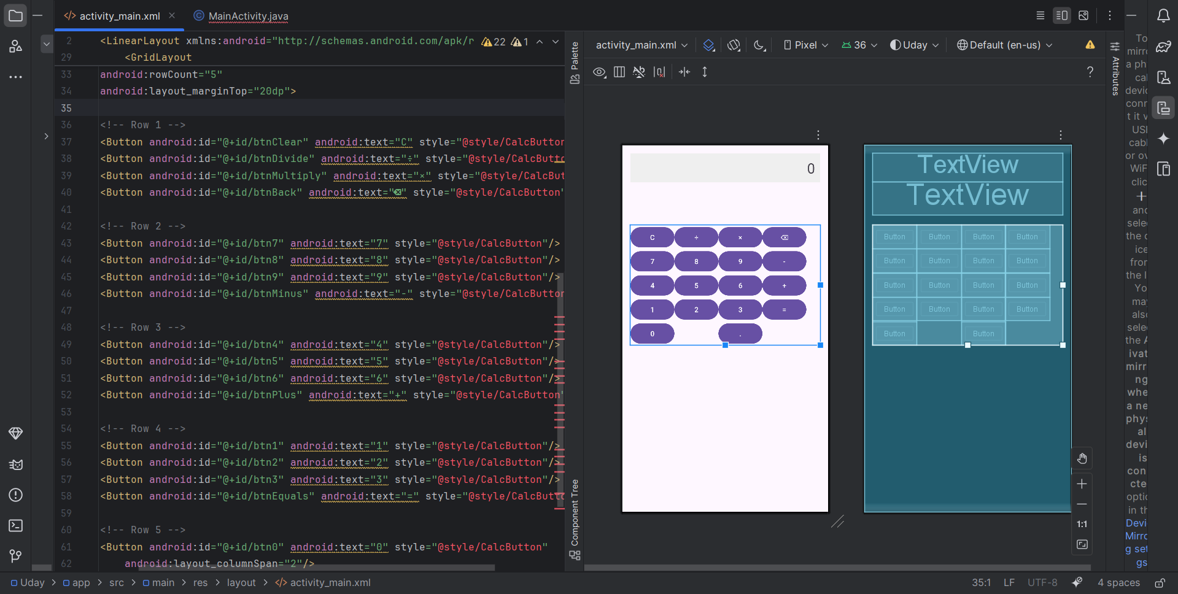
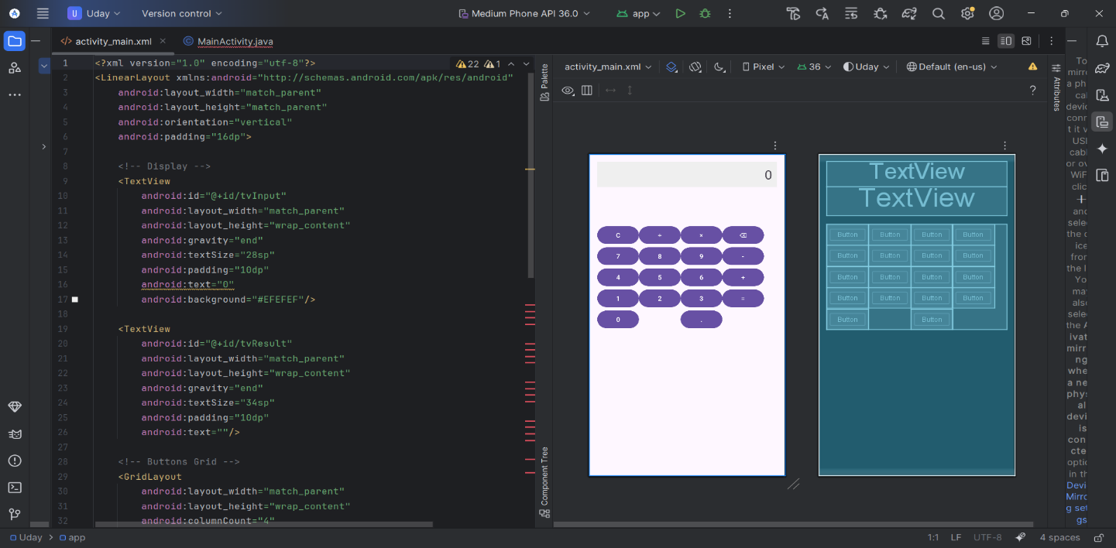

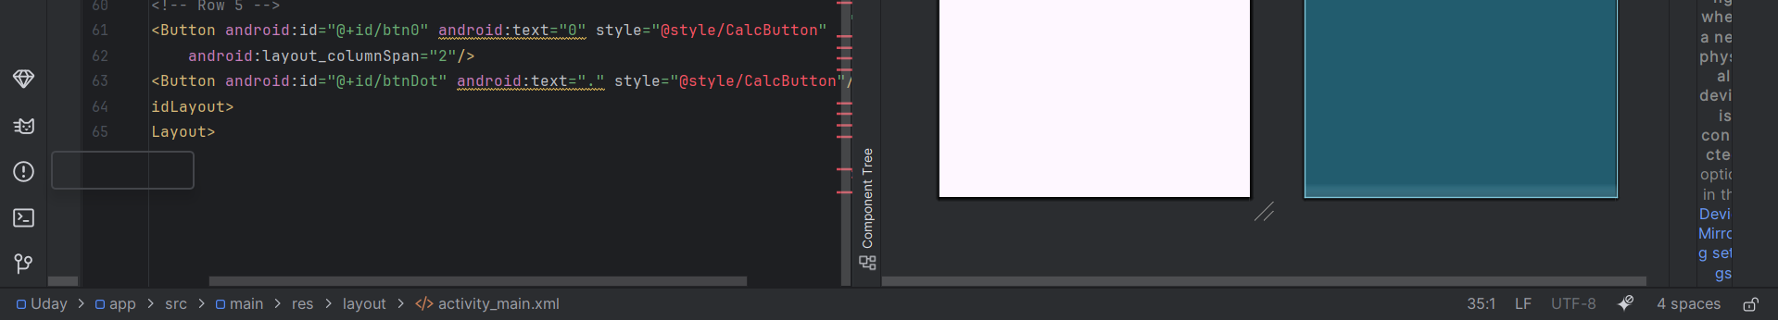

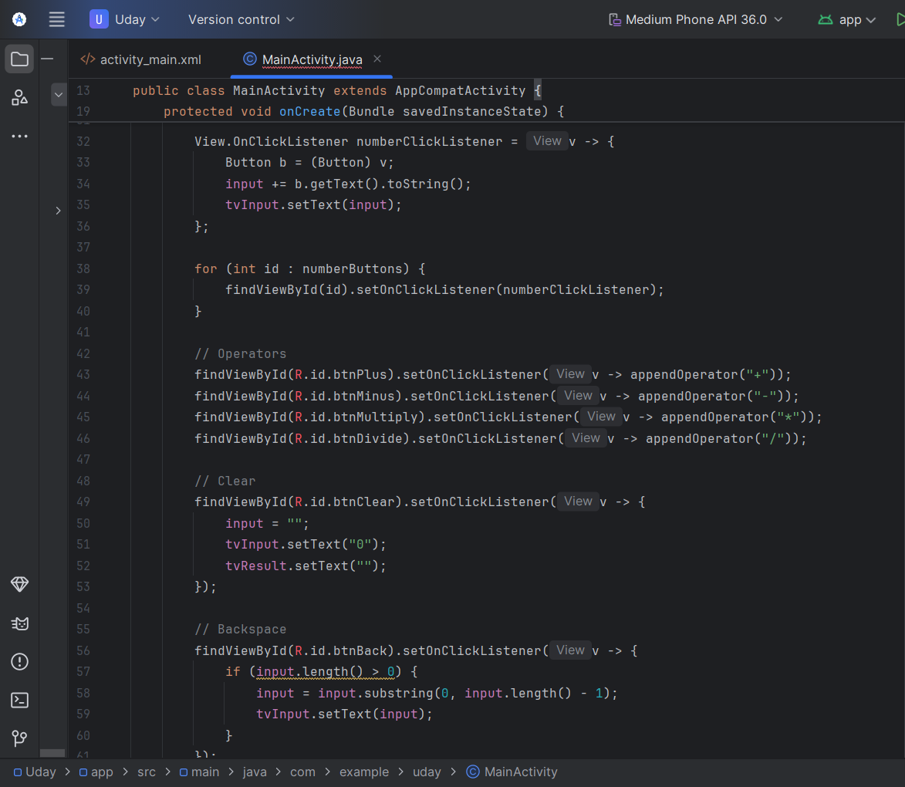
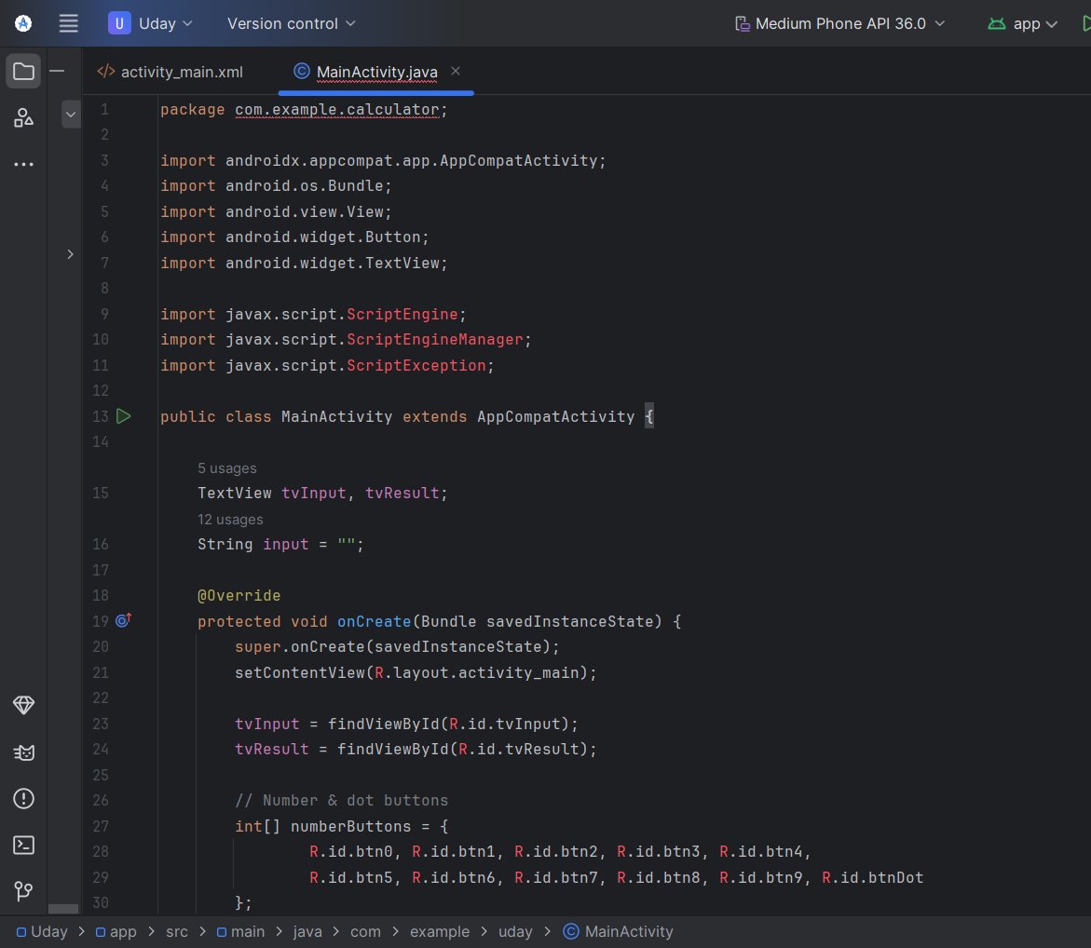
- MainActivity.java

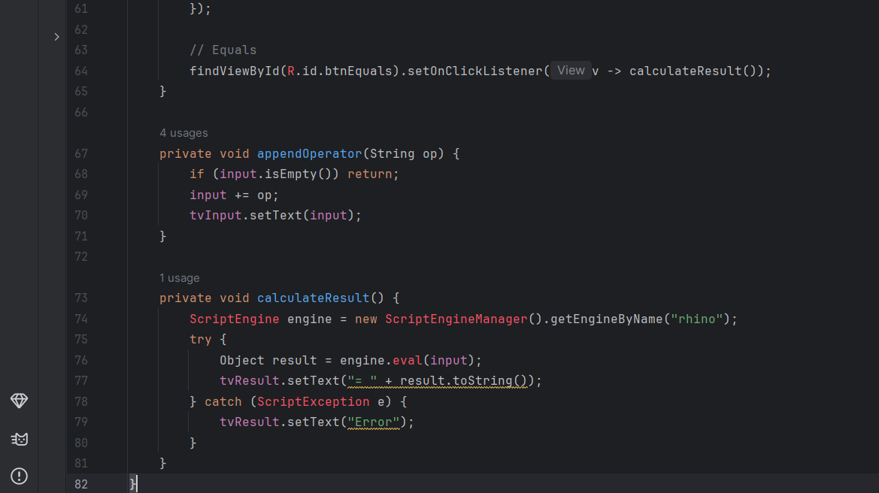
Q2. Create a Calling app Interface
