**Cryptography & Network Security Lab**

**PRN/ Roll No: 2019BTECS00090**

**Full name: Udaykumar Gadikar**

**Assignment No. 6**

Aim: Implement the DES algorithm

Theory:

DES is a block cipher and encrypts data in blocks of size of 64 bits each, which means 64 bits of plain text go as the input to DES, which produces 64 bits of ciphertext. The same algorithm and key are used for encryption and decryption, with minor differences. The key length is 56 bits.

DES consists of 16 steps, each of which is called a round. Each round performs the steps of substitution and transposition. Let us now discuss the broad-level steps in DES.

Broad Level Steps In DES

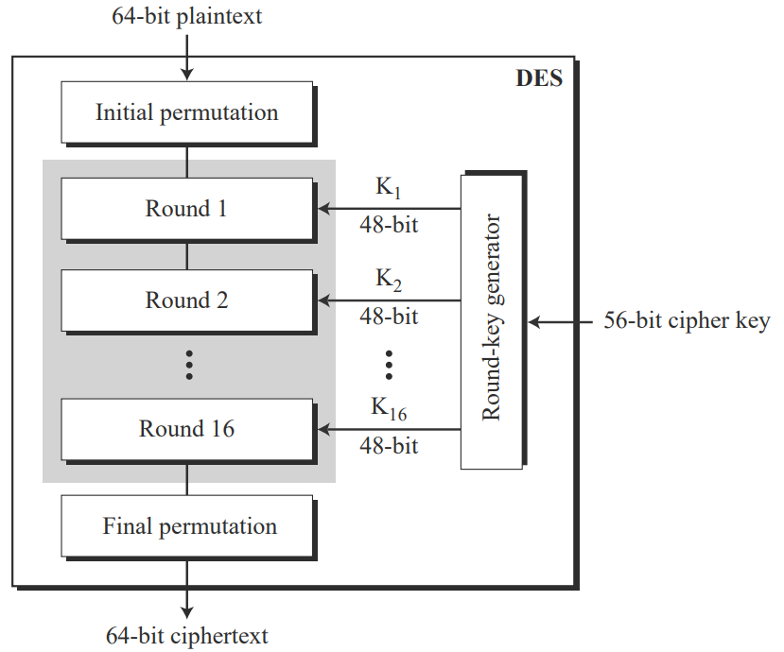

Steps in Each Round In DES

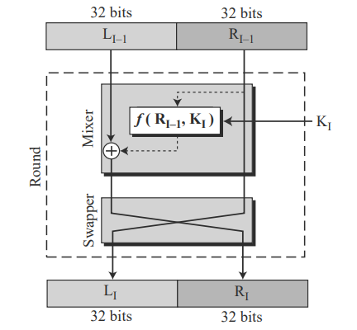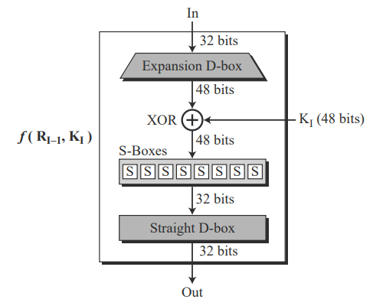

Key Generation Steps:

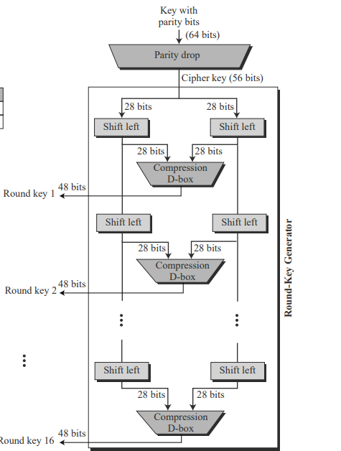

Code:

#include <bits/stdc++.h>

using namespace std;

string round_keys[16];

string pt;

string convertDecimalToBinary(int decimal)

{

    string binary;

    while(decimal != 0) {

        binary = (decimal % 2 == 0 ? "0" : "1") + binary;

        decimal = decimal/2;

    }

    while(binary.length() < 8){

        binary = "0" + binary;

    }

    return binary;

}

int convertBinaryToDecimal(string binary)

{

    int decimal = 0;

    int counter = 0;

    int size = binary.length();

    for(int i = size-1; i >= 0; i--)

    {

        if(binary[i] == '1'){

            decimal += pow(2, counter);

        }

    counter++;

    }

    return decimal;

}

// Function to do a circular left shift by 1

string shift_left_once(string key_chunk){

    string shifted="";

        for(int i = 1; i < 28; i++){

            shifted += key_chunk[i];

        }

        shifted += key_chunk[0];

    return shifted;

}

// Function to do a circular left shift by 2

string shift_left_twice(string key_chunk){

    string shifted="";

    for(int i = 0; i < 2; i++){

        for(int j = 1; j < 28; j++){

            shifted += key_chunk[j];

        }

        shifted += key_chunk[0];

        key_chunk= shifted;

        shifted ="";

    }

    return key_chunk;

}

// Function to compute xor between two strings

string Xor(string a, string b){

    string result = "";

    int size = b.size();

    for(int i = 0; i < size; i++){

        if(a[i] != b[i]){

            result += "1";

        }

        else{

            result += "0";

        }

    }

    return result;

}

// Function to generate the 16 keys.

void generate_keys(string key){

    // The PC1 table

    int pc1[56] = {

    57,49,41,33,25,17,9,

    1,58,50,42,34,26,18,

    10,2,59,51,43,35,27,

    19,11,3,60,52,44,36,

    63,55,47,39,31,23,15,

    7,62,54,46,38,30,22,

    14,6,61,53,45,37,29,

    21,13,5,28,20,12,4

    };

    // The PC2 table

    int pc2[48] = {

    14,17,11,24,1,5,

    3,28,15,6,21,10,

    23,19,12,4,26,8,

    16,7,27,20,13,2,

    41,52,31,37,47,55,

    30,40,51,45,33,48,

    44,49,39,56,34,53,

    46,42,50,36,29,32

    };

    // 1. Compressing the key using the PC1 table

    string perm_key ="";

    for(int i = 0; i < 56; i++){

        perm_key+= key[pc1[i]-1];

    }

    // 2. Dividing the key into two equal halves

    string left= perm_key.substr(0, 28);

    string right= perm_key.substr(28, 28);

    for(int i=0; i<16; i++){

        // 3.1. For rounds 1, 2, 9, 16 the key_chunks

        // are shifted by one.

        if(i == 0 || i == 1 || i==8 || i==15 ){

            left= shift_left_once(left);

            right= shift_left_once(right);

        }

        // 3.2. For other rounds, the key_chunks

        // are shifted by two

        else{

            left= shift_left_twice(left);

            right= shift_left_twice(right);

        }

        // Combining the two chunks

        string combined_key = left + right;

        string round_key = "";

        // Finally, using the PC2 table to transpose the key bits

        for(int i = 0; i < 48; i++){

            round_key += combined_key[pc2[i]-1];

        }

        round_keys[i] = round_key;

    }

}

string DES(){

    // The initial permutation table

    int initial_permutation[64] = {

    58,50,42,34,26,18,10,2,

    60,52,44,36,28,20,12,4,

    62,54,46,38,30,22,14,6,

    64,56,48,40,32,24,16,8,

    57,49,41,33,25,17,9,1,

    59,51,43,35,27,19,11,3,

    61,53,45,37,29,21,13,5,

    63,55,47,39,31,23,15,7

    };

    // The expansion table

    int expansion_table[48] = {

    32,1,2,3,4,5,4,5,

    6,7,8,9,8,9,10,11,

    12,13,12,13,14,15,16,17,

    16,17,18,19,20,21,20,21,

    22,23,24,25,24,25,26,27,

    28,29,28,29,30,31,32,1

    };

    // The substitution boxes. The should contain values

    // from 0 to 15 in any order.

    int substition_boxes[8][4][16]=

    {{

        14,4,13,1,2,15,11,8,3,10,6,12,5,9,0,7,

        0,15,7,4,14,2,13,1,10,6,12,11,9,5,3,8,

        4,1,14,8,13,6,2,11,15,12,9,7,3,10,5,0,

        15,12,8,2,4,9,1,7,5,11,3,14,10,0,6,13

    },

    {

        15,1,8,14,6,11,3,4,9,7,2,13,12,0,5,10,

        3,13,4,7,15,2,8,14,12,0,1,10,6,9,11,5,

        0,14,7,11,10,4,13,1,5,8,12,6,9,3,2,15,

        13,8,10,1,3,15,4,2,11,6,7,12,0,5,14,9

    },

    {

        10,0,9,14,6,3,15,5,1,13,12,7,11,4,2,8,

        13,7,0,9,3,4,6,10,2,8,5,14,12,11,15,1,

        13,6,4,9,8,15,3,0,11,1,2,12,5,10,14,7,

        1,10,13,0,6,9,8,7,4,15,14,3,11,5,2,12

    },

    {

        7,13,14,3,0,6,9,10,1,2,8,5,11,12,4,15,

        13,8,11,5,6,15,0,3,4,7,2,12,1,10,14,9,

        10,6,9,0,12,11,7,13,15,1,3,14,5,2,8,4,

        3,15,0,6,10,1,13,8,9,4,5,11,12,7,2,14

    },

    {

        2,12,4,1,7,10,11,6,8,5,3,15,13,0,14,9,

        14,11,2,12,4,7,13,1,5,0,15,10,3,9,8,6,

        4,2,1,11,10,13,7,8,15,9,12,5,6,3,0,14,

        11,8,12,7,1,14,2,13,6,15,0,9,10,4,5,3

    },

    {

        12,1,10,15,9,2,6,8,0,13,3,4,14,7,5,11,

        10,15,4,2,7,12,9,5,6,1,13,14,0,11,3,8,

        9,14,15,5,2,8,12,3,7,0,4,10,1,13,11,6,

        4,3,2,12,9,5,15,10,11,14,1,7,6,0,8,13

    },

    {

        4,11,2,14,15,0,8,13,3,12,9,7,5,10,6,1,

        13,0,11,7,4,9,1,10,14,3,5,12,2,15,8,6,

        1,4,11,13,12,3,7,14,10,15,6,8,0,5,9,2,

        6,11,13,8,1,4,10,7,9,5,0,15,14,2,3,12

    },

    {

        13,2,8,4,6,15,11,1,10,9,3,14,5,0,12,7,

        1,15,13,8,10,3,7,4,12,5,6,11,0,14,9,2,

        7,11,4,1,9,12,14,2,0,6,10,13,15,3,5,8,

        2,1,14,7,4,10,8,13,15,12,9,0,3,5,6,11

    }};

    // The permutation table

    int permutation_tab[32] = {

    16,7,20,21,29,12,28,17,

    1,15,23,26,5,18,31,10,

    2,8,24,14,32,27,3,9,

    19,13,30,6,22,11,4,25

    };

    // The inverse permutation table

    int inverse_permutation[64]= {

    40,8,48,16,56,24,64,32,

    39,7,47,15,55,23,63,31,

    38,6,46,14,54,22,62,30,

    37,5,45,13,53,21,61,29,

    36,4,44,12,52,20,60,28,

    35,3,43,11,51,19,59,27,

    34,2,42,10,50,18,58,26,

    33,1,41,9,49,17,57,25

    };

    //1. Applying the initial permutation

    string perm = "";

    for(int i = 0; i < 64; i++){

        perm += pt[initial_permutation[i]-1];

    }

    // 2. Dividing the result into two equal halves

    string left = perm.substr(0, 32);

    string right = perm.substr(32, 32);

    // The plain text is encrypted 16 times

    for(int i=0; i<16; i++) {

        string right_expanded = "";

        // 3.1. The right half of the plain text is expanded

        for(int i = 0; i < 48; i++) {

            right_expanded += right[expansion_table[i]-1];

    };  // 3.3. The result is xored with a key

        string xored = Xor(round_keys[i], right_expanded);

        string res = "";

        // 3.4. The result is divided into 8 equal parts and passed

        // through 8 substitution boxes. After passing through a

        // substituion box, each box is reduces from 6 to 4 bits.

        for(int i=0;i<8; i++){

            // Finding row and column indices to lookup the

            // substituition box

            string row1= xored.substr(i*6,1) + xored.substr(i*6 + 5,1);

            int row = convertBinaryToDecimal(row1);

            string col1 = xored.substr(i*6 + 1,1) + xored.substr(i*6 + 2,1) + xored.substr(i*6 + 3,1) + xored.substr(i*6 + 4,1);;

            int col = convertBinaryToDecimal(col1);

            int val = substition_boxes[i][row][col];

            res += convertDecimalToBinary(val);

        }

        // 3.5. Another permutation is applied

        string perm2 ="";

        for(int i = 0; i < 32; i++){

            perm2 += res[permutation_tab[i]-1];

        }

        // 3.6. The result is xored with the left half

        xored = Xor(perm2, left);

        // 3.7. The left and the right parts of the plain text are swapped

        left = xored;

        if(i < 15){

            string temp = right;

            right = xored;

            left = temp;

        }

    }

    // 4. The halves of the plain text are applied

    string combined_text = left + right;

    string ciphertext ="";

    // The inverse of the initial permuttaion is applied

    for(int i = 0; i < 64; i++){

        ciphertext+= combined_text[inverse_permutation[i]-1];

    }

    //And we finally get the cipher text

    return ciphertext;

}

int main(){

    cout<<"Enter Plain Text: "<<endl;

    string plainText;

    getline(cin,plainText);

    string key;

    cout<<"Enter key (Only first 64 bits are taken)"<<endl;

    getline(cin,key);

    string keyInBinary = "";

    for(int i = 0;i<key.length();i++){

        keyInBinary+=convertDecimalToBinary(int(key[i]));

    }

    int keyPadd = 64 - keyInBinary.length();

    while(keyPadd>0){

        keyInBinary+="0";

        keyPadd--;

    }

    keyInBinary = keyInBinary.substr(0,64);

    cout<<"Key In Binary Format(64 bits)"<<keyInBinary<<endl;

    string plainTextInBinary = "";

    for(int i  =0;i<plainText.length();i++){

        plainTextInBinary+=convertDecimalToBinary(int(plainText[i]));

    }

    int padd = 64 - plainTextInBinary.length()%64;

    while(padd--){

        plainTextInBinary+='0';

    }

    generate_keys(keyInBinary);

    cout<<"Plain Text length: "<<plainTextInBinary.length()<<endl;

    string decryptedPlainText = "";

    for(int i = 0;i<plainTextInBinary.length();i+=64){

        pt= plainTextInBinary.substr(i,64);

        string apt = pt;

        cout<<"Plain text: "<<pt<<endl;

        // Applying the algo

        string ct= DES();

        cout<<"Ciphertext: "<<ct<<endl;

        int j = 15;

        int k = 0;

        while(j > k)

        {

            string temp = round_keys[j];

            round_keys[j] = round_keys[k];

            round_keys[k] = temp;

            j--;

            k++;

        }

        pt = ct;

        string decrypted = DES();

        cout<<"Decrypted text:"<<decrypted<<endl;

        // Comapring the initial plain text with the decrypted text

        for(int j = 0;j<decrypted.length();j+=8){

            decryptedPlainText+=char(convertBinaryToDecimal(decrypted.substr(j,8)));

        }

        if (decrypted == apt){

            cout<<"Plain text encrypted and decrypted successfully."<<endl;

        }

        j = 15;

        k = 0;

        while(j > k)

        {

            string temp = round_keys[j];

            round_keys[j] = round_keys[k];

            round_keys[k] = temp;

            j--;

            k++;

        }

        cout<<endl;

    }

    cout<<"After convertion of bits to characters: "<<decryptedPlainText<<endl;

    return 0;

}

Screenshot:

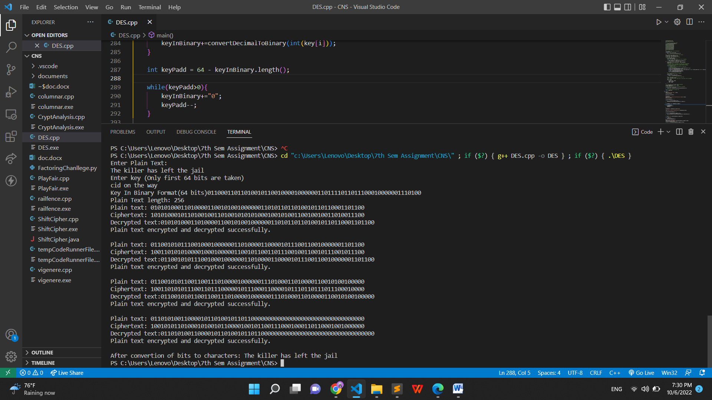

Conclusion:

The Des is implemented successfully, the decrypted text is same as the input text.