Virtual Threat Modeling and Vulnerability Assessment
  - Week 1 Report
Reference environment Isolated web application training network
Assessment approach STRIDE and qualitative risk analysis
Report date 16 October 2026
Status Simulated case study with an executable validation plan

Executive summary
This report evaluates a proposed virtual web application network based on OWASP Juice Shop. It identifies how an attacker could cross trust boundaries, compromise accounts, alter application data, interrupt service, or conceal activity. The recommended first actions are to prevent authentication bypass, enforce object ownership checks, and restrict access between the user, application, and management zones.
The case study contains ten simulated findings: two Critical, four High, and four Medium. These ratings describe a hypothetical business deployment with sensitive customer records. The actual training lab contains synthetic data, so its real business impact would be lower. The proposed controls reduce exposure, but successful retesting is required before any risk is marked resolved.

Evidence and assessment status
No virtual machines, target URLs, software inventory, screenshots, or scan exports were supplied. No network scan or exploitation was performed for this report. The architecture, finding conditions, scores, timelines, and residual scores are explicit scenario assumptions. Public documentation supports the methodology and choice of training target; it does not verify any finding in a particular deployed instance.
This document is a complete simulated analysis and a practical assessment procedure. It is not a record of a completed hands-on scan. Each finding includes the evidence needed to confirm or reject it. Before using it as proof of practical execution, attach genuine outputs from an authorized lab and update the status of each finding.

Report organization
Sections | Contents
1 and 2 | Scope, assets, trust boundaries and data flows
3 and 4 | Assessment methodology and STRIDE threat model
5 to 7 | Risk metrics and detailed simulated findings
8 and 9 | Prioritized treatment, validation and effort plan
10 | References and assessment limitations

1 Scope and virtual environment
The reference workload is OWASP Juice Shop, an intentionally insecure web application intended for training and security testing [1]. A reverse proxy, virtual firewall, log collector, and backup store are added as assessment design assumptions. They are not claimed to be default Juice Shop components.

Assessment boundaries
In scope are the three isolated subnets below, the test application, test accounts, host firewall policies, container or VM settings, local application storage, log forwarding, and recovery of synthetic records. The host hypervisor is reviewed for isolation configuration only. Production networks, public demonstration instances, third-party APIs, real personal information, and the physical host operating system are outside active testing scope.
Asset | Proposed address | Purpose and sensitivity
A1 Browser client | 10.77.10.10 | Two ordinary test accounts; synthetic user activity
A2 Reverse proxy | 10.77.20.10 | Application entry point and TLS keys
A3 Application host | 10.77.20.20 | Juice Shop, local data store and test secrets
A4 Admin and scanner | 10.77.30.10 | Authorized assessment and configuration access
A5 Log collector | 10.77.30.20 | Security events and investigation records
A6 Backup store | 10.77.30.30 | Encrypted test backups and restoration copies

Security objectives
Confidentiality means users can read only their own records and cannot obtain administrative secrets. Integrity means only authorized users can change orders, roles, configuration, or audit records. Availability means the lab service can recover from a controlled failure and resist reasonable resource misuse. The business analogue assumes confidential customer data and a one-business-day outage would be a major disruption.

Setup and containment
Create separate internal virtual networks and route them through a firewall VM; do not bridge vulnerable systems to a home, college, or corporate LAN. Use only synthetic accounts and data. Download required images during setup, record the exact release and image digest, then disable unnecessary external connectivity. Snapshot all targets and verify a restoration before testing.
Use a dedicated host or a host-only administration interface if management access is required. Permit the scanner only the documented target IPs. Start with an intentionally weak baseline only inside the isolated lab, then apply the proposed hardened policy. Preserve a baseline snapshot so educational vulnerabilities can be restored without exposing them externally.

2 Architecture and data flows
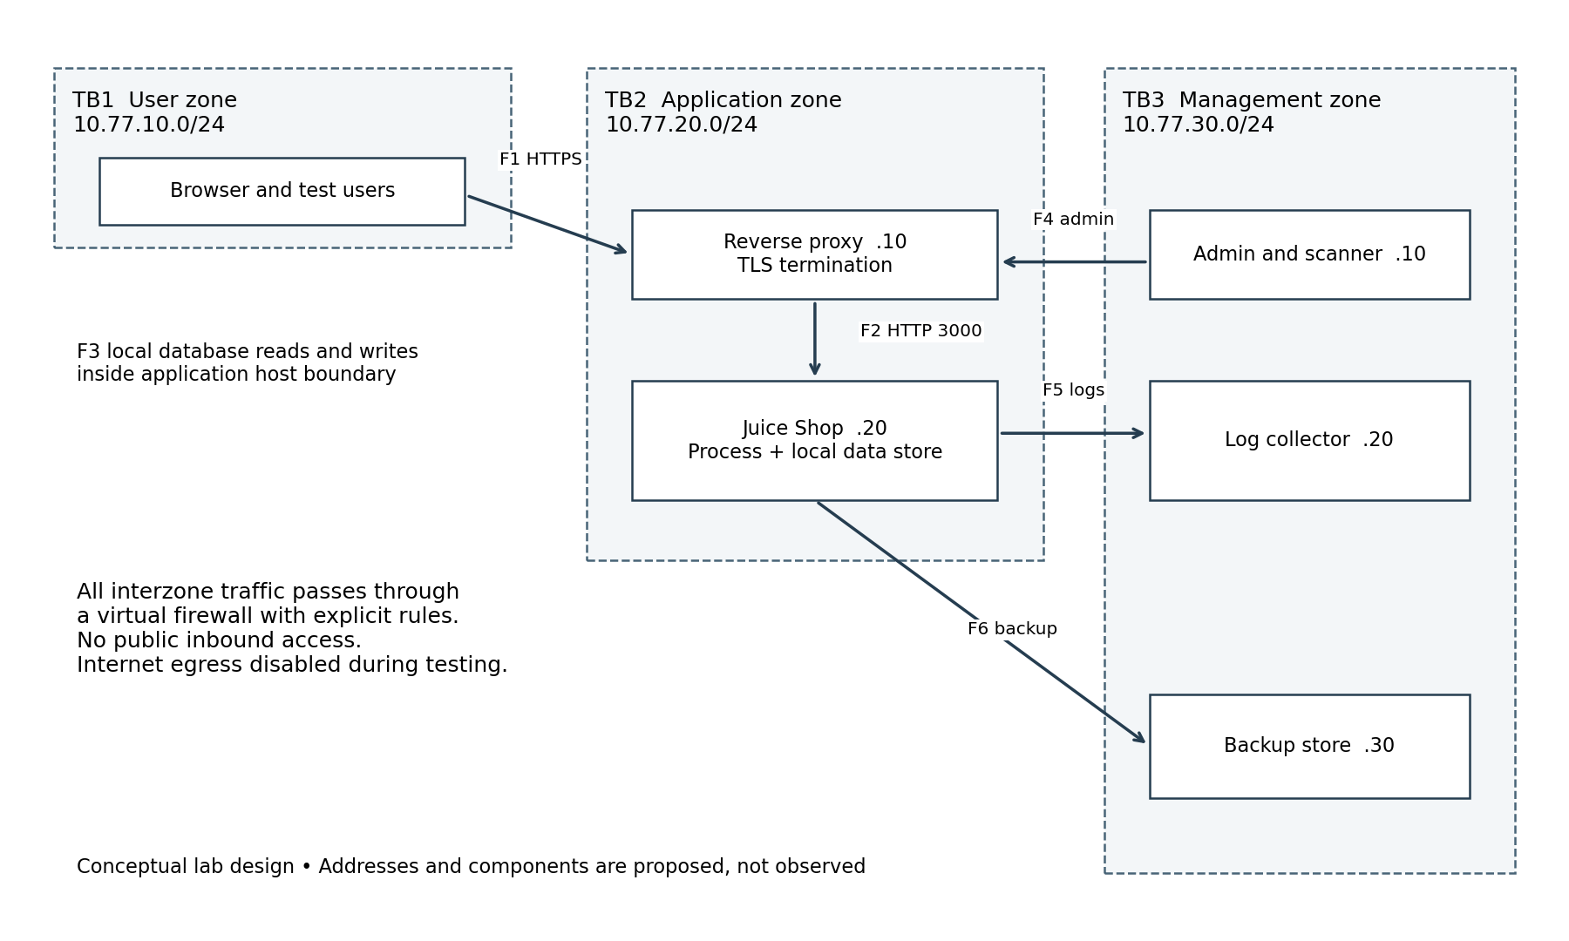
Figure 1. Proposed architecture and trust boundaries. Arrows show principal request or transfer directions; response traffic is implicit. F3 remains local to A3.
Flow | Boundary and data | Hardened rule
F1 | TB1 to TB2; login, session and orders | Client to proxy TCP 443 only
F2 | Within TB2; proxied application requests | Proxy to app TCP 3000 only; protect the segment
F3 | Application process to local storage | Restrict file access to application identity
F4 | TB3 to TB2; maintenance and configuration | Admin host to explicit management ports only
F5 | TB2 to TB3; security events | Authenticated TLS log ingestion; collector cannot administer app
F6 | TB2 to TB3; synthetic database backups | Dedicated restricted backup identity and encrypted transfer
TB1 separates untrusted user activity from application processing. TB2 includes a further privilege boundary between application code and its stored data. TB3 protects administrative credentials, evidence, and backups. Deny all other interzone traffic by default. Temporary scanner access must be time bounded and removed after validation.

3 Assessment methodology
STRIDE provides a structured way to ask what can go wrong at each process, data store, and boundary [2]. The risk analysis considers likelihood and impact in the manner described by NIST SP 800-30 [5], using a locally defined scoring matrix. The web assessment uses the OWASP testing guide as a coverage checklist [6].
Step | Procedure and rationale | Evidence to retain
1 Scope | Approve IP allowlist, test window, stop conditions and recovery; prevent unintended impact. | Scope record and snapshot IDs
2 Discover | Inventory permitted hosts and ports; compare observed services against intended design. | Nmap XML and text output
3 Review configuration | Inspect host, container, proxy, access and logging settings; find weaknesses scanners may miss. | Redacted configurations and versions
4 Assess web traffic | Map pages and API routes; run passive analysis, then targeted approved active checks. | ZAP export and endpoint inventory
5 Validate manually | Use paired test accounts and minimal safe requests; separate genuine defects from tool alerts. | Requests, responses and control tests
6 Rate and treat | Map findings to threats, justify scores and assign fixes; prioritize business consequences. | Finding register and action plan
7 Retest | Repeat original checks and negative controls; verify changes and preserve audit history. | Before and after evidence

Proposed open source scan procedure
The following commands are examples for the proposed isolated lab. They have not been executed. Run them from A4 only after confirming the target allowlist. Save UTC timestamps, tool versions, target image digest, scan options, and tester identity alongside outputs.
mkdir -p evidence
nmap -sT -sV -T3 --top-ports 1000 10.77.20.10 10.77.20.20 -oA evidence/services
nmap -sT -p- -T3 10.77.20.10 10.77.20.20 -oA evidence/tcp-all
curl -I https://shop.lab/
Configure shop.lab to resolve to the proxy and trust a lab CA before TLS testing. Use the ZAP desktop proxy to browse as an anonymous user and both test accounts, then review passive alerts. ZAP baseline scanning spiders a target and evaluates passive rules; it is not an active exploit scan [4]. A single-page application requires API and authenticated-route coverage beyond a simple crawl.
Nmap service detection helps identify listening software [3], but banners alone do not prove a CVE is exploitable. Confirm installed packages, patch status, configuration, and vendor advisories. Record UDP, unvisited routes, and unauthenticated-only areas as coverage gaps. Stop tests on unexpected access outside scope, persistent errors, data corruption, or resource saturation; restore the snapshot before continuing.

4 STRIDE threat model
The threat actor is an untrusted lab user who can reach the web entry point. Additional scenarios consider a compromised ordinary account and a compromised application process. Host administrator compromise is outside scope. The model assumes no existing access to hypervisor credentials.
ID and STRIDE | Attack scenario and entry point | Consequence and finding
T01 Spoofing | Authentication logic accepts crafted input at F1 or account protections are weak. | Impersonation or administrator access; V01, V03
T02 Tampering | A user changes an object identifier at F1 and the API does not check ownership. | Unauthorized order changes; V02
T03 Tampering | Stored user content crosses F1 and executes as script in another browser. | Actions under a victim session; V04
T04 Repudiation | Application events at F5 lack identity, timestamps or protected retention. | Actions cannot be reliably investigated; V09
T05 Information disclosure | User records or tokens travel through an unprotected F1 path or appear in browser-readable content. | Exposure of data and sessions; V02, V04, V06
T06 Denial of service | Repeated costly requests exhaust app resources or recovery copies are unavailable. | Service interruption or prolonged restoration; V08, V10
T07 Elevation of privilege | A normal account bypasses authorization; app compromise reaches excessive OS privileges. | Administrative actions or broader host impact; V01, V05
T08 Lateral movement supporting STRIDE threats | Weak network rules permit user-to-management access across TB1 and TB3. | Additional routes to spoofing, disclosure and privilege escalation; V07

Representative attack paths
Path A begins at the login interface. If V01 exists, authentication bypass permits a privileged session and access to customer records. Fix the authentication data-access logic first, then invalidate affected sessions and verify administrative authorization independently. Strong passwords alone cannot repair an authentication bypass.
Path B starts with a valid ordinary account. If V02 exists, changing a record reference accesses another user’s order. V09 then makes investigation harder because the record access is not attributable. Object-level authorization and protected event collection interrupt different stages of this path.
Path C begins with application compromise through an assumed application flaw. V05 expands the damage possible under the runtime identity, while V07 provides network routes toward management assets. Restricting runtime privileges and network reachability limits consequences even when the initial application flaw remains.
These paths are hypotheses for testing. STRIDE categories describe adversary outcomes; vulnerability IDs describe the particular control failures assumed to enable them. More than one category can apply to a single weakness.

5 Risk assessment and prioritization
Risk score = likelihood × impact, with both factors rated from 1 to 5. This is an ordinal prioritization aid, not a probability, expected financial loss, CVSS score, or a NIST-mandated formula. Scores apply to the hypothetical business deployment defined in Section 1. The same flaw in a disposable lab could have a lower impact.
Rating | Likelihood anchor | Impact anchor
1 | Rare; exceptional access and several prerequisites | Negligible effect on synthetic or public data
2 | Unlikely; restricted access or difficult prerequisites | Small localized disruption with easy recovery
3 | Possible; reachable with some access or setup | Limited confidential records or recoverable outage
4 | Likely; common access and repeatable technique | Sensitive records, material changes or extended outage
5 | Almost certain if assumed flaw is present; trivial repeatability | Broad compromise, privileged control or severe data loss
Severity bands: Low 1–4; Medium 5–12; High 13–19; Critical 20–25. Ties are resolved by attack-path position, breadth of affected assets, exposure, and the effort required for containment. Confidence for every finding is Low because no target evidence is available.
Finding | L | I | Score | Severity | Target residual
V01 Authentication bypass | 5 | 5 | 25 | Critical | 2 × 5 = 10
V02 Missing ownership checks | 4 | 5 | 20 | Critical | 2 × 5 = 10
V03 Weak account protection | 4 | 4 | 16 | High | 2 × 4 = 8
V04 Stored script injection | 4 | 4 | 16 | High | 2 × 4 = 8
V05 Excessive runtime privilege | 3 | 5 | 15 | High | 1 × 5 = 5
V06 Cleartext login path | 5 | 3 | 15 | High | 1 × 3 = 3
V07 Weak segmentation | 3 | 4 | 12 | Medium | 2 × 3 = 6
V08 Missing resource controls | 4 | 3 | 12 | Medium | 2 × 3 = 6
V09 Incomplete audit trail | 3 | 4 | 12 | Medium | 2 × 3 = 6
V10 Unverified backup recovery | 3 | 3 | 9 | Medium | 1 × 3 = 3
All residual scores are proposed targets, not measured results. Retesting must confirm control effectiveness and impact assumptions. Reduced impact for V07 and V09 assumes containment and faster investigation limit the damage.
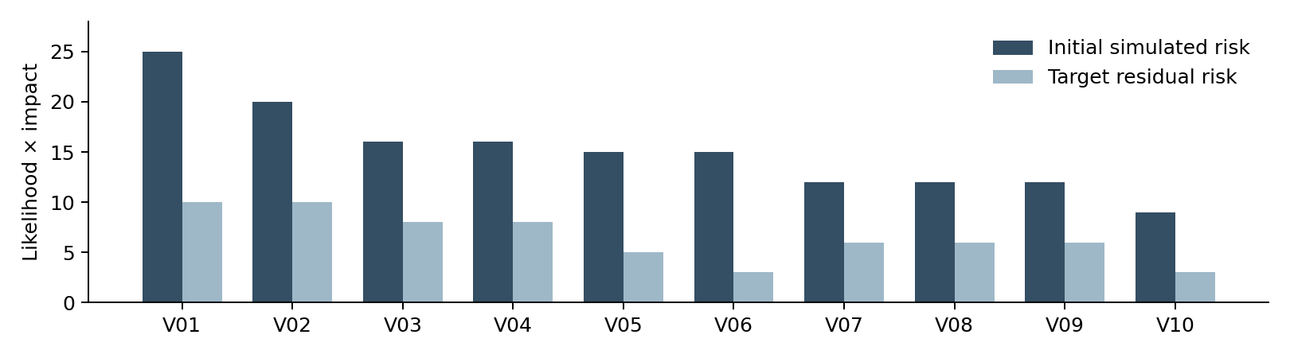
Figure 2. Scenario risk scores before treatment and conditional residual targets. Scores are not summed into an overall risk percentage.

6 Simulated application findings
All findings in Sections 6 and 7 are assumed conditions for analysis, not scan-confirmed defects. The stated evidence is required evidence, not evidence already collected.

V01 Authentication bypass through unsafe query handling
Critical 25 | T01 and T07 | A3 | CWE-89
Assume login input reaches a database query without safe parameter binding. An unauthenticated user could bypass the intended credential check and gain a privileged session. Likelihood 5 reflects direct unauthenticated reachability and repeatability under the assumption. Impact 5 reflects privileged access and broad data compromise.
Validation evidence: Review the login query implementation and capture a minimal non-destructive lab request that changes authentication outcome. Include a valid-login and invalid-login control; record the effective role. Do not extract unrelated records.
Treatment and closure: Use parameterized queries, independent authorization checks and least-privilege data access. Invalidate potentially exposed sessions. Close only when altered input fails authentication and regression tests cover the vulnerable code path.

V02 Missing object level authorization
Critical 20 | T02 and T05 | A3 | CWE-639
Assume an order API trusts a client-supplied record identifier without checking its owner. An ordinary account could read or change another account’s record. Likelihood 4 requires a valid account and discoverable record reference. Impact 5 assumes broad access to customer records and order integrity.
Validation evidence: Create synthetic accounts A and B and one record each. Retain an A-session request for B’s record and its response, plus a request for A’s own record. Confirm the server response rather than relying on UI behavior.
Treatment and closure: Enforce ownership and role checks on every server-side read and write. Default to deny. Closure requires A-to-B operations to return a denial with no data or state change, while legitimate access still works.

V03 Weak account protection
High 16 | T01 | A2 and A3 | CWE-307
Assume ordinary and administrative login routes permit repeated guessing without effective throttling, and administrative access lacks an additional authentication factor. Likelihood 4 reflects a reachable login route with little friction. Impact 4 reflects account compromise; this does not assume authentication bypass.
Validation evidence: Review account policy and identity configuration. With a sacrificial account, submit a small pre-agreed number of failed attempts and inspect server-side delay, limits and alerts. Avoid large password lists.
Treatment and closure: Apply account-aware and source-aware throttling, MFA for administrators, unique credentials and secure recovery. Retest distributed attempts at controlled volume and verify that lockout cannot readily deny access to legitimate users.

V04 Stored cross site scripting
High 16 | T03 and T05 | A3 and browser | CWE-79
Assume stored feedback is rendered without context-appropriate encoding. A later viewer could execute attacker-controlled script under the application origin. Likelihood 4 reflects ordinary user input reaching other users. Impact 4 reflects session-context actions and access to browser-readable data. HttpOnly cookies alone do not prevent such actions.
Validation evidence: Use a harmless visual marker in the isolated lab and capture the stored input, rendering context and resulting execution. Identify affected roles and pages without collecting credentials or session values.
Treatment and closure: Encode output for its HTML or JavaScript context, sanitize allowed markup and use a restrictive Content Security Policy as defense in depth. Closure requires inert rendering across all affected views and no regression in legitimate content.

7 Simulated infrastructure and operational findings

V05 Excessive application runtime privileges
High 15 | T07 | A3
Assume the application runs as root with unnecessary writable host mounts. Likelihood 3 requires initial application compromise; impact 5 reflects possible damage to mounted resources. Root in a container alone does not prove host escape.
Validation and treatment: Inspect runtime UID, capabilities, mounts and secret access. Run as a dedicated non-root identity, drop unnecessary capabilities and mounts, and protect secrets. Verify denied access to host resources while the app still functions.

V06 Login accessible over cleartext HTTP
High 15 | T05 | F1
Assume the login form can be submitted over unencrypted HTTP. Likelihood 5 applies when a user uses that path and an attacker can observe the segment; impact 3 assumes one ordinary account is exposed.
Validation and treatment: Capture only synthetic traffic to establish whether credentials or tokens are readable. Require trusted HTTPS, Secure session cookies and suitable HSTS after testing. Verify no credential-bearing HTTP submission is possible and TLS validation succeeds.

V07 Weak interzone segmentation
Medium 12 | T08 | Virtual firewall
Assume broad allow rules expose management services to the user subnet. Likelihood 3 requires a reachable service plus a further weakness; impact 4 reflects management exposure and lateral movement.
Validation and treatment: Compare rules with Figure 1 and test reachability from each zone. Apply default-deny rules with explicit sources, destinations and ports. Retest allowed and denied paths, including IPv6 if enabled; a timeout alone is insufficient evidence without firewall logs.

V08 Missing request and resource limits
Medium 12 | T06 | A2 and A3
Assume costly routes have no throttling, request-size bounds or effective runtime limits. Likelihood 4 reflects accessible expensive operations; impact 3 assumes a recoverable service outage.
Validation and treatment: Inspect proxy and runtime limits and observe a small bounded workload. Configure rate limits, timeouts, body-size limits and CPU or memory budgets. Retest against an agreed modest load; verify legitimate requests succeed and excess requests are controlled.

V09 Incomplete security event logging
Medium 12 | T04 | A3 and A5
Assume authentication failures and authorization denials omit actor, target or reliable timestamps, and logs remain locally mutable. Likelihood 3 reflects plausible misuse; impact 4 reflects delayed investigation and poor attribution.
Validation and treatment: Trigger one login failure, one access denial and one administrative change. Verify correlation at the collector. Log UTC time, event type, actor and request ID; restrict deletion, synchronize clocks, and avoid recording passwords or tokens. Retest event completeness and alert delivery.

V10 Backup recovery not verified
Medium 9 | T06 | A3 and A6
Assume backups share writable credentials with the app and have no documented restoration test. Likelihood 3 reflects accidental loss or compromise; impact 3 assumes recoverable but extended interruption.
Validation and treatment: Review access separation and restore a synthetic backup into a clean instance. Use separate credentials, encryption and a protected copy. Proposed targets are RPO 24 hours and RTO 4 hours; approve these before use and measure both during retesting.

8 Prioritized risk reduction plan
The schedule starts on the date the lab owner accepts the findings, designated Day 0. Roles below are proposed owners rather than assignments to named people. In a student lab, one person may fill several roles, but a second reviewer should check Critical findings and closure evidence.
Priority and due | Finding | Owner | Action and acceptance condition
P0 within 24 hours | V01 V02 | Application owner | Restrict affected functions and administrative access until fixed. Preserve evidence; confirm containment from an ordinary account.
P1 by Day 3 | V01 V02 | Developer and reviewer | Repair queries and object authorization. Pass original checks and negative regression cases.
P1 by Day 7 | V03 V06 | Identity and platform owner | Enforce admin MFA, throttling and TLS. Verify account protections and absence of cleartext login paths.
P1 by Day 7 | V04 V05 | Developer and platform owner | Correct rendering and reduce runtime privileges. Validate each affected view and restricted resource.
P2 by Day 14 | V07 V08 | Network and platform owner | Deploy tested allow rules and resource controls. Confirm permitted traffic, blocked paths and service health.
P2 by Day 14 | V09 | SOC or lab analyst | Centralize protected events and implement alerts. Validate event correlation and redaction.
P2 by Day 30 | V10 | Recovery owner | Protect backups and conduct a timed clean restore. Meet approved recovery targets.

Dependencies and feasibility
Take snapshots before authentication, proxy, and network changes. Repair authorization before relying on monitoring to detect misuse. Establish trusted TLS before testing secure-cookie behavior. Preserve a management recovery route before changing firewall rules. Test application functionality after reducing runtime privileges, because incorrect file permissions can cause an outage.
The most practical first controls are configuration changes: restrict reachability, require HTTPS, isolate administration, and protect logs. Application logic fixes need development and regression testing. Because Juice Shop is intentionally vulnerable, remediation demonstrations should use a separate hardened copy or configuration layer; preserve the original isolated training instance for repeatable learning.

Residual risk and exceptions
Residual scores in Section 5 assume every stated control works as designed. The system owner must explicitly accept remaining Medium risks after retesting; none are accepted automatically. If a deadline is missed, record the reason, temporary restriction, owner, review date and revised due date. A documented exception is not evidence that a vulnerability has been fixed.
A gateway filter can temporarily reduce exposure but cannot prove that unsafe database queries or missing ownership checks are repaired. Permanent closure requires validation at the application layer. Reopen a finding if a control fails, a new route bypasses it, or a later configuration change restores the original condition.

9 Verification evidence and effort plan

Evidence record and finding lifecycle
Assign evidence IDs E-V01 through E-V10 and attach the real artifacts after execution. Each record must include target and build, UTC time, tool version, test account role, exact procedure, expected behavior, observed behavior, redacted request and response, relevant configuration, reviewer, and artifact SHA-256. Preserve the original output separately from annotated screenshots.
Use the states Proposed, Observed, Confirmed, False positive, Remediated pending retest, Closed, and Accepted risk. Current status for all ten findings is Proposed. Promote a finding only when evidence supports it. A failed scanner check without manual confirmation remains Observed; an alert disproved by a valid control test is a documented false positive.
Verification area | Pass criterion | Current status
Critical application flaws | V01 and V02 regression cases fail safely; legitimate actions succeed | Not executed
Identity and browser security | MFA, throttling, HTTPS and inert content verified | Not executed
Privilege and isolation | App cannot access restricted resources; interzone rules match design | Not executed
Detection and performance | Required events reach collector; controlled excess traffic is limited | Not executed
Recovery | Clean restore meets approved RPO and RTO with data checks | Not executed

Proposed 33 hour work allocation
Activity | Hours | Expected work product
Scope and reference review | 3 | Scope, assumptions and source log
Lab build and isolation checks | 5 | Inventory, configuration and recoverable snapshots
Data flows and STRIDE analysis | 4 | Architecture and threat register
Discovery and scanner assessment | 5 | Versioned scan exports and coverage notes
Manual validation and evidence review | 5 | Confirmed or rejected finding records
Risk assessment and treatment design | 3 | Scored register and owner timelines
Remediation demonstration and retest | 4 | Before and after evidence for selected controls
Reporting and quality review | 4 | Final report and evidence index
Total planned effort | 33 | Estimated allocation, not hours already worked
Useful completion metrics are confirmed findings divided by proposed findings, tested endpoints divided by inventoried endpoints, verified controls divided by required controls, and findings closed by due date divided by findings due. All measured rates are currently unavailable because testing has not occurred. A low alert count alone is not a reliable measure of security.

10 References and limitations
The following public primary references were reviewed on 16 October 2026. They establish the training target and methodological basis. The network design, attack paths and finding register are original scenario analysis and require independent lab validation.

1 OWASP Juice Shop
OWASP Foundation. Training application purpose and project documentation.
https://owasp.org/projects/juice-shop

2 Microsoft Threat Modeling Tool threats
Microsoft Learn. STRIDE category definitions and threat modeling context.
https://learn.microsoft.com/en-us/azure/security/develop/threat-modeling-tool-threats

3 Service and Version Detection
Nmap reference guide. Service probing, version identification and limitations.
https://nmap.org/book/man-version-detection.html

4 ZAP Baseline Scan
ZAP documentation. Spidering and passive-rule behavior of baseline scans.
https://www.zaproxy.org/docs/docker/baseline-scan/

5 Guide for Conducting Risk Assessments
NIST SP 800-30 Revision 1. Risk assessment concepts and likelihood and impact analysis. The numerical bands in this report are locally defined.
https://csrc.nist.gov/pubs/sp/800/30/r1/final

6 OWASP Web Security Testing Guide
OWASP Foundation. Web testing coverage and structured testing methodology.
https://owasp.org/projects/web-security-testing-guide

Assessment limitations
Public project documentation cannot establish what is installed in a particular lab or which vulnerabilities are reachable in that build. The report therefore does not assign CVE identifiers, claim measured exploitation, or supply fabricated scan output. No practical screenshots are included because no test execution occurred.
This assessment does not cover social engineering, physical access, hypervisor exploitation, exhaustive UDP discovery, supply-chain compromise, or destructive load testing. Authenticated routes and API coverage must be documented during execution. Additional vulnerabilities may exist outside the modeled paths.

Final assessment
The modeled environment is unsuitable for handling real confidential data while the assumed Critical weaknesses remain. The proposed treatment sequence addresses direct account and data compromise first, then limits the impact of a compromise and improves detection and recovery. A deployment decision requires genuine scan evidence, manual validation, verified remediation and explicit acceptance of residual risk.

