ML-Powered Pairs Trading and Statistical Arbitrage
A Comparison of a Neural Network (MLP) and a Fuzzy Logic Controller
Udbhav&claude | Thapar Institute of Engineering and Technology (TIET) | Batch 3S14
Machine Learning Course Project

Abstract
Pairs trading bets that two historically related stocks will move back together after they drift apart. This project builds a complete pairs-trading pipeline on 40 large-cap NSE stocks using only techniques from the course: PCA and K-Means to group stocks, and then two different decision models compared against a simple rule. Model A is a multi-layer perceptron written from scratch (backpropagation and gradient descent) that predicts whether a stretched spread will revert, evaluated with a confusion matrix. Model B is a Mamdani fuzzy logic controller that converts the spread z-score and volatility into a graded position size. Both are tested out-of-sample from January 2021 to November 2026 with 10 bps transaction costs. The honest outcome is negative: the plain hard-threshold baseline gave the best result (Sharpe 0.67), the MLP had no predictive skill and almost never traded (Sharpe 0.18), and the fuzzy controller lost most of its return to trading costs (Sharpe 0.17). We analyse why, and what this teaches about applying machine learning to financial data.

1. Introduction
In statistical arbitrage, a pair is two assets whose log prices are cointegrated: a linear combination of them, the spread, is stationary and mean-reverting even though each price alone is a random walk. When the spread becomes unusually wide we go long the cheap leg and short the expensive leg, and close the position when the spread returns to normal. The position is roughly market-neutral, so profit depends on the spread reverting, not on market direction.
The aim of this project is to apply course material to this problem and answer one question: does a learned model (neural network) or an expert-rule model (fuzzy logic) improve a simple z-score trading rule, after transaction costs? Both models share the same first stage (PCA, K-Means and cointegration testing for pair selection), so any difference in results comes from the decision model alone. The course topics used are PCA, K-Means, the perceptron and multi-layer network, backpropagation, gradient descent, the confusion matrix and fuzzy logic.

2. Data and Common Pipeline

2.1 Data and split
We downloaded daily adjusted closing prices (Yahoo Finance) for 40 Nifty 50 constituents from January 2015 onward, keeping stocks with an almost complete history. Data up to 31 December 2020 is the training window: pair selection, hedge ratios, feature scaling and the MLP are all fitted only on it. Everything from January 2021 to November 2026 (about 5.9 years) is the out-of-sample test window used for every reported result. This avoids look-ahead bias.

2.2 PCA and K-Means: grouping stocks
Testing every pair of 40 stocks (780 pairs) invites false positives, so we first group similar stocks. Standardised daily returns from the training window are reduced with PCA (five components); the first component explains about 32% of variance and is the common market factor, and the top five together about half. Each stock's loadings on the five components give its coordinates. K-Means is run for k = 2 to 10 and k is chosen by the silhouette score, giving k = 5 (silhouette about 0.52). Figure 1 shows the clusters are economically sensible: IT stocks (TCS, INFY, HCLTECH, WIPRO, TECHM), pharma stocks and financials each form a separate group. Only pairs inside the same cluster are tested.
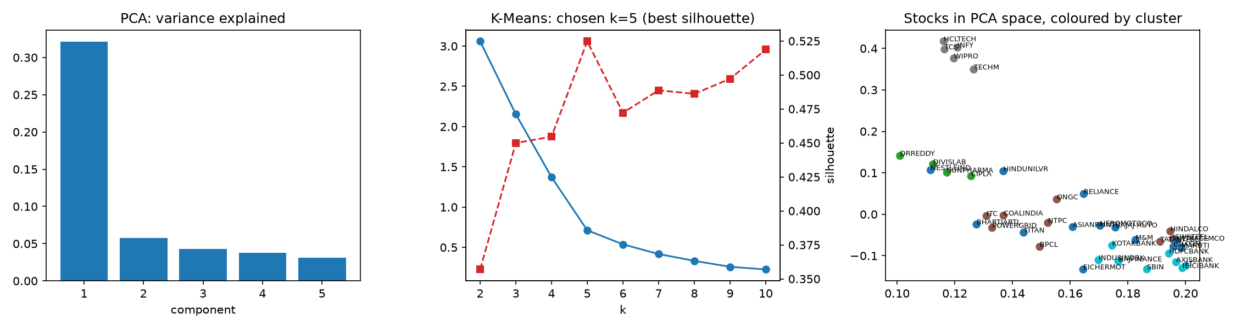
Figure 1. PCA variance explained, K-Means model selection (inertia and silhouette), and stocks in PCA space coloured by cluster.

2.3 Cointegration, spread and z-score
Within each cluster we apply the Engle-Granger cointegration test on log prices (training window, p < 0.05). We also require a mean-reversion half-life of 2 to 40 days, estimated by regressing spread changes on the lagged spread, and a positive hedge ratio. The eight pairs with the smallest p-values are kept (Table 2). For each pair the hedge ratio β is fitted by OLS on the training window and the spread and its rolling 60-day z-score are
S_t = ln A_t − β ln B_t − α , z_t = ( S_t − mean₆₀(S) ) / std₆₀(S)

2.4 Baseline strategy and backtest
The baseline is the classic hard rule: go short the spread when z > 2 (long when z < −2), exit when |z| < 0.5, and stop out if |z| > 4. A position chosen at the close of day t earns the spread change on day t+1. Every change of position costs 10 bps, and profit is normalised by gross capital (1 + |β|). The portfolio is an equal-weight combination of the eight pairs. Both models below use exactly the same backtest.

3. Model A: Multi-Layer Perceptron

3.1 Task, features and architecture
The network is a binary classifier that answers: given that the spread is currently stretched, will it revert? The label is 1 if |z| falls below 0.5 within the next 10 trading days. It is trained only on days with |z| > 1.5, since those are the days on which a trading decision is actually made. There are five input features: the z-score, its one-day change, the z-score five days earlier, a volatility ratio (20-day over 120-day standard deviation of spread changes) and the scaled five-day spread momentum, all standardised with training statistics. A single perceptron is a linear threshold unit; stacking layers lets the network learn non-linear decision boundaries. Our network is 5 – 16 – 8 – 1 with ReLU hidden units and a sigmoid output:
p = σ( W₃ · ReLU( W₂ · ReLU( W₁x + b₁ ) + b₂ ) + b₃ )

3.2 Backpropagation and gradient descent
The loss is binary cross-entropy. For a sigmoid output with this loss, the error signal at the output layer is simply (p − y)/n, and it is propagated backwards through each layer by the chain rule:
δ_L = (p − y)/n , δ_(l−1) = ( δ_l · W_lᵀ ) ⊙ 1[a_(l−1) > 0] , ∂Loss/∂W_l = a_(l−1)ᵀ δ_l
The weights are updated by mini-batch gradient descent (batch size 64) with momentum 0.9: v ← μv − η ∇W, then W ← W + v, plus a small L2 penalty and early stopping on a validation split. The network is implemented from scratch in NumPy. To confirm the backpropagation code is correct we compared its gradients with numerical (finite-difference) gradients; the relative error was about 10⁻⁹.

3.3 Training behaviour
Figure 2 (right) shows the effect of the learning rate η. With η = 0.5 and η = 0.05 the validation loss oscillates wildly (steps overshoot the minimum), while η = 0.005 is smooth but learns very slowly; we used η = 0.01. In the final run (left), training loss keeps falling to about 0.60 while validation loss stalls near 0.64 and drifts upward, a clear sign of overfitting, so early stopping halted training after about 73 epochs and kept the best weights (around epoch 33).
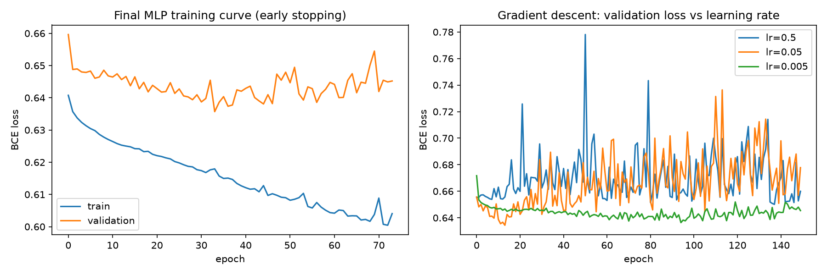
Figure 2. Left: training and validation loss of the final MLP. Right: gradient descent with three learning rates.

3.4 How the MLP is used in trading
The MLP acts as a gate: the trading rule is the same as the baseline, but a new position is opened only if the predicted probability of reversion exceeds 0.6.

4. Model B: Fuzzy Logic Controller
The fuzzy system replaces the all-or-nothing threshold with graded reasoning, and needs no training data. It is a Mamdani system with two inputs and one output (Figure 3):
- Input 1, z-score: five fuzzy sets: Very Negative, Negative, Zero, Positive, Very Positive (triangular and trapezoidal membership functions).
- Input 2, spread volatility ratio: Low, Medium, High. High volatility signals that the pair relationship may be breaking down.
- Output, position size in [−1, +1]: Strong Short, Short, Flat, Long, Strong Long (positive means long the spread).
The rule base has nine rules (Table 1). Rules are combined with min (AND) and max (OR), the output sets are clipped with min-implication, aggregated with max, and the crisp position is obtained by centroid defuzzification. Two useful properties follow: positions are scaled down when volatility is high, and the system takes no position when |z| exceeds about 5 (a built-in stop-loss).
Table 1. Fuzzy rule base (z-score and volatility to position).
z-score | Volatility Low/Med | Volatility High | Meaning
Very Negative | Strong Long | Long | Spread very cheap
Negative | Long | Flat | Spread cheap
Zero | Flat | Flat | No edge
Positive | Short | Flat | Spread rich
Very Positive | Strong Short | Short | Spread very rich

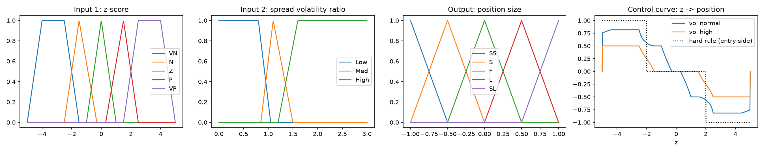
Figure 3. Membership functions, and the resulting control curve compared with the hard ±2 rule.
The control curve shows the main difference from the baseline: the fuzzy system begins to build a position at |z| of about 1 and scales it smoothly, instead of jumping from 0 to full size at |z| = 2.

5. Results

5.1 Stability of the selected pairs
Table 2 shows that the selected relationships were weak to begin with and mostly did not last. Five of the eight training p-values lie between 0.01 and 0.05, and in the test window only two pairs (EICHERMOT/GRASIM and AXISBANK/LT) were still cointegrated at the 5% level, with BAJAJ-AUTO/ULTRACEMCO borderline. No multiple-testing correction was applied, so some false positives were expected. This matters for everything that follows.
Table 2. Selected pairs: training and out-of-sample cointegration p-values, and out-of-sample Sharpe ratio per strategy (n/a = never traded).
Pair | p (train) | Half-life (days) | p (test) | Sharpe baseline | Sharpe MLP | Sharpe fuzzy
BAJAJ-AUTO / ULTRACEMCO | 0.0002 | 21.2 | 0.062 | −0.11 | 0.27 | −0.60
ITC / NTPC | 0.0006 | 23.6 | 0.871 | −0.04 | n/a | 0.06
EICHERMOT / HEROMOTOCO | 0.0049 | 22.5 | 0.406 | 0.25 | 0.32 | −0.24
BAJFINANCE / HDFCBANK | 0.0114 | 32.0 | 0.678 | 0.20 | −0.06 | 0.16
EICHERMOT / GRASIM | 0.0132 | 36.0 | 0.023 | 0.29 | n/a | 0.07
HDFCBANK / KOTAKBANK | 0.0326 | 28.5 | 0.200 | 1.08 | −0.21 | 0.31
BPCL / POWERGRID | 0.0379 | 33.2 | 0.545 | 0.08 | n/a | 0.24
AXISBANK / LT | 0.0402 | 34.7 | 0.001 | 0.52 | 0.04 | 0.59

5.2 Model A: classification quality (confusion matrix)
On the test window there are 3,365 stretched-spread days, of which 870 (25.9%) were followed by a reversion. Figure 4 and Table 3 give the confusion matrix at three probability thresholds.
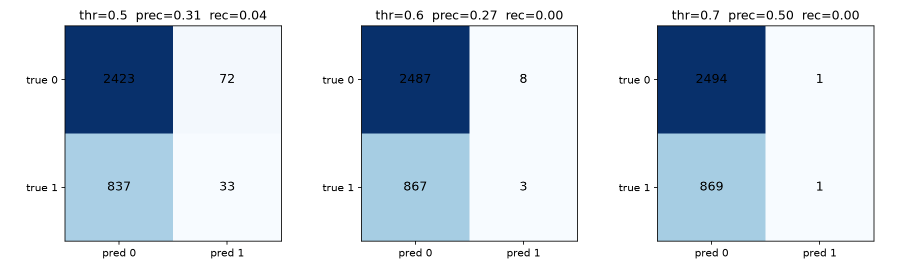
Figure 4. Confusion matrices of the MLP on the test window at thresholds 0.5, 0.6 and 0.7.
Table 3. Confusion-matrix metrics of the MLP (test window).
Threshold | TP | FP | FN | TN | Accuracy | Precision | Recall | F1
0.5 | 33 | 72 | 837 | 2423 | 0.730 | 0.314 | 0.038 | 0.068
0.6 | 3 | 8 | 867 | 2487 | 0.740 | 0.273 | 0.003 | 0.007
0.7 | 1 | 1 | 869 | 2494 | 0.741 | 0.500 | 0.001 | 0.002

Accuracy looks respectable at 73 to 74%, but it is misleading: always predicting no reversion would score 74.1% on this class balance. The network predicts reversion for only a handful of days, and recall is close to zero (3.8% at best). Precision at 0.5 (0.314) is only slightly above the 25.9% base rate. The MLP has essentially no predictive skill out-of-sample. Consequently, with the 0.6 gate, the MLP strategy opened only 7 positions in almost six years.

5.3 Trading performance
Table 4. Out-of-sample performance, January 2021 to November 2026, 10 bps cost per unit of position change.
Strategy | Ann. return | Ann. vol | Sharpe | Sortino | Max drawdown | Entries | Turnover
Baseline (hard z-score) | 2.26% | 3.38% | 0.67 | 1.04 | −6.65% | 216 | 431
Model A: MLP filter | 0.11% | 0.59% | 0.18 | 0.11 | −1.32% | 7 | 14
Model B: Fuzzy sizing | 0.39% | 2.23% | 0.17 | 0.27 | −5.33% | 835 | 1071

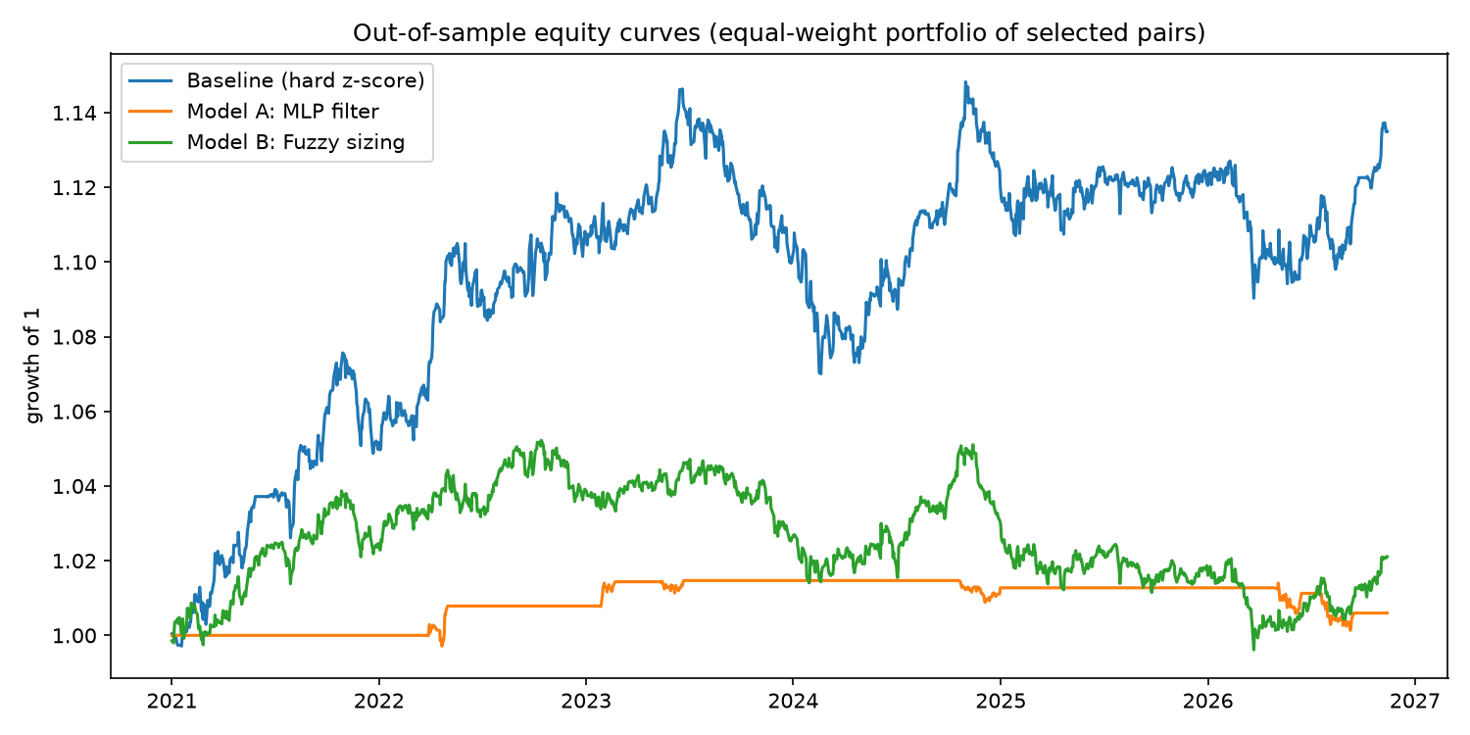
Figure 5. Out-of-sample growth of one unit of capital for the three strategies (equal-weight portfolio of the eight pairs).
The baseline is clearly best: it grew capital by about 13.5% over the test window (Sharpe 0.67), although with a drawdown of 6.7% in 2023 to 2024 when several pairs drifted apart. Model A barely moved, as it was almost always out of the market. Its low volatility and small drawdown reflect inactivity, not skill. Model B earned a small positive return with a Sharpe ratio of 0.17.

5.4 The cost of trading
Total transaction costs over the test window were 5.4% of capital for the baseline, 13.4% for the fuzzy controller and 0.2% for the MLP. Spread over about 5.9 years, this is roughly 0.9, 2.3 and 0.03 percentage points per year. Adding these back, the approximate pre-cost annual returns would be about 3.2% (baseline), 2.7% (fuzzy) and 0.1% (MLP). So the fuzzy system is not much worse than the baseline before costs. It loses because it trades so much: 835 entries and a turnover of 1,071 against 216 entries and 431 for the baseline.

6. Discussion

6.1 Why the MLP did not work
- The relationship it tries to predict stopped existing. Six of the eight pairs were no longer cointegrated out-of-sample. No classifier can forecast reversion of a spread that no longer reverts.
- Little information and few samples. All five features are derived from the spread itself, and only a few thousand stretched-spread days (pooled over 8 pairs) are available. The loss curves show the network memorises the training data (training loss falls, validation loss stalls).
- Strict gate. Requiring probability above 0.6 from a weak, poorly calibrated model leaves almost no trades, and with 7 entries the MLP's per-pair Sharpe ratios in Table 2 are statistically meaningless.

6.2 Why the fuzzy controller did not work
- Over-trading. The position is recomputed every day, so it changes constantly, and each small change pays the 10 bps cost. Costs of about 2.3% per year consume almost all of its gross return.
- It trades earlier. Starting at |z| near 1, it takes positions when the expected reversion is smaller than at |z| = 2.
- Hand-set design. The membership functions and rules were set by judgement and not tuned. Its best result was on AXISBANK/LT (Sharpe 0.59, against 0.52 for the baseline), one of the few pairs that stayed cointegrated, but this did not carry over to the portfolio.

6.3 Side-by-side comparison
Table 5. Qualitative comparison of the two models.
Aspect | Model A: MLP | Model B: Fuzzy controller
Course topics | Perceptron, backprop, gradient descent, confusion matrix | Fuzzy sets, rule base, defuzzification
Knowledge source | Learned from historical data | Written by the designer
Output | Probability of reversion (used as an on/off gate) | Position size from −1 to +1
Interpretability | Low (weights are opaque) | High (rules can be read and audited)
Main risk | Overfitting; needs data | Over-trading; arbitrary parameters
Result here | No skill; 7 trades; Sharpe 0.18 | Cost-dominated; Sharpe 0.17

6.4 Limitations
The study uses a single train/test split, only eight pairs, and pairs fixed at the end of 2020 and never re-selected. Cointegration p-values were not corrected for multiple testing. The stock universe is today's Nifty constituents, which introduces survivorship bias. Short selling in the Indian cash market is restricted, so a real implementation would need futures, whose costs and margins are not modelled. The single-layer perceptron was explained as the building block of the MLP but not tested as a separate model. These limitations make the absolute numbers uncertain; the ranking (baseline ahead of both models) is the more reliable conclusion.

7. Conclusion
We built a full pairs-trading pipeline from course techniques: PCA and K-Means grouped 40 stocks into sensible sectors, cointegration tests selected eight pairs, and two different models were compared with a hard-threshold baseline under identical, cost-aware, out-of-sample conditions. Neither model beat the baseline. The MLP, trained with backpropagation and gradient descent and checked with a confusion matrix, showed no predictive skill, because most selected pairs stopped being cointegrated and the features carried little extra information. The fuzzy controller was competitive before costs but was undone by turnover. The main lessons are that a more complex model is not automatically better, that out-of-sample testing and transaction costs decide whether an idea works, and that the quality of the pair-selection stage limits everything downstream.
Future work: re-select pairs with rolling (walk-forward) windows and correct for multiple testing; use a Kalman filter for the hedge ratio; add hysteresis or a minimum-change band to the fuzzy controller to cut turnover and tune its membership functions automatically; test a plain perceptron and a logistic baseline against the MLP; and use richer features such as volume and market-wide volatility.

References
[1] Engle, R. F. and Granger, C. W. J. (1987). Co-integration and error correction: representation, estimation, and testing. Econometrica, 55(2), 251-276.
[2] Gatev, E., Goetzmann, W. N. and Rouwenhorst, K. G. (2006). Pairs trading: performance of a relative-value arbitrage rule. Review of Financial Studies, 19(3), 797-827.
[3] Rumelhart, D. E., Hinton, G. E. and Williams, R. J. (1986). Learning representations by back-propagating errors. Nature, 323, 533-536.
[4] Zadeh, L. A. (1965). Fuzzy sets. Information and Control, 8(3), 338-353.

