

**START UP MENU**

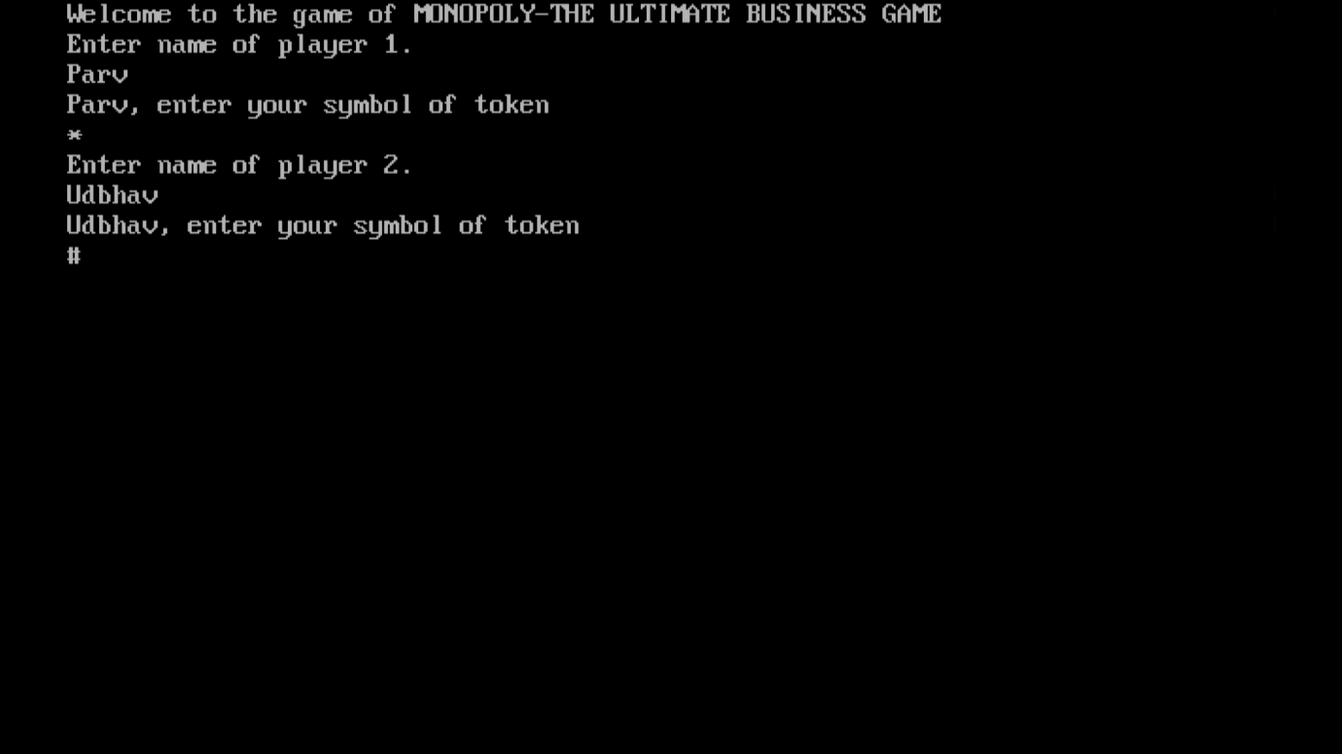

**PLAYER DETAILS**

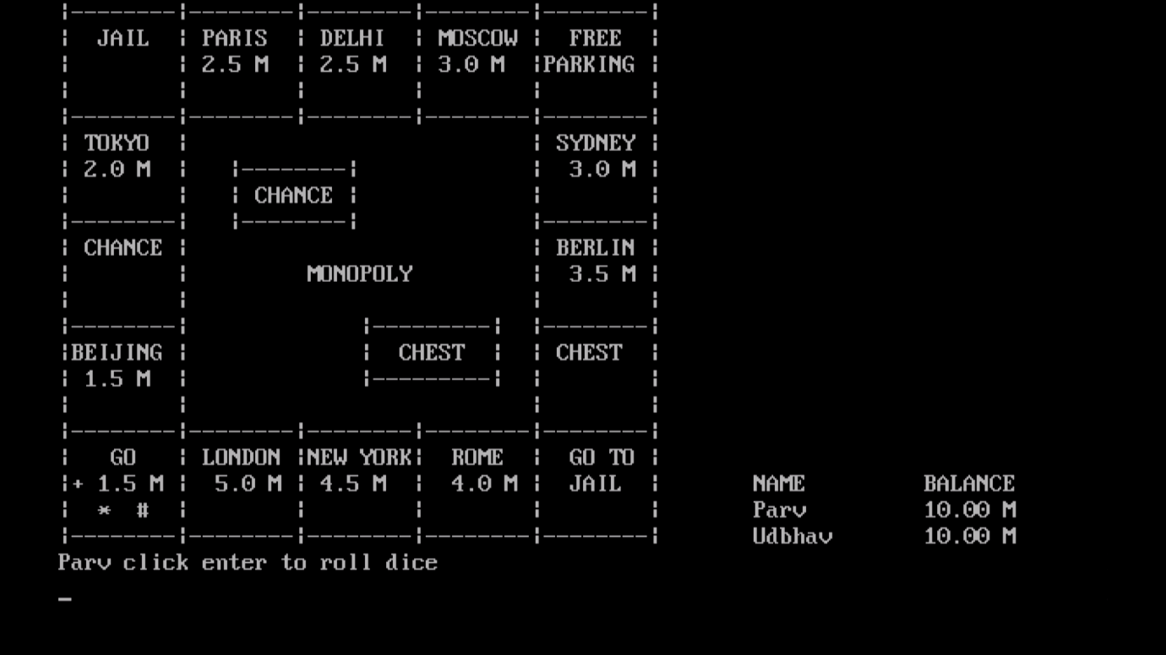

**FIRST CHANCE**

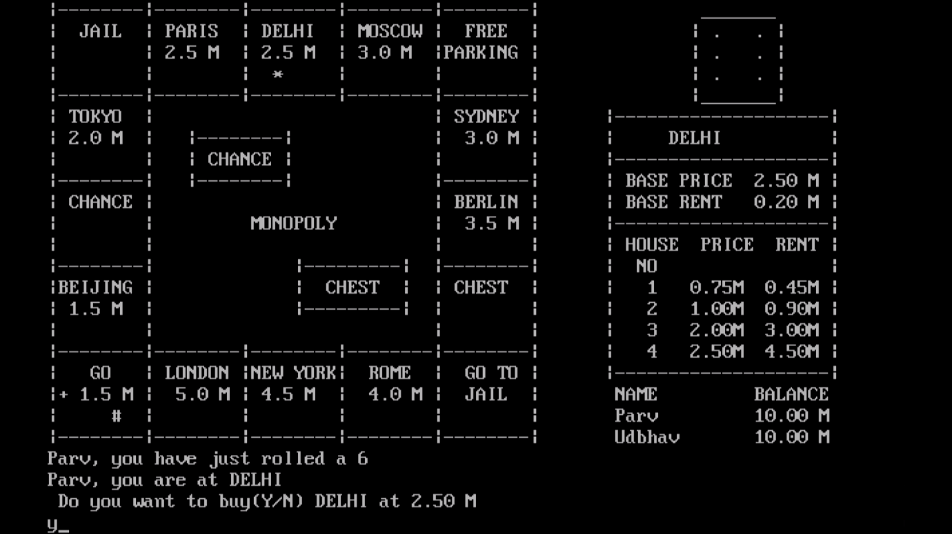

**BUYING A TICKET**

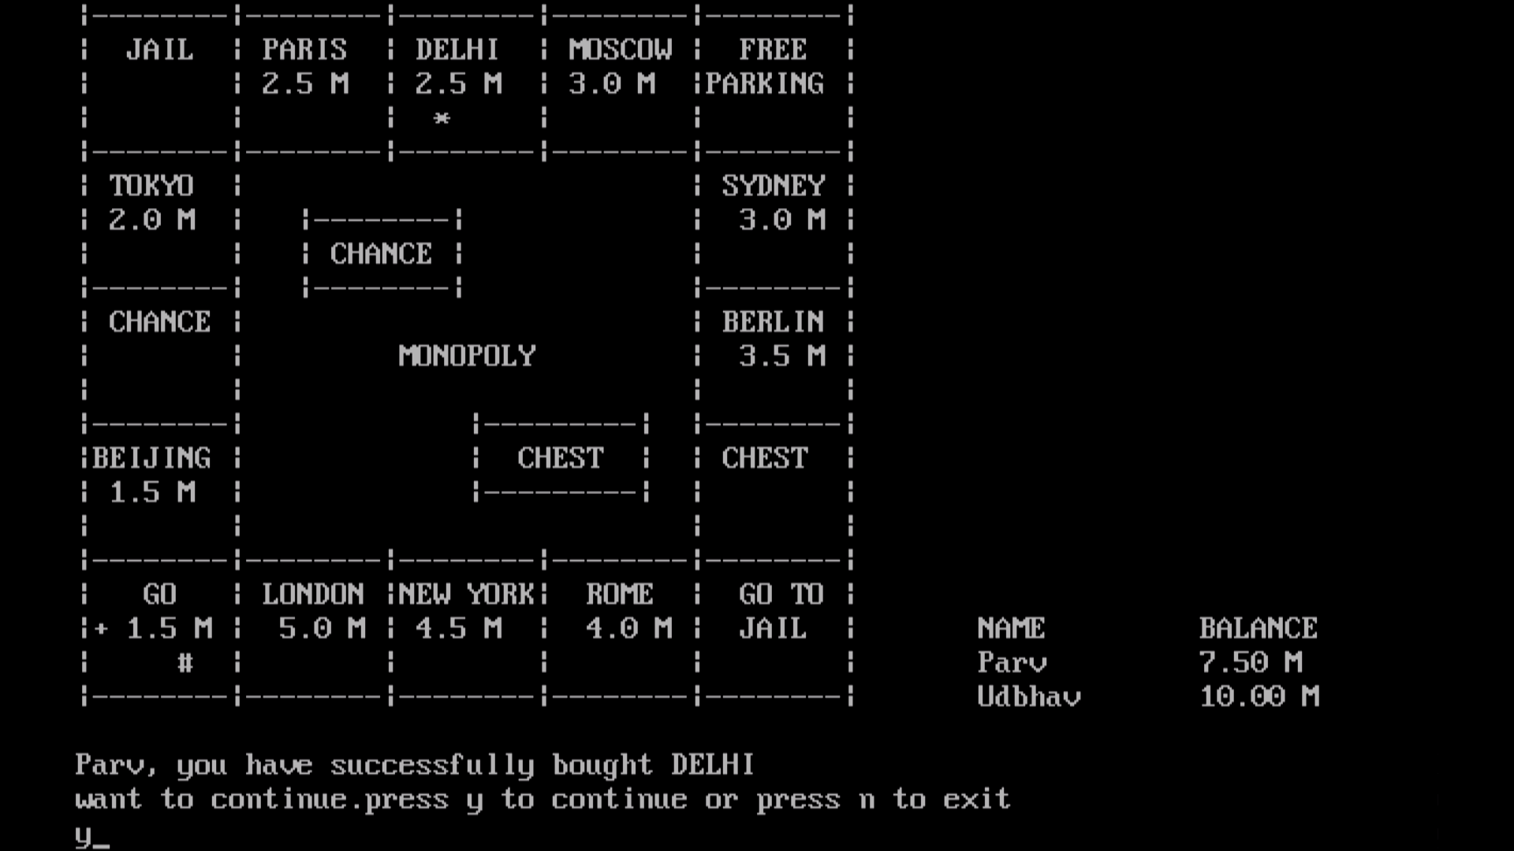

**DEDUCTION OF PRICE OF TICKET FROM THE PLAYER’S BALANCE**

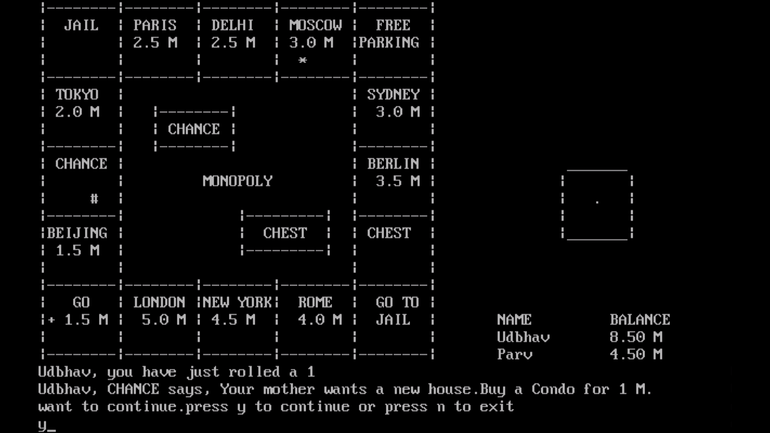

**CHANCE/CHEST**

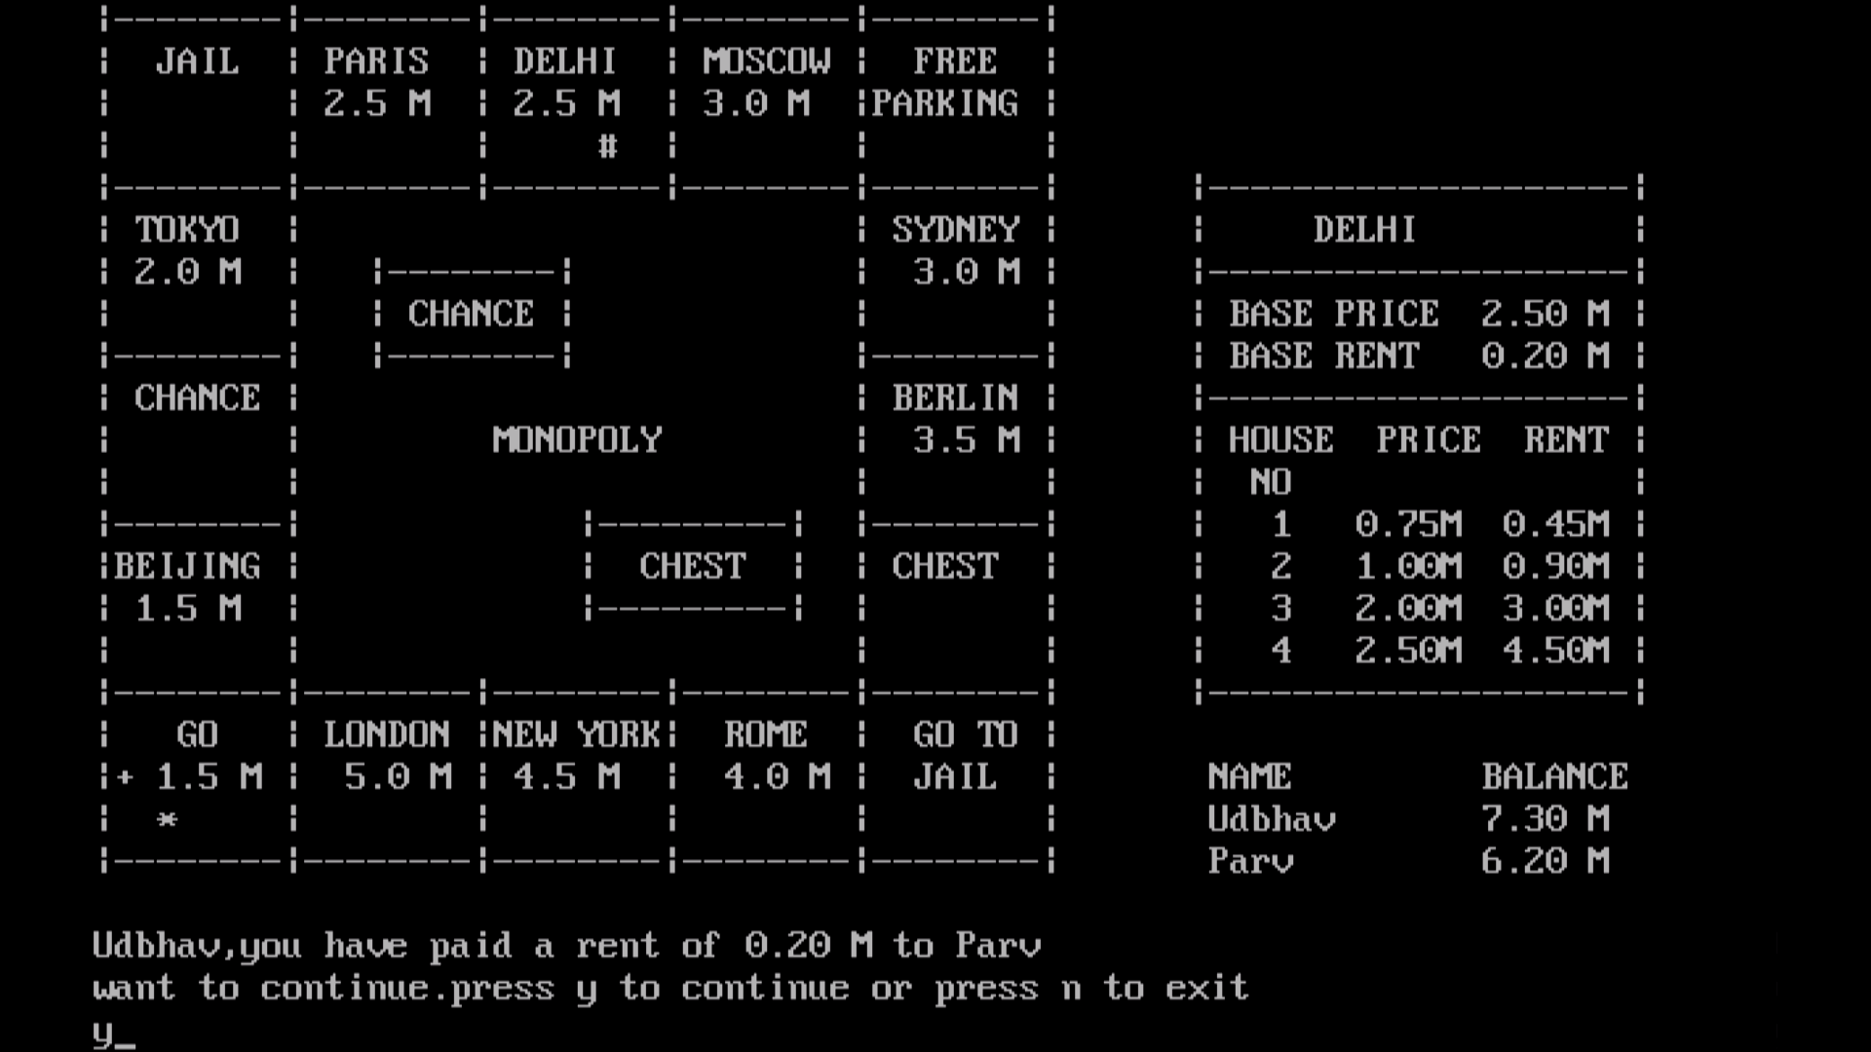

**PAYING RENT**

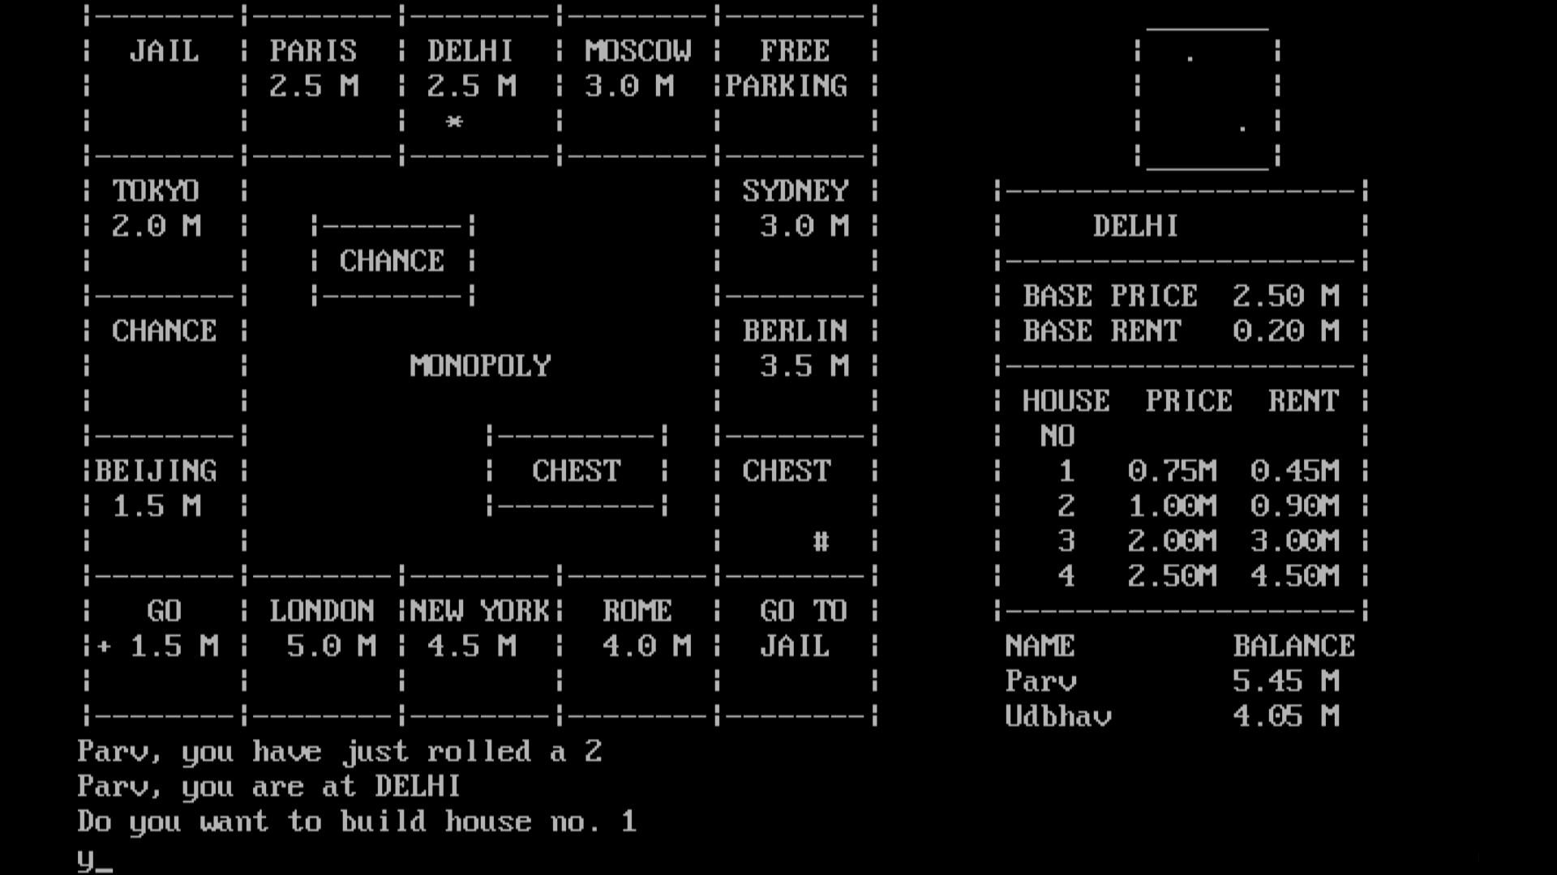

**BUILDING HOUSES ON PRE OWNED PROPERTIES**

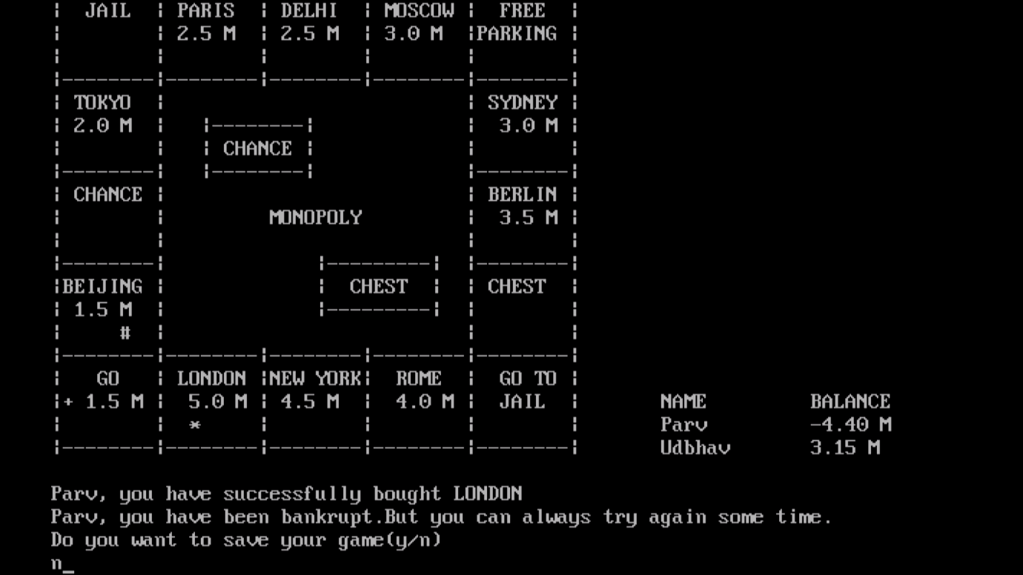

**BANKRUPTCY**

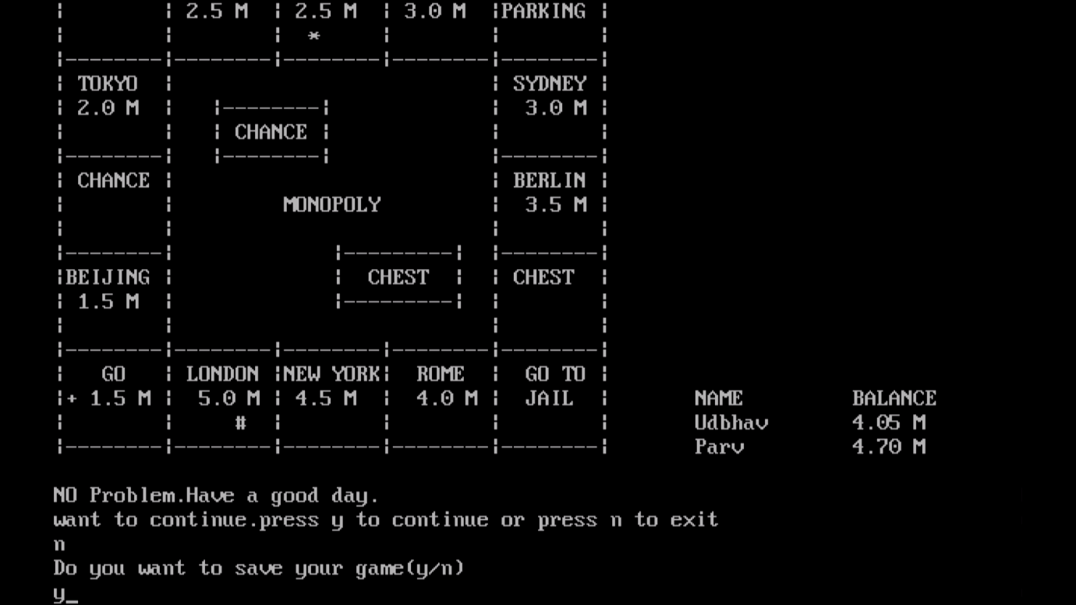

**SAVING THE GAME**



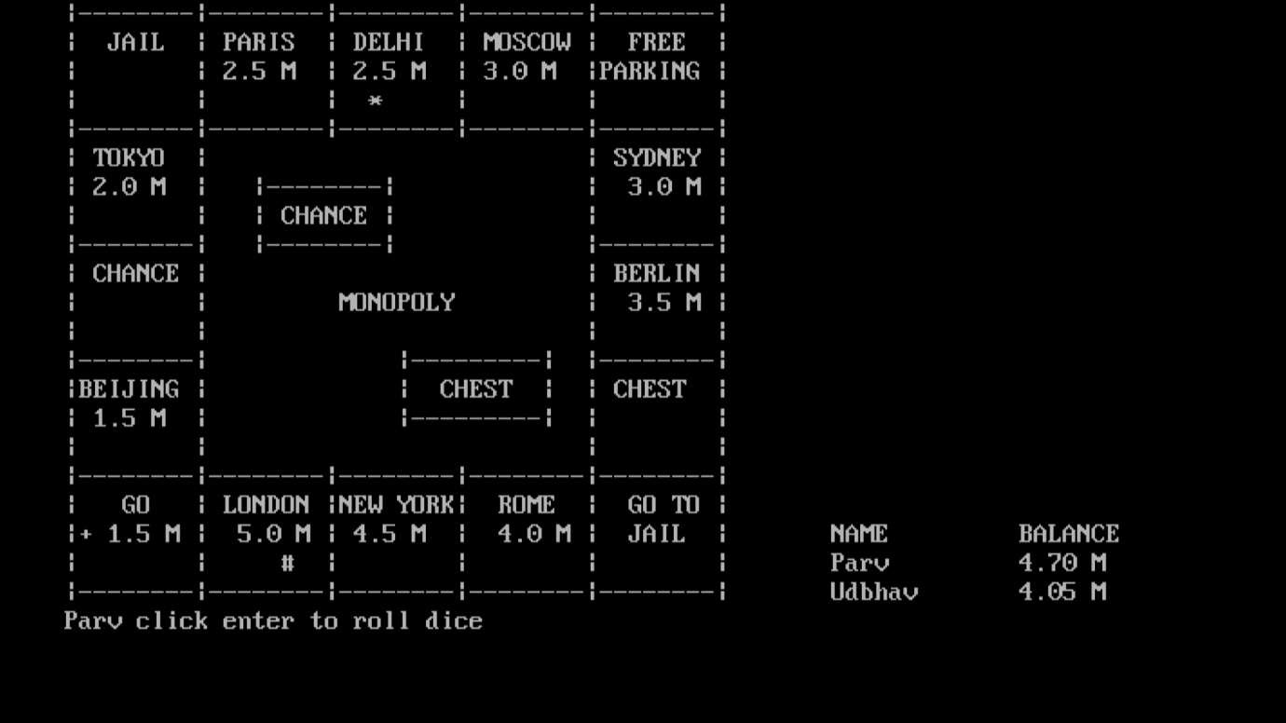

**LOADING AND RESUMING A PREVIOUSLY SAVE GAME**

L