PHISHING EMAIL DETECTION
& AWARENESS REPORT

Future Interns — Task 2: Cybersecurity
Prepared By
Maanas Sri Udbhav Maddula
Domain
Cybersecurity
Date
18 June 2026

1. Introduction
Phishing is still one of the easiest ways for attackers to get inside an organization, and that's exactly why it remains so common. Rather than breaking through technical defenses, attackers go after people directly — sending deceptive emails, building fake login pages, and attaching malicious files, all designed to trick someone into handing over a password, a bank detail, or a moment of trust.
This project set out to look at that problem up close. The goal was to analyze a set of real phishing email samples, work out what gave each one away, sort them by how dangerous they actually were, and turn those findings into awareness guidance that an organization could realistically use.
In practice, the work mirrored what a Security Operations Center (SOC) analyst does day to day: receiving a suspicious email, picking it apart, and deciding whether it's a genuine threat.

2. Objectives
The task was built around a few clear goals:
- Analyze a range of suspicious email samples.
- Examine email headers and sender information in detail.
- Identify the indicators that point to phishing.
- Classify each email by risk level.
- Investigate the links, domains, and attachments involved.
- Document the findings in a clear, professional way.
- Translate the findings into practical security awareness recommendations.

3. Tools Used
A mix of email analysis, investigation, and documentation tools supported the work:
Category | Tools
Email Analysis | Mozilla Thunderbird, Google Message Header Analyzer, MXToolbox Header Analyzer, Cisco Talos Intelligence
Investigation Platforms | TryHackMe SOC Simulator, Splunk SIEM, Threat Intelligence Sources
Documentation | Microsoft Word, GitHub

4. Methodology
Each email went through the same step-by-step process, which kept the analysis consistent across very different cases:
- Collect phishing email samples.
- Review the email content and subject line.
- Analyze sender information.
- Examine the email headers.
- Validate SPF, DKIM, and DMARC records.
- Inspect embedded links and attachments.
- Check domain reputation.
- Identify phishing indicators.
- Classify the risk level.
- Document the findings and recommendations.

5. Case Study 1 – Inheritance Scam Email
Subject | Inheritance Alert: Unknown Billionaire Relative Left You Their Hat Fortunes
Sender | eileen@trendymillineryco.me
Recipient | support@tryhackme.com
This email claimed that a wealthy, unknown relative had left the recipient an inheritance, and asked for banking details to “release the funds.” It's a familiar scam dressed up in slightly absurd detail — the “hat fortune” framing — but the underlying mechanics are the same ones used in inheritance and lottery scams for decades.
Indicators Identified
- An unexpected inheritance claim out of nowhere.
- A vague, generic financial “opportunity.”
- A request for banking details.
- Classic social engineering pressure.
- A sender domain that doesn't hold up to scrutiny.
- A financial reward that's simply too good to be real.
Risk Classification: High Risk
Verdict: Confirmed Phishing Email
Awareness Tip — No legitimate inheritance, estate, or legal process ever needs your bank details sent over email. If a message promises sudden money from a stranger, treat it as a scam and don't reply, click, or share any information.

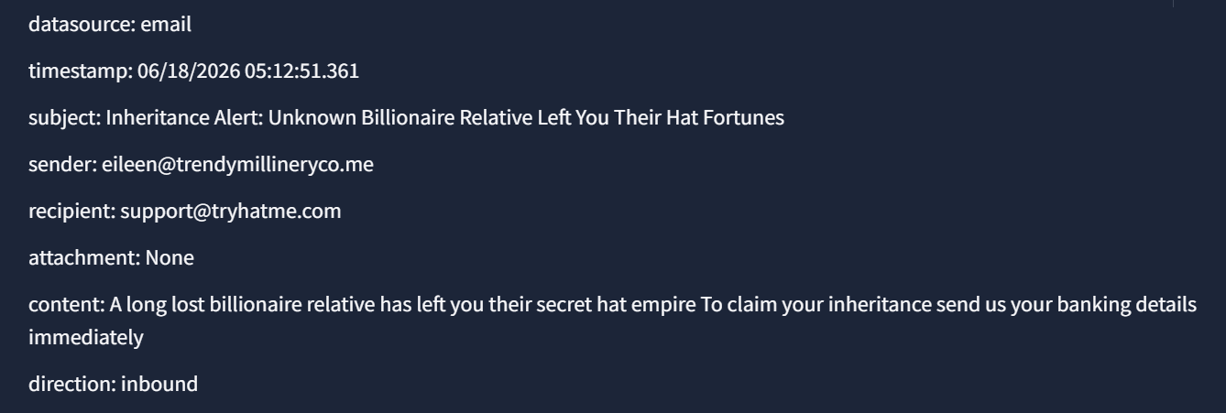

6. Case Study 2 – Malicious Invoice Attachment
Subject | FINAL NOTICE: Overdue Payment – Account Suspension Imminent
Sender | john@hatmakereurope.xyz
Attachment | ImportantInvoice-February.zip
Indicators Identified
- A ZIP file attached to the message.
- An urgent, overdue-payment storyline.
- An implied threat of legal action.
- A warning that the account would be suspended.
- A sender domain unrelated to any real biller.
- Heavy use of pressure tactics to rush the recipient.
Risk Classification: Critical Risk
Verdict: Malicious Phishing Email
This one carried real teeth: the email used urgency and the threat of legal trouble to push the recipient toward opening the attached ZIP file without thinking it through. Had it been opened, the likely outcomes include:
- Malware infection.
- Credential theft.
- Remote access compromise.
- Ransomware deployment.
Awareness Tip — Never open a ZIP, EXE, or other unexpected attachment just because an email sounds urgent. Verify overdue payment or invoice claims directly with the vendor through a known phone number or website before taking any action.
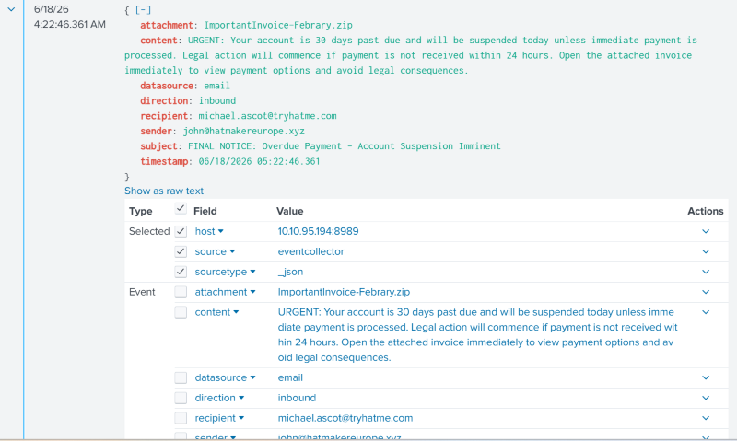

7. Case Study 3 – Fake Vacation Prize Scam
Subject line: “You've Won a Free Trip to Hat Wonderland.”
The message told the recipient they'd won an all-expenses-paid vacation, then asked for credit card details — ostensibly to “confirm” the prize. There was no contest the recipient had entered, and no way to verify the claim through any official channel.
Indicators Identified
- An unsolicited prize notification.
- A request for payment information to “claim” the prize.
- A reward that's too good to be true.
- Reliance on social engineering rather than fact.
- No legitimate way to verify the offer.
Risk Classification: High Risk
Verdict: Confirmed Phishing Email
Awareness Tip — Genuine prizes and giveaways never ask for credit card or payment details to be “released.” If you don't remember entering a contest, the safest move is to ignore and delete the message.

8. Case Study 4 – Netflix Account Suspension Phishing Email
Subject line: “Your Netflix Account is on Hold.” The email told the recipient their account had been suspended and asked them to verify payment information right away.

Visual Analysis
On the surface, this was a well-built email: genuine Netflix branding, a clean and professional layout, a payment-verification request, an urgent call-to-action button, and a suspension warning — all of it engineered to build trust and push for a fast reaction.

Header Analysis
The technical headers told a very different story than the visual design:
- SPF validation failed.
- No valid DKIM signature was present.
- DMARC verification failed.
- The return path pointed to postmaster@etekno.xyz — a domain with no connection to Netflix, and a clear sign of sender spoofing.
In short, the sender address visible to the recipient looked like Netflix, but the underlying headers revealed an entirely unrelated set of domains.

Threat Intelligence Findings
A further check using Cisco Talos Intelligence looked at the infrastructure behind the message:
Domain | google.com
Hostname | google.com
Mail Server | smtp.google.com
Web Reputation | Favorable
Blocklist Status | Not Listed

The email had passed through legitimate Google infrastructure, which on its own looked clean. But that's also exactly the point — attackers often piggyback on trusted services to improve their odds of landing in an inbox. Combined with the authentication failures and the domain mismatch, this was enough to confirm the message as fraudulent.

Indicators Identified
- Sender spoofing.
- A clear mismatch between the visible sender and the actual domain.
- SPF, DKIM, and DMARC all failing.
- An attempt to harvest credentials.
- Brand impersonation (Netflix).
- Urgency-driven language.
- A suspicious return-path domain.
Risk Classification: High Risk
Verdict: Confirmed Phishing Email
Awareness Tip — Don't trust how an email looks — logos and formatting can be copied easily. Always go to the official app or website directly to check account status, and turn on Multi-Factor Authentication so a stolen password alone isn't enough to break in.

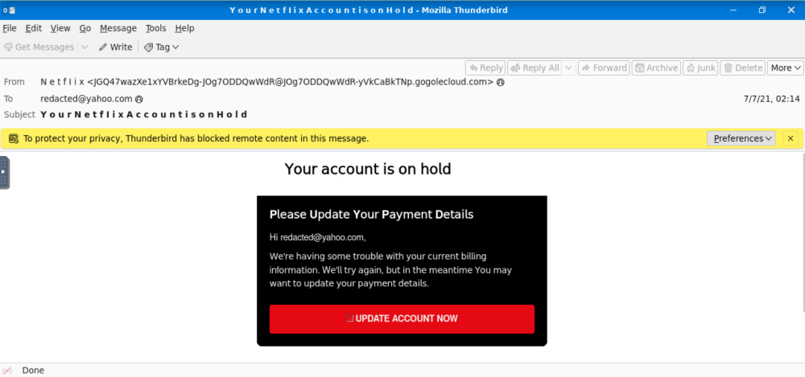
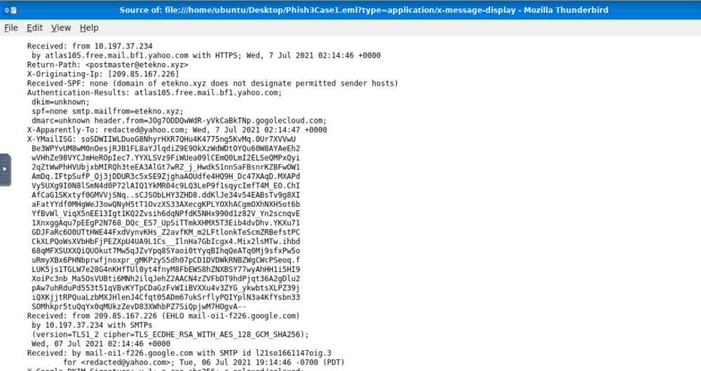

Case Study 5 – Blocked Malicious URL Investigation
Alert Name: Access to Blacklisted External URL Blocked by Firewall
Source IP: 10.20.2.17
Destination IP: 67.199.248.11
URL: http://bit.ly/3sHkX3da12340
Application: Web Browsing
Action: Blocked

Investigation Summary
During the investigation of a suspicious onboarding email, firewall logs generated an alert indicating that a user attempted to access a blacklisted external URL. The destination URL used a Bit.ly shortening service, a technique frequently used by attackers to conceal malicious destinations.
The firewall detected the connection attempt and automatically blocked the request before communication with the destination server could occur.

Indicators Identified
- Use of a URL shortening service (Bit.ly).
- Destination URL matched threat intelligence blacklist.
- User interaction with suspicious email content.
- Connection attempt to an external untrusted destination.
- Correlation with a previously flagged phishing email.

Risk Classification
Risk Level: High
Classification: Confirmed Phishing Attempt

Potential Impact
If the firewall had not blocked the connection, the user could have been redirected to a phishing website designed to steal credentials, personal information, or financial data.
Potential consequences include:
- Credential theft
- Account compromise
- Malware infection
- Unauthorized access

Remediation Actions
- Block the malicious URL and associated domains.
- Verify whether the user submitted any information.
- Review endpoint activity for additional indicators.
- Continue monitoring for related phishing campaigns.
- Conduct user awareness training.

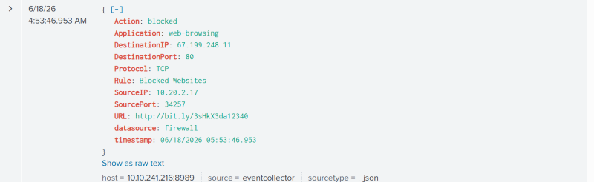

9. User Awareness Guidelines
A few simple habits go a long way toward keeping employees — and the organization — safe from phishing:
Do | Don't
Verify sender email addresses.  Check domain names carefully.  Inspect links before clicking.  Report suspicious emails immediately.  Enable Multi-Factor Authentication (MFA).  Verify requests through official channels. | Open unexpected attachments.  Share passwords through email.  Share OTPs or banking details.  Click suspicious links.  Trust urgent requests without verification.

10. Common Phishing Indicators
Across all five cases, the same handful of warning signs kept showing up. Watching for these is often enough to catch a phishing attempt before any damage is done:
- Generic greetings instead of a real name.
- Urgent or threatening language.
- Warnings about account suspension.
- Offers of unexpected financial rewards.
- Misspelled or look-alike domains.
- Unexpected attachments.
- Requests for credentials.
- Requests for banking information.
- Fake login pages.
- Suspicious hyperlinks.

11. Recommendations
Based on these findings, organizations are better protected when they put the following in place:
- Ongoing security awareness training.
- Strong email filtering solutions.
- Properly configured SPF records.
- Properly configured DKIM records.
- DMARC enforcement.
- Endpoint protection.
- Regular phishing simulations.
- Multi-Factor Authentication across critical systems.

12. Conclusion
This project worked through phishing investigation and awareness building from the ground up, using five distinct scenarios — an inheritance scam, a malicious invoice attachment, a fake prize giveaway, and a Netflix credential-harvesting attempt, blocked malicious investigation — to cover the range of tactics attackers actually use.
By combining content analysis, header examination, domain reputation checks, and threat intelligence lookups, it was possible to pull out clear indicators in each case and rank them by how serious the risk actually was.
The bigger takeaway is straightforward: technical controls matter, but so does a workforce that knows what to look for. Awareness, solid email security configuration, and ongoing monitoring together form the strongest defense against phishing.

