RESUME
PULAMARASETTY NAVEEN KUMAR 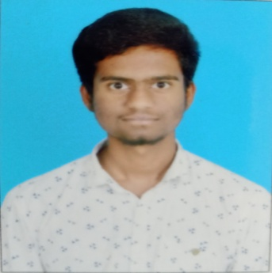
203j5a0377@raghuinstech.com , 9182490735

OBJECTIVE
To work in an organization which provides me with ample opportunities to enhance my skills and knowledge along with contributing to the growth of the organization.

EDUCATIONAL QUALIFICATION
Academics | Institution | CGPA | Year
B.Tech(Mechanical Engineering) | Raghu Institute of Technology | 8.89 | 2019-  2023(pursuing)
Diploma | Sai Ganapathi Engineering college shift polytechnic | 8.45 | 2017-2020
SSC | Sri Rama Krishna School | 9.2 | 2017

TECHNICAL SKILLS

Programming Languages:
- C
- Basics in Java

LANGUAGES

- English
- Telugu
- Hindi

MINI PROJECTS

- Multi Purpose Agricultural machine
- Foot Step power generation

STRENGTHS

- Self Motivated

- Communicating
- Honesty
- Decision Making

PERSONAL DETAILS

Name : PULAMARASETTY NAVEEN KUMAR
Father’s name : P.APPA RAO
Date of Birth : 22/06/2002
Gender : Male
Marital status : Single
Nationality : INDIAN
Mobile : 9182490735
Address : D.NO : 5-56, D.A.R nagar,Kothapalem,Gopalapatnam,Visakhapatnam,530027.

DECLARATION

I hereby declare that the above written particulars are true and correct to the best of myknowledge and belief.

Place: Visakhapatnam

Date : 22,JULY,2022. P.NAVEENKUMAR

