**Q4.Validation of the website files:**

**Css file:**

No Errors or Warnings

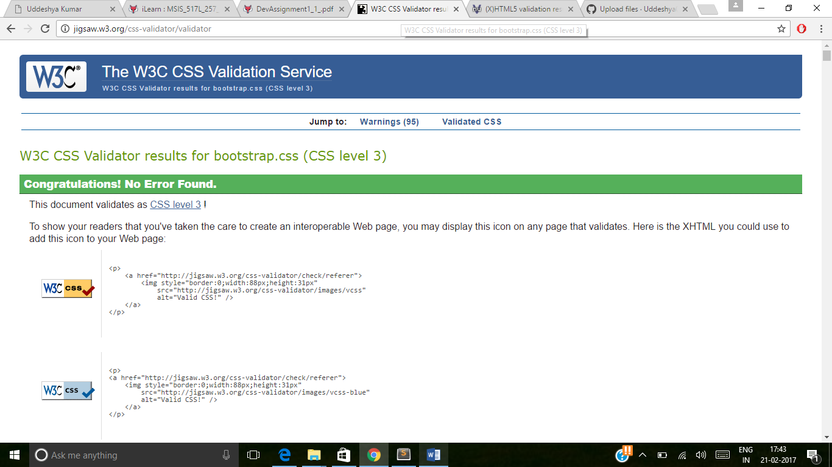

**Website2.html file:**

No Errors; 1 Warning

