Report

Date | 18th January 2026
Skillwallet ID | SWUID20250219395
Project Name | Power BI Inflation Analysis: Journeying Through Global Economic Terrain
Maximum Marks | 5 Marks

A report is a comprehensive document that provides a detailed and structured account of data analysis, findings, and insights. The primary goal of this Power BI report is to assess global price stability risk and validate the effectiveness of the inflation adjustment mechanism across four dedicated dashboard pages.

Executive Dashboard

The Executive Dashboard serves as the central command center for monitoring global economic health.

It provides high-level KPIs and aggregate visualizations to give stakeholders an immediate snapshot

of inflation volatility.

1.Key Performance Indicators (KPIs):

Total Inflation Rate: 65.37K (Cumulative metric for the selected period).

Average Inflation Rate: 42.07% (The baseline metric for global price changes).

Max & Min Inflation Rates: Identifies the extreme bounds of the dataset to highlight volatility.

YoY Change: Tracks the momentum of inflation year-over-year.

2.Performance Comparisons (Dashboard 2 & 4: Operational Focus)
Compare performance across different categories, such as regions or products, to determine which areas are excelling or underperforming.
  - Top Risk Contributors: Armenia had the highest InflationRate at 3,731.80, followed by
Bulgaria at 1,927.40 and Somalia at 1,568.10.
  - Concentrated Influence: Armenia accounted for 51.63% of the total InflationRate among the countries analyzed in the Deep Dive visual, indicating a highly concentrated single- country risk profile.
  - Extreme Volatility Hotspots: The Regional Volatility analysis (Dashboard 2) highlights that the countries with the highest rates, such as Armenia and Bulgaria, exhibit the largest spread between their Max and Min Inflation Rates, signifying the greatest risk of unpredictable price swings.
Visualizations:
- Total Inflation Rate by Date: A line chart visualizing the overall trend and seasonality of inflation spikes.
- Total Inflation Rate Distribution: A statistical breakdown showing the spread of inflation rates across the dataset.
- Average Inflation Rate by Region: A bar chart providing a quick comparative view of inflation intensity across different continents/regions.
- Interactivity:
  - Slicers: Users can filter the entire dashboard by Region, Country, and Year to isolate specific data points.

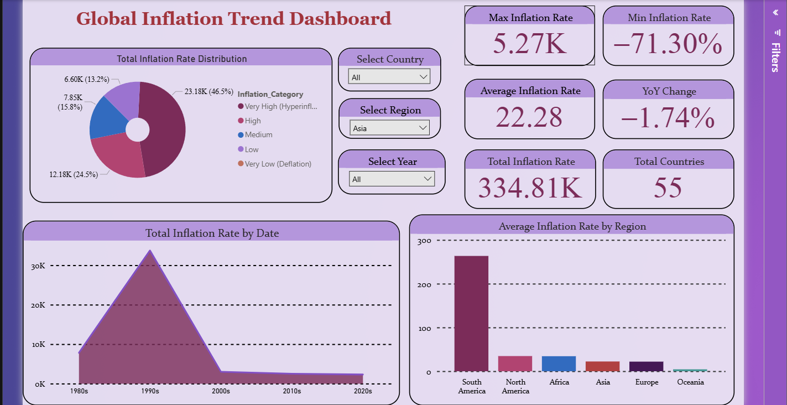

  - Inflation by Country
- Purpose: This page is dedicated to identifying outliers and performing ranked analysis at the national level. It replaces generic risk assessments with specific "Best vs. Worst" performers.
- Visualizations:
- Top Highest Inflation Rate Countries (Risk Hotspots): A ranked bar chart isolating the countries with the most severe inflation, allowing for targeted risk mitigation strategies.
- Top Lowest Inflation Rate Countries (Stability Anchors): A ranked list of economies demonstrating the highest price stability, serving as benchmarks for successful economic policy.

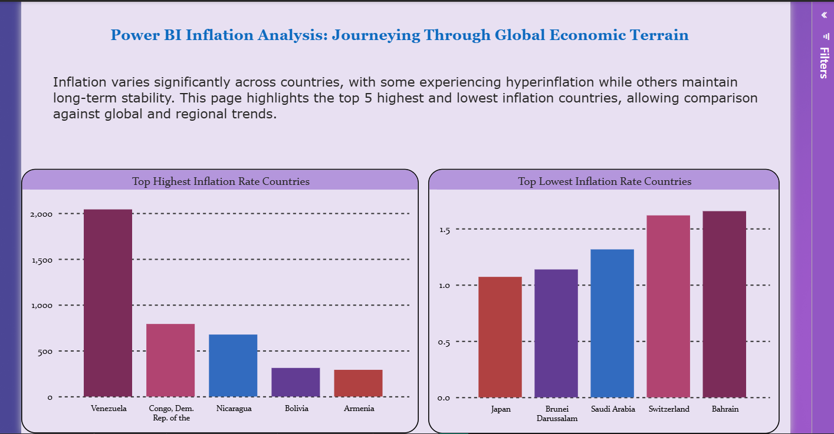

Inflation by Time
Purpose: A dedicated temporal analysis page designed to correlate inflation fluctuations with specific time periods.
Visualizations:
- Time-Series Trends: Visuals on this page focus exclusively on the chronological evolution of inflation, allowing analysts to detect cycles, seasonal impacts, or specific years of economic shock.

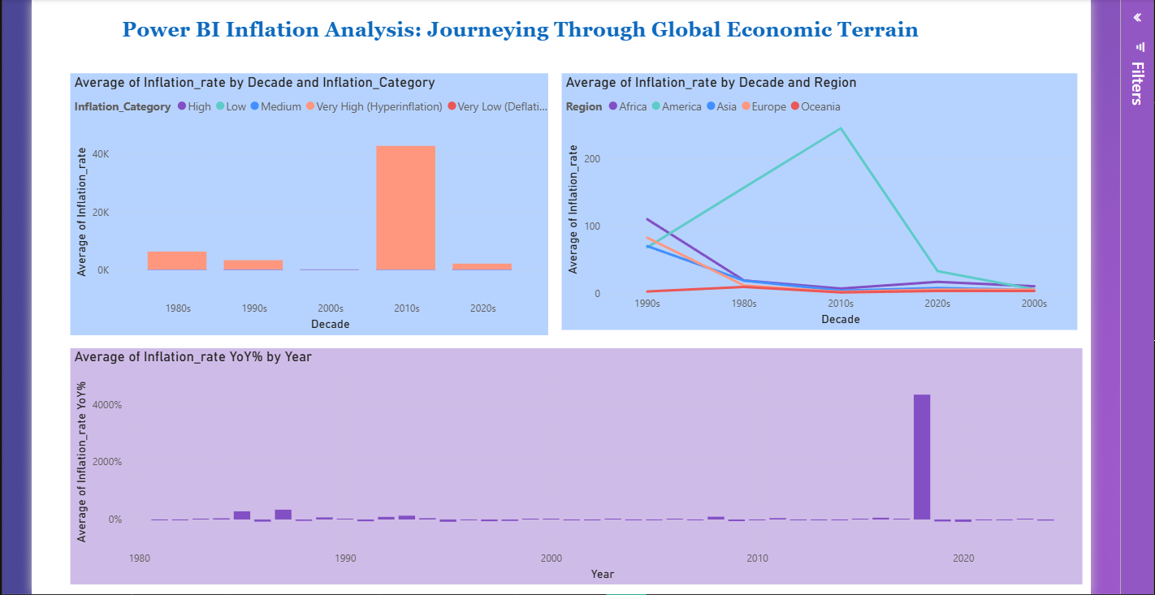

Regional Overview
Purpose: This page aggregates data to a macro-geographic level, enabling a broader view of economic zones rather than individual nations.
Visualizations:
- Average Inflation Rate by Region: Highlights which global zones (e.g., Asia, Europe, Americas) are experiencing the highest average inflationary pressure.
- Total Inflation Rate Distribution by Region: Displays how the cumulative inflation burden is shared among different regions, helping to pinpoint systemic regional issues.

