Alumni Influencers
Database Schema Documentation

Version 1.0.0
Developer: Phantasmagoria Ltd
Database: MongoDB (NoSQL) with Mongoose ODM
Relational Model: Reference-based relationships via ObjectId
1. Overview 1
1.1 Design Principles 1
1.2 Technology Stack 1
2. Entity Relationships 1
2.1 Relationship Summary 1
3. Entity: User 1
3.1 Schema Fields 1
3.2 Enum Values 1
3.3 Embedded Sub-Document: loginHistory 1
3.4 Indexes 1
3.5 Mongoose Schema (Reference) 1
4. Entity: Profile 1
4.1 Schema Fields 1
4.2 Embedded Sub-Document: degrees[ ] 1
4.3 Embedded Sub-Document: certifications[ ] 1
4.4 Embedded Sub-Document: employmentHistory[ ] 1
4.5 Indexes 1
4.6 Mongoose Schema (Reference) 1
5. Entity: Bid 1
5.1 Schema Fields 1
5.2 Enum Values 1
5.3 Bid Lifecycle 1
5.4 Indexes 1
5.5 Mongoose Schema (Reference) 1
6. Entity: API Key 1
6.1 Schema Fields 1
6.2 Embedded Sub-Document: usageStats[ ] 1
6.3 Indexes 1
6.4 Mongoose Schema (Reference) 1
7. Collection Quick Reference 1

1. Overview
The Alumni Influencers platform uses MongoDB as its primary data store, managed through the Mongoose ODM (Object Document Mapper). Although MongoDB is a document-oriented NoSQL database, the schema is designed with well-defined entity relationships enforced at the application layer via Mongoose schemas and validation rules.

The database consists of four core collections:
- users — core authentication and account management
- profiles — extended alumni information displayed to the public
- bids — the auction engine for the Alumni of the Day feature
- apikeys — security credentials issued to third-party client applications

1.1 Design Principles
- References over embedding for large or independently queried documents (e.g. Profile references User rather than embedding user data)
- Embedding for small, tightly coupled sub-documents that are always accessed together (e.g. degrees, certifications within a Profile)
- Unique indexes enforced on natural keys such as email and API key strings
- All timestamps stored in UTC ISO-8601 format

1.2 Technology Stack
Component | Detail
Database | MongoDB (NoSQL Document Store)
ODM | Mongoose v7+
ID Type | ObjectId (BSON) — auto-generated by MongoDB
Timestamps | UTC ISO-8601 (e.g. 2026-02-28T10:00:00.000Z)
Password Hashing | bcrypt (salted, 10 rounds)
Currency | GBP (default) / LKR

2. Entity Relationships
The diagram below describes the logical relationships between the four primary entities. Relationships are enforced via ObjectId references at the application layer.
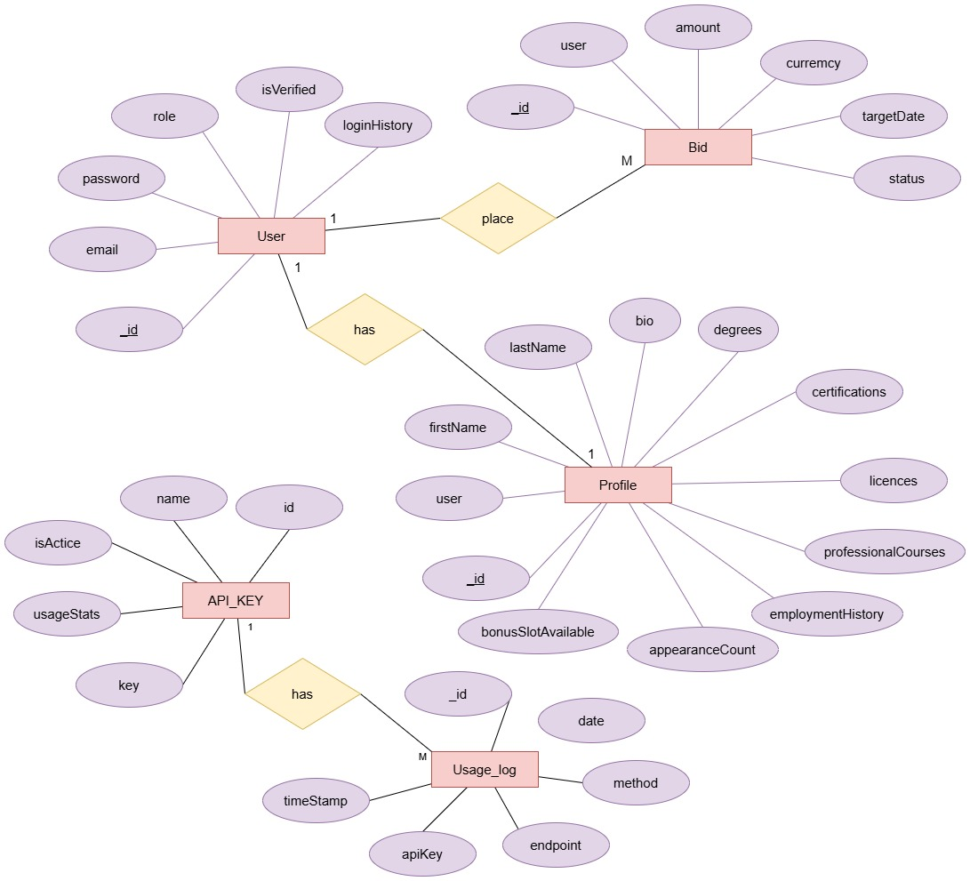

2.1 Relationship Summary

USER - PROFILE
One-to-one: every user has exactly one profile. Profile references User via ObjectId.

USER - BID
One-to-many: a user can place many bids across different target dates. Each bid references its owner User via ObjectId.

API_KEY - USAGE_LOG
One-to-many: each API key accumulates an array of usage log entries (endpoint, method, timestamp).

3. Entity: User
Collection: users
The core authentication entity. Every person who interacts with the platform has a User document. Role-based access control is managed through the role field, while email verification is tracked via isVerified.

3.1 Schema Fields
Field | Type | Constraints | Description
_id | ObjectId | PK, auto | Unique document identifier, auto-generated by MongoDB.
email | String | Unique, Required | University email address (.ac.uk or .edu domains only).
password | String | Required | bcrypt-hashed password. Never stored in plaintext.
role | String | Enum, Default: user | Access level. Either 'user' (alumni) or 'admin'.
isVerified | Boolean | Default: false | Set to true upon successful email verification click.
loginHistory | Array | Embedded | Log of past login events (timestamp, IP, user agent).
createdAt | Date | Auto (Mongoose) | Document creation timestamp (UTC).
updatedAt | Date | Auto (Mongoose) | Last modification timestamp (UTC).

3.2 Enum Values
Field | Allowed Values
role | user | admin

3.3 Embedded Sub-Document: loginHistory
Each entry in the loginHistory array captures contextual data about a successful authentication event.

loginHistory[ ] Field | Type | Description
timestamp | Date | UTC time of the login event.
ip | String | IPv4 or IPv6 address of the client.
userAgent | String | Browser / device user-agent string.

3.4 Indexes
Field | Type | Constraints | Description
email | String | Unique Index | Enforces email uniqueness across all user accounts.

3.5 Mongoose Schema (Reference)
const UserSchema = new mongoose.Schema({
email: { type: String, required: true, unique: true, lowercase: true },
password: { type: String, required: true },
role: { type: String, enum: ['user', 'admin'], default: 'user' },
isVerified: { type: Boolean, default: false },
loginHistory: [{ timestamp: Date, ip: String, userAgent: String }]
}, { timestamps: true });

4. Entity: Profile
Collection: profiles
Extended alumni data linked one-to-one with a User document. This is the primary public-facing entity.its contents are displayed on the AR client when an alumnus wins the daily bid. All academic credentials and professional history are embedded as arrays of sub-documents within the Profile.

4.1 Schema Fields
Field | Type | Constraints | Description
_id | ObjectId | PK, auto | Unique document identifier.
user | ObjectId | FK → users, Unique | Reference to the owning User document.
firstName | String | Required | Alumni's first name.
lastName | String | Required | Alumni's last name.
bio | String | Optional | Short biography displayed on the AR client.
profileImage | String | Optional | Stored filename of the uploaded JPEG/PNG image.
degrees | Array | Embedded | Academic degree records. See sub-document schema below.
certifications | Array | Embedded | Professional certifications (e.g. AWS, PMP).
licences | Array | Embedded | Professional licences (e.g. medical, legal).
professionalCourses | Array | Embedded | Short courses and CPD records.
employmentHistory | Array | Embedded | Chronological work history.
appearanceCount | Number | Default: 0 | Total times this profile has been the Alumni of the Day.
bonusSlotAvailable | Boolean | Default: false | Flag granting a free additional bid slot.
createdAt | Date | Auto (Mongoose) | Document creation timestamp (UTC).
updatedAt | Date | Auto (Mongoose) | Last modification timestamp (UTC).

4.2 Embedded Sub-Document: degrees[ ]
degrees[ ] Field | Type | Description
degreeTitle | String | Title of the degree (e.g. BSc Computer Science).
university | String | Name of the awarding institution.
completionDate | Date | Date the degree was awarded (UTC).
certificateUrl | String | Optional URL to a digital certificate or transcript.

4.3 Embedded Sub-Document: certifications[ ]
certifications[ ] Field | Type | Description
title | String | Name of the certification (e.g. AWS Solutions Architect).
issuer | String | Issuing body or organisation.
issuedDate | Date | Date the certification was issued.
expiryDate | Date | Optional expiry date (null if no expiry).
badgeUrl | String | Optional URL to the digital badge.

4.4 Embedded Sub-Document: employmentHistory[ ]
employmentHistory[ ] Field | Type | Description
jobTitle | String | Job title / role held.
company | String | Name of the employer.
startDate | Date | Employment start date (UTC).
endDate | Date | Employment end date. Null if currently employed.
description | String | Optional summary of responsibilities.

4.5 Indexes
Field | Type | Constraints | Description
user | ObjectId | Unique Index | Enforces one-to-one relationship — one profile per user.

4.6 Mongoose Schema (Reference)
const ProfileSchema = new mongoose.Schema({
user: { type: ObjectId, ref: 'User', required: true, unique: true },
firstName: { type: String, required: true },
lastName: { type: String, required: true },
bio: { type: String },
profileImage: { type: String },
degrees: [{ degreeTitle: String, university: String,
completionDate: Date, certificateUrl: String }],
certifications: [{ title: String, issuer: String,
issuedDate: Date, expiryDate: Date, badgeUrl: String }],
licences: [{ title: String, issuer: String, issuedDate: Date }],
professionalCourses: [{ title: String, provider: String, completionDate: Date }],
employmentHistory: [{ jobTitle: String, company: String,
startDate: Date, endDate: Date, description: String }],
appearanceCount: { type: Number, default: 0 },
bonusSlotAvailable: { type: Boolean, default: false }
}, { timestamps: true });

5. Entity: Bid
Collection: bids
The auction management entity. Each document represents a single bid placed by an alumnus for a specific future date. The system operates as a blind auction: users are only informed of their own bid status (Winning or Losing) without visibility into competitor amounts.

5.1 Schema Fields
Field | Type | Constraints | Description
_id | ObjectId | PK, auto | Unique document identifier.
user | ObjectId | FK → users, Required | Reference to the User who placed the bid.
amount | Number | Required, Min: 0 | The bid value in the specified currency.
currency | String | Enum, Default: GBP | Currency of the bid amount.
targetDate | Date | Required | The midnight UTC date the user is bidding to be featured.
status | String | Enum, Required | Current lifecycle state of the bid.
createdAt | Date | Auto (Mongoose) | Timestamp when the bid was first placed.
updatedAt | Date | Auto (Mongoose) | Timestamp of the most recent update (e.g. amount increase).

5.2 Enum Values
Field | Allowed Values
status | active | won | lost | superseded | cancelled

Field | Allowed Values
currency | GBP | LKR

5.3 Bid Lifecycle
Status | When Applied
active | Bid has been placed and is currently competing for the target date.
won | This bid had the highest amount at the daily cut-off time.
lost | Another bid was higher at the cut-off time.
superseded | The user increased their bid; the old document is marked superseded and a new one created.
cancelled | The user or an admin cancelled the bid before the cut-off.

5.4 Indexes
Field | Type | Constraints | Description
user + targetDate | Compound | Unique Index | Prevents a user from having more than one active bid per target date.
targetDate | Date | Index | Optimises daily winner resolution queries.

5.5 Mongoose Schema (Reference)
const BidSchema = new mongoose.Schema({
user: { type: ObjectId, ref: 'User', required: true },
amount: { type: Number, required: true, min: 0 },
currency: { type: String, enum: ['GBP', 'LKR'], default: 'GBP' },
targetDate: { type: Date, required: true },
status: { type: String,
enum: ['active','won','lost','superseded','cancelled'],
required: true }
}, { timestamps: true });

BidSchema.index({ user: 1, targetDate: 1 }, { unique: true });
BidSchema.index({ targetDate: 1 });

6. Entity: API Key
Collection: apikeys
Security credentials issued by administrators to authorise third-party client applications (such as the AR kiosk). Each key has an activation state that can be toggled, and an embedded usage log for audit purposes.

6.1 Schema Fields
Field | Type | Constraints | Description
_id | ObjectId | PK, auto | Unique document identifier.
name | String | Unique, Required | Human-readable label (e.g. 'AR Client v1').
key | String | Unique, Required | The hashed secure string used in the x-api-key header.
isActive | Boolean | Default: true | When false, all requests using this key are rejected.
usageStats | Array | Embedded | Append-only log of usage events. See sub-document below.
createdAt | Date | Auto (Mongoose) | Timestamp when the key was generated.
updatedAt | Date | Auto (Mongoose) | Timestamp of the most recent status change.

6.2 Embedded Sub-Document: usageStats[ ]
usageStats[ ] Field | Type | Description
date | Date | UTC timestamp of the API request.
endpoint | String | The path that was accessed (e.g. /api/client/alumni-of-the-day).
method | String | HTTP method used (e.g. GET).
ip | String | Optional client IP address of the requesting application.

6.3 Indexes
Field | Type | Constraints | Description
name | String | Unique Index | Enforces unique labels across all API keys.
key | String | Unique Index | Enforces uniqueness of the secret key string.
isActive | Boolean | Index | Optimises active key lookup on each API request.

6.4 Mongoose Schema (Reference)
const ApiKeySchema = new mongoose.Schema({
name: { type: String, required: true, unique: true },
key: { type: String, required: true, unique: true },
isActive: { type: Boolean, default: true },
usageStats: [{
date: { type: Date, default: Date.now },
endpoint: String,
method: String,
ip: String
}]
}, { timestamps: true });

7. Collection Quick Reference
The table below summarises all collections, their primary keys, foreign key references, and notable indexes.

Collection | PK | Foreign Keys | Unique Indexes | Other Indexes
users | _id | — | email | —
profiles | _id | user → users._id | user, email | —
bids | _id | user → users._id | user + targetDate | targetDate
apikeys | _id | — | name, key | isActive

