IoT Based Noise Pollution Monitoring System

A Project report submitted in partial fulfilment of the requirements for the degree of B.E in Electronics and Communication Engineering

By

D.chandru(513221106305)

Under the supervision of

Professor & Mentor

Department of Electronics and

Communication Engineering

Noise Pollution Monitering system

PHASE-1 : PROBLEM DEFFINITION AND DESIGN THINKING

* Problem Definition
* Design Thinking

Problem Statement

* Water (Piezometer), Slope Movement, Borehole Extensometer and Inclinometers
* Other geotechnical monitoring instruments, tools and engineering equipment suppliers
* Hosted data solutions to keep your data moving wirelessly from the field to your fingertips for geotechnical analysis

**Instantaneous Monitoring**: uses a handheld SLM to take readings for short periods of time. This may be useful to get an idea of what the typical sound level from a source may be, or to check what noise is produced during worst case conditions

**Continuous Monitoring**: uses a SLM positioned at a fixed location to measure sound levels. This type of monitoring is used to alert a site when noise levels are above a compliance limit.

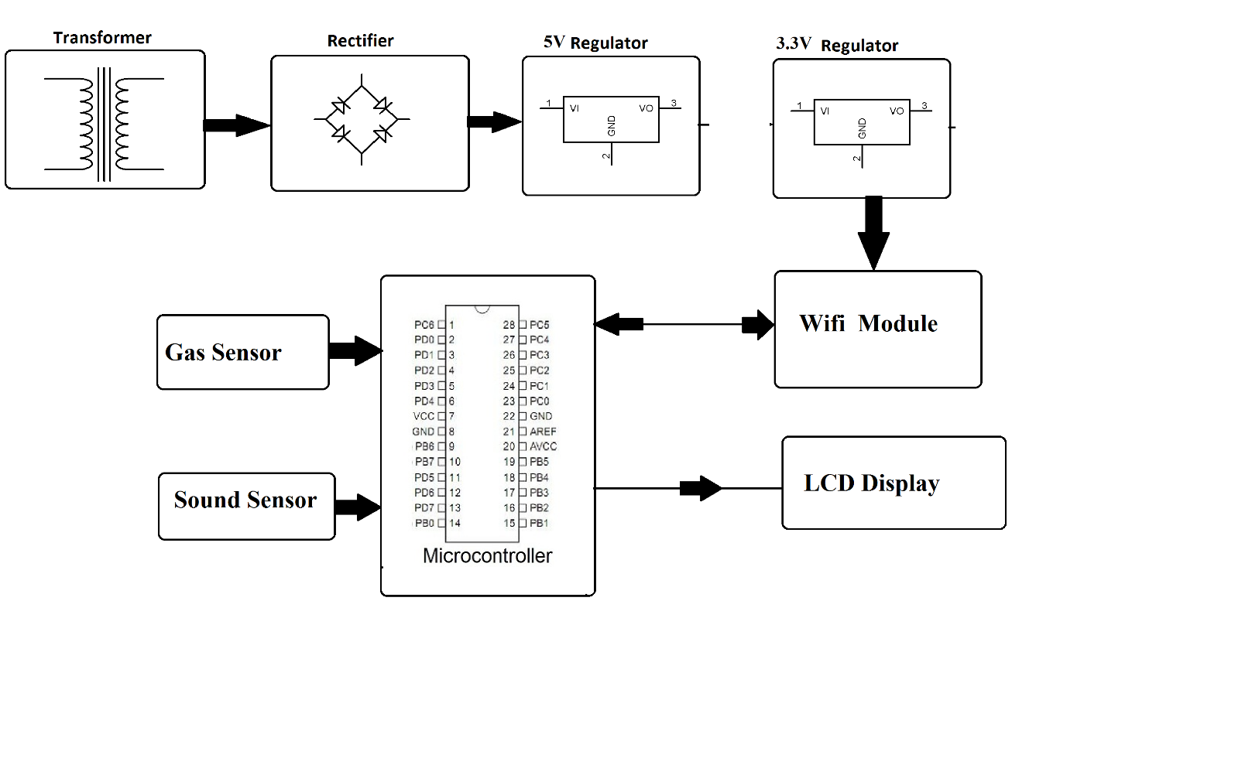

* **Project Objects:**

Real-Time noise Pollution Monitoring:

* Noise pollution is the unwanted or excessive sound in our environment. It is mainly due to increasing number of vehicles and noise producing machines in the industries.
* The effects of noise pollution also have many health issues like stress related illness, high blood pressure, speech interference, hearing loss, sleep disruption
* Our proposed system provides the solution to this problem with the help of Internet of Things .
* **Public awareness:**

i) To ascertain the perception of residents regarding noise pollution

ii)To find out the major sources of noise pollution in Nagpur city.

iii) To ascertain the opinion of residents on noise pollution during festivals and celebrations.

iv) To find out the level of awareness of people regarding laws and rules governing noise

pollution.

v) To know the experiences of residents regarding implementation of different laws and rules

governing noise pollution.

vi) To explore possible reactions of people against excessive noise.

vii) To find out the suitable solutions for control of noise pollution.

* Noise Regulation Compliance:
* ioT devices equipped with sound sensors are strategically placed throughout the factory floor to continuously monitor noise levels in real-time.

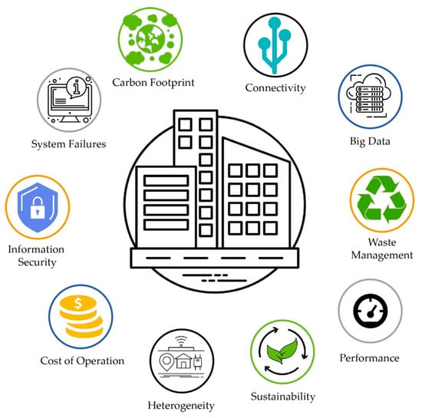

* The noise levels in any area / zone shall not exceed the ambient air quality standards in respect of noise as specified in the Schedule. (2) The authority shall be responsible for the enforcement of noise
* Improved Quality of Life:

• The users can monitor the air quality and noise levels on real time basis through blynk.

• The app will provide various categories of air quality (good, moderate, unhealthy) and noise levels (quiet, moderate, high) based on threshold limits.

• System is compact

• Cost effective

• User friendly

• Information is accessible to both authorities as well as the public.

• System is portable

Design Thinking:

• More parameters can be monitored along with air quality and noise levels by using other sensors.

• Control system can be incorporated along with this monitoring system by the use of air purifiers, filters, anti-pollution masks etc for controlling air pollution and acoustic barriers can be used for reducing noise pollution to an optimal level.

* Design thinking was used to discuss the topic of Noise pollution. An image and audio was sent as a pre-cap and children were asked to see it before the session.
* The children were guided through various stages of design thinking .
* The children came up with creative solutions like use of ear plugs, lowering the volume, planting more trees,no honking and no loudspeakers

