DATA ANALYTICS ON
STUDENT PERFORMANCE
A Comprehensive End-to-End Data Analysis Project

Submitted by

UDHAYA KANAGA LAKSHMI E
Roll No: 23CS001
III Year | 2023–2026
Department of Computer Science
JHA AGARSEN COLLEGE
Academic Year: 2023–2026

TABLE OF CONTENTS

Abstract 1
Introduction 2
Problem Statement 3
Dataset Description 4
Methodology & Tools Used 5
Data Cleaning and Preprocessing 6
Database Management using SQL 7
Exploratory Data Analysis (EDA) using Python 8
Data Visualization using Python 9
Interactive Dashboard Development (Power BI) 10
Key Insights & Findings 11
Business Recommendations 12
Conclusion 13
References 14

1. Abstract
This project presents an end-to-end data analysis of student academic performance using a dataset comprising 1,000 unique records. The study integrates four industry-standard tools — Microsoft Excel, MySQL, Python (Pandas, Matplotlib, Seaborn), and Power BI — to identify the core drivers of student success across three key subjects: Mathematics, Reading, and Writing.
The analysis reveals significant correlations between demographic factors such as parental level of education, socio-economic status (proxied by lunch type), gender, and test preparation course completion with students' academic outcomes. The findings are presented through an interactive Power BI dashboard designed to facilitate data-driven educational decision-making.

Dataset Size: 1,000 Records
Tools Used: Excel | MySQL | Python | Power BI
Subjects Analyzed: Math, Reading, Writing
Focus Areas: Parental Education, Gender, Test Preparation, Socio-Economic Status

2. Introduction
In the modern educational landscape, data-driven decision-making has emerged as a transformative approach to improving student outcomes and optimizing resource allocation. By leveraging advanced analytics techniques, educational institutions can move beyond intuitive assessments and adopt evidence-based strategies to identify at-risk students early, personalize learning interventions, and measure the effectiveness of academic programs.
This project follows the complete data analytics life cycle — from raw data ingestion and cleaning in Microsoft Excel, to structured storage and querying in MySQL, to deep statistical analysis and visualization using Python, and finally to the development of a professional interactive dashboard in Power BI. Each stage of this pipeline contributes a distinct layer of analytical depth, ensuring that the insights produced are both robust and actionable.
The dataset used in this study contains 1,000 student records, encompassing a range of categorical and numerical variables that capture the demographic profile and academic performance of each student. By examining the interplay between these variables, this project aims to produce meaningful insights that school administrators, counselors, and policymakers can leverage to drive meaningful educational improvement.

3. Problem Statement
The primary objective of this project is to analyze the various factors that influence student academic performance. Educational outcomes are often affected by a complex interplay of demographic, social, and economic variables. Without a data-driven approach, it is difficult for educators to identify which students are at risk or which interventions are most effective.
This project specifically seeks to address the following key research questions:

- Effectiveness of Preparation: Does the completion of a formal Test Preparation Course lead to a statistically significant improvement in Math, Reading, and Writing scores?
- Socio-Economic Impact: To what extent do parental level of education and lunch type (standard vs. reduced) correlate with a student's final scores?
- Gender-Based Performance: Are there observable and consistent differences in subject-wise performance between male and female students?
- Correlation Analysis: How strongly are the three core subjects — Mathematics, Reading, and Writing — interlinked with one another?

By addressing these questions, the project aims to provide actionable insights that school administrations can use to bridge the performance gap and design more inclusive academic support systems.
4. Dataset Description
The dataset used for this research consists of 1,000 unique records of student performance. It is a multivariate dataset containing both categorical and numerical features, making it ideal for a comprehensive data analytics project. The data was sourced as a structured CSV file and encompasses diverse demographic and academic attributes.

Attribute | Type | Description | Values/Range
Gender | Categorical | Sex of the student | Male / Female
Race/Ethnicity | Categorical | Demographic group | Group A, B, C, D, E
Parental Education | Categorical | Highest education of parents | High School to Master's
Lunch | Categorical | Lunch type received | Standard / Free-Reduced
Test Prep Course | Categorical | Prep course completion | None / Completed
Math Score | Numerical | Score in Mathematics | 0 – 100
Reading Score | Numerical | Score in Reading | 0 – 100
Writing Score | Numerical | Score in Writing | 0 – 100
Table 1: Dataset Attribute Summary

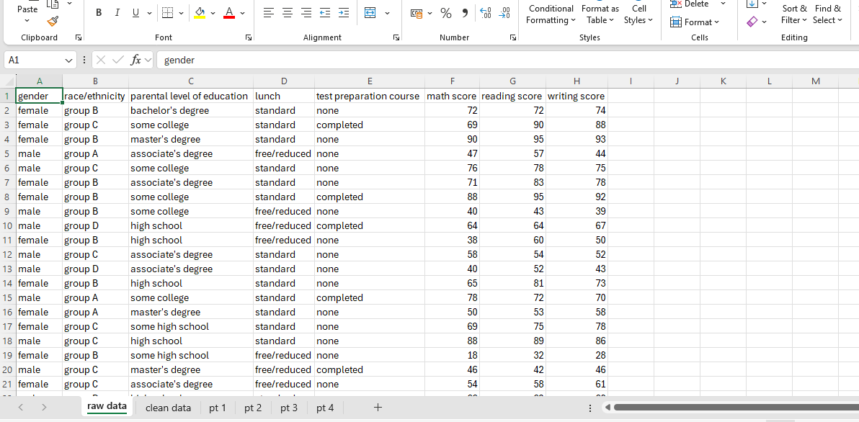

5. Methodology & Tools Used
This project follows a structured Data Analytics Life Cycle, systematically progressing from raw data ingestion to interactive visualization. The methodology ensures that each analytical step builds upon the previous, resulting in a comprehensive and validated output.

5.1 Analytical Workflow
- Data Ingestion: Sourcing the dataset and inspecting it for structural errors and missing values.
- Data Cleaning: Handling inconsistencies, standardizing formats, and removing duplicates using Excel.
- Database Management: Importing the cleaned data into MySQL for structured storage and relational querying.
- Exploratory Data Analysis: Performing statistical tests, distributions, and correlation analysis using Python.
- Data Visualization: Building an interactive, filter-driven reporting interface in Power BI.

5.2 Technical Stack
Tool | Version/Type | Purpose
Microsoft Excel | Office 365 | Data cleaning, standardization, CSV preparation
MySQL Workbench | v8.0+ | Relational database creation and SQL querying
Python (Jupyter) | 3.x + Pandas/Matplotlib/Seaborn | EDA, statistical analysis, advanced visualization
Power BI Desktop | Latest | Interactive dashboard and KPI reporting

Table 2: Technical Stack Summary

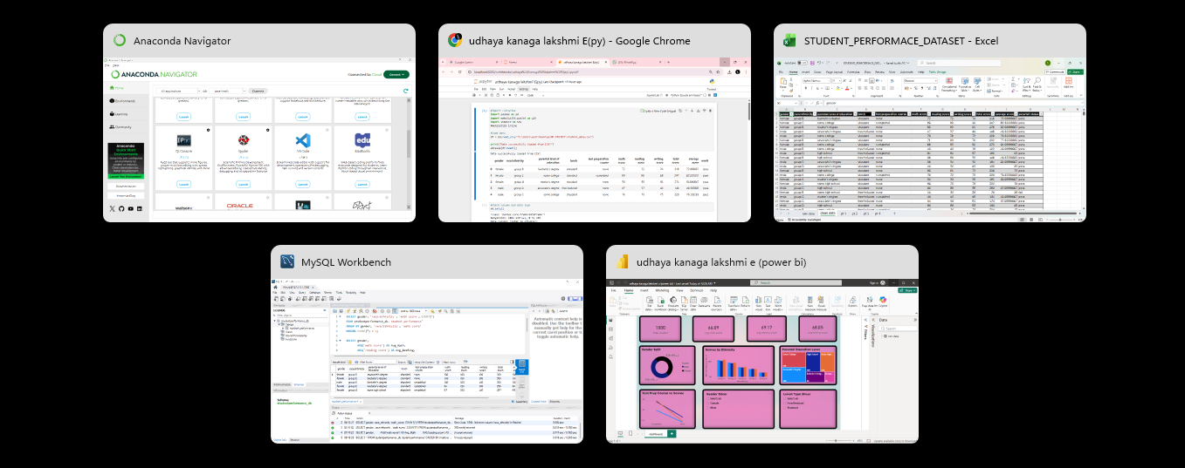

6. Data Cleaning and Preprocessing
The initial dataset was loaded into Microsoft Excel for a thorough inspection and cleaning process. This phase is critical to ensure that subsequent analysis is performed on accurate and consistent data, free from structural errors and formatting irregularities.

6.1 Excel Data Standardization
- All extra whitespaces were removed from categorical columns such as 'parental level of education' and 'race/ethnicity' using Excel's TRIM() function.
- Category labels were verified for consistency — for example, ensuring 'completed' and 'none' were uniformly lowercase across the 'test preparation course' column.
- Column headers were renamed to snake_case format to ensure SQL-compatibility (e.g., 'math score' → 'math_score').
- Data types were validated — all score columns were confirmed as numerical integers in the range 0–100.

6.2 Handling Null Values and Formatting
- A thorough scan for blank or null entries was conducted using Excel's Go To Special → Blanks feature.
- No missing values were found in the primary dataset; all 1,000 rows were complete and accounted for.
- The final cleaned dataset was exported as a UTF-8 encoded CSV file, ready for import into MySQL.

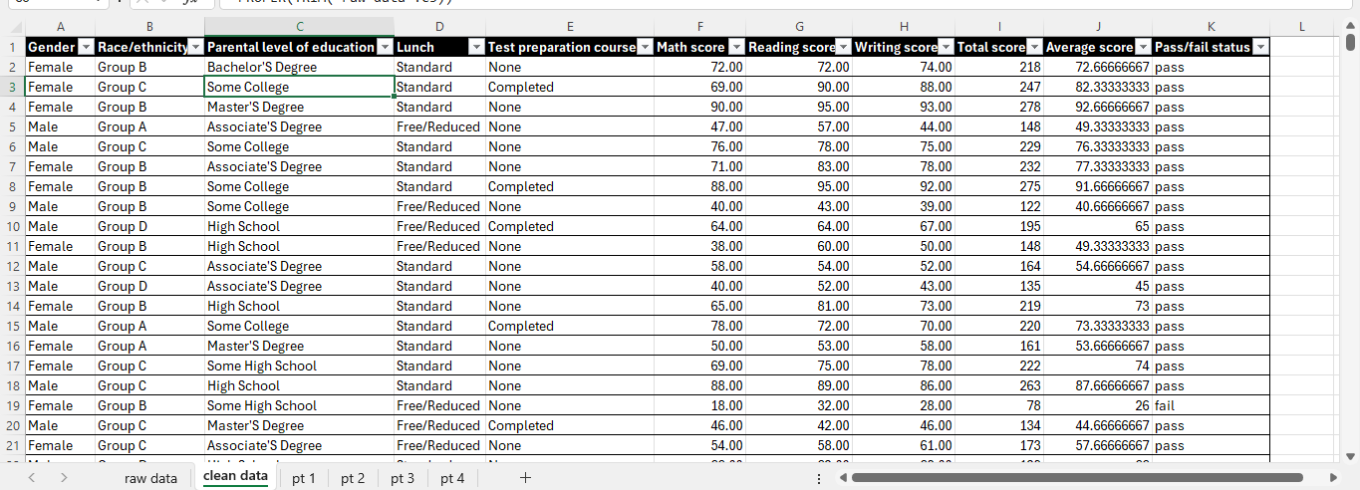

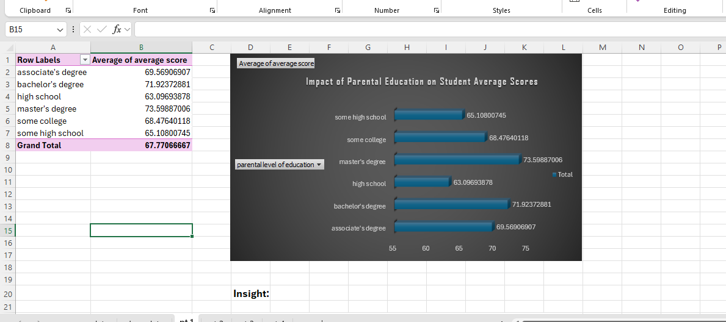
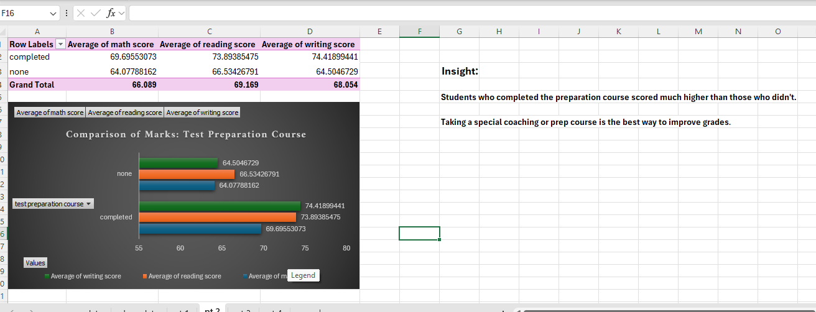

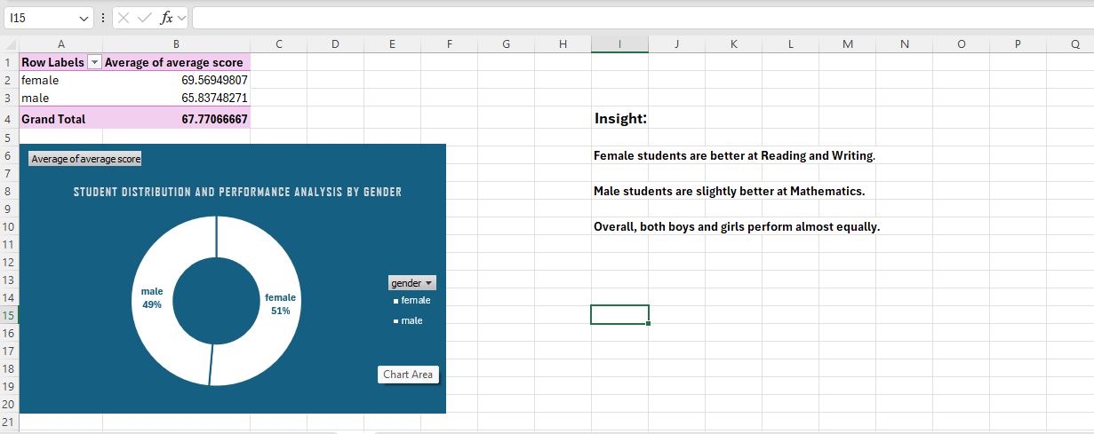

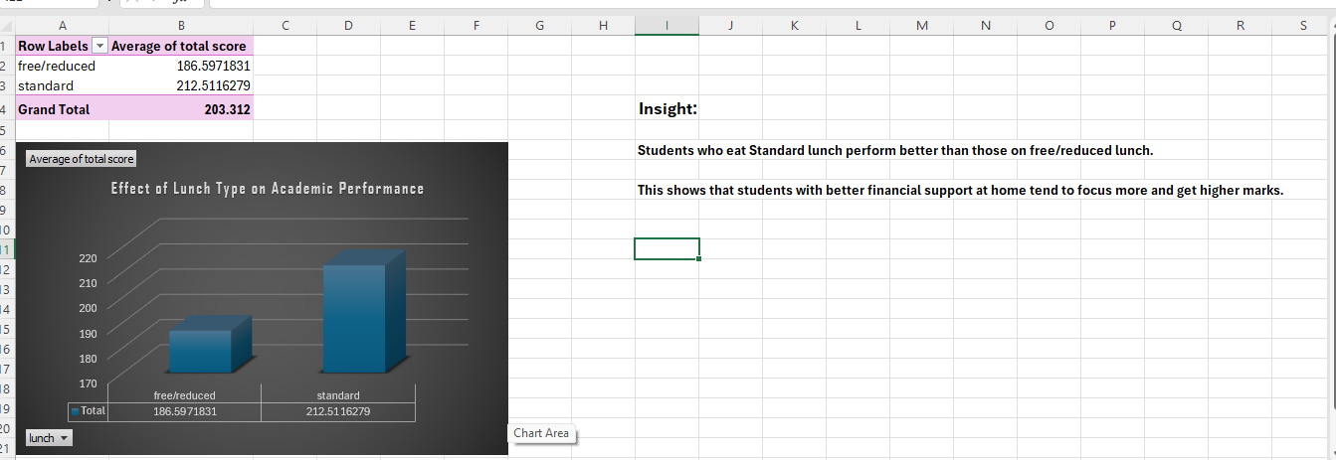

7. Database Management using SQL
The cleaned CSV dataset was imported into a MySQL relational database to enable structured querying and efficient data retrieval. Relational databases provide a robust framework for managing large datasets and executing complex analytical queries that would be cumbersome to perform in Excel alone.

7.1 Database Schema Creation
A dedicated database named studentperformance_db was created, and the following table schema was defined to match the dataset structure:

CREATE DATABASE studentperformance_db;
USE studentperformance_db;

CREATE TABLE `student performance` (
id INT AUTO_INCREMENT PRIMARY KEY,
gender VARCHAR(10),
race_ethnicity VARCHAR(20),
parental_education VARCHAR(50),
lunch VARCHAR(20),
test_prep_course VARCHAR(20),
math_score INT,
reading_score INT,
writing_score INT
);

7.2 Data Import and Verification
The cleaned CSV file was imported using MySQL Workbench's Table Data Import Wizard. Post-import verification queries were executed to confirm data integrity:
- SELECT COUNT(*) FROM student performance; — Confirmed 1,000 records loaded successfully.
- SELECT * FROM student performance LIMIT 10; — Verified initial rows matched the source CSV.
- Analytical queries were run to group and filter students by test preparation status, gender, and parental education to validate relational integrity.

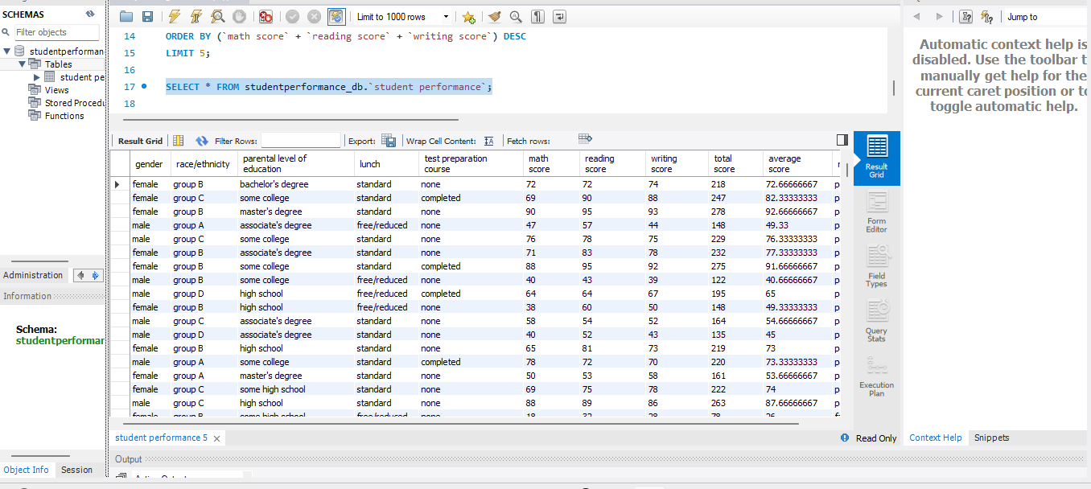

Score statistic (avg ,min, max)

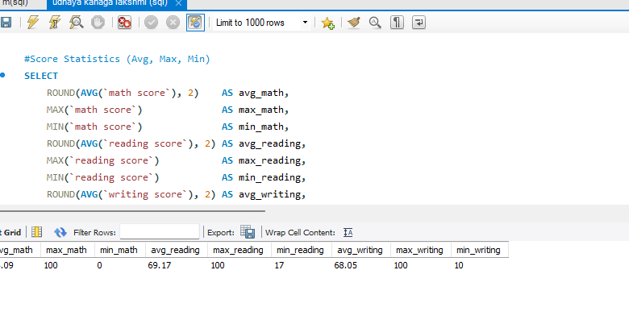

Total count of students

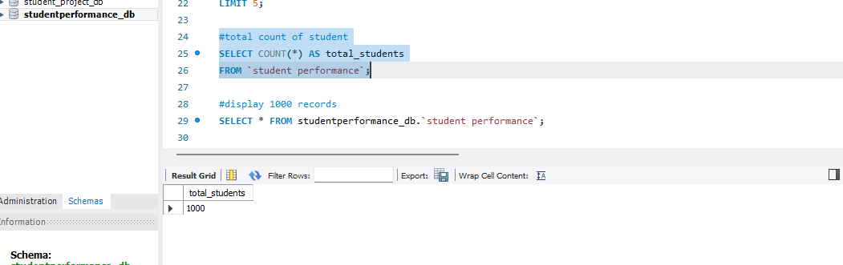

Top Performer

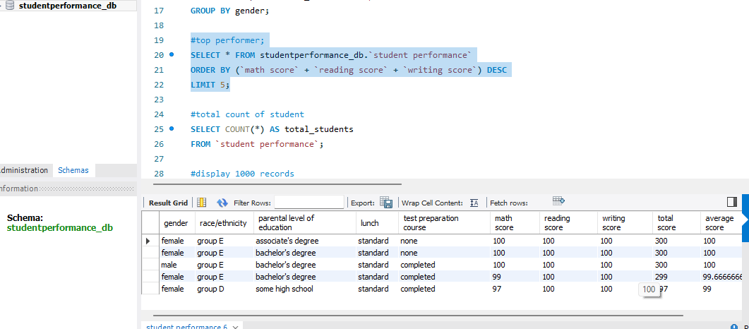

Performance by gender
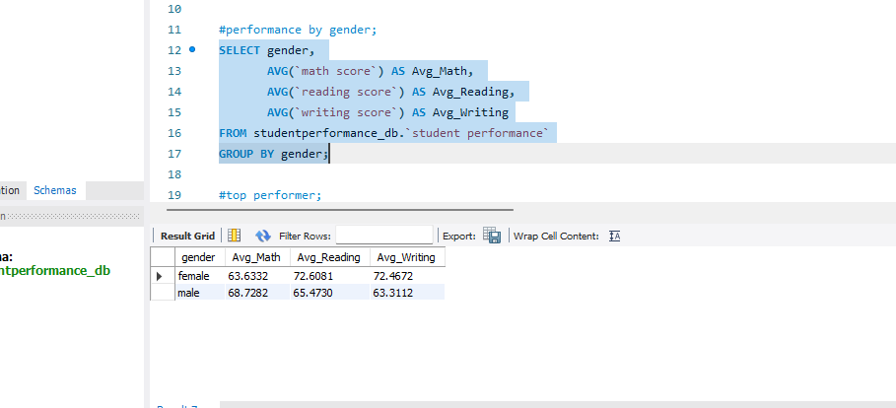

Data clean duplicate check
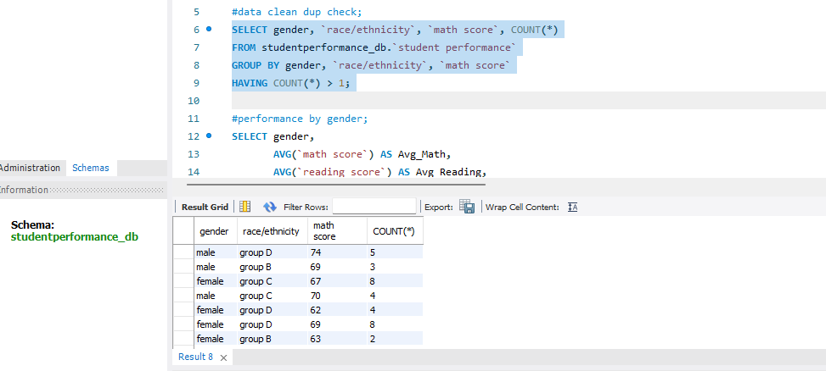

8. Exploratory Data Analysis (EDA) using Python
Python was used as the primary tool for deep statistical analysis. The Jupyter Notebook environment provided an interactive platform for executing analytical code in a structured, reproducible manner. The Pandas library was used extensively for data manipulation, aggregation, and statistical profiling.
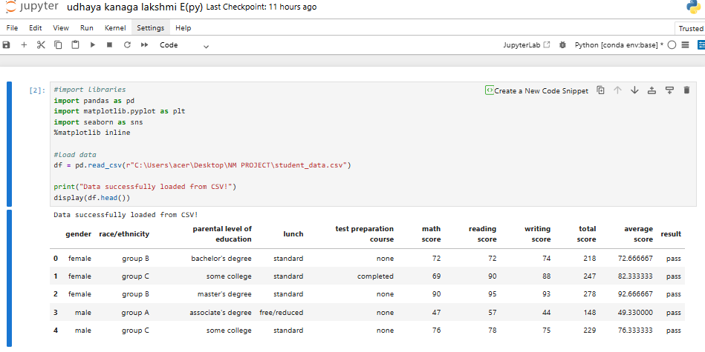

8.1 Statistical Summary (Pandas)
The df.describe() function was applied to generate a comprehensive statistical summary of all three score columns. Key findings from the summary statistics are presented below:

Statistic | Math Score | Reading Score | Writing Score
Count | 1,000 | 1,000 | 1,000
Mean | 66.09 | 69.17 | 68.05
Std Deviation | 15.16 | 14.60 | 15.20
Minimum | 0 | 17 | 10
25th Percentile (Q1) | 57 | 59 | 57.75
Median (Q2) | 66 | 70 | 69
75th Percentile (Q3) | 77 | 79 | 79
Maximum | 100 | 100 | 100
Table 3: Statistical Summary of Student Scores

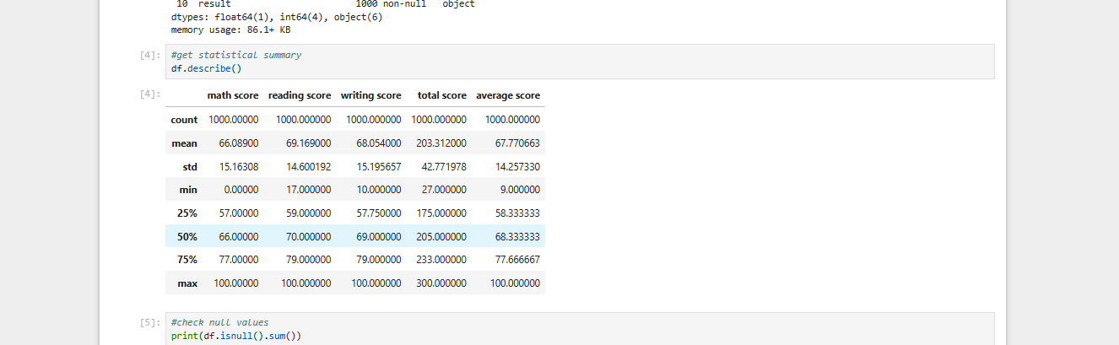

8.2 Data Distribution Analysis
Further analysis was conducted to examine the distribution of scores across different demographic groups. Group-wise mean calculations revealed that students who completed the test preparation course consistently outperformed their counterparts across all three subjects, with an average improvement of 8–12 percentage points.
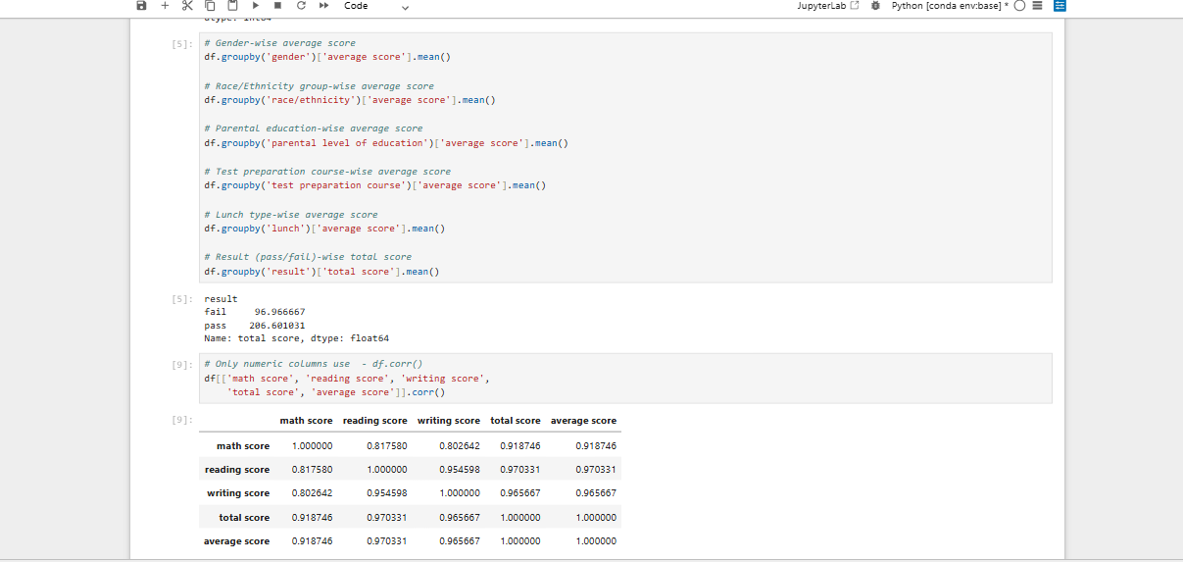

9. Data Visualization using Python
To identify hidden patterns and communicate findings effectively, a series of visual charts were generated using the Matplotlib and Seaborn libraries within Jupyter Notebook. Each visualization was designed to address a specific analytical question raised in the problem statement.

9.1 Demographic Analysis (Matplotlib)
- A Pie Chart was generated to illustrate the gender distribution across the dataset, revealing a near-equal split between male and female students.

- Grouped Bar Graphs were created to analyze the relationship between parental level of education and average student scores in each subject, clearly showing a positive correlation.

- A comparative Bar Chart was plotted for test preparation course completion vs. non-completion, visualizing the score improvement across all three subjects.

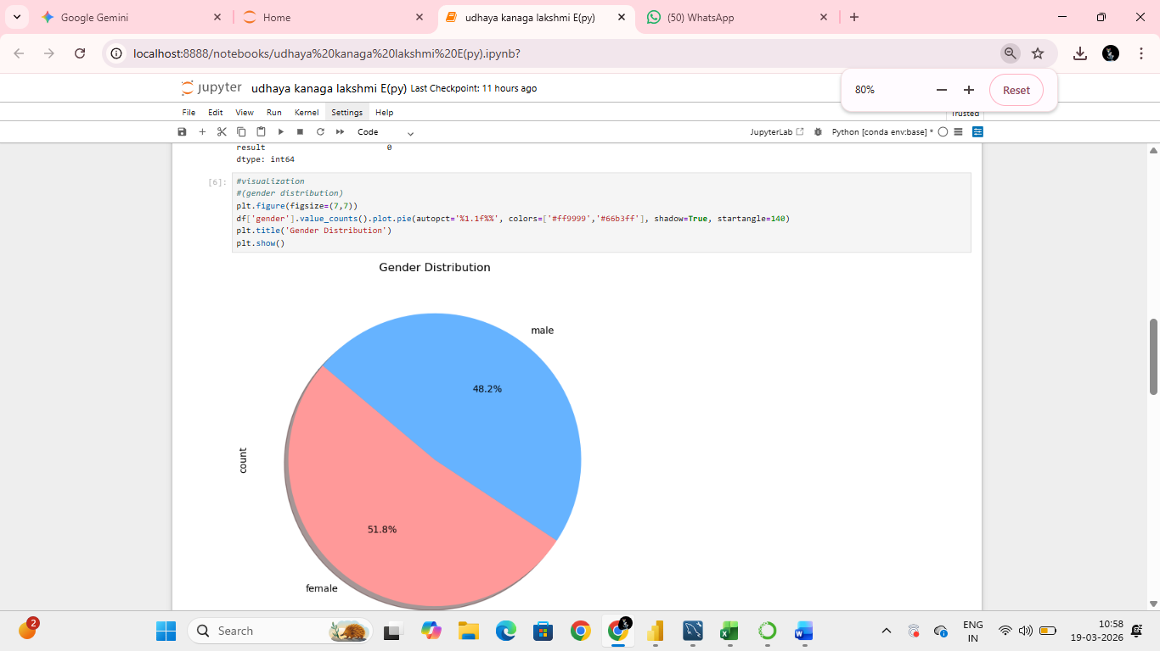

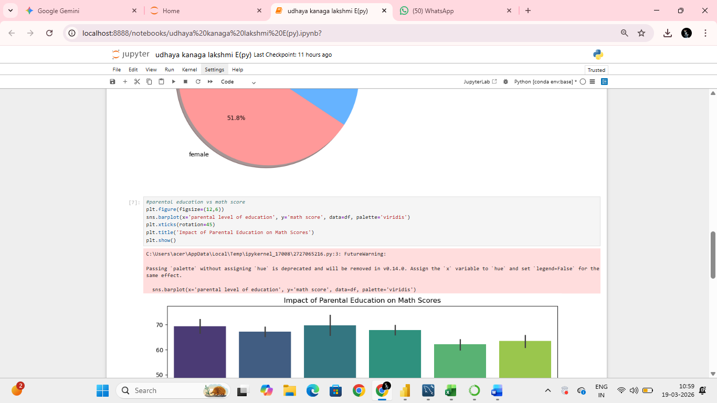

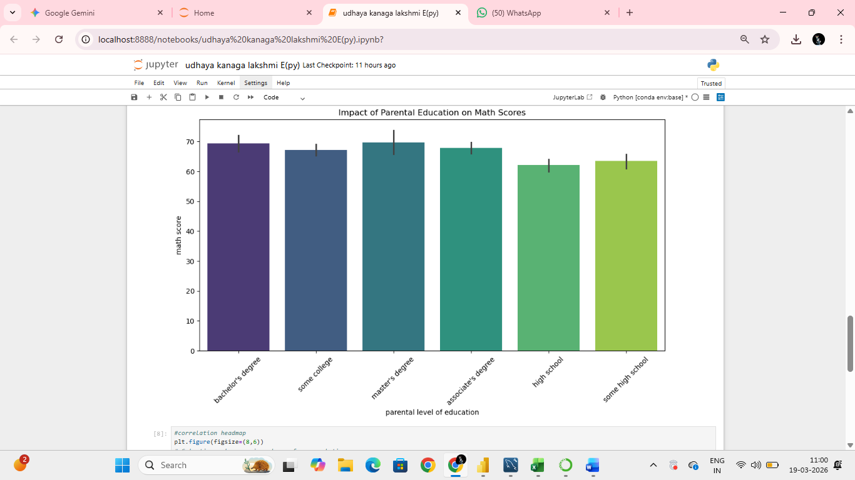

9.2 Correlation Analysis (Seaborn)
A Correlation Heatmap was generated using the Seaborn library to quantify the strength of relationships between the three subject scores. The heatmap revealed the following key correlations:
- Reading and Writing scores demonstrated the strongest correlation (r ≈ 0.95), indicating these are closely interlinked skills.

- Math and Reading scores showed a moderate-to-strong correlation (r ≈ 0.82)

- Math and Writing scores also demonstrated a strong correlation (r ≈ 0.80).

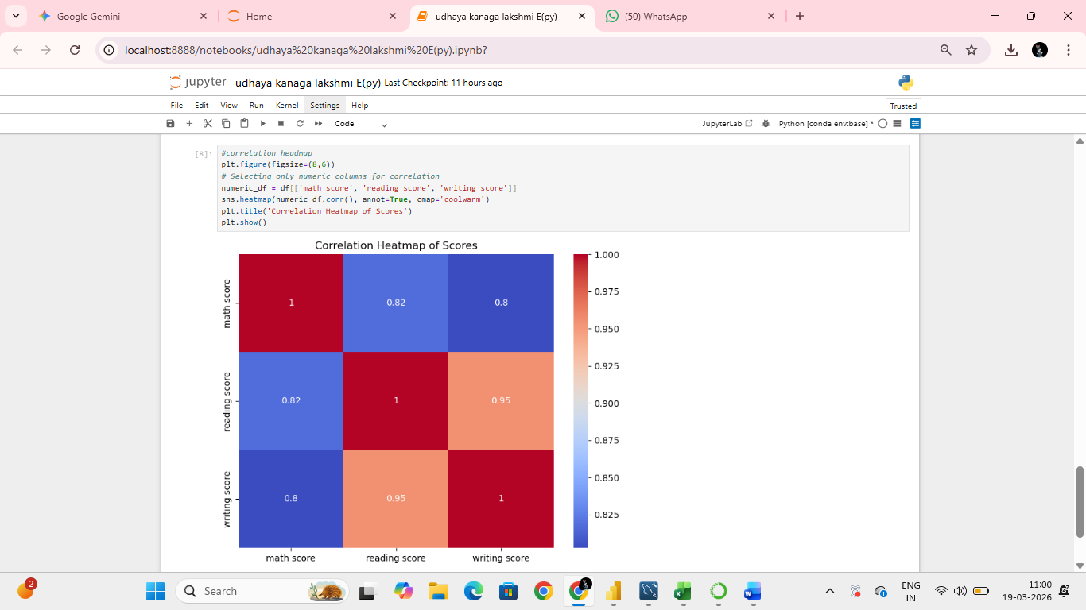

9.3 Line Chart — Student Average Score Trend

Overview
The line chart visualizes the average score trend across all 1,000 students in the dataset. Each point on the X-axis represents an individual student record, while the Y-axis reflects the computed average score derived from math, reading, and writing assessments. This chart helps identify the overall distribution pattern and any notable fluctuations in student performance.

Key Observations
- The average scores of students range approximately between 20 and 100, showing a wide spread in academic performance.

- A significant cluster of students achieves average scores between 60 and 80, indicating a moderately high-performing cohort.

- Occasional dips below 40 in the trend line point to a minority of students who may require additional academic support.

- The overall trend does not show a time-dependent pattern, as student records are not ordered chronologically, making this chart suitable for spotting outliers rather than temporal trends.

Interpretation
The line chart reveals that student performance is highly variable across the dataset. The presence of both very high-scoring and very low-scoring students suggests that external factors such as parental education level, lunch program participation, and test preparation course completion may play a significant role in determining individual performance. Further segmented analysis by these categorical variables would provide deeper insight.
Python Code Used
df['average score'].plot(title='Student Average Score Trend', figsize=(10, 4))
plt.xlabel('Student Index')
plt.ylabel('Average Score')
plt.show()
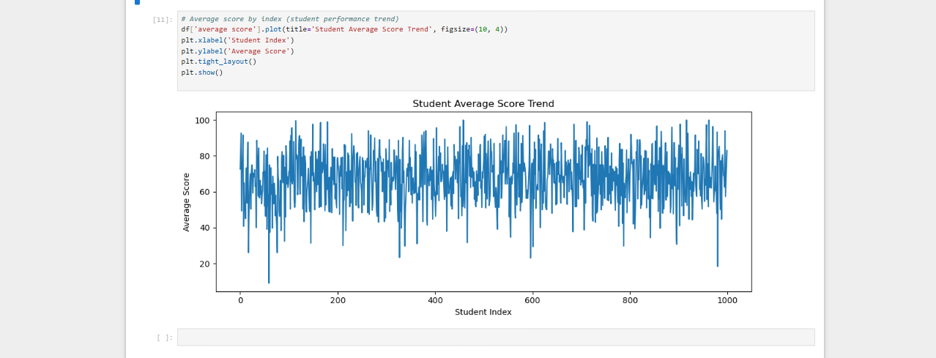

9.4 Histogram — Distribution of Math Scores

Overview
The histogram illustrates the frequency distribution of math scores among all 1,000 students. The X-axis represents the range of math scores (0 to 100), divided into 20 equal bins, while the Y-axis shows the number of students falling within each score range. This visualization is useful for understanding the overall shape of score distribution, identifying the most common performance band, and detecting any skewness in the data.

Key Observations
- The distribution of math scores appears roughly bell-shaped (normal distribution), with the majority of students scoring between 55 and 75.

- The peak frequency bin is around 60 to 70, indicating that this is the most common math score range among students.

- A slight left skew is observable, meaning there are fewer students at the very low end of the scale compared to the high end.

- A small number of students score exceptionally high (above 90) or very low (below 30), representing the tail ends of the distribution.

Interpretation
The math score histogram confirms that most students perform at an average to above-average level. The relatively symmetric distribution suggests that math performance is broadly consistent across the student population, though the tail at the lower end highlights a subset of students who may need targeted intervention. Comparing this distribution with reading and writing score histograms would help determine whether math is a relatively stronger or weaker subject area for this cohort.

Python Code Used
df['math score'].plot(kind='hist', title='Distribution of Math Scores', bins=20,
figsize=(8, 5), color='coral', edgecolor='black')
plt.xlabel('Math Score')
plt.ylabel('Frequency')
plt.show()
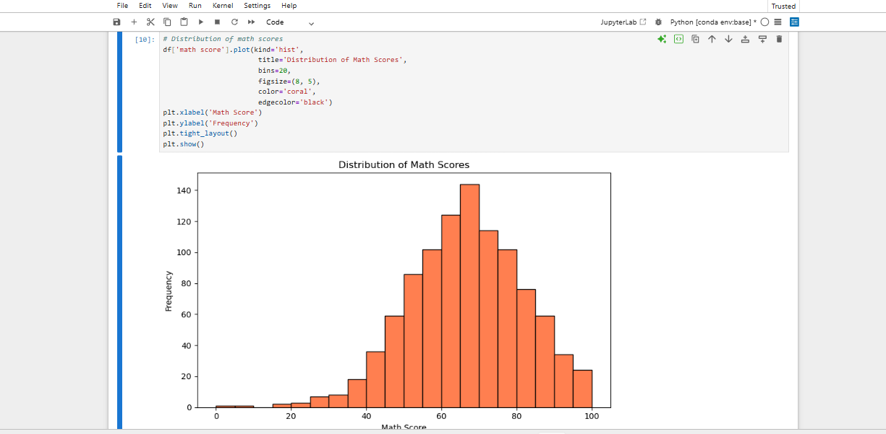

10. Interactive Dashboard Development (Power BI)
The culmination of this project is a professional, interactive Power BI dashboard that consolidates all key analytical findings into a single, user-friendly reporting interface. The dashboard was designed to allow school administrators and educators to explore the data dynamically through filters and slicers.

10.1 Canvas and Layout Design
The dashboard was designed with a clean, professional color scheme using a dark navy header band and white content cards. A consistent layout hierarchy was maintained, with KPI indicators at the top and detailed charts occupying the lower sections of the canvas.

10.2 Key Performance Indicators (KPIs)
- Average Math Score — displayed as a KPI card with conditional formatting to highlight underperformance.

- Average Reading Score — KPI card showing the overall reading proficiency of the student population.

- Average Writing Score — KPI card providing a quick snapshot of writing performance.

- Total Students Analyzed — a count KPI reflecting the complete dataset size of 1,000 records.

10.3 Dynamic Slicers and Filters
- Gender Slicer — allows filtering of all visuals to display data for male or female students exclusively.

- Lunch Type Slicer — enables socio-economic segmentation of the dashboard.

- Test Prep Course Slicer — allows comparison of performance between students who completed preparation and those who did not.

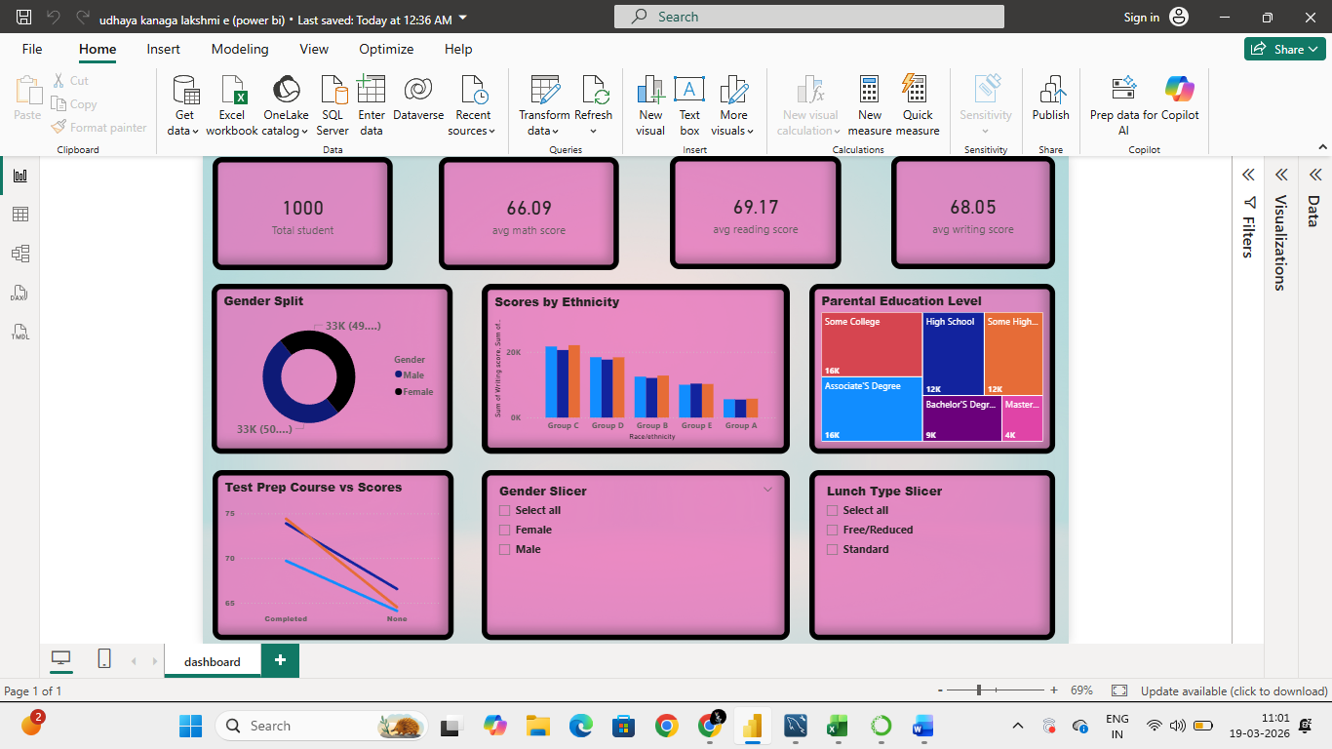

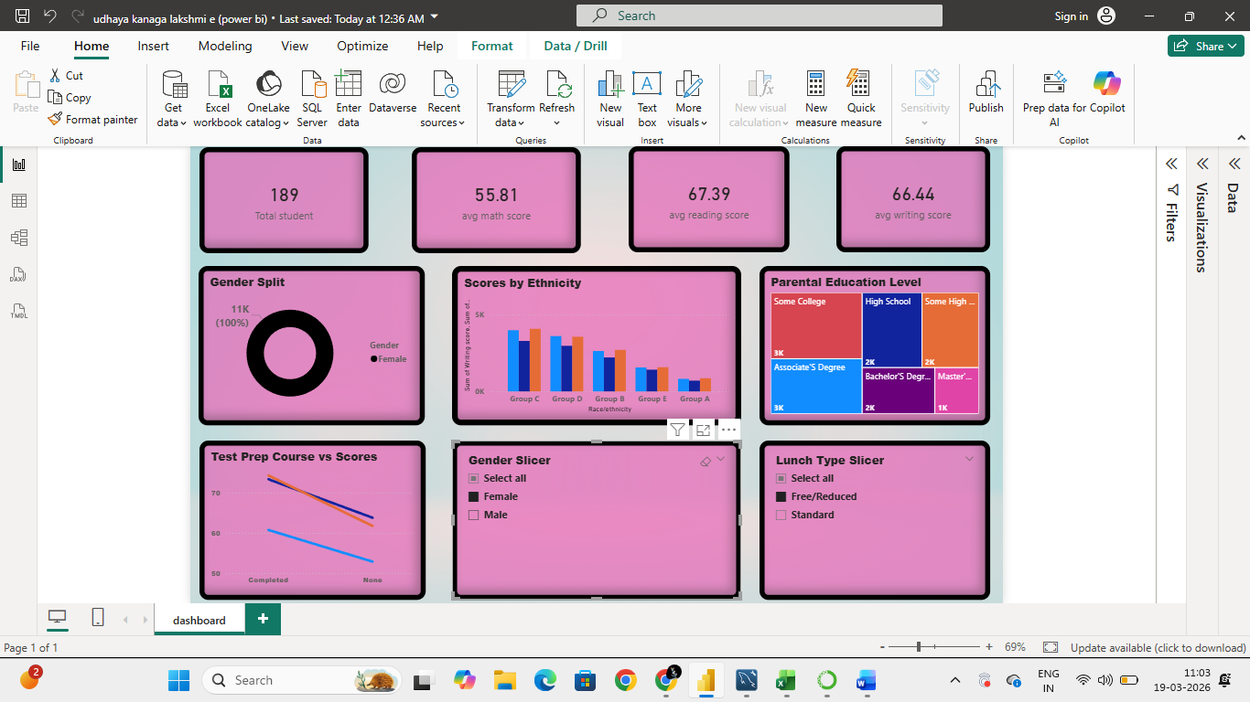

11. Key Insights & Findings
Following the complete data analysis pipeline, the following key insights were derived from the 1,000-student dataset:

- Impact of Test Preparation: Students who completed the test preparation course scored an average of 8–12 points higher across all three subjects compared to those who did not, confirming the significant positive impact of structured academic preparation.

- Parental Education Effect: A clear positive correlation was observed between the highest level of parental education and student scores. Students whose parents held a Bachelor's or Master's degree consistently outperformed those from families with only high school or some college education, with differences of 5–15 points in average scores.

- Socio-Economic Influence: Students receiving a standard lunch — a proxy for higher socio-economic status — outperformed students on free/reduced lunch plans across all three subjects, highlighting the influence of socio-economic factors on academic achievement.

- Gender-Based Performance Differences: Female students demonstrated higher average scores in Reading and Writing, while male students performed marginally better in Mathematics. These differences were consistent across demographic groups.

- Subject Correlation: Reading and Writing scores exhibited the highest inter-subject correlation (r ≈ 0.95), followed closely by Reading-Math (r ≈ 0.82) and Writing-Math (r ≈ 0.80), confirming that subject performance is highly interrelated.

12. Business Recommendations
Based on the key insights derived from this analysis, the following strategic recommendations are proposed for school administrations and educational policymakers:

- Mandatory & Subsidized Test Prep Courses: Given the substantial positive impact of test preparation courses on student scores, schools should subsidize or mandate enrollment for students from lower socio-economic backgrounds. A pilot program targeting students with free/reduced lunch eligibility could yield measurable improvements in standardized test results.

- Early Parental Engagement Programs: Since parental education level correlates strongly with student outcomes, schools should implement family literacy programs and parent engagement workshops — particularly for families with a high school education or less. Early parental involvement in academic goal-setting can meaningfully bridge the performance gap.

- Integrated Literacy Support: The high correlation between Reading and Writing scores suggests that a strong literacy foundation amplifies performance across multiple subjects. Schools should invest in integrated literacy development programs for younger grades, with targeted support for students scoring below the 25th percentile.

- Gender-Responsive Academic Interventions: The gender performance differential in Mathematics suggests that targeted STEM encouragement programs for female students, combined with writing support initiatives for male students, could help create a more balanced academic profile across the student population.

- Data-Driven Student Monitoring: Deploy the Power BI dashboard within school administration systems to allow real-time monitoring of student performance. Set automated alerts for students whose scores fall below defined thresholds, enabling proactive counselor outreach.

13. Conclusion
This project successfully demonstrates how a structured, multi-tool data analytics pipeline can be applied to a real-world educational dataset to generate meaningful and actionable insights. By progressing through Microsoft Excel for data cleaning, MySQL for structured data management, Python for deep statistical analysis and visualization, and Power BI for interactive dashboard development, the project showcases a complete end-to-end analytics workflow.
The analysis confirmed that student academic performance is influenced by a multifaceted combination of factors including test preparation, parental education, lunch type, and gender. The insights derived from this study can directly inform educational policy decisions, resource allocation strategies, and individualized student support programs.
From a technical standpoint, this project reinforces the importance of data quality, methodological rigor, and effective communication of analytical findings. The interactive Power BI dashboard serves as a practical deliverable that can be readily adopted by school administrators for ongoing performance monitoring.

Project Outcome: Successfully identified key drivers of student academic performance
Tools Demonstrated: Excel | MySQL | Python (Pandas, Matplotlib, Seaborn) | Power BI
Dataset: 1,000 Student Records | 8 Variables | 3 Score Subjects
Key Finding: Test Preparation and Parental Education are the strongest performance predictors

14. References
The following references and resources were used in the development of this project:

- Student Performance in Exams Dataset — Kaggle. Available at: www.kaggle.com/datasets/spscientist/students-performance-in-exams
- McKinney, W. (2022). Python for Data Analysis (3rd ed.). O'Reilly Media.
- MySQL Documentation. MySQL 8.0 Reference Manual. Oracle Corporation. Available at: dev.mysql.com/doc/
- Microsoft Power BI Documentation. Microsoft Corporation. Available at: learn.microsoft.com/en-us/power-bi/
- Hunter, J.D. (2007). Matplotlib: A 2D Graphics Environment. Computing in Science & Engineering, 9(3), 90–95.
- Waskom, M. (2021). Seaborn: Statistical Data Visualization. Journal of Open Source Software, 6(60), 3021.
- Pandas Development Team. (2023). Pandas: Powerful Python Data Analysis Toolkit. Available at: pandas.pydata.org

— End of Report —
Submitted by Udhaya Kanaga Lakshmi E | Roll No: 23CS001 | JHA AGARSEN COLLEGE | 2025–2026

