**Linux**

1. **Creating a shell script file**

Shell script – sample.sh

Commands(shell commands) 🡪

1. Ls
2. Pwd
3. Mkdir abc
4. Touch new
5. Running a shell script file ---🡪

Syntax -----> ./<filename>

ex----------🡪 ./sample.sh

**GITHUB**

* GitHub is a web-based interface that uses Git,
* open-source version control software
* Multiple people make separate changes to web pages at the same time

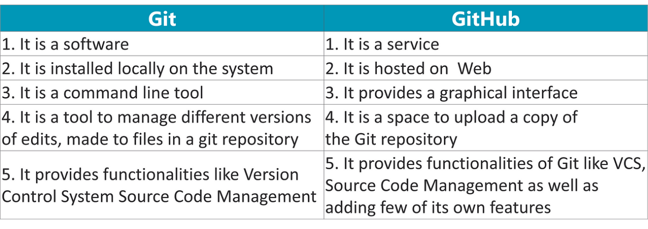

1. Create Github account - <https://github.com/signup?return_to=https%3A%2F%2Fgithub.com%2FJijendranP&source=login>

**UI**

1. Repository creation
2. Creating a file in git repo
3. Uploading a file in git repo
4. Deleting a file
5. Creating a folder
6. Adding files inside a folder
7. Creating a branch
8. Deleting a branch
9. Granting repo access to other – via collaborators
10. Folk – how to do in git

Public repo - <https://github.com/JijendranP/sample>

Private repo - <https://github.com/JijendranP/batch_2025_jan_devps>

Jije.mano@gmail.com