1. **Save Money:**

In Order to Save money, As a bank client, I want to make a deposit in my account.

**Technical Constrains:**

* Integration the bank web service with ATM software application.

**Sequence diagram:**

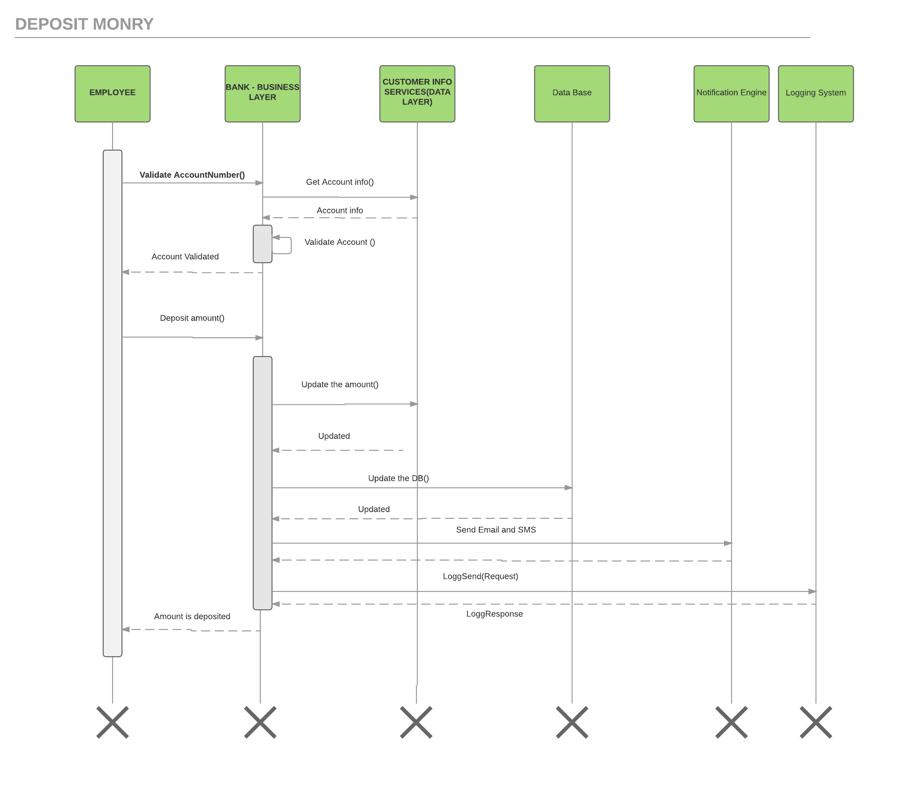

**Flow Description:**

The below webservices is exposed to the calling application ( ATM or Webapplication used by the employer of the bank from the branch office)

|  |  |
| --- | --- |
| **Web-Service** | **Description** |
| ValidateAccountNumberSrv | To validate the account number with its current status |
| Deposit AmountSrv | To update the amount in the data layer, Database and requesting the Notification layer to send an email and SMS to the Customer |

**ValidateAccountNumberSrv :**

* Receiving the request containing account number.
* Get the account info by calling the data layer.
* Validate the account to check is it a active normal account to make the transaction.
* Send back the response to the calling application.

**Deposit AmountSrv :**

* Receiving the request containing the amount to be deposited.
* Call the data layer to update the account info by **updating the balance** with the amount requested.
* The transaction details to be **updated in the transaction table** to maintain the history for the statement.
* Requesting the Notification to send the **email** and **SMS** alert to the customer registered mobile number and email address respectively.
* Log the request and response to the logging system.
* Send the response to the calling application.

1. **Withdraw Money :**

In order to retrieve some or all of my savings, As a bank client, I want to make a withdrawal from my account.

**Technical Constrains:**

* Integration the bank web service with ATM software application.

**Sequence diagram:**

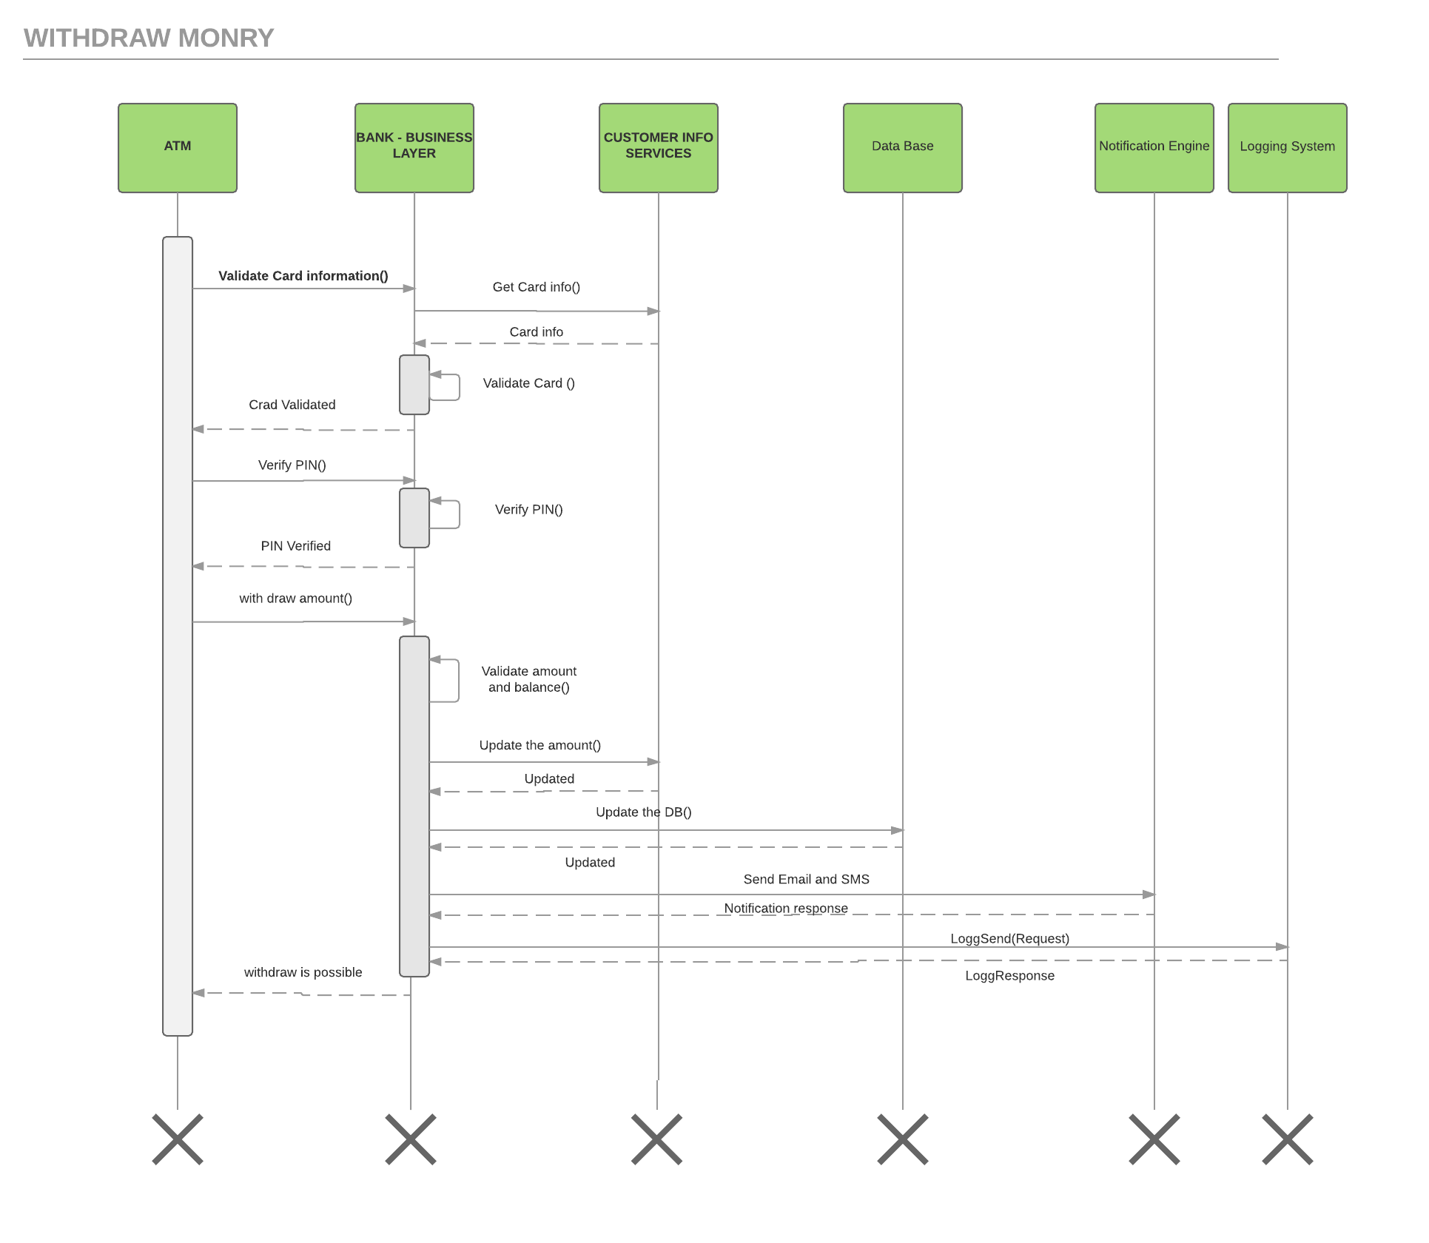

**Flow Description:**

The below webservices is exposed to the calling application ( ATM )

|  |  |
| --- | --- |
| **Web-Service** | **Description** |
| ValidateCardSrv | To validate the Card number with its current status |
| VerifyPinSrv | To verify the PIN to validate the request |
| WithDrawAmountSrv | To validate the amount & balance and update the balance of the account as well as sending the notification to the customer and updating DB and logging the information. |

**ValidateCardSrv:**

* Receiving the request containing the card number.
* Calling the data layer to receive the card information.
* Validated the card against the status, card type, expired date, account.
* Send the response back to the calling application.

**VerifyPinSrv:**

* Receiving the request containing the PIN.
* Validate the PIN against info from DB (stored (using the encoded algorithm) as part of registration with incorrect attempt if made any).
* Update the database incase if there is an incorrect attempt.
* Update the data layer to block the card if there is 3 incorrect attempt were made by the user.
* Send the response to the calling application.

**WithDrawAmountSrv:**

* Receiving the request containing the amount to withdraw.
* Validate the amount and the balance(to check if it is exceed the overdraft limit).
* Update the balance to the account by calling the data layer.
* Update the transaction details to the Database to maintain the history for the statement.
* Requesting the Notification to send the **email** and **SMS** alert to the customer registered mobile number and email address respectively.
* Log the request and response to the logging system.
* Send the response to the calling application.

1. **Statement Printing :**

In order to retrieve some or all of my savings, As a bank client, I want to make a withdrawal from my account.

**Solution 1:**

Providing the Mini statement (limited with last 10 or 15 transaction details )via ATM to user to print the details by calling the Bank webservice of business layer.

**Technical Constrains:**

* Integration the bank web service with ATM software application to print the statement.

**Solution 2:**

Providing the transaction history option via the online back application by calling the webservice of business layer to provide the statement info.

* This Screen is static page replicating the database values. So, This can be simply developed using the JavaScript libraries instead of Java-script framework (to modify the values without reloding the screen)