**Steps to follow to add Chrome Extension - Modify LinkedIn Profile Pictures**

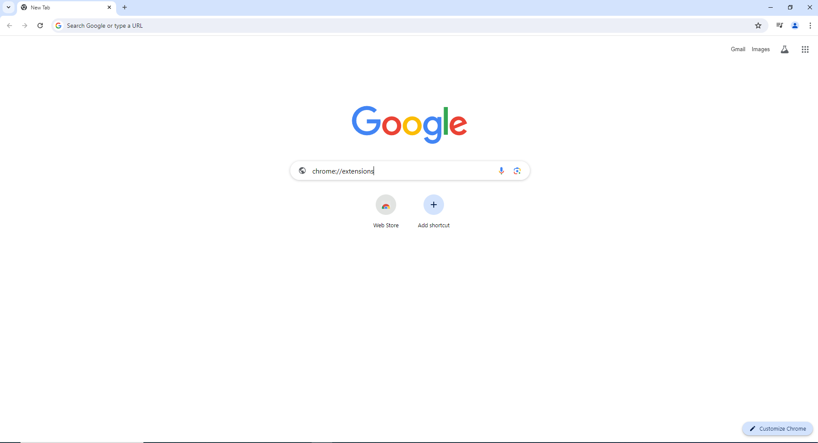

Step 1: Opening chromes extension page

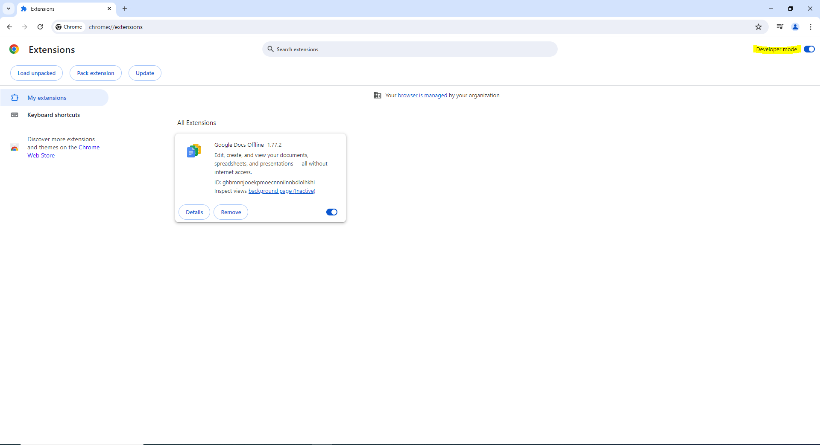

Step 2 : Turn on the developer mode

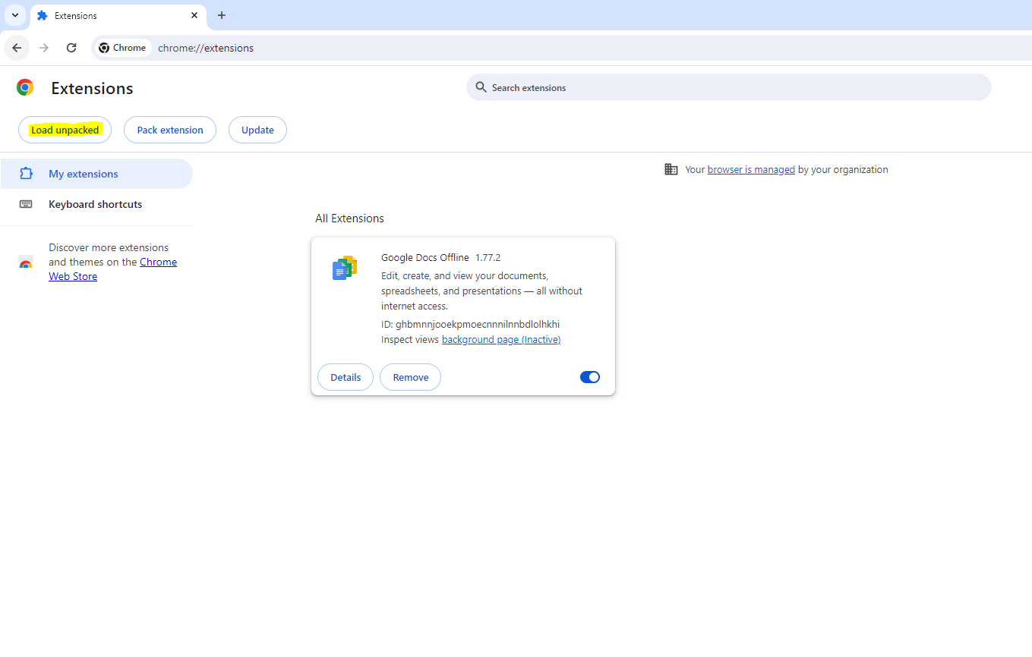

Step 3: Select load unpacked option

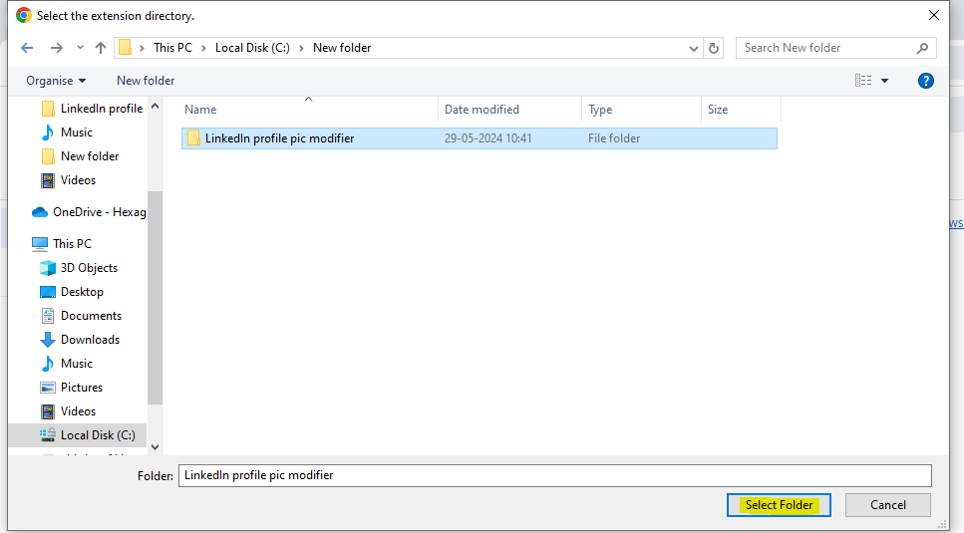

Step 4: select the folder where your extension files is present

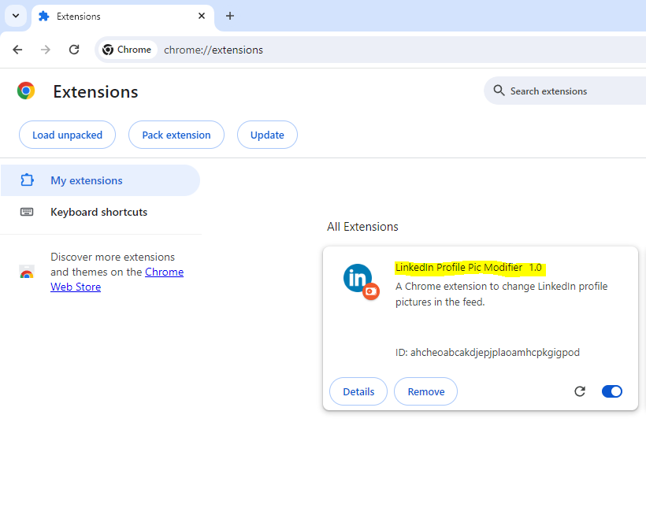Step 5: Now you can see that your extension have been added Successfully

Step 6: Select details Option

Step 7 : Then on both pin to start and incognito so it will be pinned and extension will also work on incognito mode

Step 8: Just open LinkedIn and this is the screenshot before we executing the extension



Step 9 : Just click the extension logo which is present on the top right highlighted in screen shot

Step 10 : All feed and profile changed to the picture what we given

Sample Image here you can see all the feeds and profile picture are modified extension image