HIGH-LEVEL DESIGN DOCUMENT

GenAI-Driven Adaptive Product
Specification Engine

Xebia Hackathon 2026

Field | Details
Document Type | High-Level Design (HLD)
Project Name | GenAI-Driven Adaptive Product Specification Engine
Version | 1.0
Date | April 29, 2026
Status | Draft
Audience | Architects, Engineers, Product Managers, Hackathon Evaluators

1. Introduction

1.1 Purpose
This High-Level Design (HLD) document describes the architectural blueprint and design rationale for the GenAI-Driven Adaptive Product Specification Engine. It serves as the primary reference for system architects, backend and frontend engineers, AI/ML practitioners, and hackathon evaluators who need to understand how the system is structured and how its components interact.
The document outlines key design decisions, technology selections, data flows, and integration points so that any team member can understand the system holistically before engaging with lower-level implementation details.

1.2 Scope
This document covers the following in-scope items:
- Automated detection of changes in product requirements, feature specifications, and API documentation
- AI-powered analysis and propagation of changes across all related documents
- Consistency validation across PRDs, technical specs, design docs, and API docs
- Conflict detection and resolution recommendations
- Generation of implementation-ready product documentation
- Dashboard interface for monitoring document health and synchronization status

The following are explicitly out of scope:
- Version control systems integration (Git, SVN) — future phase
- Real-time collaborative editing (Google Docs-style)
- Billing or subscription management
- Mobile native applications

1.3 Definitions, Acronyms & Abbreviations
Term | Full Form | Description
GenAI | Generative Artificial Intelligence | AI systems capable of generating text, code, and documents
HLD | High-Level Design | Architecture-level design document
PRD | Product Requirements Document | Document defining product features and requirements
API | Application Programming Interface | Interface contract between software systems
LLM | Large Language Model | Foundation AI model (e.g., Claude, GPT)
NLP | Natural Language Processing | AI field for understanding human language
RAG | Retrieval Augmented Generation | Technique combining retrieval with LLM generation
DB | Database | Persistent data storage system
UI | User Interface | Frontend layer the user interacts with
MVC | Model-View-Controller | Software architectural design pattern
REST | Representational State Transfer | Architectural style for APIs
SRS | Software Requirements Specification | Document detailing system requirements
CI/CD | Continuous Integration/Deployment | Automated build and release pipeline

1.4 References
Document | Description
Xebia Hackathon Problem Statement #15 | Original problem brief (attached image)
Anthropic Claude API Documentation | LLM API reference — docs.anthropic.com
OpenAI API Reference | Alternative LLM provider — platform.openai.com
LangChain Documentation | AI orchestration framework — langchain.com
FastAPI Documentation | Backend framework — fastapi.tiangolo.com
React Documentation | Frontend framework — react.dev
PostgreSQL Documentation | Primary database — postgresql.org
Pinecone / Weaviate Docs | Vector database for RAG — pinecone.io

2. System Overview

2.1 Problem Statement
Core Problem
In modern software development, product requirements, features, and API documentation frequently change due to evolving user needs and continuous updates. These changes are often NOT reflected across all related documents, leading to inconsistencies and confusion among teams. This mismatch results in incorrect implementations, increased bugs, and project delays.

The specific pain points are:
- Documentation fragmentation: PRDs, API specs, design docs, and technical specs live in silos
- Manual synchronization: Engineers manually propagate changes — error-prone and time-consuming
- Consistency gaps: Conflicting information causes misaligned implementations
- Stale documentation: Updated code rarely triggers documentation updates
- No intelligent alerting: Teams discover inconsistencies only during reviews or post-bug

2.2 Proposed Solution
Solution
A GenAI-powered platform that continuously monitors product documentation, automatically detects changes across all artifacts, validates consistency, identifies conflicts, and generates updated implementation-ready documentation — ensuring the entire documentation ecosystem evolves together in real time.

2.3 Goals & Objectives
Goal | Success Metric
Automated change detection | Detect changes within 60 seconds of document update
Cross-document consistency | 99% consistency score across all linked documents
Conflict identification | Zero undetected conflicts at document review time
Implementation-ready output | Generated specs accepted without manual revision in >80% of cases
Reduced documentation lag | Time from code change to doc update reduced by 90%
Team visibility | Dashboard showing real-time document health for all stakeholders

2.4 Assumptions & Constraints

Assumptions
- Documents are available in standard formats: Markdown, PDF, Confluence, Notion, or plain text
- An LLM API (Claude or OpenAI) is accessible with sufficient rate limits
- Users have basic familiarity with web-based tools
- Initial hackathon scope targets up to 50 documents per project workspace

Constraints
Constraint | Detail
Tech Stack — Backend | Python (FastAPI) for AI orchestration and REST APIs
Tech Stack — Frontend | React.js with Tailwind CSS
Tech Stack — AI Layer | LangChain + Claude Sonnet / GPT-4o
Tech Stack — Database | PostgreSQL (relational) + Pinecone (vector DB for RAG)
Deployment | Docker containers, deployable on AWS/GCP/local
Hackathon Timeline | MVP scope: core change detection + consistency validation only
LLM Rate Limits | API call batching required for large document sets

3. System Architecture

3.1 Architecture Overview
The system follows a layered, microservice-inspired architecture with five primary layers: Presentation, API Gateway, Core Services, AI Processing, and Data Storage. Each layer has well-defined responsibilities and communicates through REST APIs and event queues.

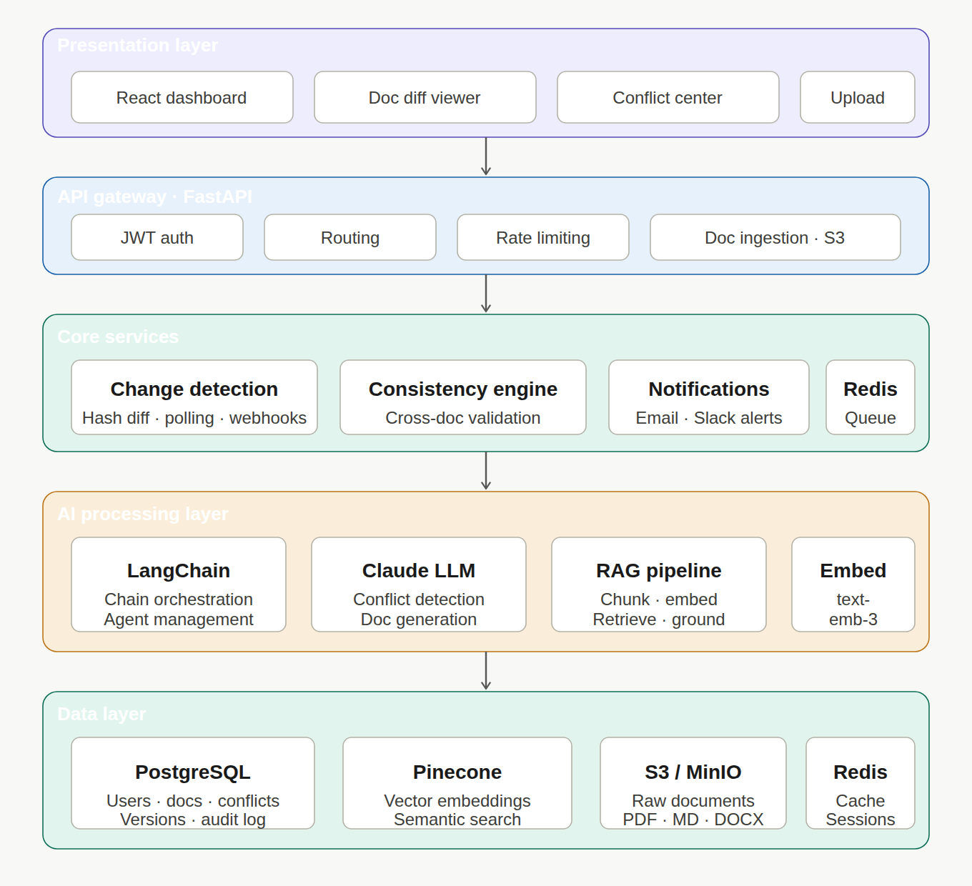

3.2 Component Description
Component | Responsibility
React Dashboard | Document upload, diff viewer, conflict display, health status
FastAPI Gateway | Authentication (JWT), routing, rate limiting, API versioning
Change Detection Service | Polls/webhooks for doc changes, diffs content, emits events
Consistency Engine | Cross-references all docs, finds contradictions using LLM
AI Orchestration (LangChain) | Chains LLM calls for analysis, summarization, and generation
Claude LLM | Natural language understanding, conflict detection, doc generation
RAG Pipeline | Embeds docs into vector DB; retrieves relevant context for LLM
PostgreSQL | Users, workspaces, document metadata, change history, audit log
Pinecone (Vector DB) | Stores document embeddings for semantic search and retrieval
S3 / File Storage | Raw document storage (PDF, Markdown, DOCX)
Notification Service | Email/Slack alerts when conflicts or updates are detected
Message Queue (Redis) | Async task queue for document processing jobs

3.3 Technology Stack
Layer | Technology | Justification
Frontend | React.js + Tailwind CSS | Component-based, rapid UI development
Backend API | Python FastAPI | Async support, auto-docs, ideal for AI workloads
AI Orchestration | LangChain | Standardized chain/agent patterns for LLM pipelines
LLM Provider | Anthropic Claude Sonnet | Superior reasoning, large context window (200K tokens)
Embeddings | OpenAI text-embedding-3-small | Cost-effective, high-quality semantic embeddings
Relational DB | PostgreSQL | ACID compliance, robust for metadata/audit logs
Vector DB | Pinecone | Managed vector store for RAG similarity search
Cache / Queue | Redis | Fast caching + async task queue (Celery)
File Storage | AWS S3 / MinIO | Scalable object storage for documents
Containerization | Docker + Docker Compose | Consistent deployment across environments
Auth | JWT + OAuth2 | Stateless, secure authentication

3.4 Design Approach
- Microservice-inspired monolith (modular monolith for hackathon; decomposable later)
- Event-driven change propagation using Redis pub/sub for near-real-time updates
- RAG pattern for context-aware document analysis — reduces LLM hallucination
- Separation of concerns: AI logic isolated in dedicated service layer
- API-first design — all features exposed as REST endpoints

3.5 Deployment View
Environment | Configuration
Local / Dev | Docker Compose — all services on localhost, port 8000 (API), 3000 (UI)
Hackathon Demo | Single cloud VM (e.g., GCP e2-standard-4), Docker Compose
Production (future) | Kubernetes cluster, managed PostgreSQL (RDS), managed Pinecone
CI/CD | GitHub Actions — lint, test, build, push Docker images

4. Database Design

4.1 Entity Relationship Overview
The PostgreSQL schema consists of six primary entities: Users, Workspaces, Documents, DocumentVersions, Changes, and Conflicts. These capture the full lifecycle of a document from creation through conflict detection.

ER Summary
Users → Workspaces (many-to-many via WorkspaceMembers) → Documents (one-to-many) → DocumentVersions (one-to-many) → Changes (one-to-many) → Conflicts (many-to-many via ConflictLinks)

4.2 Table Schemas

users
Column | Type | Description
id | UUID PK | Unique user identifier
email | VARCHAR(255) UNIQUE NOT NULL | Login email address
name | VARCHAR(100) NOT NULL | Display name
password_hash | TEXT NOT NULL | Bcrypt-hashed password
role | ENUM(admin, member) | System-level role
created_at | TIMESTAMP | Account creation time

workspaces
Column | Type | Description
id | UUID PK | Unique workspace identifier
name | VARCHAR(200) NOT NULL | Workspace/project name
owner_id | UUID FK → users.id | Creator of the workspace
created_at | TIMESTAMP | Creation timestamp

documents
Column | Type | Description
id | UUID PK | Unique document identifier
workspace_id | UUID FK → workspaces.id | Parent workspace
name | VARCHAR(300) NOT NULL | Document display name
doc_type | ENUM(PRD, API_SPEC, TECH_SPEC, DESIGN_DOC, OTHER) | Document category
storage_url | TEXT | S3/MinIO URL for raw document file
current_version_id | UUID FK → document_versions.id | Active version pointer
health_score | FLOAT | Consistency health score (0.0–1.0)
created_at | TIMESTAMP | First upload time
updated_at | TIMESTAMP | Last modified time

document_versions
Column | Type | Description
id | UUID PK | Version identifier
document_id | UUID FK → documents.id | Parent document
version_number | INTEGER NOT NULL | Sequential version number
content_hash | TEXT | SHA-256 hash of content (change detection)
content_text | TEXT | Extracted plain text of the document
embedding_id | TEXT | Reference ID in Pinecone vector DB
created_by | UUID FK → users.id | User who created this version
created_at | TIMESTAMP | Version creation timestamp

changes
Column | Type | Description
id | UUID PK | Change event identifier
document_id | UUID FK → documents.id | Document that changed
from_version_id | UUID FK → document_versions.id | Previous version
to_version_id | UUID FK → document_versions.id | New version
change_summary | TEXT | AI-generated summary of what changed
status | ENUM(pending, processed, failed) | Processing status
detected_at | TIMESTAMP | When change was detected

conflicts
Column | Type | Description
id | UUID PK | Conflict identifier
workspace_id | UUID FK → workspaces.id | Workspace where conflict exists
doc_a_id | UUID FK → documents.id | First conflicting document
doc_b_id | UUID FK → documents.id | Second conflicting document
conflict_description | TEXT | AI-generated description of the conflict
severity | ENUM(low, medium, high, critical) | Conflict severity level
status | ENUM(open, resolved, ignored) | Resolution status
resolution_note | TEXT | Notes on how conflict was resolved
detected_at | TIMESTAMP | When conflict was found
resolved_at | TIMESTAMP | When conflict was resolved (nullable)

4.3 Data Dictionary — Key Fields
Field | Explanation
health_score | Float 0.0 (critical inconsistency) to 1.0 (fully consistent). Recomputed after every consistency check run.
doc_type | Categorizes each document so the engine knows how to cross-reference: PRDs vs API specs vs tech specs vs design docs.
content_hash | SHA-256 of extracted text. If hash changes between polling cycles, a change event is emitted.
embedding_id | ID of the vector in Pinecone representing this document version's semantic content. Used for RAG retrieval.
severity (conflict) | Low = minor wording mismatch; Medium = functional discrepancy; High = contradictory requirements; Critical = implementation-blocking conflict.
status (changes) | Pending = queued; Processed = AI analysis complete; Failed = LLM or system error.

5. Functional Flow

5.1 Key Actors & Use Cases
Actor | Primary Use Cases
Product Manager | Upload PRDs, view conflict reports, approve resolved docs, monitor workspace health
Engineer | View updated technical specs, get notified of PRD changes affecting their component, sync API docs
Workspace Admin | Manage members, configure linked documents, set conflict severity thresholds
AI Engine (System Actor) | Detect changes, run consistency checks, generate summaries, flag conflicts
LLM (Claude) | Analyze document pairs, identify contradictions, generate conflict descriptions and resolution suggestions

5.2 Core Workflow: Document Change Detection & Propagation

Flow Summary
1. Document Updated → 2. Hash Check → 3. Change Detected → 4. AI Diff Analysis → 5. Embed New Version → 6. Cross-Document Consistency Check → 7. Conflict Detection → 8. Notify Team → 9. Update Dashboard

Step-by-Step Activity Flow
Step | Detail
1. Document Ingestion | User uploads document (PDF/MD/DOCX) via UI. System stores in S3, extracts text, computes hash, saves metadata to PostgreSQL.
2. Change Polling / Webhook | Scheduler polls every 60s (or webhook triggers). Computes new content hash, compares with stored hash.
3. Change Event Emission | If hash differs, creates a Change record (status=pending), stores new DocumentVersion, emits event to Redis queue.
4. AI Diff Analysis | Celery worker picks up event. Sends previous + new content to Claude LLM: 'Summarize what changed and its impact.'
5. Vector Embedding | New version content is embedded using text-embedding model. Stored in Pinecone with document metadata.
6. Consistency Check Trigger | Change triggers consistency check for all documents in the same workspace linked to the changed document.
7. RAG-Based Analysis | For each document pair, retrieve relevant sections via Pinecone. Feed to Claude: 'Identify contradictions between these sections.'
8. Conflict Record Creation | Conflicts found by LLM are stored in conflicts table with severity and description.
9. Notification | Email/Slack notification sent to workspace members listing new conflicts and their severity.
10. Dashboard Update | Health scores updated. React dashboard refreshes to show new conflict count and document status.

5.3 Sequence: User Uploads a Changed PRD

User → UI: Upload updated PRD.pdf
UI → API Gateway (POST /documents/{id}/versions)
API → S3: Store raw file
API → Text Extractor: Extract plain text
API → PostgreSQL: Save DocumentVersion record + content hash
API → Redis Queue: Emit 'process_change' task
API → UI: 202 Accepted
--- Async ---
Celery Worker → LangChain: Run diff analysis chain
LangChain → Claude API: Analyze PRD diff
Claude → LangChain: Return change summary + impacted areas
Celery → Pinecone: Upsert new embeddings
Celery → Consistency Engine: Run cross-doc check
Consistency Engine → PostgreSQL: Write conflicts found
Notification Service → Email/Slack: Alert team

5.4 AI Processing Pipeline Detail
Pipeline Stage | Description
Text Extraction | PyMuPDF (PDF), python-docx (DOCX), markdown (MD) extract clean text
Chunking | Text split into 512-token chunks with 64-token overlap for embedding
Embedding Generation | Each chunk embedded using text-embedding-3-small, stored in Pinecone
Context Retrieval (RAG) | For consistency check, retrieve top-k chunks from target documents semantically similar to changed sections
LLM Consistency Analysis | Claude receives: changed section + retrieved context + prompt template → returns structured conflict JSON
Post-processing | JSON parsed, conflicts written to DB, health scores recalculated

6. User Interface Design

6.1 Key Screens & Navigation
Screen | Description
Login / Register | Email + password login, JWT issued on success. OAuth2 Google login as optional path.
Workspace Dashboard | Overview of all documents in workspace. Health score badges (green/yellow/red). Conflict count widget. Recent changes feed.
Document List | Table of all documents with type, last updated, version, and health score. Upload new document button.
Document Detail | Current version viewer. Version history timeline. Side-by-side diff view for any two versions. Linked documents section.
Conflict Center | List of all open conflicts. Filter by severity / document pair. Expand each conflict to see AI description and recommended resolution. Mark as resolved.
AI Analysis View | For any document, show AI-generated summary of recent changes, impacted areas, and cross-document impact report.
Settings | Workspace members, notification preferences, polling interval, linked document configuration.

6.2 Navigation Flow

Navigation
Login → Workspace Dashboard → [Document List → Document Detail → Conflict Center] | [AI Analysis View] | [Settings]

6.3 Dashboard Widgets
Widget | Data Displayed
Workspace Health Score | Aggregate health across all documents (0–100 score with color coding)
Active Conflicts | Count of open conflicts by severity (critical/high/medium/low)
Recent Changes | Feed of last 10 document changes with AI summary snippet
Document Health Grid | Grid of all docs with color-coded health: green=consistent, yellow=minor issues, red=conflicts
Sync Status | Last check timestamp and next scheduled run

7. Non-Functional Requirements

7.1 Security
Requirement | Implementation
Authentication | JWT tokens with 24h expiry, refresh token rotation
Authorization | Role-based access control (Admin, Member) per workspace
Password Storage | Bcrypt hashing with salt rounds ≥ 12
Data in Transit | HTTPS/TLS 1.3 enforced for all API calls
Data at Rest | S3 server-side encryption (AES-256)
LLM API Keys | Stored in environment variables / secrets manager, never in code
Input Validation | Pydantic models validate all API inputs; file type whitelisting for uploads
Audit Log | All document changes and conflict resolutions logged with user ID and timestamp

7.2 Performance & Scalability
Requirement | Target / Strategy
API Response Time | < 200ms for CRUD endpoints; < 5s for AI analysis trigger
Change Detection Latency | < 60 seconds from document update to change event emission
AI Processing Throughput | 10 concurrent consistency checks (Celery worker pool)
Document Scale (MVP) | Up to 100 documents per workspace, up to 10MB per document
Vector DB Scale | Pinecone handles millions of vectors; no limit concern at hackathon scale
DB Scaling | Read replicas for PostgreSQL in production; connection pooling via PgBouncer
LLM Rate Limits | Exponential backoff + request queuing to stay within Claude API limits

7.3 Reliability & Availability
- Failed AI processing tasks are retried up to 3 times with exponential backoff
- Document storage (S3) provides 99.999999999% durability
- Database backups automated daily with point-in-time recovery
- Health endpoint (/health) for uptime monitoring
- Graceful degradation: if LLM API is unavailable, basic hash-based change detection continues

7.4 Usability
- Web responsive design (desktop and tablet support)
- Conflict severity color coding: red=critical, orange=high, yellow=medium, gray=low
- AI summaries written in plain English, avoiding technical jargon
- One-click 'Run Consistency Check' for immediate analysis on demand
- Onboarding wizard for first-time workspace setup

8. Risks & Mitigation

8.1 Technical Risks
Risk | Impact | Mitigation Strategy
LLM Hallucination | High — false conflict alerts confuse teams | Structured output prompting; confidence scoring; human review for critical conflicts
LLM API Rate Limits | High — consistency checks blocked during high load | Request queuing, batch processing, exponential backoff, fallback to cached analysis
LLM API Cost Overrun | Medium — unexpected API costs at scale | Token counting before calls; caching LLM responses; only re-analyze changed sections
Vector DB Stale Embeddings | Medium — outdated vectors cause poor RAG quality | Re-embed on every version update; invalidate old embeddings on document archive
Large Document Processing | Medium — PDFs > 10MB cause timeouts | Async processing with Celery; chunked upload; file size limits with clear user errors
PostgreSQL Concurrency | Low — simultaneous writes during bulk processing | Optimistic locking; DB connection pooling; write-through queue for conflict records
Data Privacy of Docs | High — sensitive product docs sent to LLM API | On-premise LLM option (Ollama) for sensitive clients; data anonymization pipeline
Single Point of Failure (Redis) | Medium — queue down stops async processing | Redis Sentinel for HA; fallback to synchronous processing for small workloads

8.2 Project / Scope Risks
Risk | Mitigation
Hackathon time constraint | Strict MVP scope: focus on change detection + consistency check; defer notification service to post-hackathon
LLM prompt tuning time | Pre-build tested prompt templates; use structured output (JSON mode) to reduce iteration
Document format diversity | Support MD and PDF first; DOCX and Confluence as stretch goals
Team dependency on Pinecone | Abstract vector DB behind an interface; swap with ChromaDB (local) if Pinecone unavailable

9. Summary

What We Are Building
The GenAI-Driven Adaptive Product Specification Engine is an AI-first documentation synchronization platform. It removes the manual burden of keeping product documents consistent by automating change detection, cross-document analysis, conflict identification, and documentation generation — powered by Claude LLM and a RAG-based consistency engine.

Aspect | Key Decisions
Architecture | Modular monolith (FastAPI) + React frontend + Redis-backed async processing
AI Strategy | LangChain orchestration + Claude Sonnet + RAG via Pinecone for grounded analysis
Data Strategy | PostgreSQL for relational metadata + Pinecone for semantic embeddings
Deployment | Docker Compose for hackathon; Kubernetes-ready for production
MVP Scope | Change detection + consistency validation + conflict dashboard
Key Differentiator | RAG-grounded LLM analysis prevents hallucination; structured conflict output is actionable

— End of Document —

