HYPERSAFE
Automotive Mixed-Criticality Task Manager (MCTM)
Complete End-to-End Technical Project Documentation
QNX Neutrino RTOS 8.0 | Raspberry Pi 4/5-class AArch64 target | C / QNX Native IPC / Real-Time Scheduling
Prepared for academic project evaluation and technical demonstration
Document date: 19 September 2026

1. Document Control and Scope
Table 1. Document control
Item | Value
Project | HyperSafe – Automotive Mixed-Criticality Task Manager (MCTM)
Target OS | QNX Neutrino RTOS 8.0
Target architecture | AArch64 little-endian (aarch64le)
Primary language | C
Evidence sources | QNX System Profiler .kev traces, terminal outputs, CSV trace, hardware bench images
Scope | Architecture, QNX implementation, scheduling, IPC, fault injection, testing, results, and engineering practice alignment
This document describes the repository and evidence package supplied for the MCTM project. It intentionally separates verified implementation facts from industry-practice guidance. The current repository contains a deterministic VehicleIO simulator behind the same QNX IPC boundary expected by SafetyTask; it therefore does not claim that the checked-in VehicleIO process is a production CAN/GPIO driver.
The terms “safety-critical”, “high-criticality” and “ASIL” are used here as architectural/workload classifications for the project. This student implementation is not presented as ISO 26262 compliant or safety-certified. A production safety case requires a separate safety lifecycle, approved safety mechanisms, verification evidence, and an appropriate QNX safety-qualified product stack.

2. Executive Summary
The Automotive Mixed-Criticality Task Manager is a QNX-based real-time software architecture that protects high-criticality workloads when processor demand or execution-time faults increase. The core system consists of SafetyTask, ControlTask, ResourceMonitor, Infotainment, SafetyMonitor, VehicleIO, FaultInjector, and an offline TraceViewer. SafetyTask has the highest priority and publishes safety state and execution measurements. ControlTask uses QNX SCHED_SPORADIC with an explicit high/low priority pair, execution budget and replenishment period. ResourceMonitor consumes safety and control status, calculates workload utilization, checks budget/deadline conditions, and chooses NORMAL, DEGRADED, or EMERGENCY operation. Infotainment is deliberately low-criticality and is reduced or suppressed as the MCTM mode becomes more restrictive.
The implementation follows the QNX architectural pattern of cooperating processes communicating primarily through message passing. QNX documentation describes the OS as a microkernel plus cooperating processes and identifies message passing as the primary IPC mechanism.[1][2] The repository also uses QNX timers/pulses for periodic behavior, kernel scheduling APIs for explicit scheduling policy, shared memory for deterministic fault injection, and QNX System Profiler traces for kernel-level runtime analysis.[3][4][5]

3. Problem Statement and Engineering Objectives
The target problem is to preserve safety-critical execution when vehicle workloads exceed available CPU capacity. The system must execute safety, mission/control and infotainment workloads with different criticality levels; inject CPU overload and execution-time overruns; dynamically degrade low-criticality workloads; and provide measurable evidence through utilization, deadline misses and a scheduling timeline.
Table 2. Problem statement requirements and implementation mapping
Requirement | Implementation evidence | Status
Safety, control and infotainment workloads at different criticality levels | Priority hierarchy and MCTM criticality values in mctm_config.h / mctm_types.h | Implemented
Mixed-criticality scheduling | ControlTask uses QNX SCHED_SPORADIC; policy engine selects operating mode | Implemented
CPU budgeting | ControlTask budget = 10 ms; SafetyTask budget = 20 ms; Infotainment workload bounded by mode | Implemented
Deadline monitoring | ControlTask and SafetyTask set deadline_missed from measured execution time | Implemented
Execution-time monitoring | clock_gettime(CLOCK_MONOTONIC) around workload execution | Implemented
Dynamic degradation | Infotainment changes 20 ms -> 5 ms -> 0 ms across modes | Implemented
Fault injection | FaultInjector + /mctm_fault_injector shared memory | Implemented
Message passing | name_attach/name_open + MsgSend/MsgReceive/MsgReply | Implemented
Monitoring timer | SafetyMonitor supervisor thread runs at 100 ms and checks stale data | Implemented
CPU utilization evidence | Task execution utilization + QNX System Profiler evidence | Partially implemented / two distinct metrics
CAN/UART/GPIO interface | Hardware bench exists, but checked-in VehicleIO is a deterministic simulator | Not in current source implementation
Scheduling timeline | QNX .kev trace + /tmp/schedule_trace.csv + TraceViewer | Implemented
CLI mandatory | All runtime components are CLI processes | Implemented

4. QNX Technical Foundation
QNX OS is structured around a small microkernel and cooperating processes. QNX documentation emphasizes that processes communicate through IPC, with message passing as the primary mechanism.[1] The design is useful for embedded real-time systems because application services can be isolated into separate process address spaces rather than collapsing the whole system into one image. QNX also documents fixed-priority preemptive scheduling and a dedicated SCHED_SPORADIC policy intended to cap thread execution within a defined period.[6][7]
The MCTM design uses these primitives directly rather than recreating them in user code. SafetyTask, ControlTask, ResourceMonitor, Infotainment, SafetyMonitor and VehicleIO are separate processes. Their control path is carried through named QNX channels and synchronous Send/Receive/Reply message passing. This gives the project a recognizably QNX-native structure rather than a generic POSIX application running on top of QNX.
QNX documentation also presents the process model and message passing as foundations for high availability: process isolation, external monitoring, and message-based task decoupling are explicitly described as useful for fault detection and recovery.[8][9] The project applies the same architectural ideas at prototype scale through an independent SafetyMonitor, bounded message sends, stale-status checks and explicit fault injection. The project does not use the QNX High Availability Manager (HAM) itself; the SafetyMonitor is an application-level supervisory process, not a replacement for HAM.

4.1 QNX Native Primitives Used by the Project
Table 3. QNX API families used and their architectural purpose
API / mechanism | Project use | QNX architectural role
name_attach() | Register local service names such as resource_monitor and control_task | Creates a named server channel for local IPC
name_open() | Locate a named service from another process | Creates a connection to the server channel
MsgSend() | Send SafetyStatusMessage, ControlStatusMessage, MCTMDecisionMessage | Synchronous kernel message passing
MsgReceive() | Receive messages and timer pulses | Server-side blocking point / event loop
MsgReply() | Complete Send/Receive transaction | Unblocks sender and returns status/data
ChannelCreate() / ConnectAttach() | Underlying channel/connection model; used conceptually by named services | Kernel IPC endpoints
SchedSet() / SchedGet() | Configure and verify ControlTask SCHED_SPORADIC | Explicit kernel scheduling policy
timer_create() / timer_settime() | Periodic SafetyTask execution and SafetyMonitor supervision | POSIX timer facility with QNX event delivery
SIGEV_PULSE | Convert timer expiry into QNX pulse notifications | Low-overhead event delivery into a channel
TimerTimeout() | Bound safety/control IPC sends so a stalled peer cannot consume the whole budget | Kernel-managed blocking timeout
clock_gettime(CLOCK_MONOTONIC) | Measure execution intervals and timestamp trace data | Monotonic time for elapsed-time measurement
shm_open() / mmap() | FaultInjector shared-memory state | Inter-process shared memory
tracelogger / System Profiler | Capture and inspect .kev kernel event traces | Kernel-level runtime analysis
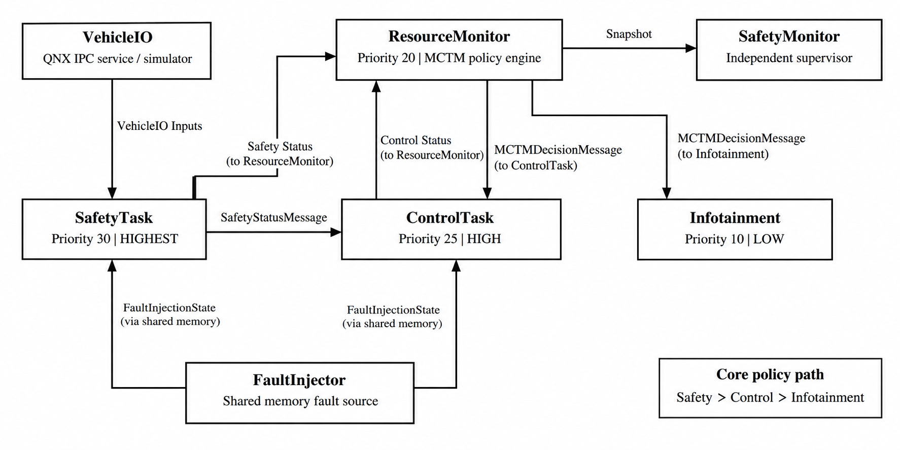
Figure 1. End-to-end MCTM architecture and QNX communication boundaries.
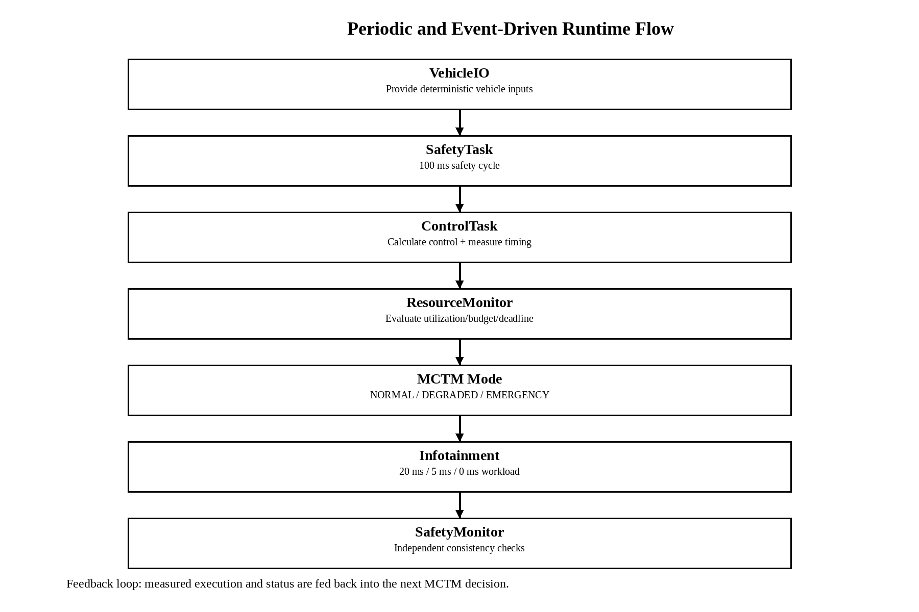
Figure 2. Runtime execution flow from vehicle input through MCTM decision and low-criticality adaptation.
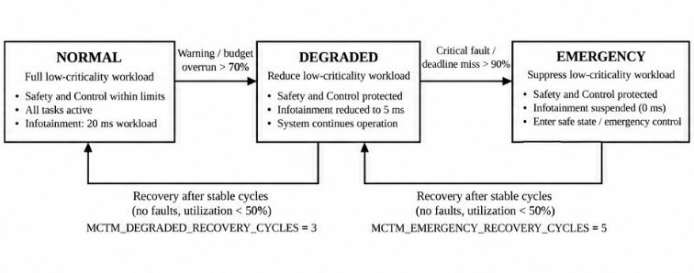
Figure 3. MCTM operating-state logic and recovery policy.
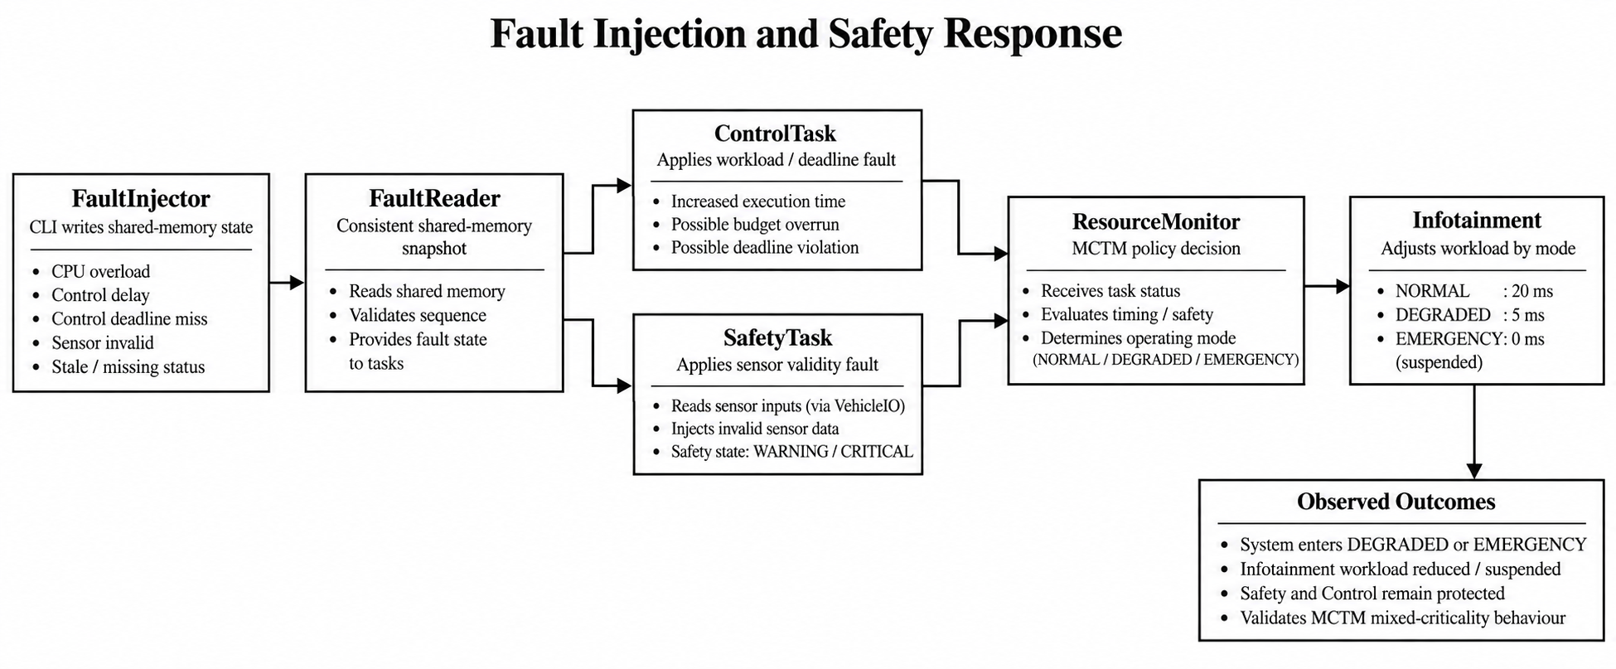
Figure 4. Fault-injection path and resulting mixed-criticality response.

5. System Requirements and Design Rationale
The architecture was chosen so that the criticality hierarchy is explicit in the code and visible at runtime. SafetyTask is assigned the highest priority, ControlTask a lower but still high priority, ResourceMonitor a monitoring priority, SafetyMonitor a supervisory priority, and Infotainment the lowest workload priority. This does not by itself create a certified mixed-criticality scheduler; instead, the project combines QNX scheduling primitives with an application-level policy manager that selectively reduces low-criticality demand.
Table 4. Core workload configuration
Workload | Criticality | QNX priority | Period | Budget | Deadline | Runtime behavior
SafetyTask | HIGHEST | 30 | 100 ms | 20 ms | 100 ms | Periodic safety evaluation
ControlTask | HIGH | 25 / 10 under SCHED_SPORADIC | 50 ms | 10 ms | 50 ms | Real-time control + injected workload
ResourceMonitor | MONITOR | 20 | Event-driven | - | - | Policy evaluation
SafetyMonitor | SUPERVISOR | 15 | 100 ms supervisor check | - | - | Stale-data and consistency checks
Infotainment | LOW | 10 | 100 ms | 30 ms configured | 100 ms | 20 ms normal, 5 ms degraded, 0 ms emergency

6. Repository and Code Organization
The repository uses one directory per runtime component plus shared headers and helper scripts. Each component has its own Makefile and defaults to the QNX AArch64 little-endian debug configuration. The root Makefile builds all components in a fixed order by recursively invoking each component Makefile.
MCTM_final_repo/
├── ControlTask/
├── FaultInjector/
├── Infotainment/
├── ResourceMonitor/
├── SafetyMonitor/
├── SafetyTask/
├── TraceViewer/
├── VehicleIO/
├── common/include/
├── docs/
├── scripts/
├── Makefile
└── README.md
Table 5. Source-level responsibilities
Module / file | Primary responsibility
mctm_config.h | Timing, priorities, thresholds, fault IDs, timeouts and task IDs
mctm_types.h | Criticality, safety state, control state and MCTM operating modes
mctm_messages.h | QNX IPC message contracts and consolidated telemetry snapshot
SafetyTask.c | Highest-criticality periodic safety loop; VehicleIO client; safety evaluation; status publication
ControlTask.c | SCHED_SPORADIC control loop; workload, execution-time, budget and deadline monitoring
ResourceMonitor.c | MCTM decision engine; utilization calculation; decision propagation; snapshots/JSON
SafetyMonitor.c | Independent supervisory process; stale data and consistency checks
Infotainment.c | Low-criticality worker with dynamic workload reduction/suppression
VehicleIO.c | Deterministic vehicle-I/O simulator implementing the message contract
FaultInjector.c / fault_reader.h | Repeatable shared-memory fault injection
SchedulingLogger.c | Shared CSV trace writer for application-level scheduling evidence
TraceViewer.c | Offline CLI summarization of schedule_trace.csv
mctm_dashboard.h | Consistent terminal formatting only; no control logic

7. Detailed End-to-End Software Design

7.1 SafetyTask
SafetyTask is the top of the criticality hierarchy. It registers a QNX channel, connects to VehicleIO, ControlTask and ResourceMonitor, creates a periodic timer, and executes one safety cycle every 100 ms. The cycle reads VehicleIoInputs, evaluates the safety state, applies the safety output state to VehicleIO, measures execution time with CLOCK_MONOTONIC, evaluates its 20 ms budget and 100 ms deadline, and publishes a SafetyStatusMessage.
The safety evaluator includes ultrasonic validity/debouncing and IR proximity handling. A critical ultrasonic distance maps to a critical safety state, while warning distance or proximity conditions cause a warning state. The message also carries the sampled vehicle values and execution timing so downstream processes can use the same observation without directly accessing hardware.
A bounded TimerTimeout() surrounds outbound status sends. This matters because a high-criticality task should not wait indefinitely for a peer process. QNX documents TimerTimeout() as a thread-local timeout mechanism for kernel blocking states.[10] In this project, the timeout is 5 ms for safety status sends.

7.2 ControlTask
ControlTask is the high-criticality controller. It configures the calling thread with QNX SCHED_SPORADIC and explicitly sets a high priority of 25, a low priority of 10, a 10 ms initial budget, a 50 ms replenishment period and a maximum of four replenishments. After calling SchedSet(), the code immediately calls SchedGet() and verifies the returned policy and timing parameters. QNX documents SCHED_SPORADIC as a policy used to cap execution time within a period.[6][7]
High priority = 25
Low priority = 10
Initial budget = 10 ms
Replenish = 50 ms
Max repl. = 4
Deadline = 50 ms
ControlTask receives SafetyStatusMessage and MCTMDecisionMessage on its QNX channel. It calculates target speed, throttle and brake, then executes a deterministic workload. Normal workload is approximately 5 ms; pressure workload is 8 ms; fault injection can override the workload to values such as 12 ms, 25 ms or 60 ms. After execution, ControlTask measures elapsed time and records deadline/budget status in ControlStatusMessage.

7.3 ResourceMonitor
ResourceMonitor is the MCTM policy engine. It stores the latest SafetyTask and ControlTask snapshots, calculates task execution utilization, evaluates budget/deadline/safety-state conditions, and produces the MCTMDecisionMessage. Utilization is calculated as execution time divided by the task period; it is therefore a task execution-utilization metric and should not be described as whole-system CPU utilization.
The decision policy is intentionally simple and auditable. Emergency conditions include a critical safety state, a safety or control deadline miss, or task utilization at or above 90 percent. Degraded conditions include warning state, budget overrun, or utilization at or above 70 percent. When none of those conditions is active, the mode is NORMAL. A separate policy-change check prevents redundant policy commands when only the reporting cycle changes.
ResourceMonitor also creates a consolidated snapshot for SafetyMonitor, pushes decisions to ControlTask and Infotainment, writes a JSON dashboard file and optionally provides telemetry data. The current terminal formatter is intentionally separate from policy logic, so improving presentation output does not change scheduling behavior.

7.4 Infotainment
Infotainment is the low-criticality workload used to demonstrate controlled degradation. It has an IPC thread for policy updates and a workload thread that performs deterministic CPU work. The workload is approximately 20 ms in NORMAL, 5 ms in DEGRADED and 0 ms in EMERGENCY. This is the most direct implementation of the requirement that non-critical work be degraded before critical work is sacrificed.

7.5 SafetyMonitor
SafetyMonitor is an independent supervisory layer. It receives ResourceMonitor snapshots and runs a 100 ms supervisor thread that checks snapshot age, SafetyTask age and ControlTask age. It also validates message size/type, cycle monotonicity and logical consistency between timing flags and measured execution. It is not the MCTM policy decision-maker; its role is observation, diagnostics and evidence of system health.
QNX documents a High Availability Manager (HAM) that can monitor processes, heartbeat them and trigger multistage recovery.[8][9] This project does not instantiate HAM. Instead, SafetyMonitor demonstrates the same engineering direction at application level: explicit health criteria, periodic supervision and isolated responsibility. A production design can combine application-level diagnostics with QNX HA features where appropriate.

7.6 VehicleIO
VehicleIO is implemented as a deterministic QNX IPC service. SafetyTask connects to the named service and requests VehicleIoInputs. The repository deliberately keeps GPIO/CAN access outside SafetyTask. This is an abstraction boundary: sensor acquisition is a service, and the critical task consumes a stable message contract.
The bench photographs show a Raspberry Pi-based prototype with ultrasonic hardware and discrete indicator LEDs. Those photographs are included as physical integration evidence. However, the checked-in VehicleIO implementation is a simulator, so the documentation does not claim that the current repository is already a production CAN/GPIO driver stack.

7.7 FaultInjector and FaultReader
FaultInjector is a CLI process that writes a FaultInjectionState into /mctm_fault_injector. The writer updates a sequence value around the shared-state write so readers can reject in-progress or inconsistent snapshots. FaultReader maps the object read-only and performs a stable-snapshot read. QNX documents shm_open() for opening shared memory objects and mmap() for mapping the object into a process address space.[11][12]
Supported scenarios include CPU overload, control delay, control deadline, stale status, missing status, sensor invalid, infotainment load and a specific 25 ms control workload. These are useful because they convert otherwise difficult-to-reproduce timing faults into repeatable, named test cases.

7.8 Scheduling Logger and TraceViewer
SafetyTask, ControlTask and Infotainment contribute application-level scheduling records to /tmp/schedule_trace.csv. TraceViewer sorts the records by timestamp, computes per-task completed executions, average and maximum execution, deadline misses and budget overruns, and reports counts of records carrying each MCTM mode. It deliberately does not infer global mode transitions from adjacent per-task snapshots, because different tasks can report at different times.

8. IPC Design and Message Flow
QNX message passing is the backbone of the project. QNX describes MsgSend(), MsgReceive() and MsgReply() as a synchronous Send/Receive/Reply model: the sender can block until the receiver replies, and the receiver blocks when no message is available.[2][13][14] The project uses named services so that PIDs and channel IDs do not have to be hard-coded into the application logic.
Table 6. IPC communication matrix
Sender | Receiver | Message / purpose | Direction
VehicleIO | SafetyTask | VehicleIoInputs request/reply | Input service
SafetyTask | ControlTask | SafetyStatusMessage | Status
SafetyTask | ResourceMonitor | SafetyStatusMessage | Status
ControlTask | ResourceMonitor | ControlStatusMessage | Status
ResourceMonitor | ControlTask | MCTMDecisionMessage | Policy
ResourceMonitor | Infotainment | MCTMDecisionMessage | Policy
ResourceMonitor | SafetyMonitor | SafetyMonitorSnapshot | Supervision
FaultInjector | ControlTask / SafetyTask | FaultInjectionState via shared memory | Fault state
ResourceMonitor | Telemetry / dashboard interface | HyperSafe telemetry / JSON snapshot | Observation
The communication pattern can be summarized as “status upward, policy downward.” SafetyTask and ControlTask publish observations upward to ResourceMonitor; ResourceMonitor publishes policy downward to ControlTask and Infotainment; SafetyMonitor receives a consolidated snapshot rather than participating in the core control loop. This separation keeps the policy engine and the independent supervisor conceptually distinct.

9. Real-Time Scheduling and Timing Design
The scheduling design combines periodic release, explicit priorities, SCHED_SPORADIC budgeting, execution-time measurement and deadline/budget classification. SafetyTask uses a periodic timer to trigger 100 ms cycles. ControlTask is governed by QNX SCHED_SPORADIC. SafetyMonitor uses a 100 ms supervisor thread. Infotainment executes its periodic workload according to the current MCTM mode.
QNX documentation states that SCHED_FIFO runs the highest-priority ready thread until it blocks or is preempted, while SCHED_SPORADIC is intended to provide a capped limit on execution time within a given period.[6][7] This is why the project uses SCHED_SPORADIC for ControlTask instead of simply relying on a fixed-priority loop.
The timing measurement uses CLOCK_MONOTONIC. QNX documents CLOCK_MONOTONIC as a continuously increasing clock that is not adjusted, and the documentation also describes CPU-time clocks for measuring actual CPU execution time.[15] The project currently uses monotonic elapsed time around the workload, which is appropriate for execution-interval measurement but should not be confused with per-thread CPU time.

10. Fault-Injection Scenarios
Table 7. Fault scenarios supported by the implementation
Fault | Injected condition | Expected observation
CPU_OVERLOAD | 12 ms control workload | Budget overrun; typically DEGRADED while deadline remains satisfied
CONTROL_DELAY | 20 ms delay | Control execution rises; budget overrun and DEGRADED response can occur
CONTROL_DEADLINE | 60 ms control workload | Budget overrun + deadline miss; MCTM transitions to EMERGENCY
STALE_STATUS | Control cycle stops advancing | SafetyMonitor / ResourceMonitor can detect stale data
MISSING_STATUS | Control status publication suppressed | Peer freshness timeout / loss of status
SENSOR_INVALID | Synthetic invalid sensor flag | Safety warning / brake-anomaly path and DEGRADED response
INFOTAINMENT_LOAD | 20 ms low-criticality workload | Demonstrates low-criticality load path
CONTROL_25MS | 25 ms control workload | Budget overrun while remaining below 50 ms deadline

10.1 Why 25 ms and 60 ms are different tests
ControlTask has a 10 ms budget and a 50 ms deadline. Therefore, a 25 ms injected workload is 2.5 times the budget but still below the deadline. The expected classification is “budget overrun” without a deadline miss. A 60 ms workload exceeds both the 10 ms budget and 50 ms deadline, so it should trigger an emergency-level response. This distinction is important because a budget overrun and a deadline miss are not interchangeable metrics.

11. Results and Evidence
The supplied evidence package contains QNX terminal captures, fault-injector outputs, SafetyMonitor/ResourceMonitor startup outputs, ControlTask scheduler verification, hardware bench photographs, and QNX System Profiler screenshots. The strongest result is the control-deadline scenario: the terminal evidence shows execution around 60.06 ms, DEADLINE=MISS, BUDGET=OVERRUN, MCTM=EMERGENCY, target speed 0 km/h, throttle 0 percent and brake 100 percent.
Table 8. Selected observed results from the supplied evidence
Scenario / trace | Observed result | Interpretation
QNX System Profiler trace 1 | 4.999 s; 253,567 events; 4 CPUs; 0 dropped buffers; ControlTask running 1.256 s; blocked 3.737 s | Valid kernel trace with substantial ControlTask scheduling activity
Alternate QNX System Profiler trace | 4.999 s; 194,499 events; 4 CPUs; 0 dropped buffers; Infotainment 940.159 ms running; VehicleIO 481.160 ms; ControlTask 263.977 ms | Runtime activity across multiple application processes
CPU_OVERLOAD | Control execution about 12.08 ms; DEADLINE=OK; BUDGET=OVERRUN; MCTM=DEGRADED | Budget-based degradation
CONTROL_DELAY | Control execution about 28.78 ms; DEADLINE=OK; BUDGET=OVERRUN; MCTM=DEGRADED | Delay fault produces degraded operation
CONTROL_DEADLINE | Control execution about 60.06 ms; DEADLINE=MISS; BUDGET=OVERRUN; MCTM=EMERGENCY; brake=100% | Deadline fault triggers emergency response
SENSOR_INVALID | Safety=WARNING; SafetyReason=BRAKE_ANOMALY; MCTM=DEGRADED; Control=CAUTION | Sensor fault propagates into safety and control adaptation

11.1 Primary QNX System Profiler Evidence
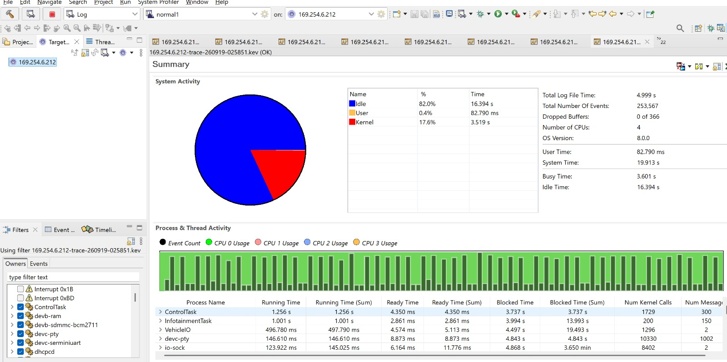
Figure 5. QNX System Profiler summary for the recorded 4.999 s kernel-event trace; four CPUs and zero dropped buffers.
The first System Profiler result is useful because it demonstrates that the project was observed at the kernel-event level rather than only through printf output. QNX explains that the System Profiler displays kernel event trace data, including process/thread activity, timing and event statistics.[3][16] The screenshot shows 253,567 events, a 4.999 s trace, four CPUs and zero dropped buffers. ControlTask has 1.256 s of running time and 3.737 s of blocked time in the shown summary. The trace should be interpreted as runtime activity evidence, not as proof of a particular safety certification claim.
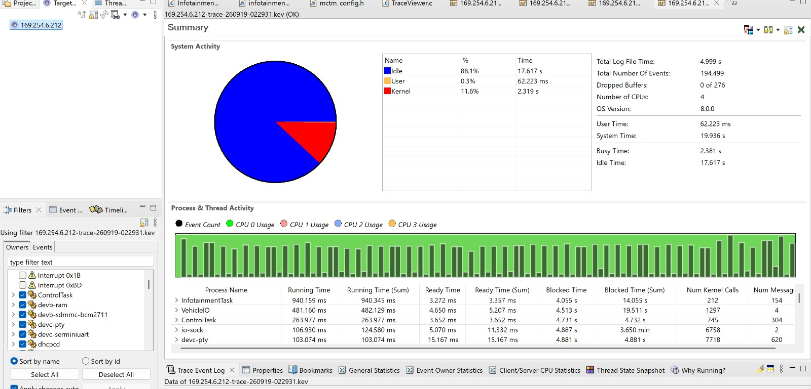
Figure 6. Second QNX System Profiler summary with multi-process activity across Infotainment, VehicleIO and ControlTask.
The second trace provides complementary evidence that several project processes are simultaneously active. The screenshot shows 4.999 s of trace time, 194,499 events, four CPUs and zero dropped buffers. The process table records approximately 940 ms of Infotainment running time, 481 ms of VehicleIO running time and 264 ms of ControlTask running time in that capture.

11.2 Normal Operation and Service Bring-Up
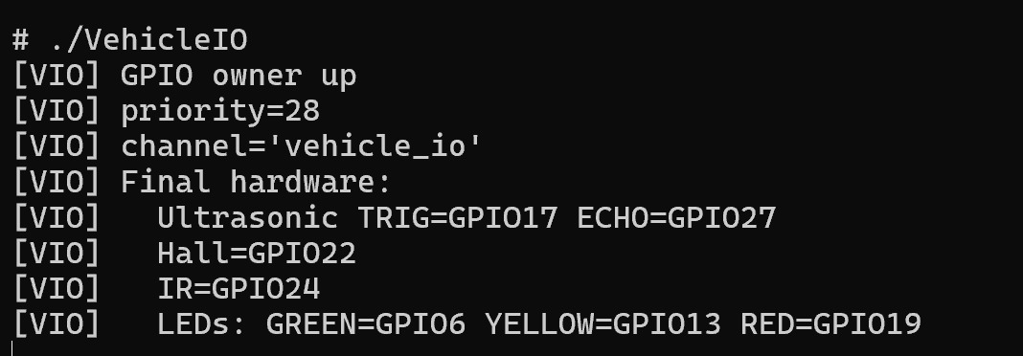
Figure 7. VehicleIO startup evidence.
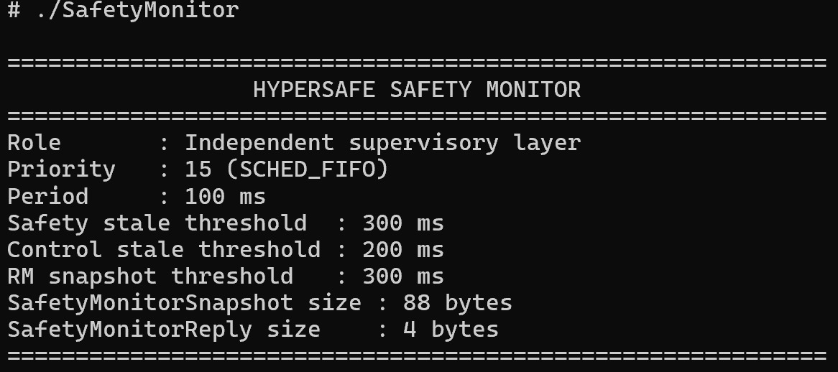
Figure 8. SafetyMonitor startup evidence.
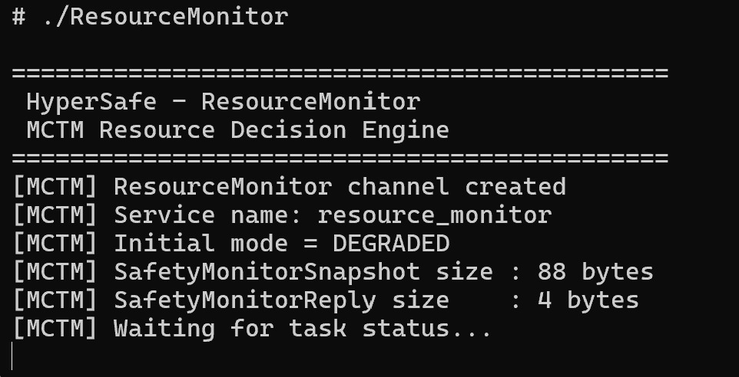
Figure 9. ResourceMonitor startup evidence.
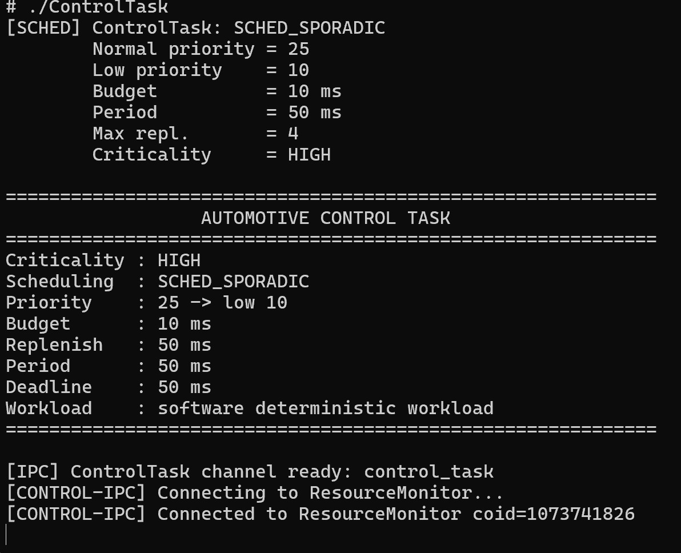
Figure 10. ControlTask scheduling configuration and verification.
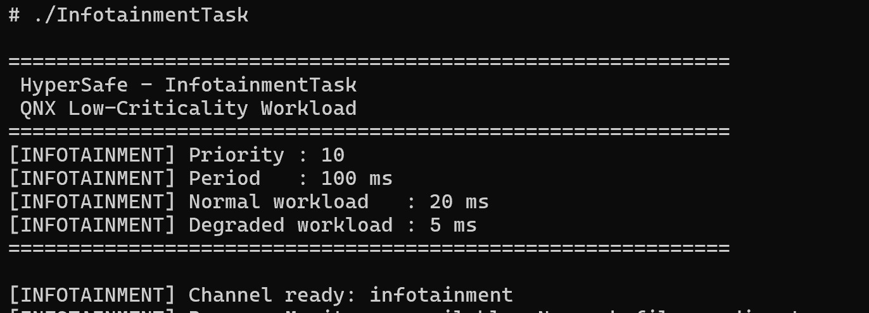
Figure 11. InfotainmentTask startup evidence.
The bring-up evidence supports the fixed seven-process runtime order documented in scripts/run_order.txt: ResourceMonitor, SafetyMonitor, VehicleIO, SafetyTask, ControlTask, Infotainment, and finally FaultInjector when a test is required.

11.3 Fault and Mode-Transition Evidence
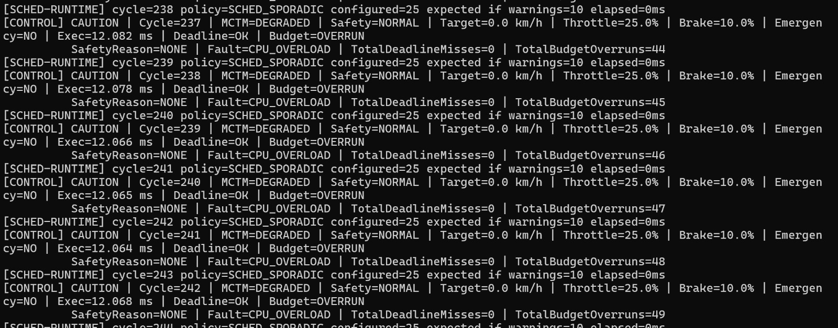
Figure 12. CPU_OVERLOAD response: ControlTask budget overrun with deadline still satisfied and MCTM in DEGRADED mode.
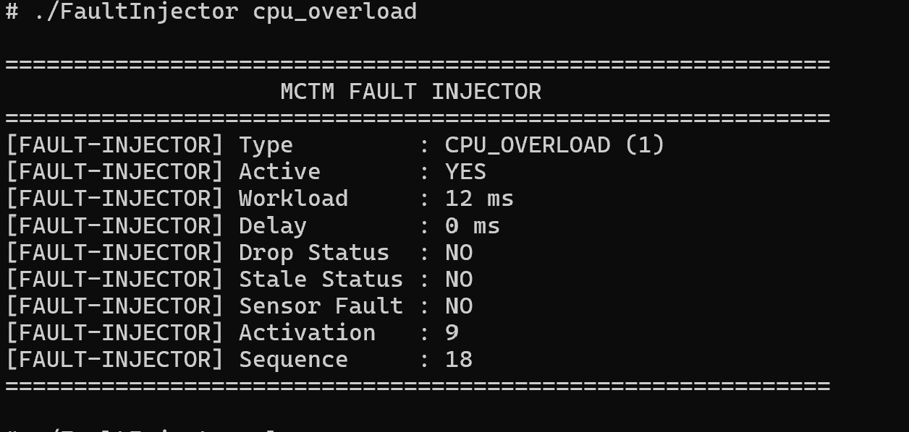
Figure 13. FaultInjector CPU_OVERLOAD configuration.
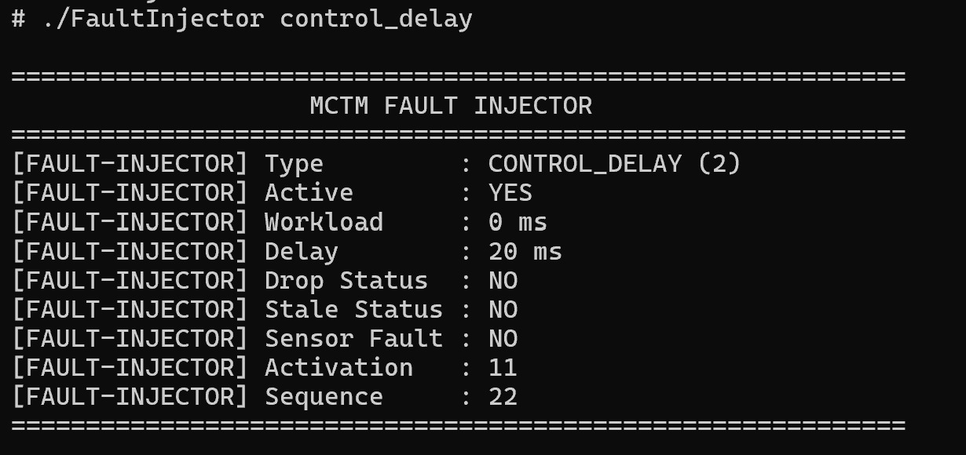
Figure 14. FaultInjector CONTROL_DELAY configuration.
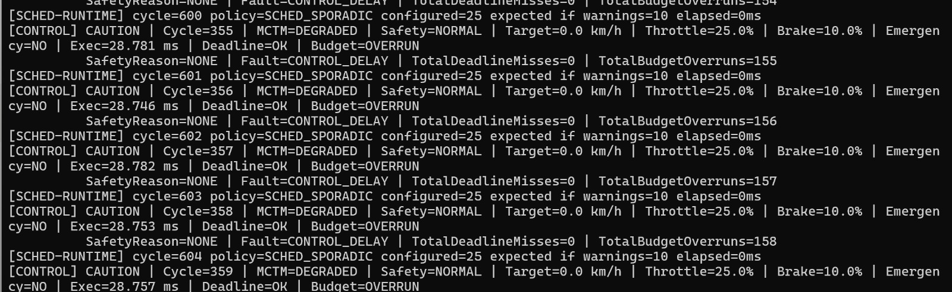
Figure 15. CONTROL_DELAY response: DEGRADED mode with CONTROL CAUTION and budget overrun.
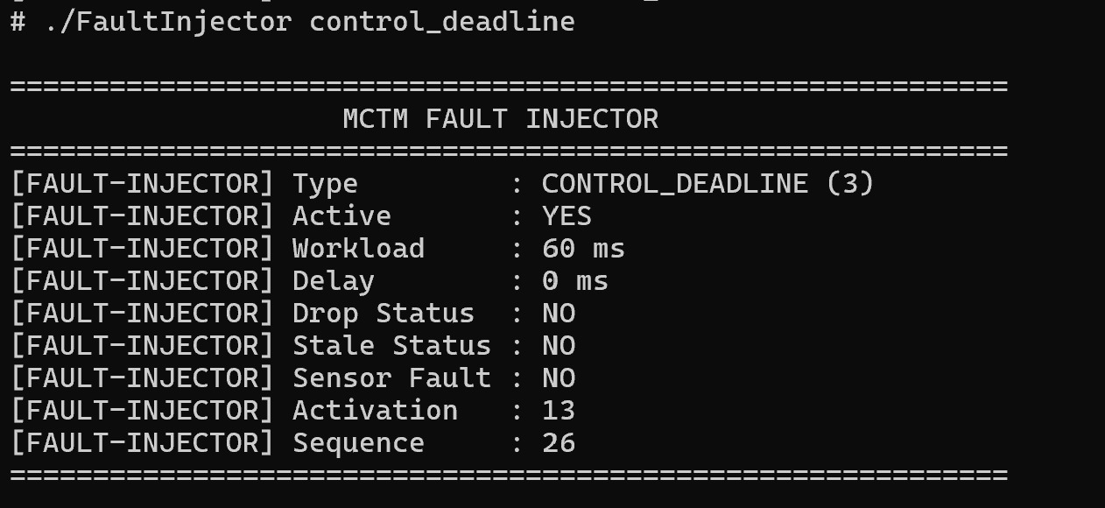
Figure 16. FaultInjector CONTROL_DEADLINE configuration.
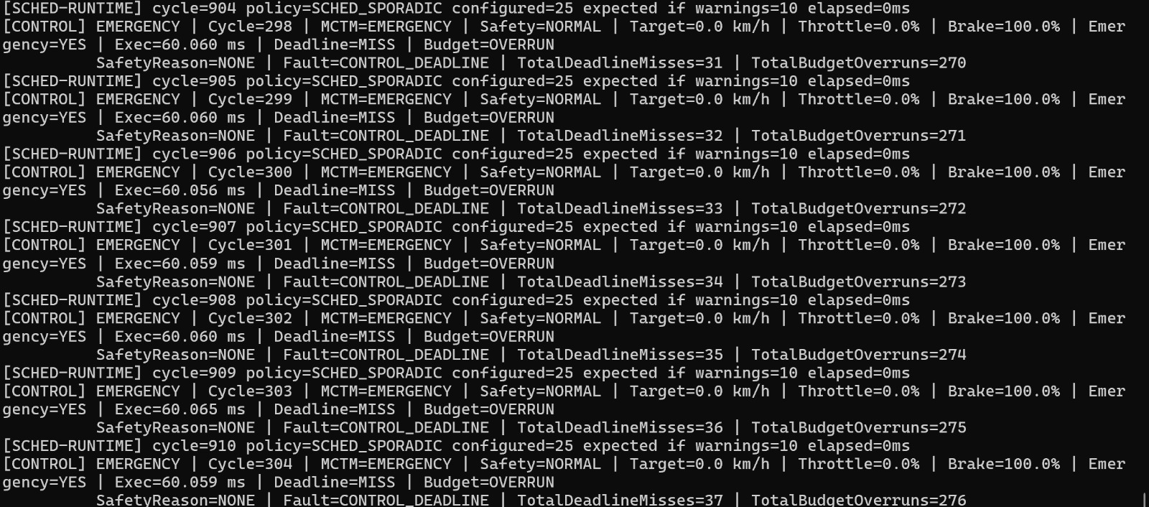
Figure 17. CONTROL_DEADLINE response: deadline miss, budget overrun and EMERGENCY control behavior.
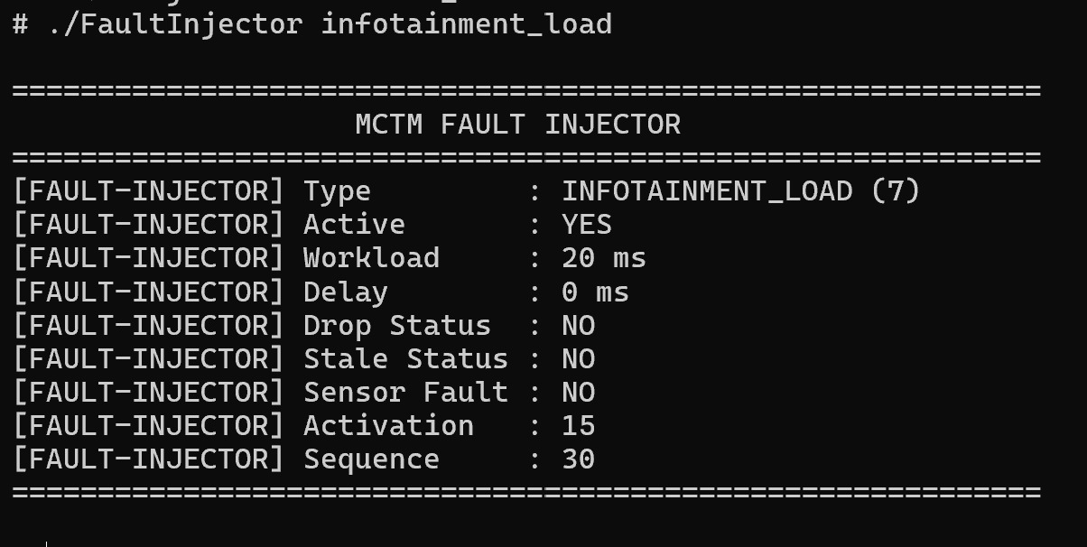
Figure 18. FaultInjector INFOTAINMENT_LOAD configuration.
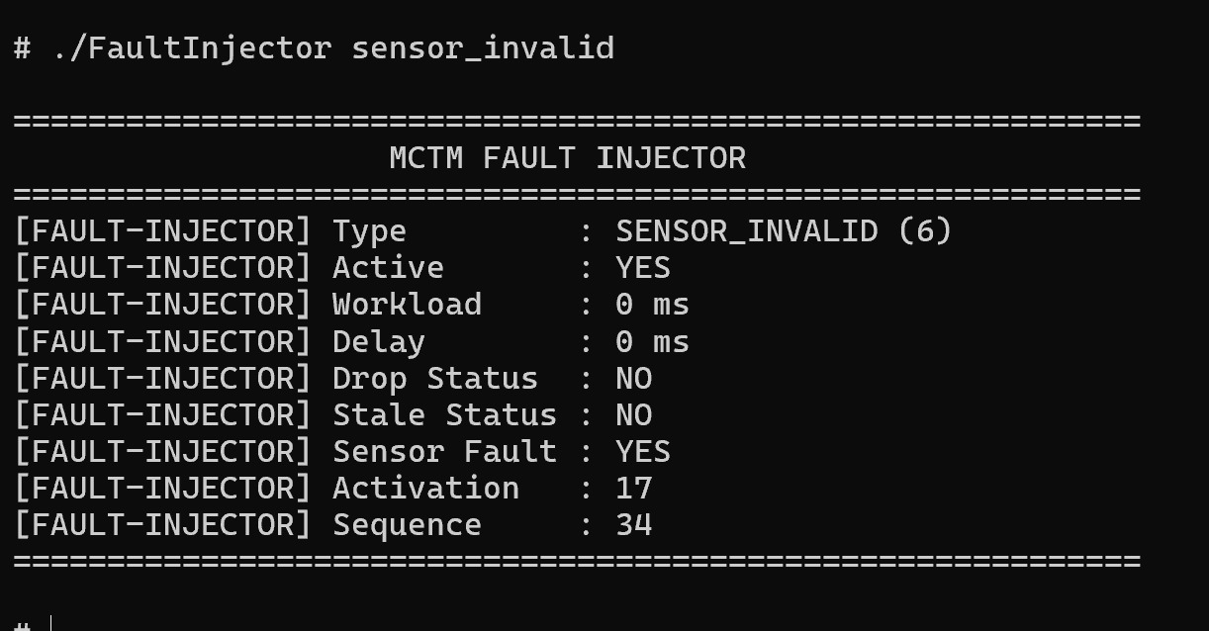
Figure 19. FaultInjector SENSOR_INVALID configuration.
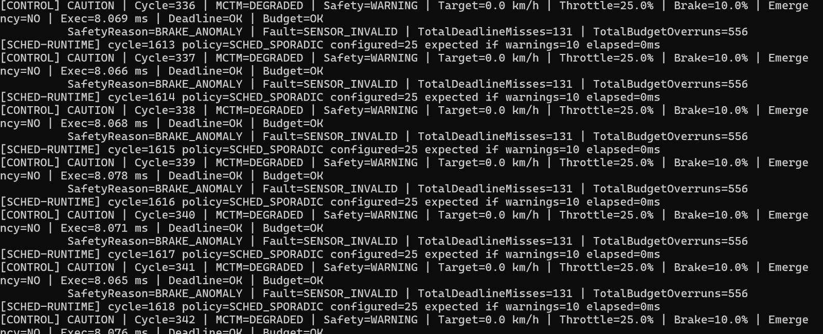
Figure 20. SENSOR_INVALID response: WARNING safety state, BRAKE_ANOMALY reason and DEGRADED MCTM mode.
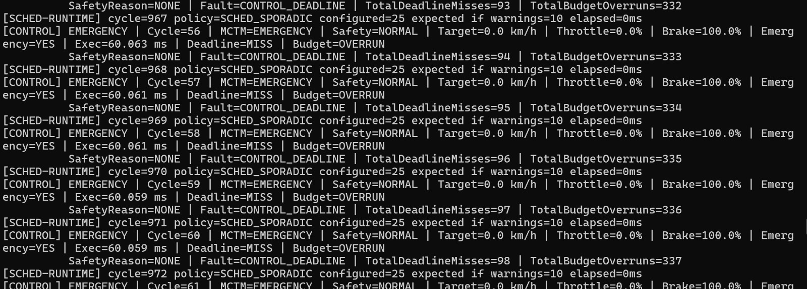
Figure 21. Extended CONTROL_DEADLINE evidence showing sustained EMERGENCY operation.
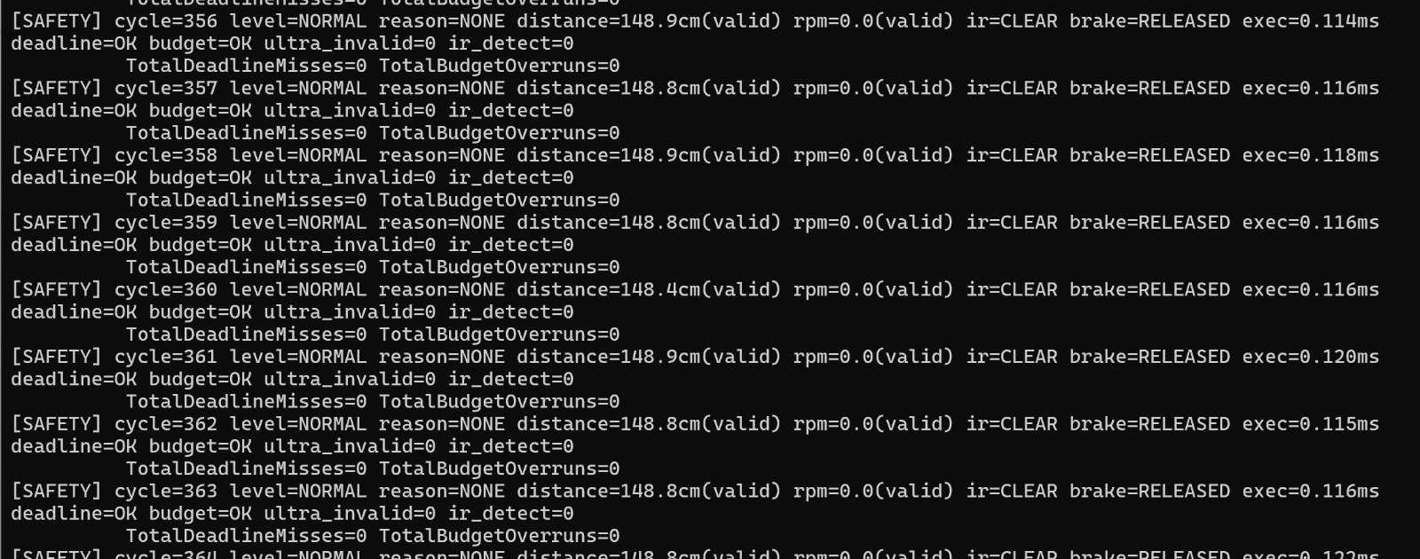
Figure 22. SafetyTask normal-operation evidence with no deadline misses or budget overruns.
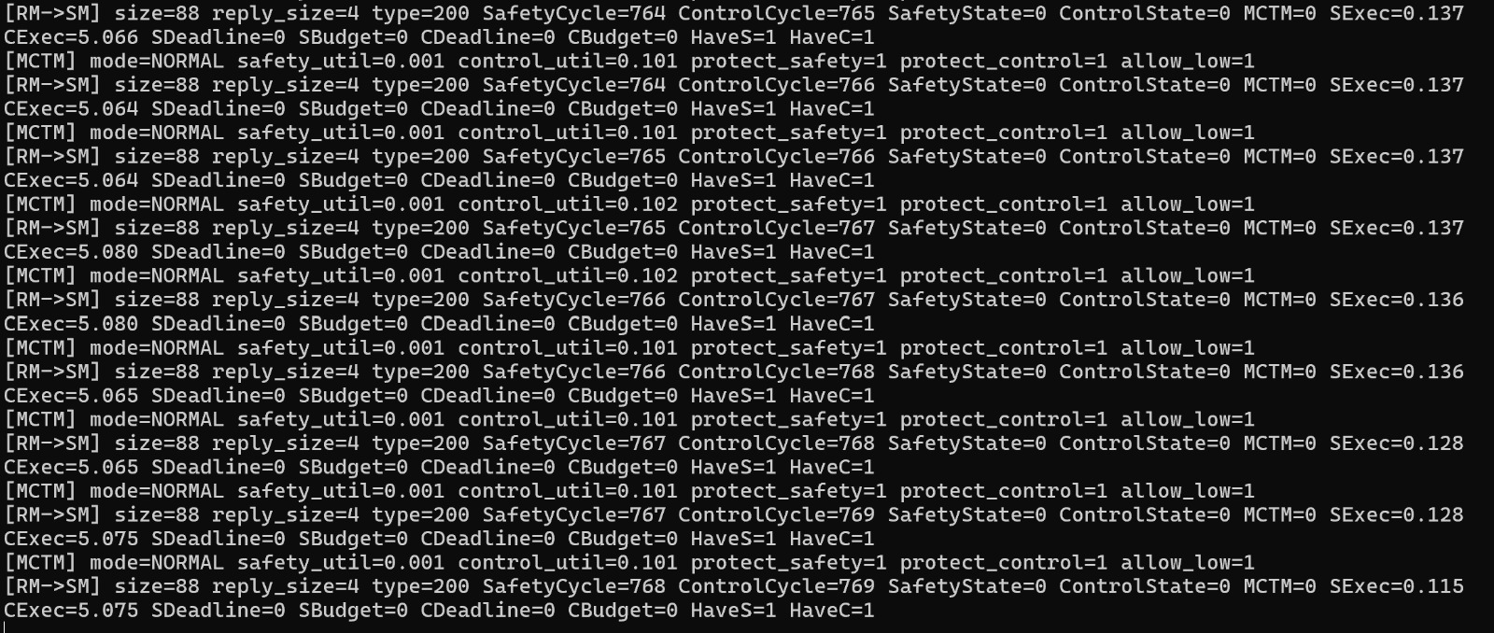
Figure 23. ResourceMonitor consolidated status output in NORMAL mode.

11.4 Physical Prototype Evidence
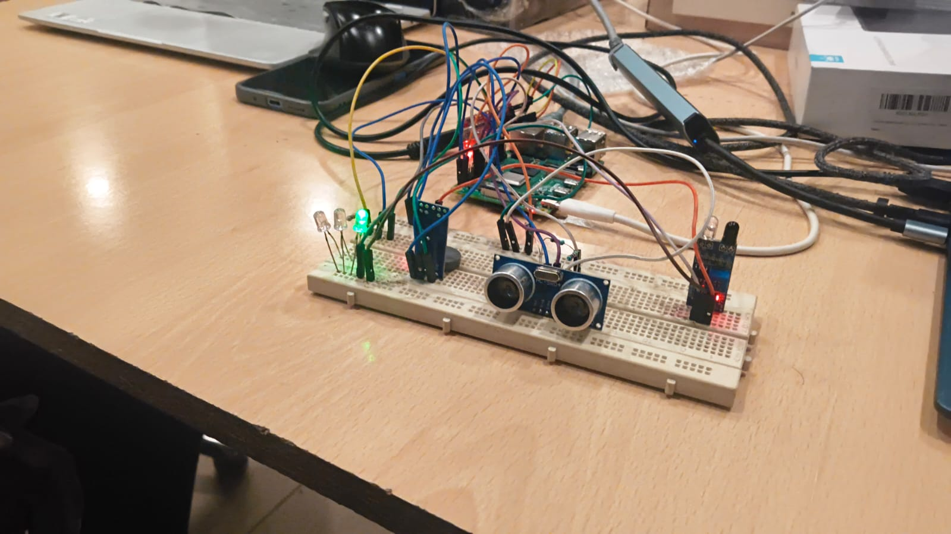
Figure 24. Raspberry Pi and breadboard prototype with ultrasonic sensor and status LEDs.
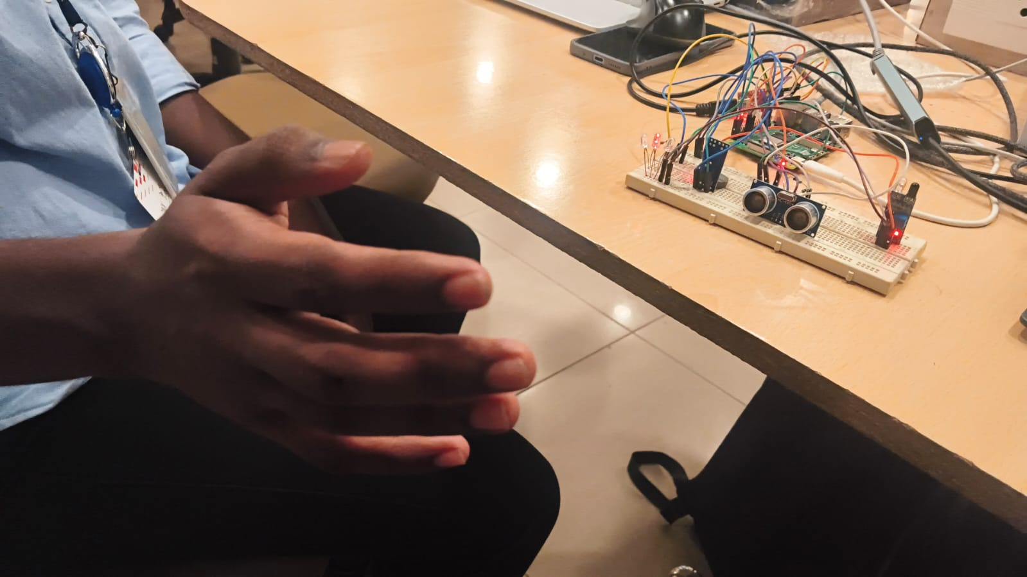
Figure 25. Prototype bench view during system interaction.
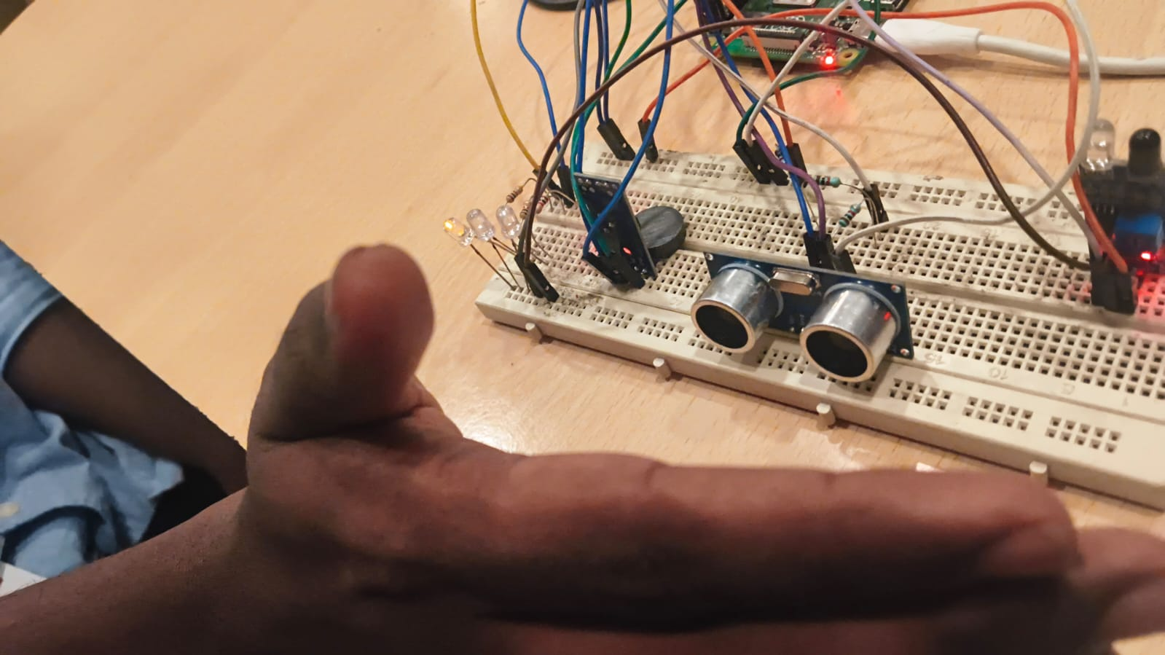
Figure 26. Close-up of ultrasonic sensing hardware and LED indicators.
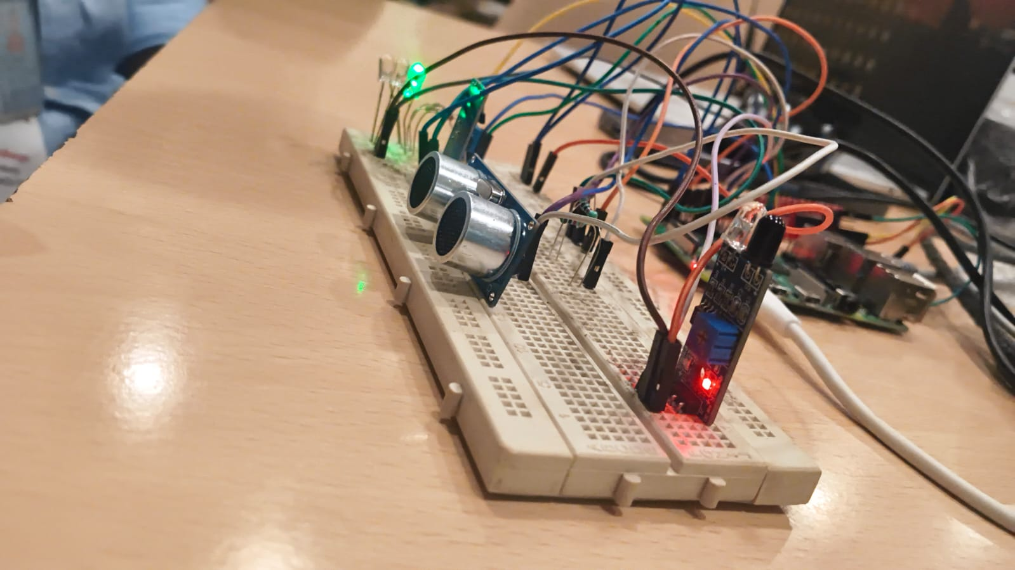
Figure 27. Angled prototype view with active indicator LEDs.
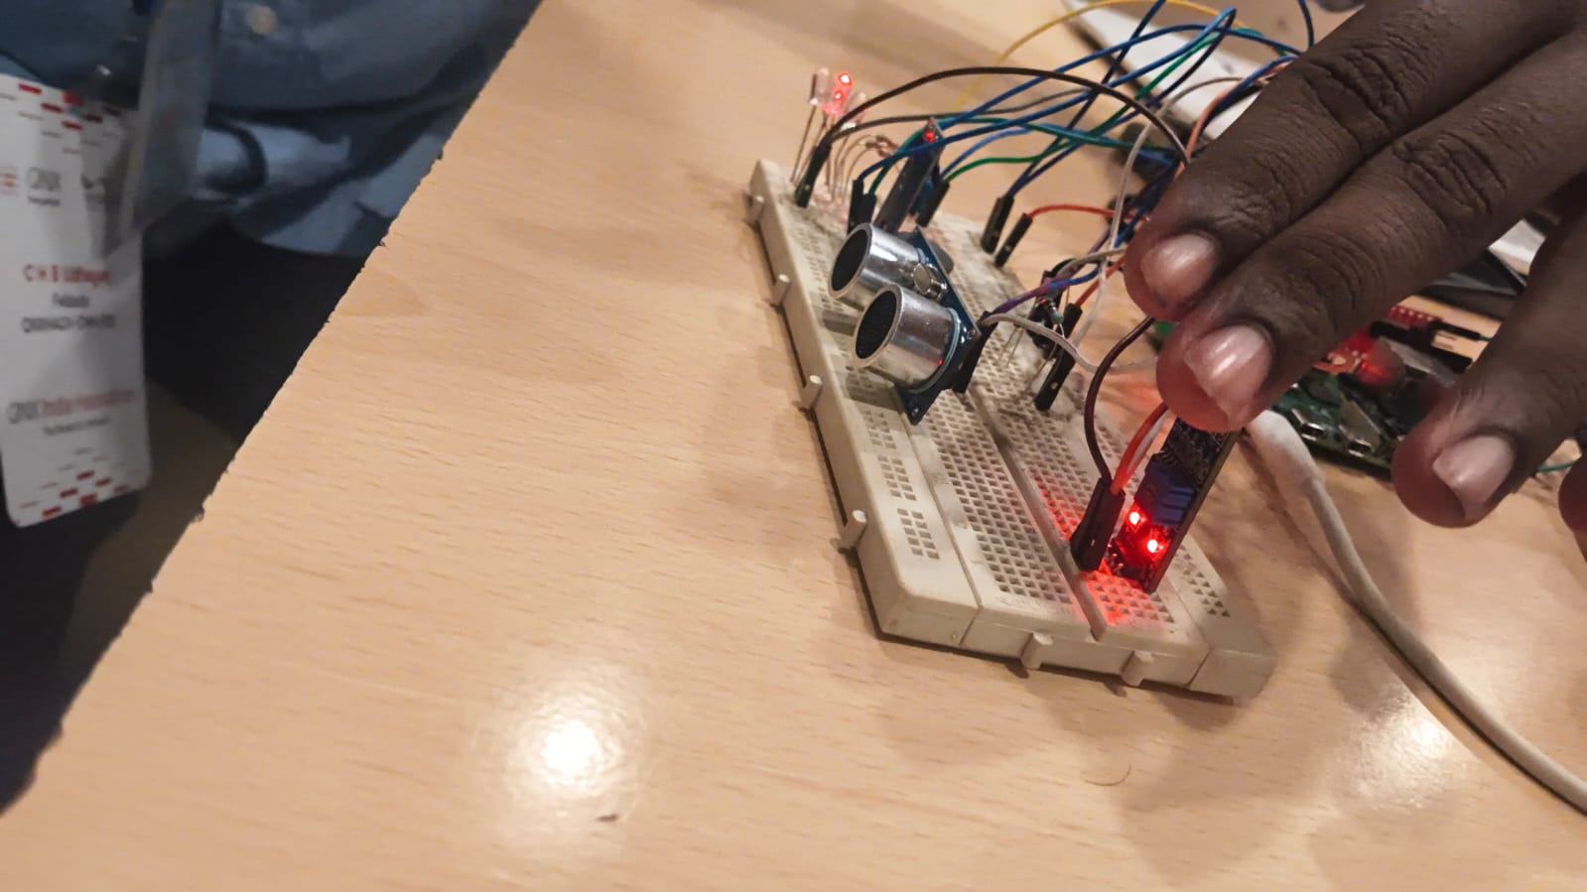
Figure 28. Prototype interaction view showing sensor, indicators and Raspberry Pi hardware.

12. Verification and Test Strategy
The project uses complementary verification layers. First, each module prints deterministic configuration and state information. Second, the application-level scheduling logger records execution and timing outcomes. Third, QNX tracelogger and System Profiler provide kernel-event evidence. Fourth, the FaultInjector provides repeatable negative testing. The combination is stronger than any one source of evidence because it lets a reviewer connect the injected stimulus, the task-level observation and the kernel-level behavior.
Table 9. Verification matrix
Test | Stimulus / procedure | Expected | Evidence
T01 Normal start | Start all seven processes in documented order | All named channels created; normal mode reached | Figures 7–11 and terminal outputs
T02 Scheduler verification | Start ControlTask | SCHED_SPORADIC policy and parameters accepted | Figure 10
T03 CPU overload | FaultInjector cpu_overload | Control budget overrun; MCTM DEGRADED; deadline still OK | Figures 12–13
T04 Control delay | FaultInjector control_delay | Control execution increases; degraded behavior visible | Figures 14–15
T05 Control deadline | FaultInjector control_deadline | Deadline miss + budget overrun; MCTM EMERGENCY; brake command active | Figures 16–17, 21
T06 Sensor fault | FaultInjector sensor_invalid | Safety WARNING / control CAUTION / MCTM DEGRADED | Figures 19–20
T07 Low-criticality load | FaultInjector infotainment_load | Infotainment load is controllable by MCTM | Figure 18 + Infotainment terminal
T08 Kernel trace | Run tracelogger during workload/fault | .kev opens in System Profiler with process/thread timing data | Figures 5–6
T09 Supervisor monitoring | Allow periodic snapshots and/or stale data | SafetyMonitor detects age/consistency issues | SafetyMonitor terminal evidence
T10 CSV trace | Inspect /tmp/schedule_trace.csv with TraceViewer | Per-task execution/deadline/budget summary | TraceViewer output

13. Application-Level Timing Interpretation
A useful way to read the results is to distinguish three related but different quantities: execution time, budget and deadline. Execution time is the measured duration of a workload instance. Budget is the preferred or allowed execution amount for the task period. Deadline is the maximum time by which the workload instance must complete. A workload can exceed its budget without missing its deadline; the 25 ms ControlTask test is the intended example. The 60 ms test exceeds both.
Table 10. ControlTask timing interpretation
Scenario | Execution | Budget (10 ms) | Deadline (50 ms) | Expected MCTM impact
Normal | ~5 ms | Within budget | Within deadline | NORMAL
Pressure | ~8 ms | Within budget | Within deadline | Pressure remains manageable
CPU_OVERLOAD | ~12 ms | Overrun | Within deadline | DEGRADED
CONTROL_25MS | ~25 ms | Overrun | Within deadline | DEGRADED
CONTROL_DEADLINE | ~60 ms | Overrun | Miss | EMERGENCY

14. Industry-Aligned QNX Engineering Practice
QNX documentation presents a microkernel/process architecture in which individual processes communicate using IPC and are isolated by virtual memory. It also provides fixed-priority scheduling, message passing, timers, shared memory, tracing and a High Availability Framework.[1][8][9] These primitives map well to common production embedded-systems engineering goals: isolate responsibilities, keep critical services small and observable, make timing assumptions explicit, bound blocking calls, and collect runtime evidence.
A production automotive program would typically add several layers beyond this project. Requirements would be traceable from system goals to software safety requirements and verification cases; safety mechanisms would be reviewed under the applicable functional-safety lifecycle; interfaces would be versioned and tested; resource budgets would be derived from schedulability analysis rather than chosen only for demonstration; and hardware access would use qualified drivers and deterministic I/O paths. For safety-certified QNX products, QNX provides separate safety documentation and certification evidence; the existence of those products must not be confused with the status of this academic prototype.
The strongest company-style engineering pattern already visible in this project is the separation of concerns: SafetyTask owns safety evaluation, ControlTask owns control calculation, ResourceMonitor owns MCTM policy, SafetyMonitor owns independent observation, and VehicleIO owns the I/O boundary. This makes failures easier to localize and gives the test plan a clear mapping from stimulus to responsible component.
Table 11. Prototype practice versus production-oriented practice
Area | Current project | Production-oriented extension
IPC | QNX named channels + MsgSend/Receive/Reply | Versioned interface contracts, error policy, fault containment and timing budgets
Scheduling | Explicit priorities and SCHED_SPORADIC | Schedulability analysis, WCET evidence, priority/inversion analysis
Fault handling | Software FaultInjector and SafetyMonitor | Systematic fault injection, watchdog/HAM strategy, recovery state machine
Vehicle I/O | Deterministic simulator | Production CAN/UART/GPIO/resource-manager drivers
Tracing | .kev + CSV | Automated performance regression and trace-based acceptance tests
Safety evidence | Terminal output + figures | Requirements-to-test traceability and formal safety evidence
Functional safety | Architectural demonstration only | Separate safety lifecycle, safety plan, analysis and certification evidence

15. Limitations and Scope Boundaries
- The checked-in VehicleIO implementation is a deterministic simulator. The hardware photographs demonstrate a prototype bench, but physical CAN/UART/GPIO driver integration is not represented by the current repository source.
- The MCTM utilization metric is task execution time divided by task period. It should not be presented as whole-processor utilization.
- The project uses application-level SafetyMonitor supervision and does not instantiate QNX High Availability Manager (HAM).
- The project is an academic prototype and is not an ISO 26262 safety-certified product.
- The current evidence package demonstrates overload, delay, deadline and sensor-fault behavior; a formal WCET campaign and exhaustive schedulability proof are outside this scope.

16. Build and Deployment Procedure
The root Makefile recursively builds the eight repository components using qcc with the QNX AArch64 little-endian compiler variant. The default build profile is aarch64le-debug.
./scripts/build_all.sh
# or
make -C ControlTask
make -C ResourceMonitor
The runtime order is intentionally fixed so that named channels exist before clients connect. The recommended order is ResourceMonitor, SafetyMonitor, VehicleIO, SafetyTask, ControlTask, Infotainment, and FaultInjector. FaultInjector is a one-shot test utility and should be invoked only when a scenario is being tested.
./FaultInjector/build/aarch64le-debug/FaultInjector clear
./FaultInjector/build/aarch64le-debug/FaultInjector control_25ms
./FaultInjector/build/aarch64le-debug/FaultInjector control_deadline
For kernel tracing, QNX documents tracelogger as the service that receives kernel events and writes them to a .kev file; the IDE System Profiler opens these files for analysis.[16][17] The documentation also recommends running a single tracelogger instance at a time.[17]
tracelogger -f /data/home/mctm_trace.kev

17. Evidence Collection Procedure
For a professional experiment record, capture the test in the same order every time: record baseline terminal output; clear the fault state; start tracelogger; inject the named fault; capture the terminal state change; stop tracing; open the .kev in System Profiler; record the measured execution/deadline/budget values; and archive the trace alongside the test identifier. This produces a reproducible chain from stimulus to result.
The supplied evidence already contains strong examples. The control-deadline test is the clearest single scenario because the terminal output contains the injected 60 ms workload, measured execution around 60.06 ms, deadline miss, budget overrun and MCTM emergency control response. The QNX System Profiler screenshot is then used as independent kernel-event evidence rather than as the sole proof of the policy transition.

18. Discussion of the Most Important Result
The central result is not simply that a fault was detected. The more important result is the policy response: a control timing fault is detected at the workload level, ResourceMonitor changes MCTM policy, and the low-criticality workload is given less or no CPU work while the critical control output moves toward a safe state. In the strongest supplied deadline-fault evidence, ControlTask reports zero target speed, zero throttle, 100 percent brake and EMERGENCY status while the deadline-miss and budget-overrun counters increase.
This is the intended mixed-criticality behavior: the system degrades low-criticality work to preserve higher-criticality behavior. The result should be presented as an architectural demonstration of graceful degradation, not as proof of safety certification or deterministic worst-case latency under all possible loads.

19. Conclusion
HyperSafe implements a coherent QNX-native mixed-criticality task manager built around process separation, synchronous IPC, explicit real-time scheduling, timing measurements, application-level policy decisions, fault injection and kernel-event tracing. The architecture maps directly to the supplied automotive problem statement: SafetyTask represents the highest-criticality workload, ControlTask represents the high-criticality control workload, Infotainment is intentionally expendable under pressure, ResourceMonitor makes the MCTM policy decision, SafetyMonitor independently supervises system health, and FaultInjector makes negative testing repeatable.
The strongest technical evidence is the combination of ControlTask SCHED_SPORADIC verification, CPU-overload and deadline-fault terminal results, the 25 ms and 60 ms timing scenarios, and QNX System Profiler traces showing process-level and kernel-level activity. The remaining work needed for a production-oriented system would center on physical I/O integration, formal worst-case execution-time and schedulability evidence, system-level safety analysis, and an appropriate safety-certified software/hardware lifecycle.

20. QNX Documentation and Function Links
The following official QNX documentation was consulted while preparing this report. Links are listed so each major QNX function or mechanism used by the project can be reviewed directly.
1. QNX OS Architecture and Concepts: https://www.qnx.com/developers/docs/8.0/com.qnx.doc.neutrino.prog/topic/overview.html
2. Interprocess Communication (IPC): https://qnx.com/developers/docs/8.0/com.qnx.doc.neutrino.sys_arch/topic/ipc.html
3. QNX System Profiler: https://qnx.com/developers/docs/8.0/com.qnx.doc.ide.userguide/topic/sysprofiler_tool.html
4. Analyzing kernel activity with the System Profiler: https://qnx.com/developers/docs/8.0/com.qnx.doc.ide.userguide/topic/sysprofiler_analyzing_kernel.html
5. Message-passing API: https://qnx.com/developers/docs/8.0/com.qnx.doc.neutrino.sys_arch/topic/ipc_Message_API.html
6. SchedSet() / scheduling policy: https://www.qnx.com/developers/docs/8.0/com.qnx.doc.neutrino.lib_ref/topic/s/schedset.html
7. FIFO and sporadic scheduling: https://www.qnx.com/developers/docs/8.0/com.qnx.doc.neutrino.prog/topic/overview_FIFO_scheduling.html
8. QNX High Availability – process monitoring and recovery: https://www.qnx.com/developers/docs/8.0/com.qnx.doc.neutrino.prog/topic/process_High_Availability.html
9. QNX Intrinsic High Availability: https://www.qnx.com/developers/docs/8.0/com.qnx.doc.ham/topic/qnxapproach_INTRINSIC.html
10. name_attach(): https://qnx.com/developers/docs/8.0/com.qnx.doc.neutrino.lib_ref/topic/n/name_attach.html
11. name_open(): https://qnx.com/developers/docs/8.0/com.qnx.doc.neutrino.lib_ref/topic/n/name_open.html
12. MsgSend(): https://qnx.com/developers/docs/8.0/com.qnx.doc.neutrino.lib_ref/topic/m/msgsend.html
13. MsgReceive(): https://qnx.com/developers/docs/8.0/com.qnx.doc.neutrino.lib_ref/topic/m/msgreceive.html
14. MsgReply(): https://qnx.com/developers/docs/8.0/com.qnx.doc.neutrino.lib_ref/topic/m/msgreply.html
15. ChannelCreate(): https://qnx.com/developers/docs/8.0/com.qnx.doc.neutrino.lib_ref/topic/c/channelcreate.html
16. ConnectAttach(): https://qnx.com/developers/docs/8.0/com.qnx.doc.neutrino.lib_ref/topic/c/connectattach.html
17. TimerTimeout(): https://qnx.com/developers/docs/8.0/com.qnx.doc.neutrino.lib_ref/topic/t/timertimeout.html
18. timer_create(): https://qnx.com/developers/docs/8.0/com.qnx.doc.neutrino.lib_ref/topic/t/timer_create.html
19. timer_settime(): https://qnx.com/developers/docs/8.0/com.qnx.doc.neutrino.lib_ref/topic/t/timer_settime.html
20. SIGEV_PULSE / sigevent: https://qnx.com/developers/docs/8.0/com.qnx.doc.neutrino.lib_ref/topic/s/sigevent.html
21. clock_gettime(): https://qnx.com/developers/docs/8.0/com.qnx.doc.neutrino.lib_ref/topic/c/clock_gettime.html
22. shm_open(): https://qnx.com/developers/docs/8.0/com.qnx.doc.neutrino.lib_ref/topic/s/shm_open.html
23. mmap(): https://qnx.com/developers/docs/8.0/com.qnx.doc.neutrino.lib_ref/topic/m/mmap.html
24. tracelogger: https://qnx.com/developers/docs/8.0/com.qnx.doc.neutrino.utilities/topic/t/tracelogger.html
25. QNX SAT – controlling tracelogger: https://qnx.com/developers/docs/8.0/com.qnx.doc.sat/topic/datacapture_Running_tracelogger.html
26. QNX OS for Safety product documentation / safety context: https://www.qnx.com/download/

21. Appendix A – Evidence Catalogue
The following appendix preserves the remaining supplied screenshots so that the final document contains a continuous evidence record. Captions retain the original source filename where the exact terminal context is not otherwise unambiguous.
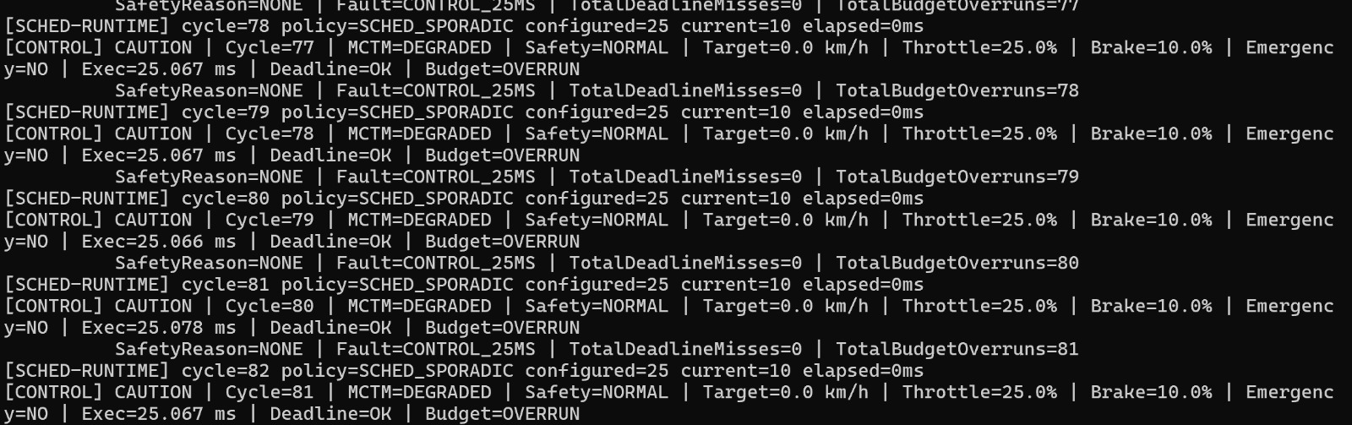
Figure 29. Runtime evidence screenshot retained from source file 8.jpeg.
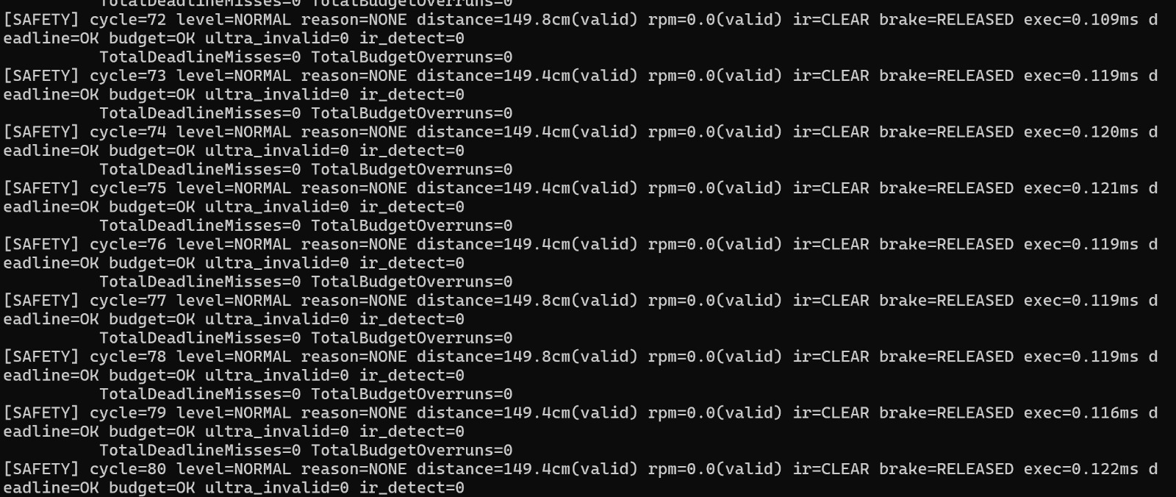
Figure 30. Runtime evidence screenshot retained from source file 9.jpeg.
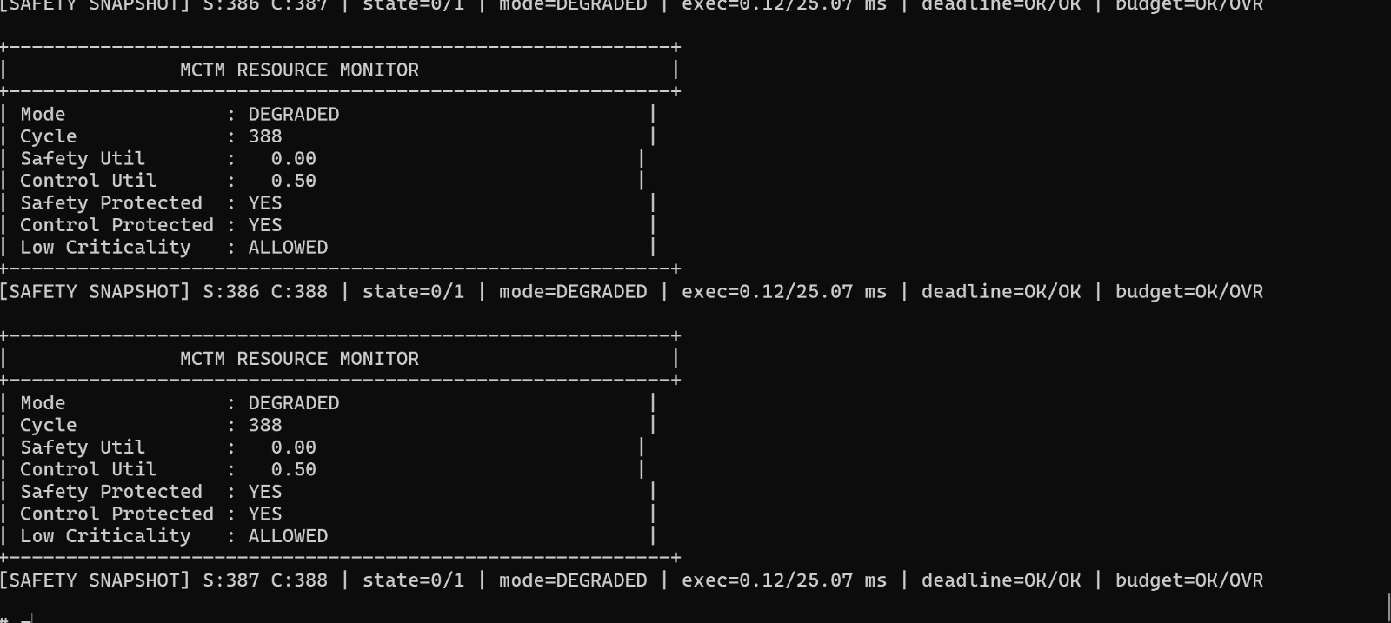
Figure 31. Runtime evidence screenshot retained from source file 10.jpeg.
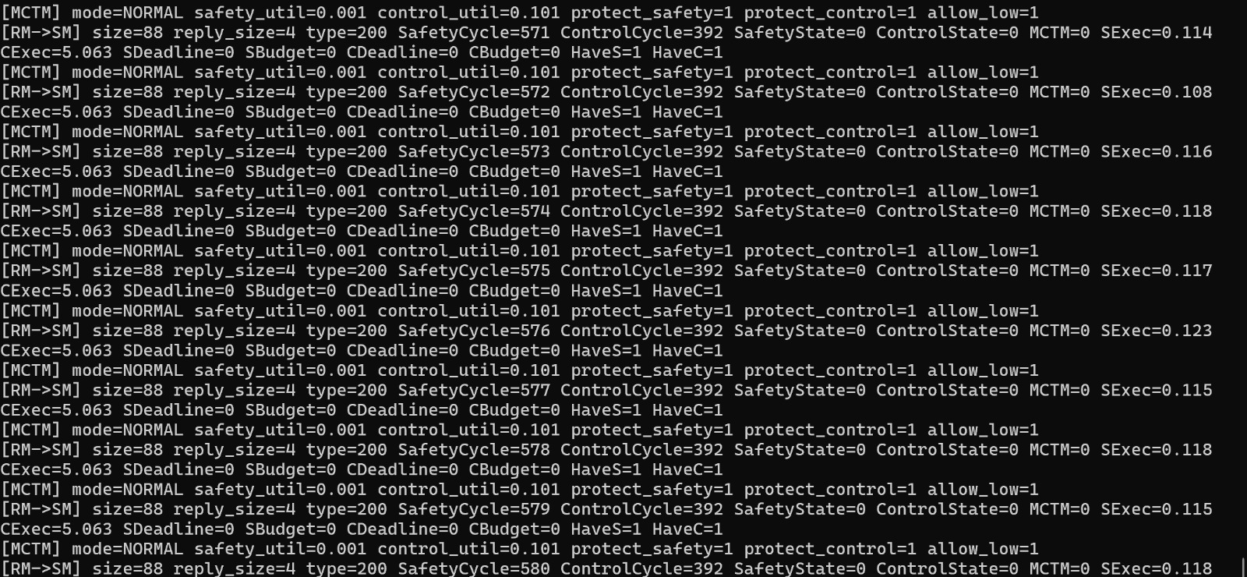
Figure 32. Runtime evidence screenshot retained from source file 11.jpeg.
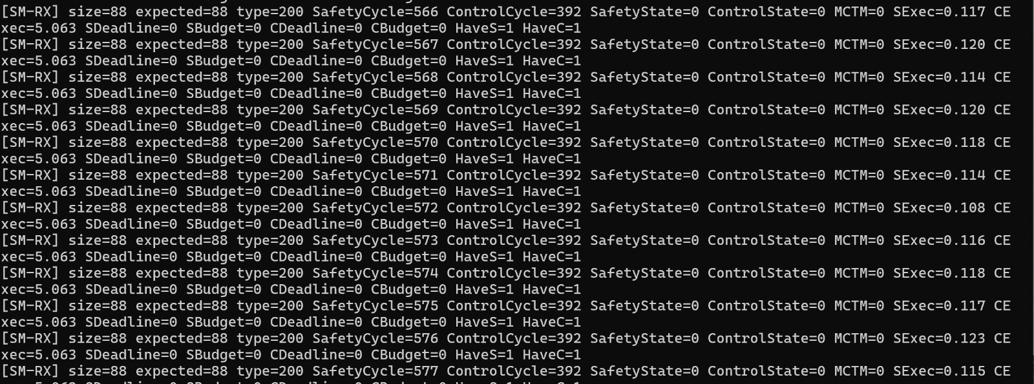
Figure 33. Runtime evidence screenshot retained from source file 12.jpeg.
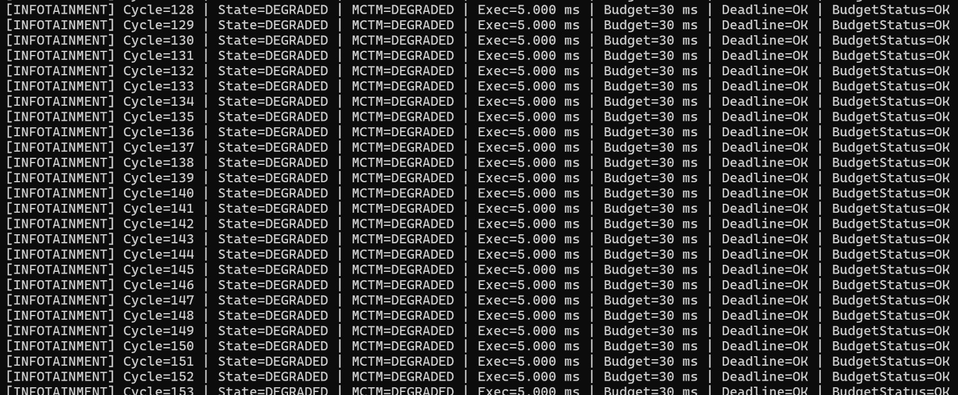
Figure 34. Runtime evidence screenshot retained from source file 13.jpeg.
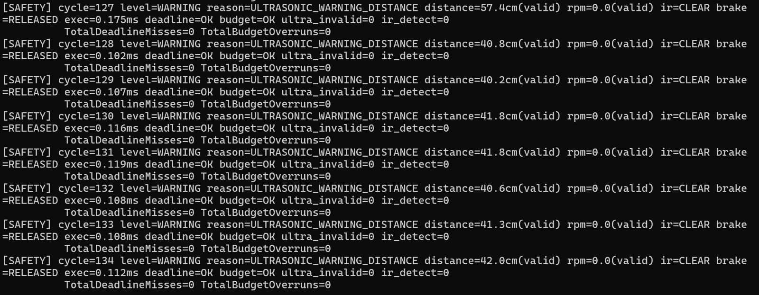
Figure 35. Runtime evidence screenshot retained from source file 14.jpeg.
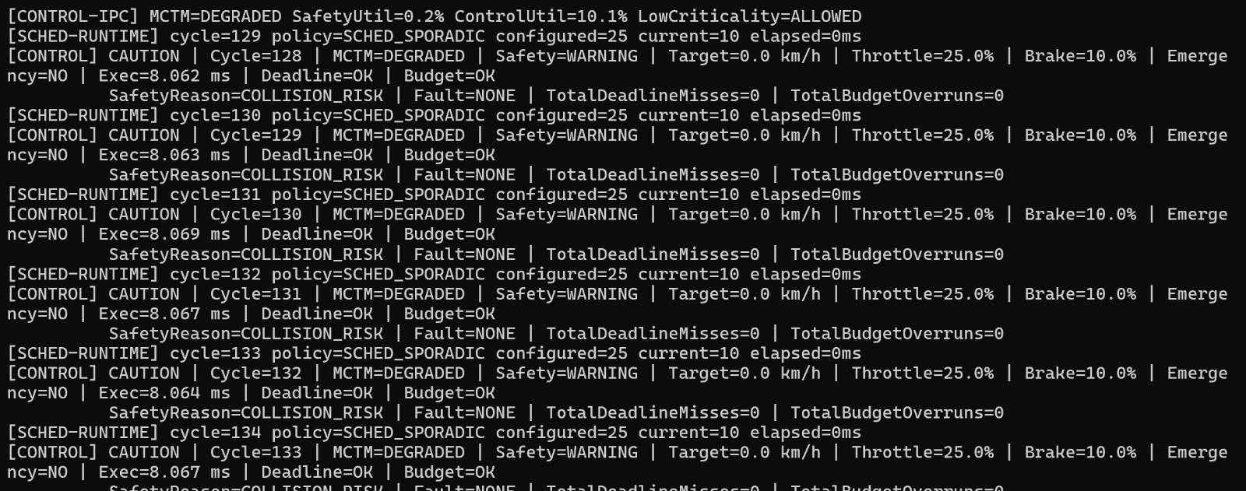
Figure 36. Runtime evidence screenshot retained from source file 15.jpeg.
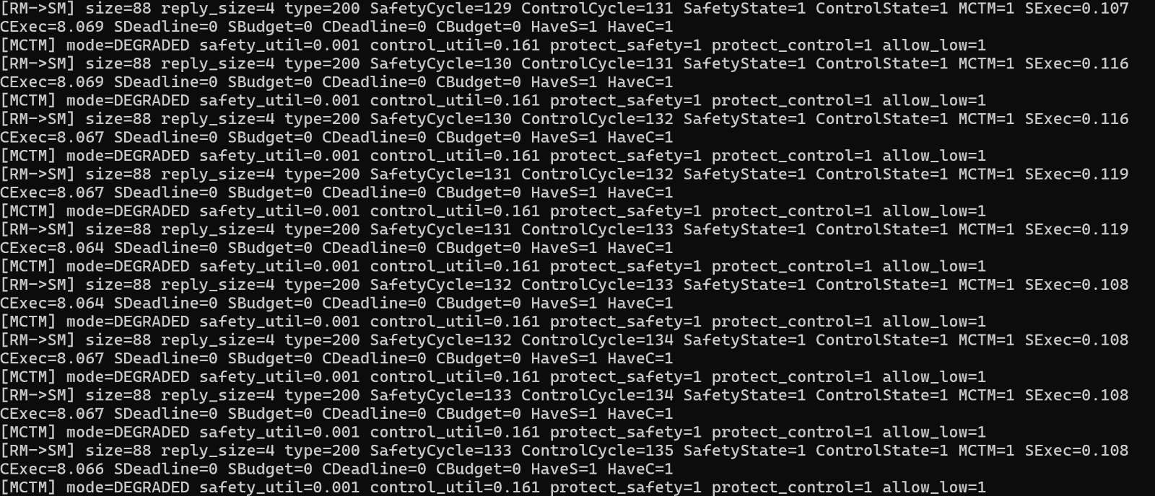
Figure 37. Runtime evidence screenshot retained from source file 16.jpeg.
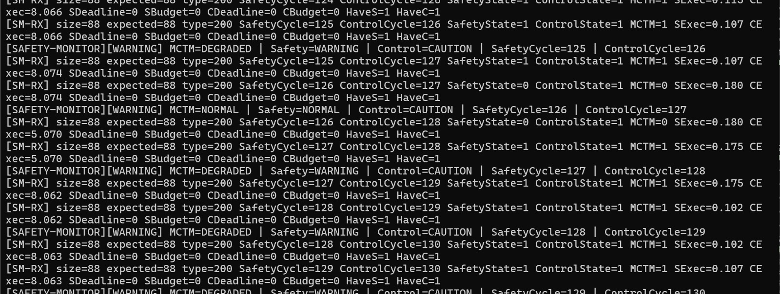
Figure 38. Runtime evidence screenshot retained from source file 17.jpeg.
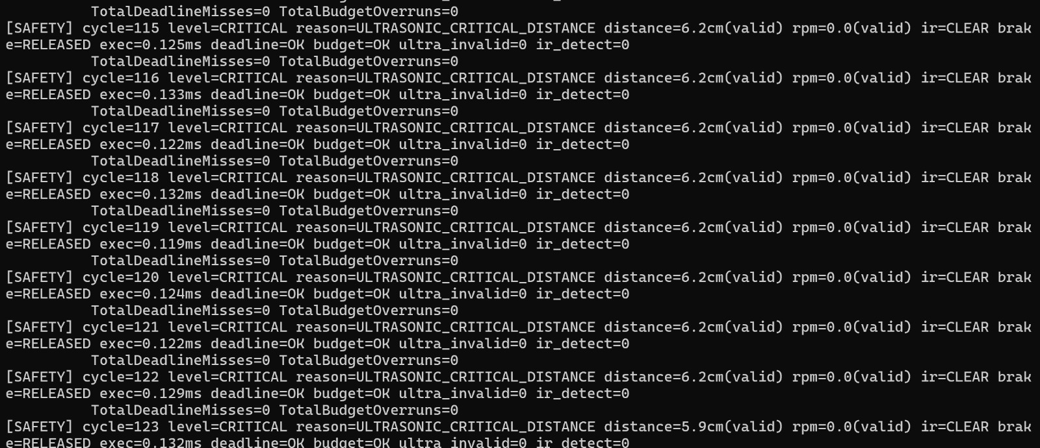
Figure 39. Runtime evidence screenshot retained from source file 18.jpeg.
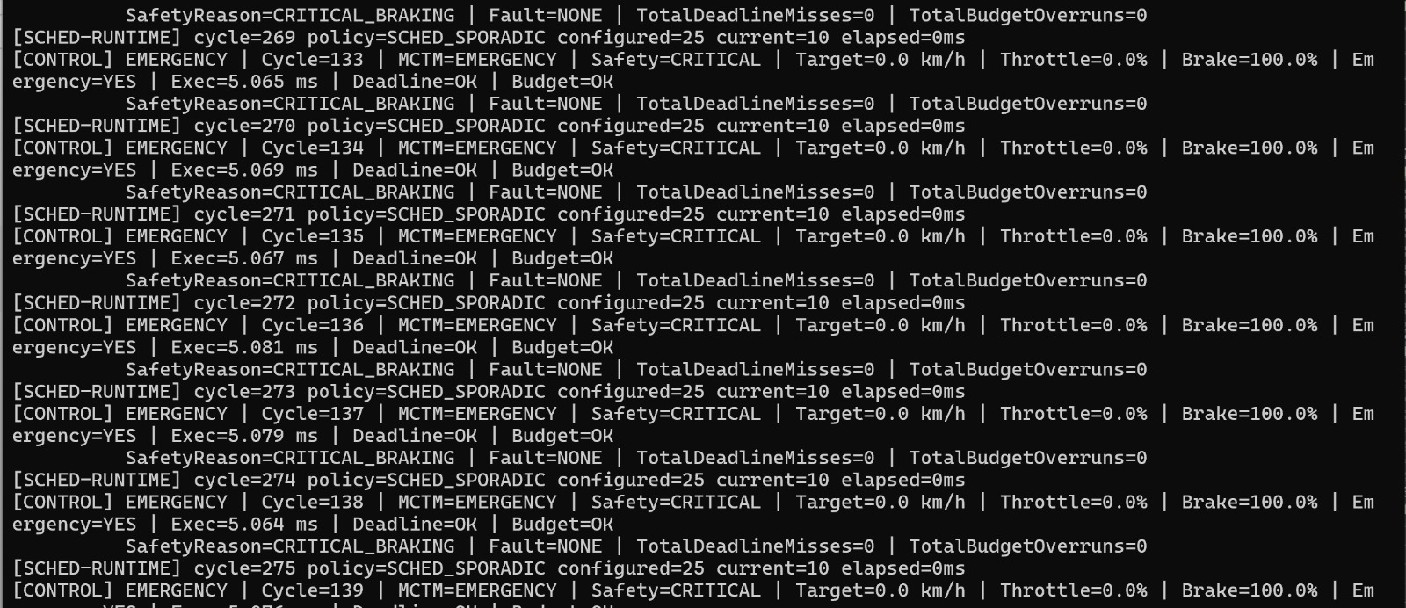
Figure 40. Runtime evidence screenshot retained from source file 19.jpeg.

22. Appendix B – Reproducibility Checklist
Table 12. Final reproducibility checklist
Item | Check
QNX 8.0 target booted and reachable | Completed for supplied runtime evidence
All runtime binaries built for aarch64le | Build system prepared; compile on QNX target required for final verification
Runtime order documented | scripts/run_order.txt
Fault scenarios repeatable | FaultInjector CLI
Application trace archived | /tmp/schedule_trace.csv
Kernel trace archived | .kev file
System Profiler screenshot archived | Supplied evidence package
Terminal outputs archived | Supplied evidence package
Hardware bench photographs archived | Supplied evidence package
No safety certification claim made | Explicitly bounded in this document

