1. **Get Input from the User and calculate average**

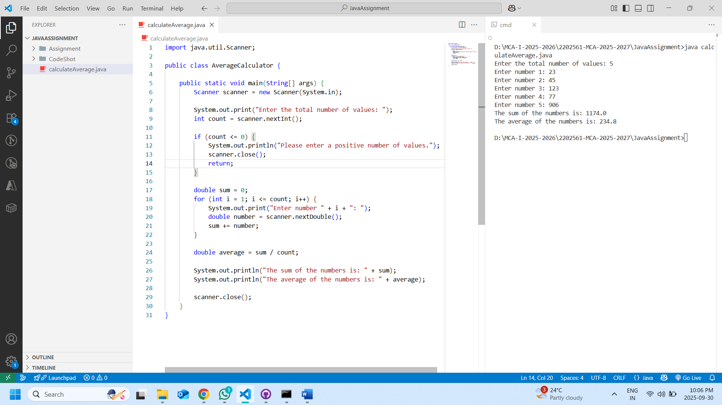

1. **Multiply Two Floating-Point Numbers**

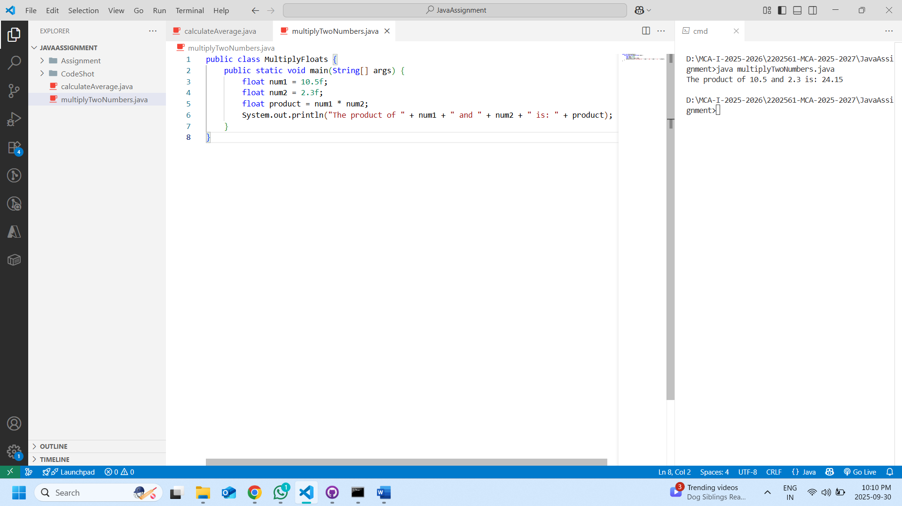

1. **Swap Two Numbers**

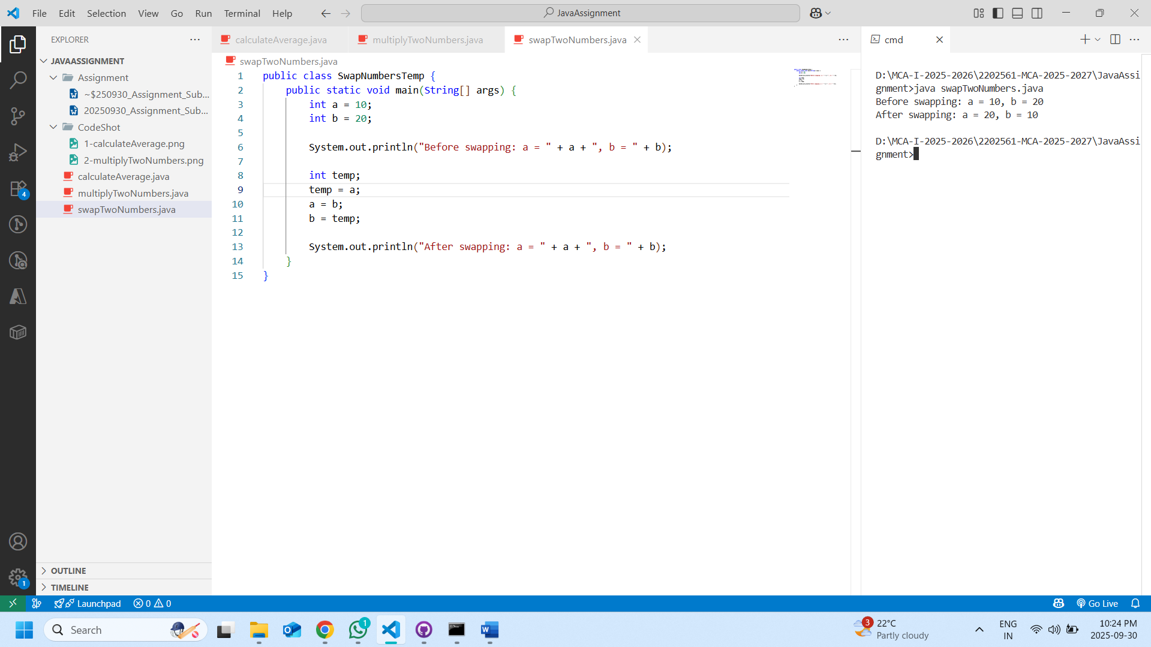

1. **Check Even or Odd Integers**

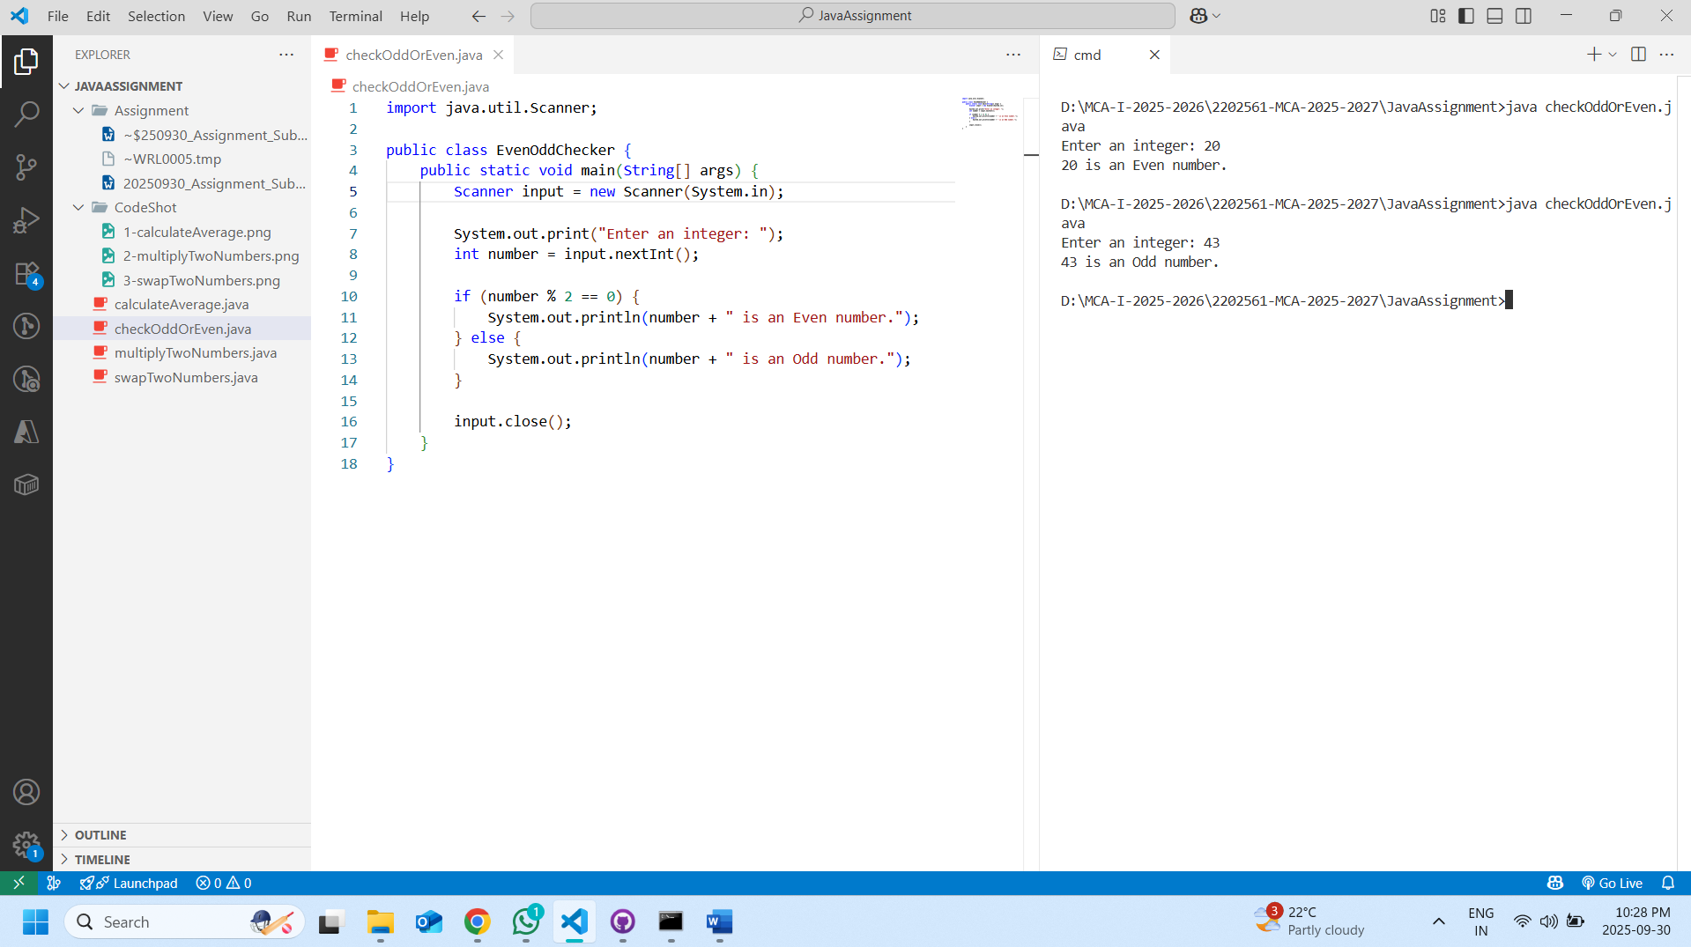

1. **Check no, is divisible by 6,11 (e. g. no = 55)**

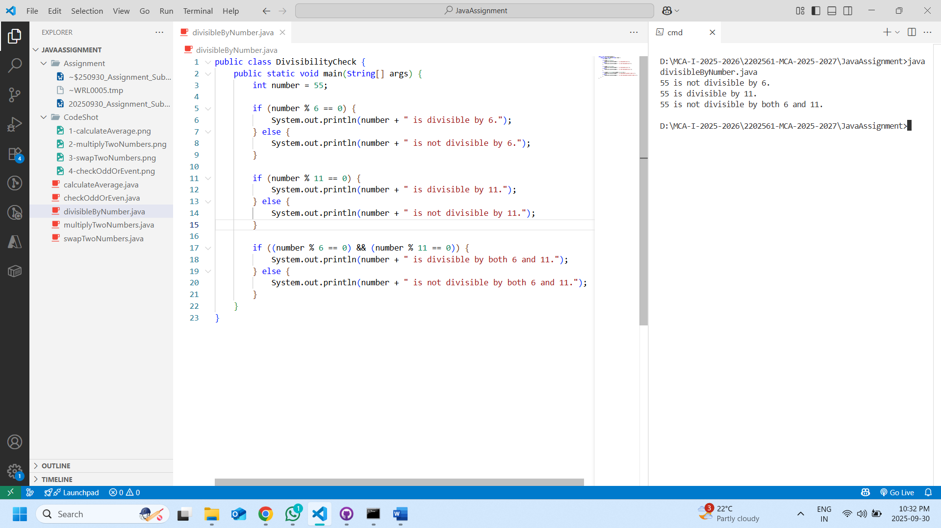

1. **Check given no. is leap year not.**

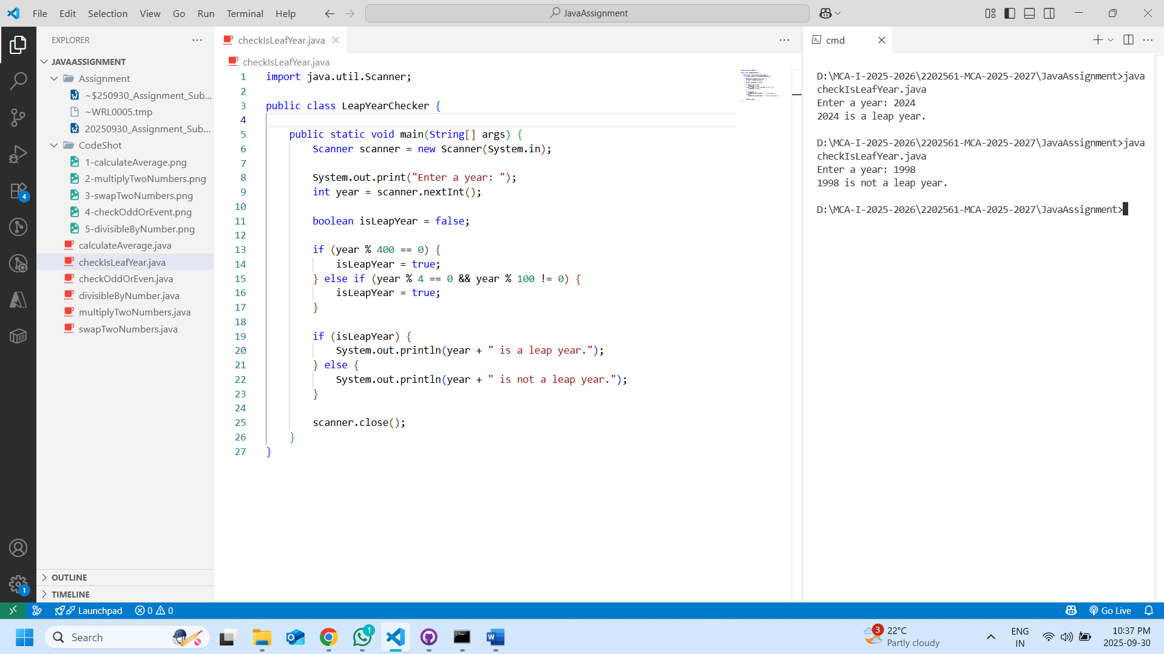

1. **Find Largest Among 3 Numbers**

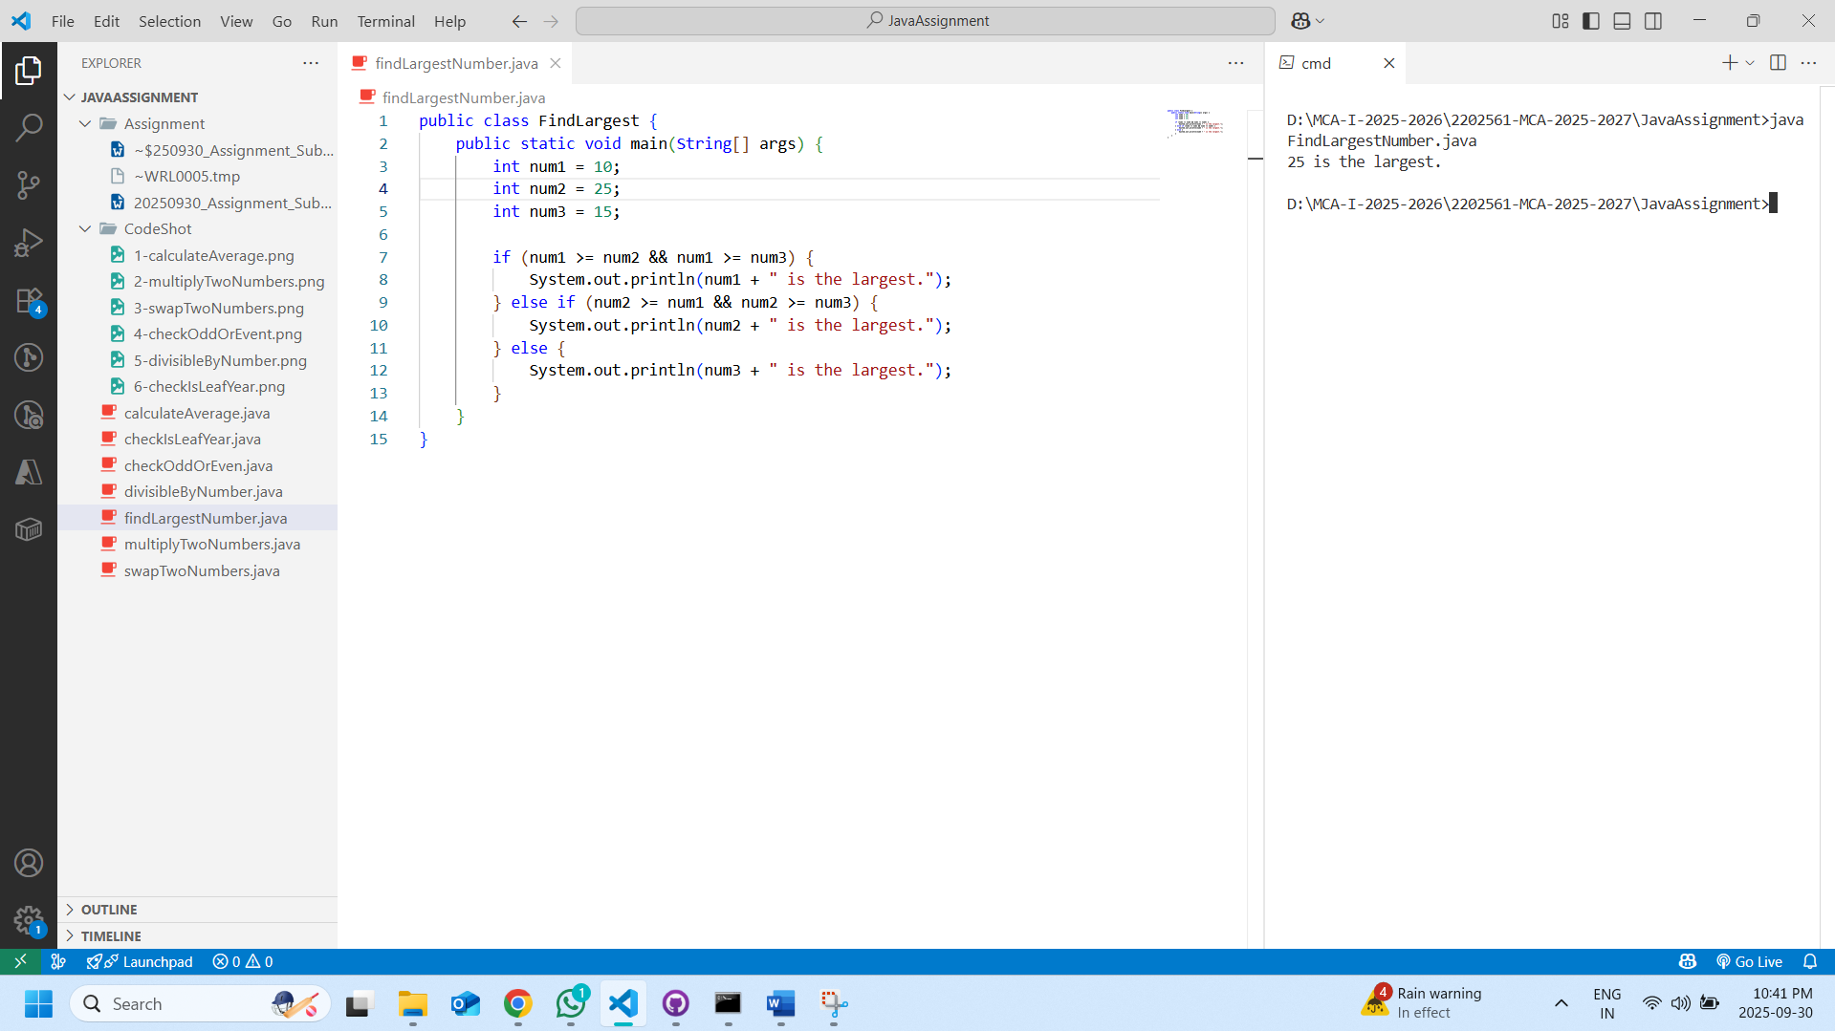

1. **Calculate Simple Interest**

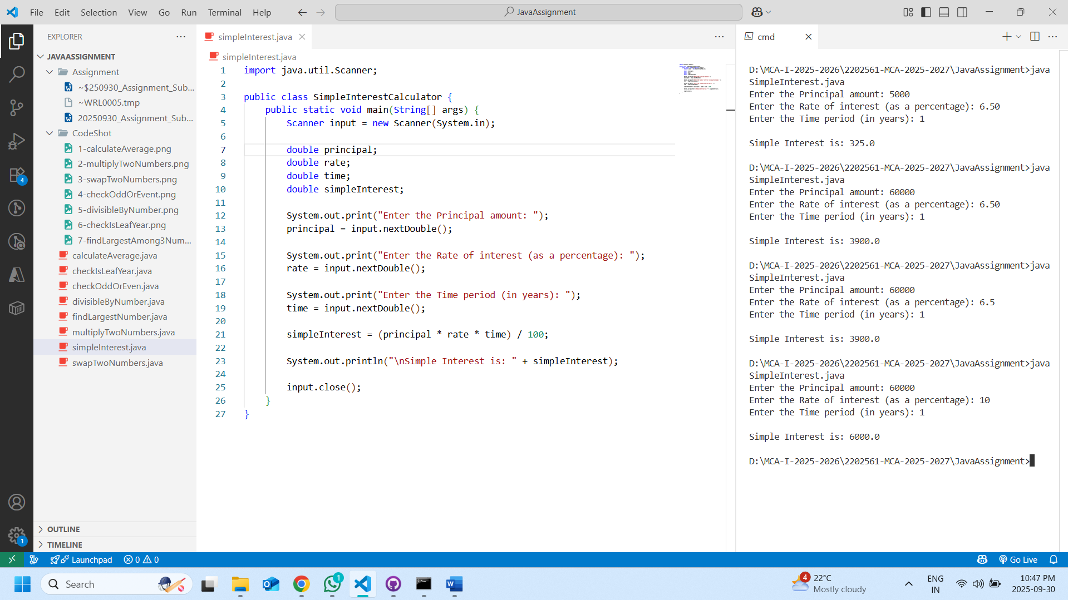

1. **Find the Perimeter of a Rectangle**

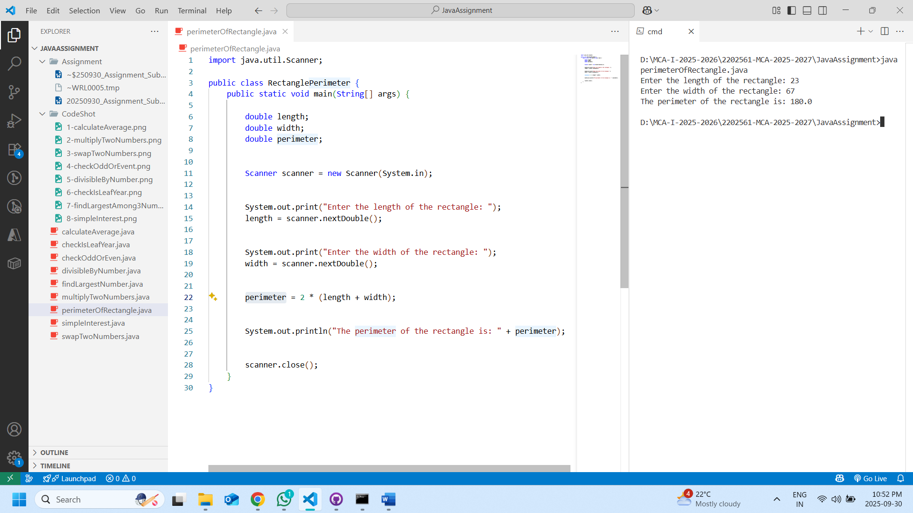

1. **Find area of circle**

