Name | Udhayarajan J
Class | MCA - I
Sub | Java Programming
Type | Experiment Practical Program
Date | 2025-11-12
Roll No | 2202561

Experiment 2: Introduction of arrays and different operations on arrays

Design an application by using arrays
a. Finding the Largest/Smallest Element
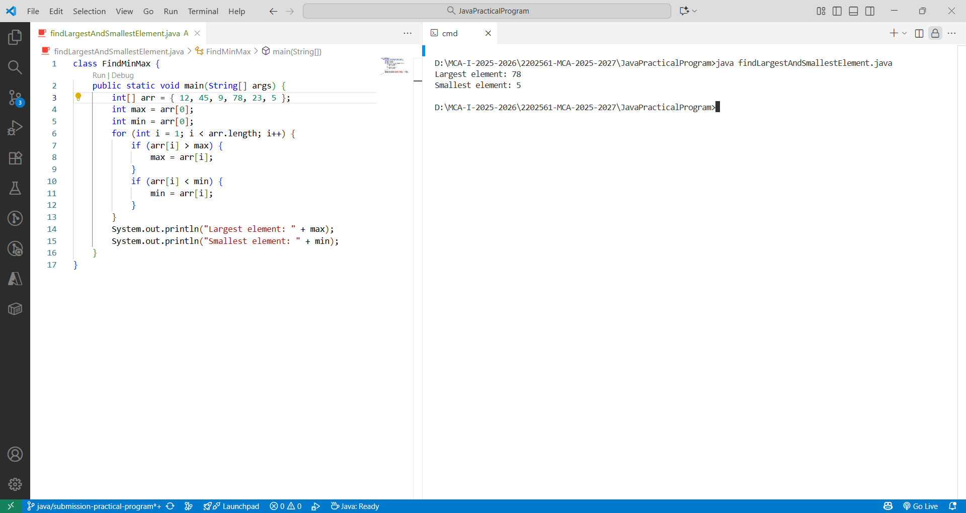
b. Reversing an Array
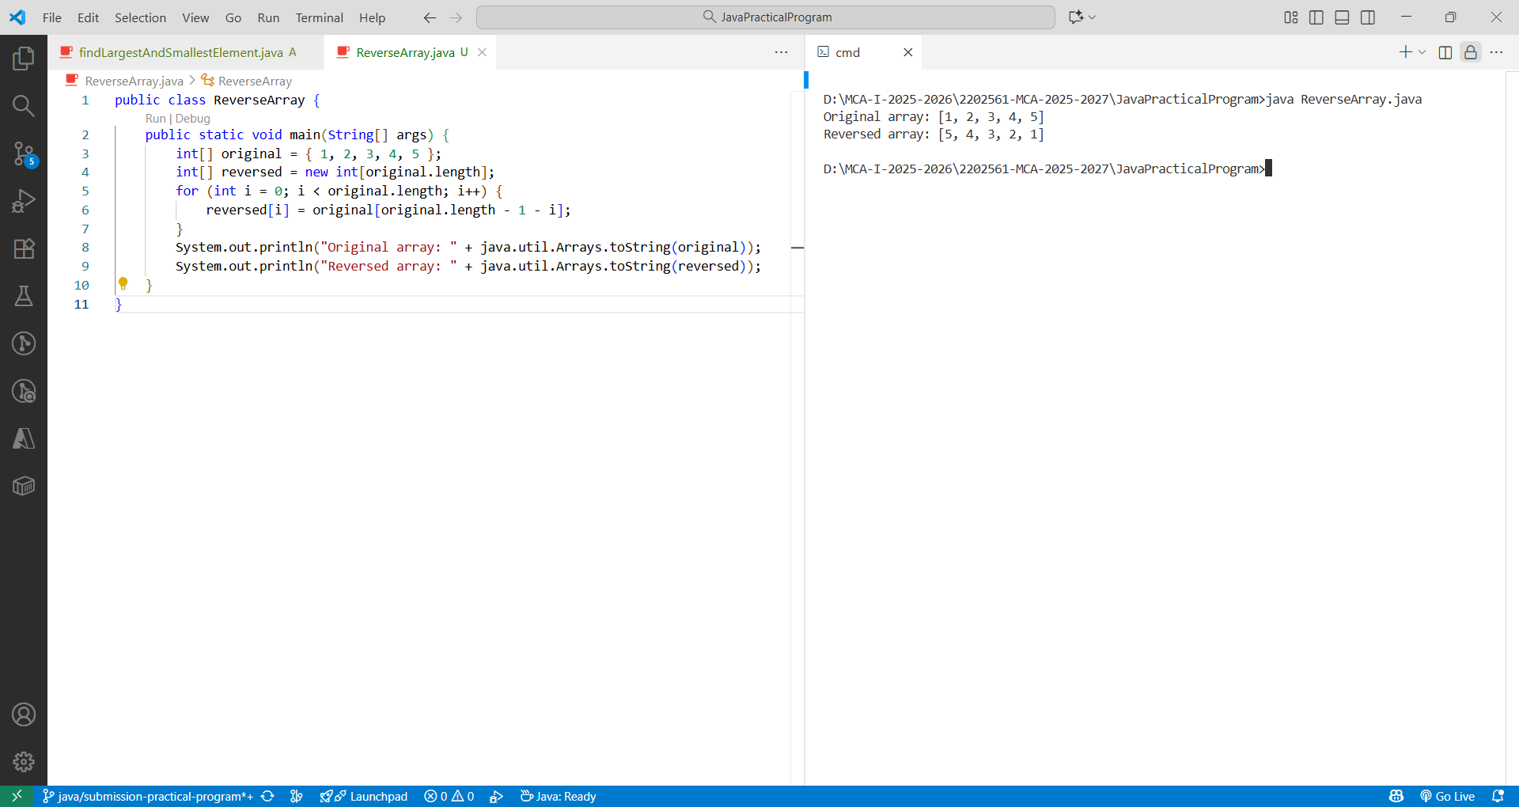

c. Sum of all elements in a 2D Array
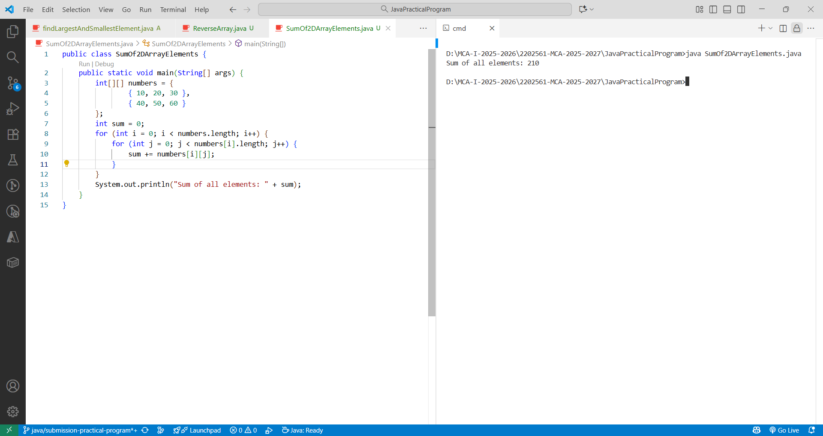

d. Sum of elements in each row of a 2D array
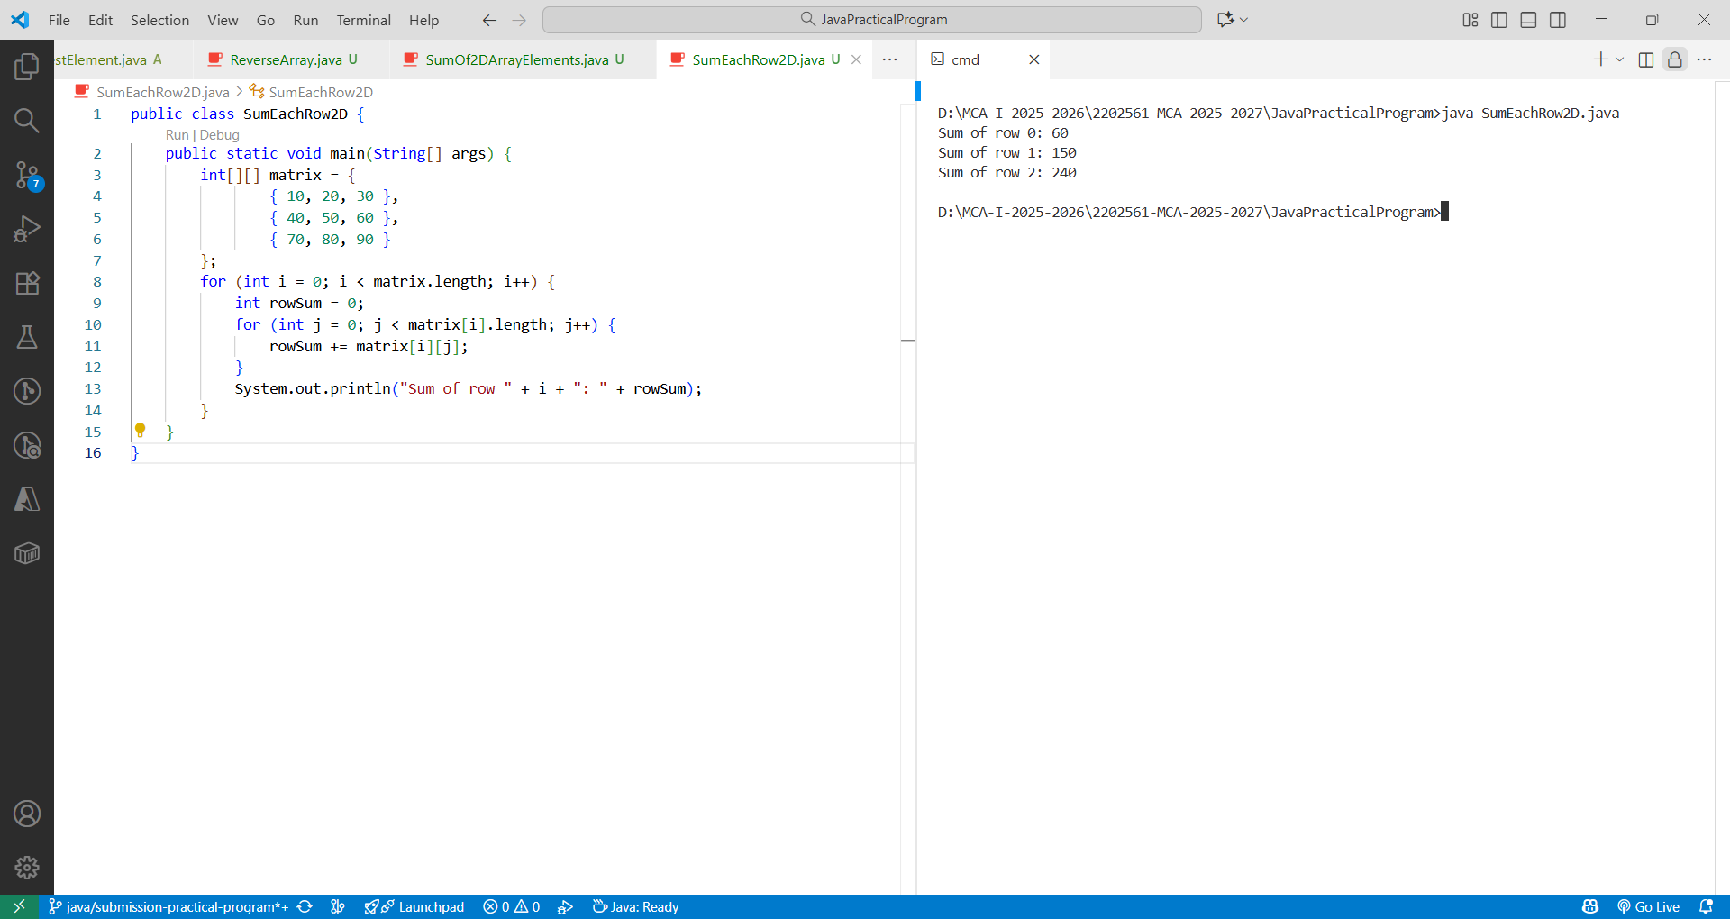

3: Package

- Write a program for Implementation of package to create class and methods in mynmathfunction package

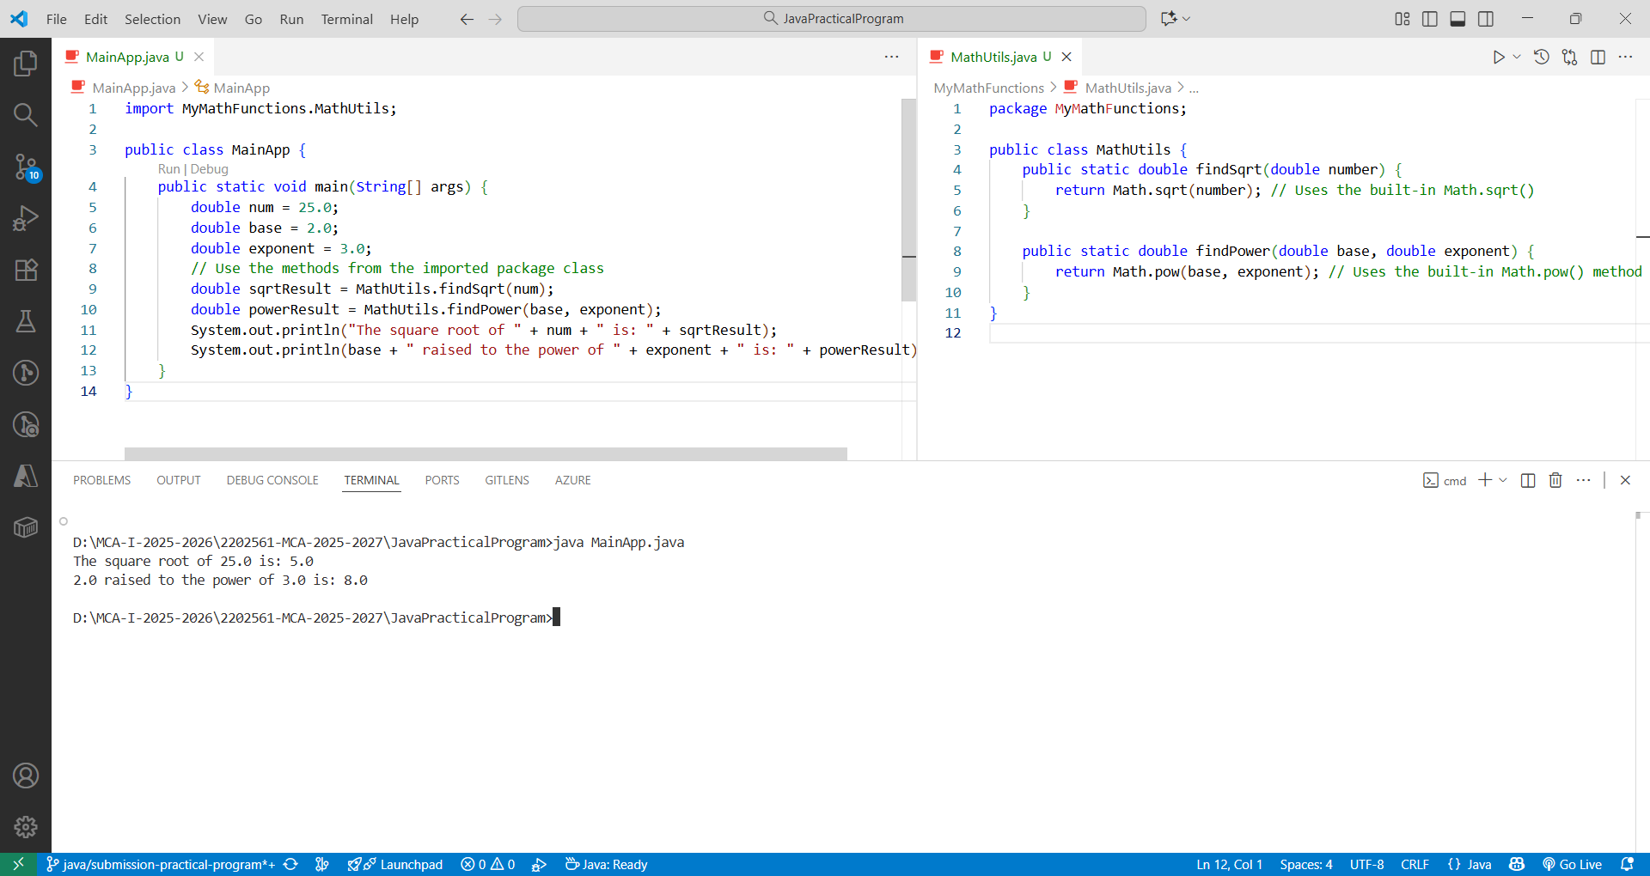

b. abstract class Experiment for calculating area
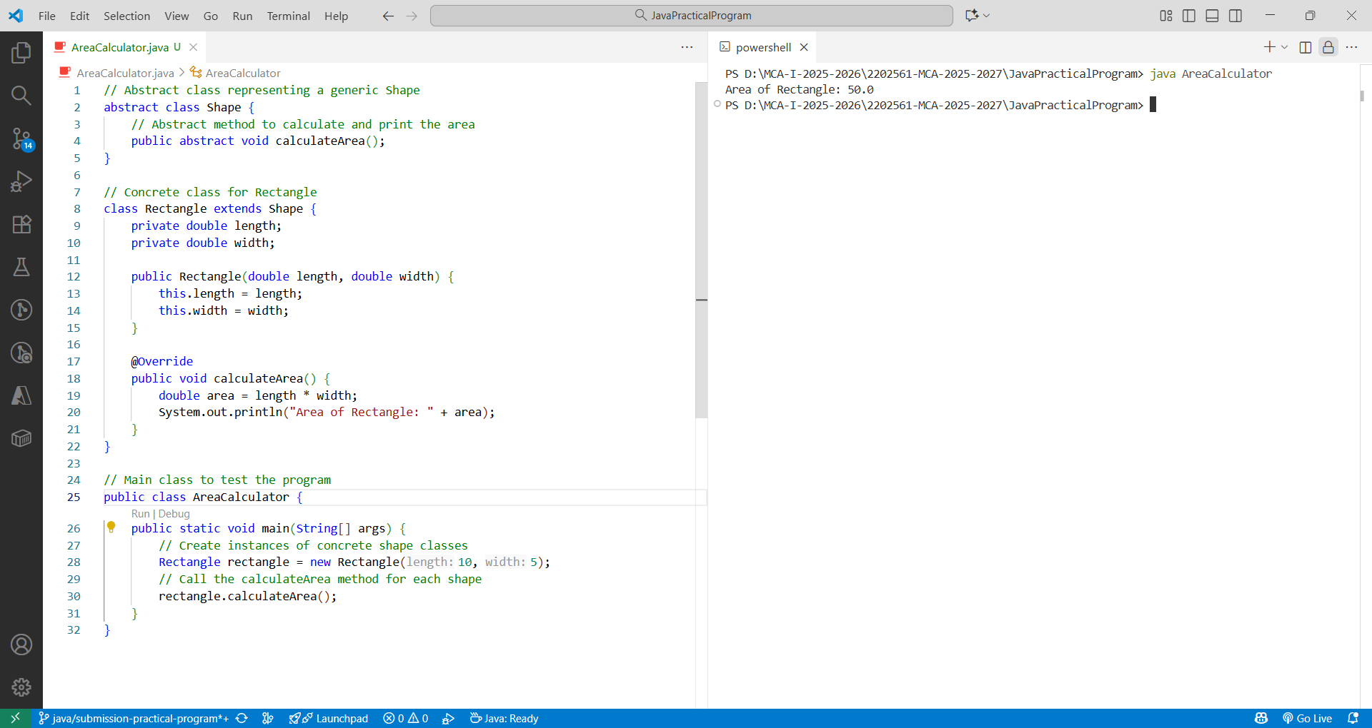

c. Interface program for calculating product amount
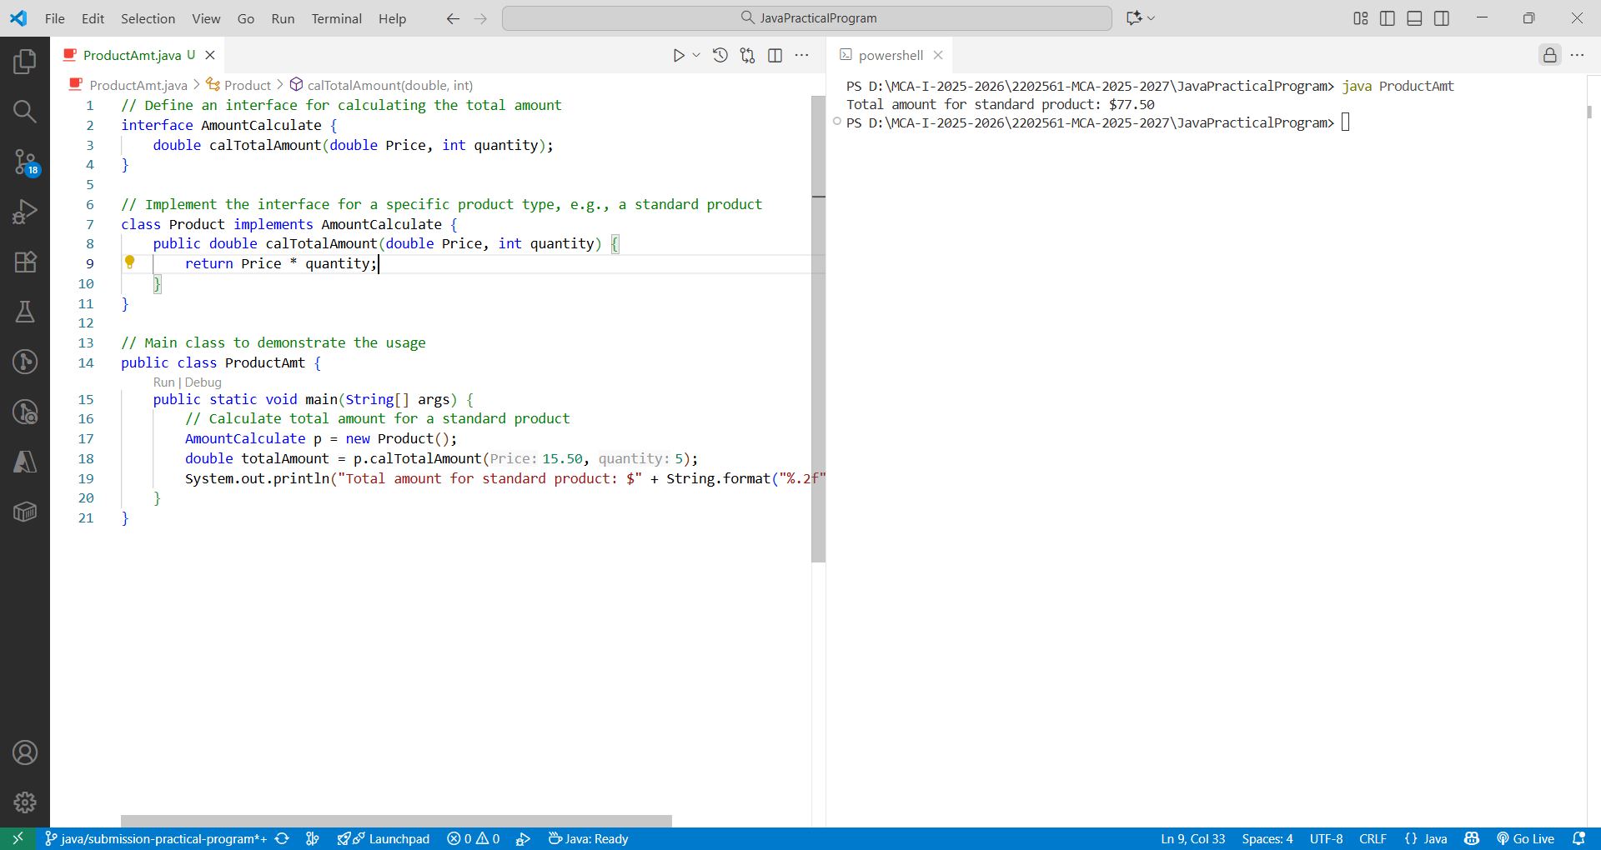

4: Introduction to string and its different operations
- Use of Different string methods

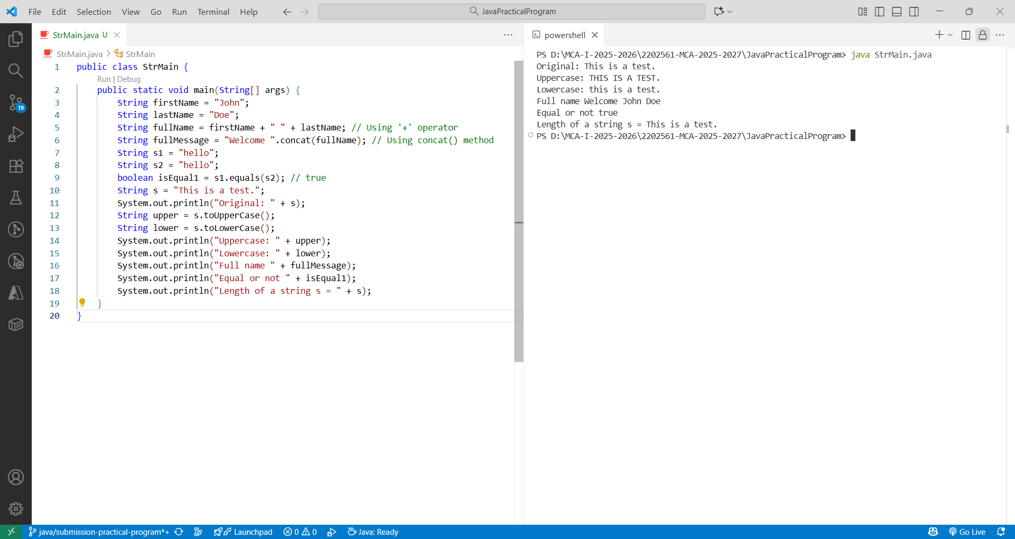

- b. Design application using String, StringBuilder, StringTokenizer Experiment

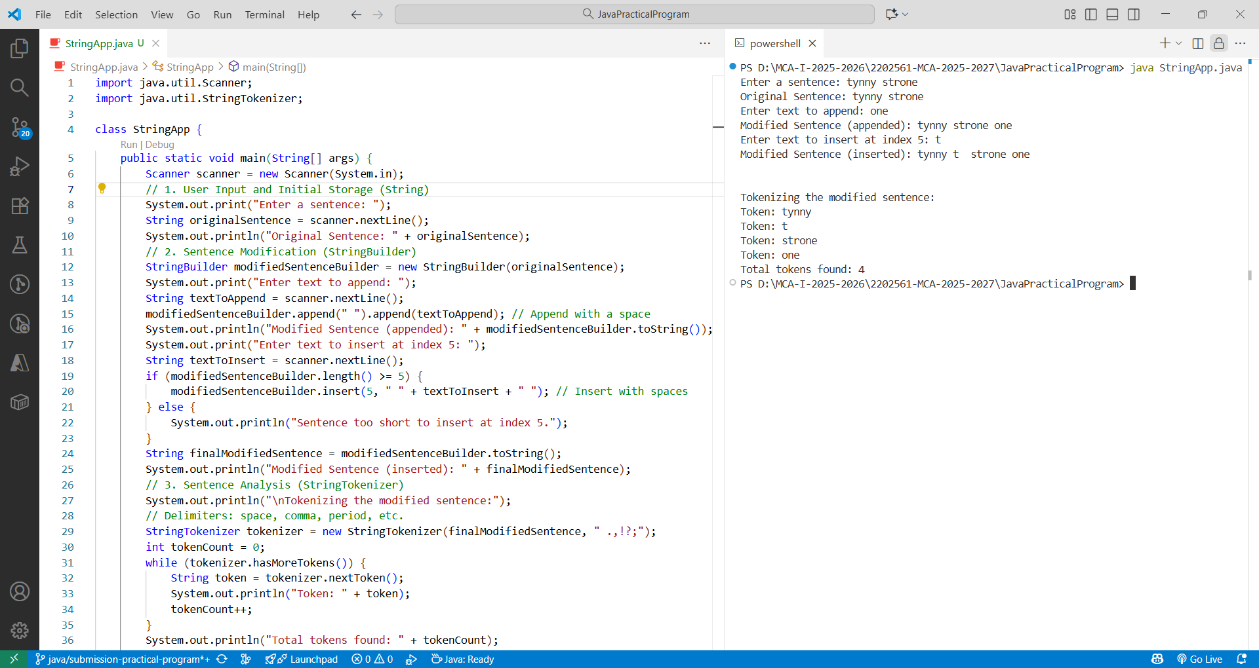

5: Exception Handling -Test any five of standard exception and user Defined Custom Exceptions in java

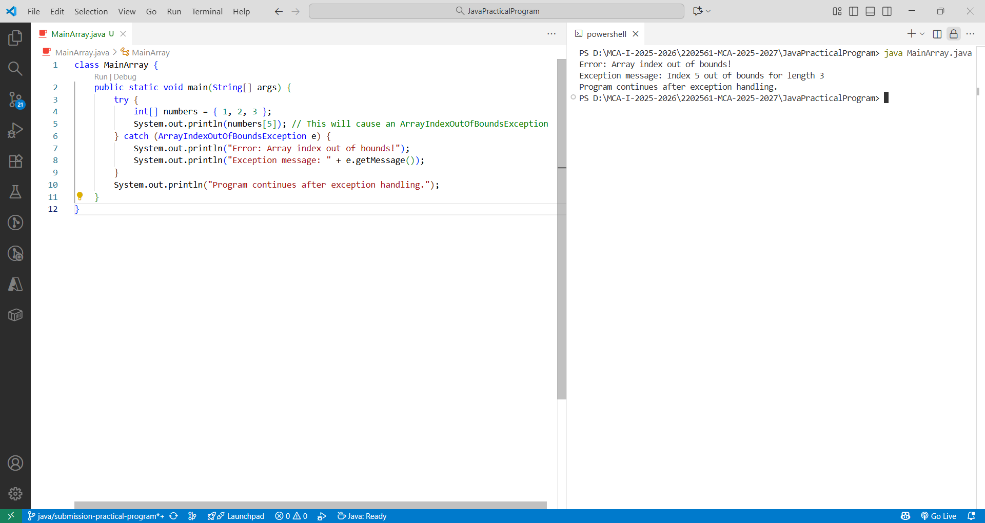

- c. Try-catch-finally block with multiple catch statements.

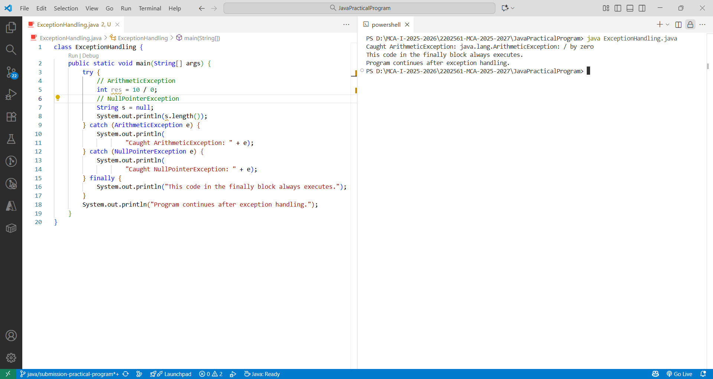

- d. User-defined exceptions

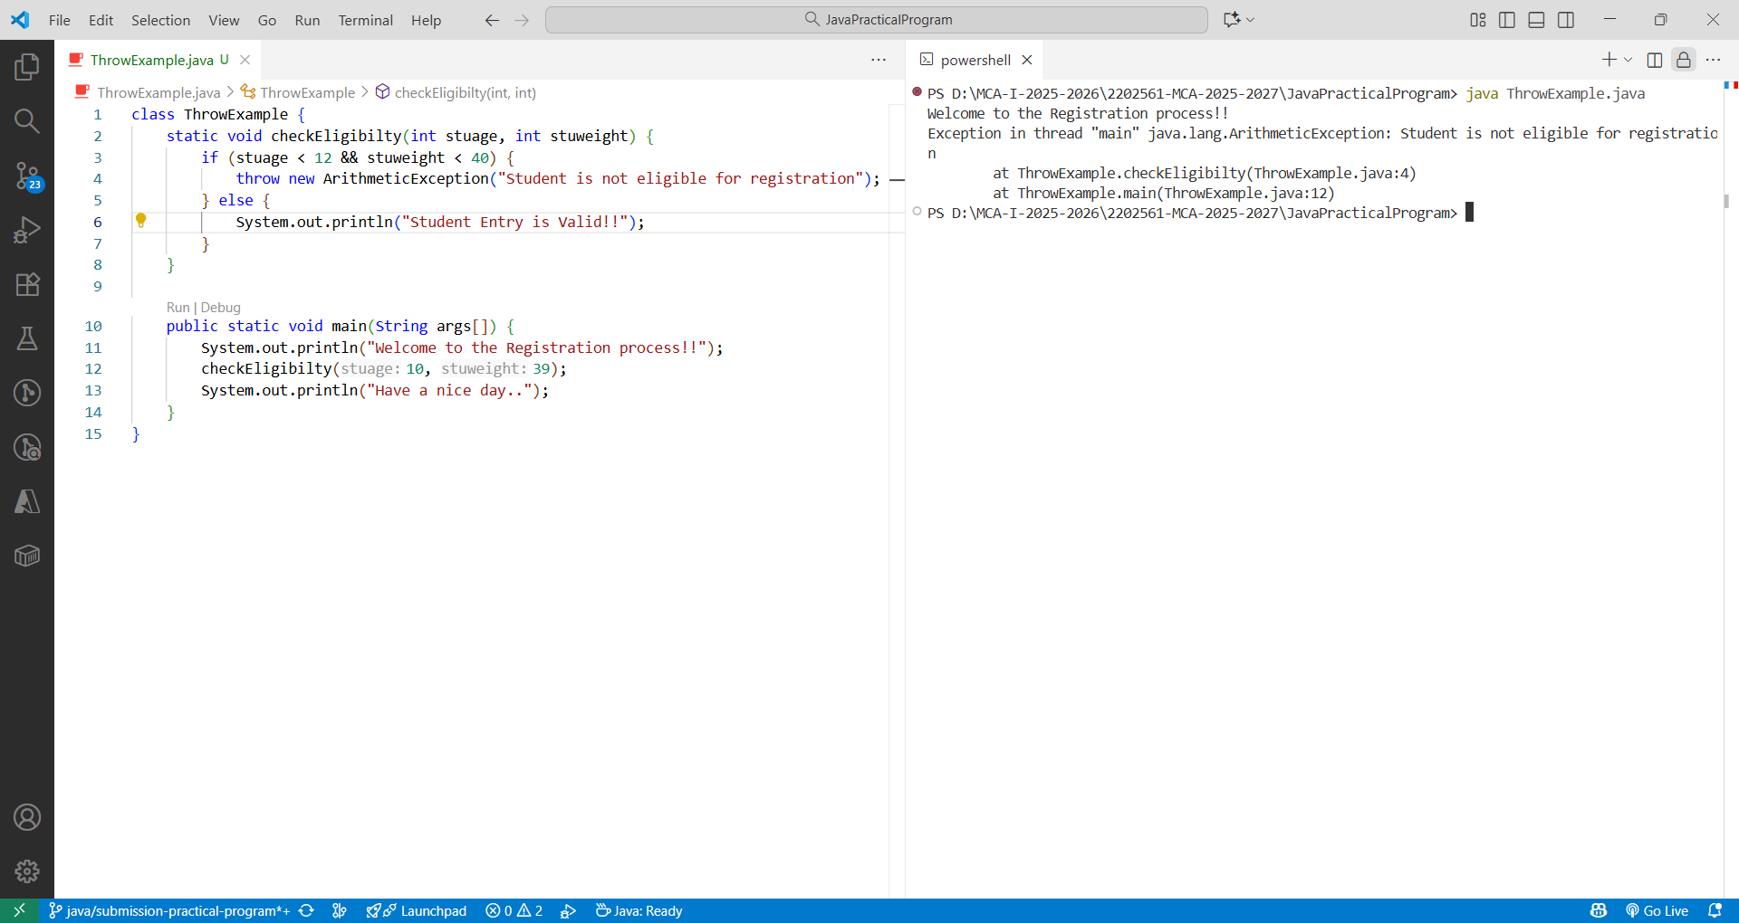

Experiment 6: Multithreading
Implement a Thread - 1. Extending the Thread class

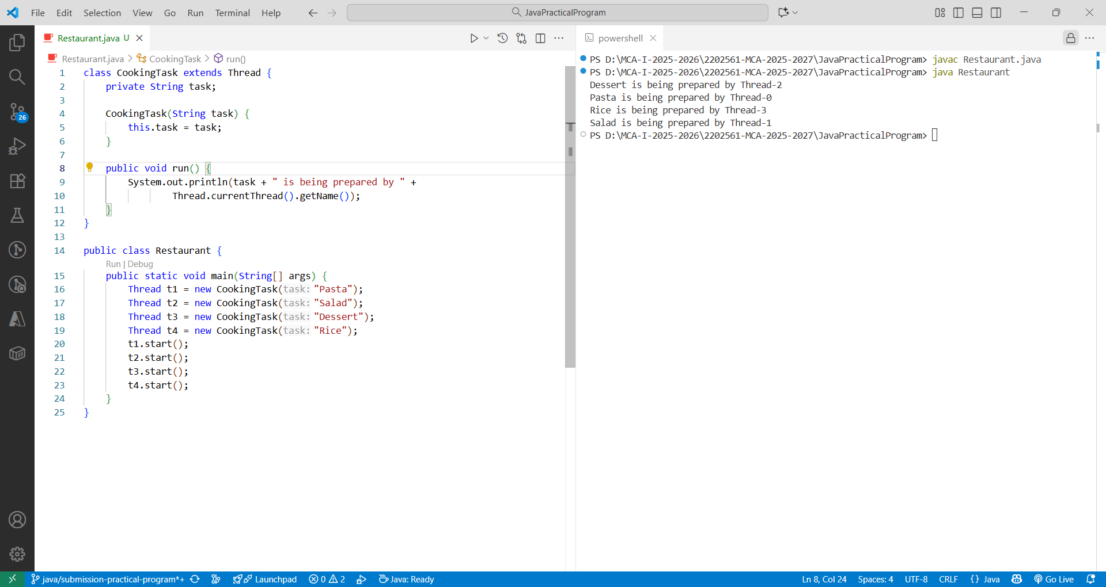

- b. Implement Thread using the Runnable Interface

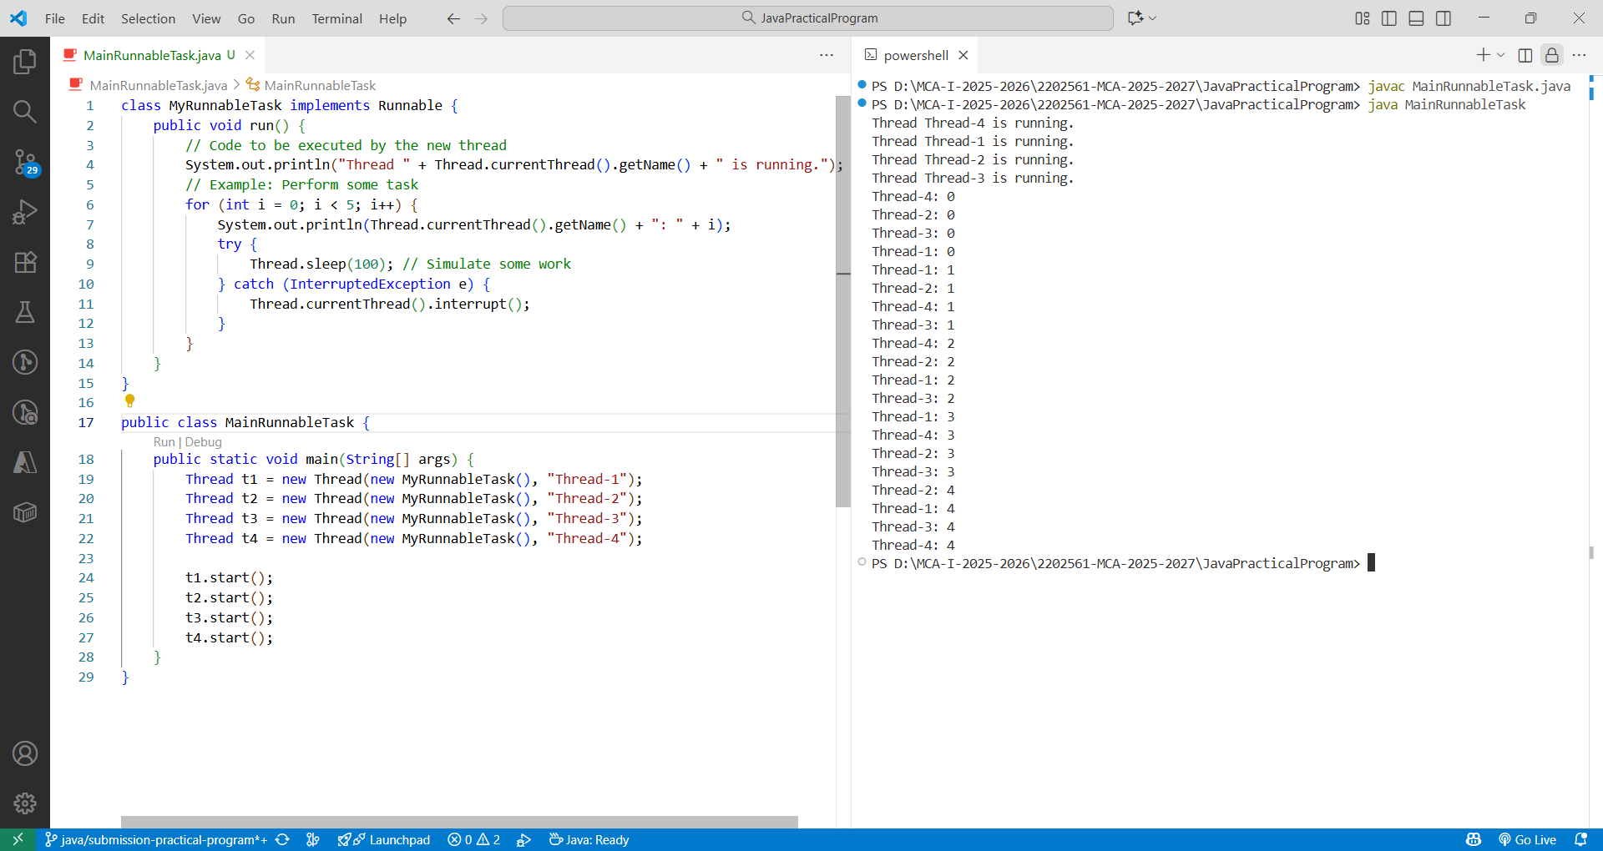

Experiment 7: Collections
- Add and remove element using ArrayList

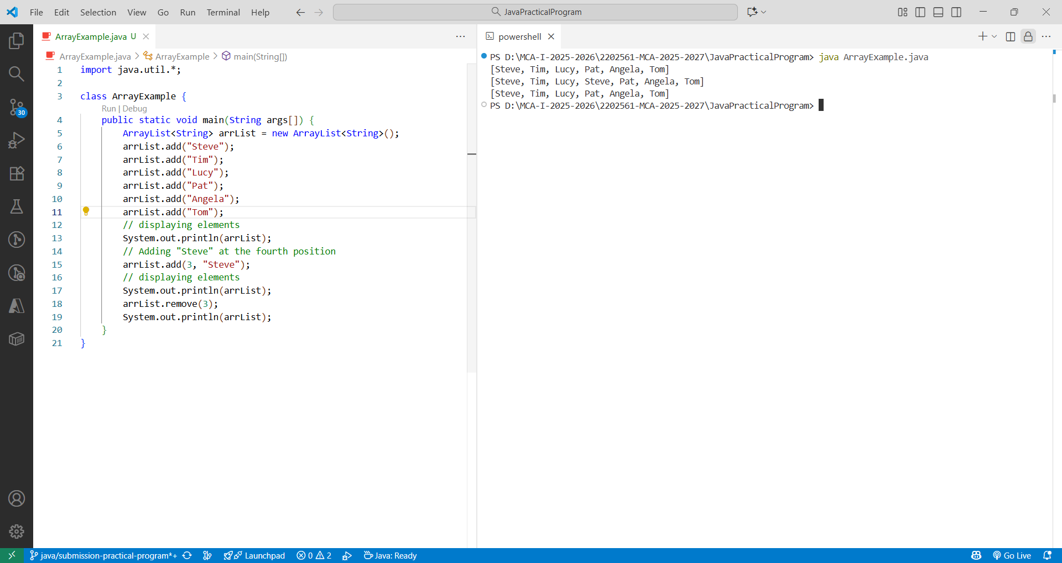

- b. To find maximum element vector using predefined method

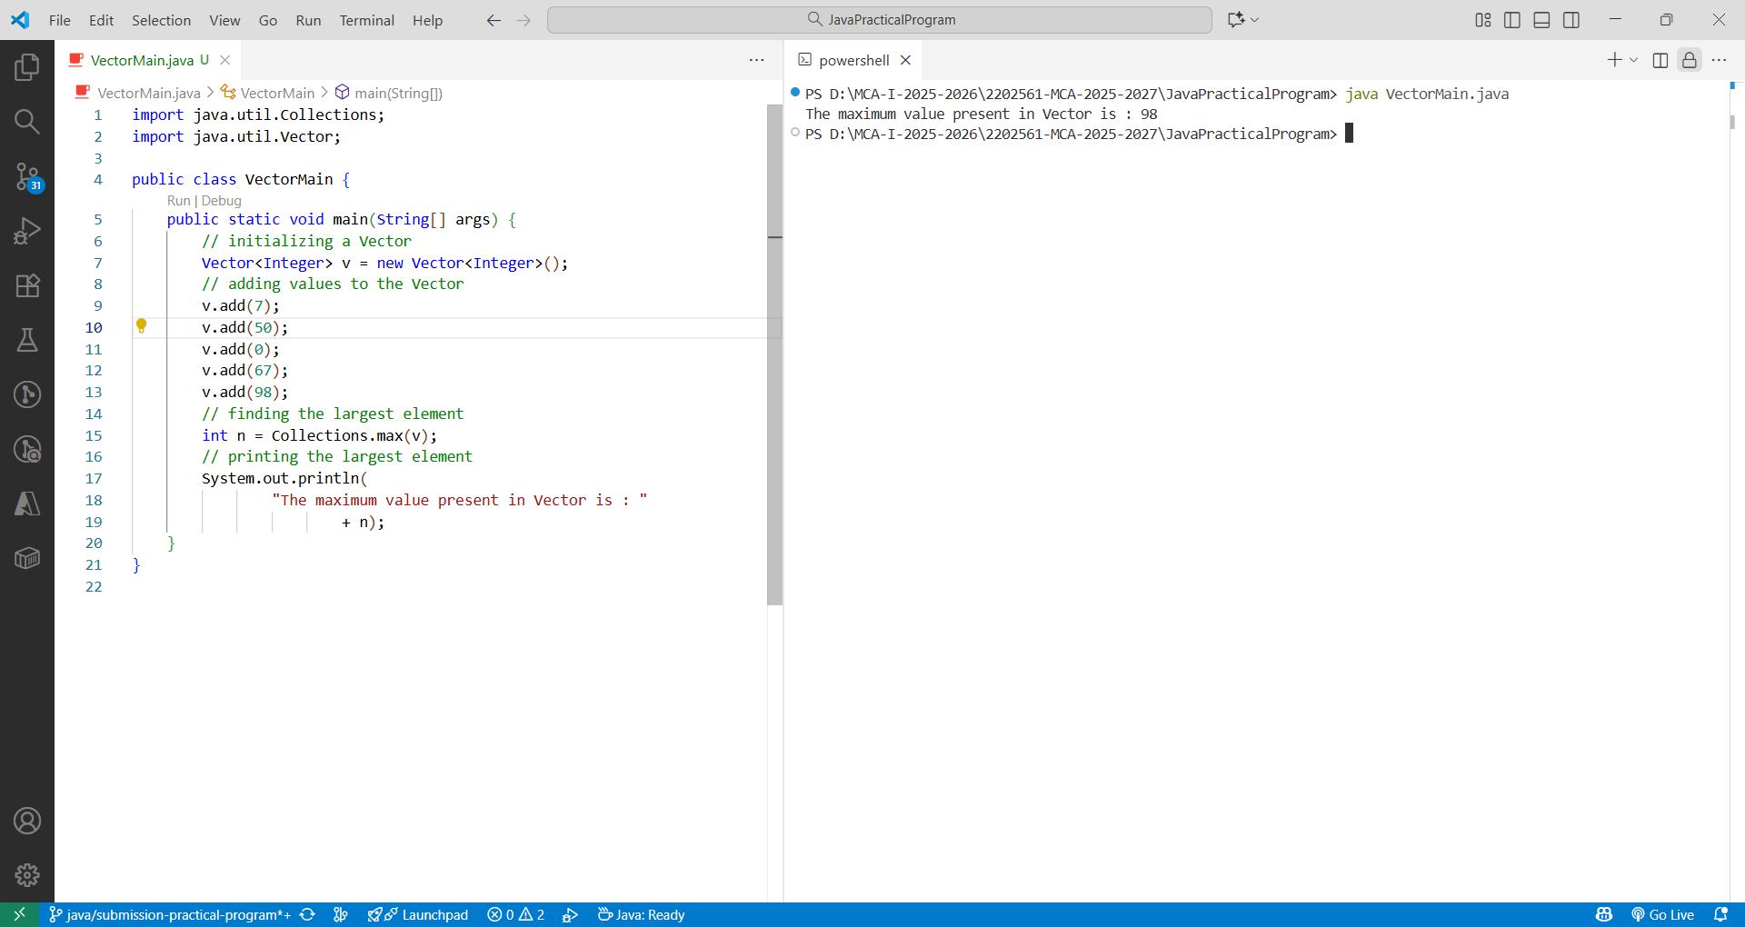

- c. to get the elements of Linkedlist

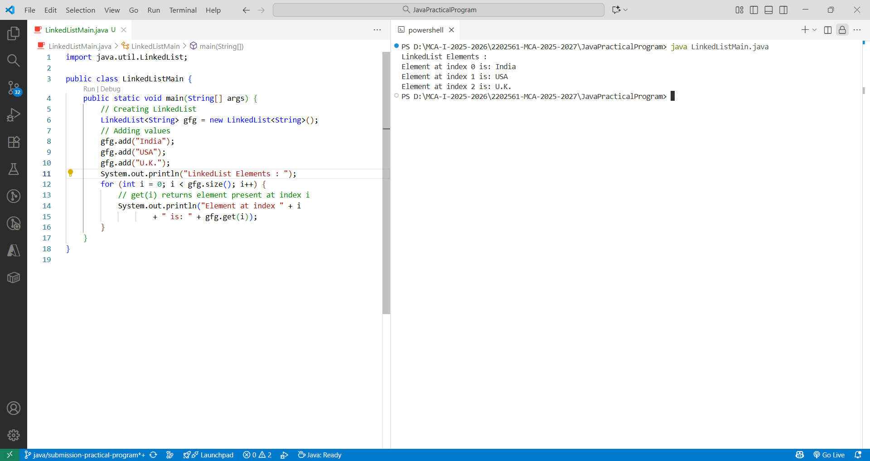

- d. to get the elements of HashSet

