**Instructables link:**

<https://www.instructables.com/id/Smart-Bin-3/>

**Youtube video:**

<https://youtu.be/qlfrr9Re6dM>

**Adafruit IO Share Dashboard:**

https://io.adafruit.com/Udi5/dashboards/dustbingraphs

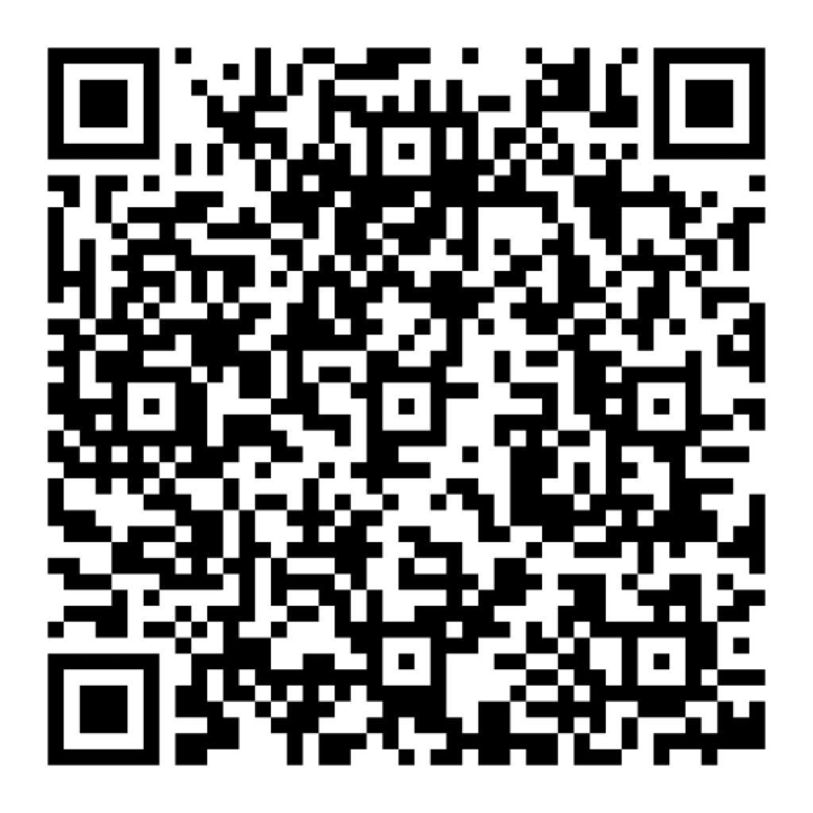**Blynk QR:**