**INTRODUCTION:**

Fundamental analysis is the analysis of the critical factors that affect the value of a stock. The intrinsic value of an equity share depends on a multitude of factors. The earnings of the company, the growth rate, and the risk exposure of the company have a direct bearing on the price of the share. These factors internally rely on a host of other factors like economic environment in which they operate, the industry they belong to, and the companies’ own performance. The appraisal of the intrinsic value is done through.

* Economic analysis
* Industry analysis
* Company analysis

The fundamental analysis is a combination of economic, industry and company analysis to obtain a stock’s current fair value and predict its future value. This kind of fundamental analysis is also known as ‘top-down approach’ because the analysis starts from an analysis of the economy, moves to industry, and narrows down to the company. This is also called EIC (economy, industry and company) analysis.

Stock value

Fig. no: 1 EIC circle

**Economic Analysis:**

Economic Analysis is the study of the general economy factors that go into an evaluation of a security’s value. The stock market is an integral part of the economy. When the level of economic activity is low, stock prices are low, and when the level of economic activity is high, stock prices are high, reflecting a booming outlook for the sales and profits of firms. An analysis of the macroeconomic environment is essential to understand the behavior of stock prices. The commonly analyzed macroeconomic factors are as follows:

* Gross Domestic Product(GDP)
* Savings and investment
* Inflation
* Interest rates
* Budgets and Fiscal deficit
* Tax structure
* Balance of payments
* Foreign Direct Investment (FDI)
* Investment by Foreign Institutional Investors (FIIs)
* International economic conditions
* Business cycles and investor physiology
* Monsoon and agriculture
* Infrastructure facilities
* Demographic factors

**Gross Domestic Product:**

The GDP represents the aggregate monetary value of the goods and services produced in the economy during a specified period. Although GDP is usually calculated on an annual basis, quarterly estimates are also available. The common equation for the calculation of GDP is:

**GDP = consumption + Investment + exports – imports**

The growth rate of GDP points out the prospects for the industrial sector and the return investors can expect from an investment in shares. A decline in the GDP indicates a potential economic slowdown. A high GDP growth rate is advantageous to the stock market.

**Savings and investments**:

Growth in savings leads to more investments. High capital investment means possibility of more production, more demand and supply, better prices in the future and consequently, higher business profits and a positive outlook for the stock market. Savings are distributed over different assets like equity shares, deposits, mutual fund units, real estate, and bullion. The primary market is a channel through which the savings of investors are made available to corporate bodies. Over the years, house hold and private corporate savings have increased and, in turn, the gross domestic investment has also increased.

**Inflation:**

Inflation refers to a situation where too much money is chasing too few goods. Inflation indicates a rise in the price of goods and services. Along with the growth of GDP, if the inflation rate also increases, the real rate of growth would be very low. Inflation and stock markets have a very close relationship. If there is inflation, the stock market is adversely affected. The price of stock is directly related to the performance of the company. Inflation typically results in the following:

* High raw material cost
* Non availability of cheap credit due to raise in interest rates
* Low earnings

These factors have a negative impact on the stock price and market return. If there is a mild level of inflation, it is good for the stock market but high rates of inflations are harmful.

**Interest rates:**

Interest rates have direct impact on economy; the base rate of banks affects the cost of borrowed funds, the base rate in the minimum rate of interest at which banks lend to anyone. It is the floor rate below which the RBI will not allow banks to lend.

The base rate is influenced by the RBI’s bank rate, the repo rates, and the cash reserve ratio. A decrease in the interest rates implies low cost of finance for firms and more profitability. More money is available at a low interest rate to brokers who do business with borrowed money. Availability of affordable funds encourages speculation and a rise in the price of shares. An increase in lending rates affects firms which depend on banks for their working capital and growth requirements.

**Budget and Fiscal deficit:**

The budget draft provides a detailed account of government revenues and expenditures. A deficit budget may lead to a high rate of inflation and adversely affect the cost of production. A surplus budget may result in deflation. A balanced budget is highly favorable to the stock market.

Fiscal deficit is the difference between government’s total receipts (excluding borrowings) and total expenditure. It can be expressed as follows:

**Fiscal deficit = total expenditure (revenue+ capital) – (revenue receipts + non debit capital receipts)**

If capital expenditure and total expenditure is high and deficit occurs, it is a healthy sign. Capital expenditures augment the productive capacity of the economy. If a deficit occurs due to excessive revenue expenditure like interest payment, subsidies, and administrative expenses, then the deficit is not conductive to economic growth because these expenditures are unproductive in nature.

**Tax structure:**

Every year in March the business community eagerly waits for the statement from the government regarding the tax policy. Concessions and incentives given to a particular industry encourage investment in that particular industry.

**Balance of payments:**

The balance of payments is the record of a country’s money receipts from abroad and payments to foreign countries. The difference between receipts and payments may be a surplus or a deficit. Balance of payments is a measure of the strength of the Rupee on the external account. If the deficit increases, the Rupee value may depreciate against other currencies, there by affecting the cost of imports. Industries involved in the exports and imports are markedly affected by changes in the foreign exchange rate. The volatility of the foreign exchange rates affects the investment of the foreign institutional investors in the Indian stock market. A favorable balance of payments has a positive effect on the stock market.

**Foreign Direct Investment:**

The definition FDI includes different elements, namely, equity capital, reinvested earnings of foreign companies, inter-company debt transactions, short-long term loans, financial leasing, trade credits, investments made by foreign venture capital investors, and so on. FDI help in the upgrading of technology, skills, and managerial capabilities and bring much needed capital into the economy. They also help in providing employment opportunities. Inflow of capital helps the economy grow and has a positive impact on the stock market.

**Investment by Foreign Institutional Investors (FIIS):**

FIIS are considered to be the main drivers of the stock market. Outflows of FII investments affect the stock market negatively.

**International Economic conditions:**

Worldwide economies are not independent but independent. The boom or depression in our country affects other countries stock market.

**Business cycles and investor physcology:**

The business cycle contains four phases with distinct features, namely, boom, recession, depression, and recovery.

During a boom, the economic activity is at its peak, and the growth of industry and GDP are prominent. Companies record high turnover and profits. They engage in expansion plans, mergers, and acquisitions, these leads to investor optimism. Retails investors, big and small, are enthusiastic about the market and are willing to invest. The market reaches a new high.

Some of the companies may fail to fulfill the goals and as their profit margin falls, the next phase of the trade cycle, recession, sets in. Economic growth declines, an there is an economic slowdown. The stock market reacts with a fall in the price and volume of stock. Fear grips the market. The recession slips into depression. It results in additional fall in growth rates and increase in unemployment. The investor becomes pessimistic about the market. Panic prevails, and the stock market reaches a low level.

After a while the economy slowly begins to recover. Some entrepreneurs begin to realize that things cannot get any worse and start investing in the business. The recovery starts, in the stock market, the mood changes to hope and caution. Once again, the cycle goes on.

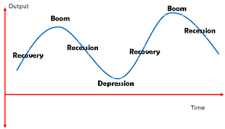

**Fig: 2, Cycle**

**Monsoon and Agriculture:**

In spite of technological advancement, Indian agriculture still depends heavily on the monsoons. Good monsoons are a boon for agriculture. Agriculture is directly and indirectly linked to many industries. When the monsoon fails, agricultural production and hydro power generation decline. They cast a shadow on the share market.

**Infrastructure facilities:**

Good infrastructure facilities affect the stock market favourably. Infrastructure facilities are essential for the growth of the industrial and agricultural sectors. A wide communications network is a must for the growth of the economy. Regular supply of energy without any power cuts will enhance production. The banking and financial sectors should also be strong enough to provide adequate support to industry and agriculture.

**Demographic factors:**

Demographic data provide details about the population by age, occupation, literacy, and geographic location. This is needed to forecast the demand for consumer goods. The population by age indicates the availability of a skilled workforce.

**Industry Analysis:**

An analysis of the performance, prospects, and problems of an industry of interest is known as industry analysis. The economic analysis gives an indication about the direction of the economy and the stock market. Industry analysis is required because the return and risk level of industries differ. The risk factors related to the automobile industry are different from those related to information technology industry. Consumer spending has a greater impact on automobile industry than on the IT industry. The performance of an industry reflects the performance of the companies it consists of.

An industry is a group of firms that have a similar technological structure of production and produce similar products.

**Kinds of industries:**

Industries can be classified on the basis of business cycle, i.e., classified according to their reactions to the different phases of business cycle. They are classified as growth, cyclical, defensive, and cyclical growth industries.

**Growth industry:**

Growth industries have special features of high rate of earnings and growth in expansion, independent of the business cycle. The expansion of the industry depends mainly on technological change.

**Cyclical industry:**

The growth and profitability of an industry move in tandem with the business cycle. During a boom, industries enjoy growth and during a depression they suffer a setback.

**Defensive industry:**

A defensive industry defines the movement of the business cycle. The stocks of defensive industries can be held by the investor for income earning purpose. They expand and earn income in a depression too, under the government’s umbrella of protection, and are counter-cyclical in nature.

**Cyclical growth industry:**

This is a new type of industry that is cyclical and at the same time growing.

**Industry life cycle:**

The industry life cycle theory is generally attributed to Julius Grodinsky, a professor at the Wharton school of Business. The life cycle of the industry is separated into four well defined stages as given below

* Pioneering stage
* Rapid growth stage
* Maturity and stabilization stage and
* Declining stage

**Pioneering stage:**

In this stage, the prospective demand from the product is promising and the technology of the product is low. The demand for the product encourages many producers to produce that particular product. There is sever competition and only the fittest companies survive this stage. The producers try to develop the brand name, differentiate the product, and create a product image. This leads to non-price competition too. The sever competition often leads to the change of position of the firms in terms of market shares and profits. In this situation it is difficult to select companies for investment because the survival rate is unknown.

**Rapid growth stage:**

This stage starts with the appearance of surviving forms from the pioneering stage. The companies that have withstood the competition steadily improve their market share and financial performance. The technology used in production improves resulting in low cost of production and good quality of products. The companies have stable growth in this stage and they declare dividend to their share holders. It is advisable to invest in the shares of these companies.

**Maturity and stabilization stage:**

In the stabilization stage, the growth rate tends to moderate and the rate of growth more or less equals the industrial growth rate or the gross domestic product growth rate. Symptoms of obsolescence may appear in technology. To keep going, technological innovations in the production process and products have to be introduced. Investors must closely monitor the events that take place in the maturity stage of industry.

**Declining stage:**

In this stage, demand for the particular product and the earnings of the companies in the industry decline. Innovation and changes in consumer preferences lead to this stage. The specific feature of the declining stage is that event in a boom; the growth of the industry is low and declines at a higher rate during a recession. It is better to avoid investing in the shares of the low-growth industry. Even during a boom. Investment in the shares of these types of companies leads to erosion of capital.

**Other Factors:**

A part from industry life cycle analysis, an investor must also analyze factors such as those given below.

* Growth of the industry
* Cost structure and profitability
* Nature of the product
* Nature of the competition
* Government policy
* Labour
* Research and development

**Growth of the industry:**

The historical performance of the industry in terms of growth and profitability should be analyzed. Even though history may not repeat in the exact manner, by looking into the past growth of the industry, an analyst can predict the future.

**Cost structure and profitability:**

The cost structure, that is the proportion fixed and variable costs, affects the cost of production and profitability of the firm. The higher the fixed cost component, the greater is the sales volume required to reach the firm’s break-even point. Once the break-even point is reached and production is on track, profitability can be increased by utilizing the capacity to full. Once the maximum capacity is reached, capital must again be invested in the fixed equipment. Hence, the lower the fixed costs, the easier it is to adjust to changing demand and to reach break-even point.

**Nature of the product:**

The products produced by the industries are demanded by the consumers and other industries. An investor must analyze the condition of the feeder industry as well as the end-user industry to assess the demand for industrial goods.

In the case of the consumer goods industry, a change in consumer preference, technological innovations, and substitute products affect demand.

**Nature of the competition:**

The nature of competition is an essential factor that determines the demand for a particular product, its profitability, and the price of the scrip concerned. The supply may arise from indigenous producers and multinationals. Multinationals are also entering the field with sophisticated process and better quality products. The company’s ability to withstand the competition locality and from the multinationals affects its earnings. If too many firms are present in the organized sector, the competition will be severe. It will lead to a decline in the price of the product. The investor, before investing in the scrip of a company, should analyze the market share of the particular company’s product and compare it with the top five companies.

**Government policy:**

Government policies affect the very nerve of the industry and the effects differ from industry to industry. Tax subsidies and tax holidays are provided for export-oriented products. The government regulates the size of production and the pricing of certain products. In some cases, entry barriers are placed by the government. When selecting an industry government policy regarding the particular industry should be carefully evaluated. Liberalization and delicensing have brought immense threat to existing domestic industries in several sectors.

**Labour:**

The analysis of the labour scenario in a particular industry is of great importance. The numbers of trade unions and their operating mode have an impact on labour productivity and modernization of the industry. If the trade unions are strong and strikes occur frequently, it will lead to a fall in production. In an industry of high fixed costs, the stoppage of production may lead to losses. When trade unions oppose the introduction of automation, in the product market the company may stand to lose owing to the high cost of production. An unhealthy labour relationship also leads to loss of customer’s goodwill.

**Research and Development:**

For any industry to survive the competition in the national and international markets, the product and production process have to be technically competitive. This depends on the R&D in the particular company or industry. Economies of scale and new markets can be obtained only through R&D. the percentage of expenditure on R&D should be studied diligently before making an investment.

**Company Analysis:**

Evaluating the financial performance of a company on the basis of qualitative and quantitative factors is called company analysis. Qualitative factors are non-quantifiable factors that represent certain aspects of a company’s business. Integrating such information into evaluation of stock prices can be quite difficult. At the same time, they cannot be ignored. The management factor is a qualitative factor. It is difficult to measure, yet exerts tremendous influence on the profitability, or even the existence of the company. Quantifiable factors are measurable factors like earnings, sales and cost of production, which directly affect the revenue of the company.

**Qualitative factors:**

The Qualitative factors that affect the values of the company’s shares are

* Business model
* Management
* Corporate governance
* Corporate culture

**Business model:**

The business model describes the way in which a company makes money. A business model may be simple or very complex. Even before making a financial analysis an investor must know what exactly the company does. It provides a description of the company’s operations and mode of revenue generation, nature of expenses, organizational structure and its sales and marketing efforts. A review of the business model reveals the possible success level of the company.

**Management:**

Good and capable management teams generate profits for investors. The management of a firm should efficiently plan, organize, actuate, and control the activities of the company. The basic objective of management is to attain the stated objectives of the company for the good of the equity holders, the public, and the employees. The following are the sources of management analysis:

* Conference calls
* Management discussion and analysis
* Management ownership of the equity stock

**Corporate governance:**

Corporate governance refers to the set of systems and practices put in place by a company to ensure accountability, transparency and fairness in dealings to safeguard the interests of the stake holders. The system and practices are defines and determined in the company charters and by-laws, as well as in corporate laws and regulations. Corporate governance is needed for the following reasons:

* To provide the framework for the creation of long-term trust between the company and the stake holders.
* To encourage induction of independent directors with rich experience and innovative ideas.
* To enable the management to monitor and face risk.
* To facilitate a careful decision-making process and reduce the liability of top management and directors.
* To ensure that proper checks and balances are in place to prevent non-ethical and illegal activities in company management.

**Corporate culture:**

Corporate culture refers to the collective beliefs, value systems and process of company. It gives a company a unique entity. Every company has a set of values and goals that helps to define what the business is all about. The basis of corporate culture is usually expressed in terms of the policies and procedures adopted in the company’s functioning. A strong corporate culture that enables adoption to a changing market leads to a strong financial results. A corporate culture that values employees, customers and owners and encourages leadership from everyone in the company is bound to perform well. If the customer needs change, a firm’s corporate culture changes the practices to meet these new needs.

**Quantitative factors:**

The following are the quantitative factors that influence the stock values:

* Earnings of the company
* Competitive edge
* Financial leverage
* Operational leverage
* Production efficiency
* Financial statements

**Earnings of the company:**

The earnings of the company decide its stock value in the market. The company pays dividend from its earnings. Growing earnings result in high valuation of the stock. The income for a company is generated through operating sources and non operating sources.

An investor should be aware that the income of the company may vary due to the following reasons:

* Change in sales
* Change in costs
* Depreciation and method adopted
* Depletion of resource in the case of oil, mining, forest products, gas, etc.
* Inventory accounting method
* Replacement cost of inventories
* Wages, salaries and fringe benefits
* Income tax and other taxes.

The measurement of earnings is done through:

* earnings per share
* diluted earnings per share
* growth in earnings
* price earnings multiples
* intrinsic value

**Financial Leverage:**

The degree of utilization of borrowed money in a business is known as financial leverage. This depends on the financing decisions of the company. These decisions involve the selection of the appropriate financing mix and deciding the capital structure or leverage. Capital structure refers to the proportion of long-term debt capital and equity capital in the company. The long-term debt capital includes bonds, debentures, etc, and preference share capital. A fixed rate of interest has to be paid for long term debt capital and payment is obligatory. A high degree of financial leverage (high usage of debt capital) results in high interest payments. This will affect the bottom line earnings per share negatively. As a company increases debt and preferred equities, interest payment increase. This reduces the EPS and increases the risk of stock returns.

The leverage effect of debt is highly advantageous to equity holders during a boom because the positive side of the leverage effect induces instability in earnings per share and can lead to bankruptcy. Hence, it is important to limit the debt component of the capital and keep it to a reasonable level. The limit depends on the firm’s earning capacity and its fixed assets.

**Operating leverage:**

If a firms fixed costs are a major portion of total costs, the firm is said to have a high degree of operating leverage. Leverage means the use of a lever to raise a heavy object with little force. A high degree of operating leverage implies that, other factors being constant, a relatively small change in sales results in a large change in return on equity.

**Competitive edge:**

Some companies rise to a position of eminence and dominance. The large companies are successful in meeting the competition. Once companies attend a leadership position in the market, they seldom lose it. Overtime they prove their ability to withstand the competition and retain a sizeable share of the market. The competitive of a company can be assessed by looking at the following aspects;

* market share
* growth of annual share
* stability of annual sales
* forecast sales

**Production efficiency:**

Production efficiency means producing the maximum output at minimum cost per unit of output. This efficiency measures how well the production or transformation process is performing. Increasing efficiency boosts the capacity of a business, without any change in the number of input employed. Efficient production efficiency enables the firm to produce goods at a lower cost than competitions and generate more profit possibly at lower prices. An expanding company that maintains high operating efficiency with a low break-even point earns more than the company with a high break-even point. This ultimately benefits the investor in the form of high earnings per share. Thus, increase in the production efficiency results in the following:

* increase in profitability
* low operational cost
* optimum use of company resources
* enhanced competitiveness and market share
* superior return to the investor

**Financial analysis:**

The best source of financial information about a company is its own financial statements. This is a primary source of information for evaluating the investment prospects in a company’s stock. The statement gives the historical and current information about the company’s operations. Historical financial statement helps to predict the future. The following are considered for analyzing the financial statements of a company:

* Balance sheet
* Profit and loss account.
* Comparative financial statements
* Trend analysis
* Common size statements
* Fund flow analysis
* Cash flow analysis
* Ratio analysis

**RESEARCH METHODOLOGY:**

**RESEARCH PROBLEM:**

Capital market has always been susceptible to the variety of variables pertaining the prices, trading, behavior, settlement, liquidity and economy. Every time one kind of formula or principle does not work that’s why I have decided to do research by using fundamental analysis in pharmaceutical industry. All stake holders (investors, brokers, management, merchant bankers, regulatory agencies, Government and researchers etc.) of the stock market have benefited by taking the use of technical and fundamental analysis.

**OBJECTIVES OF THE STUDY:**

1. To describe the economic factors influencing the securities market.
2. To analyse the Industry performance.
3. To analyse the company performance.
4. To analyse the growth of selected pharmaceutical industry.

**NEED FOR THE STUDY:**

Stock markets are the place to trade stock and securities; it operates as facilitator between investors and borrowers of capital by means of pooling of funds, sharing business risk and transferring their wealth. Prices of the shares are changing in stock markets on a daily basis. These changes in share price may associate with the changes in the underlying economic factors, industry performance and company’s growth. Hence by studying this topic we can analyse the stocks of pharmaceutical industry.

**SCOPE OF THE STUDY:**

The purpose of the project is to study about the growth of pharmaceutical companies by using fundamental analysis.The data used in analysis of the selected companies for a period of five years from 2013 to 2017 has been collected from the annual reports published by the companies.

**SOURCES OF DATA:**

Data collection is a process of collecting information from all the relevant sources to find answers to the research problem, test the hypothesis and evaluate the outcomes. Data collection methods can be divided into two categories: secondary methods of data collection and primary methods of data collection.

Secondary data is data that has been collected for another purpose. When we use Statistical Method with Primary Data from another purpose for our purpose we refer to it as Secondary Data. It means that one purpose's Primary Data is another purpose's Secondary Data.

The secondary data is considered for this study. It is collected from;

* Journals.
* Research articles.
* Newspapers.
* Websites of the companies.

**SAMPLE SIZE:**

This study considered the pharmaceutical companies listed in the NSE. This has high capitalization market share in the pharmaceutical industry at present.

**TOOLS FOR ANALYSIS:**

* Economy analysis.
* Industry analysis.
* Company analysis.
* Ratio analysis.

**LIMITATIONS OF THE STUDY:**

1. This study focused only on quantitative factors such as GDP, inflation rates, exchange rates, foreign exchange reserves, agriculture, industrial, service, currency markets & export growth and it does not include qualitative factors.
2. The Fundamental analysis may not be achieved if developed countries influenced by economic recession. Due to lack of experience and different perception amongst the analyst, bias may occur.

3. The study is limited to five years of data only.

4. The study is restricted to only 5 pharmaceutical companies.

5. The study is limited to secondary data only.

**Nicholas J Lillie (2016)** Using the Student Investment Fund at Claremont McKenna College as a proxy for inexperienced investors, I demonstrate that inexperienced investors using fundamental analysis produce momentum-like buying patterns. The results show that the Student Investment Fund is on average buying stocks that outperform Car hart’s four-factor asset pricing model in the year before purchase. As a result, the Student Investment Fund has, on average, underperformed the S&P500 by .48% per year since 1996. My thesis explores why the Student Investment Fund may have adopted momentum-like purchasing patterns and what steps can be taken to remedy it.

**Richard C. Grimm (2012)**explores fundamental analysis todetermine its application as an Austrian approach to common stock selection. The Thymologic method and the category of understanding are applied as frameworks for an Austrian approach and to evaluate fundamental analysis as a process for common stock selection. The analysis supports the conclusion that fundamental security analysis can be practiced in a manner consistent with traditional Austrian views and is suitable as a common stock selection method by those who wish to adhere to such views.

**Hossein Khanifar (2012)**this paper studies affecting factorson analysts’ decisions in Tehran Stock Exchange. Principally, analysts use two types of fundamental and technical analyses in their decisions. In present research, they have studied the affecting factors on analysts’ decisions in the format of fundamental analysis. Such analysis is studied in three sectors: (1) economy/market, (2) industry, firm. This paper uses analytical approach to study affecting factors on analysts’ decisions. Its statistical population contains analysts in brokering companies at Tehran Stock Exchange. Based on the results, it was determined that firm – related factors such as actual EPS, estimated EPS, profit margin, P/E ratio and sale rate have the highest importance in analysts’ decisions followed by economy/market related factors and industry – related factors.

**Dyna Sen (2012)**He has taken fundamental analysis researchbeyond the spatial and temporal bounds of previous studies. They have investigated how detailed financial statement data enter the decisions of market makers by examining how current changes in the fundamental signals chosen can provide information on subsequent earnings changes. Using global data from 1990 to 2000, they have extended the body of research using fundamental signals for prediction of future earnings changes. Contextual factors such as prior earnings news, industry membership, macroeconomic conditions and country of incorporation that may influence this predictive ability are also investigated. Results indicate that the fundamental signals are significant predictors of both short- and long-term future earnings changes. Research results provide evidence to support the use of fundamental analysis.

**Jenni L., Bettman, Stephen. J. Sault, Emma. Schultz (2008),** proposes an equity valuation model integrating Fundamental and Technical analysis, they tend to recognize their potential as complements rather than as substitutes. Testing confirms the complementary nature of Fundamental and Technical analysis by showing that in spite of each performing in isolation models integrating both have superior explanatory power.

**Sanjay Seghal and Meenkashi gupta (2005)** presents the survey which aims at providing insights about the way technical traders operate in the financial market and the trading strategies that they adopt. The survey covered institutional and individual technical traders with a long and active trading record for the Indian market. In this study also it is observed that the sample respondents tend to use Technical analysis along with Fundamental analysis for security selection.

**Pascal Nguyen, (2003)** constructs a simple financial score designed to capture short term changes in firm operating efficiency, profitability and financial policy. The scores exhibit a strong correlation with market adjusted returns in the Current fiscal period and the same continues in the following period also.

**Nobert. M. Flies, Ronald Macdonald (2002)**assign a special importance to the open, high, low and closed prices in forecasting the mean and volatility of exchange rates using Technical analysis. In this paper the authors propose to investigate the time series properties and the informational content of these different prices, using range and Co integration methods. In sum, in this article it is argued that a Technical analysis of high low and close prices is useful way of learning about latent granger causality in high frequency exchange rate.

**Doran Nissim and Stephen.H.Penman (2001),** this research work envisages on Financial Statement Analysis and identifies that this analysis has traditionally been seen as part of the Fundamental analysis required for equity valuation. This paper outlines a financial statement analysis for use in equity valuation. Standard profitability is incorporated, and extended and is complemented with an analysis of growth.

**Thomas Oberlechner (2001)** presents the findings of a questionnaire and an interview survey on the perceived importance of Technical and Fundamental analysis among foreign exchange traders and financial journalists in Frankfurt, London, Vienna and Zurich. Foreign Exchange traders confirm that, out of the both forecasting approaches, technical analysis is more prominent than the other. But the Financial journalists put more emphasis on fundamental analysis than foreign exchange traders.

**Joseph. D. Piotroski (2000)** examines whether a simple accounting based Fundamental Analysis strategy, when applied to a broad portfolio of high Book to Market firms, can shift the distribution of returns earned by an investor. The research shows that the mean returns earned by a high Book to Market investor can be increased by at least 7.5% annually through the selection of financially strong high Book to Market firms.

**Yu-Hon Luis and David Mole (1998)** reports on the use by foreign exchange dealers in Hong Kong of fundamental and technical analyses to form their forecasts of exchange rate movements. The findings of this study reveal that more than 90 percent of the respondents rely on both fundamental and technical analyses for predicting future rate movements at different horizons.

**Lev and Thiagarajan (1993)** use conceptual arguments to study their ratios. They demonstrate that the earnings prediction signals in variables like growth in accounts receivables relative to sales growth and gross margin rate are incrementally associated with contemporaneous stock returns and are significant in predicting future earnings.

**Yasaswy N.J (1993)** disclosed how 'turnaround stocks' offer big profits to bold investors and also the risks involved in investing in such stocks. Turnaround stocks are stocks with extraordinary potential and are relatively under priced at a given point of time. He also revealed that when the economy is in recession and the fundamentals are weak, the stock market, being a barometer of the economy, also tends to be depressed. A depressed stock market is an ideal hunting ground for 'bargain hunters', who are aggressive investors. Sooner or later recovery takes place which may take a very long time. He concluded that the investors' watch work is 'caution' as he may lose if the turnaround strategy does not work out as anticipated.

**Lewis Mendel’s (1992)** reviewed the nature of market risk, which according to him is very much 'global'. He revealed that certain risks that are so global that they affect the entire investment market. Even the stocks and bonds of the well-managed companies face market risk. He concluded that market risk is influenced by factors that cannot be predicted accurately like economic conditions, political events, mass psychological factors, etc. Market risk is the systemic risk that affects all securities simultaneously and it cannot be reduced through diversification.

**Nabhi Kumar Jain (1992)**specified certain tips for buying shares for holding and also for selling shares. He advised the investors to buy shares of a growing company of a growing industry. Buy shares by diversifying in a number of growth companies operating in a different but equally fast growing sector of the economy. He suggested selling the shares the moment company has or almost reached the peak of its growth. Also, sell the shares the moment you realize you have made a mistake in the initial selection of the shares. The only option to decide when to buy and sell high priced shares is to identify the individual merit or demerit of each of the shares in the portfolio and arrive at a decision.

**Carter Randal (1992)** offered to investors the underlying principles of winning on the stock market. He emphasized on long-term vision and a plan to reach the goals. He advised the investors that to be successful, they should never be pessimists. He revealed that - though there has been a major economic crisis almost every year, it remains true that patient investors have consistently made money in the equities market. He concluded that investing in the stock market should be an un-emotional endeavor and suggested that investors should own a stock if they believe it would perform well.

**L.C.Gupta (1992)** revealed the findings of his study that there is existence of wild speculation in the Indian stock market. The over speculative character of the Indian stock market is reflected in extremely high concentration of the market activity in a handful of shares to the neglect of the remaining shares and absolutely high trading velocities of the speculative counters. He opined that, short- term speculation, if excessive, could lead to "artificial price". An artificial price is one which is not justified by prospective earnings, dividends, financial strength and assets or which is brought about by speculators through rumors’, manipulations, etc. He concluded that such artificial prices are bound to crash sometime or other as history has repeated and proved.

**David.L.Scott and William Edward (1990)** reviewed the important risks of owning common stocks and the ways to minimize these risks. They commented that the severity of financial risk depends on how heavily a business relies on debt. Financial risk is relatively easy to minimize if an investor sticks to the common stocks of companies that employ small amounts of debt. They suggested that a relatively easy way to ensure some degree of liquidity is to restrict investment in stocks having a history of adequate trading volume. Investors concerned about business risk can reduce it by selecting common stocks of firms that are diversified in several unrelated industries.

**Ou and Penman (1989)** use financial statement analysis of income statement and balance sheet ratios to forecast future earnings. The primary motivation for this research is to identify mispriced securities. However, these authors demonstrate that the information in the earnings prediction signals is helpful in generating abnormal stock

**Jack Clark Francis (1986)** revealed the importance of the rate of return in investments and reviewed the possibility of default and bankruptcy risk. He opined that in an uncertain world, investors cannot predict exactly what rate of return an investment will yield. However he suggested that the investors can formulate a probability distribution of the possible rates of return. He also opined that an investor who purchases corporate securities must face the possibility of default and bankruptcy by the issuer. Financial analysts can foresee bankruptcy. He disclosed some easily observable warnings of a firm's failure, which could be noticed by the investors to avoid such a risk.

**Preethi Singh (1986)** disclosed the basic rules for selecting the company to invest in. She opined that understanding and measuring return and risk is fundamental to the investment process. According to her, most investors are 'risk averse'. To have a higher return the investor has to face greater risks. She concludes that risk is fundamental to the process of investment. Every investor should have an understanding of the various pitfalls of investments. The investor should carefully analyse the financial statements with special reference to solvency, profitability, EPS, and efficiency of the company.

**Grewal S.S and Navjot Grewall(1984)** revealed some basic investment rules and rules for selling shares. They warned the investors not to buy unlisted shares, as Stock Exchanges do not permit trading in unlisted shares. Another rule that they specify is not to buy inactive shares, i.e., shares in which transactions take place rarely. The main reason why shares are inactive is because there are no buyers for them. They are mostly shares of companies, which are not doing well. A third rule according to them is not to buy shares in closely-held companies because these shares tend to be less active than those of widely held ones since they have a fewer number of shareholders. They caution not to hold the shares for a long period, expecting a high price, but to sell whenever one earns a reasonable reward.

**INDUSTRY PROFILE:**

The first Indian Pharmaceutical company, Bengal Chemicals and Pharmaceutical Works, which still exists today as one of 5 government-owned drug manufacturers, appeared in Calcutta in 1930. These five public sector drug-manufacturing units under the Ministry of Chemicals and Fertilizers are: Indian Drugs and Pharmaceutical Limited (IDPL), Hindustan Antibiotics Limited (HAL), Bengal Immunity Limited (BIL), Bengal Chemicals and Pharmaceutical Limited (BCPL) and Smith Stan Street Pharmaceutical Limited (SSPL). In addition, there are a number of pharmaceutical manufacturing units under the control of state governments such as Goa Antibiotics Ltd. and Karnataka Antibiotics Ltd. For the next 60 years, most of the drugs in India were imported by multinationals either in fully-formulated or bulk form. There are 24,000 licensed pharmaceutical companies. Of the 465 bulk drugs used in India, approximately 425 are manufactured here. India has more drug manufacturing facilities that have been approved by the U.S. Food and Drug Administration than any country other than the US. Indian generics companies supply 84% of the AIDS drugs that Doctors without Borders uses to treat 60,000 patients in more than 30 countries.

The Indian pharmaceutical industry currently tops the chart amongst India's science-based industries with wide ranging capabilities in the complex field of drug manufacture and technology. A highly organized sector, the Indian pharmaceutical industry is estimated to be worth $ 6 billion, growing 104 at about 10 percent annually. It ranks very high amongst all the third world countries, in terms of technology, quality and the vast range of medicines that are manufactured. It ranges from simple headache pills to sophisticated antibiotics and complex cardiac compounds; almost every type of medicine is now made in the Indian pharmaceutical industry.

The Indian pharmaceutical sector has expanded drastically in the last two decades. The Pharmaceutical industry in India is an extremely fragmented market with severe price competition and government price control. The Pharmaceutical industry in India meets around 90% of the country's demand for bulk drugs, drug intermediates, pharmaceutical formulations, chemicals, tablets, capsules, orals and injectables. There are approximately 300 big and medium scale Pharmaceutical companies and about 8000 Small scale units, which form the core of the pharmaceutical industry in India.

In future it will be a growth period of the Indian Pharmaceutical Industry. The growth is expected to emerge from three major areas:

1. Contract research and development services.

2. Export led business of generics and bulk drugs and

3. Growth in specialty therapeutic areas in the domestic market.

As regards the pharmaceutical marketing in the world, India is becoming one of the front runner destinations because of its second largest population in the world, the pace of development of its economy, adoption of technological advancements, economical medical treatment cost and also availability of world renowned physician’s etc. Following are the advantages of Indian Healthcare Scenario: Competent workforce: India possesses a skillful work force with high managerial and technical competence. Cost-effective chemical synthesis: The track record for development, particularly in the area of improved cost-beneficial chemical synthesis for various drug molecules is excellent. Legal and Financial Framework: India is a democratic country with a solid legal framework and strong financial markets. There is already an established international industry and business community. ™ Information and Technology: It has a good network of world-class educational institutions and established strengths in Information Technology. Globalization: The country is committed to a free market economy and globalization. Above all, it has a 70 million middle class market, which is constantly growing.

Since the end of the 1980s, India has been exporting more pharmaceutical than it imports. Over the last ten years the export surplus has widened from EUR 370 m to EUR 2 bn. At 32% in 2006, the export ratio was about twice as high as in 1996 and will likely rise further in the coming years The government started to encourage the growth of drug manufacturing by Indian companies in the early 1960s, and with the Patents Act in 1970, the pharmaceutical industry developed with greater space. This 116 Patent Act removed composition patents from food and drugs, and though it kept process patents, these were shortened to a period of five to seven years. The lack of patent protection made the Indian market undesirable to the multinational companies that had dominated the market, and while they streamed out, Indian companies started to take their places. They carved a niche in both the Indian and world markets with their expertise in reverse engineering new processes for manufacturing drugs at low costs. Although some of the larger companies have taken small steps towards drug innovation, the industry as a whole has been following this business model until the present. Until the 1970s, India’s pharmaceutical market was mainly supplied by large international corporations. Only cheap bulk drugs were produced domestically by state-owned companies founded in the 1950s and 60s with the help of the World Health Organization (WHO). These state-run firms provided the foundation for the sector’s growth since the 1970s. Back then, Indian government aimed to reduce the country’s strong dependence on pharmaceutical imports by flexible patent legislation and to create a self reliant sector. In addition, it introduced high tariffs and limits on imported medicines and demanded that foreign pharmaceutical companies reduce their shares in their Indian subsidiaries to two fifths. This made India a less attractive location for international companies, many of which left the country as a consequence. Especially Indian Drugs and Pharmaceutical Ltd. (IDPL) are credited with speeding up the development of a national pharmaceutical industry. In the 1980s, however, the decline of state-run companies began - among other things because of 117 increasing central government bureaucracy and insufficient corporate governance. By contrast, the weakening of the Patent system and numerous protectionist measures sped up the development of a major national pharmaceutical industry on a private-sector basis, which made it possible to provide the population with a large number of drugs. Legal changes in India, in 2005, made it considerably more difficult to produce “new” generics. Foreign pharmaceutical, which enjoy 20 years of patent protection, can no longer be copied by means of alternative production procedures and sold in the domestic market. Hence, a reorientation was required in India’s pharmaceutical industry. It now focuses on drugs developed in-house and contract research or contract production for western drug makers. The sector’s development is slowed by major infrastructure problems. These are, above all, qualitative and quantitative shortcomings in the power and transport sectors. In 2001, India’s pharmaceutical industry became the focus of public debate when CIPLA, the country's second-largest pharmaceutical company, offered an AIDS drug to African countries for the price of USD 300, while the same preparation cost USD 12,000 in the US. This was possible because the Indian company produced an all-in-one generic pill which contains all three substances (Stavudine, Lamivudine and Nevirapine) required in the treatment of AIDS. This kind of production is much more difficult in other countries as the patents are held by three different companies. In the final analysis, the price slump was a result of 118 India's lax patent legislation. In 2005, patent legislation was tightened, so India’s pharmaceutical sector had to adjust.

**DEVELOPMENT OF INDIA’S PHARMACEUTICAL INDUSTRY:**

Till the 1970s, India’s pharmaceutical market was mainly supplied by large international corporations. Only economical bulk drugs were produced domestically by state-owned companies founded in the 1950s and 60s with the help of the World Health Organization (WHO). These state-run firms provided the foundation for the sector’s growth since the 1970s. Back then, Indian government aimed to reduce the country’s strong dependence on pharmaceutical imports by flexible patent legislation and to create a self reliant sector. In addition, it introduced high tariffs and limits on imported medicines and demanded that foreign pharmaceutical companies reduce their shares in their Indian subsidiaries to two-fifths. Large Market Share for Generic Drugs As there was no efficient patent protection between 1970 and 2005; many Indian drug producers copied expensive original preparations by foreign firms and produced these generics by means of alternative production procedures. This proved more cost-efficient than the expensive development of original preparations as no funds were required for research, which contained the financial risks. This spending may come to as much as EUR 600 m for only one drug. This kind of money could previously only be raised by large corporations in the industrial countries. The competitiveness of generics producers is based on cost-efficient production. In this field, Indian companies are currently in top position. At 119 one-fifth, India’s share in the global market for generic drugs is considerably higher than its share in the overall pharmaceutical market (approx. 2%). At the same time, India’s pharmaceutical companies gained know-how in the manufacture of generic drugs. Hence the name “pharmaceutical company of the poor” which is frequently applied to India. This is of significance for the domestic market as disposable income is as little as EUR 1,900 per year for roughly 140 million of the total of 192 million Indian households, which means the majority of Indians, cannot afford expensive western preparations. Exports of Pharmaceutical Products In 2006, India’s pharmaceutical industry exported products worth EUR 3 bn, up from only EUR 650 m in 1996, which was due to the fact that demand for low-cost generic drugs is strongly on the rise, above all in the US, Europe and Japan. At 22%, export growth in 2006 was even twice as high as the global average and in Germany (roughly 11% each). Meanwhile, India’s export ratio has reached 32% about double the figure registered ten years ago. For some time now, India has exported more pharmaceutical products than it imports. Over the last ten years, the export surplus has risen from about EUR 370 m to currently just under EUR 2 bn. Slightly over 80% of the drugs are sold to the US and Europe, where Indian companies are benefiting from the population’s purchasing power as well as regulatory changes (greater cost-consciousness). By contrast, traditional sales markets such as Russia, Southeast Asia, Africa and Latin America have lost its importance. However, only 60 production locations of India’s pharmaceutical sector have been certified by the World Health Organization, which implies they comply with the strict quality standards imposed by the US Food and Drug Administration (FDA), Compliance with FDA standards is the precondition for selling products on the important US market.

**Market Size**

Indian pharmaceutical sector is estimated to account for 3.1 – 3.6 per cent of the global pharmaceutical industry in value terms and 10 per cent in volume terms. It is expected to grow to US$100 billion by 2025. The market is expected to grow to US$ 55 billion by 2020, thereby emerging as the sixth largest pharmaceutical market globally by absolute size. Branded generics dominate the pharmaceuticals market, constituting nearly 80 per cent of the market share (in terms of revenues). The sector is expected to generate 58,000 additional job opportunities by the year 2025.

India’s pharmaceutical exports stood at US$ 16.8 billion in 2016-17 and are expected to grow by 30 per cent over the next three years to reach US$ 20 billion by 2020, according to the Pharmaceuticals Export Promotion Council of India (PHARMEXCIL). Export of pharmaceutical items reached Rs. 696.84 billion (US$ 10.76 billion) during April 2017 – January 2018.

Indian companies received 304 Abbreviated New Drug Application (ANDA) approvals from the US Food and Drug Administration (USFDA) in 2017. The country accounts for around 30 per cent (by volume) and about 10 per cent (value) in the US$ 70-80 billion US generics market.

India's biotechnology industry comprising bio-pharmaceuticals, bio-services, bio-agriculture, bio-industry and bioinformatics is expected grow at an average growth rate of around 30 per cent a year and reach US$ 100 billion by 2025. Biopharma, comprising vaccines, therapeutics and diagnostics, is the largest sub-sector contributing nearly 62 per cent of the total revenues at Rs 12,600 crore (US$ 1.89 billion).

**Investments**

The Union Cabinet has given its nod for the amendment of the existing Foreign Direct Investment (FDI) policy in the pharmaceutical sector in order to allow FDI up to 100 per cent under the automatic route for manufacturing of medical devices subject to certain conditions.

The drugs and pharmaceuticals sector attracted cumulative FDI inflows worth US$ 15.59 billion between April 2000 and December 2017, according to data released by the Department of Industrial Policy and Promotion (DIPP).

Some of the recent developments/investments in the Indian pharmaceutical sector are as follows:

* As of March 2018, a consortium led by Indian private equity firm Chrys Capital is planning to buy a 10 per cent stake in Mankind Pharma for US$ 350 million.
* The exports of Indian pharmaceutical industry to the US will get a boost, as branded drugs worth US$ 55 billion will become off-patent during 2017-2019.#
* Private equity and venture capital (PE-VC) investments in the pharmaceutical sector have grown at 38 per cent year-on-year between January-June 2017, due to major deals in this sector.

**Government Initiatives**

Some of the initiatives taken by the government to promote the pharmaceutical sector in India are as follows:

* In March 2018, the Drug Controller General of India (DCGI) announced its plans to start a single-window facility to provide consents, approvals and other information. The move is aimed at giving a push to the Make in India initiative.
* The Government of India is planning to set up an electronic platform to regulate online pharmacies under a new policy, in order to stop any misuse due to easy availability.
* The Government of India unveiled 'Pharma Vision 2020' aimed at making India a global leader in end-to-end drug manufacture. Approval time for new facilities has been reduced to boost investments.
* The government introduced mechanisms such as the Drug Price Control Order and the National Pharmaceutical Pricing Authority to deal with the issue of affordability and availability of medicines.

**Road Ahead**

The Indian pharmaceutical market size is expected to grow to US$ 100 billion by 2025, driven by increasing consumer spending, rapid urbanization, and raising healthcare insurance among others. Pharma sector’s revenues are expected to grow by 9 per cent year-on-year through fiscal 2020. Going forward, better growth in domestic sales would also depend on the ability of companies to align their product portfolio towards chronic therapies for diseases such as such as cardiovascular, anti-diabetes, anti-depressants and anti-cancers that are on the rise.

The Indian government has taken many steps to reduce costs and bring down healthcare expenses. Speedy introduction of generic drugs into the market has remained in focus and is expected to benefit the Indian pharmaceutical companies. In addition, the thrust on rural health programmes, lifesaving drugs and preventive vaccines also augurs well for the pharmaceutical companies.

**COMPANY PROFILE:**

1. **SUN PHARMA :**

Sun pharmaceutical industries limited are an Indian multinational company headquartered in Mumbai, Maharashtra that manufactures and sells pharmaceutical formulations and active pharmaceutical ingredients (APIs) primarily in India and the United States. The company offers formulation in various therapeutic areas, such as cardiology, psychiatry, neurology, gastroenterology and diabetology. It also provides APIs such as warfarin, carbamazepine, etodolac, and yclorazepate, as well as anticancer, steroids, peptides, sex hormones, and controlled substances.

Sun Pharmaceuticals was established by Mr. Dilip Shanghvi in 1983 in Vapi with five products to treat psychiatry ailments. Cardiology products were introduced in 1987 followed by gastroenterology products in 1989. Today, it is the largest chronic prescription company in India and a market leader in psychiatry, neurology, cardiology, orthopedics, gastroenterology.

The 2014 acquisition of Ranbaxy has made the company the largest pharma company in India, the largest Indian pharma company in the US, and the 4th largest specialty generic company globally.

Over 72% of Sun Pharma sales are from markets outside India, primarily in the US. The US is the single largest market, accounting for about 50% turnover; in all, formulations or finished dosage forms, account for 93% of the turnover. Manufacturing is across 26 locations, including plants in the US, Canada, Brazil, Mexico and Israel. In the US, the company markets a large basket of generics, with a strong pipeline awaiting approval from the U.S. Food and Drug Administration (FDA).

Sun Pharma was listed on the stock exchange in 1994 in an issue oversubscribed 55 times. The founding family continues to hold a majority stake in the company. Today Sun Pharma is the second largest and the most profitable pharmaceutical company in India, as well as the largest pharmaceutical company by market capitalisation on the Indian exchanges.

The Indian pharmaceutical industry has become the third largest producer in the world in terms of volumes and is poised to grow into an industry of $20 billion in 2015 from the current turnover of $12 billion.In terms of value India still stands at number 14 in the world.

In 2009 Sun Pharma's Caraco Pharmaceutical's plant in Detroit was closed due to unsanitary conditions resulting in the seizure of $20 million of drugs by the FDA for contamination issues. In December 2016 the FDA sent Sun a warning letter about nine violations at its manufacturing plant in Halol. Sun Pharma requested the USFDA to withdraw approval for 28 Abbreviated New Drug Applications (ANDAs) belonging to its wholly owned subsidiary Ranbaxy Laboratories.

Sun Pharma has complemented growth with select acquisitions over the last two decades. In 1996, Sun purchased a bulk drug manufacturing plant at Ahmednagar from Knoll Pharmaceuticals and MJ Pharma's dosage plant at Halol that are both U.S. FDA approved today. In 1997, Sun acquired Tamil Nadu Dadha Pharmaceuticals Limited (TDPL) based in Chennai, mainly for their extensive gynecology and oncology brands. Also in 1997, Sun Pharma initiated their first foray into the lucrative US market with the acquisition of Caraco Pharmaceuticals, based in Detroit.

In 1998, Sun acquired a number of respiratory brands from Natco Pharma. Other notable acquisitions include Milmet Labs and Gujarat Lyka Organics (1999), Pradeep Drug Company (2000), Phlox Pharma (2004), a formulation plant at Bryan, Ohio and ICN, Hungary from Valeant Pharma and Able Labs (2005), and Chattem Chemicals (2008). In 2010, the company acquired a large stake in Taro Pharmaceuticals, amongst the largest generic derma companies in the US, with operations across Canada and Israel. The company currently owns 69% stake in Taro, for about $260 million.

In 2011, Sun Pharma entered into a joint venture with MSD to bring complex or differentiated generics to emerging markets (other than India).

In 2012, Sun announced acquisitions of two US companies: DUSA Pharmaceuticals, a dermatology device company; and generic pharma company URL Pharma.  In 2013, the company announced an R&D joint venture for ophthalmology with the research company, Intrexon.

On 6 April 2014, Sun Pharma announced that it would acquire 100% of Ranbaxy Laboratories Ltd, in an all-stock transaction, valued at $4 billion. Japan's Daiichi Sankyo held 63.4% stake in Ranbaxy. After this acquisition, Sun Pharma has become the largest pharmaceutical company in India, the largest Indian Pharma company in the US, and the 5th largest generic company worldwide.

In December 2014, the Competition Commission of India approved Sun Pharma's $3.2 billion bid to buy Ranbaxy Laboratories, but ordered the firms to divest seven products to ensure the deal doesn't harm competition.

In March 2015, Sun Pharma announced it had agreed to buy GlaxoSmithKline's opiates business in Australia to strengthen its pain management portfolio.

In 2007, Sun Pharma demerged its innovative R&D arm, and listed it separately on the stock market as the Sun Pharma Advanced Research Company Ltd. In 2013, SPARC declared revenue of Rs. 873 million. SPARC focuses on new chemical entities (NCE) research and new drug delivery systems and offers an annual update of its pipeline (NDDS)

Sun Pharma stood second in the India's Most Reputed Brands (Pharmaceutical) list in a study conducted by Blue Bytes, a leading Media Analytics firm in association with TRA Research, a brand insights organization (both a part of the Comniscient Group).

1. **CIPLA :**

Cipla limited is an Indian multinational pharmaceutical and biotechnology company, headquartered in Mumbai, India. Cipla primarily develops medicines to treat respiratory, cardiovascular disease, arthritis, diabetes, weight control and depression; other medical conditions.

As of 17 September 2014, its market capitalisation was 517 billion (US$7.9 billion) (US$7.7 billion), making it India's 42nd largest publicly traded company by market value.

Cipla limited was founded by Khwaja Abdul Hamied as 'The **C**hemical, **I**ndustrial & **P**harmaceutical **La**boratories' in 1935 in Mumbai. The name of the Company was changed to 'Cipla Limited' on 20 July 1984. In the year 1985, US FDA approved the company's bulk drug manufacturing facilities. Led by the founder’s son Yusuf Hamied, a Cambridge-educated chemist, the company provided generic AIDS and other drugs to treat poor people in the developing world. In 1994, Cipla launched Deferiprone, the world’s first oral iron chelator. In 2001, Cipla offered medicines (antiretrovirals) for HIV treatment at a fractional cost (less than $350 per year per patient).

In 2013 Cipla acquired the South African company Cipla-Medpro, kept it as a subsidiary, and changed its name to Cipla Medpro South Africa Limited. At the time of the acquisition Cipla-Medpro had been a distribution partner for Cipla and was South Africa's third biggest pharmaceutical company. The company had been founded in 2002 and was known as Enaleni Pharmaceuticals Ltd. In 2005, Enaleni bought all the shares of Cipla-Medpro, which had been a joint venture between Cipla and Medpro Pharmaceuticals, a South African generics company, and in 2008 it changed its name to Cipla-Medpro.

They are the world's largest manufacturer of antiretroviral drugs

Cipla has 34 manufacturing units in 8 locations across India and has presence in 100 countries. Exports accounted for 48% 49.48 billion (US$760 million) of its revenue for FY 2013-14. Cipla spent INR 517 cr. (5.4% of revenue) in FY 2013-14 on R&D activities. The primary focus areas for R&D were development of new formulations, drug-delivery systems and APIs (active pharmaceutical ingredients). Cipla also cooperates with other enterprises in areas such as consulting, commissioning, engineering, project appraisal, quality control, know-how transfer, support, and plant supply.

As on 31 March 2013, the company had 22,036 employees (out of which 2,455 were women (7.30%) and 23 were employees with disabilities (0.1%)). During the FY 2013-14, the company incurred ₹12.85 billion (US$200 million) on employee benefit expenses.

The equity shares of Cipla are listed on the Bombay Stock Exchange, where it is a constituent of the BSE SENSEX index, and the National Stock Exchange of India, where it is a constituent of the CNX Nifty. Its Global Depository Receipts (GDRs) are listed on the Luxembourg Stock Exchange.As on 30 September 2014, the promoter group, Y. K. Hamied and his family, held around 36.80% equity shares in Cipla. Around 148,000 individual shareholders held approx. 18.67% of its shares. LIC is the largest non-promoter shareholder with approx. 6.45% shareholding in the company by the end of September 2013.

* In 2012, Cipla received the Thomson Reuters India Innovation Award.
* Cipla won Dun & Bradstreet American Express Corporate Awards for 2006.
* In 2005, Forbes included Cipla in the 200 'Best under a billion' list of best small Asian companies.
* In 1980, Cipla won Chem excil Award for Excellence for exports.
* Cipla stood third in the India's Most Reputed Brands (Pharmaceutical) list in a study conducted by Blue Bytes, a leading Media Analytics firm in association with TRA Research a brand insights organization (both a part of the Comniscient Group).

In August 2007, Cipla launched an emergency contraception drug "i-pill" sold over the counter, which was controversial with regard to its being available without a prescription and the large amount of drug contained per dose.

### Generic drugs

In the late 1960s, Cipla began manufacturing a new, patented drug, propranolol, without the permission of the drug's patent holder, Imperial Chemical Industries (ICI), which protested to the Indian government. The CEO of Cipla successfully lobbied the government of Indira Gandhi to change India's patent laws to eliminate patents that directly covered drugs, and instead to allow only patents that covered methods to make drugs. This change made propranolol and other patented drugs generic and led to criticism of both India's patent laws and Cipla. India reinstated patents on drugs in 2005.

1. **Cadila Healthcare**

**Cadila Healthcare** is an Indian multinational pharmaceutical company which is headquartered at Ahmedabad in Gujarat state of western India. The company is the fourth largest pharmaceutical company in India, with INR 54.7 Billion revenue (2015). It is a significant manufacturer of generic drugs.

Cadila was founded in 1952 by Ramanbhai Patel (1925–2001), formerly a lecturer in the L.M. College of Pharmacy, and his business partner Indravadan Modi. It evolved over the next four decades into an established pharmaceutical company.

In 1995 the Patel and Modi families split, with the Modi family's share being moved into a new company called Cadila Pharmaceuticals Ltd. and Cadila Healthcare became the Patel family's holding company. Cadila Healthcare had its initial public offering on the Bombay Stock Exchange in 2000 as stock code 532321.

In 2015 the company acquired another Indian pharmaceutical company called German Remedies. On June 25, 2007, the company acquired Química e Farmacêutica Nikkho do Brasil Ltda (Nikkho) as part of Zydus Healthcare Brasil Ltda.

In 2010, Cadila Healthcare received a Wellcome Trust Award under the "R&D for Affordable Healthcare in India" initiative.

In 2014, Cadila Healthcare launched the world's first adalimumab biosimilars under the brand name Exemptia at one-fifth the originator's price. Zydus Cadila Healthcare has also launched its first research based drug molecule Saroglitazar in treatment of Diabetic Dyslipidemia under brand name "Lipaglyn". SoviHep is the first sofosbuvir brand launched in India by Zydus in year 2015.

From nine pharmaceutical production operations in India as well as a Zydus Cadila develops and manufactures a large range of pharmaceuticals as well as diagnostics, herbal products, skin care products and other OTC products. Starting from late 2015, having concluded a voluntary license agreement with Gilead, the company also produces the generics for hepatitis C treatment (i.e. sofosbivur, distributed under the brand name SoviHep).

The company makes active pharmaceutical ingredients at three sites in India:

**Ankleshwar plants**

Zydus Cadila's plant complex at Ankleshwar in Bharuch District of Gujarat, has been producing drug material since 1972. There are around 12 plants in the complex, which is ISO 9002 and ISO 14001 certified approved by the U.S. Food and Drug Administration (FDA). Total plant capacity at Ankleshwar is around 180 million tonnes.

**Vadodara plant**

Zydus Cadila's plant at Dhabhasa, in Vadodara District's Padra taluka (in the eastern part of the district) in Gujarat, was commissioned in 1997 by a company called Banyan Chemicals, and acquired by Zydus Cadila in 2002. The plant has a 90 million tone capacity. It is approved by the U.S. FDA and is also approved to World Health Organization(WHO) good manufacturing practice (GMP) standards.

**Patalganga plant**

Zydus Cadila acquired an API plant at Patalganga in Maharashtra state, 70 km from Mumbai, about 859 km from Nagpur, in the 2001 German Remedies deal. This plant operates to WHO GMP standards

1. **Aurobindo Pharma Limited**

**Aurobindo Pharma Limited** is a pharmaceutical manufacturing company headquartered in HITEC City, Hyderabad, India. The company manufactures generic pharmaceuticals and active pharmaceutical ingredients. The company’s area of activity includes six major therapeutic/product areas: antibiotics, anti-retrovirals, cardiovascular products, central nervous system products, gastroenterologicals, and anti-allergic. The company markets these products in over 125 countries. Its marketing partners include AstraZeneca and Pfizer

The company commenced operations in 1988-89 with a single unit manufacturing semi-synthetic penicillin (SSP) in Pondicherry. Aurobindo Pharma became a public company in 1992 and listed its shares in the Indian stock exchanges in 1995. Aurobindo Pharma also has a presence in key therapeutic segments such as neurosciences, cardiovascular, anti-retrovirals, anti-diabetics, gastroenterology and cephalosporin’s, among others.

Aurobindo Pharma features among the top 10 companies in India in terms of consolidated revenues. Aurobindo exports to over 125 countries across the globe with more than 70% of its revenues derived out of international operations.

In 2014, Aurobindo purchased the generic operations of Actavis in 7 Western European countries for $41 million.

Aurobindo Pharma plans to expand its product portfolio with high value products in oncology, hormones, biosimilars and novel drug delivery solutions like depot injections, inhalers, patches and films. It has also set its sights on geographic expansion in new territories like Poland, Italy, Spain, Czech Republic, Portugal and France as generic penetration in these countries is low.

In 2017, Aurobindo Pharma inked a pact to acquire Portugal’s Generis Farmaceutica SA from Magnum Capital Partners for a consideration of €135 million. It also acquired four biosimilars products from Swiss firm TL Biopharmaceutical AG.

Legal issues:

In December 2016, the attorneys general of 20 states filed a civil complaint accusing Aurobindo Pharma of a coordinated scheme to artificially maintain high prices for a generic antibiotic and diabetes drug. The complaint alleged price collusion schemes between six pharmaceutical firms including informal gatherings, telephone calls, and text messages.

1. **Dr. Reddy’s Laboratories:**

**Dr. Reddy's Laboratories** is an Indian multinational pharmaceutical company based In Hyderabad, Telangana, India. The company was founded by Anji Reddy, who previously worked in the mentor institute Indian Drugs and Pharmaceuticals Limited, of Hyderabad, India. Dr. Reddy's manufactures and markets a wide range of pharmaceuticals in India and overseas. The company has over 190 medications, 60 active pharmaceutical ingredients (APIs) for drug manufacture, diagnostic kits, critical care, and biotechnology products.

Dr. Reddy's began as a supplier to Indian drug manufacturers, but it soon started exporting to other less-regulated markets that had the advantage of not having to spend time and money on a manufacturing plant that would gain approval from a drug licensing body such as the U.S. Food and Drug Administration (FDA). By the early 1990s, the expanded scale and profitability from these unregulated markets enabled the company to begin focusing on getting approval from drug regulators for their formulations and bulk drug manufacturing plants in more-developed economies. This allowed their movement into regulated markets such as the US and Europe. In 2014, Dr. Reddy Laboratories was listed among 1200 of India's most trusted brands according to the Brand Trust Report 2014, a study conducted by Trust Research Advisory, a brand analytics company.

By 2007, Dr. Reddy's had seven FDA plants producing active pharmaceutical ingredients in India and seven FDA-inspected and ISO 9001 (quality) and ISO 14001 (environmental management) certified plants making patient-ready medications – five of them in India and two in the UK.

In 2010, the family-controlled Dr Reddy's denied that it was in talks to sell its generics business in India to US pharmaceutical giant Pfizer, which had been suing the company for alleged patent infringement after Dr Reddy's announced that it intended to produce a generic version of atorvastatin, marketed by Pfizer as Lipitor, an anti-cholesterol medication Reddy's was already linked to UK pharmaceuticals multinational Glaxo Smithkline.

Dr. Reddy's originally launched in 1984 producing active pharmaceutical ingredients. In 1986, Reddy's started operations on branded formulations. Within a year Reddy's had launched Norilet, the company's first recognized brand in India. Soon, Dr. Reddy's obtained another success with Omez, its branded omeprazole – ulcer and reflux oesophagitis medication – launched at half the price of other brands on the Indian market at that time.

Within a year, Reddy's became the first Indian company to export the active ingredients for pharmaceuticals to Europe. In 1987, Reddy's started to transform itself from a supplier of pharmaceutical ingredients to other manufacturers into a manufacturer of pharmaceutical products.

### International expansion

The company's first international move took it to Russia in 1992. There, Dr. Reddy's formed a joint venture with the country's biggest pharmaceuticals producer, Biomed. They pulled out in 1995 amid accusations of scandal, involving "a significant material loss due to the activities of Moscow's branch of Reddy's Labs with the help of Biomed's chief executive".Reddy's sold the joint venture to the Kremlin-friendly Sistema group. In 1993, Reddy's entered into a joint venture in the Middle East and created two formulation units there and in Russia. Reddy's exported bulk drugs to these formulation units, which then converted them into finished products. In 1994, Reddy's started targeting the US generic market by building state of art manufacturing facility.

### Global expansion

The company elected to expand globally, and acquired other entities. In March 2002, Dr. Reddy’s acquired BMS Laboratories, Beverley, and it’s wholly owned subsidiary Meridian Healthcare, for 14.81 million Euros. These companies deal in oral solids, liquids and packaging, with manufacturing facilities in London and Beverley in the UK. Recently, Dr. Reddy’s entered into an R&D and commercialization agreement with Argenta Discovery Ltd., a private drug development company based in the UK, for the treatment of chronic obstructive pulmonary disease (COPD).

Dr. Reddy’s entered into a 10-year agreement with Rheoscience A/S of Denmark for the joint development and commercialization of Balaglitazone (DRF-2593), a molecule for the treatment of type-2 diabetes. Rheoscience holds this product’s marketing rights for the European Union and China, while the rights for the US and the rest of the world will be held by Dr. Reddy’s. Dr. Reddy’s conducted clinical trials of its cardiovascular drug RUS 3108 in Belfast, Northern Ireland, in 2005. The trials were conducted to study the safety and the pharmacokinetic profiles of the drug, which is intended for the treatment of atherosclerosis, a major cause of cardiovascular disorders.

Dr. Reddy’s entered into a marketing agreement with Euro drug Laboratories, a pharmaceutical company based in Netherlands, for improving its product portfolio for respiratory diseases. It introduced a second-generation xanthine bronchodilator, Doxofylline, which is used for the treatment of asthma and COPD patients.

In 2004, Reddy’s acquired Trigenesis Therapeutics Inc; a US-based private dermatology company. This acquisition gave Reddy’s access to proprietary products and technologies in the dermatology sector.

Dr. Reddy’s Para 4 application strategy for generic business received a severe setback when Reddy’s lost the patent challenge in the case of Pfizer’s drug Norvasc (amlodipine maleate), a drug indicated for the treatment of hypertension and angina. The cost involved in patent litigation as well as the unexpected loss of the patent challenge affected Reddy’s plans to start speciality business in the US generic markets.

In March 2006, Dr. Reddy’s acquired Betapharm Arzneimittel GmbH from 3i for 480 million Euros. This is one of the largest-ever foreign acquisitions by an Indian pharmaceutical company. Betapharm is Germany’s fourth-largest generics pharmaceutical company, with a 3.5% market shares, including 150 active pharmaceutical ingredients.

Reddy’s has promoted India’s first integrated drug development company Perlecan Pharma Pvt Ltd together with ICICI ventures capital fund management company Ltd and CitigroupVenture Capital International growth partnership Mauritius Ltd. The combined entity will undertake clinical development and out-licensing of new chemical entity assets.

Dr. Reddy's is presently licensed by Merck & Co. to sell an authorized generic version of the popular drug simvastatin (Zocor) in the USA. Since Dr. Reddy's has a license from Merck, it was not subject to the exclusivity period on generic simvastatin.

As of 2006, Dr. Reddy’s Laboratories exceeded $500 million USD in revenues, flowing from their APIs, branded formulations and generics segments; the former two segments account for almost 75% of revenues. Dr. Reddy's deals in and manages all the processes, from the development of the API to the submission of finished dosage dossiers to the regulatory agencies.

**Economic Analysis – Performance of the Indian Economy**

India had undergone structural changes in policies from import substitution regime to free market regime in the early1990s. It has been two decades since India liberalized its policies. The stabilization-cum-structural adjustment reforms have become one of the landmarks for the recent spate of India’s economic development. Following are the macro economic factors which describe the performance of the Indian economy.The Indian pharmaceutical industry has grown in recent years to become a major manufacturer of health care products to the world. India produced about 8% of the global pharmaceutical supply in 2011 by value, including over 60,000 generic brands of medicines. The industry grew from $6 billion in 2005 to $36.7 billion in 2016, a compound annual growth rate (CAGR) of 17.46%. It is expected to grow at a CAGR of 15.92% to reach $55 billion in 2020. India is expected to become the sixth-largest pharmaceutical market in the world by 2020. It is one of the fastest-growing industrial sub-sectors and a significant contributor of India's export earnings. The state of Gujarat has become a hub for the manufacture and export of pharmaceuticals and active pharmaceutical ingredients (APIs).

**Gross domestic product:**

The Gross Domestic Product (GDP) in India was worth 2.264 trillion US dollars in 2016. The GDP value of India represents 3.33 percent of the world economy. GDP in India averaged 550.27 USD Billion from 1970 until 2014, reaching an all time high of 2.264USD trillion in 2016 and a record low of 63.50 USD Billion in 1970. GDP in India is reported by the World Bank Group.

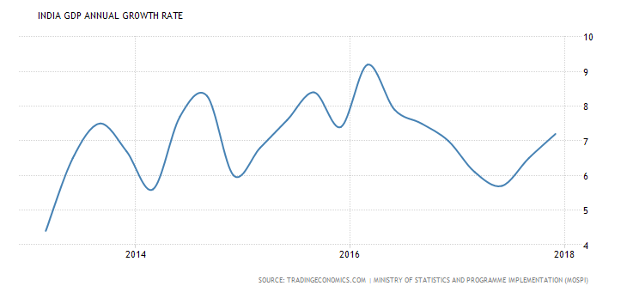

Fig: 3, GDP graph

**Inference:**From the above analysis it is observed that the gross domestic product growth rate in India is high in the late 2017. As India is a fast developing country the GDP of India may increase over a period of time and produce high returns to investor.

**Savings and investment:**

From 1990 to 2000, Indian households preferred to invest in financial assets to Physical assets. From 2000 to 2007, more savings were routed to Physical assets. Interestingly in 2007/08, more investments were made in financial assets. This shows that retails/small investors participated in stock markets when their valuations were at peak. The markets eventually crashed in 2008.From 2008 to till 2015, we preferred physical savings to financial savings. The Financial Savings during 2014-15, 2015-16 & 2016-17 were Rs 12,826 billion, Rs 15,142 billion and Rs 18,204 billion. There has been a steep increase of around 20% when compared to financial savings of 2015-. The savings in Physical Assets were Rs 14,650 billion, Rs 14,164 billion, & Rs 15,908 billion during 2012-13, 2013-14 and 2014-15 respectively. The data for 2015-16 was Rs 14,951 billion were invested in physical assets. The above data clearly indicates that there has been a gradual increase in financial savings rate over the last few years.

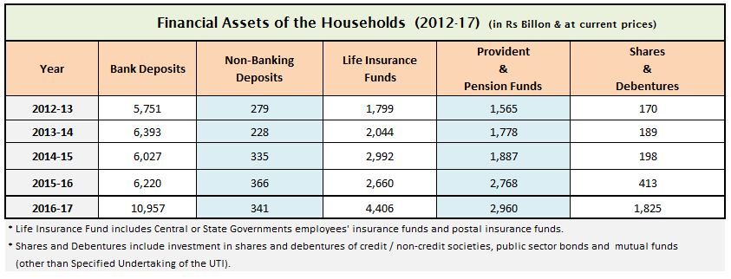

**Fig 4 savings and investment**

**Inference:**From the above table, it is observed that there is a steady increase in the savings made both by the individuals and the corporate sectors of the country which indicates a high investment made in capital and other assets in turn producing a high rate of return.

**Inflation:**

Consumer prices in India increased 5.07 percent year-on-year in January of 2018, below a 17 month high of 5.21 percent in December and market expectations of 5.14 percent. Still, the inflation remained above 4.8 percent for the third month, the level not seen since July of 2016 and above 4 percent medium-term target of the Reserve Bank of India.

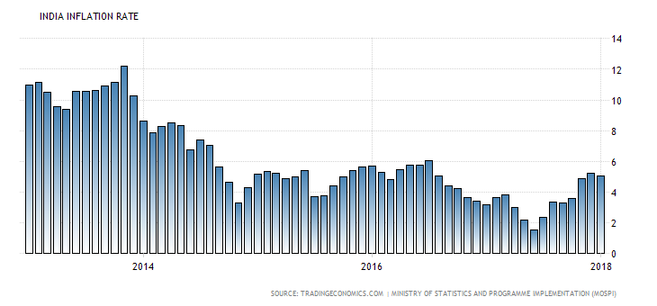

Fig: 5, inflation graph

**Inference:**From the above analysis it is clear that the inflation rate in the country was huge and reached its peak in late 2015 and then there is steady decline in the rate of inflation in 2016 which is a positive sign to an investor to invest in stock market.

**Budget and fiscal deficit:**

## India is expected to record a government budget deficit equal to 3.50 percent of the country’s gross domestic product in the 2017 fiscal year which ends on March 31st 2018. India is expected to record a government budget deficit equal to 3.50 percent of the country's Gross Domestic Product in the 2017 fiscal year which ends on March 31st 2018. The government is targeting a 3.3 percent budget gap in the 2018 fiscal year. Government Budget in India averaged -3.86 percent of GDP from 1991 until 2016, reaching an all time high of -2.04 percent of GDP in 1997 and a record low of -7.80 percent of GDP in 2009.

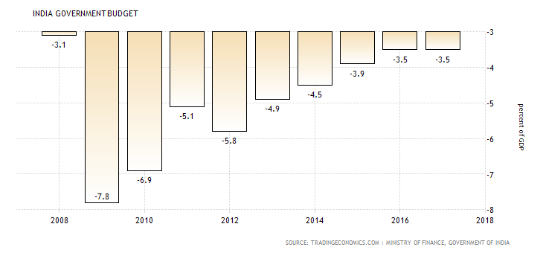

Fig: 6, Budget graph

**Inference:**From the above analysis it is shown that the country’s budget is in deficit, but still it a sign of favorable investment opportunity as 2015 and 2016 budgets are balanced budgets to the investor as there are number of amendments made by the Indian government which helps the investors in earning high returns.

**Foreign direct investment:**

Foreign Direct Investment in India increased by 4323 USD Million in December of 2017. Foreign Direct Investment in India averaged 1281.80 USD Million from 1995 until 2017, reaching an all time high of 8579 USD Million in August of 2017 and a record low of -1336 USD Million in November of 2017.

## India Foreign Direct Investment

Fig: 7, FDI graph

**Inference:**From the above analysis it is clearly visible that there is a huge foreign direct investment inflow in the Indian economy which has a positive impact on the stock market and a better opportunity for an investor to enhance his returns.

**Interest rates:**

## The Reserve Bank of India kept its benchmark interest rate steady at 6 percent on February 7th 2018, matching market expectations. Policymakers reinforced the decision is consistent with a neutral stance of monetary policy aiming to reach the medium-term inflation target of 4 percent +/- 2 percent, while supporting growth. The reverse repo rate was also left on hold at 5.75 percent and the marginal standing facility rate and the Bank Rate at 6.25 percent. Interest Rate in India averaged 6.67 percent from 2000 until 2018, reaching an all time high of 14.50 percent in August of 2000 and a record low of 4.25 percent in April of 2009.

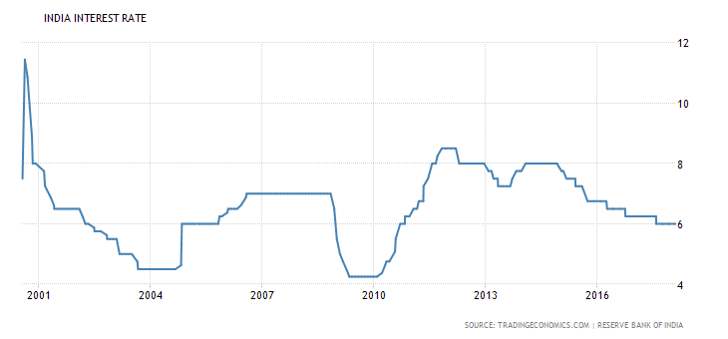

Fig:8, Interest rate graph

**Inference:**From the above analysis the graph clearly shows that there is a decrease in the interest rates in India which is a positive signh for the growth of economy, as the intersest rates are decreased the investor can borrow the fund for a low rate of interst and earn appropriate returns by investing the borrrwed fund.

**Balance of payment:**

## India's trade deficit widened to USD 16.3 billion in January of 2018 from a USD 9.9 billion a year earlier and above market expectations of a USD 12.97 billion gap. It is the highest trade deficit since May of 2013. Imports jumped 26.1% year-on-year to 40.68 billion as purchases rose for: petroleum, crude and products (42.6%); electronic goods (12.2%); machinery, electrical and non-electrical (29.1%); pearls, precious and semi-precious stones (55.7%); and coal, coke and briquettes (31.7%). In contrast, gold imports slumped 22.1%. Exports increased 9.1% to USD 24.4 billion, boosted by sales of engineering goods (15.8%); petroleum products (39.5%); oil (42.6%); gems and jewelry (0.9%); organic and inorganic chemicals (33.6%); and drugs and pharmaceuticals (8.6%). Considering the April 2017-January 2018 period, the country's trade gap widened to USD 131.2 billion from USD 88.3 billion a year earlier. Balance of Trade in India averaged -2333.54 USD Million from 1957 until 2018, reaching an all time high of 258.90 USD Million in March of 1977 and a record low of -20210.90 USD Million in October of 2012.

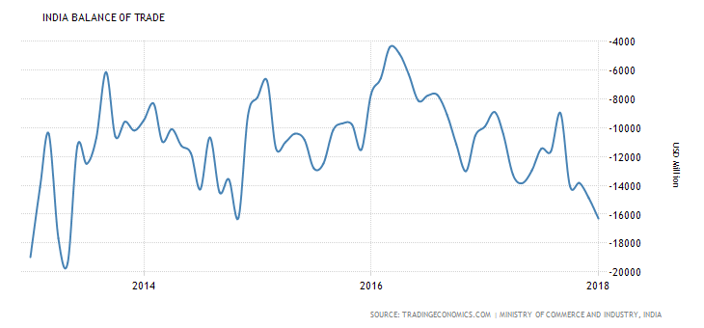

Fig:9, Balance of payment graph

**Inference:**

From the above analysis it can be said that though the balance of payments of the economy is in deficite, the indian ecomy with its griwth rate is overcoming its deficite balance slowly which is a positive sign of incresing the exports and decreasing the imports.

**Tax Structure:**

The Corporate Tax Rate in India stands at 34.61 percent. Corporate Tax Rate in India averaged 34.92 percent from 1997 until 2018, reaching an all-time high of 38.95 percent in 2001 and a record low of 32.44 percent in 2011.

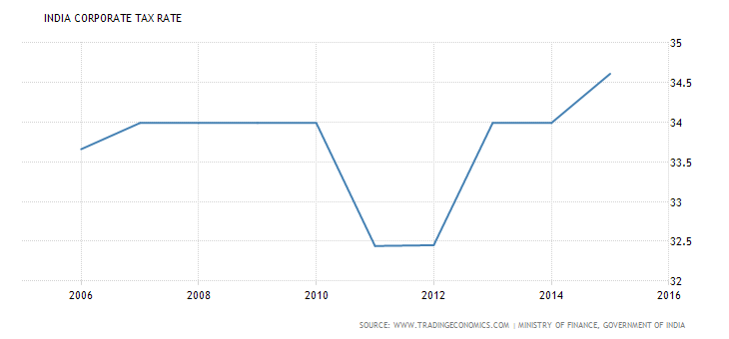

Fig: 10, Tax graph

**Inference:**From the above analysis, it can be stated that there is a high taxation rate on the corporate which do not encourage the investors for the investments. If the government of takes initiatives for tax holidays and tax subsides then the investors may come forward for making the investments.

**Demographic profile:**

## The total population in India was estimated at 1299.0 million people in 2016, according to the latest census figures. Looking back, in the year of 1950, India had a population of 359.0 million people.

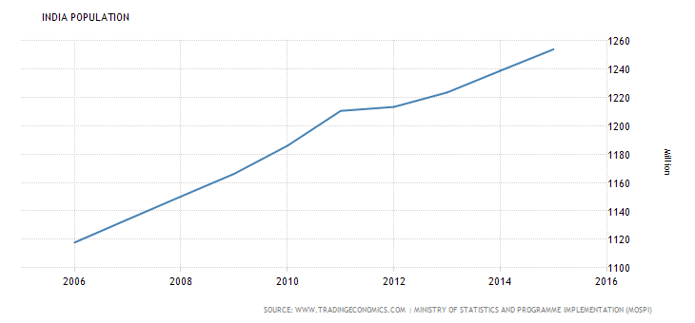

Fig: 11, Population graph

**Inference:**From the above analysis the graph clearly states that there is a high growth rate of population which results in skill full work force and huge human capital availability in the Indian economy, the demand for the product can be forecasted and the investor if invests in that product sector can earn a huge returns.

**Foreign Institutional Investors:**

FIIs have invested a net of US$ 89.5 billion in 2014-15— expected to be their highest investment in any fiscal year. Of this, a huge amount—US$ 57.2 billion—was invested in debt and it is their record investment in the asset class, while equities absorbed US$ 32.3 billion.

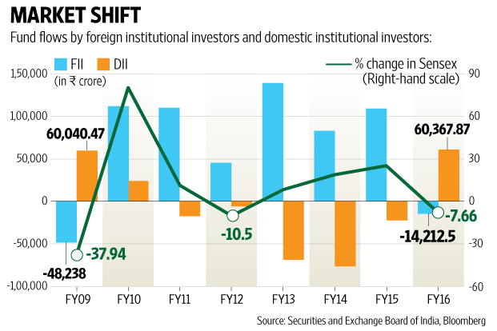

Fig: 12, foreign institutional investors

**Inference:**

The above stated statistics clearly shows the amount of investments made by foreign institutions in the Indian markets, implies the rapid growth of Indian economy in the competitive global markets.

**Infrastructure facilities:**

Infrastructure output in India went up 2.9 percent year-on-year in January of 2016, following a 0.9 percent growth rate in December. Infrastructure accounts for nearly 38 percent of India's industrial output. Considering the April to January, infrastructure output rose 2 percent. Construction Output in India averaged 5.01 percent from 2005 until 2016, reaching an all-time high of 11.66 percent in January of 2010 and a record low of -1.30 percent in November of 2016.

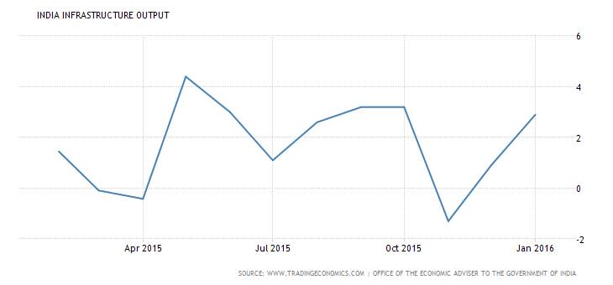

Fig: 13, Infrastructure graph

**Inference:**From that above analysis it can be said that the growth of infrastructure plays a major role in the economic development of the country and contributes to both industrial sector and agricultural sector.

**INDUSTRY ANALYSIS:**

An analysis of the performance, prospects, and problems of an industry of interest is known as industry analysis. The economic analysis gives an indication about the direction of the economy and the stock market. Industry analysis is required because the return and risk level of industries differ. The risk factors related to the automobile industry are different from those related to information technology industry. Consumer spending has a greater impact on automobile industry than on the IT industry. The performance of an industry reflects the performance of the companies it consists of.

An industry is a group of firms that have a similar technological structure of production and produce similar products.

**Kinds of industries:**

Industries can be classified on the basis of business cycle, i.e., classified according to their reactions to the different phases of business cycle. They are classified as growth, cyclical, defensive, and cyclical growth industries.

**Growth industry:**

Growth industries have special features of high rate of earnings and growth in expansion, independent of the business cycle. The expansion of the industry depends mainly on technological change.

**Cyclical industry:**

The growth and profitability of an industry move in tandem with the business cycle. During a boom, industries enjoy growth and during a depression they suffer a setback.

**Defensive industry:**

A defensive industry defines the movement of the business cycle. The stocks of defensive industries can be held by the investor for income earning purpose. They expand and earn income in a depression too, under the government’s umbrella of protection, and are counter-cyclical in nature.

**Cyclical growth industry:**

This is a new type of industry that is cyclical and at the same time growing.

**Industry life cycle:**

The industry life cycle theory is generally attributed to Julius Grodinsky, a professor at the Wharton school of Business. The life cycle of the industry is separated into four well defined stages as given below

* Pioneering stage
* Rapid growth stage
* Maturity and stabilization stage and
* Declining stage

**Pioneering stage:**

In this stage, the prospective demand from the product is promising and the technology of the product is low. The demand for the product encourages many producers to produce that particular product. There is sever competition and only the fittest companies survive this stage. The producers try to develop the brand name, differentiate the product, and create a product image. This leads to non-price competition too. The sever competition often leads to the change of position of the firms in terms of market shares and profits. In this situation it is difficult to select companies for investment because the survival rate is unknown.

**Rapid growth stage:**

This stage starts with the appearance of surviving forms from the pioneering stage. The companies that have withstood the competition steadily improve their market share and financial performance. The technology used in production improves resulting in low cost of production and good quality of products. The companies have stable growth in this stage and they declare dividend to their shareholders. It is advisable to invest in the shares of these companies.

**Maturity and stabilization stage:**

In the stabilization stage, the growth rate tends to moderate and the rate of growth more or less equals the industrial growth rate or the gross domestic product growth rate. Symptoms of obsolescence may appear in technology. To keep going, technological innovations in the production process and products have to be introduced. Investors must closely monitor the events that take place in the maturity stage of industry.

**Declining stage:**

In this stage, demand for the particular product and the earnings of the companies in the industry decline. Innovation and changes in consumer preferences lead to this stage. The specific feature of the declining stage is that event in a boom; the growth of the industry is low and declines at a higher rate during a recession. It is better to avoid investing in the shares of the low-growth industry. Even during a boom. Investment in the shares of these types of companies leads to erosion of capital.

**Other Factors:**

A part from industry life cycle analysis, an investor must also analyze factors such as those given below.

* Growth of the industry
* Cost structure and profitability
* Nature of the product
* Nature of the competition
* Government policy
* Labor
* Research and development

**Growth of the industry:**

The historical performance of the industry in terms of growth and profitability should be analyzed. Even though history may not repeat in the exact manner, by looking into the past growth of the industry, an analyst can predict the future.

**Cost structure and profitability:**

The cost structure, that is the proportion fixed and variable costs, affects the cost of production and profitability of the firm. The higher the fixed cost component, the greater is the sales volume required to reach the firm’s break-even point. Once the break-even point is reached and production is on track, profitability can be increased by utilizing the capacity to full. Once the maximum capacity is reached, capital must again be invested in the fixed equipment. Hence, the lower the fixed costs, the easier it is to adjust to changing demand and to reach break-even point.

**Nature of the product:**

The products produced by the industries are demanded by the consumers and other industries. An investor must analyze the condition of the feeder industry as well as the end-user industry to assess the demand for industrial goods.

In the case of the consumer goods industry, a change in consumer preference, technological innovations, and substitute products affect demand.

**Nature of the competition:**

The nature of competition is an essential factor that determines the demand for a particular product, its profitability, and the price of the scrip concerned. The supply may arise from indigenous producers and multinationals. Multinationals are also entering the field with sophisticated process and better quality products. The company’s ability to withstand the competition locality and from the multinationals affects its earnings. If too many firms are present in the organized sector, the competition will be severe. It will lead to a decline in the price of the product. The investor, before investing in the scrip of a company, should analyze the market share of the particular company’s product and compare it with the top five companies.

**Government policy:**

Government policies affect the very nerve of the industry and the effects differ from industry to industry. Tax subsidies and tax holidays are provided for export-oriented products. The government regulates the size of production and the pricing of certain products. In some cases, entry barriers are placed by the government. When selecting an industry government policy regarding the particular industry should be carefully evaluated. Liberalization and delicensing have brought immense threat to existing domestic industries in several sectors.

**Labor:**

The analysis of the labor scenario in a particular industry is of great importance. The numbers of trade unions and their operating mode have an impact on labor productivity and modernization of the industry. If the trade unions are strong and strikes occur frequently, it will lead to a fall in production. In an industry of high fixed costs, the stoppage of production may lead to losses. When trade unions oppose the introduction of automation, in the product market the company may stand to lose owing to the high cost of production. An unhealthy labor relationship also leads to loss of customer’s goodwill.

**Research and Development:**

For any industry to survive the competition in the national and international markets, the product and production process have to be technically competitive. This depends on the R&D in the particular company or industry. Economies of scale and new markets can be obtained only through R&D. the percentage of expenditure on R&D should be studied diligently before making an investment.

**Pollution standards**

Pollution standards are very high and strict in the industrial sector. This is particularly so in the leather and chemical and pharmaceutical industries that has significant industrial effluents.

**Analytical tools**

The strength of the industry and its competitiveness can be analyzed with help of SWOT and Porter’s five force model.

**SWOT analysis** (or **SWOT matrix**) is a strategic planning technique used to help a person or organization identify the strengths, weakness, opportunities and threats related to business competition or project planning. It is intended to specify the objectives of the business venture or project and identify the internal and external factors that are favorable and unfavorable to achieving those objectives. Users of a SWOT analysis often ask and answer questions to generate meaningful information for each category to make the tool useful and identify their competitive advantage.

Strengths and Weakness are frequently internally-related, while Opportunities and Threats commonly focus on environmental placement.

* Strengths: characteristics of the business or project that give it an advantage over others
* Weaknesses: characteristics of the business that place the business or project at a disadvantage relative to others
* Opportunities: elements in the environment that the business or project could exploit to its advantage
* Threats: elements in the environment that could cause trouble for the business or project

The degree to which the internal environment of the firm matches with the external environment is expressed by the concept of strategic fit. Identification of SWOTs is important because they can inform later steps in planning to achieve the objective. First, decision-makers should consider whether the objective is attainable, given the SWOTs. If the objective is not attainable, they must select a different objective and repeat the process.

**PORTER’S FIVE FORCE MODEL**

Five forces model was created by M. Porter in 1979 to understand how five key competitive forces are affecting an industry. The five forces identified are:

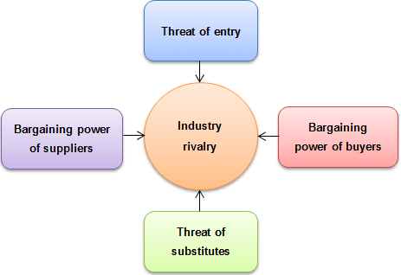

Fig: 14, porter’s five force model

These forces determine an industry structure and the level of competition in that industry. The stronger competitive forces in the industry are the less profitable it is. An industry with low barriers to enter, having few buyers and suppliers but many substitute products and competitors will be seen as very competitive and thus, not so attractive due to its low profitability.

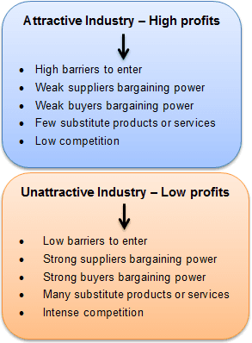

Fig: 15, Types of industry

It is every strategist’s job to evaluate company’s competitive position in the industry and to identify what strengths or weakness can be exploited to strengthen that position. The tool is very useful in formulating firm’s strategy as it reveals how powerful each of the five key forces is in a particular industry.

**Threat of new entrants:** This force determines how easy (or not) it is to enter a particular industry. If an industry is profitable and there are few barriers to enter, rivalry soon intensifies. When more organizations compete for the same market share, profits start to fall. It is essential for existing organizations to create high barriers to enter to deter new entrants. Threat of new entrants is high when:

* Low amount of capital is required to enter a market;
* Existing companies can do little to retaliate;
* Existing firms do not possess patents, trademarks or do not have established brand reputation;
* There is no government regulation;
* Customer switching costs are low (it doesn’t cost a lot of money for a firm to switch to other industries);
* There is low customer loyalty;
* Products are nearly identical;
* Economies of scale can be easily achieved.

**Bargaining power of suppliers:** Strong bargaining power allows suppliers to sell higher priced or low quality raw materials to their buyers. This directly affects the buying firms’ profits because it has to pay more for materials. Suppliers have strong bargaining power when:

* There are few suppliers but many buyers;
* Suppliers are large and threaten to forward integrate;
* Few substitute raw materials exist;
* Suppliers hold scarce resources;
* Cost of switching raw materials is especially high.

**Bargaining power of buyers:** Buyers have the power to demand lower price or higher product quality from industry producers when their bargaining power is strong. Lower price means lower revenues for the producer, while higher quality products usually raise production costs. Both scenarios result in lower profits for producers. Buyers exert strong bargaining power when:

* Buying in large quantities or control many access points to the final customer;
* Only few buyers exist;
* Switching costs to other supplier are low;
* They threaten to backward integrate;
* There are many substitutes;
* Buyers are price sensitive.

**Threat of substitutes:** This force is especially threatening when buyers can easily find substitute products with attractive prices or better quality and when buyers can switch from one product or service to another with little cost. For example, to switch from coffee to tea doesn’t cost anything, unlike switching from car to bicycle.

**Rivalry among existing competitors:** This force is the major determinant on how competitive and profitable an industry is. In competitive industry, firms have to compete aggressively for a market share, which results in low profits. Rivalry among competitors is intense when:

* There are many competitors;
* Exit barriers are high;
* Industry of growth is slow or negative;
* Products are not differentiated and can be easily substituted;
* Competitors are of equal size;
* Low customer loyalty.

Although, Porter originally introduced five forces affecting an industry, scholars have suggested including the sixth force: **complements**. Complements increase the demand of the primary product with which they are used, thus, increasing firm’s and industry’s profit potential.

**Pharmaceutical sector in India:** Indian pharmaceutical sector accounts for about 3.1 – 3.6 per cent of the global pharmaceutical industry in value terms and 10 per cent in volume terms and is expected to grow to US$ 100 billion by 2025. India contributes the second largest share of pharmaceutical and biotech workforce in the world. With 71 per cent market share, generic drugs form the largest segment of the Indian pharmaceutical sector. India has become the third largest global generic API merchant market by 2016, with a 7.2 per cent market share. The country accounts for the second largest number of Abbreviated New Drug Applications (ANDAs) and is the world’s leader in Drug Master Files (DMFs) applications with the US Indian Drugs & Pharmaceuticals sector has received cumulative FDI worth US$ 15.59 billion between April 2000 – December 2017.

Indian drugs are exported to more than 200 countries in the world, with the US as the key market. Generic drugs account for 20 per cent of global exports in terms of volume, making the country the largest provider of generic medicines globally and expected to expand even further in coming years. India exported pharmaceutical items worth US$ 16.84 billion in FY17 and US$ 8.49 billion during April – November 2017.

The Government of India plans to set up a US$ 640 million venture capital fund to boost drug discovery and strengthen pharmaceutical infrastructure. The ‘Pharma Vision 2020’ by the government’s Department of Pharmaceuticals aims to make India a major hub for end-to-end drug discovery.

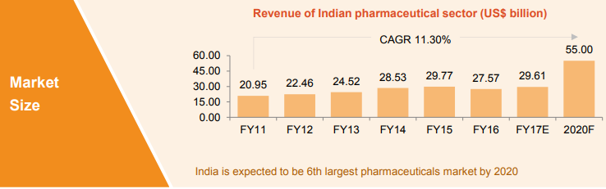

Fig: 16 Revenues of Indian pharmaceutical sector

India is the third largest pharmaceuticals market in the world in terms of value and eleventh largest in terms of volume. It has established itself as a global manufacturing and research hub. A large raw material base and the availability of a skilled workforce give the industry a definite competitive advantage. India is the largest supplier of generic medicines globally (20 per cent of global export volume).

**Exports**

Pharmaceutical export from India stood at US$ 16.4 billion in 2016-17. India is expected to rank amongst the top three pharmaceutical markets with export value worth US$ 20 billion in terms of incremental growth by the year 2020.

**Pharmaceutical Export Promotion Council**

The Pharmaceutical Export Promotion Council (PHARMEXCIL) was set up in 2004 by Ministry of Commerce and Industry, Government of India, for the promotion of pharma exports.

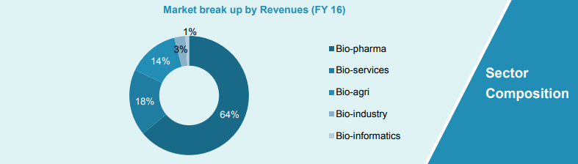

Fig: 17 sector composition

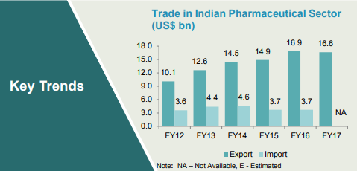 Fig: 18 Trades of pharmaceutical sector

**GOVERNMENT INITIATIVES TOWORDS PHARMA:**

The Union Budget 2017-18 shows an increase of 23% in the health expenditure that is likely to give further impetus to the pharma sector. The government, as part of the Budget, has proposed amendments to the Drugs and Cosmetics Rules to ensure availability of generic drugs at reasonable prices and promote the use of generic medicines.7 the government has also introduced a range of fiscal incentives to promote domestic manufacturing, including the reduction of inverted duty structure and basic customs duty.

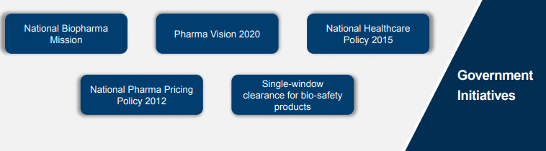

Fig: 19 Government initiatives

**Company Analysis:**

Liquidity ratio refers to the ability of a company to interact its assets that is most readily converted into cash. Assets are converted into cash in a short period of time that are concerns to liquidity position. However, the ratio made the relationship between cash and current liability. The Liquidity ratio we can satisfy on the three ratios, those are:

1) Current ratio

2) Quick ratio or acid test

**Current ratio:**

The current ratio is calculated by dividing current assets by current liabilities. Current asset includes inventory, trade debtors, advances, deposits and repayment, investment in marketable securities in short term loan, cash and cash equivalents, and current liabilities are comprised short term banks loan, long term loans-current portion, trade creditors liabilities for other finance etc. Generally current ratios are acceptable of short term creditors for any company.

The formula is shown as below; Current Ratio = Current assets /Current liabilities.

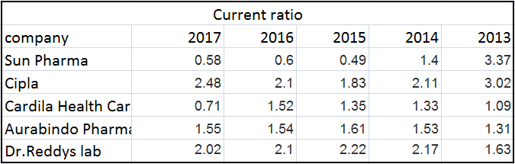

**Table no 1: current ratio**

**Inference:**The above tale no : 1 suggests the current ratio of Dr. Reddy’s laboratories and Cipla companies have adequate current ratio where it suggests that the company has good liquidity position for paying out there liabilities.

**Quick ratio:**

Quick ratio or acid test Quick ratio or acid test ratio is estimating the current assets minus inventories then divide by current liabilities. It is easily converted into cash at turn to their book values and it also indicates the ability of a company to use its near cash.

The formula of quick ratio or acid test ratio are as follow as;

Quick ratio = (Current asset- inventories)/Current liabilities

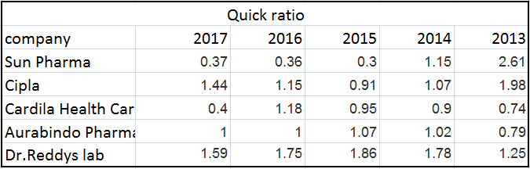

Table no 2: quick ratio

**Inference:** The above table no 2 suggests that Dr Reddy’s laboratories, Cipla, Aurabindo pharmaceuticals have adequate quick ratio which suggests that the companies have good inventory which can e easily convertible into cash. And also suggests that the use of the near cash.

**Total asset turnover ratio**

The total asset turnover ratio measures the ability of a company to use its assets to generate sales. It considers all assets including property ,plant and equipment, capital working in process, investment –long term, inventories, trade debtors, advances, deposit and prepayment, investment in market securities, short term loan, cash and cash equivalents etc. In these criteria a high ratio means the company is achieving more profit. The formula is following as: Total asset turnover = Sales / Total asset

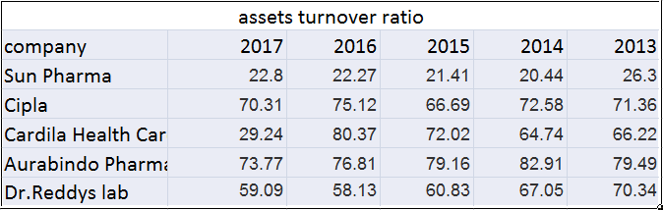

**Table no 3: assets turnover ratio**

**Inference:**The above table no 3 suggests that the Aurabindo is achieving high profits because of high asset turnover ratio when compared to all other four companies. This means Aurabindo pharma are using their assets to generate good amount of sales.

**Inventory turnover ratio:**

The inventory turnover ratio measures the number of times on average the inventory was sold during the period. The ratio is calculating the cost of goods sold by average inventory. The measurement of average inventory is; at first we are adding two years inventory after that we divide in to two. Inventory turnover ratio is also known as inventory turns ratio and stock turnover ratio.

Inventory Turnover Ratio = Cost of Goods Sold / Average Inventory

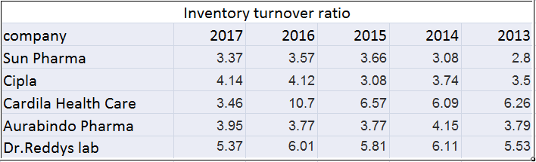

**Table 4: inventory turnover ratio**

**Inference:** The above table 4 suggests that Dr. Reddy’s laboratories have high inventory turnover ratio because of controllable merchandise (i.e., effective use of buying and selling the products) due to which Dr. Reddy’s laboratories have high inventory turnover ratio when compared with all other 4 companies.

**Dividend payout ratio:**

The dividend payout ratio is the amount of dividends paid to stockholders relative to the amount of total net income of a company. The amount that is not paid out in dividends to stockholders is held by the company for growth. The amount that is kept by the company is called retained earnings.

Net income shown in the formula can be found on the company's income statement.

This formula is used by some when considering whether to invest in a profitable company that pays out dividends versus a profitable company that has high growth potential. In other words, this formula takes into consideration steady income versus reinvestment for possible future earnings, assuming the company has a net income.

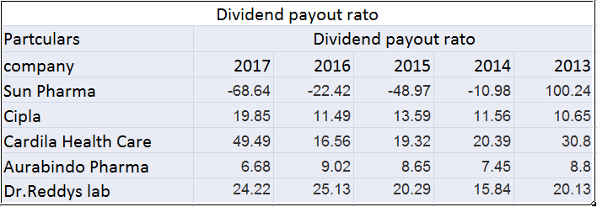

**Table 5: dividend payout ratio**

**Inference:** The above table 5 indicates that the net income of Cardila and Dr. Reddy’s laboratories have high net income which is available to equity shareholders after the retained earnings. Hence as they have high net income this yields in high dividends.

**Earnings per share:**

Earnings per share or EPS are an important financial measure, which indicates the profitability of a company. It is calculated by dividing the company’s net income with its total number of outstanding shares. It is a tool that market participants use frequently to gauge the profitability of a company before buying its shares.

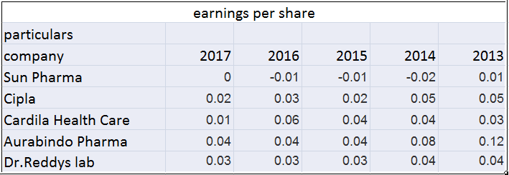

**Table 6: earnings per share**

**Inference:** The above table no 6 suggests that Aurabindo pharma and Dr. Reddy’s laboratories are having high earnings per share which suggests that they are able to generate good amount of returns for the shareholders.

**Diluted earnings per share:**

A company's earnings per share, or EPS, are simply the company's total income minus any preferred dividends, divided by the number of outstanding shares. However, this doesn't paint a completely accurate picture of the company's financial condition. Many companies have other existing obligations that could result in additional shares being issued. For example, if a company issues stock options to its employees or has any outstanding bonds that could be converted into common stock, then it could result in the issuance of more shares and the dilution of existing shareholders.

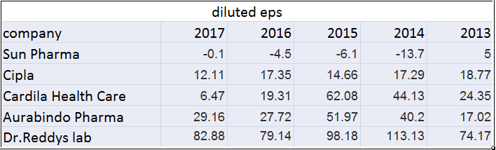

Table 7: diluted EPS

**Inference:** the above table 7 suggests that Dr. Reddy’s laboratories have high convertible share which suggests that Dr. Reddy’s laboratories can issue more number of shares and also can dilute the existing shareholders.

**Return on asset ratio:**

The Return on Assets ratio can be directly computed by dividing net income by average total asset. It finds out the ability of the company to utilize their assets and also measure of efficiency of the company in generating profits. 36 Return on Total Assets = Net profits after taxes / total assets*100

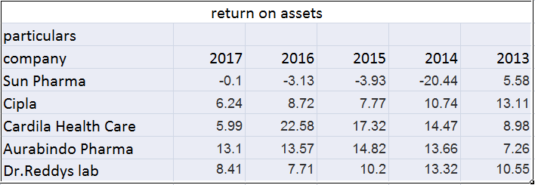

Table 8: return on assets

**Inference:**The above table no 8 suggests that Aurabindo pharma has good return on asset which suggests that they have good profits which they are maintains to keep some of them as retained earnings.

**Book value per share ratio:**

Book value per share is the amount each share would receive. If the company were liquidity on the basis of amount reported on the balance sheet. Book value per share = Common stockholders’ equity / Outstanding shares.

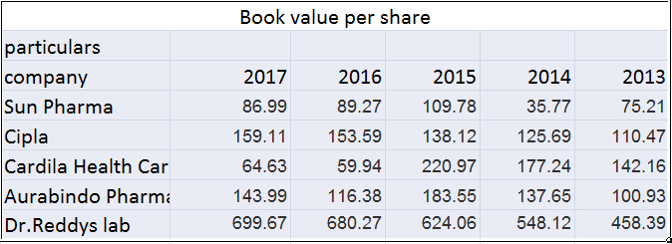

**Table 9: book value per share**

**Inference:** The above table no 9 suggests that Dr. Reddy’s laboratories has highest book value per share which suggests that this is the amount will be received by shareholder when the companies are liquidating.

**Return on capital employed:**

Return on capital employed or ROCE is a profitability ratio that measures how efficiently a company can generate profits from its capital employed by comparing net operating profit to capital employed. In other words, return on capital employed shows investors how many dollars in profits each dollar of capital employed generates.ROCE is a long-term profitability ratio because it shows how effectively assets are performing while taking into consideration long-term financing. This is why ROCE is a more useful ratio than return on equity to evaluate the longevity of a company. This ratio is based on two important calculations: operating profit and capital employed. Net operating profit is often called EBIT or earnings before interest and taxes. EBIT is often reported on the income statement because it shows the company profits generated from operations. EBIT can be calculated by adding interest and taxes back into net income if need be.Capital employed is a fairly convoluted term because it can be used to refer to many different financial ratios. Most often capital employed refers to the total assets of a company less all current liabilities. This could also be looked at as stockholders’ equity less long-term liabilities. Both equal the same figure.

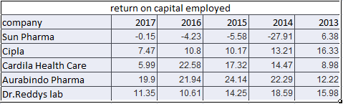

Table 10: return on capital employed

**Inference:** The above table 10 suggests that Aurabindo, Cardila, and Dr. Reddy’s lab have good return on their capital employed, which suggests that investing in those companies will help us to yield more profits.

**Debt equity ratio:**

The debt-equity ratio is a measure of the relative contribution of the creditors and shareholders or owners in the capital employed in business. Simply stated, ratio of the total long term debt and equity capital in the business is called the debt-equity ratio.

It can be calculated using a simple formula: Total liabilities / equity

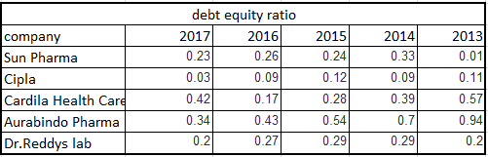

Table 11: debt equity ratio

**Inference:** The above table no 11 suggests that Cardila and Aurabindo have good debt equity ratio which suggests that these companies having good position to repay their obligations.

**Findings:**

* The gross domestic product of the Indian economy has a rapid growth rate.
* There is a steady increase in the savings made by both individuals and the corporate.
* There is a decrease in the rate of inflation of the country.
* The budget of the Indian economy is in deficit but still in a balanced position.
* There is a huge inflow of foreign direct investment in the Indian economy.
* RBI has decreased the repo rate which implies deflation in the country.
* There is decrease in the deficit balance of payments compared to previous years.
* There is a huge rate of tax imposed on the corporate.
* High growth rate of population.
* Investments by foreign institutional investors in the country are increased.
* Growth of infrastructure facilities.
* India is expected to be 6th largest pharmaceutical industry by 2020.
* The imports of pharmaceuticals have been decreased
* Aurabindo and Dr. Reddy’s laboratories have very good earnings per share.
* From the above study we have seen that in 2013 sun pharma was performing a lot better than all other pharmaceuticals. From 2014 it started to decline in its profits. And it has very less intrinsic value when compared with other 4 pharmaceuticals

**Suggestions:**

Based on the findings of the study, the following policy recommendations are proposed:

* The government could increase an agricultural production of country may decrease the inflation rate to boost Gross domestic product, which also can support the economic growth.
* The Indian pharmaceutical industries have good sales growth and global market share and revenue growth also reveals that much growth and pharmaceutical industry still stands under developing industry, so which may reduce the cost of production through the latest technologies to increase the revenue.
* As an investor who should be aware about economic environment, market condition, Industry policy and RBI policy, etc., and also they should focus on both internal and external factors regarding the company before going to investment.

**Conclusion:**

Fundamental analysis is the useful tool for investment through by analysing the macroeconomic factors, industry condition and the company’s financial situation and so on. The study revealed that economic analysis by the Gross Domestic Product (GDP), Inflation, Interest rates, Foreign exchange rates, foreign reserves, foreign inflows, Exports and Agricultural production has a positive growth rate during the study period. From the Industry analysis shows that the Indian pharmaceutical industry has a high growth rate and its sales and net profit also shows increasing trend and the company analysis revealed that its financial performance through the financial ratios, which indicates that Dr. Reddy’s laboratories, Cipla and Aurabindo pharma are financially in satisfactory position during the study period. Through the fundamental analysis, investor can relate the possible factors to ensure investment risk and expect a reasonable return. But the fundamental analysis does not advice to investors for investment by basis on buying and selling of a particular security. So the investors can take only the decision whether the investment is to be worthy or not. The main motto of fundamental analysis is to reduce the risk and maximize the return on investment.

**Books:**

* Punithavathy, Pandian, “*Security Analysis and Portfolio Management*”, second edition, Vikaspublistions.
* Frank .K. Reilly, Keith.C. Brown, “*Investment Analysis and Portfolio management”*, tenth edition, South western cengage learning.
* Ranganatham, M. and Madhumathi, R. (2007), *“Investment Analysis and Portfolio Management”*, Dorling Kindersley (India) Pvt. Ltd., Delhi.

**Research papers:**

* Avadhani, V.A. (2011), *“Security Analysis & Portfolio Management*”, Himalaya Publishing House, New Delhi.
* Abarbanell, Jeffery S. and Bushee, Brian J. (1998), “*Abnormal Returns to a Fundamental Analysis Strategy”*, The Accounting Review, Volume 73, Number 1, pp.19-45.
* Chandra, Prasanna (2010), “*Investment Analysis and Portfolio Management*”, Tata McGraw Hill Education Pvt. Ltd., New Delhi.
* Dr. Sreemoyee Guha Roy, “*Equity Research: Fundamental and Technical Analysis”*, International journal on science and research.
* Hemal Pandya and Hetal Pandya “*fundamental analysis of indian automobile industry*” International Journal of Current Research, Vol. 5, Issue, 5, pp.1273-1286, May, 2013.
* Lee, C. Jevons (1987), “*Fundamental Analysis and the Stock Market*”, Journal of Business Finance & Accounting, Volume 14, No. 1, pp. 131-141.
* Mrs. J hema “*fundamental analysis with special reference to pharmaceutical companies listed in nse*” Volume 7, Issue 2, February (2016), pp. 123-133.
* Mr. Suresh a.s“*a study on fundamental and technical analysis*”International Journal of Marketing, Financial Services & Management ResearchVol.2, No. 5, May (2013).
* Mitra, Subrata Kumar (2011), “*How Rewarding is Technical Analysis in the Indian Stock Market,*” Quantitative Finance, Volume 11, No. 2, pp. 287-297.
* Sehgal, Sanjay and Gupta, Meenakshi (2005), “*Technical Analysis in Indian Capital Market... A Survey”,* Decision, Volume 32, No. 1, pp. 91-122.
* Suresh A.S., “*A Study on fundamental and technical analysis*”, Vol – 2, International Journal on Marketing, may 2013.
* Venkatesh C.K, Madhu Tyagi, “*Fundamental Analysis as a method of share valuation in comparison with technical analysis.*” Bangladesh Research publication Journal may 2011.

**Websites:**

* [Www.Rbi.gov.in](http://Www.Rbi.gov.in)
* Http://www.ibef.org/
* Http://ficci.in
* [Www.moneycontrol.com](http://www.moneycontrol.com)
* Www.tradeingeconomics.com
* Www.nseindia.com
* [Www.profit.ndtv.com](http://www.profit.ndtv.com)
* [Www.money.rediff.com](http://www.money.rediff.com)
* Www.issue.com
* http://www.iaeme.com/ijm/index.asp