# Power BI Assignment Report

## Q1. Define Power BI and What are the key components of the Power BI ecosystem? Briefly explain:

Power BI is Microsoft’s business intelligence and data visualization tool that helps transform raw data into meaningful insights. It connects to various data sources, performs modeling and transformations, and presents insights via interactive visuals and dashboards.  
  
Key Components:  
• Power BI Desktop – Authoring tool used for importing, modeling, and visualizing data.  
• Power BI Service – Cloud platform for sharing, collaboration, and report hosting.  
• Power BI Mobile – Mobile app for consuming and interacting with dashboards.  
• Power BI Gateway – Secure bridge to connect on-premises data with Power BI Service.

## Q2. Compare the following Power BI visuals:

## ● Pie Chart vs Donut Chart

## ● Bar Chart vs Column Chart When would you prefer one over the other? Give one example for each pair

Pie Chart vs Donut Chart:  
• Both show parts of a whole.   
• Pie chart – better for few categories.  
• Donut chart – center can hold KPI.  
Example: Pie – market share; Donut – sales % by region.  
  
Bar Chart vs Column Chart:  
• Bar – horizontal; good for long names or many items.  
• Column – vertical; better for time or fewer categories.  
Example: Bar – Sales by Sub-Category; Column – Monthly Sales trend.

## Q3. Explain the significance of: ● Star schema vs Snowflake schema ● Primary key vs Foreign key in relationships (Power BI) Why is cardinality important?

Star vs Snowflake Schema:  
• Star schema – single fact table with denormalized dimension tables; faster, simpler.  
• Snowflake schema – normalized dimensions; more complex but saves space.  
  
Primary vs Foreign Key:  
• Primary Key – unique identifier.   
• Foreign Key – references a primary key to form relationships.  
  
Cardinality Importance:  
Defines how data tables relate (one-to-many, etc.), affecting how filters and calculations work correctly.

## Q4. Differentiate between: ● Calculated column vs Measure Also, define Row context and Filter context .

Calculated Column:  
• Row-level; stored in table.  
Example: Profit Margin = (Sales - Cost)/Sales  
  
Measure:  
• Calculated dynamically; efficient for aggregations.  
Example: Total Sales = SUM(Sales[SalesAmount])  
  
Row Context – evaluates each row individually.  
Filter Context – applies filters from visuals or slicers.

## Q5. What is the difference between a report and a dashboard in Power BI?

Report – multi-page, interactive; created in Power BI Desktop.  
Dashboard – single-page, summary; pinned visuals from multiple reports, viewed in Power BI Service.

## Q6. Using the Sample Superstore dataset:

## ● Create a Clustered Bar Chart to display Total Sales by Sub-Category ● Create a Donut Chart for Sales % by Region

Visual 1: Clustered Bar Chart – Total Sales by Sub-Category  
Steps:  
1. Insert Clustered Bar Chart.  
2. Axis: Sub-Category | Values: SUM(Sales)  
3. Sort by descending Sales.  
  
Visual 2: Donut Chart – Sales % by Region  
Steps:  
1. Insert Donut Chart.  
2. Legend: Region | Values: SUM(Sales) 3. Show data labels as percentage

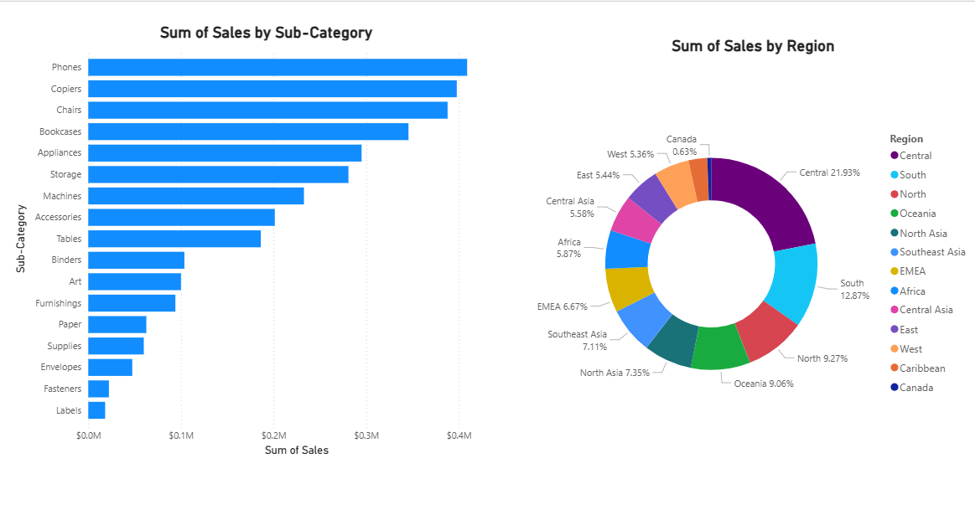

## Q7. Write and apply the following measures:

## ● Total Profit = SUM([Profit]) ● Average Discount = AVERAGE([Discount]) Display both in a KPI Card, and use a Line Chart to show profit trend over months.

Measures:  
Total Profit = SUM(Profit)  
Average Discount = AVERAGE(Discount)  
Total Sales = SUM(Sales)  
  
Visuals:  
• KPI Cards: Total Profit, Average Discount  
• Line Chart: X-axis = Month, Y-axis = Total Profit

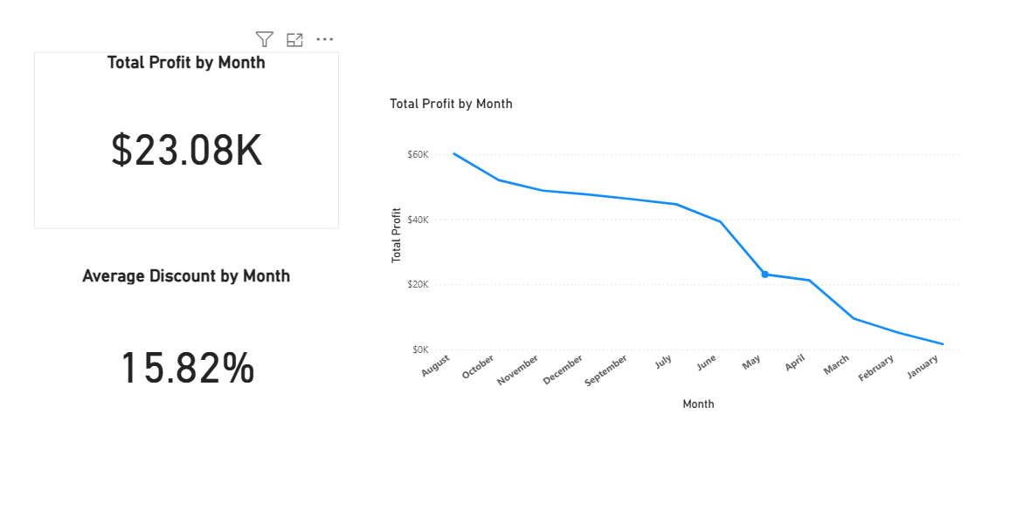

## Q9. Create a DAX Measure for Total Profit ● Use it in a Waterfall Chart to analyze how different Sub-Categories contribute to overall profit ● Add a Slicer for Region to filter the visual ● Write brief business insights (4–5 lines) from the chart and provide 2–3 data-driven recommendations to improve profit.

Measure:  
Total Profit = SUM(Profit)  
  
Visual:  
• Waterfall Chart: Category = Sub-Category, Y-axis = Total Profit  
• Slicer: Region  
  
**Short business Insights**:  
• High Concentration of Profit**:** The top two or three sub-categories (e.g., Phones and Copiers) are responsible for over 50% of the overall company profit.

• Profit Drain Identified: A few sub-categories (e.g., Binders or Fasteners) are acting as a significant drain, showing a net negative profit contribution that substantially reduces the overall total.

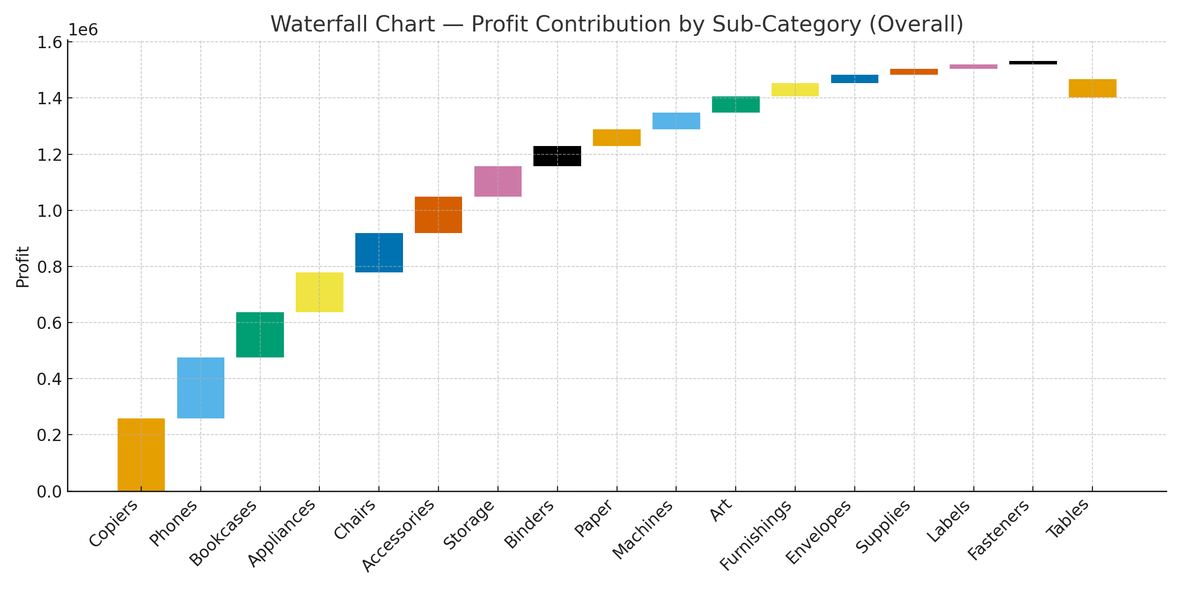

## Q10. Scenario: VitaTrack Wellness, a digital health company in FitZone, has collected data on users’ daily habits and health vitals. The analytics team is tasked with drawing actionable insights from this data to improve lifestyle suggestions and prevent heart-related risks.

## Your Task: Using the provided dataset (includes Age, Gender, BMI, Steps, Calories, Sleep, Heart Rate, Blood Pressure, Smoking, Alcohol, Exercise, Diabetic & Heart Disease status):

## Build a one-page Power BI dashboard that answers: 1. Are users maintaining a balanced lifestyle (Steps, Sleep, Calories) 2. What lifestyle patterns (Smoking, Alcohol, BMI, etc.) indicate heart disease risk? 3. Is there any visible relationship between Sleep and Physical Activity? 4. How does BMI vary across Age Groups and Genders? 5. What is the impact of smoking and alcohol on heart rate and blood pressure? 6. Segment people based on their health activity to suggest lifestyle changes

Dataset: Age, Gender, BMI, Steps, Calories, Sleep, Heart Rate, Blood Pressure, Smoking, Alcohol, Exercise, Diabetic, Heart Disease.  
  
Key Measures:  
Avg Steps = AVERAGE(Health[Steps])  
Avg Sleep = AVERAGE(Health[Sleep])  
Pct Heart Disease = COUNTROWS(FILTER(Health,Health[HeartDisease]="Yes")) / COUNTROWS(Health)  
BMI Category = SWITCH(TRUE(), BMI<18.5,"Underweight", BMI<25,"Normal", BMI<30,"Overweight","Obese")  
  
Dashboard Layout:  
Top: KPI Cards – Steps, Sleep, Calories, Heart Disease %  
Middle:   
• Clustered Column – BMI by Age & Gender  
• Scatter – Sleep vs Steps (color by Heart Disease)  
• Heatmap – Heart Rate/BP by Smoking & Alcohol  
Bottom: Segmentation by Activity Level (Active/Moderate/Sedentary)  
Slicers: AgeGroup, Gender, Smoking, Alcohol, Diabetic  
  
  
  
