ProofGrid
Backend Engineering & Data Pipeline Specification
Implementation-grade backend source of truth for the Code Cubicle 6.0 prototype

Backend doctrine
LLM plans. Code executes. Evidence proves. PostgreSQL owns truth. External indexes accelerate discovery but never become authoritative.

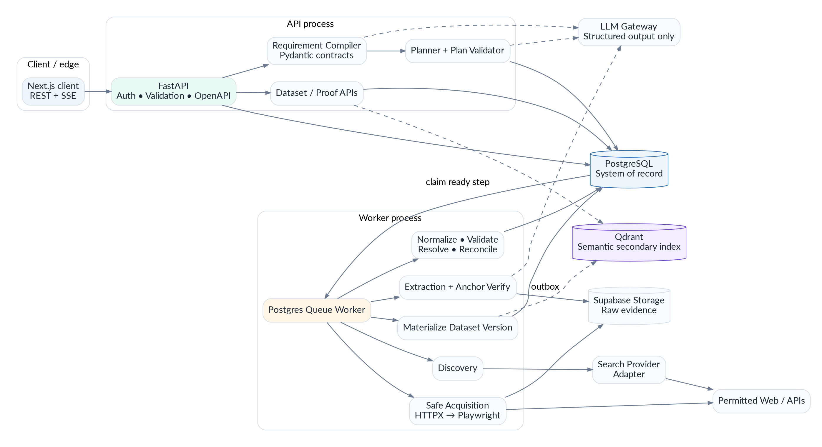
Figure 1. ProofGrid backend architecture: one authoritative relational core, bounded AI, isolated acquisition, and an evidence-first trust pipeline.
Version 1.0 • Research and design checked 26 September 2026

Contents
1. Executive decision and backend principles
2. Technology stack and rationale
3. Runtime topology and service boundaries
4. Repository architecture and coding rules
5. Domain contracts and invariants
6. Database architecture and persistence model
7. Authentication, authorization and tenancy
8. Requirement Compiler
9. Trust Contract Engine
10. Planner, PlanDAG and deterministic plan validation
11. Workflow executor and Postgres-backed queue
12. Source discovery and SourcePolicy
13. Safe acquisition: HTTP, static extraction and browser fallback
14. Raw evidence storage and content normalization
15. Structured extraction and Evidence Anchor Verification
16. Field normalization and validation
17. Entity resolution and deduplication
18. Claim Ledger, conflict detection and canonicalization
19. Trust-status engine
20. Dataset materialization, search and ProofCell read APIs
21. Dataset versioning and diff engine
22. Qdrant semantic layer and consistency model
23. REST API contract
24. Server-Sent Events and run monitoring
25. Caching, rate limits, budgets and cost accounting
26. Error taxonomy, retries and graceful degradation
27. Security architecture and threat model
28. Privacy, source permissions and retention
29. Observability, auditability and diagnostics
30. Performance, concurrency and capacity targets
31. Test architecture and evaluation corpus
32. CI/CD, migrations and deployment
33. Feature flags, fixture mode and demo reliability
34. Optional Pathway and n8n extensions
35. Implementation order and team ownership
36. Backend Definition of Done
Appendix A. Core SQL and indexes
Appendix B. API endpoint catalog
Appendix C. State, event and error enums
Appendix D. Environment variables
Appendix E. Architecture Decision Records
Appendix F. Research references

1. Executive decision and backend principles
ProofGrid is not a chatbot backend and it is not a generic scraper service. The backend is a controlled data-compiler and evidence system: it compiles a natural-language request into a typed contract, validates an executable workflow, acquires permitted sources, converts source material into verifiable claims, resolves identity and disagreement, and materializes a fast dataset view without losing the underlying evidence.
The most important design decision
Use a modular monolith plus a separate worker process. Keep all business truth in PostgreSQL. Use AI only where ambiguity requires semantics; use deterministic code for state transitions, security, budgets, normalization, persistence, retries and data integrity.

1.1 Non-negotiable principles
- PostgreSQL is the system of record. Qdrant, search APIs and browser sessions are secondary capabilities, never authoritative stores.
- Raw web content is untrusted data. It can never directly control tools, database writes, shell commands, credentials or workflow state.
- Every LLM output crossing a backend boundary is schema-constrained and validated. Free-form prose is not allowed to become executable state.
- Claims are append-only facts about what a source asserted. Canonical values are derived views and may change across dataset versions; source claims are never silently overwritten.
- Every expensive action is budgeted before execution and re-checked at runtime. A planner cannot fan out without deterministic limits.
- Every retry is idempotent. Worker crashes, network failures or duplicate deliveries must not duplicate claims, versions or exports.
- Partial results are a supported product state. One broken source must not destroy a useful dataset.
- No CAPTCHA bypass, credential-wall bypass, private-network fetches or hidden browser credentials in the golden path.
- The live hackathon path stays simpler than the production roadmap: no Kafka, no microservice swarm, no Temporal dependency, no autonomous browser agent as a requirement.

1.2 What makes this backend different
Mechanism | Why it matters
Evidence Anchor Verification | The backend verifies that an extracted evidence quote or structured pointer actually exists in the stored source document before a claim can contribute to a strong trust state.
Claim Ledger + canonical read model | The system preserves all source assertions while separately materializing a fast row view for the UI. Trust survives optimization.
Trust Contract | Quality rules are explicit inputs to execution, not a hidden score added after scraping.
Postgres queue + leases | The MVP gets durable jobs, retries and recovery without Redis/Celery infrastructure.
Outbox consistency | Qdrant and optional webhooks are updated from committed database events, preventing split-brain between the system of record and secondary services.
Typed field-policy registry | Money, dates, locations, URLs and entity references have different normalization/conflict semantics rather than one generic string pipeline.

2. Technology stack and rationale
The stack is deliberately conservative. The prototype should feel technically serious because the contracts, data model and execution semantics are strong—not because it runs the most infrastructure.
Layer | Primary choice | Reason
Runtime | Python 3.12 | Mature ecosystem compatibility for AI/data/web tooling; pin exact patch version in deployment.
API | FastAPI | Typed async HTTP API, dependency injection and automatic OpenAPI integration.
Contracts | Pydantic v2 + JSON Schema | One contract system for request validation, LLM structured output and frontend schema exchange.
DB access | SQLAlchemy 2 async + psycopg 3 | Explicit transactions, repository boundaries and a mature Postgres path.
Migrations | Alembic | Versioned reproducible schema evolution.
Primary DB | Supabase PostgreSQL | Managed Postgres, backups, auth/storage option and fast hackathon setup.
Raw evidence | Supabase Storage | Keep large immutable HTML/text/PDF evidence out of hot relational rows.
Semantic index | Qdrant | Entity candidate retrieval and semantic dataset search only.
HTTP acquisition | HTTPX | Async streaming, explicit limits/timeouts and controllable redirects.
Content extraction | Trafilatura + lxml/BeautifulSoup | Deterministic main-text and DOM extraction before LLM use.
Browser fallback | Playwright Chromium | Deterministic rendering/interaction inside isolated non-persistent contexts.
Search discovery | SearchProvider adapter | Choose Exa/Tavily/Brave via environment without coupling business logic to one vendor.
LLM | Provider-agnostic ModelGateway | Pin planner/extractor model IDs in environment; require native structured-output capability.
Telemetry | structlog + OpenTelemetry; Sentry optional | Machine-readable correlation plus traces and exceptions.
Tests | pytest + pytest-asyncio + respx + Hypothesis | Unit/async HTTP/property testing without live web dependency.
Static quality | Ruff + mypy | Fast lint/format plus strict type checking on domain/service layers.

Why no Redis in v1
The queue is small, durable workflow state already lives in PostgreSQL, and PostgreSQL explicitly supports SKIP LOCKED for queue-like multi-consumer access. Add Redis only if profiling proves the database queue is the bottleneck.

3. Runtime topology and service boundaries
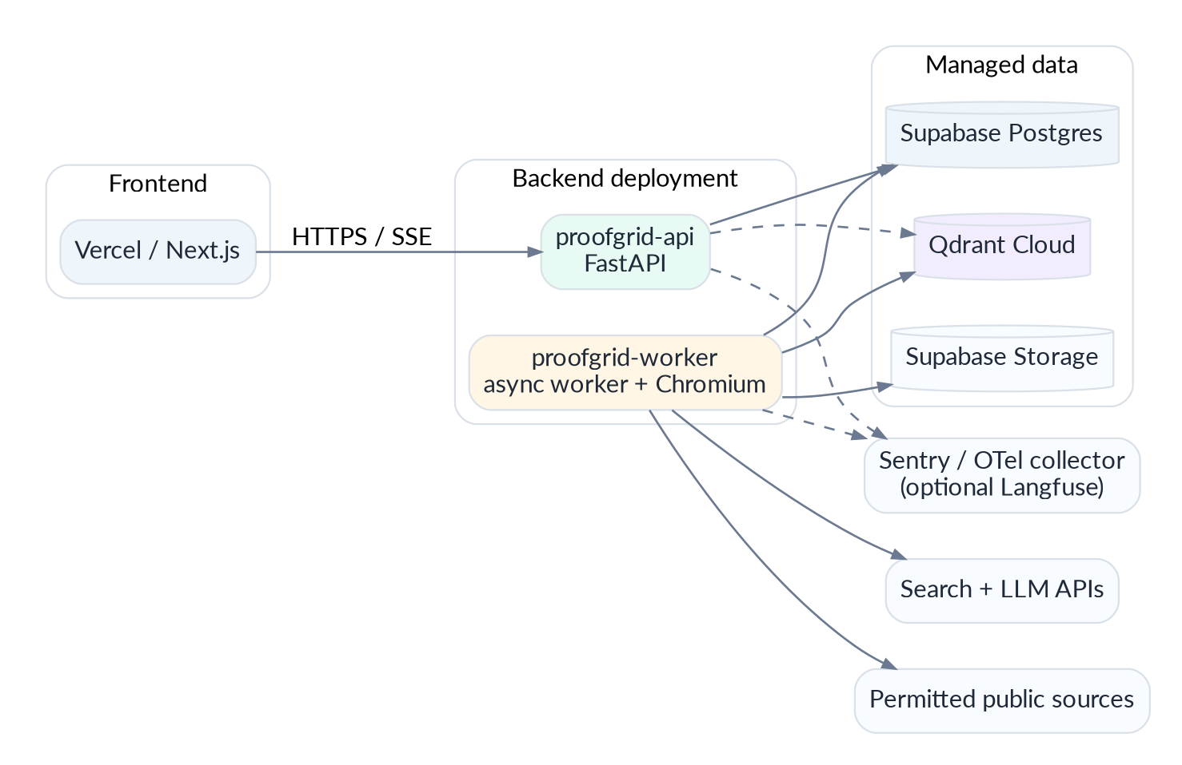
Figure 2. Deployment topology: the same backend codebase produces a stateless API process and a stateful worker process; managed data services sit outside both.

3.1 Processes
Process | Responsibilities | Must not do
proofgrid-api | REST/OpenAPI, auth, compile/plan requests, dataset/proof reads, run creation/cancel, SSE stream. | Long crawling, browser automation, bulk model extraction.
proofgrid-worker | Claim ready steps, execute operators, acquisition, extraction, trust pipeline, materialization, outbox dispatch. | Serve user-facing HTML or hold interactive session state.
migration job | Run Alembic migrations once per deploy. | Start app traffic before schema is compatible.
optional dispatcher | Can be same worker loop initially; sends Qdrant/webhook outbox events. | Own authoritative state outside Postgres.

3.2 Golden request lifecycle
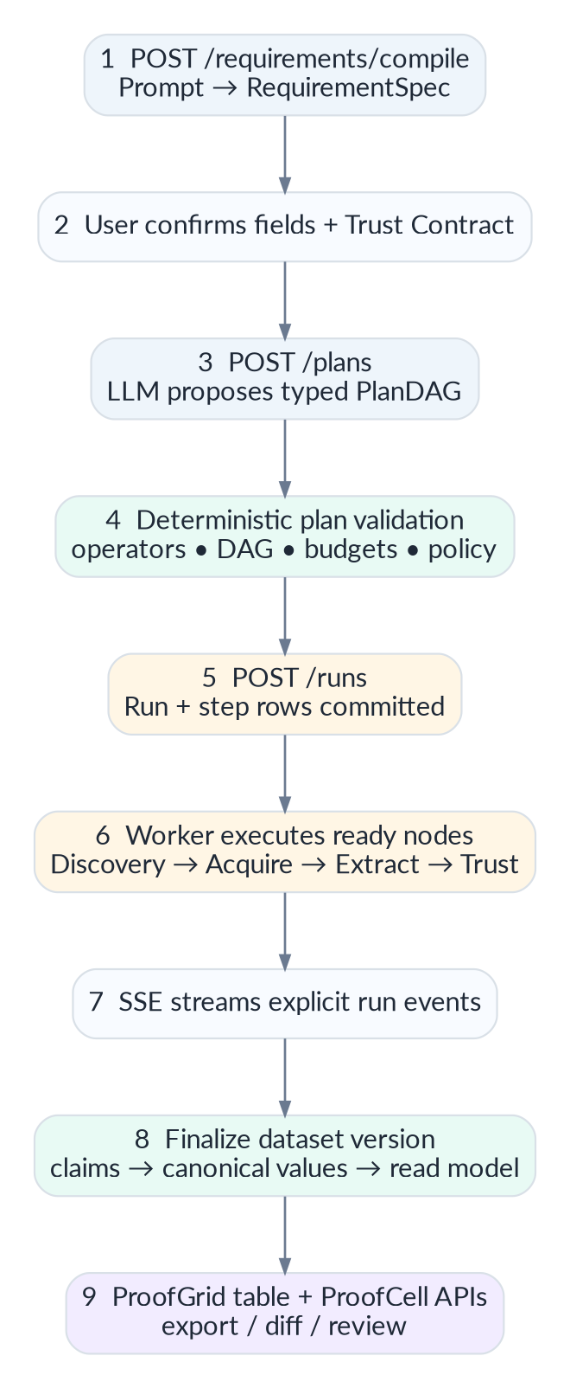
Figure 3. Request-to-dataset lifecycle. Human confirmation sits between AI interpretation and expensive execution.

4. Repository architecture and coding rules
backend/
pyproject.toml
alembic.ini
app/
main.py
api/
deps.py
routers/{requirements,plans,runs,datasets,proof,review,exports,health}.py
core/
config.py errors.py ids.py time.py security.py
domain/
enums.py contracts.py events.py policies.py
services/
requirements/ planning/ execution/ acquisition/
extraction/ normalization/ validation/
entity_resolution/ trust/ datasets/ exports/
adapters/
llm/ search/ browser/ storage/ vector/
persistence/
db.py models/ repositories/ queries/
workers/
runner.py operators.py outbox.py
observability/
logging.py tracing.py metrics.py
alembic/versions/
tests/
unit/ contract/ integration/ security/ e2e/ fixtures/
scripts/
seed_demo.py capture_fixture.py replay_run.py

4.1 Dependency rule
Layering rule
domain → no infrastructure imports. services → depend on protocols/interfaces. adapters/persistence → implement protocols. API and workers → compose services. Route handlers contain no business rules. ORM models never leak into the public API.

4.2 Coding standards
- Use timezone-aware UTC timestamps only; serialize ISO 8601 with Z/offset.
- Use Decimal for money and PostgreSQL NUMERIC for normalized numeric values; never float for financial claims.
- Use enums for persisted workflow states and reason codes. State changes occur through transition functions, not arbitrary UPDATE statements.
- Every external call has a timeout, retry classification and correlation metadata.
- No unbounded queries or unpaginated dataset endpoints. Every list API has a hard maximum limit.
- No direct provider SDK calls from domain services. They go through ModelGateway, SearchProvider, VectorIndex, ObjectStore and BrowserRenderer interfaces.
- Raw SQL is permitted only for queue claims, performance-critical queries and database-specific features; isolate it under persistence/queries and test it.

5. Domain contracts and invariants

5.1 RequirementSpec
class RequirementSpec(BaseModel):
entity_type: str
goal: str
fields: list[FieldSpec]
filters: list[FilterSpec] = []
geography: list[str] = []
time_window: DateRange | None = None
source_hints: list[HttpUrl] = []
limit: int = Field(default=100, ge=1, le=500)
refresh: RefreshPolicy | None = None
class FieldSpec(BaseModel):
key: str
label: str
data_type: Literal['text','url','money','date','location','entity_ref','entity_list','number','boolean']
required: bool = False
origin: Literal['user','ai_inferred']

Invariant: the original prompt is retained for audit, but downstream execution consumes the typed RequirementSpec. Any AI-inferred field remains explicitly tagged so the frontend can surface it before execution.

5.2 TrustContract
class TrustContract(BaseModel):
require_evidence_anchor: bool = True
minimum_independent_sources: int = Field(default=1, ge=1, le=5)
prefer_first_party: bool = True
allow_secondary_sources: bool = True
allow_single_source_output: bool = True
preserve_conflicts: bool = True
strict_required_fields: bool = False
max_source_age_days: int | None = None
max_pages: int = 60
max_browser_pages: int = 6
max_llm_calls: int = 80
max_estimated_cost_usd: Decimal = Decimal('3.00')

TrustContract is stored with the workflow version. A rerun against a different contract creates a new workflow version so results remain reproducible.

5.3 PlanDAG
class PlanNode(BaseModel):
key: str
operator: OperatorType
depends_on: list[str] = []
params: dict[str, Any] = {}
critical: bool = True
retry_policy: RetryPolicy = RetryPolicy()
class PlanDAG(BaseModel):
nodes: list[PlanNode]
expected_pages: int
expected_browser_pages: int
expected_llm_calls: int
schema_hash: str

5.4 Claim contract
class Claim(BaseModel):
entity_id: UUID
field_key: str
raw_value: Any
normalized_value: Any
value_type: str
source_id: UUID
evidence_anchor_id: UUID | None
extraction_method: str
extractor_version: str
observed_at: datetime
source_independence_cluster_id: UUID | None

Immutability rule
A Claim is never edited to match a newer source. If evidence changes, create a new RawDocument and a new Claim. Canonical values can point to a different claim in a later DatasetVersion.

6. Database architecture and persistence model
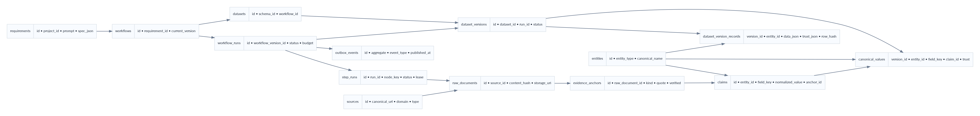
Figure 4. Core relational model. The read model is deliberately separated from the claim ledger so the UI can be fast without sacrificing provenance.

6.1 Write model versus read model
ProofGrid uses a small CQRS-like separation inside one PostgreSQL database. The write model captures requirements, runs, raw documents, evidence anchors, claims, entity decisions and canonical values. The read model stores a denormalized snapshot per dataset version for fast grid reads. This is not microservice CQRS; it is a data-layout optimization with one transactional authority.
Model | Tables | Purpose
Authoritative write model | raw_documents, evidence_anchors, entities, claims, conflicts, canonical_values | Explainability, provenance, review and reproducible derivation.
Execution model | workflow_runs, step_runs, run_events, cost_events | Durable workflow state, recovery and monitoring.
Read model | dataset_version_records | Fast table pagination/filter/search plus trust summary and pointers to proof.
Integration model | outbox_events | Reliable eventual updates to Qdrant and optional webhooks.

6.2 Core table inventory
Table | Responsibility
projects | Workspace/ownership boundary. Single demo project is acceptable in MVP.
requirements | Original prompt + compiled RequirementSpec and schema hash.
trust_contracts | Quality/source/budget contract version.
workflows | Logical reusable workflow.
workflow_versions | Immutable PlanDAG + requirement/contract references.
workflow_runs | One execution; status, budgets, counters and final dataset version.
step_runs | Durable node execution, lease, attempt, idempotency and error state.
run_events | Ordered user-visible/event-log stream for SSE replay.
sources | Canonical URL/domain/type and source-policy metadata.
raw_documents | Fetch metadata, content hash, storage URI, HTTP metadata, parser version.
evidence_anchors | Quote/JSON-pointer/DOM anchor with verification status.
entities | Stable identity for real-world objects.
entity_aliases | Known names/domains and supporting source metadata.
claims | Append-only source assertions for one entity field.
entity_match_candidates | Explainable merge/review/separate features and decision.
conflicts | Unresolved claim sets for one entity field/version.
datasets | Logical output dataset linked to workflow.
dataset_versions | Immutable dataset snapshot generated by one run.
canonical_values | Chosen/derived field value + trust state + chosen claim pointer.
dataset_version_records | Denormalized row JSONB + trust summary + row hash.
exports | Export request/result metadata and storage URI.
cost_events | Provider units/cost estimates per run/step.
outbox_events | Transactional secondary-index/webhook updates.
model_calls | Model, prompt version/hash, tokens, latency, validity; never secrets/raw evidence body.

6.3 Transaction boundaries
- Step completion: write step outputs + step status + run_event + relevant outbox event in one database transaction.
- Claim batch ingestion: insert claims and evidence anchors transactionally; duplicate idempotency keys become no-ops.
- Dataset finalization: use a transaction-scoped advisory lock keyed by dataset_id so two finalizers cannot create competing current versions.
- Qdrant synchronization occurs after commit through outbox dispatch; Qdrant failure cannot roll back authoritative Postgres truth.
- Exports read a fixed dataset_version_id, never the moving “latest” alias, so generated files are reproducible.

7. Authentication, authorization and tenancy
Authentication is not the innovation, so it must be secure but lightweight. The backend should support two modes: DEMO_SINGLE_WORKSPACE for the hackathon and AUTHENTICATED for a deployable product.
Mode | Behavior
DEMO_SINGLE_WORKSPACE | A server-configured project_id is injected; no anonymous database access from the browser. Suitable for judged demo only.
AUTHENTICATED | Supabase Auth issues JWTs; FastAPI validates issuer/audience/signature via cached JWKS, then authorizes project membership.

- Frontend never receives Supabase service-role credentials or database passwords.
- If Supabase Data API is exposed, enable RLS on all exposed tables and revoke grants that are not intentionally required. The preferred architecture still routes ProofGrid data through FastAPI.
- Every project-scoped query includes project_id at the repository boundary; integration tests assert cross-project denial.
- Admin-only actions: source policy override, fixture capture, model/provider configuration and hard-delete raw evidence.

8. Requirement Compiler
The compiler is an AI-assisted parser, not an agent loop. Its only job is to turn a business request into a typed RequirementSpec plus a proposed schema that the user can inspect.

8.1 Compiler algorithm
- Pre-check prompt length and obvious unsupported requests; assign correlation_id.
- Build a compact structured-output prompt containing allowed field types, filter operators and source policy summary.
- Call ModelGateway with response schema RequirementSpecDraft; temperature/variance is kept low.
- Validate through Pydantic. On schema failure, issue exactly one repair call containing only validation errors and previous JSON.
- Run deterministic semantic checks: duplicate field keys, invalid relative dates, impossible numeric filters, limit/budget bounds.
- Compute schema_hash from canonical JSON and persist prompt + compiled object + prompt_version + model metadata.
- Return interpreted fields with origin=user or ai_inferred. No workflow is executed until explicit user confirmation.

8.2 Compiler failure behavior
Condition | Result
Model timeout | COMPILER_MODEL_TIMEOUT; retryable once.
Invalid structured output twice | COMPILER_SCHEMA_INVALID; user keeps original prompt and can retry.
Ambiguous critical requirement | Return needs_clarification=true with 1–3 specific fields; do not guess silently.
Unsupported source request | Compile succeeds but source policy warning is attached so Plan Preview can block execution.

9. Trust Contract Engine
The contract converts UX controls into deterministic backend policy. Presets are only templates; the stored contract always contains explicit values.

9.1 Source independence
Counting two URLs as two independent confirmations is wrong when both duplicate the same press release. For the MVP, compute an independence key using registrable domain plus near-duplicate content clustering. Same registrable domain is never counted as two independent sources for one claim unless an explicit source adapter says otherwise.
independence_key = registrable_domain(source.url)
if content_similarity(doc_a, doc_b) >= 0.95:
assign_same_independence_cluster()
support_count = count(distinct source_independence_cluster_id)

9.2 Contract enforcement points
Stage | Enforcement
Plan validation | max pages/browser/model calls/cost; forbidden operator/source classes.
Acquisition | source permission, robots decision, allowed content types, authentication wall handling.
Extraction | require evidence anchor, required field coverage policy.
Canonicalization | minimum independent support, first-party preference, conflict preservation.
Finalization | strict_required_fields can produce PARTIAL rather than silently filling missing values.

10. Planner, PlanDAG and deterministic plan validation
The planner may propose a graph but cannot invent code. It chooses from a finite registry of typed operators and parameter schemas.
Operator | Typed I/O | Purpose
DISCOVER | RequirementSpec → CandidateSource[] | Generate bounded search queries and source candidates.
FETCH_HTTP | CandidateSource → RawDocument | Safe HTTP acquisition.
FETCH_BROWSER | CandidateSource → RawDocument | Rendered fallback for allowlisted cases.
EXTRACT | RawDocument + DatasetSchema → ClaimDraft[] | Structured deterministic/LLM extraction.
NORMALIZE | ClaimDraft[] → NormalizedClaim[] | Field policy registry.
VALIDATE | NormalizedClaim[] → ValidatedClaim[] | Type, evidence, business and cross-field rules.
ENTITY_RESOLVE | ValidatedClaim[] → EntityDecision[] | Match to stable entities.
RECONCILE | Claims → CanonicalValue[] + Conflict[] | Support/contradiction and canonical choice.
MATERIALIZE | Canonical values → DatasetVersion | Read model + hashes.
INDEX | DatasetVersion → outbox events | Semantic index updates.
EXPORT | DatasetVersion → export | CSV/JSON/evidence bundle.

10.1 Plan validator
def validate_plan(plan, requirement, contract):
assert unique_node_keys(plan)
assert acyclic(plan) # topological sort
assert all(node.operator in REGISTRY for node in plan.nodes)
assert typed_edges_compatible(plan)
assert len(plan.nodes) <= MAX_PLAN_NODES
assert plan.expected_pages <= contract.max_pages
assert plan.expected_browser_pages <= contract.max_browser_pages
assert plan.expected_llm_calls <= contract.max_llm_calls
assert estimate_cost(plan) <= contract.max_estimated_cost_usd
assert no_unapproved_source_class(plan)
return ValidatedPlan(...)

A plan that fails validation is never “best-effort executed.” It is rejected, the reason is returned to the user, and a replan can be requested with the violation encoded as a constraint.

11. Workflow executor and Postgres-backed queue
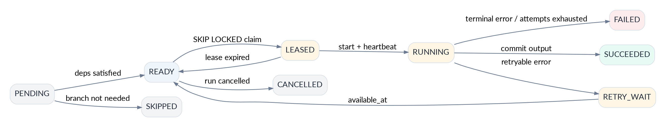
Figure 5. Step state machine. Lease expiry recovers crashed workers without losing the run.

11.1 Queue claim query
WITH candidate AS (
SELECT id
FROM step_runs
WHERE status = 'READY'
AND available_at <= now()
ORDER BY priority DESC, created_at ASC
FOR UPDATE SKIP LOCKED
LIMIT 1
)
UPDATE step_runs s
SET status = 'LEASED',
leased_by = :worker_id,
lease_expires_at = now() + interval '60 seconds',
attempt = attempt + 1,
updated_at = now()
FROM candidate c
WHERE s.id = c.id
RETURNING s.*;

PostgreSQL documents SKIP LOCKED as appropriate for queue-like multi-consumer access because consumers can skip rows currently locked by another worker. It is not used for ordinary user queries.

11.2 Lease and heartbeat
- After claim, the worker transitions LEASED → RUNNING and starts a heartbeat every ~20 seconds.
- Lease duration is configurable; default 60 seconds. Heartbeat extends lease only if leased_by matches the worker.
- A sweeper returns expired LEASED/RUNNING steps to READY if retry policy allows; otherwise FAILED.
- Worker shutdown stops claiming, finishes/abandons safely, and releases database connections. There is no in-memory-only run state.

11.3 Idempotency
idempotency_key = sha256(
f"{workflow_run_id}:{node_key}:{canonical_input_hash}:{operator_version}"
)
UNIQUE(step_run_id, idempotency_key)
UNIQUE(claim_idempotency_key)
UNIQUE(dataset_version_id, entity_id, field_key)

11.4 Retry policy
Failure class | Retry? | Policy
HTTP 429 / 5xx | Yes | Exponential backoff + jitter; honor Retry-After when sane.
Timeout | Yes | Bounded 1–2 retries; then alternate source/partial result.
4xx permission/auth/CAPTCHA | No | Mark blocked/unsupported; do not bypass.
Invalid LLM JSON | Once | Structured repair call; second failure terminal for that document.
Pydantic/business validation | Usually no | Preserve rejected claim diagnostic; do not repeatedly hallucinate.
DB serialization/transient connection | Yes | Short transaction retry.
Budget exceeded | No | RUN_BUDGET_EXCEEDED; finalize partial outputs if useful.

12. Source discovery and SourcePolicy
Discovery answers “which sources are worth attempting?”; it does not scrape. The provider is swappable because search quality, pricing and hackathon credits can change.
class SearchProvider(Protocol):
async def search(self, query: str, *, limit: int, recency_days: int | None) -> list[SearchHit]: ...
class SourcePolicyDecision(BaseModel):
allowed: bool
reason_code: str
robots_allowed: bool | None
requires_auth: bool = False
source_class: str | None = None

12.1 Candidate URL normalization
- Normalize scheme/host casing, remove fragments, sort/remove known tracking parameters, preserve meaningful query parameters.
- Use registrable-domain parsing for source independence and per-domain concurrency.
- Deduplicate by canonical_url_hash before fetch. Keep original discovered URL for audit.
- Do not silently rewrite HTTP to HTTPS if the original redirects; follow only after safe redirect validation.

13. Safe acquisition: HTTP, static extraction and browser fallback
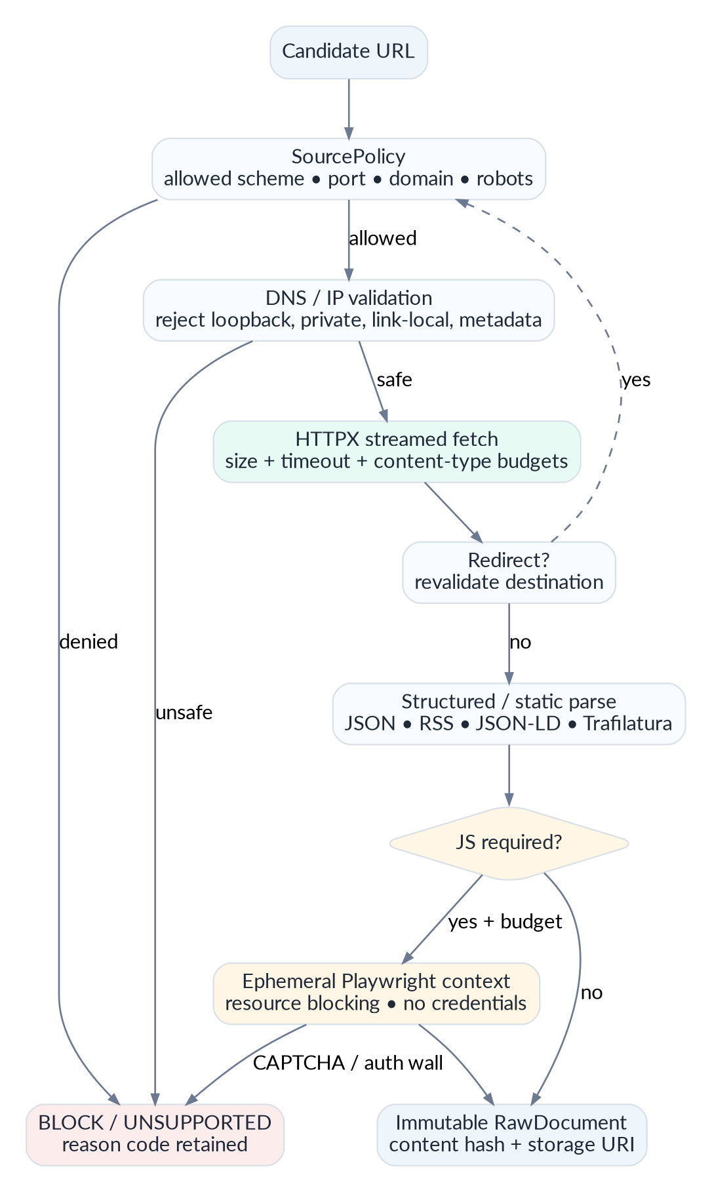
Figure 6. Acquisition is an escalation ladder with security gates on every URL and redirect.

13.1 Safe URL validation
- Allow only http and https. Block file, ftp, gopher, data and arbitrary schemes.
- Allow ports 80/443 by default; any other port requires explicit server-side allowlist.
- Resolve A/AAAA records and reject loopback, private RFC1918/RFC4193, link-local, multicast, unspecified and cloud metadata addresses.
- Disable automatic redirects. Re-run the complete validation pipeline for every Location destination before following it.
- Enforce infrastructure egress controls where the hosting platform allows it; application validation alone should not be the only SSRF barrier in production.
- Reject userinfo in URLs and normalize internationalized domains before policy checks.

13.2 HTTP client budgets
Setting | Prototype default | Reason
connect timeout | 5 s | Fail fast on unreachable hosts.
read timeout | 12 s | Enough for normal public pages; browser is fallback.
total redirects | ≤ 5 | Avoid loops and SSRF chains.
max response body | 5 MB | Prevent memory abuse; PDFs can use separate configurable limit.
HTTP concurrency | 8 global / 2 per registrable domain | Fast without hammering one site.
accepted content | HTML, JSON, RSS/XML, text, CSV, bounded PDF | Reject executables/archives by default.
user agent | Named ProofGrid crawler string | Transparent identity for permitted crawling.

13.3 Static extraction path
HTTPX streams the body while enforcing byte limits. For HTML: parse JSON-LD/schema.org first, then deterministic DOM selectors/adapters, then Trafilatura main-text extraction. Store both the sanitized text representation and the original bounded source artifact when policy allows.

13.4 Browser fallback
- Use Playwright only when static fetch cannot obtain required content and browser budget remains.
- Create one non-persistent BrowserContext per source or bounded batch; no login cookies or local profile.
- Block images, fonts, video and other unnecessary resource types to reduce latency and attack surface.
- Wait for explicit page readiness conditions; do not use infinite “network idle” waits on noisy sites.
- Capture final URL and revalidate it; enforce navigation count, wall-clock timeout and maximum rendered HTML size.
- If CAPTCHA/authentication appears, return SOURCE_REQUIRES_MANUAL_ACCESS. No bypass logic.

14. Raw evidence storage and content normalization
RawDocument is the audit substrate. The database stores metadata and hashes; large bodies live in object storage. Content is immutable by content hash.
RawDocument:
id, source_id, canonical_url, final_url
fetched_at, http_status, content_type, byte_length
etag, last_modified
sha256_original, sha256_extracted_text
storage_uri_original, storage_uri_text
acquisition_method: HTTP | BROWSER | API | FIXTURE
robots_decision, policy_decision
parser_version, renderer_version

14.1 Content-addressed reuse
If the same content hash appears again, downstream extraction can reuse cached results when schema_hash, extractor_version and model_id also match. A new fetch observation can still be stored for freshness without duplicating the binary object.

14.2 Supported document adapters
Content type | Adapter
application/json | Validate/flatten known structures; preserve JSON pointer for evidence anchors.
HTML | JSON-LD → source adapter → Trafilatura/lxml text representation.
RSS/Atom/XML | Safe parser; entries become candidate source documents.
text/csv | Bounded CSV parser; header/schema checks.
PDF | PyMuPDF text extraction for text PDFs; OCR intentionally out of MVP unless required.
Unknown/binary | Reject with UNSUPPORTED_CONTENT_TYPE.

15. Structured extraction and Evidence Anchor Verification
Figure 7. Trust pipeline: no claim reaches a strong trust state without evidence, normalization and identity handling.

15.1 Extraction ladder
- 1. Structured source adapter / official API fields.
- 2. JSON-LD/schema.org or stable deterministic selector.
- 3. Regex/heuristic parser for well-defined types such as dates and amounts.
- 4. LLM structured extraction over the cleaned relevant text only.
- 5. Browser-rendered document follows the same extraction ladder; browser itself is not the extractor.

15.2 LLM extractor boundary
Extractor input:
dataset_schema
field descriptions
cleaned source text chunks
source metadata (URL, publication date if known)
Extractor capabilities:
RETURN JSON ONLY matching ClaimDraft[] schema
Extractor does NOT receive:
database credentials
arbitrary tools
browser controls
shell/filesystem access
planner state
secrets

15.3 Evidence Anchor Verification
This is a required differentiator. The model may propose an evidence quote, but the backend—not the model—decides whether it is anchored.
Anchor type | Verification
TEXT_EXACT | Evidence quote must occur byte/character-exactly in extracted text.
TEXT_NORMALIZED | Unicode normalization + whitespace folding; quoted text must still map back to a concrete span.
JSON_POINTER | Pointer must resolve in the stored JSON and the normalized claim must derive from that value.
DOM_SELECTOR | Selector/XPath must resolve in the stored/sanitized DOM snapshot; captured text is hashed.
UNANCHORED | No verified anchor found. Claim may be retained for review but cannot satisfy require_evidence_anchor.

def verify_text_anchor(document_text, proposed_quote):
if proposed_quote in document_text:
return EXACT(span_of(proposed_quote))
nq = normalize_unicode_whitespace(proposed_quote)
nt, map_back = normalize_with_offset_map(document_text)
if nq in nt:
return NORMALIZED(map_back[span_of(nq)])
return UNANCHORED

Anti-hallucination rule
A syntactically valid value with an unverified evidence anchor is still unproven. Pydantic validates shape; Evidence Anchor Verification validates that the source actually contained the supporting material.

16. Field normalization and validation
ProofGrid uses a FieldPolicy registry keyed by schema data_type. Each policy defines parse, normalize, compare and conflict semantics. This prevents “everything is a string” logic.
Type | Normalization | Comparison / conflict semantics
money | Parse raw amount/currency; Decimal value; retain original string; never silently convert currencies without conversion metadata. | Compare same-currency normalized amounts; different currency is not automatically equal.
date | Parse date plus precision (day/month/year) and original text. | Do not call May 2026 vs 15 May 2026 a hard conflict if precision differs.
url | Canonicalize host/path/tracking params; keep source URL separate. | Exact canonical URL / domain rules.
location | Normalize country/region aliases while preserving raw representation. | Structured components; avoid semantic merge solely on display name.
entity_ref | Normalize name/suffixes and resolve stable entity_id. | Entity resolution engine decides identity.
entity_list | Normalize members, set-based comparison, stable entity refs where possible. | Jaccard/set overlap with missingness semantics.
text | Whitespace/Unicode cleanup only; preserve original claim. | Usually no conflict unless field schema declares categorical text.
number | Decimal/integer range rules. | Exact/tolerance comparator configured by field.

16.1 Validation layers
- Contract/type validation: Pydantic and JSON Schema.
- Evidence validation: anchor exists and belongs to the referenced RawDocument.
- Field validation: parser/range/domain rule.
- Cross-field validation: examples include funding_date ≤ source publication time unless clearly future event, URL domain consistency and currency/value coupling.
- Cross-source validation: support/contradiction after entity resolution.
- TrustContract validation: required evidence/support thresholds and source policy.

17. Entity resolution and deduplication
Entity resolution is conservative because false merges destroy provenance. The backend optimizes candidate generation first, then makes an explainable decision.

17.1 Candidate pipeline
- Normalize name (Unicode casefold, punctuation, legal suffix dictionary) and derive registrable domains.
- Blocking: country/region + name prefix and/or exact domain. This avoids O(n²) all-pairs matching.
- Lexical candidates: PostgreSQL pg_trgm / RapidFuzz similarity on normalized names.
- Semantic candidates: Qdrant top-k over normalized_name + compact description, filtered to dataset/entity type where useful.
- Cross-field features: exact domain, location compatibility, founder/investor overlap, canonical social URL, website title.
- Decision: AUTO_MERGE only above a conservative rule/threshold; REVIEW in the middle band; KEEP_SEPARATE below.

17.2 Prototype decision features
Feature | Role
exact registrable domain | Very strong signal, but not sufficient for parent/subsidiary edge cases.
normalized name similarity | Strong lexical signal.
token/Jaro-Winkler similarity | Handles order and small spelling variation.
location compatibility | Supporting signal; never sole merge reason.
founder/entity overlap | Supporting identity evidence.
semantic similarity | Candidate retrieval / supporting signal, not authoritative identity.
contradictory hard identifiers | Can veto auto-merge and force review.

MVP rule
Use blocking + RapidFuzz/pg_trgm + one Qdrant candidate pass. Keep Splink/Fellegi-Sunter as the production evolution unless the team already knows it. The demo needs explainable correctness more than a complex linkage framework.

18. Claim Ledger, conflict detection and canonicalization
A source claim and a canonical value are different concepts. Claims state “Source S asserted V.” Canonicalization states “For DatasetVersion D, ProofGrid displays C, based on these claims and this policy.”

18.1 Claim ingestion
- Derive or resolve entity_id before final claim insertion; provisional entity candidates may be used during the extraction batch.
- Persist raw_value and normalized typed value together.
- Reference one verified evidence_anchor when possible; one source field can produce multiple anchors if necessary.
- Attach source independence cluster, extraction method/version and workflow step/run IDs.
- Compute claim_idempotency_key from document hash + entity stable key + field + normalized value + extractor version.

18.2 Conflict engine
Claims conflict only after field-specific normalization/comparison. Conflicts are not a generic string inequality. For each entity + field + dataset version, group agreeing normalized claims; count independent support; preserve all groups.

18.3 Canonical choice policy
- If exactly one valid group exists, choose it subject to TrustContract support requirements.
- If multiple groups exist, mark CONFLICTING. A canonical display value may still be selected when policy allows using first-party/source-class preference, independent support count and recency, but losing claims remain visible.
- If no claim satisfies evidence/validation requirements, field is NEEDS_REVIEW or MISSING depending on whether rejected/unanchored claims exist.
- Canonicalization stores a resolution_reason_code and chosen_claim_id; it never deletes competing claims.

19. Trust-status engine
The UI must not display invented “93% confidence.” The backend emits categorical trust states derived from inspectable evidence.
State | Backend derivation
VERIFIED | Contract satisfied with verified evidence and authoritative/independent corroboration as required; no unresolved material conflict.
SUPPORTED | Multiple independent anchored claims agree, but the stricter VERIFIED condition is not met.
SINGLE_SOURCE | One valid anchored source supports the field and the contract permits single-source output.
CONFLICTING | Two or more valid claim groups materially disagree.
NEEDS_REVIEW | Evidence exists but anchor/identity/validation/review threshold is unresolved.
MISSING | No usable claim was found for the field.

def derive_trust(field_ctx, contract):
if field_ctx.has_material_conflict:
return CONFLICTING
if field_ctx.valid_independent_support >= contract.minimum_independent_sources:
if field_ctx.meets_verified_policy:
return VERIFIED
return SUPPORTED
if field_ctx.valid_claims and contract.allow_single_source_output:
return SINGLE_SOURCE
if field_ctx.rejected_or_unresolved_claims:
return NEEDS_REVIEW
return MISSING

20. Dataset materialization, search and ProofCell read APIs
The canonical tables are excellent for proof, but expensive to pivot for every grid request. MATERIALIZE creates a denormalized DatasetVersionRecord for each entity.
dataset_version_records.data_json = {
"company_name": "Example AI",
"funding_amount": {"amount": "4500000", "currency": "USD"},
"funding_date": "2026-08-15",
"investors": ["Fund A", "Fund B"]
}
dataset_version_records.trust_json = {
"funding_amount": "VERIFIED",
"investors": "SUPPORTED"
}

20.1 Grid query strategy
- Pagination is server-side with hard caps. For MVP use offset pagination for a few hundred rows; expose a stable sort key. Production can move to keyset/cursor pagination.
- Whitelist field keys and operators from the dataset schema; never interpolate raw filter expressions into SQL.
- Use GIN on data_json for basic containment and explicit columns for stable metadata (entity_id, trust summary, created_at). For heavily queried dynamic numeric fields, production can add a typed field index table.
- Full-text/semantic search is separate from exact structured filters. Qdrant returns candidate entity IDs; PostgreSQL applies authorization and structured filters.

20.2 ProofCell API
GET /v1/datasets/{dataset_id}/versions/{version_id}/records/{entity_id}/proof/{field_key}
→ canonical value + trust state
→ resolution reason
→ supporting claims
→ conflicting claims
→ evidence anchors
→ source metadata
→ normalization/extraction history

21. Dataset versioning and diff engine
A rerun creates a new immutable DatasetVersion. “Not rediscovered” is not automatically deletion.
- Compute stable entity_id across versions.
- Compute canonical field hashes and a row_hash over canonical JSON + trust states.
- Classify entity changes: ADDED, CHANGED, UNCHANGED, MISSING_LATEST.
- Classify field changes: VALUE_CHANGED, TRUST_CHANGED, EVIDENCE_CHANGED, CONFLICT_CHANGED.
- Only a user/retention policy marks an entity as intentionally removed; a single failed crawl does not.
row_hash = sha256(canonical_json({
"entity_id": str(entity_id),
"data": data_json,
"trust": trust_json,
}))

22. Qdrant semantic layer and consistency model
Qdrant is a secondary index. PostgreSQL is authoritative. The backend must remain functional if Qdrant is unavailable: semantic search and semantic candidate generation degrade, but workflows and proof remain correct.

22.1 Point design
vector text = normalized_name + "\n" + compact_entity_description
payload = {
"project_id": "...",
"dataset_id": "...",
"entity_id": "...",
"entity_type": "company",
"country": "IN",
"last_dataset_version_id": "..."
}

22.2 Allowed uses
- Entity-resolution candidate retrieval before deterministic/cross-field scoring.
- Semantic dataset search (“AI infrastructure for hospitals”) followed by PostgreSQL authorization/filtering.

22.3 Outbox consistency
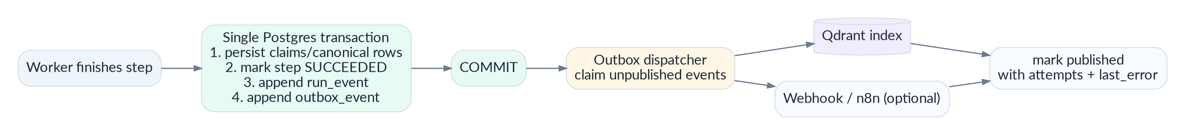
Figure 8. Transactional outbox prevents a committed dataset from depending on an uncommitted Qdrant/webhook side effect.
Outbox dispatch is at-least-once. Upserts to Qdrant use entity_id as the stable point ID, making repeated delivery idempotent. Dispatcher records attempts and last_error and exposes outbox lag as a metric.

23. REST API contract
Version all public routes under /v1. FastAPI generates OpenAPI, but the explicit contract below remains the product agreement. Use a consistent error envelope and correlation ID.
Method | Route | Contract
POST | /v1/requirements/compile | Compile prompt → RequirementSpec draft.
PATCH | /v1/requirements/{id} | Apply user field/filter edits before planning.
POST | /v1/requirements/{id}/trust-contract | Persist explicit TrustContract.
POST | /v1/requirements/{id}/plan | Generate + validate PlanDAG preview.
POST | /v1/workflows/{id}/runs | Create queued run from immutable workflow version.
GET | /v1/runs/{run_id} | Current run/step/counter snapshot.
GET | /v1/runs/{run_id}/events | SSE stream with replay cursor.
POST | /v1/runs/{run_id}/cancel | Request cancellation; cooperative worker stop.
GET | /v1/datasets | List datasets.
GET | /v1/datasets/{id}/versions | Version history.
GET | /v1/datasets/{id}/versions/{vid}/records | Paginated grid query/filter/sort.
GET | /v1/datasets/{id}/versions/{vid}/records/{eid}/proof/{field} | ProofCell payload.
GET | /v1/datasets/{id}/diff | Diff two versions.
GET | /v1/review | Conflicts/entity matches needing review.
POST | /v1/review/entity-match/{id} | Human merge/separate decision.
POST | /v1/review/conflict/{id} | Human canonical decision/annotation.
POST | /v1/exports | Create version-pinned export.
GET | /v1/exports/{id} | Status/download metadata.
GET | /v1/health/live | Process liveness.
GET | /v1/health/ready | DB + required dependency readiness.

23.1 Error envelope
{
"error": {
"code": "SOURCE_BLOCKED_BY_POLICY",
"message": "This source is not eligible for automated collection.",
"retryable": false,
"correlation_id": "req_...",
"details": {"source_id": "...", "reason": "ROBOTS_DISALLOW"}
}
}

23.2 API correctness rules
- Use 409 for state/version conflicts, 422 for contract validation, 429 for application-level budget/rate enforcement, 503 for required dependency readiness failure.
- Never return internal stack traces, provider keys or raw model prompts to clients.
- Use ETag/If-None-Match on immutable or versioned read endpoints where practical.
- Every mutation returns the resulting immutable/version ID so frontend does not infer state.

24. Server-Sent Events and run monitoring
The frontend only needs server→client progress, so SSE is simpler than a bidirectional WebSocket. The backend writes ordered run_events first; the SSE endpoint streams from that log. Reconnection can replay missed events.
event: step.progress
id: 1842
data: {"run_id":"...","step":"extract","status":"RUNNING",
"input_count":12,"output_count":31,"duration_ms":4210}
# Client reconnects with Last-Event-ID: 1842
# Server resumes WHERE seq > 1842 ORDER BY seq

Event | Payload purpose
run.state_changed | QUEUED/RUNNING/PARTIAL/COMPLETE/FAILED/CANCELLED
step.started | Node/operator began.
step.progress | Counts, duration and bounded progress metadata.
step.retry_scheduled | Attempt, available_at, reason.
source.discovered | Optional low-volume discovery event.
claims.extracted | Aggregate count; do not stream sensitive full claims by default.
conflict.detected | Aggregate/record IDs used to update UI badge.
dataset.version_created | New version ID and summary.
run.completed | Final counters, partial flag, dataset version.
heartbeat | Keeps intermediaries/client aware of live stream.

25. Caching, rate limits, budgets and cost accounting

25.1 Cache keys
Cache | Key | Lifetime | Notes
robots | origin + user_agent | ~24h or HTTP cache headers | Policy decision; conservative refresh on errors.
fetch | canonical_url + etag/last_modified/content_hash | Source/freshness dependent | Revalidate; never serve stale as “fresh” silently.
extraction | document_hash + schema_hash + extractor_version + model_id | Content-addressed | Highest-value cost saver.
embedding | embedding_text_hash + model_id | Content-addressed | Avoid duplicate vectors.
search discovery | normalized query + recency + provider | Minutes/hours | Short cache to reduce repeated API cost.

25.2 Runtime budget gates
The Plan Preview estimate is not enough; every operator checks remaining budget before an expensive action. Budget counters are transactionally incremented.
BudgetCounter:
pages_fetched / max_pages
browser_pages / max_browser_pages
llm_calls / max_llm_calls
llm_input_tokens / max_llm_input_tokens
llm_output_tokens / max_llm_output_tokens
estimated_usd / max_estimated_cost_usd
wall_clock_seconds / max_run_seconds

25.3 Rate limiting
- Per-domain semaphore controls outbound fetch concurrency. Global semaphore bounds total sockets/browser tabs.
- API mutation rate limits can be enforced at edge/reverse proxy for the hackathon; production may use distributed counters.
- Provider adapters implement their own 429 handling and expose Retry-After to the scheduler.
- No user can override hard server safety ceilings even if TrustContract requests larger budgets.

26. Error taxonomy, retries and graceful degradation
Code | Scope | Behavior
SOURCE_BLOCKED_BY_POLICY | terminal source | Skip source; expose reason.
SOURCE_ROBOTS_DISALLOW | terminal source | Skip; never browser-escalate to evade.
SOURCE_REQUIRES_MANUAL_ACCESS | terminal source | Auth/CAPTCHA/paywall; retain candidate.
SOURCE_TIMEOUT | retryable source | Retry bounded then alternate/partial.
UNSUPPORTED_CONTENT_TYPE | terminal doc | Skip document.
EVIDENCE_UNANCHORED | claim-level | Retain for review; cannot satisfy strict proof.
EXTRACTION_SCHEMA_INVALID | document-level | One structured repair attempt.
ENTITY_MATCH_AMBIGUOUS | review-level | Do not auto-merge.
RUN_BUDGET_EXCEEDED | run-level | Stop new expensive work; finalize partial.
DEPENDENCY_QDRANT_UNAVAILABLE | degraded | Continue without semantic features.
DEPENDENCY_LLM_UNAVAILABLE | step/run | Retry bounded; deterministic extraction may still proceed.
INTERNAL_INVARIANT_VIOLATION | terminal | Fail safely, log correlation ID, no silent data corruption.

26.1 Partial completion
A run is PARTIAL when the critical core produced a usable dataset but one or more non-critical steps/sources failed or budget ended. The UI receives failed source counts and reasons. COMPLETE is reserved for the validated plan finishing according to contract.

27. Security architecture and threat model
The backend processes attacker-controlled URLs and arbitrary internet text. Security is therefore a core data-pipeline property, not a deployment afterthought.
Threat | Example | Backend control
Indirect prompt injection | Scraped text tries to instruct model/tools. | Extractor has no tools/privileges; planner never sees raw pages; structured schema gate; evidence verification.
SSRF | URL targets localhost/private cloud metadata/internal services. | Scheme/port/IP validation, redirect revalidation, egress controls, no arbitrary protocols.
SQL injection | Dynamic filters/search. | SQLAlchemy parameters + field/operator whitelist; no raw filter interpolation.
Stored XSS | Evidence contains scripts/HTML. | Return evidence as text; sanitize any rendered markup; frontend CSP.
Credential leakage | Logs/prompts/raw pages expose secrets. | Server-only secret manager/env, log redaction, no secrets in model prompts, isolated browser.
Resource exhaustion | Huge pages/redirects/LLM fanout. | Byte/time/page/token/concurrency budgets; streaming reads.
Queue duplicate execution | Worker crash or retry. | Lease + idempotency keys + unique constraints.
Cross-tenant access | Guess IDs. | project_id authorization at repository boundary + optional RLS defense-in-depth.
Supply-chain risk | Dependency compromise. | Pinned lockfile, dependabot/audit, minimal runtime image, no dynamic pip install.

27.1 Prompt injection privilege separation
Security boundary
Downloaded content is data, never authority. The only component that sees raw web text is the extraction path, and its only permitted output is typed ClaimDraft JSON. It cannot schedule new tools, browse another URL, write directly to the database, or access secrets.

27.2 Secret handling
- One environment/secret store per environment; no .env committed.
- Service-role/database credentials exist only in API/worker backend deployments.
- Provider keys are never stored in workflow JSON, run events or model-call prompt bodies.
- Structured logs redact Authorization, Cookie, Set-Cookie, API key headers and configured sensitive fields.

28. Privacy, source permissions and retention
The backend enforces the product promise “public/permitted sources only.” robots.txt is respected as crawler guidance but is not treated as access authorization by itself; source policy also considers authentication/paywall/CAPTCHA and configured domain restrictions.
Data class | Default retention | Notes
Raw source artifact | 30 days in prototype; configurable | Long enough for proof/demo; delete sooner if source/user policy requires.
Extracted text representation | 30 days / aligned to raw artifact | Content-addressed; restricted access.
Claims/evidence metadata | Persistent with dataset history | May survive raw-body deletion if policy permits and evidence text is minimal.
Dataset versions | Persistent until user deletes | Core product history.
Run/model logs | 14–30 days | No full raw web bodies or secrets.
Exports | 7 days default | Regenerate from immutable dataset version; signed/private download.

- No collection behind authentication walls without an explicit authorized connector design.
- No CAPTCHA bypass.
- Minimize personal data; the golden demo focuses on companies/funding rather than private individuals.
- Support project/data deletion as a cascade job; hard-delete object-storage artifacts and vector points through outbox cleanup.

29. Observability, auditability and diagnostics

29.1 Correlation fields
correlation_id
project_id
workflow_id / workflow_version_id
run_id
step_run_id
source_id / raw_document_id
entity_id (when safe)
operator
attempt
provider / model_id (when applicable)

29.2 Metrics worth shipping
Metric | Interpretation
queue_ready_depth | Number of READY steps.
step_duration_seconds | Histogram by operator/status.
source_fetch_total | By HTTP status/policy result/acquisition method.
bytes_fetched_total | Outbound data volume.
claims_extracted_total | By field/method/validation result.
evidence_anchor_success_ratio | Anchored / proposed claims.
entity_review_ratio | Ambiguous entity decisions / total candidates.
conflict_rate | Conflicted fields / populated fields.
run_partial_rate | Partial runs / completed runs.
budget_utilization | Pages/browser/model/cost ratios.
outbox_lag_seconds | Oldest unpublished outbox event.
qdrant_sync_failures_total | Secondary index health.
llm_structured_output_invalid_total | Model contract reliability.

29.3 Logging rules
- JSON structured logs in deployed environments; human pretty logs locally.
- No raw evidence body in logs. Log hashes, sizes, IDs and reason codes.
- Every external call logs latency, status, attempt and provider correlation when available.
- Run events are product/audit events; logs are diagnostics. Do not use logs as durable workflow state.

30. Performance, concurrency and capacity targets
Targets are chosen for a live hackathon prototype with tens to hundreds of rows, not fictional web-scale throughput.
Target | Goal | Notes
Requirement compile p95 | ≤ 5 s | Model-dependent; show progress immediately.
Plan generation + validation p95 | ≤ 5 s | Typed bounded graph.
Dataset grid API p95 | ≤ 300 ms for ≤500 rows | Postgres read model; no proof joins in grid path.
ProofCell API p95 | ≤ 350 ms typical | Indexed claim/evidence lookups.
SSE event propagation | ≤ 1 s after commit | Poll/listen strategy; correctness over sub-100ms latency.
HTTP concurrency | 8 global, 2/domain default | Configurable.
Browser concurrency | 1–2 contexts default | Chromium is expensive; isolate from API process.
Run capacity | 3 concurrent demo runs | Adequate for judging/team usage.
Raw page body | ≤5 MB default | Separate bounded PDF limit.
Queue claim | ≤500 ms typical | Index READY + available_at + priority.

30.1 Optimization order
- Reuse cached raw documents/extractions by content hash.
- Use deterministic extraction before model calls.
- Strip irrelevant DOM before LLM input.
- Parallelize independent HTTP sources within domain/global limits.
- Keep browser fallback rare.
- Batch embeddings and upsert through outbox.
- Materialize read model once; do not reconstruct each row from claims on every table request.

31. Test architecture and evaluation corpus
CI must not depend on the live web. External behavior is tested through captured permitted fixtures and mocked provider adapters; a separate smoke suite can hit live sources before demo.
Test layer | Required coverage
Unit | Normalizers, field comparators, state transitions, plan validator, budget logic, URL canonicalizer.
Property-based | Money/date parsers, URL normalization, idempotency hash stability, diff invariants.
Contract | Pydantic schemas, OpenAPI snapshots, LLM structured-output parsers, adapter interfaces.
Database integration | Queue concurrency/SKIP LOCKED, unique constraints, transaction rollback, advisory finalization lock, outbox.
Acquisition security | SSRF cases: IPv4/IPv6 private ranges, redirects, userinfo, alternative textual IP forms, metadata hosts.
Golden extraction | Stored HTML/JSON/PDF fixtures with expected claims + anchors.
Evidence verification | Exact/normalized/JSON pointer anchors plus hallucinated quote rejection.
Entity resolution | Curated pairs: merge/review/separate, including subsidiaries and similar names.
End-to-end fixture | Prompt → plan → fixture acquisition → claims → materialized dataset → ProofCell.
Load/smoke | k6/locust API reads, 3 concurrent runs, worker crash/recovery.

31.1 Release-blocking quality gates
- 0 duplicate step execution in concurrency test.
- 0 SSRF bypasses in the curated security suite.
- 100% of VERIFIED/SUPPORTED demo claims have a verified evidence anchor.
- No auto-merge of known-negative entity pairs in the golden entity set.
- Fixture E2E is deterministic and runnable offline.
- Migrations apply cleanly to empty DB and upgrade the previous release schema.

32. CI/CD, migrations and deployment

32.1 CI pipeline
1. uv sync / install locked dependencies
2. ruff check + ruff format --check
3. mypy app/domain app/services
4. pytest unit + contract
5. start ephemeral PostgreSQL
6. alembic upgrade head
7. pytest integration + security + fixture E2E
8. generate OpenAPI and compare intentional diff
9. docker build API/worker image
10. optional dependency/security audit

32.2 Migration discipline
- Every schema change is an Alembic revision committed with the code that uses it.
- Autogenerate is a starting point, not an approval mechanism—review types, constraints, indexes and destructive changes manually.
- Deploy order: migrate → readiness check → API/worker rollout. Additive-first migrations avoid downtime.
- Large backfills become worker/admin jobs; do not run unbounded data migration in request startup.

32.3 Deployment
Figure 9. Logical backend deployment. API and worker are separately scalable but share one codebase and database.
Deploy the backend on a container platform suitable for long-running workers (Railway, Render, Fly.io or equivalent), not only serverless request functions. Chromium belongs in the worker image. Frontend may remain on Vercel.

33. Feature flags, fixture mode and demo reliability
Flag | Effect
AUTH_ENABLED | Enable Supabase JWT auth versus single demo workspace.
ENABLE_BROWSER | Allow Playwright fallback.
ENABLE_QDRANT | Enable semantic candidate/search features.
ENABLE_PATHWAY | Enable optional incremental stream integration.
ENABLE_N8N_WEBHOOKS | Dispatch optional workflow events.
STRICT_EVIDENCE | Reject unanchored claims from materialization.
ACQUISITION_MODE | LIVE or FIXTURE.
SHOWCASE_DATASET_ID | Optional known dataset for stage demo.
MAX_CONCURRENT_RUNS | Hard server guardrail.

33.1 Honest fixture mode
Fixture mode replays previously captured permitted RawDocuments through the exact same downstream extraction/trust/materialization code. The UI and run metadata must label acquisition_method=FIXTURE. This is a resilience mode for internet/demo failure, not fake “live” crawling.

34. Optional Pathway and n8n extensions

34.1 Pathway
Do not place Pathway in the golden synchronous path. Add it after the one-shot product works, as an incremental/living-dataset input that emits changed source observations into the same workflow/claim pipeline. This preserves one trust system regardless of ingestion mode.

34.2 n8n
Use n8n at the boundary: run completed → Slack/Sheets/webhook; scheduled external trigger → ProofGrid run API. Core data execution remains in ProofGrid because claim lineage, leases and dataset versions are domain-specific.

35. Implementation order and team ownership
Phase | Exit criterion | Primary owner
Phase 0 — contracts + DB | RequirementSpec, TrustContract, PlanDAG, migrations, basic API/worker skeleton. | Backend lead
Phase 1 — vertical slice | Compile → fixed/validated plan → queue → fixture RawDocument → claim → dataset row. | Backend + AI
Phase 2 — live acquisition | Search adapter + SourcePolicy + safe HTTP + raw storage. | Data/backend
Phase 3 — proof layer | Structured extraction + evidence anchor verifier + normalizers + ProofCell endpoint. | AI + backend
Phase 4 — identity/trust | Entity resolution + conflict engine + categorical trust states. | Data/backend
Phase 5 — frontend contract | Grid API + SSE + filters + review endpoints + export. | Backend + frontend
Phase 6 — differentiators | Qdrant semantic candidates/search; version diff; browser fallback. | Backend/data
Phase 7 — resilience | Fixture capture/replay, load/security tests, monitoring, stage checklist. | Whole team

Build order rule
Do not integrate Qdrant, Pathway, n8n or general browser automation until the fixture vertical slice can produce a ProofCell whose evidence anchor is verified and whose dataset row is materialized from the Claim Ledger.

36. Backend Definition of Done
- □ A prompt compiles to a typed RequirementSpec and invalid model JSON cannot enter execution state.
- □ A user-confirmed TrustContract is versioned with the workflow and enforced at plan/runtime/finalization boundaries.
- □ A valid PlanDAG is acyclic, typed, budgeted and contains only registered operators.
- □ Two worker processes can claim queue items concurrently without duplicate step execution.
- □ Worker death/lease expiry recovers a step without duplicate claims or dataset versions.
- □ SSRF suite blocks private/loopback/link-local/metadata targets and revalidates redirects.
- □ At least two live source types can be fetched without browser automation; one browser fallback path is optional/known.
- □ Every VERIFIED/SUPPORTED demo field has a backend-verified evidence anchor tied to immutable RawDocument metadata.
- □ Claims remain immutable when canonical value changes or sources disagree.
- □ Entity resolution produces merge/review/separate decisions with inspectable feature evidence.
- □ Conflicts remain visible and losing claims are never destroyed.
- □ Dataset grid reads use a materialized read model and ProofCell fetches the underlying claims/anchors.
- □ A rerun creates an immutable DatasetVersion and diff reports added/changed/missing/trust/conflict changes.
- □ Qdrant outage does not corrupt or block authoritative Postgres data.
- □ SSE reconnect can replay missed run events using event sequence/Last-Event-ID.
- □ Fixture E2E works without public internet and is visibly labeled FIXTURE.
- □ Logs contain correlation IDs but no secrets or full raw evidence bodies.
- □ CI passes lint, types, unit, DB integration, security and fixture E2E tests.

Appendix A. Core SQL and indexes

A.1 Queue indexes
CREATE INDEX ix_step_runs_ready
ON step_runs (status, available_at, priority DESC, created_at)
WHERE status IN ('READY','RETRY_WAIT');
CREATE INDEX ix_step_runs_lease_expiry
ON step_runs (lease_expires_at)
WHERE status IN ('LEASED','RUNNING');
CREATE UNIQUE INDEX ux_step_idempotency
ON step_runs (workflow_run_id, node_key, idempotency_key);

A.2 Provenance/data indexes
CREATE UNIQUE INDEX ux_raw_documents_content_hash
ON raw_documents (sha256_original);
CREATE INDEX ix_claims_entity_field
ON claims (entity_id, field_key, observed_at DESC);
CREATE UNIQUE INDEX ux_canonical_field
ON canonical_values (dataset_version_id, entity_id, field_key);
CREATE UNIQUE INDEX ux_dataset_record
ON dataset_version_records (dataset_version_id, entity_id);
CREATE INDEX ix_dataset_record_data_gin
ON dataset_version_records USING gin (data_json jsonb_path_ops);
CREATE EXTENSION IF NOT EXISTS pg_trgm;
CREATE INDEX ix_entities_name_trgm
ON entities USING gin (normalized_name gin_trgm_ops);
CREATE INDEX ix_outbox_unpublished
ON outbox_events (created_at)
WHERE published_at IS NULL;

A.3 Advisory finalization lock
-- Acquire inside finalization transaction.
SELECT pg_advisory_xact_lock(hashtextextended(:dataset_id::text, 0));
-- Re-check whether this run already owns a finalized version, then create exactly once.

Appendix B. API endpoint catalog
The route list in Section 23 is normative. Implementation must preserve versioned immutable identifiers in all dataset/proof routes. FastAPI/OpenAPI schemas should be generated from the same Pydantic response models used in contract tests.

B.1 Dataset record query
GET /v1/datasets/{dataset_id}/versions/{version_id}/records
?limit=50
&offset=0
&sort=company_name:asc
&filter=funding_amount.gt:1000000
&filter=trust.funding_amount.in:VERIFIED,SUPPORTED
&q=healthcare%20AI
Server validates every field/operator against DatasetSchema before SQL/Qdrant execution.

Appendix C. State, event and error enums
Category | Values
RunStatus | CREATED, QUEUED, RUNNING, PARTIAL, COMPLETE, FAILED, CANCEL_REQUESTED, CANCELLED
StepStatus | PENDING, READY, LEASED, RUNNING, RETRY_WAIT, SUCCEEDED, FAILED, SKIPPED, CANCELLED
TrustStatus | VERIFIED, SUPPORTED, SINGLE_SOURCE, CONFLICTING, NEEDS_REVIEW, MISSING
AcquisitionMethod | API, HTTP, BROWSER, FIXTURE
EvidenceStatus | EXACT, NORMALIZED, JSON_POINTER, DOM_SELECTOR, UNANCHORED
EntityDecision | AUTO_MERGE, REVIEW, KEEP_SEPARATE, HUMAN_MERGE, HUMAN_SEPARATE
VersionChange | ADDED, CHANGED, UNCHANGED, MISSING_LATEST

Appendix D. Environment variables
Variable | Meaning
APP_ENV | local|preview|production
DATABASE_URL | PostgreSQL connection string; server only.
SUPABASE_URL | Project URL if using Auth/Storage.
SUPABASE_SERVICE_ROLE_KEY | Server only; never browser.
SUPABASE_JWKS_URL | JWT verification when auth enabled.
RAW_EVIDENCE_BUCKET | Private object-storage bucket.
SEARCH_PROVIDER | exa|tavily|brave|mock
SEARCH_API_KEY | Selected provider secret.
LLM_PROVIDER | Provider adapter selector.
PLANNER_MODEL | Model ID with structured-output support.
EXTRACTOR_MODEL | Model ID for bulk structured extraction.
LLM_API_KEY | Selected provider secret.
QDRANT_URL | Secondary vector service.
QDRANT_API_KEY | Vector service secret.
EMBEDDING_MODEL | Embedding model ID.
AUTH_ENABLED | true|false
ACQUISITION_MODE | LIVE|FIXTURE
ENABLE_BROWSER | true|false
ENABLE_QDRANT | true|false
STRICT_EVIDENCE | true|false
MAX_CONCURRENT_RUNS | Server cap.
MAX_HTTP_CONCURRENCY | Global outbound cap.
MAX_DOMAIN_CONCURRENCY | Per registrable domain cap.
SENTRY_DSN | Optional exception telemetry.
OTEL_EXPORTER_OTLP_ENDPOINT | Optional trace export.
LOG_LEVEL | INFO default production.

Appendix E. Architecture Decision Records
ADR | Decision | Why
ADR-01 | Modular monolith + worker, not microservices. | Minimize operational risk while keeping clean module/service boundaries.
ADR-02 | PostgreSQL is authoritative. | Relational provenance, transactions, workflow state and versions require one strong source of truth.
ADR-03 | Postgres queue for MVP. | Durability without Redis/Celery; SKIP LOCKED supports queue-like consumers.
ADR-04 | LLM planner + deterministic executor. | Semantic flexibility without giving AI control of retries, budgets or writes.
ADR-05 | Human schema/Trust Contract checkpoint. | Prevents plausible but unwanted AI assumptions before cost is spent.
ADR-06 | Evidence Anchor Verification is mandatory for strong trust. | A source URL alone does not prove a field actually appears in the source.
ADR-07 | Claim Ledger separate from canonical read model. | Preserve disagreement and lineage while serving a fast data grid.
ADR-08 | Qdrant is a secondary semantic index. | Useful for candidate retrieval/search, unsafe as authoritative workflow/provenance store.
ADR-09 | Browser is fallback only. | Higher cost/failure/attack surface than HTTP/static extraction.
ADR-10 | Categorical trust, not fake probability. | No calibrated labeled data exists in the hackathon; explainable states are more honest.
ADR-11 | Transactional outbox for external side effects. | Prevents Postgres/Qdrant/webhook split-brain and makes retries idempotent.
ADR-12 | Fixture mode uses same downstream pipeline. | Demo reliability without faking trust/data processing logic.

Appendix F. Research references
• PostgreSQL 18 SELECT / SKIP LOCKED — https://www.postgresql.org/docs/18/sql-select.html
• PostgreSQL advisory locks — https://www.postgresql.org/docs/current/explicit-locking.html#ADVISORY-LOCKS
• PostgreSQL pg_trgm — https://www.postgresql.org/docs/current/pgtrgm.html
• FastAPI dependencies and concurrency — https://fastapi.tiangolo.com/tutorial/dependencies/
• Pydantic documentation — https://docs.pydantic.dev/
• SQLAlchemy 2.0 — https://docs.sqlalchemy.org/en/20/
• Alembic — https://alembic.sqlalchemy.org/
• Supabase RLS — https://supabase.com/docs/guides/database/postgres/row-level-security
• Supabase Storage access control — https://supabase.com/docs/guides/storage/security/access-control
• Qdrant filtering — https://qdrant.tech/documentation/search/filtering/
• Qdrant hybrid queries — https://qdrant.tech/documentation/search/hybrid-queries/
• Playwright BrowserContext — https://playwright.dev/python/docs/api/class-browsercontext
• OpenTelemetry Python — https://opentelemetry.io/docs/languages/python/
• W3C PROV overview — https://www.w3.org/TR/prov-overview/
• OWASP SSRF Prevention Cheat Sheet — https://cheatsheetseries.owasp.org/cheatsheets/Server_Side_Request_Forgery_Prevention_Cheat_Sheet.html
• RFC 9309 Robots Exclusion Protocol — https://www.rfc-editor.org/rfc/rfc9309.html
• WHATWG Server-Sent Events — https://html.spec.whatwg.org/dev/server-sent-events.html
• OpenAPI Specification — https://spec.openapis.org/oas/
Research note: external tools and provider pricing change quickly. The backend intentionally hides search/model providers behind adapters and environment configuration so the core contracts do not depend on a vendor snapshot.
Backend source of truth
If an implementation detail conflicts with a visual shortcut, preserve these invariants first: typed contracts, deterministic execution, source-policy safety, immutable claims, verified evidence anchors, explicit conflict handling, idempotent durable state and PostgreSQL authority.

