FRONTEND EXPERIENCE SPECIFICATION

ProofGrid
UX + UI Design System
The evidence-native analytical workbench for turning a request into a dataset you can prove.
Version 1.0 · Code Cubicle 6.0 · 26 September 2026
Design thesis
ProofGrid should feel like a modern forensic research desk: structured like a spreadsheet, calm like a high-end editorial product, and precise like a developer tool. It must never look like a generic chatbot wrapped in rounded gradient cards.

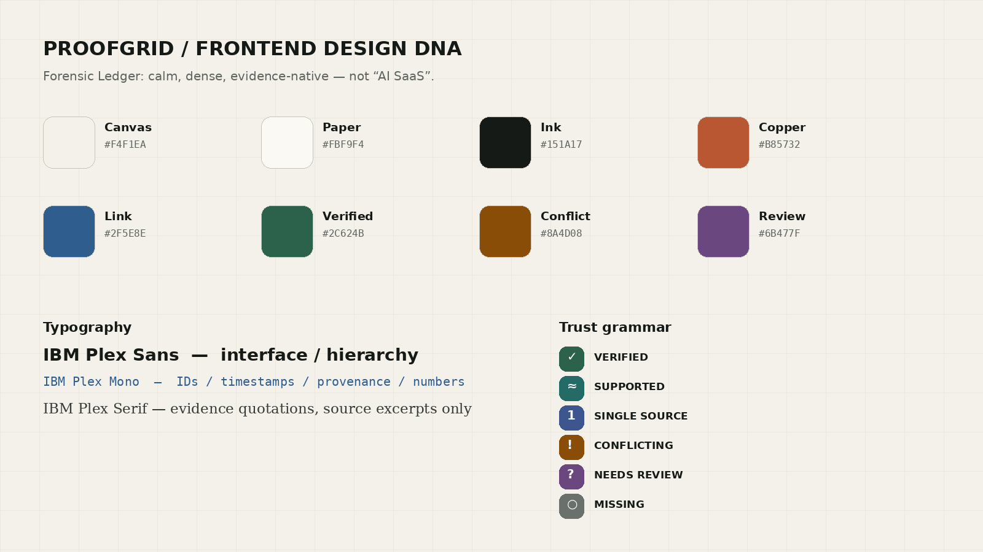
Figure 1 — “Forensic Ledger” visual language: paper, ink, evidence, grid, and restrained signal color.

Contents
1. Purpose, research basis and design decision
2. UX strategy and product personality
3. Visual direction — Forensic Ledger
4. Information architecture
5. Primary journey and interaction model
6. Screen-by-screen UX specification
7. ProofGrid workbench and ProofCell
8. Design system — typography
9. Design system — color and trust grammar
10. Layout, spacing, density, borders and elevation
11. Components and interaction patterns
12. Motion, animation and micro-interactions
13. Responsive behavior
14. Accessibility and inclusive interaction
15. Frontend technology stack
16. Frontend architecture and state model
17. Performance and loading strategy
18. Failure, empty and partial-result states
19. Antigravity build guardrails — anti-AI-slop rules
20. Definition of Done and visual QA checklist
21. Research references

1. Purpose, research basis and design decision
This document is the frontend source of truth for the ProofGrid prototype. It extends the existing ProofGrid PRD and TRD; it does not change their product architecture. The user journey remains: RequirementSpec → schema negotiation → Trust Contract → PlanDAG → live execution → versioned dataset → evidence inspection / review / export.
External research was used only to improve frontend implementation and accessibility: W3C WCAG 2.2, Next.js App Router guidance, Tailwind CSS design-token support, Radix accessibility primitives, Motion reduced-motion support, TanStack Table/Virtual, React Flow accessibility, and IBM Plex typography guidance. Product behavior and terminology come from the ProofGrid PRD/TRD.
Core frontend decision
Do not design ProofGrid as “AI chat + results cards.” Design it as an analytical workspace where AI is an invisible compiler behind a visible, inspectable data workflow.

Product requirement | Frontend consequence
Natural-language requirement compiler | Large structured “brief composer”, followed immediately by a machine interpretation screen — not a chat transcript.
Trust Contract | Evidence requirements are shown before execution as editable controls, not hidden settings.
Claim Ledger + ProofCell | Every data cell can reveal canonical value, raw claims, source evidence, transformations, conflict state and timestamps.
Constrained PlanDAG | Default UI shows a readable stage rail; advanced graph view is secondary.
Living Dataset | Dataset version, last refresh and diff actions are first-class in the header.
Conflict-aware data | Conflicts stay visible in the table and evidence drawer; never silently “cleaned away”.

2. UX strategy and product personality
ProofGrid has two simultaneous jobs: reduce effort for a business user and earn trust from a technical judge. The interface therefore needs progressive disclosure: simple language first, technical proof one interaction away.
Principle | Rule
Evidence before decoration | Use visual weight for provenance, conflict and workflow state before charts or vanity metrics.
One decision per stage | Ask, interpret, trust, plan, run, prove. Do not put all settings on the first screen.
Dense when data is primary | The dataset workbench should be compact and information-rich; marketing-page spaciousness is wrong there.
Calm by default | Neutral canvas, low-chroma surfaces, almost no decorative animation; signal colors mean something.
Inspectability | Every AI-derived interpretation has an edit path; every claim has a source path.
Keyboard optional, never mandatory | Power users gain shortcuts, while every action remains visible and accessible.
No false certainty | Use explicit trust states (Verified / Supported / Single Source / Conflicting / Needs Review / Missing), not unexplained percentages.

Product personality: precise, investigative, quiet, slightly editorial, technically literate. It should feel more like an analyst’s notebook + data grid + provenance debugger than an AI assistant.

3. Visual direction — “Forensic Ledger”
The visual concept combines three metaphors: a ledger (structured rows and versions), a forensic evidence board (claims, sources, contradiction), and an editorial research notebook (readable source excerpts). The resulting UI is deliberately anti-glassmorphism and anti-gradient.
- Primary surface is warm off-white “paper”, not stark #FFFFFF everywhere. It lowers glare and makes evidence highlights legible.
- Fine 1px rules and faint grid lines create structure. Use borders more than shadows.
- Copper is the brand accent for active/focused proof interactions. It is not a trust-status color.
- Trust states each have both a symbol and a color so information is never color-only.
- Rounded corners are restrained: 6–12px. Do not use 20–32px floating “AI cards”.
- No colored background blobs, aurora gradients, glass panels, sparkles, animated mesh gradients or decorative glowing orbs.
- Whitespace is asymmetric and editorial on onboarding screens; the workbench becomes intentionally denser once a dataset exists.
Figure 2 — Design DNA and trust grammar.

4. Information architecture
Primary area | Purpose | Primary objects
Ask | Create a new data requirement | Prompt, examples, saved briefs
Datasets | Explore persistent results | Dataset, version, record, ProofCell, filters
Workflows | View reusable collection plans | Workflow, version, schedule, runs
Review Queue | Resolve ambiguity only where needed | Entity matches, conflicting claims, low-evidence cells
Sources | Inspect source health and permissions | Domain, source type, last fetched, failures
Exports | Find generated outputs | CSV, JSON, share events / webhooks

Navigation pattern: a 56px icon rail that expands to ~220px on desktop. Keep the top bar contextual — current dataset/workflow name, version, run state, search, command palette and export. Avoid a second permanent horizontal navigation layer.
Default route hierarchy: /ask, /datasets, /datasets/[id], /datasets/[id]/diff, /workflows, /workflows/[id], /runs/[id], /review, /sources, /exports.

5. Primary journey and interaction model
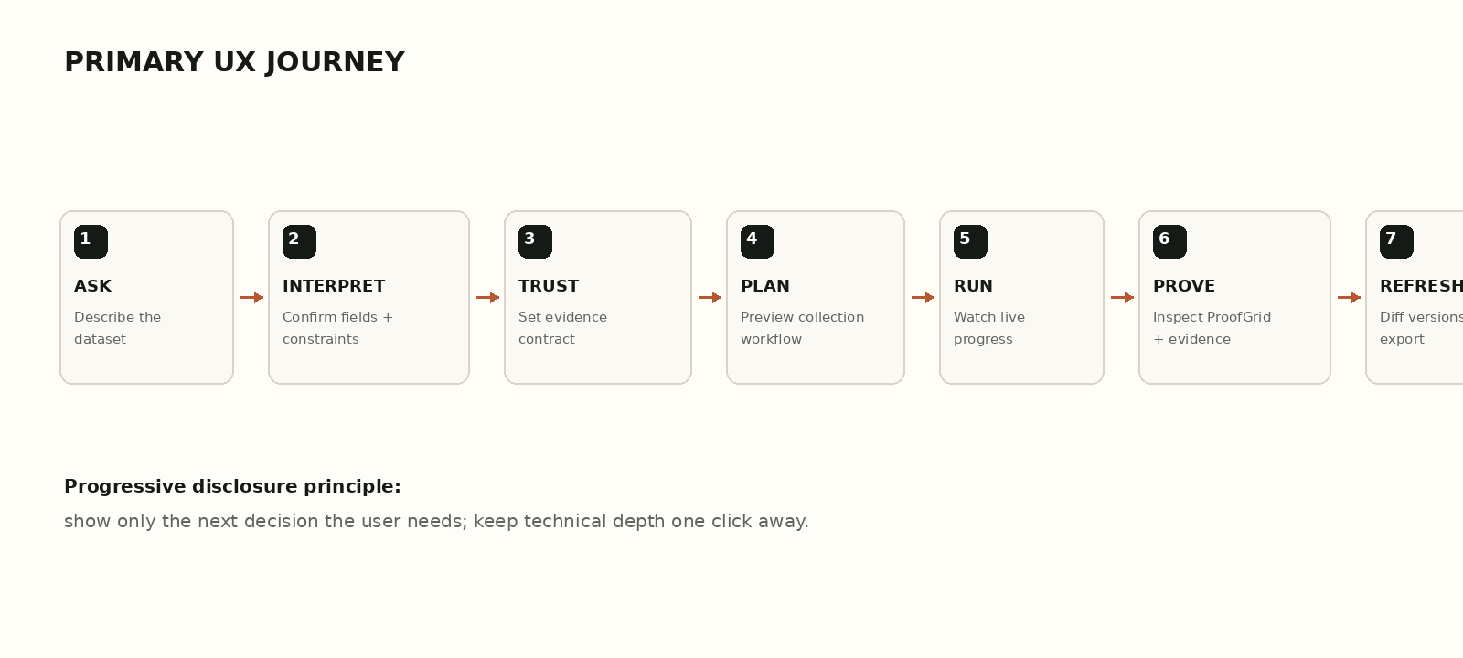
Figure 3 — Primary product journey. Each stage exposes one main decision and one clear next action.
- ASK — user writes the dataset they need. Placeholder language must say “Describe the dataset, not the answer.”
- INTERPRET — show entity type, filters, date/geography constraints and proposed fields as editable rows. AI-inferred fields are visually tagged.
- TRUST — offer Balanced / Strict / Exploratory presets plus advanced controls: require source, minimum independent sources, prefer first-party, permitted source types.
- PLAN — show a 5–7 stage human-readable workflow summary. Technical DAG view is available under “Inspect plan”.
- RUN — replace blank waiting with a stage timeline, source counters, record counts, partial-result warnings and cancel action.
- PROVE — open the dataset workbench. The data table is the hero. Every cell with evidence can open a ProofCell drawer.
- REFRESH — show “what changed” between versions before surfacing “current” as if history never existed.

6. Screen-by-screen UX specification

6.1 Ask / Brief Composer
- Use a large 2–4 line textarea inside the page, not a centered chatbot bubble. Keep the rest of the page quiet.
- Above the field: “What dataset do you need?” Below: compact structured examples users can click to populate, not pill carousels.
- Primary CTA: Compile request. Secondary action: paste URLs / constrain sources.
- Display a small privacy/source policy note inline: public/permitted sources only.
- On submit, transition into the Interpretation Studio; do not append an assistant message under the prompt.

6.2 Interpretation Studio
- Two-pane desktop composition: left = original brief; right = interpreted structure. On smaller screens stack vertically.
- Show fields as table rows with name, type, required toggle and provenance tag (You / AI inferred).
- Editable filter chips must be real form controls with visible labels, not decorative chips.
- When the system inferred something not present in the prompt, visually mark it in copper and explain “AI inferred”.

6.3 Trust Contract
- Default preset is Balanced. Presets change explicit controls; they are not opaque modes.
- Controls: require source for every field, minimum supporting independent sources, prefer first-party, allow secondary sources, allow single-source output, preserve conflicts.
- Preview consequence in plain language: “Conflicting values will remain visible and enter Review.”
- Advanced details collapse by default; hackathon judges can expand and inspect the exact contract.

6.4 Plan Preview
- Default is a horizontal/vertical stage rail: Discover → Fetch → Extract → Validate → Resolve → Store. Each stage shows tool type, estimated pages and expected cost/time.
- Advanced “Inspect DAG” lazily loads React Flow. This view is read-only for MVP; editing is not necessary.
- Show policy checks before Run: source permission, page budget, browser budget, token budget.

6.5 Run Monitor
- Persistent top status: RUNNING / PARTIAL / COMPLETE / FAILED. Use text + icon + color.
- Each stage row shows state, duration, input count, output count and failures. Do not use a single generic spinner.
- Live metrics: sources discovered, sources fetched, claims extracted, entities resolved, conflicts found.
- If some sources fail, display the partial dataset as soon as usable. Failure must be visible, not fatal to the whole interface.

6.6 Dataset Workbench
- Use a real data grid with sticky header, resizable columns, sorting, filtering, keyboard navigation and server-side operations for large data.
- First column is frozen. Trust indicator is integrated per cell, not only at row level.
- Top toolbar prioritizes dataset search, trust filter, source filter, version, diff, export. Avoid vanity statistic cards above the table.
- Double-click or Enter edits user-owned metadata only; canonical source-derived values should open evidence/review instead of silent inline overwrite.

6.7 ProofCell Evidence Drawer
- Opens from the right at ~440–520px. Keep the table visible to preserve context.
- Order: canonical value → trust state → “why accepted” → supporting claims → conflicting claims → evidence quote → source metadata → transformation history.
- Anchor the evidence quote to the stored RawDocument and show extraction method + retrieved timestamp in monospace.
- Provide Open source and Copy citation actions. Do not auto-navigate away from the dataset.

6.8 Review Queue
- Only uncertain items appear: ambiguous entity merge, important conflict, insufficient evidence, restricted source decision.
- Review cards are comparison-oriented: Side A / Side B with matching signals. Provide Merge / Keep separate / Defer.
- Conflicts show all claims; reviewer may choose canonical value without deleting losing claims.

6.9 Version Diff / Living Dataset
- Show version timeline and summary counts: Added, Changed, Missing-latest, Evidence-changed, Conflict-changed.
- Default diff is row-oriented with inline highlighting, not two complete tables side-by-side.
- Clicking a change opens the same ProofCell model so the user can understand *why* the value changed.

7. ProofGrid workbench and ProofCell
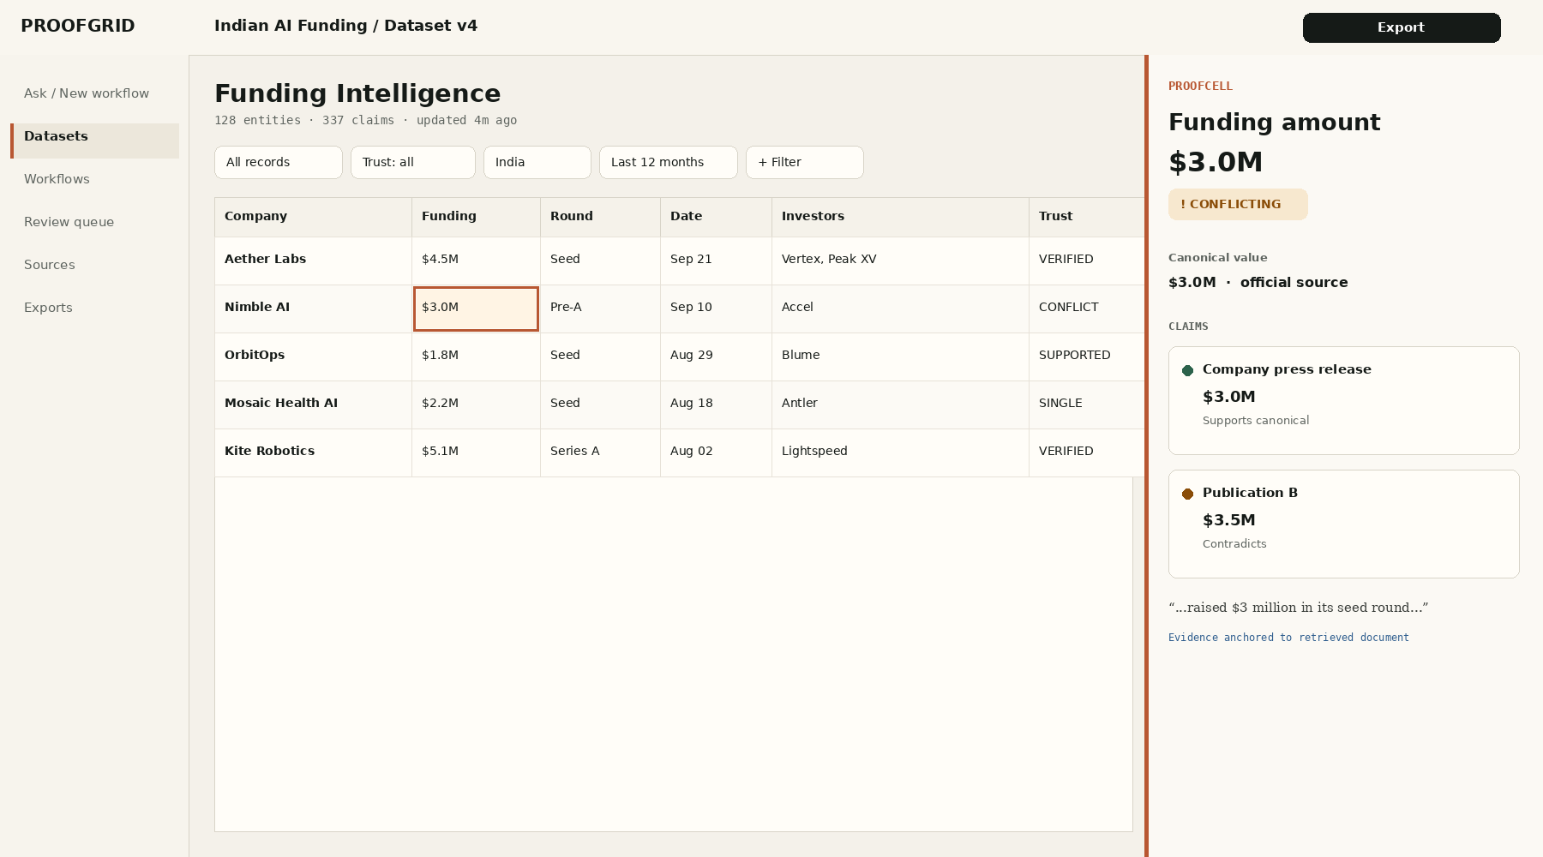
Figure 4 — Proposed dataset workbench: compact grid + evidence drawer. Data remains visible while proof is inspected.
The workbench is where the interface becomes intentionally dense. The user should feel that they are inspecting a dataset, not scrolling through generated cards.
Element | Default behavior | Power-user behavior
Cell | Value + trust mark | Focus cell, press E/Enter to inspect evidence
Row | Canonical entity summary | Shift-select rows for export / review actions
Column header | Sort + data type | Open menu for filter, pin, hide, resize
Trust filter | All statuses | Quick filter: Conflicting / Needs Review
Search | Lexical dataset search | Optional semantic mode clearly labeled
Drawer | ProofCell evidence | J / K moves to previous/next evidence-bearing cell
Version | Latest | Open diff timeline

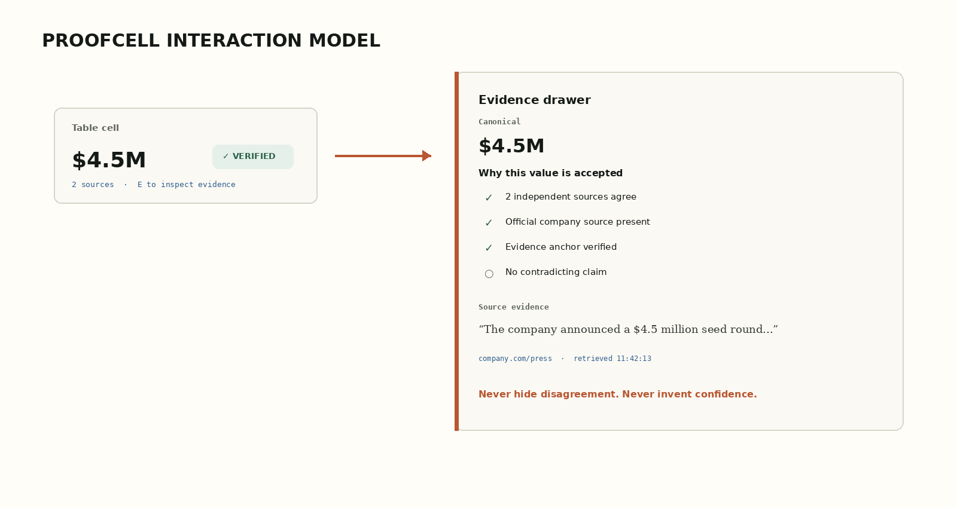
Figure 5 — ProofCell interaction: trust is explained using observable evidence, not an opaque score.

8. Design system — typography
Typeface decision
Use IBM Plex as a three-role family: Plex Sans for interface, Plex Mono for machine/provenance data, and Plex Serif only for quoted source evidence. This creates a coherent human↔machine tone without the “default AI app” look of Inter/Geist everywhere. IBM states Plex is open-source and spans Sans, Mono and Serif families with broad language support.

Role | Typeface | Weight | Typical size | Usage
Display | IBM Plex Sans | 600 | 32–40px | Page title, landing statement only
Heading L | IBM Plex Sans | 600 | 24–28px | Dataset/workflow titles
Heading M | IBM Plex Sans | 600 | 18–20px | Panels, drawer sections
Body | IBM Plex Sans | 400 | 14–16px | UI copy, labels, forms
Dense body | IBM Plex Sans | 400/500 | 13–14px | Tables, metadata labels
Machine | IBM Plex Mono | 400/500 | 11–13px | IDs, hashes, timestamps, URLs, durations, counts
Evidence quote | IBM Plex Serif | 400/italic | 15–17px | Source excerpt only

- Keep UI copy sentence case. Avoid ALL CAPS except 10–12px monospace eyebrows such as CLAIMS, PROVENANCE, RUN 04.
- Use tabular numerals for amounts, counts, durations and dates wherever the chosen font supports it.
- Dense table line-height: 1.25–1.35. Reading text: 1.45–1.6.
- Preferred body line length on prose/help panels: 55–75 characters. The data grid is exempt.
- Font loading: use local/self-hosted WOFF2 or a reliable package; only ship weights actually used. Do not load the entire Plex family matrix.

9. Design system — color and trust grammar
Use design tokens, not raw color values in components. Tailwind CSS theme variables are appropriate because they map tokens into utilities while remaining accessible as CSS variables. Prefer OKLCH in the codebase for predictable lightness adjustments; publish hex fallbacks/documentation values for handoff.
Token | Light value | Purpose
--canvas | #F4F1EA | Application background
--paper | #FBF9F4 | Navigation/panel background
--surface | #FFFDF8 | Tables, inputs, foreground surfaces
--ink | #151A17 | Primary text / primary action
--muted | #5E645F | Secondary text
--border | #D8D4C8 | Hairlines / separators
--grid | #E8E3D8 | Background grid / row separators
--copper | #B85732 | Brand accent, active proof/focus
--link | #2F5E8E | Links/source navigation
--verified | #2C624B | Verified status
--supported | #246B68 | Supported status
--single | #3E568F | Single-source status
--conflict | #8A4D08 | Conflict status
--review | #6B477F | Needs-review status
--missing | #6A716C | Missing / unknown status

Status colors are never used alone. Pair each with a symbol and readable label: ✓ Verified, ≈ Supported, 1 Single source, ! Conflicting, ? Needs review, ○ Missing.
Primary buttons are ink-on-ivory or ivory-on-ink, not brand-copper everywhere. Copper is therefore available as a rare attention signal for selected evidence, focus and AI-inferred content without competing with trust colors.
Dark mode is optional after the light theme is polished. Build tokens so it is possible, but do not split hackathon effort unless core UX is complete.

10. Layout, spacing, density, borders and elevation
System | Specification
Base spacing | 4px. Common steps: 4 / 8 / 12 / 16 / 24 / 32 / 48.
Desktop shell | 56px collapsed rail or ~220px expanded. Context top bar 56–64px.
Page grid | 12-column content grid for configuration screens. Dataset workbench uses full available width.
Max prose width | ~720–800px. Do not cap the data table.
Table row height | 36px dense, 44px comfortable. User preference can persist.
Radii | 4px controls / 8px inputs & chips / 10–12px drawers and panels. Pills only for tags/status.
Borders | 1px neutral hairlines; 2–3px copper only for focus/selected evidence.
Shadows | Very rare. Use subtle 0 1px 2px rgba(20,24,21,.08) for menus/drawers only.
Background texture | Optional CSS grid: 1px lines at low alpha every 24/96px on onboarding/configuration canvas. Disable behind dense tables.

Avoid card soup. A panel should exist because it establishes a region or interaction boundary, not because every metric needs a rounded rectangle.

11. Components and interaction patterns
Component | Design rule
Button | Three levels only: primary ink, secondary outline, tertiary text/icon. Destructive red appears only when necessary.
Input | Flat surface + 1px border. Focus = 2px copper outer ring; no glowing blue box-shadow.
Segmented control | Use for Trust preset and table density. Maximum 3–4 options.
Tag / chip | Compact; tags are metadata, not buttons unless visually interactive.
Status badge | Symbol + label + low-chroma tinted background. Never show only a colored dot.
Tooltip | For icon meaning and provenance abbreviations. No critical content hidden only on hover.
Popover | For quick filters and column options. Complex evidence always opens a drawer.
Drawer | Right-side persistent-context inspection: ProofCell, record detail, run step detail.
Dialog | Reserve for destructive confirmation or multi-step decision that cannot coexist with context.
Toast | Only for brief confirmations/errors. Long-running workflow state belongs in the run monitor.
Table | TanStack Table state model + virtualization only when dataset size justifies it.
Workflow graph | React Flow in advanced Inspect DAG view; default is readable stage rail.
Command palette | ⌘K / Ctrl+K for navigation and dataset actions. It complements visible UI; it does not replace it.
Icons | Phosphor-style line icons at 16–18px; consistent 1.5–2px visual weight. Avoid AI sparkle/star iconography.

12. Motion, animation and micro-interactions
Motion should communicate causality, state change and progress. There should be no ambient animation simply to make the product “feel AI”. Motion for React is suitable because it supports user reduced-motion preferences; reduced motion should replace large transforms with opacity/state changes.
Interaction | Duration | Motion
Hover / press | 80–120ms | Color/border only; 0–1px translate on press at most
Popover / menu | 120–160ms | Opacity + 4px translate
Drawer open | 180–220ms | X translate 16–24px + opacity; never full-screen fly-in on desktop
Stage transition | 160–220ms | Content crossfade + subtle vertical shift
Proof status update | 400–600ms total | 150ms tint flash, then settle; no confetti
Run progress | Continuous only while active | Width/progress + subtle status pulse; no large spinner
Version diff highlight | 220ms | Background tint in/out

- Use one easing family: snappy ease-out for UI (approximately cubic-bezier(.2,0,0,1)).
- No spring/bounce on drawers, tables, warnings or evidence states.
- Never animate table row position while the user is reading unless they explicitly sort/filter.
- Respect prefers-reduced-motion globally. Preserve educational opacity/status transitions while removing large transforms/parallax.
- Disable all auto-playing decorative motion in reduced-motion mode.

13. Responsive behavior
ProofGrid is desktop-first because its core artifact is a data workbench. Responsive design should preserve functionality without pretending that a 12-column dataset editor is comfortable on a phone.
Viewport | Behavior
≥1440px | Expanded navigation optional; table + 440–520px ProofCell drawer can coexist.
1024–1439px | Collapsed 56px rail; drawer 400–440px; column hiding becomes important.
768–1023px | Configuration flows remain two-column where possible. Dataset table scrolls horizontally; evidence drawer overlays ~50–60% width.
<768px | Read/review mode: cards/row summaries for records, full-screen evidence sheet, filters in bottom sheet. Do not attempt full workflow graph editing.

For the hackathon, optimize first for the actual demo laptop: 1366×768 and 1440×900. Test both. Avoid layouts that only look good on a 16-inch 1728px Mac display.

14. Accessibility and inclusive interaction
Target WCAG 2.2 AA. Radix Primitives are a strong behavior layer because they implement WAI-ARIA patterns, keyboard navigation and focus management, but accessibility remains the product team’s responsibility for labels, semantics and content.
Area | Requirement
Contrast | Normal text ≥4.5:1; large text ≥3:1. Non-text focus/control boundaries must remain perceptible.
Keyboard | All flows complete without a mouse. Table cells, drawers, menus and workflow nodes have deterministic tab/focus behavior.
Focus | Never remove outline without replacement. Use a 2px copper ring with sufficient offset.
Targets | Aim for ≥24×24 CSS px minimum interaction area and preferably ~40px for common buttons.
Status | Do not communicate trust state with color only; include symbol + visible label / accessible name.
Dynamic updates | Run progress and completion use polite aria-live/status semantics; errors are announced.
Motion | Respect prefers-reduced-motion.
Evidence | Quote text remains selectable; source URLs have clear accessible names.
Table | Header associations, sort state and focus behavior are explicit. Consider a non-table mobile representation.
Graph | If React Flow is used, keep keyboard focusability and provide descriptive aria-labels for nodes/edges.

15. Frontend technology stack
Layer | Primary choice | Why
Framework | Next.js App Router + TypeScript | Matches TRD; Server Components reduce shipped client JS and interactive islands can stay client-side.
Styling | Tailwind CSS + CSS variables / @theme | Fast iteration with an explicit custom token system; no default component aesthetic.
Primitives | Radix UI Primitives | Accessible, unstyled behavior layer; lets ProofGrid own the visual language.
Variants | class-variance-authority + clsx / tailwind-merge | Keep component variants deterministic instead of long conditional class strings.
Motion | Motion for React | Small purposeful transitions + reduced-motion support.
Data grid | TanStack Table | Headless sorting/filtering/column state; full style control.
Virtualization | TanStack Virtual | Only for large row/column counts; keeps DOM bounded.
Workflow graph | React Flow — lazy-loaded | Advanced PlanDAG inspection only; keyboard/screen-reader features are available.
Server state | TanStack Query where client caching is useful | Mutation status, cached dataset pages, controlled invalidation.
Local UI state | Zustand or small context stores | Drawer state, table density, pinned columns, workspace preferences. Avoid a giant global store.
Forms | React Hook Form + Zod | Fast forms with typed validation; compatible with JSON Schema mapping if needed.
Icons | Phosphor Icons | Less generic than Lucide, broad semantic coverage; use line weights consistently.
Command palette | cmdk + Radix Dialog | Accessible composable command experience; style from scratch.
Charts | No general chart library by default | Most ProofGrid value is tabular/evidence. Use small custom SVG/visx only when a chart has a real question to answer.

Anti-template rule
Do not install shadcn/ui and keep its default appearance. If any generated primitive code is used, treat it as behavior scaffolding only and restyle fully to ProofGrid tokens.

16. Frontend architecture and state model
app/
(shell)/layout.tsx
ask/page.tsx
datasets/[datasetId]/page.tsx
datasets/[datasetId]/diff/page.tsx
workflows/[workflowId]/page.tsx
runs/[runId]/page.tsx
review/page.tsx
components/
primitives/ # Radix-backed, ProofGrid-styled
shell/ # nav rail, top bar, command menu
brief/ # prompt + interpretation + trust contract
plan/ # stage rail + lazy DAG inspector
run/ # run timeline + live counters
grid/ # table, headers, cells, filters
proof/ # ProofCell drawer, claim cards, evidence quote
diff/ # version diff UI
lib/
api/ # typed API client
events/ # SSE client + reconnect logic
tokens/ # design constants
keyboard/ # shortcuts
a11y/ # announcements/focus helpers
- Keep pages/layouts server-rendered unless interactivity is required. The dataset grid, filters, drawer, run monitor and command palette are Client Components.
- Use URL/search params for shareable dataset filters when practical; keep purely visual preferences in local storage.
- Run events arrive through SSE/EventSource. Maintain an ordered event log keyed by run_id; derive UI state from explicit backend statuses rather than client-side guessing.
- Optimistic UI is appropriate for local preferences and review actions with clear rollback. Do not optimistically claim that a source was verified or a workflow completed.
- Lazy-load React Flow, large diff visualizations and any browser-only heavy dependency.

17. Performance and loading strategy
Frontend speed is part of perceived intelligence. Next.js guidance supports using Server Components for server-rendered/static work and Client Components only where interactivity is required. TanStack Virtual should be used when rows/columns are large; it keeps the DOM small rather than treating virtualization as a data-fetching strategy.
Target | Goal
LCP | ≤2.5s at p75
INP | ≤200ms at p75
CLS | ≤0.1
Dataset first usable paint | Show shell/header immediately; table skeleton and first page stream independently
Table scroll | No noticeable jank at demo dataset size; virtualize when row count/column count crosses tested threshold
Drawer open | <100ms input response; animation finishes ≤220ms
Run event latency | UI reflects SSE event within ~250ms after receipt

- Prefetch likely next routes from the shell, but do not prefetch heavyweight DAG inspector code.
- Use server-side pagination/filtering for datasets too large to ship to the browser. Virtualization is not a replacement for server-side operations.
- Debounce expensive search/filter requests; do not debounce simple local state.
- Memoize column definitions and cell renderers. Keep ProofCell drawer outside the virtualized row subtree.
- Use skeletons shaped like the final layout to prevent CLS. Avoid generic shimmer everywhere; simple neutral placeholders are sufficient.

18. Failure, empty and partial-result states
State | What the user sees
No dataset yet | One clear brief composer + 3 compact examples; no dashboard full of zero-value cards.
Parsing uncertainty | Highlight inferred/ambiguous fields and require confirmation before execution.
No permitted sources | Explain which policy blocked collection and offer source constraint edit; never silently switch to restricted scraping.
Partial run | Dataset opens with amber “Partial” banner and a source-failure summary; successful claims remain usable.
No records | Show sources checked and why zero records passed filters; offer “Edit brief” rather than “Try again”.
Conflict | Visible cell state + ProofCell claim comparison; conflict contributes to Review Queue.
SSE disconnected | Keep last known state, show reconnecting indicator, fall back to polling if implemented.
Cached/fixture demo mode | Clearly label “Fixture evidence” / “Cached raw documents” in the run monitor; never pretend cached data is live.

19. Antigravity build guardrails — anti-AI-slop rules
Use this section as a hard implementation contract
AI coding tools tend to produce a familiar aesthetic unless constrained. The following rules are deliberate acceptance criteria, not taste suggestions.

- DO NOT use a purple/blue gradient hero, blurred aurora background, glassmorphism, neon border glow or floating 3D orb.
- DO NOT put every block in a rounded card. Prefer flat sections, ruled panes and the data grid.
- DO NOT use 20–32px radius globally. Default radii are 4/8/12px.
- DO NOT make the product a chat transcript. The prompt is a compiler input; the output becomes structured UI.
- DO NOT use sparkles / magic-wand / starburst as the generic icon for AI. Name the function: Compile, Interpret, Extract, Verify.
- DO NOT show fabricated avatar faces or testimonial-style social proof inside the app.
- DO NOT animate background blobs or continuously move decorative objects.
- DO NOT use huge empty whitespace once inside the dataset workbench. Data tools require density.
- DO NOT reduce provenance to “Source: 2 links”. Implement the ProofCell drawer structure exactly.
- DO NOT use opaque “97% confidence”. Use the trust-state grammar.
- DO NOT copy shadcn/Linear/Notion styling literally. Radix is behavior infrastructure; ProofGrid owns the surface design.
Antigravity visual acceptance test: hide the ProofGrid logo. A reviewer should still identify the product as an evidence/data-intelligence workbench from the grid, trust marks, proof rail, evidence drawer, source quotes and version controls — not as a generic SaaS template.

20. Definition of Done and visual QA checklist
Area | Ship criterion
Ask flow | Prompt → interpretation → Trust Contract → plan works without chat UI.
Dataset grid | Sticky/resizable columns; trust state visible per cell; no horizontal layout collapse at 1366×768.
ProofCell | Canonical value, claim list, conflict state, evidence quote, source and timestamp all visible.
Review | At least one ambiguous merge/conflict can be resolved without losing original claims.
Run monitor | Stage-by-stage progress and partial failure are visible.
Versioning | Latest version + diff entry point visible in dataset header.
Typography | IBM Plex family implemented with limited weights; no accidental fallback during demo.
Colors | Tokens only; no random Tailwind palette leakage. Contrast checked.
Motion | Reduced-motion works; no ambient animation.
Keyboard | Tab order, Enter/E evidence action, Escape drawer close, Ctrl/⌘K command palette.
Performance | No visible jank when filtering/sorting the demo dataset; React Flow lazy-load verified.
Responsive | 1366×768, 1440×900 and mobile review mode tested.
A11y | Labels, focus, ARIA status updates, non-color trust semantics and table headers verified.

Before the hackathon demo, record a 90-second golden-path screen capture. Then replay the live flow using the same prompt and verify every transition against the recording. This catches accidental density, spacing and state regressions that unit tests will not.

21. Research references
Reference | URL | Why used
W3C — Understanding WCAG 2.2 | https://www.w3.org/WAI/WCAG22/understanding/ | Accessibility target including focus, status and target-size guidance.
Next.js — App Router / Server and Client Components | https://nextjs.org/docs/app | Use Server Components by default; layer Client Components where interactivity/browser APIs are required.
Next.js — Production Checklist | https://nextjs.org/docs/app/guides/production-checklist | Server Components, code splitting, prefetching and rendering optimizations.
Tailwind CSS — Theme variables | https://tailwindcss.com/docs/theme | CSS-first design-token system using @theme.
Radix Primitives — Accessibility | https://www.radix-ui.com/primitives/docs/overview/accessibility | WAI-ARIA patterns, keyboard support and focus management.
Motion for React — Accessibility | https://motion.dev/docs/react-accessibility | Reduced-motion support and guidance for replacing large transforms with calmer transitions.
TanStack Table — Virtualization guide | https://tanstack.com/table/latest/docs/framework/react/guide/virtualization | Table state vs virtualization responsibilities; when large tables should virtualize.
React Flow — Accessibility | https://reactflow.dev/learn/advanced-use/accessibility | Keyboard/screen-reader support for nodes/edges and ARIA configuration.
IBM Design Language — Typeface | https://www.ibm.com/design/language/typography/typeface/ | IBM Plex family, open-source license information, Sans/Mono/Serif families and global language support.
web.dev — Core Web Vitals | https://web.dev/articles/vitals | Reference thresholds: LCP 2.5s, INP 200ms, CLS 0.1 at p75.
MDN — oklch() | https://developer.mozilla.org/en-US/docs/Web/CSS/Reference/Values/color_value/oklch | OKLCH is broadly available in modern browsers and suitable for tokenized color systems.

This design specification intentionally does not treat external product screenshots as templates. The unique interaction grammar — Trust Contract, ProofCell, Claim Ledger, conflict-preserving evidence drawer and versioned ProofGrid — comes from the ProofGrid PRD/TRD and is the product’s own design language.

