The folder contains (default) pneumatic parameters for known pneumatic relays/pressure sensors.
To initialize a fresh AP/FF device with the right pneumatic parameters, use SA Dump page and select “Pneumatic” from the drop=down menu:
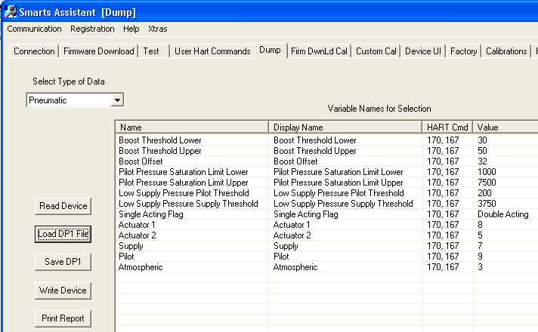It is self-explanatory.

Or you can do it the hard way, from the (Custom) commands page, using commands 170 for reading and 171 for writing (factory mode only). Use subcommand 167 in both cases.

For use, please see control.c in SVi1000 LCX and AP 3.2.1. The intention was to capture hardcoded values of 3.2.1.

Notes:
1. Definitions of types and values are in pneumatics.{h,c}, unchanged since LCX.
2. Relay coefficients for AP are stolen from AP 3.2.1; must be same for 3.2.3
3. When/if we rescale the pressures representation in the firmware, pressure thresholds will need to be rescaled.
4. Note the difference in high pilot pressure limit between LCX and AP-1. It was a change in LCX.

