**FF PROJECT – COMPLETE BUILD**

***(From DDL to Functional FW)***

**Introduction**

*This document serves as a concise “HOW-TO Guide for building Foundation Fieldbus FW from a DDL file down to the downloadable firmware.*

*The present process renders a set of mandatory steps, which must be followed in order to complete the build successfully.*

*This guide implies that all programming steps such as:*

* *Creating or modifying the DDL file;*
* *Modifying the GW script in accordance with the DDL file;*
* *Modifying necessary .C files*

*are all completed prior to the start of the build process.*

*The guide also implies that the directory structure and file distribution in said structure exactly follow the rules described below.*

***The build process and the associated work flow are illustrated by the following diagrams.***

**Common DD Libraries**

Modify DDL file

svi_positioner.ddl

Modify GW Script

SVI_Positioner_APP.gw

Modify Source File

appl_ptb.c

Build Entire FW

Load to Device

With IAR

**DDL File (text)**

**Tokenizer**

**GenVFD**

**Binary DD**

**GenVFD**

**IAR Build**

**GW Script (text)**

**VFD definitions**

**.C files**

**IAR Build**

**Manually Defined Source**

**.C file**

***DCS Function***

The first step in the build process is Tokenizing the DDL text file to Binary DD file. It is done by using the FF library and the Tokenizer utility, provided by the Foundation.

We follow recommendation of the FF foundation and install the library and the Tokenizer in the folder with the absolute path: <C:\FF\>. All the following steps will be based on such installation.

*Note: it is possible to follow a different path, however the programmer who have chosen such option must modify batch files created for a single step build process (as described later in this document).*

Installation files for the Tokenizer and the library are in TFS, folder

<$/Firmware-SVI II AP FF/FF_DD_LIB>

“Get” these files to the local folder of your choice, expand them and follow exactly instructions in the “ReadMe.txt” file in the <mkDD> folder. You will install the Tokenizer, the FF DD Library and the DD IDE along with the “Slick Edit” IDE source editor.

(Neither DD IDE nor “Slick” will be used for the described build process).

The following image show the expected installation of the DD Library and utilities.

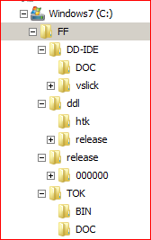

Normally there will be no programming or building work done explicitly in the FF folder.

**Working Directory Tree**

The working directory tree containing the .C source, the DDL files and GW scripts must start with the folder with the name <FD-SW>. This root folder does not have an obligatory absolute path – it can be placed anywhere you find convenient. This root folder must be mapped to the folder in TFS

<$/Firmware-SVI II AP FF/FD-SW>

The DDL files reside in the folder **<….\target\appl\fbif\ddl**> . The Binary DD files in the result of the build process are copied in the subfolder <….\ddl\0008>. (0008 is the device type of the SVI valve).

The modification of various files: DDL, GW, .C and distribution of their respective resident folders is described in the documents “FF_Adding_Parameters.docx” and “ADDING_FF_Objects.pptx”.

The directory tree in the working folder is shown on figure below. The screenshot was made from the computer, where the FF FW root folder <FD-SW> is a subfolder of <FF_SANDBOX>.

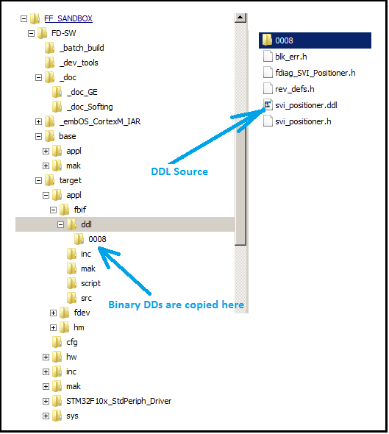

The programmer is expected to “Get” the code base from TFS, <$/Firmware-SVI II AP FF/FD-SW> to the local folder <…\FD-SW>.

Most of the time while modifying the FF FW a programmer needs to work in 3 folders:

* …\FD-SW\target\appl\fbif\ddl, DDL and associated .H files;
* …\FD-SW\target\appl\fbif\script, predominantly SVI_Positioner_APP.gw file;
* …\FD-SW\target\appl\fdev\src and …\FD-SW\target\appl\fdev\inc, .C and .H files

With DDL and FW parts residing in the folders as described in the above document the total build process is reduced to the simple procedure:

* To clean the remnants of the old build:

Open Windows “Run” utility and call the batch file **FF_Clean_FW.bat** from the folder:

…\FD-SW\_batch_build

* To build the new image:

Open Windows “Run” utility and call the batch file **FF_TokDD_and_compile.bat** from the folder:

…\FD-SW\_batch_build

* To build the new image without rebuilding the DD image from the DDL file:

Open Windows “Run” utility and call the batch file **FF_Compile_FW.bat** from the folder:

…\FD-SW\_batch_build. *Note: In this case do NOT clean the previous build.*

To further simplify the above building process create desktop shortcuts for the batch files used in building process and initiate building from the shortcuts.

The resulting FW image files are saved in the following folders (debug and release versions respectively):

…FD-SW\target\mak\FF_SVI_DBG

…\FD-SW\target\mak\FF_SVI_REL

For instruction for JTAG loading the created FW image to the device see the document “Softing_FW_Build.docx”.

------------- End of Document -------------