**SOFTING FIRMWARE**

**BUILD AND DOWNLOAD INSTRUCTION**

*The process described in this article is correct as of June 9th 2012.*

*It is expected to change and evolve.*

The following document presents step-by-step the build process and downloading of the Softing Foundation Fieldbus FW.

We assume that the root folder for the Softing project is called “Softing”.

1. BUILDING FW
2. The “embOS” plug-in from Softing must be saved as a subdirectory on the local computer. This plug-in consists of several subdirectories as shown on the Fig. below. The folder structure must be presented as shown.

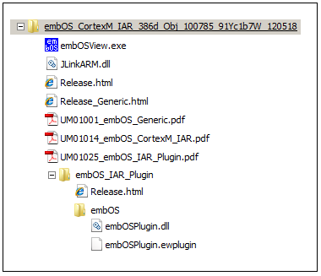

1. The directory structure of the Softing project should look like the Figure below:

It is important to preserve the position of the subfolders “Target” and “mak” within it.

Subfolder “mak” contains subfolders “FF_SVI_DBG” and “FF_SVI_REL” for “Debug” and “Release” versions of the FW respectively. Inside each of these latter subfolder there must exist a subfolder “lib” which contains all necessary library files.

Resulting from build process in addition to the “lib” subfolder the subfolders: “exe”, “lst” and “obj” will be automatically created. Only “exe” subfolder is important for our purpose.

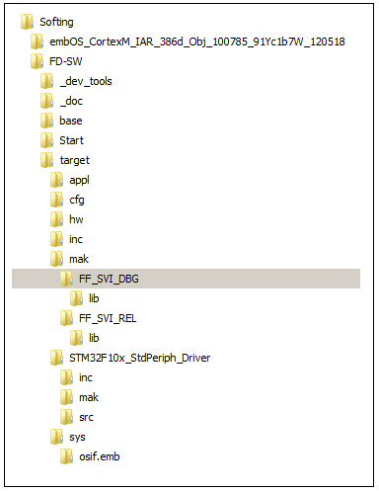

1. To build the FW do the following:

* Open “Command Line” box.
* Send the following list of commands (they may be copied and pasted from this document one by one or combined in a batch file).

**PATH C:\Softing\FD-SW\_dev_tools;%PATH%**

**cd C:\Softing\FD-SW\target\mak**

**set EMBOS=C:/Softing/embOS_CortexM_IAR_386d_Obj_100785_91Yc1b7W_120518/Start**

**set CC_CORTEX_M3=C:/Program Files/IAR Systems/Embedded Workbench 6.30/arm**

* For “Debug” version type the command: **make ff_svi_debug**
* For “Release” version type the command: **make ff_svi_release**

(These commands may be included in the batch file) .

* As a result of these commands in the “exe” folder there will be created the following files:

In the FF_SVI_DBG subfolder:

svi_ff_debug.map

svi_ff_debug.out

svi_ff_debug.txt

svi_ff_uta_debug.map

svi_ff_uta_debug.out

svi_ff_uta_debug.txt

In the FF_SVI_DBG subfolder:

svi_ff_release.map

svi_ff_release.out

svi_ff_release.txt

svi_ff_uta_release.map

svi_ff_uta_release.out

svi_ff_uta_release.txt

*Notice: Files with the suffix “****_uta_****” is for* ***Upper Test Agent*** *FW and without it – for the* ***Basic Device*** *FW.*

1. LOADING IMAGE TO THE DEVICE VIA J-TAG

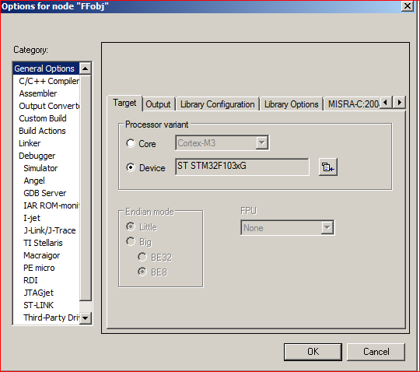

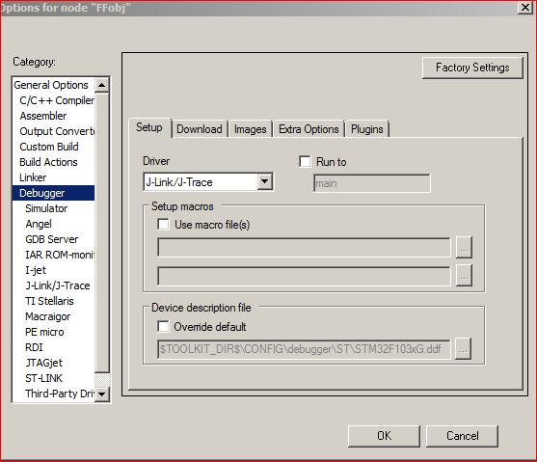

This document describes how to load the built image to the FW via J-TAG connection, using the IRA IDE debugger. The FW is presumed to have already been built by the method described above.

There are two ways of loading the image – one is to use the existing project and “add” it to a Workspace opened or created in the IDE. This method has the drawback of not working if your directory structure does not exactly repeat that of the computer where the project has been created.

The more versatile method is to build your own project following rules below

* Open IAR Embedded Workbench **6.30**.
* Choose Project > New Project > Externally built executable
* Save the project in the folder and under the name of your choice. Keep it opened.
* Choose Project > Add Files to add the executable file (filename extension “.out”) to the project.

*Note: by default “.out” file will not be visible in the build folder; in the right lower corner find the pull-down menu “source files” and select “*.* All Files”.*

* Set up the debugger with options as shown on the included screenshots.

The only project options that are meaningful to set for this kind of project are options in the General Options and Debugger categories.

* Save the workspace.

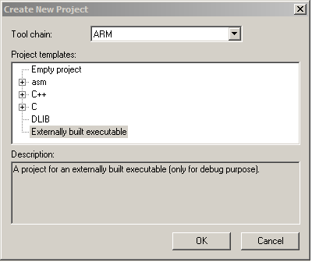

* Select the project in the workspace window and click the Download and Debug button.
* Several times the dialog with the header “J-Link …. Warning” will be displayed – ignore it, just hit OK.
* At the end of the load process the following dialog will be displayed:

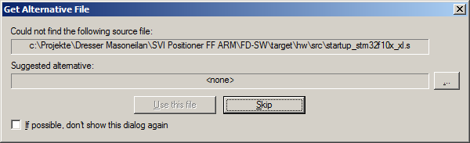

It is a reference to the symbolic information file. You may ignore it and just hit “Skip”.

If the symbolic information is needed, follow your working path to the folder ..\target\hw\src\ and select the file “startup_stm32f10x_xl.s”, then hit “Use this file”.

* At this point the image is loaded to the device.

Once created and saved the project and the workspace can be reused whenever you rebuild your executable file.

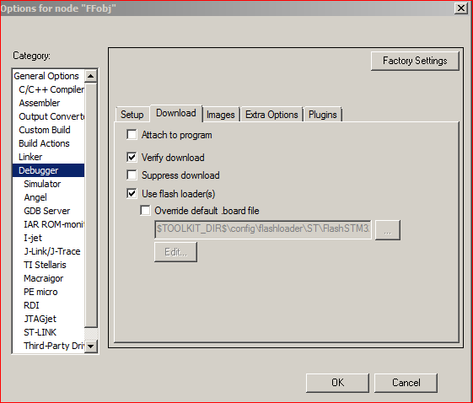

1. CONNECTING J-LINK FOR LOADING THE IMAGE

The image below shows the position of the connector to which the J-LINK “pigtail” must be connected for loading the Softing FF image. Make note of the orientation of the cable – red wire has to be on the side further away from the rectangular cutout of the casing.

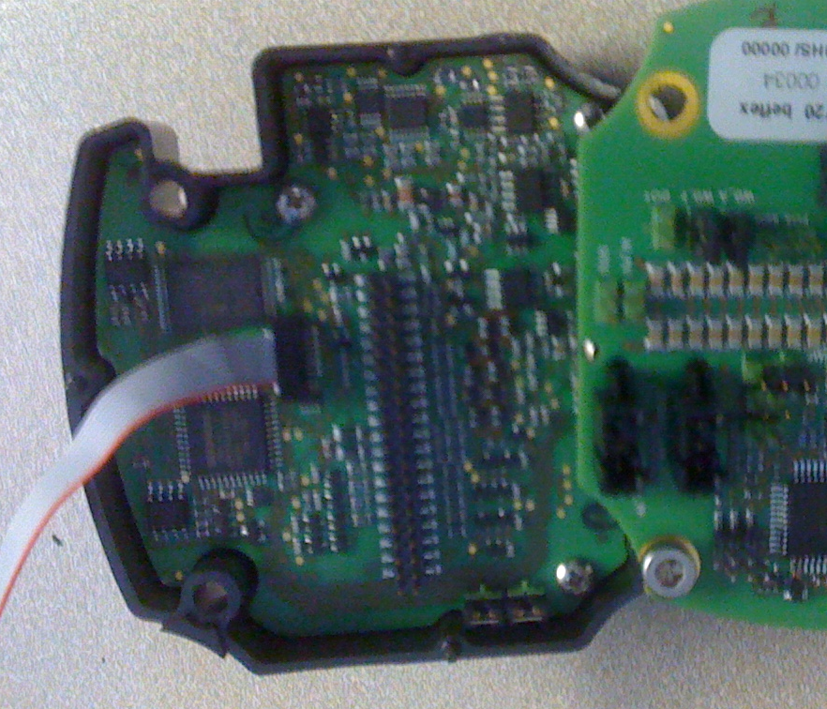

**APPENDIX 1**

**FW Build Instructions from Softing**

HOWTO - Generation of FF field device FW

IMPORTANT: The libraries (base.a, eep.a, ffbs.a, stub.a, uta.a) contained in target\mak\FF_SVI_REL\lib and target\mak\FF_SVI_DBG\lib must not be removed!

Development Tools: - IAR ARM compiler V6.30

- embOS RTOS V3.84d

To generate the FW:

- open a DOS command line box

- make sure that the path to the compiler is properly set in environment variable CC_CORTEX_M3, like "set CC_CORTEX_M3=C:/Programme/IAR Systems/Embedded Workbench 6.0_0/arm"

- make sure that the path to the RTOS is properly set in environment variable EMBOS, like:

"set EMBOS=C:/Tools/ARM/embOS_CortexM_IAR_Obj_v384d_100785_FR8WIU1I_120504/Start"

- in DOS Command Line box change to the according Project directory

- afterwards change to target\mak

- to generate the Debug FW call: "make ff_svi_debug"

- to generate the Release FW or call: "make ff_svi_release"

- to clean the generated FWs and related objects/libs call:

"make clean_ff_svi_release" or "make clean_ff_svi_debug"