TB mode bugs

# It is possible to get APP in failsafe and TB in AUTO

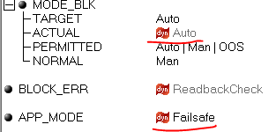

In addition,

* APP failed state is not registered  
  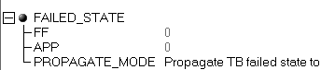
* Faults are not shown  
  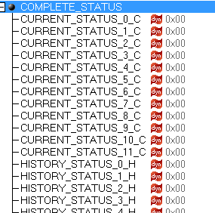 
* TB target mode can change without affecting actual mode  
  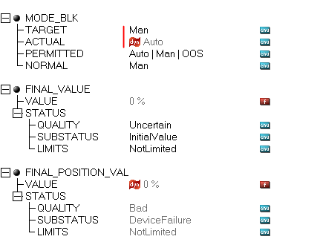

Steps to reproduce:

1. Have RB and TB in AUTO, APP in Normal
2. Disable IPC with command 255.16
3. Wait a minute (or less)
4. Issue RB.RESTART=Processor

Similar effect can be achieved with disabling only periodic IPC with command 255.2

# It is possible to get APP stuck in AUTO even if TARGET=OOS

Steps to reproduce:

1. Have RB and TB in AUTO, APP in Normal
2. Disable periodic IPC with command 255.2
3. Wait a minute (or less)
4. Issue RB.RESTART=Processor

# After re-enabling IPC traffic, asynchronous commands are not processed

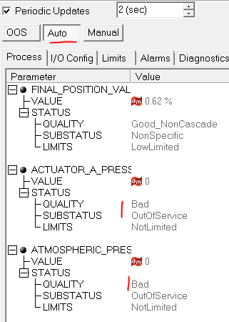

Resetting device with RB.RESTART=Processor results in comm. error and status = Uncertain/Initial value.

The screenshot is after in and out of OOS.

# “Restore TB to factory” results in comm. Error

With MRD=3

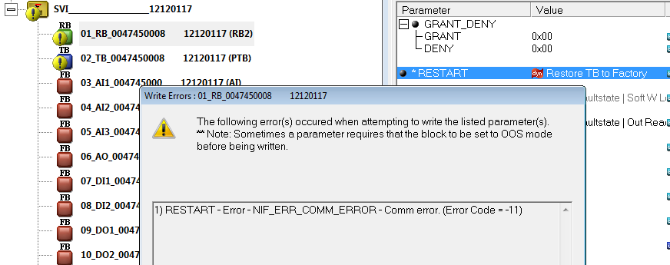

Additionally, there are persistent errors

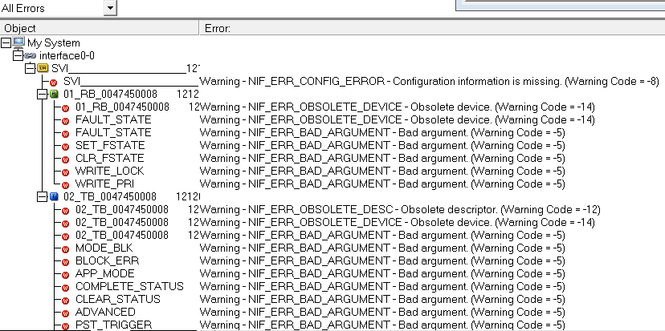

Had to restart Configurator to bring it to its senses.

With MRD=10, Configurator survives but the error is the same.

## Another scenario

“Restore to factory” results in comm. error and there are no communications with APP anymore:

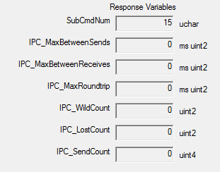

In particular, TB mode is senseless:

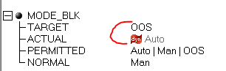

The only good news is that APP is in failsafe.

