

**LUI – Local User Interface**

**Implementation Specification**

Table of Contents

1. Introduction 3

2. General Architecture 4

2.1 Menu Tree 4

2.2 Cycle Menu 4

2.3 Main Menu 5

2.4 Custom 1 and Custom 2 5

2.5 SVI FF Revision 5

2.6 Tight Shutoff High 5

2.7 Manual Tune 6

*2.8* Sub Menu of node *FF Info* 6

2.9 Sub Menu of node *Dev Info [This section is NA at this moment]* 8

2.10 Sub Menu of node *RB* 9

2.11 Sub Menu of node *TB, AO, PID and DO* 10

3. Revision History 11

# Introduction

The purpose of this document is to present the design of the Local User Interface (LUI) for FF SVI project.

This document is based on the following assumptions.

* There are 3 lines on LCD
* There are max 9 characters displayed in each line
* There are 7 languages are supported: English, French, Spanish, Portuguese, Japanese, Italian and German.

# General Architecture

## Menu Tree

Inherited from AP, the menu tree is show as picture below. There are 2 modes, normal and setup.

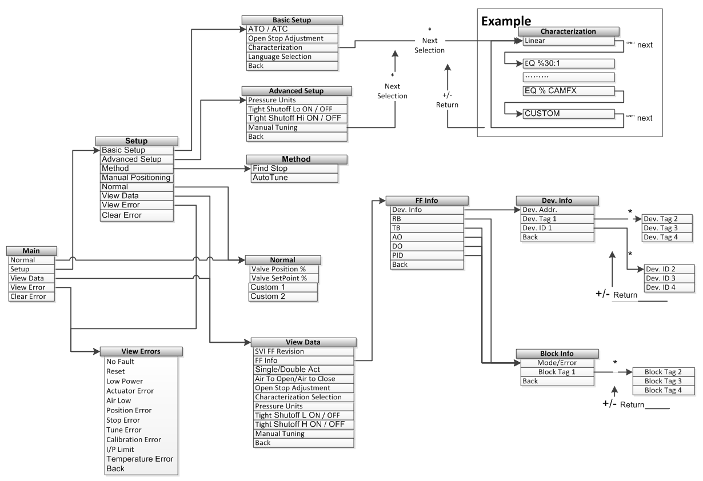

## Cycle Menu

When the device stays at normal mode and power up, the LCD loops some variables, it is called cycle menu. SETPOINT and POSTION always display, and there are 2 custom variables, which can be configured by tools. They will be described in the below section.

## Main Menu

There is a defined main menu for Masoneilan’s existing product line when user push any button at cycle menu, and user can navigate them by pushing +/- key, and down to the submenu by * key. Normally the nodes are: [Current Mode], [Permitted mode], [View Data], [View Err], [Clr Err] and etc.

## Custom 1 and Custom 2

There are 9 choices for them which are listed below.

* 1. Characterized SP (Default for the Custom 1). [WORKING_SP, TB]
  2. Characterized Position (Default for the Custom 2). [WORKING_POS, TB]
  3. PID.SP [SP, PID]
  4. PID.PV [PV, PID]
  5. PID.OUT [OUT, PID]
  6. AI1.OUT [OUT, AI]
  7. AI2.OUT [This block will be available soon]
  8. AO.SP
  9. DO.SP [DO, SP]

The selection is done by tools, when corresponding objects of transducer block are configured. FFP will transfer these data to APP by IPC commands 186#:

* Index value 1 [0-8] for the selection of *custom 1*
* Index value 2 [0-8] for the selection of *custom 2*
* The values of the 9 variables, in float
* The status of the variables, the detail please refer to p49 FF-890.pdf

The index of these variable while IPC transferring, please refer to *IPC Implementation documentation.*

## SVI FF Revision

A string will display the firmware version for both APP and FFP cores. But the detail format of the string needs further considerations.

## Tight Shutoff High

It is a new feature comparing with AP, and user can set the tight shutoff value of high position.

## Manual Tune

It is a new feature comparing with AP, and user can choice the PID parameters among:

* Auto
* 5 Camflex
* 6 Camflex
* #10-12
* #10-24
* #23-12
* 9 Camflex
* #23-24

## Sub Menu of node *FF Info*

A new node named as “FF Info” will be created as the sub menu of “View Data”.

When press * key at node “FF Info”, user can navigate to its sub menu, show as diagram below:

FF Info

*

Dev Info

+

RB

Back

DO

PID

AO

TB

Here, terms and abbreviations are:

Dev Info: Device Information

RB: resource block

TB: transducer block

AO: Analog output block

PID: PID block

DO: Digital output block

Back: Go to the upper menu

## Sub Menu of node *Dev Info [This section is NA at this moment]*

When press * key at node “Dev Info”, user can navigate to its sub menu, show as diagram below:

Dev Info

*

Dev Addr

+

*

Dev ID2

Dev ID3

Dev ID1

+

*

+

Dev Tag3

Dev Tag4

Dev Tag2

Dev ID4

Back

Dev Tag1

Here, terms and abbreviations are:

Dev Addr: device address

Dev ID1: Part1 of device identification, character 1-9

Dev ID2: Part2 of device identification, character 10-18

Dev ID3: Part3 of device identification, character 19-27

Dev ID4: Part4 of device identification, character 28-32

Dev Tag1: Part1 of device tag, character 1-9

Dev Tag2: Part1 of device tag, character 10-18

Dev Tag3: Part1 of device tag, character 19-27

Dev Tag4: Part1 of device tag, character 28-32

Back: Go to the upper menu

The according data will be displayed at the bottom line when corresponding node is navigated by press key +/-.(Navigating among parts of “Dev ID” and “Dev Tag” is by key *)

## Sub Menu of node *RB*

When press * key at node “RB”, user can navigate to its sub menu, show as diagram below:

RB

*

RB Info

+

+

RB Tag2

RB Tag3

RB Tag4

*

RB Tag1

Back

Here, terms and abbreviations are:

RB Info: resource block identification, including the mode and error

|  |  |
| --- | --- |
| Block error value | Display string |
| 0 | OK |
| others | ERR |

|  |  |
| --- | --- |
| Block mode value | Display string |
| 0x01 | ROUT |
| 0x02 | RCAS |
| 0x04 | CAS |
| 0x08 | AUTO |
| 0x10 | MAN |
| 0x20 | LO |
| 0x40 | IMAN |
| 0x80 | OOS |
| others |  |

PS: You can find the detail from page 55 of spec ff-890.pdf

RB Tag1: Part1 of resource block tag, character 1-9

RB Tag2: Part1 of resource block tag, character 10-18

RB Tag3: Part1 of resource block tag, character 19-27

RB Tag4: Part1 of resource block tag, character 28-32

Back: Go to the upper menu

The according data will be displayed at the bottom line when corresponding node is navigated by press key +/-. (Navigating among parts of “RB Tag” is by key *)

## Sub Menu of node *TB, AO, PID and DO*

When press * key at node “TB”,”AO”, “PID” and “DO”, user can navigate to its sub menu, and similar to section 2.8 resource block.

The according data will be displayed at the bottom line when corresponding node is navigated by press key +/-. (Navigating among parts of “Block Tag” is by key *)

# Revision History

The table below describes the revision history of this document.

|  |  |  |
| --- | --- | --- |
| Rev. | Changed figure, table, chapter | Title or brief description |
| 0.0.0 | 07/13/2012 | Initial version. |
| 0.0.1 | 08/28/2012 | Update the scheme of whole menu tree, and dev tag, dev ID, block tag. |
| 0.0.2 | 08/30/2012 | Update content of block mode, custom 1 and custom 2. |
|  |  |  |
|  |  |  |
|  |  |  |