PID Block for SVI II
Firmware Design Description

 | MESCO Project Information
 |  | Project # | 18133
 |  | Project Manager / Initials | Adolf Rudnicki/ ar
 | Customer Project Information
 |  | Company | Masoneilan DRESSER Flow Solutions
 |  | Project Manager / Initials | Daniel Giovanoni/ DG
 |  | Document Identification | 0000.doc
 |  | Issued by | Christian Heil/ch
 |  | Issue Date | 2013-03-25
 |  | Classification | Confidential
 |  | Status | Release
 |  | Version | V2.0

Version | Author  yyyy-mm-dd/ Initials | Document Approvals
V2.0 | 2013-03-25/ch | Change Description  Design review | Mesco Project Manager (Date / Sign)
V2.0 | 2013-03-25/ch | Change Description  Design review | Customer Contact Person (Date / Sign)
V1.0 | 2013-03-21/ch | Change Description  created | Mesco Project Manager (Date / Sign)
 |  | Change Description | Mesco Project Manager
 |  | Change Description | Customer Contact Person
 |  | Change Description | Mesco Project Manager
 |  | Change Description | Customer Contact Person
 |  | Change Description | Mesco Project Manager
 |  | Change Description | Customer Contact Person

Table of contents
1 Change history 5
1.1 Changes documentation 5
1.2 Template 5
2 Scope 6
2.1 Objectives 6
2.2 Purpose of document 6
2.3 Applicable documents 6
3 Firmware architecture 7
3.1 System overview 7
3.2 Internal SW/SW interfaces 7
3.3 Class diagram 8
3.4 Short description of classes 8
3.5 Data and control flow between component/modules 9
3.6 Program control flow 10
3.7 Timing/performance specification 10
3.7.1 Timing overview table 10
3.7.2 Start-up 11
3.7.3 Write Access 11
3.7.3.1 Division by Zero 11
3.7.3.2 Macros 12
3.7.4 Bumpless Transfer 13
3.7.4.1 Conditions for Bump 13
3.7.4.2 Related Macros 14
3.8 Data structures 15
3.9 Different FW versions / compiler switches 16
4 Detailed module descriptions 17
4.1 Controller_pid.c 17
4.1.1 Pid_algo 17
4.1.2 Pid_prm 17
4.1.3 Pid_check_convert_to_ideal 17
4.1.4 Pid_check_convert_to_series 18
4.1.5 Pid_check_convert_to_parallel 18
4.1.6 Pid_check_convert_to_i_pd 19
4.1.7 Pid_check_convert_to_ip_d 19
5 Project organization 20
5.1 Project folders and files 20
5.2 Build and program process 21
5.2.1 Building the DD 21
5.2.2 Building the SW 21
5.2.3 Static Code Analysis 21
6 Appendixes 22
6.1 Creating Bode Plots 22
6.1.1 Folders and Files 23
6.1.2 Input and Outputs 23
6.2 Acronyms and abbreviations 24

Table of Figures
Fig. 1: System overview 7
Fig. 2: Class diagram 8
Fig. 3: Data flow between components/modules 9
Fig. 4: Program control flow 10

Table of Tables
Table 1: Applicable documents 6
Table 2: Short description of system components 7
Table 3: Short description of classes 8
Table 4: Timing overview table 10
Table 5: Compiler switches 16
Table 6: Build configurations 16
Table 7: Re-calculations to Ideal 17
Table 8: Re-calculations to Series 18
Table 9: Re-calculations to Parallel 18
Table 10: Re-calculations to I-PD 19
Table 11: Re-calculations to IP-D 19
Table 12: Project folders 20
Table 13: Test folders 23
Table 14: Result files 23
Table 15: Acronyms and abbreviations 24

Change history

Changes documentation
Status: M=Modified, A=Added, D=Deleted
Version | Chapter | Change | Status
2.0 | 3.7.3.1 | Divisions by zero | A

Template
This document is based on the template 10_nnnnn_FWDD version as shown below.

Version | Changes | Created  (yyyy-mm-dd/nn) | Checked  (yyyy-mm-dd/nn) | Released  (yyyy-mm-dd/nn)
1 | initial | 2010-10-07/ ff |  | 2010-10-11/rh

Scope

Objectives
MESCO has developed the prototypical implementation of a FOUNDATION Fieldbus communication adapter for a digital valve positioner SVI II. The valve controlling application software was implemented by Dresser while the porting for the basic FOUNDATION Fieldbus stack was done by Softing. MESCO’ s task is to enhance the PID block functionalities.

Purpose of document
This document describes how the firmware requirements will be implemented in the device. It contains the firmware architecture and will go top down to the description of the necessary functions.

Applicable documents
Ref | Doc-Identification | Document Title | Date  yyyy-mm-dd | Version / Release
/1/ | 10_18133_FwR | Firmware Requirements | 2012-11-27 | 7.0
/2/ | 10_18133_FF_Profile | PID Block enhancements | 2012-11-12 | 5.0
Table 1: Applicable documents

Firmware architecture

System overview
The figure below outlines the system components. It illustrates the external interfaces.

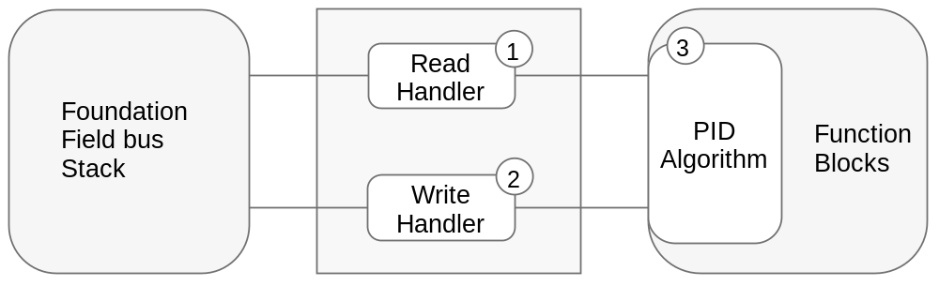
Fig. 1: System overview

# | Item | Description
1 | Read Handler | Allows the read access to all the parameters supported
2 | Write Handler | Allows the write access to all the parameters supported. It performs the range check also.
3 | PID block | The PID algorithms
Table 2: Short description of system components

Internal SW/SW interfaces
The PID block is embedded into the function blocks. These are part of the Foundation Fieldbus stack from SOFTING. The read handler and write handler are provided by SOFTING but must be adapted to the requirements of the PID block.

Class diagram

ffbl_krn
+
pid_re_calc()
ffbl_pid
+
Execute_PIDFB() :unsigned short
+
Read_handler_PIDFB() :unsigned short
+
Write_handler_PIDFB() :unsigned short
Foundation Field
Bus Stack
controller_pid
+
pid_prm()
pid_algo() :float
+
pid_control() :float
+
Fig. 2: Class diagram

Short description of classes
Module | Description
Foundation  Fieldbus Stack | Software package. It handles all the events from the field bus.
ffbl_pid | It includes the data handler and the PID block. Here the parameters of the block are handled.
ffbl_krn | Here the PID algorithms and the parameter re-calculation are linked.
Controller_pid | Here the PID algorithms and the parameter re-calculation are implemented.
Table 3: Short description of classes

Data and control flow between component/modules
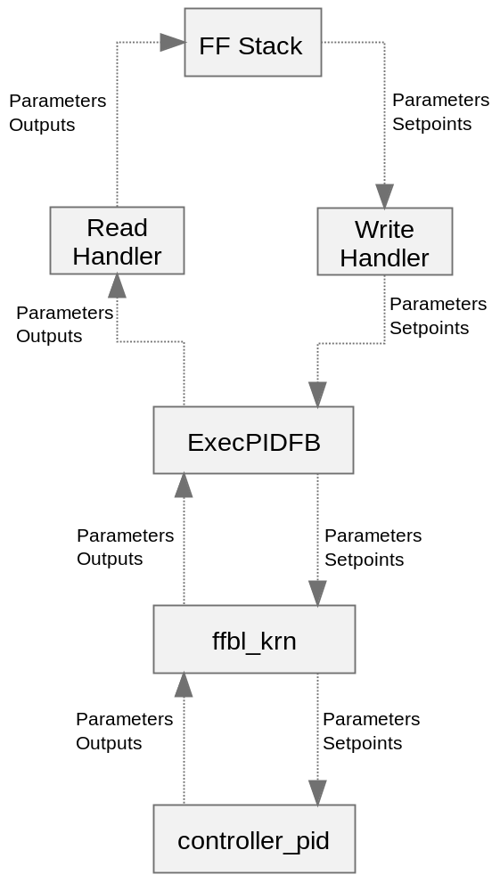
Fig. 3: Data flow between components/modules

Program control flow
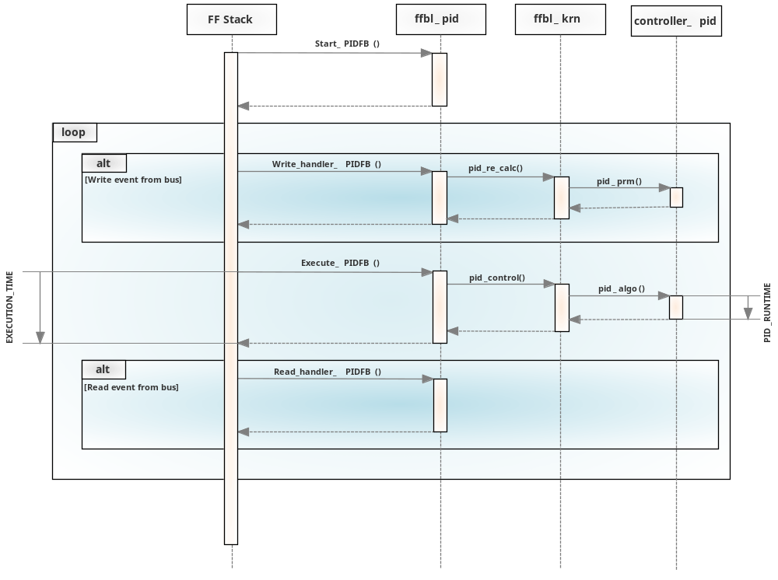
Fig. 4: Program control flow

Timing/performance specification

Timing overview table
#define | Required  time | Real  time | Description
PID_RUNTIME | 20ms |  | This is the runtime of the PID algorithms only
EXECUTION_TIME | TBD |  | The total time required for the block algorithm to execute. This time in 1/32 of a millisecond is used by a configuration device in developing a schedule for function block execution.  Actually it is not possible to estimate this value, because there are no experiences with the FF stack running on modern 32 bit architecture.
Table 4: Timing overview table

Start-up
The start-up of the system is not relevant because of the fact that the PID block is not called during start-up. The initialization of the PID block is altered by Mesco in that way, that some default values have to be set as defined in /2/.

ALGORITHM = 0 {Ideal}
TFPD = 0.0 s
TFPID = 0.0 s

Furthermore the following internal variables of the algorithm have to be set to defaults.
Kpvl = 0
Kpvc = 0
Kp2 = 1

Some values for realizing the macro cycle delay have to be initialized.
Last_I_sum = 0
Last_algorithm = 0 {Ideal}
I_sum = 0
Last_deviation = 0;
Last_tfpid = 0
Last_outputvalue = 0;

Write Access
Writing parameters needs a range checking to provide the PID algorithm with useful parameters. The ranges of parameters are defined in /2/. In case of re-scheduling time constants must be re-calculated too.

Parameters RESET and RATE: the re-calculation is done in
VOID Calc_timer_values_PIDFB (T_PIDFB *, T_PIDFB_DATA *)

In case of violate the ranges of RESET and/or RATE warning bits or error bits have to be set.
This is done in
VOID Check_config_PIDFB (T_PIDFB *)

Division by Zero
- During writing parameters a zero will be handled. A division by zero is avoided.
- During runtime the algorithm avoids any division. So a division by zero is avoided.
- During re-calculation because of changing the algorithm divisions occur. It will be checked whether a division by zero would occur. If the divisor is zero then the re-calculation will be avoided and all values are set to their default values.

Macros
The following macros are defined for setting the error / warning bits in BLOCK_ERR_DESC.

The macros below are the allowed ranges.
#define BLK_ERRTIMEERRMIN 4
#define BLK_ERRTIMEWARNMIN 10

Error bit when RATE or RESET < (BLK_ERRTIMEERRMIN * block_execution_period)
#define BLK_ERR_TIMECONSTERR 0x00000008

Warning bit when RATE or RESET < (BLK_ERRTIMEWARNMIN * block_execution_period)
#define BLK_ERR_TIMECONSTWARN 0x00000004

When reading BLOCK_ERR_DESC with the NI-FBUS configurator the bit order and the byte order are reversed. So these bits appear like follows:
BLK_ERR_TIMECONSTERR 0x10000000
BLK_ERR_TIMECONSTWARN 0x20000000

Bumpless Transfer
In case of changing the algorithm it can happen, that the output value jumps to a new value.
This will be avoided in the following way. The same strategy is used when the block mode changes between AUTO, CAS or RCAS.
Note: This strategy is used in cases where the integral path is activated. When the integral path is deactivated the integral term would not be changed. The result is an output value with an offset.

Out _{t} actual output value
Out _{(t-1)} last output value
P_{t,} actual proportional term
D _{t} actual differential term
I_{t} actual integral term

Out _{t} = P _{t} + D _{t} + I _{t}

IF (CONDITION FOR BUMP)
{
bump = Out _{t} – Out _{(t-1)}
The integral term must be reduced by this value.
I _{t} = I _{t} – bump
The output value does not change
Out _{t} = Out _{(t-1)}
}

In case of changing the block mode from MANUAL to AUTO, CAS or RCAS the difference between Manual output and actual output must be taken in account.

Here: bump = Out _{t} – Manual Output

In case of changing the block mode from ROUT to AUTO, CAS or RCAS the difference between Remote output and actual output must be taken in account.

Here: bump = Out _{t} – RemoteInValue Output

Conditions for Bump
The condition for bump depends from the following issues.
- switching the parameter ALGORITHM
- switching the Block Mode from AUTO to RCAS and vice versa
- switching the Block Mode from AUTO to CAS and vice versa
- switching the Block Mode from MAN to AUTO

To communicate these conditions to the PID algorithm the structure T_PIDFB_DATA will be extended as follows:

USIGN8 bump_flag;
USIGN8 last_new_target_mode;

Related Macros
#define CONDNO 0x00 no condition
#define CONDALGOCHG 0x01 switching the parameter ALGORITHM
#define CONDMANAUTO 0x02 switching the Block Mode from MAN to AUTO
#define CONDMODECHG 0x04 switching Block Mode between AUTO, CAS, RCAS

Data structures
The already existing data structures T_PIDFB_DATA and T_PIDFB from SOFTING are used. The missing parameters are additionally included.

The structure T_PIDFB_DATA will be extended as follows:

FLOAT last_algorithm; /* value from the general SW structure */
FLOAT P_factor; /* proportional gain */
FLOAT kp_1; /* value from the general SW structure */
FLOAT kp_2; /* value from the general SW structure */
FLOAT ki; /* value from the general SW structure */
FLOAT kd; /* value from the general SW structure */
FLOAT tfpd_factor; /* macro cycle time divided by tfpd */
FLOAT tfpid_factor; /* macro cycle time divided by tfpid */
FLOAT last_tfpid; /* static value */
FLOAT kpvl; /* value from the general SW structure */
FLOAT kpvc; /* value from the general SW structure */
FLOAT last_pv; /* static value */
FLOAT last_pre_kd_value; /* static value */
FLOAT last_outputvalue;
FLOAT last_I_sum;
USIGN8 bump_flag;

The structure T_PIDFB will be extended as follows:

USIGN8 algorithm; /* FF parameter */
FLOAT tfdp; /* FF parameter */
FLOAT tfpid, /* FF parameter */

Different FW versions / compiler switches
Compiler switch | Description
_WIN32 | Compile debug version for simulated tests on Windows PC
_TIMEMEAS | Compile debug embedded application including setting GPIOs for time measurement
Table 5: Compiler switches

Configuration | Activated  switches | Description
Application | No switches | Build Application Release Version
Timing | _TIMEMEAS | Build debug embedded version with activated GPIOs for time measurement
Simulation | _WIN32 | Build debug version. Used for simulated tests on Windows PC.
Table 6: Build configurations

Detailed module descriptions

Controller_pid.c
This module includes the PID algorithm. It performs all the calculations.

Pid_algo
float pid_algo(T_PIDFB_DATA * p_pidfb_data,
T_PIDFB * p_pidfb,
T_PIDFB_CONTROL_DATA * p_control_data)
This is the algorithm. It performs the PID.

Pid_prm
void pid_prm(T_PIDFB_DATA * p_pidfb_data, T_PIDFB * p_pidfb)

This function distributes the parameters from the field bus to all the internal coefficients dependent from the actual value of ALGORITHM.
Switching from one algorithm to another can produce a bump at the output in cases, where the integral term is deactivated.
In these cases switching the algorithms should be done only in Out Of Service mode!

Pid_check_convert_to_ideal
Static void pid_check_convert_to_ideal(T_PIDFB_DATA * p_pidfb_data, T_PIDFB * p_pidfb);

This function performs the re-calculation of the PID parameters in case of switching the parameter ALGORITHM to IDEAL. The FF parameters RESET, RATE and GAIN are re-calculated also.
This concerns to FWR. 27 and FWR.29.
The following formulas are used.

Parallel -> Ideal | I-PD -> Ideal | IP-D -> Ideal | Series -> Ideal
Ki_{Ideal} = Ki_{par} / Kp2_{par} | Kp1_{Ideal} = Kpvl_{I_PD} | Kp1_{Ideal} = Kp2_{IP_D} | Kp1_{Ideal} = Kp1_{Series}
Kd_{Ideal} = Kd_{par} / Kp2_{par} | Ki_{Ideal} = Ki_{I_PD} | Ki_{Ideal} = KiI_{P_D} / Kp2_{IP_D} | Ki_{Ideal} = Ki_{Series}
Kp1_{Ideal} = Kp2_{par} | Kd_{Ideal} = Kpvc_{I_PD} / Kpvl_{I_PD} | Kd_{Ideal} = Kpvc_{IP_D} / kp2_{IP_D} | Kd_{Ideal} = Kd_{Series}
Kp2_{Ideal} = 1 | Kp2_{Ideal} = 1 | Kp2_{Ideal} = 1 | Kp2_{Ideal} = 1
Kpvc_{I_PD} = 0 | Kpvc_{Ideal} = 0 | Kpvc_{Ideal} = 0 | Kpvc_{Ideal} = 0
Kpvl_{I_PD} = 0 | Kpvl_{Ideal} = 0 | Kpvl_{Ideal} = 0 | Kpvl_{Ideal} = 0
Table 7: Re-calculations to Ideal

Pid_check_convert_to_series
Static void pid_check_convert_to_series(T_PIDFB_DATA * p_pidfb_data, T_PIDFB * p_pidfb);

This function performs the re-calculation of the PID parameters in case of switching the parameter ALGORITHM to SERIES. The FF parameters RESET, RATE and GAIN are re-calculated also.
This concerns to FWR. 23.
The following formulas are used.

Parallel -> Series | I-PD -> Series | IP-D -> Series | Ideal -> Series
Ki_{Series} = KI_{Par} / Kp2_{Par} | Kp1 _{Series} = Kpvl_{I_PD} | Kp1 _{Series} = Kp2_{IP_D} | Kp1_{Series} = Kp1_{Ideal}
Kd_{Series} = Kd_{Par}/Kp2_{Par} | Ki _{Series} = Ki _{I_PD} | Ki_{Series} = Ki_{IP_D} / Kp2_{IP_D} | Ki _{Series} = Ki _{Ideal}
Kp1_{Series} = Kp2_{Par} | Kd_{Series} = Kpvc_{I_PD} / Kpvl_{I_PD} | Kd_{Series} = Kpvc_{IP_D}/Kp2_{IP_D} | Kd _{Series} = Kd _{Ideal}
Kp2_{Series} = 1 | Kp2_{Series} = 1 | Kp2_{Series} = 1 | Kp2_{Series} = 1
Kpvc _{Series} = 0 | Kpvc _{Series} = 0 | Kpvc _{Series} = 0 | Kpvc _{Series} = 0
Kpvl _{Series} = 0 | Kpvl _{Series} = 0 | Kpvl _{Series} = 0 | Kpvl _{Series} = 0
Table 8: Re-calculations to Series

Pid_check_convert_to_parallel
Static void pid_check_convert_to_parallel(T_PIDFB_DATA * p_pidfb_data, T_PIDFB * p_pidfb);

This function performs the re-calculation of the PID parameters in case of switching the parameter ALGORITHM to PARALLEL. The FF parameters RESET, RATE and GAIN are re-calculated also.
This concerns to FWR. 19 and FWR.24.
The following formulas are used.

Series -> Parallel | I-PD -> Parallel | IP-D -> Parallel | Ideal -> Parallel
Kp2_{Par} = kp1_{Series} | Kp2_{Par} = Kpvl_{I_PD} | Ki_{Par} = Ki_{IP_D} | Kp2_{Par} = kp1_{Ideal}
Kd_{Par} = Kd_{Series}*Kp1 _{Series} | Ki _{Par} = Ki_{I_PD} * Kp1_{I_PD} | Kp2_{Par} = Kp2_{IP_D} | Ki_{Par} = Ki _{Ideal} * Kp1_{Ideal}
Ki_{Par} = Ki_{Series} * Kp1_{Series} | Kd _{Par} = Kpvc_{I_PD} | Kd_{Par} = kpvc_{IP_D} | Kd_{Par} = Kd_{Ideal} * Kp1_{Ideal}
Kp1_{Par} = 1 | Kp1_{Par} = 1 | Kp1_{Par} = 1 | Kp1_{Par} = 1
Kpvc _{Par} = 0 | Kpvc _{Par} = 0 | Kpvc _{Par} = 0 | Kpvc _{Par} = 0
Kpvl _{Par} = 0 | Kpvl _{Par} = 0 | Kpvl _{Par} = 0 | Kpvl _{Par} = 0
Table 9: Re-calculations to Parallel

Pid_check_convert_to_i_pd
Static void pid_check_convert_to_i_pd(T_PIDFB_DATA * p_pidfb_data, T_PIDFB * p_pidfb);

This function performs the re-calculation of the PID parameters in case of switching the parameter ALGORITHM to I-PD. The FF parameters RESET, RATE and GAIN are re-calculated also. This concerns to FWR. 26.
The following formulas are used.

Parallel -> I-PD | Series -> I-PD | IP-D -> I-PD | Ideal -> I-PD
Kpvl _{I-PD} = Kp2_{Par} | Ki _{I-PD} = Ki _{Series} | Ki _{I-PD} = Ki_{IP-D} | Kp1_{I-PD} = Kp1_{Ideal}
Kpvc _{I-PD} = Kd _{Par} | Kp1_{I-PD} = Kp1 _{Series} | Kp1_{I-PD} = Kp1_{IP-D} | Ki _{I-PD} = Ki _{Ideal}
Ki _{I-PD} = Ki_{Par} / Kp2 _{Par} | Kpvl_{I-PD} = Kp1_{Series} | Kpvl _{I-PD} = Kp2_{IP-D} * Kp1_{IP-D} | Kpvl _{I-PD} = Kp1 _{Ideal}
Kp1 _{I-PD} = Kp2 _{Par} | Kpvc_{I-PD} = Kd _{Series} * Kp_{Series} | Kpvc _{I-PD} = Kpvc_{IP-D} / Kp2_{IP-D} | Kpvc _{I-PD} = Kd _{Ideal} * Kp1_{Ideal}
Kp2_{I-PD} = 0 | Kp2_{I-PD} = 0 | Kp2_{I-PD} = 0 | Kp2_{I-PD} = 0
Kd _{I-PD} = 0 | Kd _{I-PD} = 0 | Kd _{I-PD} = 0 | Kd _{I-PD} = 0
Table 10: Re-calculations to I-PD

Pid_check_convert_to_ip_d
Static void pid_check_convert_to_ip_d(T_PIDFB_DATA * p_pidfb_data, T_PIDFB * p_pidfb);

This function performs the re-calculation of the PID parameters in case of switching the parameter ALGORITHM to IP-D. The FF parameters RESET, RATE and GAIN are re-calculated also.
This concerns to FWR. 28.
The following formulas are used.

Parallel -> IP-D | Series -> IP-D | I-PD -> IP-D | Ideal -> IP-D
Ki _{IP-D} = Ki _{Par} | Kp2 _{IP-D} = Kp1_{Series} | Ki_{IP-D} = Ki _{I-PD} * Kp1_{I-PD} | Ki_{IP-D} = Ki_{Ideal} * Kp1_{Ideal}
Kp2 _{IP-D} = Kp2 _{Par} | Ki _{IP-D} = Ki _{Series} * Kp1 _{Series} | Kp2_{IP-D} = Kpvl _{I-PD} / Kp1_{I-PD} | Kp2_{IP-D} = Kp1_{Ideal}
Kpvc _{IP-D} = Kd _{Par} | Kpvc _{IP-D} =  Kd _{Series} * Kp1 _{Series} | Kpvc_{IP-D} =  Kpvc _{I-PD} *KPVL _{I-PD} | Kpvc_{IP-D} =  Kd_{Ideal} * Kp1_{Ideal}
Kp1 _{IP-D} = 1 | Kp1 _{IP-D} = 1 | Kp1 _{IP-D} = 1 | Kp1_{IP-D} = 1
Kpvl _{IP-D} = 0 | Kpvl _{IP-D} = 0 | Kpvl _{IP-D} = 0 | Kpvl _{IP-D} = 0
Kd _{IP-D} = 0 | Kd _{IP-D} = 0 | Kd _{IP-D} = 0 | Kd _{IP-D} = 0
Table 11: Re-calculations to IP-D

It is possible that more than one instance of the PID is performed. Static duration variables are avoided.
When the FF Parameter RESET is set to 0 then the internal values I_sum and last_I_sum are set to 0 also.

Project organization

Project folders and files
The following table describes some folders which belong to the firmware project. The complete project folders and files are downloaded from customer’s site.

Folder | Content description
C:\FF | The DD build tools and supporting files
C:\FF\dresser | The custom specific DD files
C:\snapshot\FD-SW\_batch_build | All the build files
C:\snapshot\FD-SW\base\appl\ffbl\src\ffbl_pid.c | Source file to adapt by Mesco
C:\snapshot\FD-SW\base\appl\ffbl\src\ffbl_krn.c | Source file to adapt by Mesco
C:\snapshot\FD-SW\base\appl\ffbl\inc\ffbl_pid.h | The related header file
C:\snapshot\FD-SW\target\appl\fdev\src\controller_pid.c | Source files created by Mesco
C:\snapshot\FD-SW\target\appl\fdev\src\mcu.c | Source files created by Mesco, temporarily
C:\snapshot\FD-SW\target\appl\fdev\inc\controller_pid.h | The related header file
C:\snapshot\FD-SW\target\appl\fdev\inc\defs_pid.h | Macros for ALGORITHM and Error bits
C:\snapshot\FD-SW\target\appl\fdev\inc\mcu.h | Timemeasurement, temporarily
C:\snapshot\FD-SW\target\fbif\src | Source files created during building the DD
C:\snapshot\FD-SW\target\fbif\inc | Header files created during building the DD
Table 12: Project folders

Build and program process
The development environment and the necessary settings are provided from customers to MESCO. It is necessary to build the DD before building the SW because of the fact that some source files are generated during building the DD.

Building the DD
The following steps are necessary to extend the DD.
The folder C:\FF\dresser includes all the DD files.

- Extend the file C:\FF\dresser\svi_positioner.ddl by the new parameters
- Extend the file C:\FF\dresser\svi_positioner.h by the labels of the new parameters
- Extend the file C:\snapshot\FD-SW\target\appl\fbif\script\pidfb.gw by the default values and data types
- Execute C.\FF\mkDD dresser/svi_positioner.ddl
- Result is in C:\FF\release\004745\0008\*.*
- Copy C:\FF\release\004745\0008\*.* to C:\snapshot\FD-SW\target\appl\fbif\ddl\0008\*.*
- Copy C:\FF\dresser\*.* to C:\snapshot\FD-SW\target\appl\fbif\ddl\*.*

Building the SW
The new source must be included in a make file to be buildable, and the name of the make file is mn.mak.
Execute the batch C:\snapshot\FD-SW\_batch_build\FF_TokDD_and_compile.bat.

Static Code Analysis
This is done by Lint.
1. in the command-line window, change to FIRMWARE directory
2. Run gnumake -f ffbuild.mak fflint
3. Result is seen in C:\snapshot\FD-SW\target\appl\fdev\src\lint.log

Appendixes

Creating Bode Plots
The PID algorithm is tested in a module test.
FFPID.exe is the console application.

rem algo, Series
rem I gain
rem I I rate
rem I I I reset
rem I I I I setpoint pv stepresponse
rem V V V V V v v filtertime
call ffpid.exe 1 1.0 1.0 0.0 0.0 1.0 1 0.0

algo : 0 Ideal
1 Serial
2 Parallel
3 I-PD
4 IP-D
gain: proportional value [s]
rate: differential value [s]
reset: integral time [s]
setpoint: value
pv: process value
stepresponse: 1 means PV is constant
0 means PV is a spectrum of sine waves, result is the frequency response

The frequency range starts at 1/10⁶ and ends at ¼. The frequency is multiplied by 1.01. So the result is a logarithmic value.
The number of samples is 2*10⁶ at the beginning. It decreases down to 90 samples.

For creating Bode plots a tool named GNUPLOT is used.

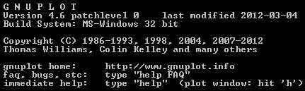

Folders and Files
For this batch files are created to create all combinations.
The table below shows the algorithm tested with parameters provided.
Folder | GAIN | RESET | RATE | ALGORITHM
Plots\plots_I_PD_GAIN | 1.0 | 0.0 | 0.0 | I-PD
Plots\plots_I_PD_GAIN_RESET | 1.0 | 2.0 | 0.0 | I-PD
Plots\plots_I_PD_GAIN_RESET_RATE | 1.0 | 2.0 | 0.2 | I-PD
Plots\plots_I_PD_STEPS | 1.0 | 1.0 | 1.0 | I-PD
Plots\plots_IP_D_GAIN | 1.0 | 0.0 | 0.0 | IP-D
Plots\plots_IP_D_GAIN_RESET | 1.0 | 2.0 | 0.0 | IP-D
Plots\plots_IP_D_GAIN_RESET_RATE | 1.0 | 2.0 | 0.2 | IP-D
Plots\plots_IP_D_STEPS | 1.0 | 1.0 | 1.0 | IP-D
Plots\plots_IDEAL_GAIN | 1.0 | 0.0 | 0.0 | IDEAL
Plots\plots_IDEAL_GAIN_RESET | 1.0 | 2.0 | 0.0 | IDEAL
Plots\plots_IDEAL_GAIN_RESET_RATE | 1.0 | 2.0 | 0.2 | IDEAL
Plots\plots_IDEAL_STEPS | 1.0 | 1.0 | 1.0 | IDEAL
Plots\plots_SERIAL_GAIN | 1.0 | 0.0 | 0.0 | SERIAL
Plots\plots_SERIAL_GAIN_RESET | 1.0 | 2.0 | 0.0 | SERIAL
Plots\plots_SERIAL_GAIN_RESET_RATE | 1.0 | 2.0 | 0.2 | SERIAL
Plots\plots_SERIAL_STEPS | 1.0 | 1.0 | 1.0 | SERIAL
Plots\plots_PARALLEL_GAIN | 1.0 | 0.0 | 0.0 | PARALLEL
Plots\plots_PARALLEL_GAIN_RESET | 1.0 | 2.0 | 0.0 | PARALLEL
Plots\plots_PARALLEL_GAIN_RESET_RATE | 1.0 | 2.0 | 0.2 | PARALLEL
Plots\plots_PARALLEL_STEPS | 1.0 | 1.0 | 1.0 | PARALLEL
Table 13: Test folders

Input and Outputs
The table below lists the related result files. These files exist in all the folders listed above.

File / Frequency Response | Description
FFPID.exe | The test program
Freq.bat | Batch file to execute a frequency response
Plot.gp | Control file for GNUPLOT
Results | Description
Ffpid.dat | Ascii table with output values of the PID
Plot_Out_Angel.png | Plot of the phase angle
Plot_Out_In.png | Plot of the attenuation
File / Step Response | Description
FFPID.exe | The test program
Step.bat | Batch file to execute a step response
Plotstep.gp | Control file for GNUPLOT
Results | Description
pidstepD.dat | Ascii table with output values, step response for differential term
pidstepI.dat | Ascii table with output values, step response for integral term
pidstepP.dat | Ascii table with output values, step response for proportional term
pidstepD.png | Plot of the step response for differential term
pidstepI.png | Plot of the step response for integral term
pidstepP.png | Plot of the step response for proportional term
Table 14: Result files

Acronyms and abbreviations

Abbreviation | Detailed / Complete
/TBD/ | To Be Defined
µC or uC | Microcontroller
CPU | Central Process Unit
HW | Hardware
SW | Software
FW | Firmware
Ver | Version
N.C. | Not Connected
FF | Foundation Fieldbus
DUT | Device Under Test
Table 15: Acronyms and abbreviations

/*** End of document ***/

