ASSIGNMENT 1
REQUIREMENT ANALYSIS
Course: B.Tech. CSE Semester: 5
Subject: System Design (TCS-504)
Movie Ticket Booking System

G. DEMO RUN
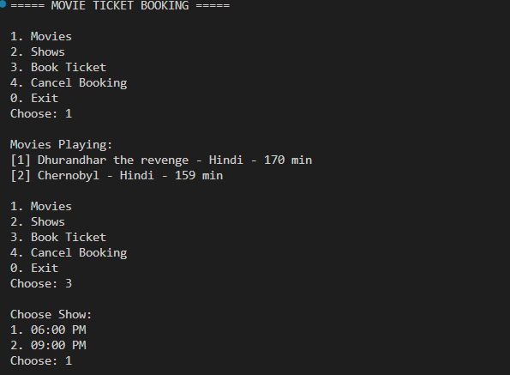
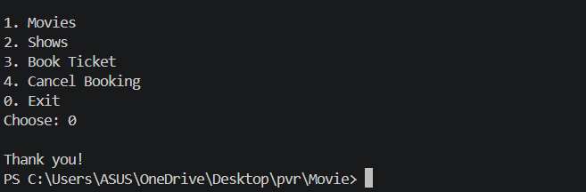

Edge case Tested

1. booking a seat that is already BOOKED → rejected, nothing changes

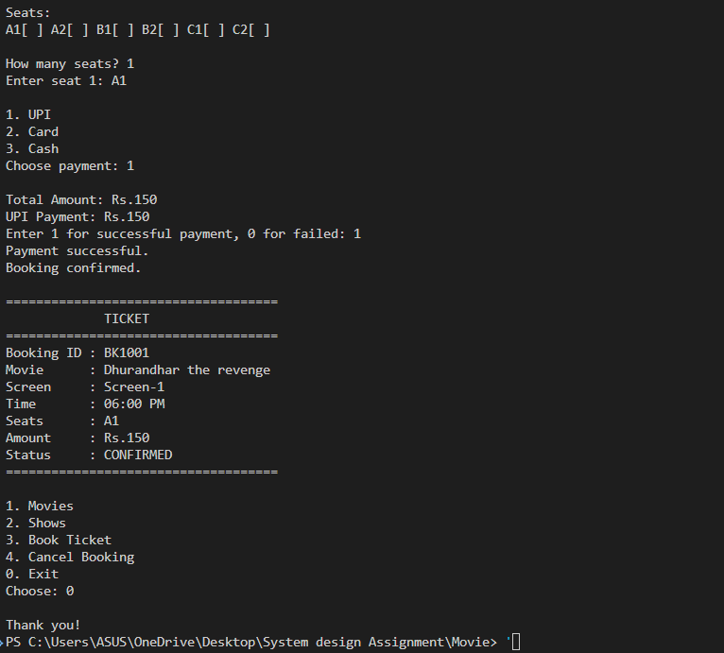

2. A failed payment → booking NOT confirmed, seats released

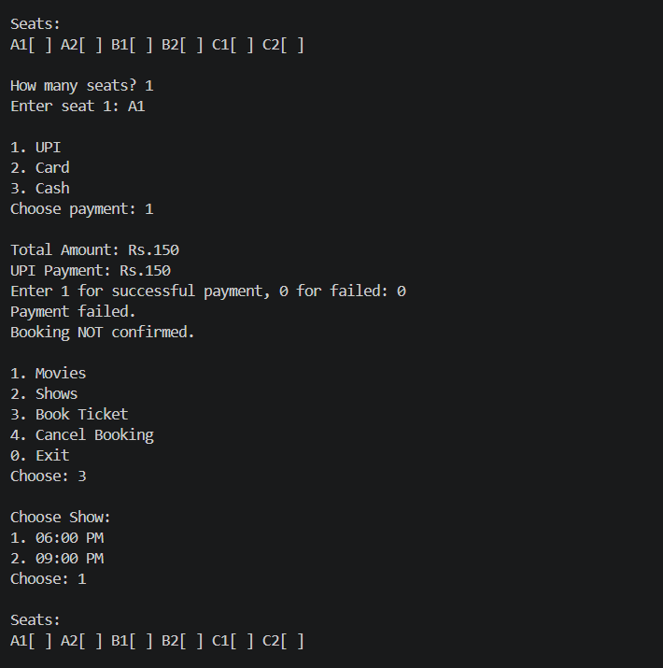

3. cancelling a booking → those seats show AVAILABLE again

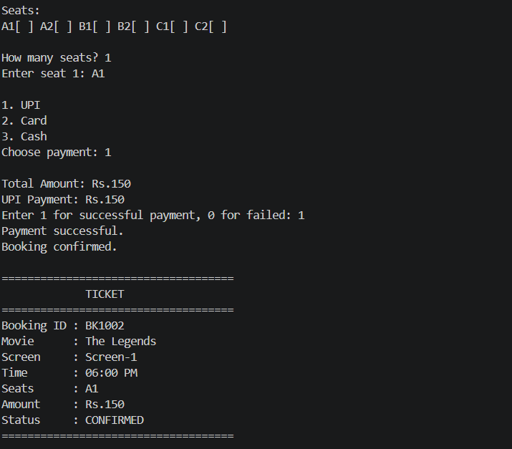
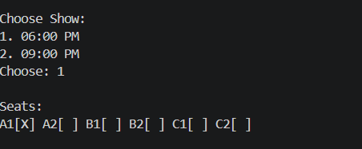
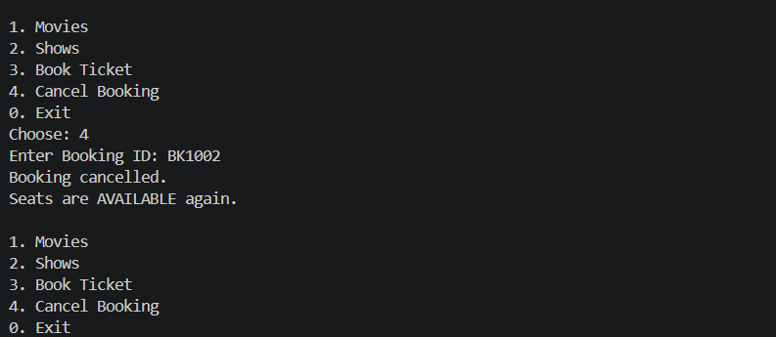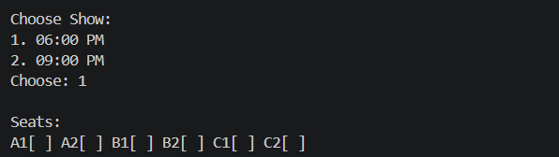
4. an invalid seat number or menu choice → a clear message, no crash

