MESI and MOESI Cache-Coherence State Diagrams
Oct 9, 2026 · @Vansh

At a glance
MESI stops one core from reading a stale copy of a line by giving every cached line one of four states (M, E, S, I) and having every cache watch, or snoop, the shared bus. MOESI adds a fifth state, Owned, so a dirty line can be shared without writing it back to memory first.
The diagrams here use the classic snooping-bus teaching model: each cache sees every bus request and updates its own copy of the line. Real Intel, AMD and Arm designs may use rings, meshes, snoop filters or directories, so these are teaching models, not a drawing of the team's CPU.
Evidence label | What it means | Where it applies here
EXTERNAL EVIDENCE | Backed by public vendor documentation | MESI state definitions (Intel SDM), purpose of Owned state
THEORETICAL | Protocol teaching model; every arrow still needs review against a chosen spec | All state diagrams, transition tables and traces
PENDING LOCAL VERIFICATION | Needs data from the team's actual machine | CPU model, topology, any coherence counters
Scope: state definitions and abstract transitions only. Cache hierarchy (Module 03), the conceptual coherence introduction (Module 04) and hardware measurements (benchmark module) are covered elsewhere.

MESI stable states
Intel's Software Developer's Manual describes MESI as Modified, Exclusive, Shared and Invalid for Intel 64 and IA-32 cache coherence (EXTERNAL EVIDENCE). The table summarizes the stable-state teaching model; exact transaction names depend on the implementation.
State | Valid here? | Other valid copies? | Relation to memory | Local read | Local write
M Modified | Yes | None in the basic model | This cache is newer; memory is stale | Hit | Hit, no bus traffic
E Exclusive | Yes | None | Clean; matches memory | Hit | Hit; silently becomes M
S Shared | Yes | May exist | Clean in basic MESI | Hit | Must gain write permission and invalidate other copies
I Invalid | No | Others may hold valid copies | Local copy is unusable | Miss; must fetch the line | Miss; must fetch the line with write permission
Five invariants every diagram must keep:
- M and E are exclusive: no other cache holds a valid copy of the line.
- S allows many readable copies.
- I means the local copy cannot serve ordinary loads.
- A store to a shared line cannot leave other caches treating their copies as current.
- A line's state is a hardware concept; Java fields do not map one-to-one to cache lines.

MESI state diagram with bus snooping
On a snooping bus every cache sees every request, so a core that wants to write only has to announce it once.
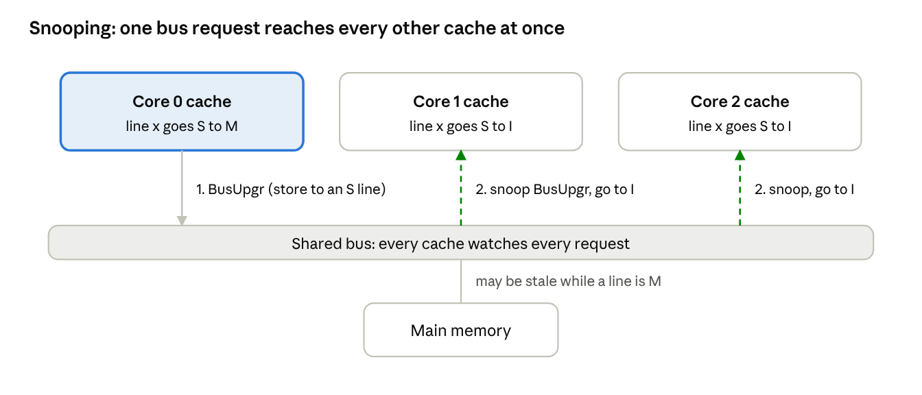
bus snooping overview · 3 caches, 1 bus
Here Core 0 stores to a line that all three caches hold in S; its BusUpgr is the only message, and each other cache invalidates when it sees it.

Processor-side transitions
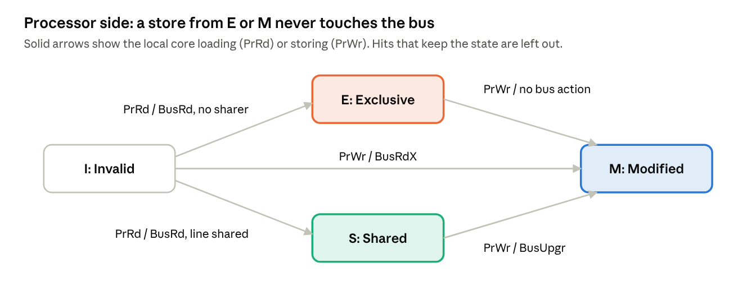
MESI processor-side transitions · 4 states, 5 arrows
A miss, or a store to an S line, puts a request on the bus; stores from E and M stay silent.

Snoop-side transitions
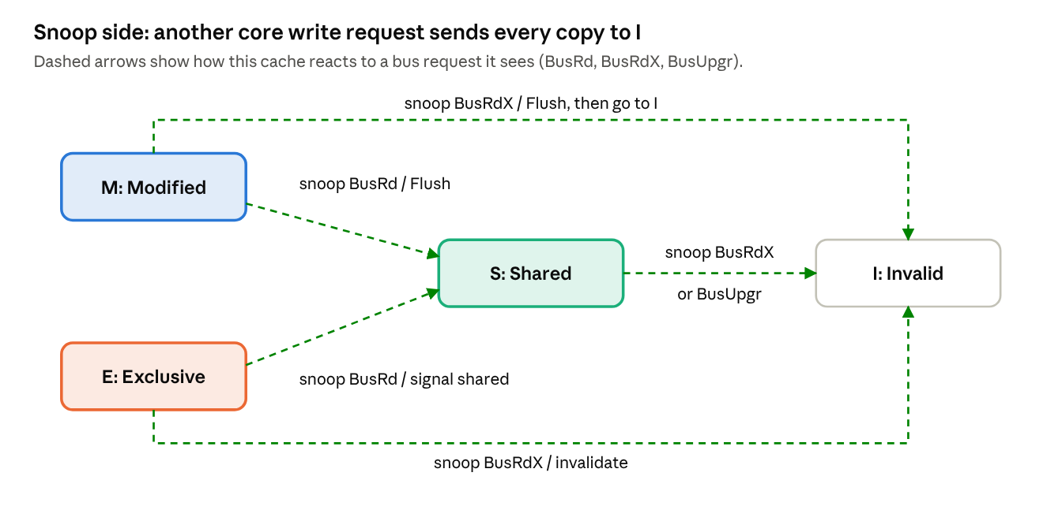
MESI snoop-side transitions · 4 states, 5 arrows
A Modified line must supply its data (Flush) when another core asks for it, then drops to S for a read or to I for a write.

MESI transition table with bus snooping
The table reads one line per arrow in the diagram above. Names follow the common textbook snooping model: PrRd and PrWr are the local core's load and store; BusRd asks for a readable copy; BusRdX asks for a copy with write permission; BusUpgr asks other caches to invalidate when the requester already holds the data. Real controllers use their own request names and transient states (THEORETICAL).
Side | Current state | Event | Bus action | Next state
Processor | I | PrRd | BusRd | S if another cache shares it, otherwise E
Processor | I | PrWr | BusRdX | M
Processor | E | PrRd | None (hit) | E
Processor | E | PrWr | None (hit) | M
Processor | S | PrRd | None (hit) | S
Processor | S | PrWr | BusUpgr (or BusRdX) | M
Processor | M | PrRd or PrWr | None (hit) | M
Snoop | M | BusRd seen | Flush: supply data, write back | S
Snoop | M | BusRdX seen | Flush: supply data | I
Snoop | E | BusRd seen | Signal "shared" | S
Snoop | E | BusRdX seen | None | I
Snoop | S | BusRd seen | Signal "shared" | S
Snoop | S | BusRdX or BusUpgr seen | None | I
Snoop | I | Any bus request | Ignore | I
Whether memory or another cache supplies the data, and whether the write-back happens at once, varies by implementation. Replacement of a line is local and is not necessarily announced on the bus.

Three event traces
Each trace follows one cache line holding x through the MESI snooping model. States are the simplified outcome, not a log from real hardware (THEORETICAL).

1. Read-only sharing (both caches start in I)
Step | Event | Bus traffic | C0 | C1
1 | C0 reads x | BusRd; no sharer answers | E | I
2 | C1 reads x | BusRd; C0 snoops and signals "shared" | S | S
3 | Both read x again | None | S | S
Both cores now read from their own caches without going back to DRAM. Which cache supplies the data in step 2 depends on the protocol.

2. C0 writes after both cores have read (both start in S)
Step | Event | Bus traffic | C0 | C1
1 | C0 executes x = 1 | BusUpgr requests write permission | S, waiting | S, waiting
2 | C1 snoops the upgrade | C1 invalidates its copy | S to M after grant | I
3 | C1 later reads x | BusRd; C0 flushes the modified line | S | S
C1 cannot keep using the old value after step 2; its next read must fetch current data through the coherence path.

3. Competing writers on one line
Step | Event | Bus traffic | C0 | C1
1 | C0 writes | BusRdX | M | I
2 | C1 writes | BusRdX; C0 flushes and invalidates | I | M
3 | C0 writes again | BusRdX; C1 flushes and invalidates | M | I
4 | C1 writes again | Same pattern repeats | I | M
The line moves back and forth between cores, which can add traffic and latency. This is a conceptual picture of ownership ping-pong, not a measured result and not proof that it happened on the team's machine.

MOESI: what the Owned state adds
MOESI adds O (Owned) to the four MESI states. In the common teaching model, an Owned cache holds the authoritative dirty data while other caches may also hold read-only copies, and the owner must make sure the data reaches memory eventually. A dirty line can therefore be shared without an immediate write-back to main memory (EXTERNAL EVIDENCE: Intel's core-to-core article describes the purpose of an Owned state).
State | Teaching-model meaning | Dirty? | Shared copies allowed? | Caveat
M Modified | Only valid copy, newer than memory | Yes | No | None in the basic model
O Owned | Dirty owner; supplies data to readers | Yes | Yes | Exact owner duties depend on the protocol
E Exclusive | Only valid copy, matches memory | No | No | Often becomes M on a local store
S Shared | Clean read-only copy | No | Yes | May coexist with an O owner
I Invalid | No usable local copy | n/a | n/a | Later access must refetch data and permission
The key difference from MESI is on the snoop side: when a Modified line is read by another core, MESI sends it to S and writes it back, while MOESI sends it to O and keeps the dirty responsibility in that cache.

MOESI state diagram and transition table
The processor-side transitions match MESI, with one addition: a store to an O line must invalidate the other sharers before the line becomes M. The snoop side is where MOESI differs, because a Modified or Owned cache keeps the dirty data and supplies readers directly (THEORETICAL).

Snoop-side transitions
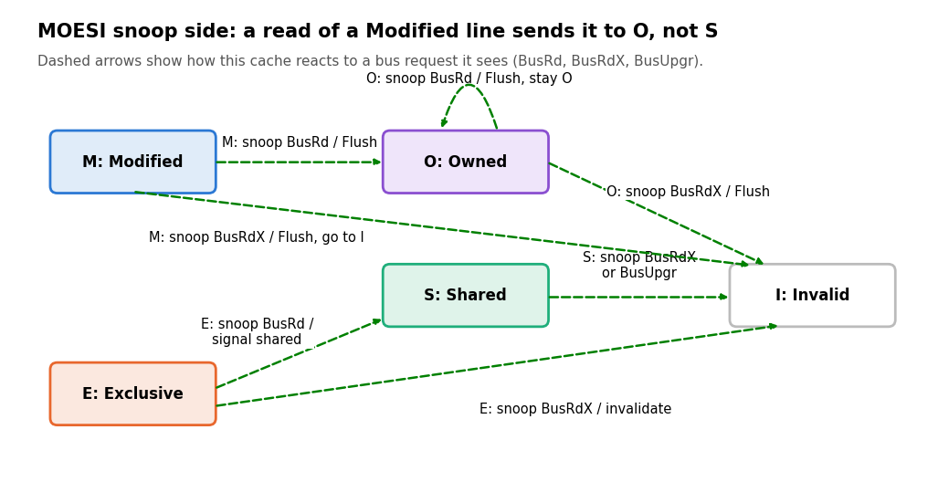
MOESI snoop-side transitions · 5 states
A BusRd leaves an M line in O instead of writing it back, and an O line stays in O while it supplies each new reader. A BusRdX sends every copy, including the owner, to I.
Side | Current state | Event | Bus action | Next state
Processor | I | PrRd | BusRd | S if another cache shares it, otherwise E
Processor | I | PrWr | BusRdX | M
Processor | E | PrRd | None (hit) | E
Processor | E | PrWr | None (hit) | M
Processor | S | PrRd | None (hit) | S
Processor | S | PrWr | BusUpgr (or BusRdX) | M
Processor | O | PrRd | None (hit) | O
Processor | O | PrWr | BusUpgr (or BusRdX); sharers invalidate | M
Processor | M | PrRd or PrWr | None (hit) | M
Snoop | M | BusRd seen | Flush: supply data; keep dirty duty | O
Snoop | M | BusRdX seen | Flush: supply data | I
Snoop | O | BusRd seen | Flush: supply data to reader | O
Snoop | O | BusRdX seen | Flush: supply data | I
Snoop | O | BusUpgr seen | None (data already with requester) | I
Snoop | E | BusRd seen | Signal "shared" | S
Snoop | E | BusRdX seen | None | I
Snoop | S | BusRd seen | Signal "shared" | S
Snoop | S | BusRdX or BusUpgr seen | None | I
Snoop | I | Any bus request | Ignore | I
As with MESI, exact request names, transient states and write-back timing vary by implementation, and the Owned state is not used by every vendor protocol (THEORETICAL). Replacement of an O line is a case where the owner must write the dirty data back to memory first.

MESI vs MOESI side by side
MOESI's only structural change is letting a dirty line be shared; no universal latency or throughput win follows from the state names alone.
Aspect | MESI | MOESI
States | M, E, S, I | M, O, E, S, I
Another core reads a Modified line | M goes to S; dirty data is supplied and written back as required | M goes to O; owner keeps the dirty data and supplies readers
Dirty line with other sharers | Not allowed; shared lines are clean | Allowed: one O owner plus S copies
Memory write-back when sharing starts | Needed in the basic model | Can be deferred until the owner gives up the line
Other core writes | Holders go to I | Holders, including the owner, go to I
Source in this module | Intel SDM Vol. 3A §11.4 (EXTERNAL EVIDENCE) | Intel core-to-core article, conceptual (EXTERNAL EVIDENCE); a normative spec is still to be chosen
Host-specific claim allowed? | No, until CPU and manual edition are confirmed | No, until a vendor spec for the exact variant is selected
Arm's AMBA ACE specification documents a different five-state model (UC, UD, SC, SD, I). It is a separate protocol with its own names and must not be relabeled as MESI or MOESI.

Evidence policy and the Java Memory Model boundary
This module is protocol documentation only. No Java code, JMH benchmark, hardware-counter capture or local state trace is claimed, and a timing difference in a Java benchmark would not prove any MESI or MOESI transition.
Item | Status | What is still needed
MESI state definitions | EXTERNAL EVIDENCE | Cite the exact Intel SDM edition and section used
MOESI Owned-state explanation | EXTERNAL EVIDENCE (conceptual) | Pick a vendor spec that defines MOESI; cite its section before any host claim
State diagrams and transition tables | THEORETICAL | Review each arrow against the chosen protocol's rules
Target machine and microarchitecture | PENDING LOCAL VERIFICATION | Record CPU model, stepping, core topology and OS
Coherence traffic measurements | PENDING | Belongs to the benchmark owner; use validated CPU counters
Build and tests | NOT APPLICABLE | Documentation-only module
The hardware protocol keeps cached copies consistent. It does not make count++ atomic, and it does not by itself create Java's happens-before relationship, which is defined in the Java Language Specification, Chapter 17 (§17.4.5). Keep protocol state diagrams separate from Java-level synchronization claims.

Likely reviewer questions
Question | Short answer
Why does E to M need no bus request? | E means this is the only valid copy, so there is no other sharer to invalidate.
Why must S ask permission before a store? | Other valid copies may exist; the writer must invalidate them so nobody keeps using an obsolete copy.
What is the practical difference between M and O? | Both are dirty. M is exclusive; O lets other caches share the line while one cache keeps the dirty-data duty.
Does MOESI guarantee lower latency than MESI? | No. Results depend on workload, interconnect, topology and implementation policy.
Do these diagrams prove what the team's CPU does? | No. They are teaching models until matched to the target architecture's own documentation.
Does coherence make Java code correct? | No. Coherence does not replace atomic operations or happens-before relationships.

Sources
References taken from the module handoff; the pages were not re-opened while building this document.
- Intel 64 and IA-32 Architectures SDM, Vol. 3A, §11.4 "Cache Control Protocol", Table 11-4: Intel MESI state definitions.
- Intel, "Faster Core-to-Core Communications": explanatory article on coherent multicore behavior and the Owned state; not a normative spec.
- Arm AMBA AXI and ACE Protocol Specification, IHI 0022H, Appendix D: ACE five-state model, a different protocol from MESI and MOESI.
- Oracle, The Java Language Specification, SE 21, Chapter 17: Java memory model and happens-before.

