Summer Training Report on

**Deep learning models for medical imaging applications**

Submitted in partial fulfillment of the requirements for the completion of one month’s summer internship/training [ART 355]

## Udit Sharma 00219011922

Under the supervision of

## Dr. Sanjay Kumar Singh

UNIVERSITY SCHOOL OF AUTOMATION AND ROBOTICS GURU GOBIND SINGH INDRAPRASTHA UNIVERSITY

EAST DELHI CAMPUS, SURAJMAL VIHAR, DELHI- 110032

# DECLARATION

I hereby declare that the Summer Training Report entitled Deep Fake detection is an authentic record of work completed as requirements of Summer Training (ART 355) during the period from 25th June 2024 to 6th August 2024 in the University School of Automation and Robotics under the supervision of Dr. Sanjay Kumar Singh.

(Signature)

Udit Sharma 00219011922

Date:

(Signature of Supervisor)

Dr. Sanjay Kumar Singh

Date:

## Acknowledgement

I would like to express my deepest gratitude and appreciation to Dr. Sanjay Kumar Singh for his invaluable guidance, unwavering support, and expertise throughout my internship. His mentorship, insightful suggestions, and encouragement significantly enriched my understanding of portfolio optimization techniques.

Furthermore, I extend my sincere thanks to the esteemed technical and non-technical faculty members of USAR, whose collective knowledge and dedication fostered an enriching learning environment. Their continuous support, constructive feedback, and encouragement was instrumental in shaping this internship report.

Lastly, I express my gratitude to my family and friends for their constant encouragement, understanding, and support during this endeavor.

Udit Sharma

University School of Automation and Robotics Date……………….

# Table of Contents

**Acknowledgment (ii) Chapter 1: Abstract (iv)**

**Chapter 2: Introduction (2)**

**Chapter 3: Problem Statement (4)**

**Chapter 4: Model (5-6)**

**4.1 : CNN (6)**

**Chapter 5: Alogotithm (7-8)**

* 1. **: Existing Algorithm (7)**

**Chapter 6: Advantages an Disadvantages (9)**

* 1. **: Advantages (9)**
  2. **: Disadvantages (9)**

**Chapter 7: Steps of Code (10)**

* 1. **: Data loading and preprocessing (10)**
  2. **: Model Training (10)**
  3. **Model Evaluation (10)**

**Chapter 8: Methodology (11-12)**

* 1. **: Code Flow Chart (11)**
  2. **: App UCD (12)**

**Chapter 9: Hardware and Software Used (13-15)**

* 1. **: Software (13)**
  2. **: Hardware (14)**

**Chapter 10: Screenshot of code… (16-20)**

**Chapter 11: Output (21-24)**

**Chapter 12: Bibliography …**…………………………………………………**(25)**

# Chapter1: Abstract

Deepfake videos, which enable one to accurately manipulate faces using advanced deep learning algorithms have attracted much attention in recent years. While the abundance of deepfake videos on-line (especially those in relation to celebrities and politicians) is troubling. Those doctored videos are weaponized to harm reputations and manipulate public opinion, severely undermining social harmony. But while the deepfake tech itself is value-neutral, its deployment as a weapon of malintent has gotten all too common.

In ticking both these boxes, deepfakes are therefore the subject of many research efforts to try and prevent their societal risks. This segment encompasses the instantiation of detection techniques and initiates in gigantic benchmarks. In this paper, we survey the work in recent years on detecting deepfake videos across different works including audio/visual-based counter-forensics and adversarial detection defense approaches proposed towards obtaining new benchmarks to speed up research development. It was observed that available detection approaches are still not suitable enough for deployment in the real. Therefore, future research should focus on enhancing the generalization and robustness of these detection methods.

# Chapter 2: Introduction

The concern regarding morphed videos has raised concern over the years especially when deepfake technology which makes use of deep learning tools modifies images and pictures used since then. Deepfake algorithms are capable of inserting faces seen in other video clips or movies into given video clips through procedures like autoencoders or generative adversarial networks (GANs). It thereby simplifies the entire process involved when constructing substituted face videos as long as being

While deepfake technology has potential applications in areas such as filmmaking and virtual reality, its abuse for malicious purposes has become widespread as shown in Figure 1, with many fake videos circulate online targeting mainly politicians and celebrities. The first deepfake cases surfaced in 2017 when a Reddit user named deepfakes made a celebrity porn video. This is the beginning of the inevitable manipulation of technology. After that, applications like FakeApp and FaceSwap appeared, making it easier to create deepfakes. In June 2019, an app called DeepNude created real-world clothing, causing global concern. In addition to violating individual privacy, these tools are widely used to run political campaigns and sway public opinion. As a result, deepfake content detection has become an important issue for individuals, companies and governments around the world.

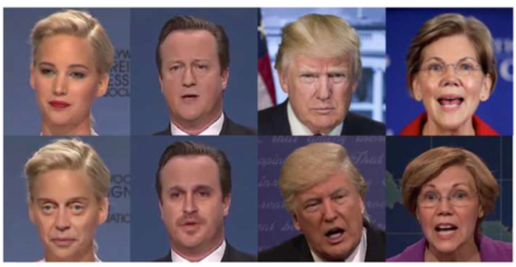

****FIGURE 1****

The growing interest in deepfake technology, has led to an increase in related research efforts. The past two years have seen tremendous progress in the development of new detection techniques. Initially, the number of video datasets available for deepfake detection tasks has been expanded. From small datasets like DeepFake-TIMIT and UADFV to large datasets like FaceForensic++, Celeb-DF, DFDC, DeeperForensic, the resources available for training and recognition models have grown exponentially. Recently, companies such as Amazon, Facebook and Microsoft collaborated to create the DeepFake Detection Challenge (DFDC), which aims to advance new technologies in deepfake video detection as well as the DeeperForensics Challenge This was organized by the These initiatives has led to the development of many effective detection methods, which have proven effective in fraud detection industries Despite these advances, there are still significant issues in the depth field of vision. As deepfake techniques continue to evolve, the number of automated videos increases, potentially making traditional detection methods inadequate to new

deepfake algorithms so it is important to investigate future improvements to deepfake research and develop corresponding methods of discovery. This review will focus on existing video detection systems developed for deepfake video, with the aim of promoting further development of deepfake video detection.

# Chapter3: Problem Statement

# Deepfake detection refers to the task of identifying whether a video has been manipulated or altered using AI techniques. The primary goal is to create a model capable of accurately discerning real videos from deepfakes, especially as the manipulations become increasingly subtle. The detection process relies on various cues that suggest unnatural or inconsistent patterns within the video, which may arise from the limitations of the deepfake generation algorithms.

# One of the main challenges in deepfake detection stems from the advancement of generative models, such as Generative Adversarial Networks (GANs), which are commonly used for creating deepfake videos. GAN-based techniques generate videos by altering facial expressions or swapping faces between individuals in such a realistic manner that it becomes difficult to visually distinguish them from real content. As a result, traditional video forensics, which relies on detecting obvious artifacts or inconsistencies, is often ineffective. Modern deepfake detection systems must thus employ more sophisticated techniques involving machine learning, deep learning, and computer vision.

# To understand the problem more deeply, it is essential to grasp how deepfake videos are created. Typically, deepfake generation involves two main components:

# Encoder-Decoder Architecture: The encoder captures key features of a person’s face and compresses this information into a latent space, while the decoder reconstructs the face from this compressed data. By training the encoder to map multiple people's faces into the same latent space, and using different decoders for each individual, the system can generate realistic face swaps.

# Generative Adversarial Networks (GANs): GANs consist of two neural networks—a generator and a discriminator. The generator creates fake data (in this case, images or videos), while the discriminator tries to distinguish between real and fake data. These networks are trained together, with the generator improving its ability to create convincing fake content and the discriminator becoming more skilled at detecting forgeries.

# This rapid development of GANs has led to the creation of highly realistic deepfakes, which are often used for nefarious purposes. Misuse of deepfakes can result in the spread of false information, manipulation of public opinion, and serious privacy violations. Such risks make the detection of deepfakes a crucial task in combating digital disinformation.

# Detecting deepfakes presents several technical challenges due to the evolving sophistication of generative algorithms:

# **Subtle Artifacts**: As GAN models improve, the artifacts or visual inconsistencies that once betrayed deepfakes are becoming less apparent. Detecting these subtle flaws requires advanced techniques that can spot imperceptible anomalies in facial expressions, eye movements, or skin textures.

# **High Variability**: There are multiple ways to create deepfakes, each using different architectures, data, and objectives. As a result, detection models must generalize well across a wide range of deepfake generation methods.

# **Temporal Coherence**: While detecting deepfakes from individual frames might be feasible in some cases, modern approaches consider the temporal dynamics of videos. Inconsistencies in motion, lighting changes, or unnatural transitions between frames can indicate tampering, but detecting such patterns requires models to analyze videos across time.

# **Adversarial Techniques**: Deepfake creators often employ adversarial techniques to bypass detection systems. They might slightly modify deepfake videos in ways that cause detection models to fail, exploiting the weaknesses of existing algorithms.

# **Data Scarcity**: Training deepfake detection models requires a large dataset of both real and fake videos. However, obtaining sufficient labeled deepfake videos that represent a wide range of generation techniques is challenging. Furthermore, publicly available datasets often do not cover all the recent advancements in deepfake creation.

# Chapter 4: Models

This CNN model, implemented using TensorFlow's Keras API, is designed for image classification to detect deepfakes. It begins with an input layer that processes images of size (64, 64, 3), representing the height, width, and RGB channels. A Lambda Layer converts the input data to the `float32` format, ensuring compatibility with TensorFlow's operations. Then, a Normalization Layer standardizes pixel values, stabilizing training and improving performance by ensuring that the model learns features more effectively.

The core of the model consists of two Convolutional Layers, each followed by a ReLU Activation Function. These layers extract spatial features such as edges, textures, and patterns from the input images, which are critical for distinguishing real content from deepfakes. The Max-Pooling Layer reduces the spatial dimensions of the feature maps, allowing the model to focus on the most prominent features while reducing the computational complexity. To prevent overfitting, Dropout Layers randomly deactivate neurons during training, ensuring that the model generalizes well to unseen data.

After the convolutional and pooling layers, a Flatten Layer reshapes the feature maps into a one-dimensional vector, preparing them for the final classification stage. A Dense Layer with a single neuron and a Sigmoid Activation Function outputs a probability score between 0 and 1, indicating whether an image is real (0) or a deepfake . The binary cross-entropy loss function guides the training process, optimizing the model’s ability to classify images accurately.

This architecture is carefully designed to detect subtle manipulations in deepfake videos, such as unnatural facial expressions or texture mismatches. By combining convolutional layers for feature extraction, max-pooling for dimensionality reduction, and dropout for regularization, the model achieves a balance between complexity and efficiency, making it effective for deepfake detection tasks.

# Chapter 5: Existing Algorithm and Improvement

The problem of deepfake detection has garnered significant attention in recent years due to the rapid advancements in deep learning and generative models, such as Generative Adversarial Networks (GANs). These techniques have been used to create hyper-realistic synthetic content, especially videos and images, posing serious challenges for media integrity, security, and trust. To counteract these threats, a wide array of research has been conducted to develop effective methods for detecting deepfakes.

**1. Convolutional Neural Networks (CNNs)**

CNNs have emerged as a popular approach for deepfake detection, primarily because of their ability to extract hierarchical spatial features from images. Several works have focused on using CNN architectures to identify artifacts and irregularities in facial expressions, lighting, or textures that deepfake generation processes often leave behind.

For example, in the work by Afchar et al. (2018), a shallow CNN-based architecture called MesoNet was proposed for deepfake detection. MesoNet leverages a series of convolutional and pooling layers to capture both global and mesoscopic features, which are critical in identifying subtle manipulations in deepfake videos. The use of shallow networks like MesoNet has demonstrated that even simple CNN architectures can detect deepfakes with competitive performance while maintaining computational efficiency.

Other researchers, such as Güera and Delp (2018), extended the CNN approach by integrating temporal information from videos. Their model combined a CNN for frame-level feature extraction with a Long Short-Term Memory (LSTM) network for analyzing temporal sequences. This hybrid model exploited both spatial and temporal inconsistencies in deepfake videos, enabling improved detection accuracy by recognizing unnatural transitions or inconsistencies between consecutive frames.

**2. Capsule Networks**

Another line of research explores the use of Capsule Networks (CapsNets) , as proposed by Sabour et al. (2017). Unlike traditional CNNs, Capsule Networks capture spatial hierarchies between features using dynamic routing mechanisms. Works such as that by Nguyen et al. (2019) have demonstrated that CapsNets are capable of detecting subtle distortions in face manipulations by preserving pose information, which is often corrupted during the creation of deepfakes. This capability allows CapsNets to outperform standard CNNs in certain deepfake detection tasks, especially those involving slight facial manipulations that are difficult to identify.

**3. Frequency Domain Analysis**

Another emerging approach in deepfake detection involves analyzing images in the frequency domain rather than the pixel domain. Durall et al. (2020) proposed using Discrete Fourier Transforms (DFT) to capture discrepancies in frequency patterns between real and deepfake images. GAN-based deepfake generation models often produce artifacts in high-frequency components that are imperceptible in the pixel domain but become evident in the frequency domain. By analyzing these frequency inconsistencies, this method provides a robust solution to detect artifacts that CNNs trained on pixel data might miss.

**4. Attention Mechanisms and Transformer Models**

More recently, transformer-based architectures have shown promise in image classification tasks, including deepfake detection. Vision Transformers (ViTs), proposed by Dosovitskiy et al. (2020), have been adapted for deepfake detection tasks due to their ability to model long-range dependencies across image patches. While CNNs are effective at capturing local features, ViTs excel at learning global context, which can be critical for detecting subtle, dispersed artifacts in deepfake videos. Attention mechanisms in transformers allow the model to focus on the most relevant parts of the image, enhancing detection accuracy.

**5. Multi-Modal Approaches**

Some researchers have explored multi-modal techniques by combining visual, audio, and textual data to improve deepfake detection. These models jointly analyze both visual manipulations and inconsistencies in the audio, such as unnatural synchronization between lip movements and speech. Li et al. (2020) demonstrated that leveraging both visual and audio cues can significantly enhance deepfake detection performance compared to single-modality models.

**6. Adversarial Training and Robustness**

Another related avenue of research is focused on adversarial training to improve the robustness of deepfake detection models. Since deepfake generation models are constantly evolving, detection algorithms must be resilient to new techniques. Adversarial training, where the detection model is trained alongside adversarial examples, can improve the model's ability to generalize to new types of deepfakes. This strategy has been explored in works like Zhao et al. (2021), where adversarial training methods help counteract the improvements in generative models by enhancing the detection model’s robustness to novel deepfake techniques.

# Chapter 6: Advantages and Limitations

**Advantages**

1. **High Accuracy in Feature Extraction**

Convolutional Neural Networks (CNNs) excel in detecting spatial patterns and features within images, making them highly effective for identifying the subtle artifacts often left behind in deepfakes. These artifacts, such as unnatural lighting, textures, or facial expressions, can be efficiently extracted by convolutional layers, allowing CNNs to achieve high accuracy in image classification tasks like deepfake detection.

1. **Scalability and Flexibility**

CNNs are versatile and can be easily scaled to handle different types of image resolutions and datasets. By adjusting the depth of the network or the number of filters, CNN architectures can be customized for specific tasks, such as frame-by-frame video analysis for detecting deepfake manipulations. Additionally, CNNs can be adapted for multi-modal systems that combine video frames, audio, and other input data, making them flexible in real-world applications.

1. **Efficient for Large Datasets**

Due to their hierarchical structure, CNNs can efficiently process large datasets by downsampling images via pooling layers. This ensures that the model remains computationally manageable while retaining essential features. Given the vast amount of data involved in deepfake detection (e.g., videos consisting of thousands of frames), CNNs are well-suited to handle such scale.

1. **Ability to Leverage Pretrained Models**

CNNs can take advantage of transfer learning, where a pretrained model (e.g., VGG, ResNet) on large datasets like ImageNet is fine-tuned on a deepfake detection dataset. This allows for faster training and improved performance, as the model can start from a well-established base of feature extraction knowledge.

**Limitations**

1. **Vulnerability to Evolving Deepfake Techniques**

While CNNs are effective at detecting artifacts in current deepfake methods, they can struggle to keep up with the rapid advancements in deepfake generation. As generative models (like GANs) become more sophisticated, they produce higher-quality deepfakes with fewer visible artifacts. CNNs, trained to detect specific cues, may miss these subtle or non-existent artifacts in newer deepfake models, limiting their effectiveness over time.

**2. Overfitting to Training Data**

CNN models, especially deeper architectures, can be prone to overfitting, particularly when trained on limited datasets. Overfitting occurs when the model becomes too specialized in detecting deepfakes in the training data but fails to generalize well to new, unseen data. This is especially problematic in deepfake detection since the variance in the data (e.g., different types of manipulations or faces) is quite high.

**3. Limited Temporal Analysis**

While CNNs are excellent at processing individual frames from videos, they are not inherently designed to capture temporal relationships between frames. Deepfake videos often contain temporal inconsistencies that are hard to detect with CNNs alone. Although hybrid models (like CNN-LSTM) have been proposed, CNNs themselves do not natively account for temporal dynamics, which can limit their performance when analyzing entire video sequences.

**4. Computationally Intensive**

Despite being efficient for large datasets, CNNs can still be computationally intensive, particularly when handling high-resolution images or processing videos frame-by-frame. Training deep CNNs requires significant computational resources, often necessitating the use of GPUs or TPUs. This limits their accessibility for smaller organizations or in environments with limited computational infrastructure.

# Chapter 7: Steps of Code

# The process of implementing a Convolutional Neural Network (CNN) for detecting deepfakes involves several stages, from handling video data to building and training the model. Below is a detailed theoretical explanation of each step involved in this deepfake detection task using TensorFlow's Keras API.

# **1: Data Loading and Preprocessing on Deepfake Videos**

# **1.1 Data Loading**

# Deepfake detection involves large datasets of both real and manipulated (deepfake) videos. Each video must be broken down into individual frames, as CNNs are designed to work with images, not videos. By extracting frames at set intervals (e.g., every 10th frame), the dataset becomes manageable while retaining the essential visual information needed for deepfake detection.

# Once extracted, these frames are stored in a format suitable for further processing. This step helps to convert the complex temporal data of videos into a set of spatial data (images) that the CNN can process efficiently.

# **1.2 Data Preprocessing**

# Preprocessing the data is essential to ensure compatibility with the model and to enhance the model’s performance during training. This includes several key steps:

# Resizing: All frames are resized to a consistent shape (e.g., 64x64 pixels). This standardization ensures that each image has the same dimensions, allowing for uniform input across the CNN.

# Normalization: Each pixel’s value in an image typically ranges from 0 to 255. Normalizing these values (scaling them to a range between 0 and 1) stabilizes the learning process and improves the model’s convergence speed. Normalization helps prevent large values from overwhelming the network during training.

# Train-Test Split: The dataset is split into training, validation, and test sets. The training set is used to optimize the model’s parameters, the validation set helps in tuning the model (e.g., hyperparameter optimization), and the test set evaluates the final model performance. A common split ratio is 80% for training, 10% for validation, and 10% for testing.

# **Step 2: Building the CNN Model Architecture**

# The core of deepfake detection is the CNN model, which is designed to extract spatial features from the image data. This model typically consists of several specialized layers that work together to learn from the visual patterns in the deepfake video frames.

# **2.1 Input Layer**

# The input layer is the starting point of the model, where the preprocessed images (with a fixed size of 64x64 pixels and 3 color channels for RGB) are fed into the network. The input shape is defined based on these dimensions.

# **2.2 Lambda Layer**

# This layer ensures the data type is compatible with TensorFlow's operations by casting the input data into the required format (e.g., `float32`). This ensures that the data is properly handled and that numerical operations are consistent across the network.

# **2.3 Normalization Layer**

# Following the input, a normalization layer is added to standardize the pixel values further, enhancing the stability of the training process. Normalizing data at this stage helps the model learn more effectively by keeping gradients in a manageable range.

# **2.4 Convolutional Layers**

# The convolutional layers form the backbone of the CNN, responsible for extracting meaningful features from the images.

# **2.5 Dropout Layers**

# Dropout layers are inserted after convolutional layers to prevent overfitting. During training, dropout randomly "drops" a fraction of neurons, forcing the network to be more robust and preventing it from relying too heavily on specific features in the training set. This technique improves generalization to unseen data.

# **2.6 Flattening Layer**

# Once the spatial features have been extracted and pooled, they must be prepared for the final decision-making process. The feature maps are flattened into a one-dimensional vector. This allows the next layer, a fully connected dense layer, to process these features for classification.

# **2.7 Dense Layer with Sigmoid Activation**

# The dense layer serves as the decision-making component of the network. It consists of a single neuron with a sigmoid activation function. This function outputs a probability score between 0 and 1, which corresponds to the likelihood of an image being real or a deepfake. This binary classification (real or fake) is the core task of the model.

# **Step 4: Model Training**

# Training the CNN involves feeding the processed training data into the model and iterating over it multiple times (epochs). During each epoch, the model updates its internal parameters (weights) based on the loss calculated for the training examples. Key considerations during training include:

# Batch Size: The number of samples processed before the model updates its weights. Larger batch sizes lead to faster training, while smaller batch sizes offer more granular updates.

# Validation Set: To monitor the model’s performance and avoid overfitting, the validation set is used during training. The model's performance on this data gives an indication of how well it is generalizing beyond the training set.

# **Step 5: Model Evaluation**

# After training, the model is evaluated on the test set to measure its generalization ability. The key metric is usually accuracy, but in deepfake detection, other metrics like precision (how many detected fakes are correct), recall (how many fakes were detected), and the F1 score (balance between precision and recall) are also important. These metrics help assess the model’s overall effectiveness at identifying deepfakes.

# **Step 6: Inference on New Data**

# Once the model is trained, it can be used to detect deepfakes in new, unseen videos. The same preprocessing steps (frame extraction, resizing, normalization) are applied to the new data, which is then fed into the model. The model will output a probability score indicating whether each frame is classified as real or a deepfake.

# Chapter 8: Methodology

# Deepfake detection is a challenging problem that requires identifying subtle manipulations in video frames. A Convolutional Neural Network (CNN) model can be employed to detect these manipulations by learning the spatial patterns in image data. This CNN model is implemented using TensorFlow's Keras API and is designed with layers that optimize image classification, particularly for detecting deepfakes. Below is a detailed explanation of the architecture and training process, focusing on each component's role.

# **1.Input and Data Preprocessing**

# The first step in the model is the input layer, which accepts images with a fixed shape of (64, 64, 3). These images are derived from video frames, where each frame is resized to 64x64 pixels, with 3 channels representing the RGB color values. Handling this image size helps in keeping the computational load manageable without losing essential details.

# Following the input layer, a lambda layer is incorporated to cast the input data into the `float32` format. TensorFlow requires this format for operations, ensuring that all data is compatible with the internal operations of the framework. This layer is crucial for maintaining consistency in the data processing pipeline.

# Next, a normalization layer is applied to the input data. Normalization adjusts the pixel values to fall between 0 and 1 by dividing the original values (0 to 255) by 255. This step is vital because normalized inputs make the model's training process more stable and efficient. It reduces the risk of exploding or vanishing gradients, which can disrupt learning in deep networks.

# **2.Feature Extraction using Convolutional Layers**

# The core of the CNN architecture consists of two convolutional layers, each equipped with a ReLU (Rectified Linear Unit) activation function. These convolutional layers are designed to extract key spatial features from the input images.

# **First Convolutional Layer:** This layer applies multiple filters (e.g., 32 filters) to the input image. These filters learn to detect simple patterns such as edges, corners, and textures. The ReLU activation function is applied to introduce non-linearity, allowing the network to capture complex patterns in the data.

# 

# **Max-Pooling Layer:** After the first convolutional layer, a max-pooling layer is used. Max-pooling down-samples the feature maps by taking the maximum value from a set of neighboring pixels. This reduces the spatial dimensions of the image while retaining the most prominent features, helping the model focus on the essential information while also reducing computational complexity.

# **Second Convolutional Layer:** This layer applies additional filters (e.g., 64 filters) to further extract more abstract features from the pooled feature maps. As images move through successive convolutional layers, the network begins to detect higher-level patterns, such as textures or shapes that might reveal deepfake manipulations.

# **3.Overfitting Prevention with Dropout Layers**

# Dropout layers are incorporated into the model to prevent overfitting—a situation where the model learns patterns specific to the training data but performs poorly on unseen data. Dropout randomly deactivates a fraction of the neurons during each training iteration, ensuring the model does not rely too heavily on particular neurons. This encourages the model to generalize better to new data, making it more robust in detecting deepfakes across a variety of inputs.

# **4.Flattening and Dense Layers for Classification**

# Once the spatial features have been extracted from the image, they must be prepared for classification. A flattening layer transforms the two-dimensional feature maps from the convolutional layers into a one-dimensional vector. This vector represents all the extracted features of the image, which are now ready to be fed into a fully connected dense layer.

# The final dense layer consists of a single neuron, which uses a sigmoid activation function. This activation function outputs a probability score between 0 and 1, where values close to 1 indicate that the image is likely a deepfake, while values near 0 suggest that the image is real. This binary classification is the core output of the model, providing a clear prediction of whether an input frame is genuine or manipulated.

# **5.Model Summary and Training Process**

# The entire CNN model is summarized, detailing each layer and the number of trainable parameters within the network. This summary provides insight into the model's complexity, highlighting how each layer contributes to the overall task of deepfake detection.

# The training process involves feeding the preprocessed image data into the model. Training data consists of both real and deepfake images, which are passed through the model in batches during each training epoch. The model's weights are updated iteratively based on the loss function—binary cross-entropy in this case—which measures the discrepancy between the predicted output and the true labels.

# The optimizer used during training is typically Adam, which adjusts the learning rate dynamically to ensure efficient convergence. Additionally, the validation data helps monitor the model’s performance after each epoch, ensuring that it is not overfitting to the training set. Dropout layers and the max-pooling operation further aid in improving the model's ability to generalize.

# The trained model learns to classify new images based on subtle differences that may indicate manipulation, such as slight changes in facial textures or lighting that are common in deepfake videos. By focusing on these differences, the CNN becomes capable of accurately detecting deepfakes, enhancing its ability to classify both real and fake video frames effectively.

# 

# Chapter 9: Hardware and Software Used

## : Software

* + 1. **: Jupyter Notebook**

Jupyter Notebook is an open-source web application used for interactive computing. It enables users to create and share documents that contain live code, equations, visualizations, and narrative text. Its flexibility allows programmers, data scientists, researchers, and educators to create computational narratives called "notebooks" that combine code execution, explanatory text, and multimedia output. The platform supports various

programming languages, including Python, R, and Julia, offering an interactive environment where users can write and execute code snippets in cells, visualize data, and coherently explain their analysis, fostering collaboration and reproducibility in data analysis, research, and software development.

## : Python:

Python is a high-level, versatile programming language known for its readability and simplicity. It emphasizes code readability and has a clean and easy-to-understand syntax, making it a popular choice for beginners and professionals alike. Python supports multiple programming paradigms, including procedural, object-oriented, and

functional programming styles. It offers a vast ecosystem of libraries and frameworks that facilitate various tasks, from web development and data analysis to artificial intelligence and scientific computing. Python's

versatility, extensive community support, and robustness have made it a go-to

language for diverse applications, including software development, data science, machine learning, automation, and more.

## : Kaggle:

Kaggle is a popular platform for data science and machine learning that offers a vast repository of datasets across various domains, such as finance, healthcare, and natural language processing. These datasets are typically shared by the community

and are freely accessible, allowing users to explore, analyze, and use them for model training. Kaggle datasets range from small,

clean datasets to large, complex ones, making them valuable for both beginners and experienced data scientists. Kaggle Notebooks are also an integrated environment for running code on the platform. These notebooks support languages like Python and R, enabling users to perform data analysis, build machine learning models, and visualize data directly in the browser. Kaggle Notebooks are equipped with built-in GPUs and TPUs for accelerated computation and can be easily shared with the community, making collaboration and learning from others more accessible.

## : Google Colab :

Google Colab, short for Collaboratory, is a cloud-based service offered by Google that provides a Jupyter Notebook environment for writing and executing Python code collaboratively. This platform enables users to create interactive documents, known as notebooks, containing live code, visualizations, explanatory text, and mathematical equations. One of its notable advantages is the provision of free access to GPU and TPU resources, which are beneficial for running computationally intensive tasks such as machine learning and deep learning models. Users can seamlessly integrate their work with Google Drive, enabling easy storage, access, and sharing of Colab notebooks. Furthermore, it supports a wide array of Python libraries and frameworks, including TensorFlow, PyTorch, Pandas, and more, making it versatile for data science, machine learning, and research projects. Its collaborative features facilitate real-time collaboration among multiple users on coding projects, fostering teamwork and knowledge sharing. The platform's accessibility, coupled with its powerful computing resources and integration with Google's ecosystem, makes Google Colab a popular choice for individuals and teams seeking a convenient, cloud-based environment for Python programming and data analysis tasks.

## : Hardware Used

* + 1. **: ASUS Gen11 Laptop**

The ASUS Gen11 laptop is a computing device produced by ASUS, a renowned technology company. As part of the ASUS brand, Gen11 laptops represent a line of modern laptops that

incorporate the latest technology and hardware specifications. These laptops typically feature Intel's 11th-generation processors, offering improved performance and efficiency for various computing tasks. ASUS Gen11 laptops often include features such as high-resolution displays, powerful processors, ample RAM and storage, sleek designs, and a range of connectivity options. They cater to different user needs, including productivity, gaming, content creation, and everyday use, providing a balance between performance, portability, and functionality.

## : Central Processing Units (CPUs)

High-performance Central Processing Units (CPUs) equipped with multi-core architectures play a pivotal role in deep learning model training tasks. CPUs handle intricate calculations and iterative processes inherent in optimization algorithms. Their processing power and ability to execute complex instructions efficiently aid in tasks such as model training preprocessing and back-testing strategies. While CPUs may not match the parallel processing capabilities of GPUs, they remain essential for training models.

## : GPU

GPUs are highly effective for parallel processing tasks due to their architecture, which is specifically designed to handle numerous calculations simultaneously. In deep learning, complex mathematical computations, large-scale simulations, and optimization algorithms are commonplace. GPUs, with their parallel computing capabilities, significantly accelerate these processes, drastically reducing the time required for tasks like training neural networks, fine- tuning hyperparameters, and running inference. Many modern deep learning techniques, especially those involving large models such as convolutional neural networks (CNNs) or

transformers, rely heavily on GPUs for efficient training and deployment, making them indispensable in the field.

## : Random Access Memory (RAM)

Ample Random Access Memory (RAM) is crucial for deep learning, aiding in storing and accessing extensive datasets swiftly. High-capacity RAM enables efficient data processing and model computations, allowing algorithms to operate on substantial datasets without encountering bottlenecks due to memory limitations. Fast access to data stored in RAM enhances the overall performance of optimizing the model training.

# Chapter 10: Screenshot of the Code

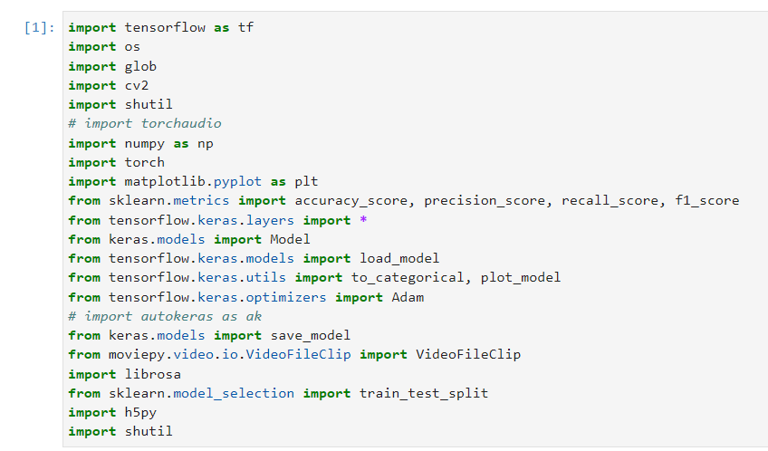

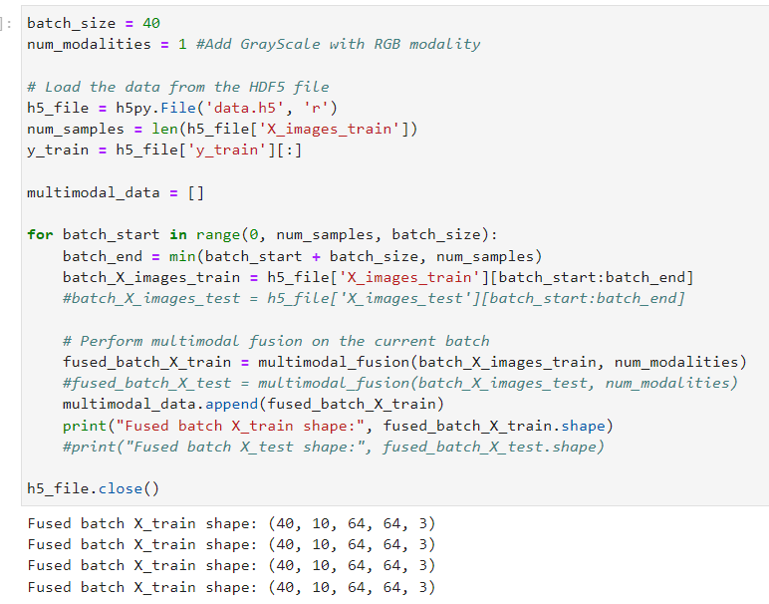

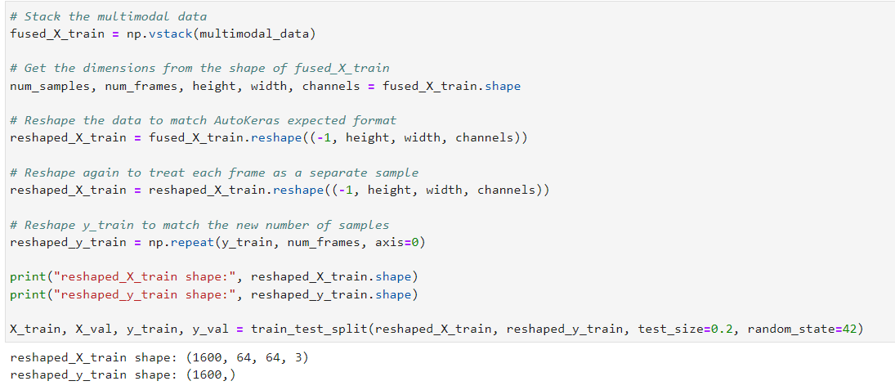

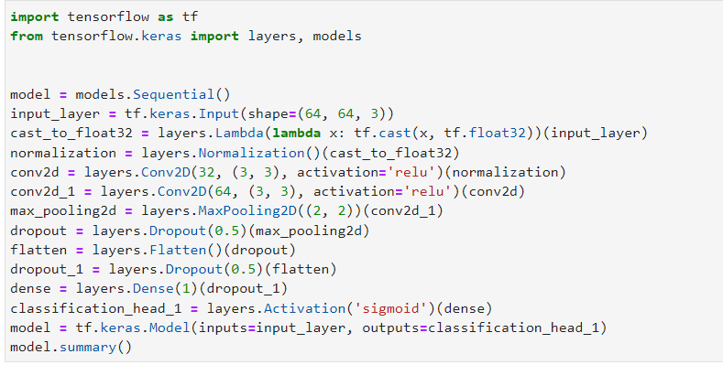

# Chapter 11: Output

# 

# 

**Chapter 12: Bibliography**

### Research Paper 1: Very Deep Convolutional Networks for Large-Scale Image Recognition

**What they do:** Developed very deep convolutional networks for large-scale image recognition. **Model they use:**

* **Technology:** Convolutional Neural Network (CNN)
* **Models/Algorithms:** VGGNet

**Reference:** Simonyan, K., & Zisserman, A. (2015). Very deep convolutional networks for large-scale image recognition. International Conference on Learning Representations (ICLR) 2015. arXiv:1409.1556v6 [cs.CV].

### Research Paper 2: Deep Fakes: A Looming Challenge for Privacy, Democracy, and National Security

**What they do:** Explored the implications of deep fakes on privacy, democracy, and national security. **Model they use:**

* **Technology:** Legal and social analysis

**Reference:** Chesney, R., & Citron, D. K. (2018). Deep fakes: A looming challenge for privacy, democracy, and national security. California Law Review, 107, Forthcoming. U of Texas Law, Public Law Research Paper No. 692; U of Maryland Legal Studies Research Paper No. 2018-21.

### Research Paper 3: Exposing AI Generated Fake Face Videos by Detecting Eye Blinking

**What they do:** Exposed AI-generated fake face videos by detecting the absence of eye blinking. **Model they use:**

* **Technology:** Computer Vision
* **Models/Algorithms:** Eye Blinking Detection

**Reference:** Li, Y., Chang, M.-C., & Lyu, S. (2018). In Ictu oculi: Exposing AI generated fake face videos by detecting eye blinking. arXiv:1806.02877v2 [cs.CV].

### Research Paper 4: Exposing DeepFake Videos By Detecting Face Warping Artifacts

**What they do:** Exposed deepfake videos by detecting face warping artifacts. **Model they use:**

* **Technology:** Computer Vision
* **Models/Algorithms:** Face Warping Artifact Detection

**Reference:** Li, Y., & Lyu, S. (2019). Exposing deepfake videos by detecting face warping artifacts. arXiv:1811.00656v3 [cs.CV]. [https://doi.org/10.1016/S0969-4765(19)30137-7](https://doi.org/10.1016/S0969-4765(19)30137-7" \t "_new).

### Research Paper 5: MesoNet: A Compact Facial Video Forgery Detection Network

**What they do:** Developed a compact network for detecting facial video forgeries. **Model they use:**

* **Technology:** Neural Networks
* **Models/Algorithms:** MesoNet

**Reference:** Afchar, D., Nozick, V., Yamagishi, J., & Echizen, I. (2018). MesoNet: A compact facial video forgery detection network. arXiv:1809.00888v1 [cs.CV]. [https://doi.org/10.1109/WIFS.2018.8630761](https://doi.org/10.1109/WIFS.2018.8630761" \t "_new).