ASSIGNMENT 5
COMPUTER VISION

UDIT SINGH PARIHAR
2018701024

1st part: Optical flow
1.
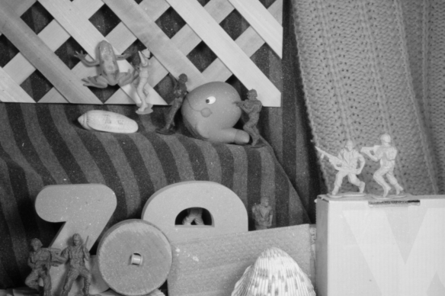

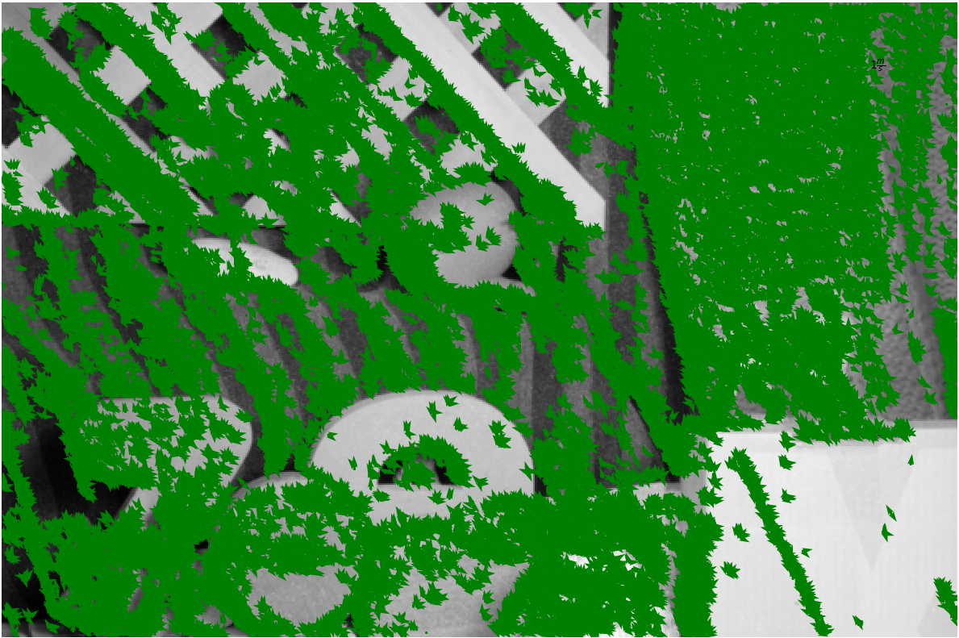

Optical flow on moving objects only.

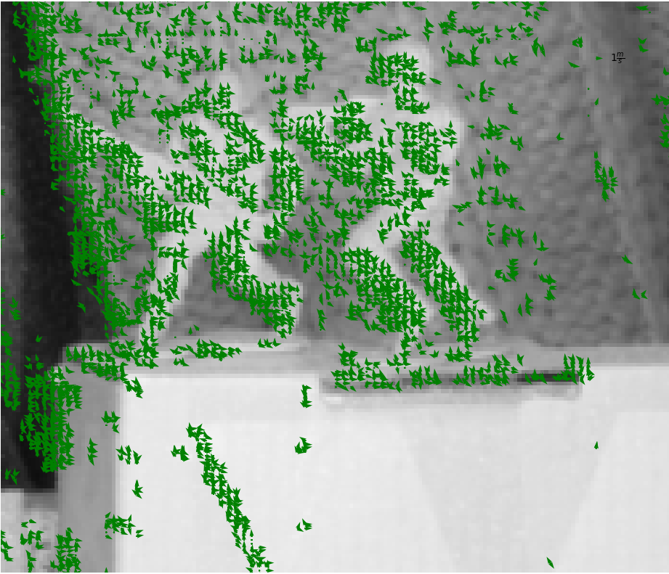

No optical flow on white box below soldiers.

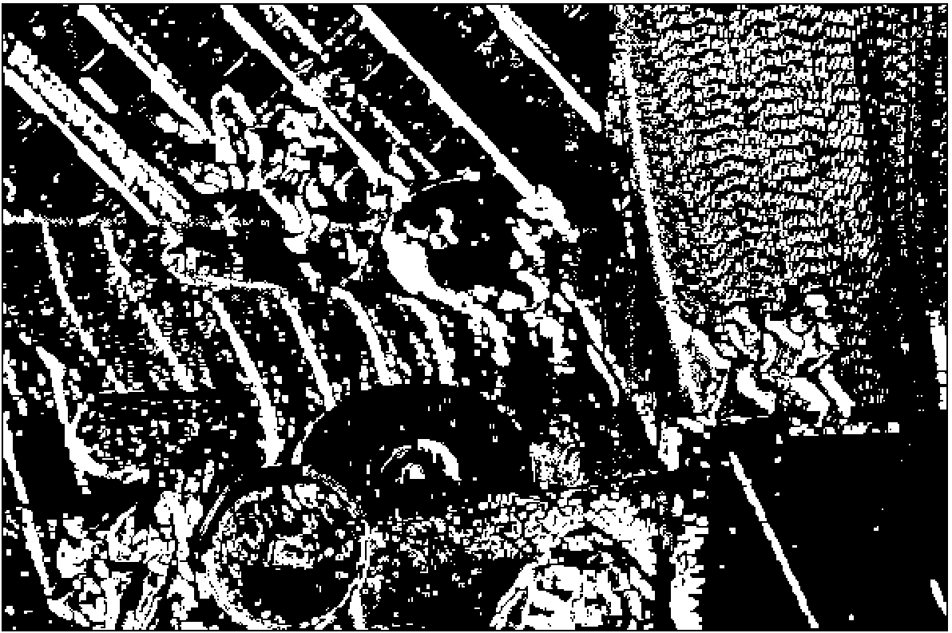
Moving objects in white and non – moving object in black.

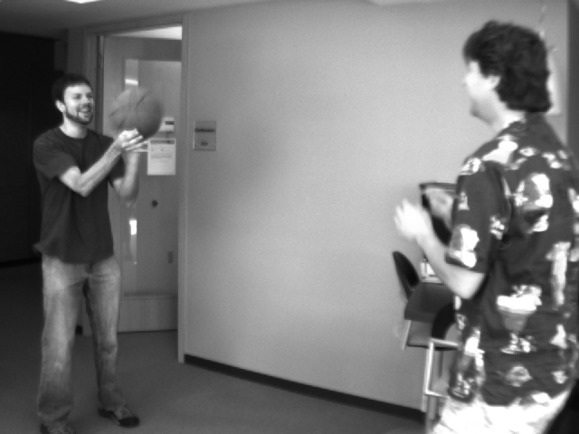
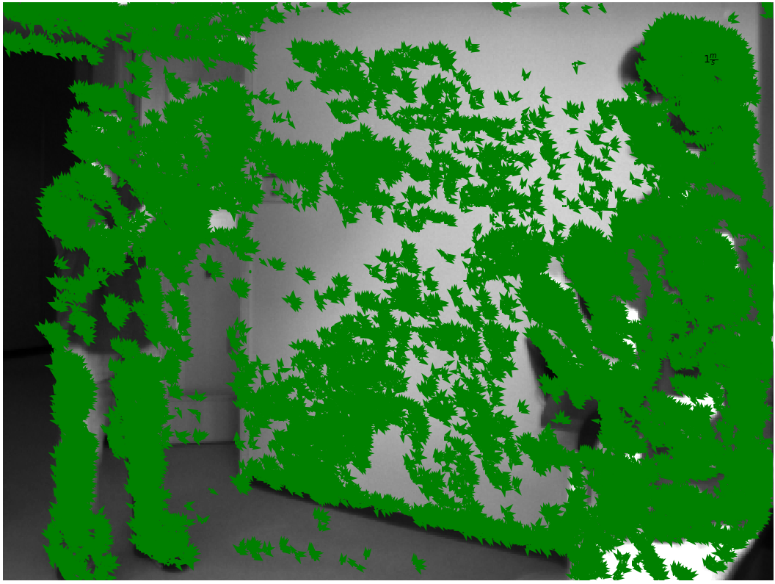
2.

Moving person and basketball

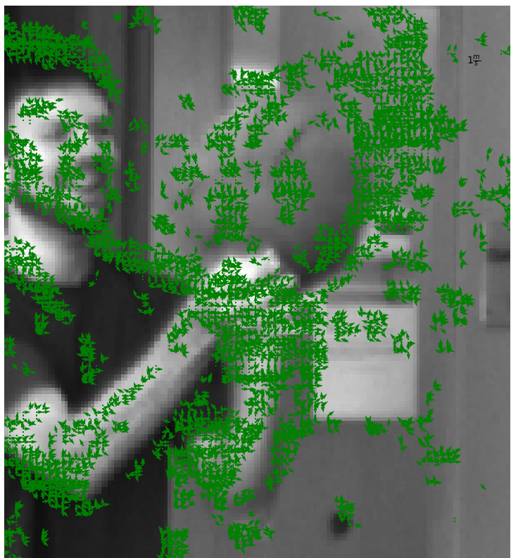
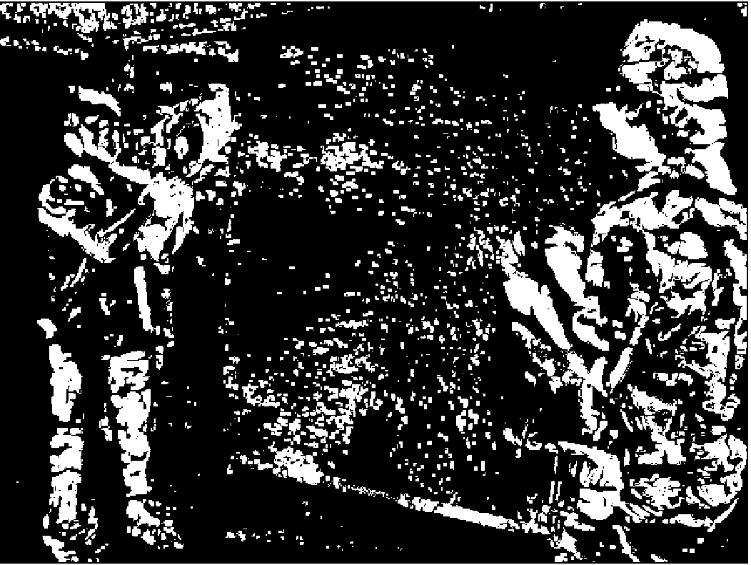
Optical flow around basketball only, no flow on wall

Clear identification of person and basketball and person

3.
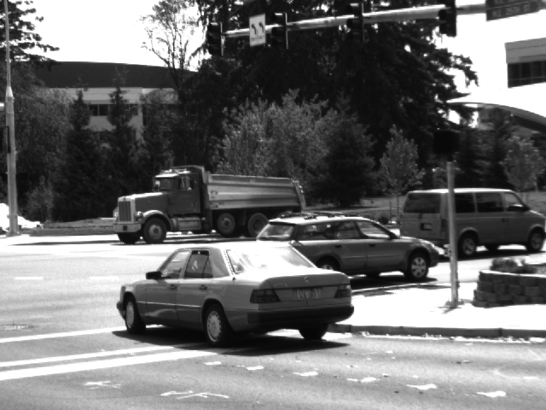

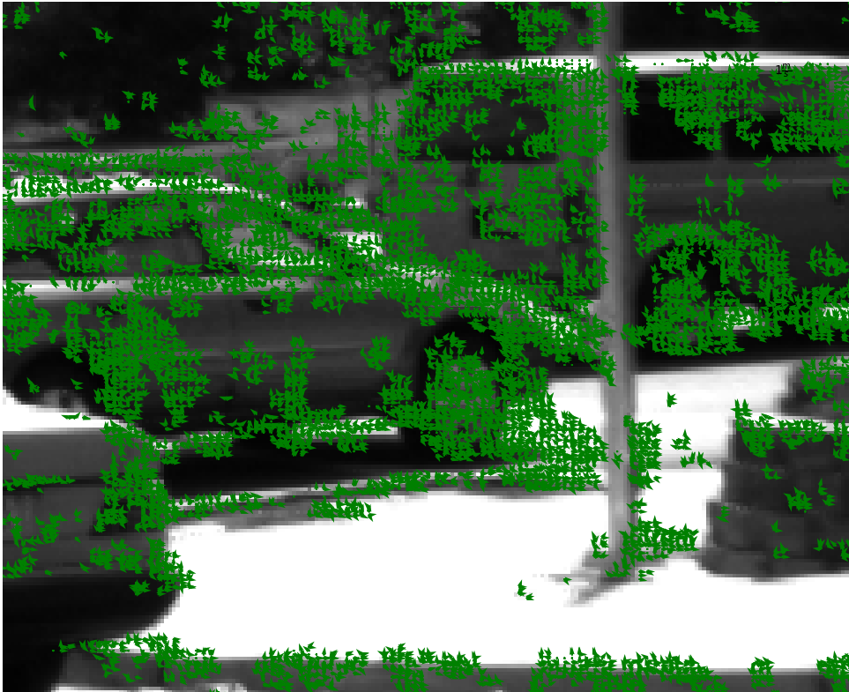
Moving vehicle and stationary pole.

4.
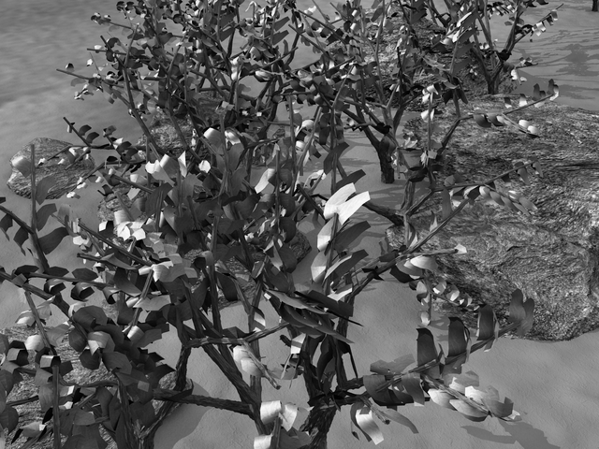

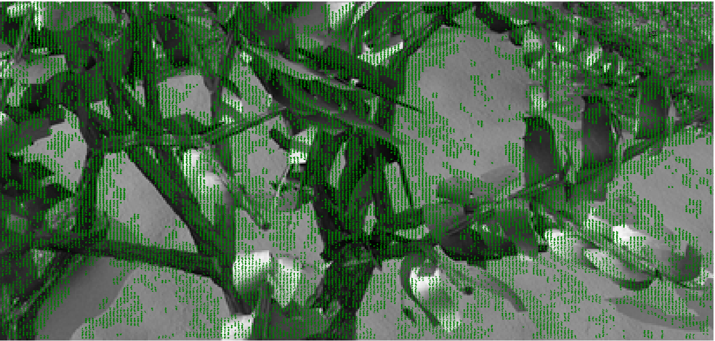

Moving plant and stationary floor.

5.
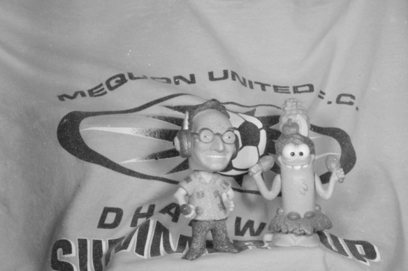

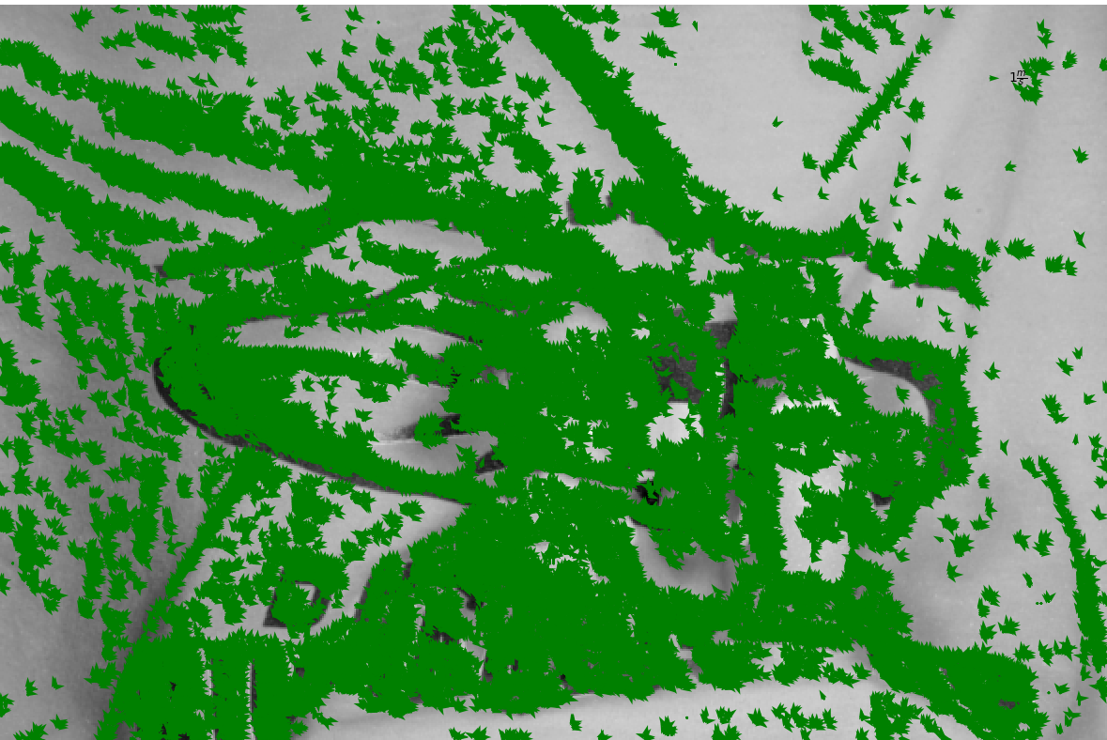
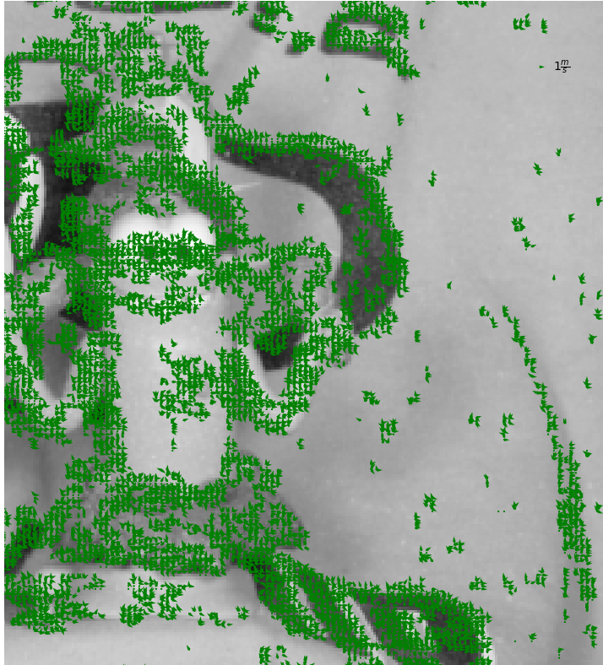

2nd part: Segmentation:

Works well on small movement frames.

Binary thresholding done on norm space of
velocity vector.

3rd part:

With moving camera, every pixel will have non zero velocity vector. If the camera velocity is known from external sensor like IMU, then this velocity could be subtracted from the optical velocity vector of all pixels.

Second approach could be to have a prior information about moving objects to track, but we would only get relative velocity only.

